

**Graduation Project**

**PROPOSAL DOCUMENT**

REX_COFEEE MANAGEMENT SYSTEM

|  |  |
| --- | --- |
| Mentor: | MSc Huy Nguyen Dang Quang |
| Project Team: | 2 |
| Team Members: | Nguyen Quang Bao  Nguyen Thanh Long Hien  Phan Nhat Huy |

**PROJECT INFORMATION**

|  |  |  |  |
| --- | --- | --- | --- |
| **Project Acronym** | RMS | | |
| **Project Title** | Rex_Coffee | | |
| **Start Date** | Nov 06, 2024 | **End Date** | Nov 13, 2024 |
| **Lead Institution** | The Faculty of Information Technology, Duy Tan University | | |
| **Project Mentor** | MSc Huy Nguyen Dang Quang | | |
| **Project Manager & Contact Details** | MSc Huy Nguyen Dang Quang  Email: huyndq@duytan.edu.vn  Phone: 0935525354 | | |
| **Members** | Nguyen Quang Bao | nguyenquangbao575@gmail.com | 0779598354 |
| Nguyen Thanh  Long Hien | hiennguyen05102005@gmail.com | 0702747211 |
| Phan Nhat Huy | nhathuyphan21@gmail.com | 0905839107 |

**PROPOSAL DOCUMENT**

|  |  |  |  |
| --- | --- | --- | --- |
| **Document Title** | Proposal Document | | |
| **Reporting Period** | Nov 2024 | | |
| **Author(s)** | Nguyen Quang Bao  Nguyen Thanh Long Hien  Phan Nhat Huy | | |
| **Date** | Nov 12, 2024 | **Filename** | COFFEE_SHOP_Proposal_Version-1.1.docx |
| **Access** | Project and FIT program | | |

**DOCUMENT HISTORY**

|  |  |  |  |
| --- | --- | --- | --- |
| **Version** | **Person** | **Date** | **Description** |
| 1.0 | Nguyen Quang Bao  Nguyen Thanh Long Hien  Phan Nhat Huy | Nov 11, 2024 | Draft |
| 1.1 | Nguyen Quang Bao  Nguyen Thanh Long Hien  Phan Nhat Huy | Nov 12, 2024 | Complete |

**SIGNATURE**

***Document Approvals:*** *The following signatures are required for approval of this document.*

|  |  |  |
| --- | --- | --- |
| MSc Huy Nguyen Dang Quang  Mentor |  | Date |
| Nguyen Quang Bao  Leader |  | Date |
| Nguyen Thanh Long Hien  Member |  | Date |
| Phan Nhat Huy  Member |  | Date |

**Table of Contents**

I. Introduction 7

1. Purpose 7

2. Scope 7

3. References 8

II. Project Overview 9

1. Project Definition 9

2. Business Needs 9

2.1. Business Problem 9

2.2. Business Needs 9

III. Proposal Solution 10

1. Project Goal 10

1.1. Business Function Diagram 11

1.2. System Context Diagram 12

1.3. DFD Level 1 Diagram 14

2. Technical Constraints 14

IV. Master Plan 16

1. Master Schedule 16

2. Organization Management 17

2.1. Human Resource 17

2.2. Cost Estimation 18

**Table**

Table 1: References 8

Table 2: Master Schedule 16

Table 3: Human Resource 17

Table 4: Detail Cost Estimation 18

**Figure**

Figure 1: Business Function Diagram 11

Figure 2: System Context Diagram 12

Figure 3: DFD Level 1 12

# Introduction

## Purpose

The document provides an overview of the project including the purpose and scope of the project:

* The document provides an overview of the project including the purpose and scope of the project.
* Also, identifies the daily operational processes of the cafe.
* Identify management needs for software operations.
* Identify challenges and desired improvements that provide a solution to the business needs and provide an overview of the system architecture.
* Provide functionality to facilitate customer service for employees.
* Enhance the quality of the customer experience.
* Explore user interface and experience requirements.
* Provide an overview of resources, schedule, solution, and budget for the project

## Scope

This document provides a scope of interview about the cafe management system that should focus on the following key aspects to understand the needs and desires of the cafe:

This document provides the daily operation process of the cafe, how to manage staff, manage revenue and expenses, manage orders and payments.

The proposal includes the introduction of solutions, identifying the best way to develop the software that we do, the total estimated cost, payback period, and the break-even volume for the project.

## References

|  |  |  |
| --- | --- | --- |
| **No.** | **References** | **Document Information** |
| 1 | **How to run a coffee shop easier** | <https://www.facebook.com/groups/httpschuquancaphe.vn/posts/4396727010363849/>. |
| 2 | **Analyze and design functions for the system** | <https://studyresource.duytan.edu.vn/access/content/group/229472/Group%20Project/ur_project_1_2023.pdf>.  <https://studyresource.duytan.edu.vn/access/content/group/229472/Template/Proposal%20Document%20Template.docx>. |
| 3 | **Cafe Management Systems** | CoffeeCup, Upserve, CafeX: Provide specialized coffee shop management solutions, from ordering, payment to revenue reporting and customer interaction. |
| 4 | **Information & Resources for Cafe Owners** | CoffeeBI, Perfect Daily Grind, Barista Institute: Sites that share knowledge about the coffee industry, market trends, and how to manage and develop services for coffee shops. |

Table 1: References

# Project Overview

## Project Definition

The Coffee Shop Management System is designed to streamline and automate daily operations in a coffee shop. This system provides tailored functionalities for key stakeholders, including customers, waiters, baristas, cashiers, and administrators. It integrates features such as order management, menu updates, payment processing, and revenue management, ensuring a seamless experience for both customers and staff

## Business Needs

### Business Problem

Coffee shop face multiple challenges, including:

* Inefficient order-taking processes, leading to delays and errors.
* Lack of visibility into real-time inventory, causing dissatisfaction when items are out of stock
* Manual management of tables, orders, and payments, resulting in operational bottlenecks
* Difficulty in generating revenue reports and tracking performance metrics
* Limited interaction between staff roles, which affects overall efficiency and customer satisfaction

### Business Needs

The coffee shop requires a unified and automated management system to address these challenges by:

* Enhancing the customer experience through streamlined ordering and real-time updates
* Providing staff with tools to manage and track orders efficiently, minimizing errors
* Allowing administrators to oversee operations, update menus, and manage tables and prices dynamically
* Offering detailed revenue and performance insights to improve decision-making and profitability
* Ensuring seamless

# Proposal Solution

## Project Goal

Build a coffee shop management system with the goal of improving efficiency and increasing productivity in inventory management and interaction between employees and customers.

Allow customers to access and view the menu via phone, making it easy for them to order and pay, increasing convenience.

Easily manage customer issues, seating and appointment schedules.

Easily manage revenue, account, menu, monitor and evaluate business process effectiveness.

Helps reduce manual operations, improve service speed and reduce human errors, improve service quality, and increase customer satisfaction.

### Business Function Diagram

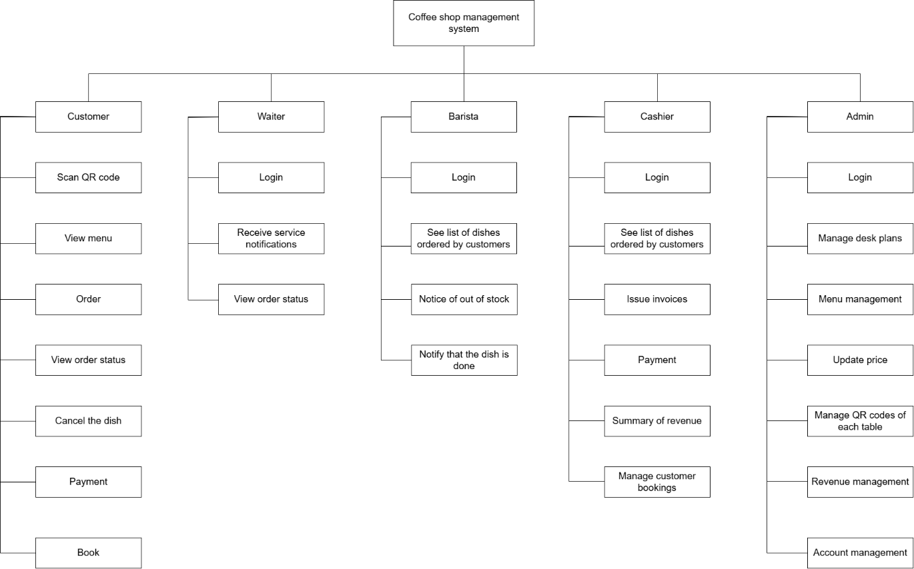

Figure 1: Business Function Diagram

### System Context Diagram

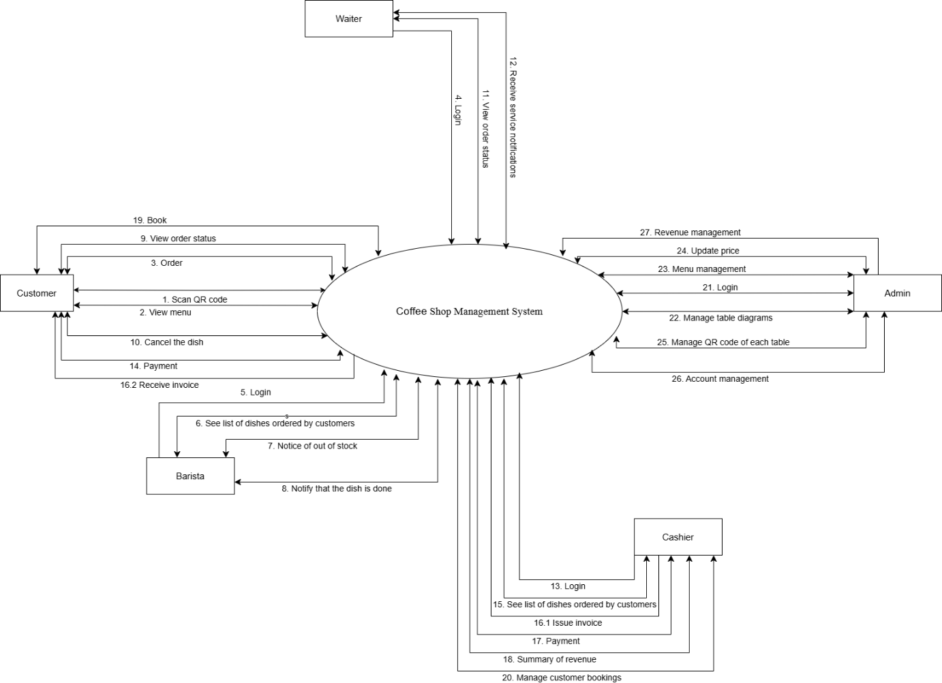

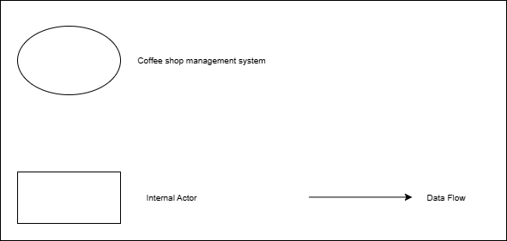

Figure 2: System Context Diagram

The "Rex_Coffee" system with key features that meet business requirements includes

* For Customer role include:
  + Order, view the menu, choose dishes by scanning the QR code at the table to access the system.
  + Make reservations in advance by registering online or calling the phone number on the website.
  + View invoices and totals through the screen.
  + Payment.
* For Waiter role include:
  + Login.
  + Receive order notifications from barista
  + Serve the dish when it is done.
* For Coffee barista role include:
* Login.
  + Receive the list of dishes ordered by the customer.
  + Notify and request customers to re-select when out of stock via phone screen.
  + Notify the waiter when the dish is finished.
* For Cashier role include:
* Login.
  + Check the customer's desk code through the system.
  + Issue invoices and collect payment from customers.
  + Summarize daily, weekly, monthly revenue and report to admin.
* For Admin role include
  + Account management
  + Manage table plans
  + Menu management
  + Manage QR codes
  + Update price
  + Login
  + Revenue management

### DFD Level 1 Diagram

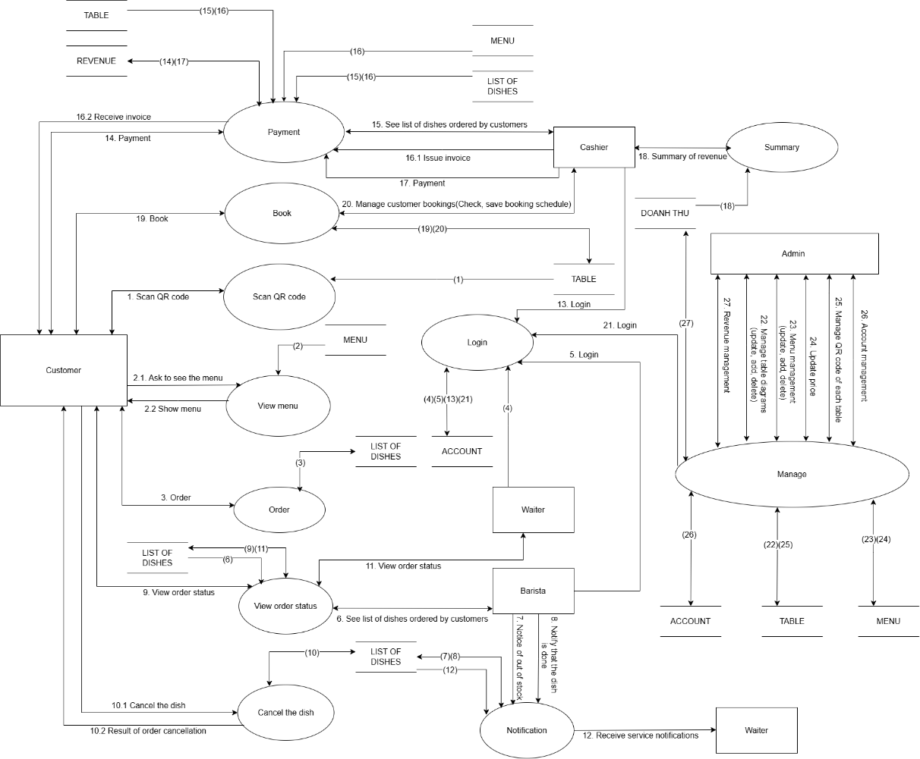

*Figure 3: DFD Level 1 Diagram*

## Technical Constraints

*For Windows application development*

* Tool develop: Visual Studio 2022
* Language: C#, ASP.NET Core
* Database: MongoDB

*Test tool*

* Manual test

*Other constraint*

* Resource: 03 people
* Budget: Limited
* Time: The project must be completed within 1 week frame
* Environment: Windows

# Master Plan

## Master Schedule

|  |  |  |  |  |
| --- | --- | --- | --- | --- |
| **No.** | **Task name** | **Duration** | **Start** | **Finish** |
| 1 | **Start Up** |  | Nov 06, 2024 | Nov 12, 2024 |
| 1.1 | Gathering Requirement | 1 day | Nov 10, 2024 | Nov 10, 2024 |
| 1.2 | Analyzing Requirement | 2 days | Nov 10, 2024 | Nov 11, 2024 |
| 1.3 | Define Functional Requirements list | 1 day | Nov 11, 2024 | Nov 11, 2024 |
| 1.4 | Building a Business Function Diagram | 1 day | Nov 11, 2024 | Nov 11, 2024 |
| 1.5 | Building a System Context Diagram | 1 day | Nov 11, 2024 | Nov 11, 2024 |
| 2 | Create a proposal document | 2 days | Nov 11, 2024 | Nov 12, 2024 |
| 3 | Final Release | 1 day | Nov 12, 2024 | Nov 12, 2024 |

Table 2: Master Schedule

## Organization Management

### Human Resource

**TEAM INFORMATION**

|  |  |  |  |
| --- | --- | --- | --- |
| **Full Name** | **Position** | **Phone** | **Email** |
| Huy Nguyen Dang Quang | Mentor | 0935525354 | huyndq@duytan.edu.vn |
| Nguyen Quang Bao | Team leader | 0779598354 | nguyenquangbao575@gmail.com |
| Nguyen Thanh Long Hien | Team member | 0702747211 | hiennguyen05102005@gmail.com |
| Phan Nhat Huy | Team member | 0905839107 | nhathuyphan21@gmail.com |

Table 3: Human Resource

### Cost Estimation

|  |  |  |
| --- | --- | --- |
| **Description** | **Amount** | **Unit** |
| Number of members | 3 | Persons |
| Number of working hours per day | 2 | Hours |
| The number of working days | 7 | Days |
| Salary for one hour | 3 | $ |

Table 4: Detail Cost Estimation

The explanation for the table

Amount of working hours = 7 * 3 * 2 = 42 hours

Total Cost Estimate = 42*3= 126$

Responsibility

The detail of Responsibility will be mentioned in the later documents of each phase.