**SOFTWARE REQUIREMENT SPECIFICATION**

**DOCUMENT**

**Version:** Version 2.2

**ABSTRACT**

This document is intended to be the SRS for developing **COURSE MANAGEMENT**

|  |  |  |  |
| --- | --- | --- | --- |
| **Project Title** | **Course management** | | |
| **Project Mentor** | **Nguyen Quang Bao** | | |
| **Start Date** | 04/04/2025 | **End Date** |  |

Table of Contents

Revision History 4

1. Introduction 5

1.1. Purpose 5

1.2. Intended Audience and Reading Suggestions 5

1.3. References 5

2. Project Overview 6

2.1. Project Description 6

2.2. Business Problems 6

2.3. Business Need 6

2.4. Project Analyst 6

2.4.1. Business Function Diagram 6

2.4.2. System Context Diagram 7

2.4.3. Data Flow Diagram 7

2.5. Software Requirement Specification 8

2.5.1. High level Functional Requirement (FR) 8

2.5.2. Stakeholders 9

2.5.3. Use case 9

2.5.3.1. List of use cases 9

2.5.3.2. <<Course Management>> Use Case Diagram Overview 10

2.5.4. Use Case Specification 10

*UC 01: Create new course* 10

*UC 02: View course* 10

*UC 03: Search course* 10

*UC 04: Update course information* 10

*UC 05: Delete course* 10

2.5.5. Software Quality Attributes 10

2.5.5.1. Usability 10

2.5.5.2. Reliability 11

2.6. Software Design Description 11

2.6.1. Sequence Diagrams 11

2.6.1.1. Create a new course 11

2.6.1.2. View course 11

2.6.1.3. Search course 11

*2.6.1.4.* Update course information 11

2.6.1.5. Delete course 11

2.6.2. Activity Diagrams 11

2.6.2.1. Create a new course 11

2.6.2.2. View course 11

2.6.2.3. Search course 11

2.6.2.4. Update course information 11

2.6.2.5. Delete course 11

2.6.3. State Diagram 11

2.6.4. Class Diagram 12

2.6.5. Allocation Diagram 12

Appendix A: Glossary 12

# Revision History

|  |  |  |  |  |
| --- | --- | --- | --- | --- |
| Date | Change Iterm | Description | by | Version |
| 16/04/2025 | Draft |  | Bao | 1.0 |
| 18/04/2025 | Update BFD, DFD level_0, DFD level_1 |  | Bao | 1.1 |
| 19/04/2025 | Update DFD level_1, DFD level_2 | Adjust DFD level_1 | Bao | 1.2 |
| 19/04/2025 | Update Use Case Diagram, Use Case Specification | Create function | Bao | 1.3 |
| 21/04/2025 | Update Use Case Specification | Read function | Bao | 1.4 |
| 04/05/2025 | Update Use Case Specification | Search and Delete function, Adjust Read function | Bao | 1.5 |
| 04/05/2025 | Update Use Case Specification | Update function | Bao | 2.0 |
| 05/05/2025 | Update Software Quality Attributes |  | Bao | 2.1 |
| 08/05/2025 | Update Activity Diagram | All functions | Bao | 2.2 |
|  |  |  |  |  |

# Introduction

## Purpose

This documentation describes a course management application including all the necessary information and feature materials in detail for implementation. It helps administrators to track, update, delete and create new courses.

## Intended Audience and Reading Suggestions

|  |  |
| --- | --- |
| Intended Audience | Reading Suggestions |
| Architect analyst and designer | Overall description and user cases to architect and design the system |

## References

|  |  |  |
| --- | --- | --- |
| No. | References | Document Information |
| 1 | Jeremy Dick. Elizabeth Hull, Ken Jackson | “*Requirements Engineering*” – Academic book |
| 2 | Nguyen Dang Quang Huy - Duy Tan university | Slide: *Requirements Engineering* |
| 3 | Nguyen Dang Quang Huy – Duy Tan university | SRS Template |
| 4 | W3Schools | https://www.w3schools.com/cs/index.php |
| 5 | TITV | *SQL server Database Connection* (Video series) |
| 6 | K Team | *WinForms C# tutorial* (Video series) |
| 7 | ChatGPT |  |

# Project Overview

## Project Description

This project is created to help administrators manage all courses like tracking, updating, deleting and creating new courses.

## Business Problems

The administrator finds it very difficult to manage all the courses in the system, including:

* Lack of real-time course visibility
* Manual management of courses leading to operational bottlenecks

## Business Need

The administrator needs a unified, easy-to-use management system that tracks all course information:

* Ensuring seamless
* Provides a visual overview of the entire course management system

## Project Analyst

## Business Function Diagram

## System Context Diagram

## Data Flow Diagram

* Level 1:

* Level 2:

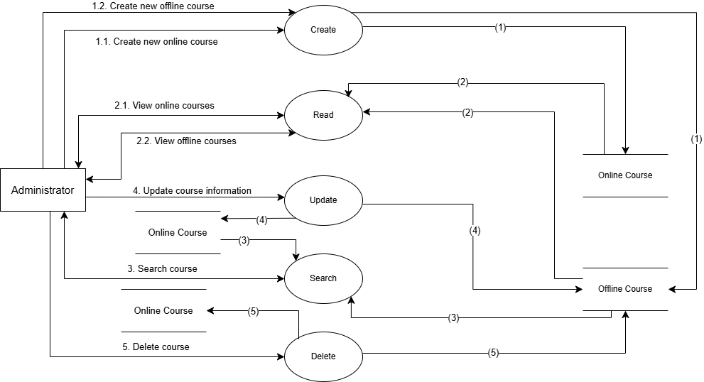

## Software Requirement Specification

## High level Functional Requirement (FR)

|  |  |  |
| --- | --- | --- |
| FR1.1 | Title | Create new course |
| Stakeholder | Administrator who uses this application to create some new courses |
| Description | The system helps administrators easily create new online or offline course |
| FR1.2 | **Title** | **View course** |
| Stakeholder | Administrator who uses this application to keep track of all courses |
| Description | The system displays all online and offline courses. So, the administrator will have a visual overview of the courses and easily track it |
| FR1.3 | **Title** | **Search course** |
|  | Stakeholder | Administrator who uses this application to search for course information |
|  | Description | The administrator just needs to enter the course ID to search for course information. And the system will display the correct course that the administrator is looking for |
| FR1.4 | **Title** | **Update course information** |
|  | Stakeholder | Administrator who uses this application to adjust some course information and update it |
|  | Description | The administrator just needs to enter the course ID to search for course information. Then, the system will display the correct course. The administrator enters the necessary information to adjust and then presses the update button to update this information into the database |
| FR1.5 | **Title** | **Delete course** |
|  | Stakeholder | Administrator who uses this application to delete course |
|  | Description | The administrator just needs to enter the course ID to search for course information. Then, the system will display the correct course. The administrator presses the delete button to remove that course from the system |

## Stakeholders

|  |  |
| --- | --- |
| Stakeholder | Description |
| Administrator | People who use course management systems to track and manage all courses |

## Use case

## List of use cases

|  |  |  |
| --- | --- | --- |
| Use case ID | Use case name | Functional Req. |
| UC.01 | Create new course | FR1.1 |
| UC.02 | View course | FR1.2 |
| UC.03 | Search course | FR1.3 |
| UC.04 | Update course information | FR1.4 |
| UC.05 | Delete course | FR1.5 |

## <<Course Management>> Use Case Diagram Overview

## Use Case Specification

### *UC 01: Create new course*

1. Use Case Specification

|  |  |  |  |  |  |
| --- | --- | --- | --- | --- | --- |
| **Use Case ID** | UC.01 | | | | |
| **Use Case Name** | Create new course | | | | |
| **Created by** | Bao Nguyen | | **Last updated by** | | Bao Nguyen |
| **Date Created** | Apr 19, 2025 | | **Date last updated** | | Apr 19, 2025 |
| **Actors** | Administrator | | | | |
| **Brief Description** | When the administrator wants to create new online or offline course, simply enter the information, click on the “**Online**” or “**Offline**” radio button, and then press the “**Create**” button to create a new course. | | | | |
| **Goal** | This Use Case allows the actor to create a new course | | | | |
| **Trigger** | User Click to “**Online**” or “**Offline**” radio button, and then press the “**Create**” button. | | | | |
| **Pre-conditions** | Choose “**Create**” from menu strip | | | | |
| **Post-conditions** | Show course creation interface | | | | |
| **Main Flow** | **Step** | **Actor Action** | | **System Response** | |
| **1** | Users Choose “**Create**” from menu strip | | System displays the course creation interface | |
| **2** | Users enter the information | |  | |
| **3** | Users click to the “**Online**” or “**Offline**” radio button, | | System will allow users to enter correct information according to the selected course type | |
| **4** | Users press the “**Create**” button. | | System will save the data to the database | |
| **5** |  | | Display message: “**Created successfully**” | |
| **Alternative Flow** | **Step** | **Actor Action** | | **System Response** | |
| **1** | Users Choose “**Create**” from menu strip | | System displays the course creation interface | |
| **2** | Users enter the information | |  | |
| **3** | Users click to the “**Online**” or “**Offline**” radio button | | System will allow user to enter correct information according to the selected course type | |
| **4** | Users press the “**Reset**” button | | All entered information will be reset | |
| **5** | Users enter the information | |  | |
| **6** | Users click to the “**Online**” or “**Offline**” radio button | | Continue working (return to step 3 in main flow) | |
| **Exception Flow** | **Exception Flow 1: System loses connection to database** | | | | |
| **Step** | **Actor Action** | | **System Response** | |
| **1** | Users Choose “**Create**” from menu strip | | System displays the course creation interface | |
| **2** | Users enter the information | |  | |
| **3** | Users click to the “**Online**” or “**Offline**” radio button | | The system will allow user to enter correct information according to the selected course type | |
| **4** | Users press the “**Create**” button. | | The system tries to save the data to the database but loses connection | |
| **5** |  | | Display message: “**Error connecting to server. Please try again later**.” | |
| **Exception Flow 2: Incorrect data type entered** | | | | |
| **1** | Users Choose “**Create**” from menu strip | | System displays the course creation interface | |
| **2** | Users enter the information | |  | |
| **3** | Users click to the “**Online**” or “**Offline**” radio button | | The system will allow user to enter correct information according to the selected course type | |
| **4** | Users press the “**Create**” button. | | The system recognizes that there is an incorrect data type entered and displays the message: "**There is incorrect data entered. Please re-enter**" | |
| **Priority** | High | | | | |
| **Business Rule** | * Users must select the course type (Online or Offline) before the system allows creating a course. * The system must check the input data before saving. If the data is invalid (incorrect format, missing information), the system will display an error message and not save the data * Data is only saved when there is a database connection. In case of disconnection, the system must report an error and not save the data. * When the “Reset” button is pressed, all entered information should be cleared and the user can re-enter information. | | | | |

1. Prototype

### *UC 02: View course*

1. Use Case Specification

|  |  |  |  |  |  |
| --- | --- | --- | --- | --- | --- |
| **Use Case ID** | UC.02 | | | | |
| **Use Case Name** | View course | | | | |
| **Created by** | Bao Nguyen | | **Last updated by** | | Bao Nguyen |
| **Date Created** | Apr 21, 2025 | | **Date last updated** | | May 4, 2025 |
| **Actors** | Admininistrator | | | | |
| **Brief Description** | When the administrator wants to see all courses, simply select the “**Online**” or “**Offline**” radio button, and then the system will display accurate information according to the selected course type | | | | |
| **Goal** | This Use Case allows the actor to see the online or offline courses | | | | |
| **Trigger** | User Click to “**Online**” or “**Offline**” radio button | | | | |
| **Pre-conditions** | Choose “**Read**” from menu strip | | | | |
| **Post-conditions** | Show course reading interface | | | | |
| **Main Flow** | **Step** | **Actor Action** | | **System Response** | |
| **1** | Users Choose “**Read**” from menu strip | | System displays the course reading interface | |
| **2** | Users click to the “**Online**” or “**Offline**” radio button | | System will send a requirement and extract data from the database | |
| **3** |  | | Course information will be displayed on the Data Grid View table | |
| **Alternative Flow** | **Step** | **Actor Action** | | **System Response** | |
| **1** | Users Choose “**Read**” from menu strip | | System displays the course reading interface | |
| **2** | Users enter the ID course | |  | |
| **3** | Users press the “**Search**” button | | System will send a requirement and extract data from the database | |
| **4** |  | | Course information will be displayed on the Data Grid View table | |
| **Exception Flow** | **Exception Flow 1: System loses connection to database** | | | | |
| **Step** | **Actor Action** | | **System Response** | |
| **1** | Users Choose “**Read**” from menu strip | | System displays the course reading interface | |
| **2** | Users click to the “**Online**” or “**Offline**” radio button | | System will send a requirement and extract data from the database | |
| **3** |  | | System tries to extract the data to the database but loses connection | |
| **4** |  | | Display message: “**Error connecting to server. Please try again later**.” | |
| **Exception Flow 2: Course don’t exist** | | | | |
| **1** | Users Choose “**Read**” from menu strip | | System displays the course reading interface | |
| **2** | Users enter the ID course | |  | |
| **3** | Users press the “**Search**” button | | System will send a requirement and extract data from the database | |
| **4** |  | | System cannot find the course and displays message: “**Course does not exist, please re-enter**” | |
| **Priority** | High | | | | |
| **Business Rule** | * Users must select the course type (Online or Offline) for the system to display accurate course information. * Enter correct course information if user wants to use search function to search. * Course information is only displayed when there is a database connection. In case of disconnection, the system must report an error and not save the data. * If user enters incorrect course information, the system must display message reminding the user to enter correct information. | | | | |

1. Prototype

### *UC 03: Search course*

1. Use Case Specification

|  |  |  |  |  |  |
| --- | --- | --- | --- | --- | --- |
| **Use Case ID** | UC.03 | | | | |
| **Use Case Name** | Search course | | | | |
| **Created by** | Bao Nguyen | | **Last updated by** | | Bao Nguyen |
| **Date Created** | May 4, 2025 | | **Date last updated** | | May 8, 2025 |
| **Actors** | Admininistrator | | | | |
| **Brief Description** | When the administrator wants to search for a course, simply enter the ID course in the textbox to display the appropriate course | | | | |
| **Goal** | This Use Case allows the actor to see the searched course | | | | |
| **Trigger** | Enter the ID course and press the “**Search**” button | | | | |
| **Pre-conditions** | Choose “**Read**” or “**Delete**” from menu strip | | | | |
| **Post-conditions** | Show course information | | | | |
| **Main Flow** | **Step** | **Actor Action** | | **System Response** | |
| **1** | Users Choose “**Read**” or “**Delete**” from menu strip | | System displays the course reading or deleting interface | |
| **2** | Users enter the ID course into textbox | |  | |
| **3** | Users press the “**Search**” button | | System will send a requirement and extract data from the database | |
| **4** |  | | Course information will be displayed on the Data Grid View table | |
| **Exception Flow** | **Exception Flow 1: System loses connection to database** | | | | |
| **Step** | **Actor Action** | | **System Response** | |
| **1** | Users Choose “**Read**” or “**Delete**” from menu strip | | System displays the course reading or deleting interface | |
| **2** | Users enter the ID course into textbox | |  | |
| **3** | Users press the “**Search**” button | | System will send a requirement and extract data from the database | |
| 4 |  | | System tries to extract the data to the database but loses connection | |
| **5** |  | | Display message: “**Error connecting to server. Please try again later**.” | |
| **Exception Flow 2: Course don’t exist** | | | | |
| **1** | Users Choose “**Read**” or “**Delete**” from menu strip | | System displays the course reading or deleting interface | |
| **2** | Users enter the ID course into textbox | |  | |
| **3** | Users press the “**Search**” button | | System will send a requirement and extract data from the database | |
| **4** |  | | System cannot find the course and displays message: “**Course does not exist, please re-enter**” | |
| **Exception Flow 3: Enter incorrectly search keyword** | | | | |
| **1** | Users Choose “**Read**” or “**Delete**” from menu strip | | System displays the course reading or deleting interface | |
| **2** | Users enter incorrectly search keyword | |  | |
| **3** | Users press the “**Search**” button | | System recognizes that the entered keyword is incorrect and displays the message: “**Keyword is incorrect. Please re-enter the keyword**” | |
| **4** | Users enter the ID course into textbox | |  | |
| **5** | Users press the “**Search**” button | | Continue working (return to step 3 in main flow) | |
| **Priority** | High | | | | |
| **Business Rule** | * Users must enter correct keyword to use the search function * Course information is only displayed when there is a database connection. In case of disconnection, the system must report an error and not save the data. * If users enter incorrect keyword, the system must display message reminding the user to enter correct information. | | | | |

1. Prototype

### *UC 04: Update course information*

1. Use Case Specification

|  |  |  |  |  |  |
| --- | --- | --- | --- | --- | --- |
| **Use Case ID** | UC.05 | | | | |
| **Use Case Name** | Update course | | | | |
| **Created by** | Bao Nguyen | | **Last updated by** | | Bao Nguyen |
| **Date Created** | May 4, 2025 | | **Date last updated** | | May 4, 2025 |
| **Actors** | Admininistrator | | | | |
| **Brief Description** | When the administrator wants to update a course, simply enter the ID course in the textbox to display the appropriate course | | | | |
| **Goal** | This Use Case allows the actor to update the searched course | | | | |
| **Trigger** | Enter information and press the “Update” button to update course | | | | |
| **Pre-conditions** | Choose “**Update**” from menu strip | | | | |
| **Post-conditions** | Show course updating interface | | | | |
| **Main Flow** | **Step** | **Actor Action** | | **System Response** | |
| **1** | Users Choose “**Update**” from menu strip | | System displays the course updating interface | |
| **2** | Users enter the ID course into textbox | |  | |
| **3** | Users press the “**Search**” button | | System will send a requirement and extract data from the database | |
| **4** |  | | Course information will be displayed on the Data Grid View table | |
| **5** | Users enter information into textbox | |  | |
| **6** | Users press the “**Update**” button | | System will save the data to the database | |
| **7** |  | | Display the message: “**Updated successfully**” | |
| **Alternative Flow** | **Step** | **Actor Action** | | **System Response** | |
| **1** | Users Choose “**Update**” from menu strip | | System displays the course updating interface | |
| **2** | Users enter the ID course into textbox | |  | |
| **3** | Users press the “**Search**” button | | System will send a requirement and extract data from the database | |
| **4** |  | | Course information will be displayed on the Data Grid View table | |
| **5** | Users enter information into textbox | |  | |
| **6** | Users press the “**Reset**” button | | All entered information will be reset | |
| **7** | Users enter information into textbox | |  | |
| **8** | Users press the “**Update**” button | | Continue working (return to step 6 in main flow) | |
| **Exception Flow** | **Exception Flow 1: System loses connection to database** | | | | |
| **Step** | **Actor Action** | | **System Response** | |
| **1** | Users Choose “**Update**” from menu strip | | System displays the course updating interface | |
| **2** | Users enter the ID course into textbox | |  | |
| **3** | Users press the “**Search**” button | | System will send a requirement and extract data from the database | |
| 4 |  | | System tries to extract the data to the database but loses connection | |
| **5** |  | | Display message: “**Error connecting to server. Please try again later**.” | |
| **Exception Flow 2: Course don’t exist** | | | | |
| **1** | Users Choose “**Update**” from menu strip | | System displays the course updating interface | |
| **2** | Users enter the ID course into textbox | |  | |
| **3** | Users press the “**Search**” button | | System will send a requirement and extract data from the database | |
| **4** |  | | System cannot find the course and displays message: “**Course does not exist, please re-enter**” | |
| **Exception Flow 3: Enter incorrectly search keyword** | | | | |
| **1** | Users Choose “**Update**” from menu strip | | System displays the course updating interface | |
| **2** | Users enter incorrectly search keyword | |  | |
| **3** | Users press the “**Search**” button | | System recognizes that the entered keyword is incorrect and displays the message: “**Keyword is incorrect. Please re-enter the keyword**” | |
| **4** | Users enter the ID course into textbox | |  | |
| **5** | Users press the “**Search**” button | | Continue working (return to step 3 in main flow) | |
| **Priority** | High | | | | |
| **Business Rule** | * Users must enter correct keyword to use the search function * Course information is only displayed when there is a database connection. In case of disconnection, the system must report an error and not save the data. * If users enter incorrect keyword, the system must display a message reminding the user to enter correct information. * The system must check the input data before saving and updating. If the data is invalid (incorrect format, missing information), the system will display an error message and not save the data * When the “Reset” button is pressed, all entered information should be cleared and the user can re-enter information. | | | | |

1. Prototype

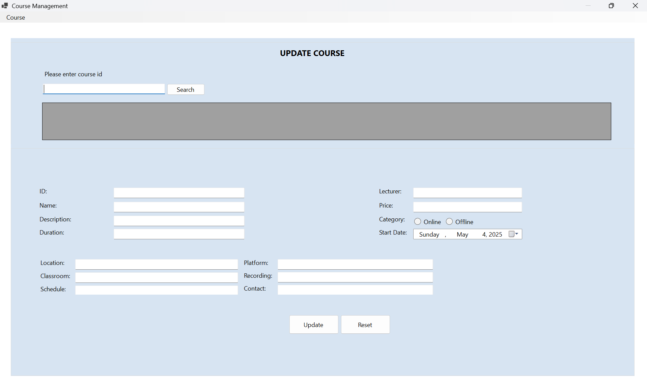

### *UC 05: Delete course*

1. Use Case Specification

|  |  |  |  |  |  |
| --- | --- | --- | --- | --- | --- |
| **Use Case ID** | UC.04 | | | | |
| **Use Case Name** | Delete course | | | | |
| **Created by** | Bao Nguyen | | **Last updated by** | | Bao Nguyen |
| **Date Created** | May 4, 2025 | | **Date last updated** | | May 4, 2025 |
| **Actors** | Admininistrator | | | | |
| **Brief Description** | When the administrator wants to delete a course, simply enter the ID course and press the “**Search**” button to display the appropriate course. Finally press the “**Delete**” button to delete it. | | | | |
| **Goal** | This Use Case allows the actor to delete the online or offline course. | | | | |
| **Trigger** | Enter the ID course, press the “**Search**” button, and then press the “**Delete**” button. | | | | |
| **Pre-conditions** | Choose “**Delete**” from menu strip | | | | |
| **Post-conditions** | Show course deleting interface | | | | |
| **Main Flow** | **Step** | **Actor Action** | | **System Response** | |
| **1** | Users Choose “**Delete**” from menu strip | | System displays the course deleting interface | |
| **2** | Users enter the ID course into textbox | |  | |
| **3** | Users press the “**Search**” button | | System will send a requirement and extract data from the database | |
| **4** |  | | Course information will be displayed on the Data Grid View table | |
| **5** | Users press the “**Delete**” button | | System will display a confirmation message. | |
| **6** | Users select “**Yes**” | | System will delete that course, update the database and display the message: “**Deletion successful**”. | |
| **Alternative Flow** | **Step** | **Actor Action** | | **System Response** | |
| **1** | Users Choose “**Delete**” from menu strip | | System displays the course deleting interface | |
| **2** | Users enter the ID course into textbox | |  | |
| **3** | Users press the “**Search**” button | | System will send a requirement and extract data from the database | |
| **4** |  | | Course information will be displayed on the Data Grid View table | |
| **5** | Users press the “**Delete**” button | | System will display a confirmation message. | |
| **6** | Users select “**No**” | | System returns to deleting interface | |
| **Exception Flow** | **Exception Flow 1: System loses connection to database** | | | | |
| **Step** | **Actor Action** | | **System Response** | |
| **1** | Users Choose “**Delete**” from menu strip | | System displays the course deleting interface | |
| **2** | Users enter the ID course into textbox | |  | |
| **3** | Users press the “**Search**” button | | System will send a requirement and extract data from the database | |
| **4** |  | | System tries to extract the data to the database but loses connection | |
| **5** |  | | Display message: “**Error connecting to server. Please try again later**.” | |
| **Exception Flow 2: Course don’t exist** | | | | |
| **1** | Users Choose “**Delete**” from menu strip | | System displays the course deleting interface | |
| **2** | Users enter the ID course into textbox | |  | |
| **3** | Users press the “**Search**” button | | System will send a requirement and extract data from the database | |
| **4** |  | | System cannot find the course and displays message: “**Course does not exist, please re-enter**” | |
| **Exception Flow 3: Enter incorrectly search keyword** | | | | |
| **1** | Users Choose “**Delete**” from menu strip | | System displays the course deleting interface | |
| **2** | Users enter the ID course into textbox | |  | |
| **3** | Users press the “**Search**” button | | System recognizes that the entered keyword is incorrect and displays the message: “**Keyword is incorrect. Please re-enter the keyword**” | |
| **4** | Users enter the ID course into textbox | |  | |
| **5** | Users press the “**Search**” button | | Continue working (return to step 3 in main flow) | |
| **Priority** | High | | | | |
| **Business Rule** | * Course information is only displayed when there is a database connection. In case of disconnection, the system must report an error and not save the data. * If users enter incorrect course information, the system must display the message reminding the user to enter correct information. * Users must enter correct keyword to use the search function * The system must display a message to the user if they delete successfully. | | | | |

1. Prototype

## Software Quality Attributes

## Usability

**GUI**

- The interface should be elegant, simple and out‐standing.

- All images must also provide attributes.

**Usability for end‐users**

- Searching tools should be easy to use.

- Users can use the main functionality of the system without logging in to the system.

**Installation**

- The system must be easy to deploy. Customer can deploy successfully and learn to

configure, maintain the system within one day of training.

- The documentation for installation must be included. It describes detailed steps for

installing or deploying the system. The customer can follow the steps without direct help from

the developing team.

## Reliability

- The database must be backed up regularly and can be recovered if necessary.

- Not conflict with other software.

## Software Design Description

## Sequence Diagrams

## Create a new course

## View course

## Search course

## Update course information

## Delete course

## Activity Diagrams

## Create a new course

## View course

## Search course

## Update course information

## Delete course

## State Diagram

## Class Diagram

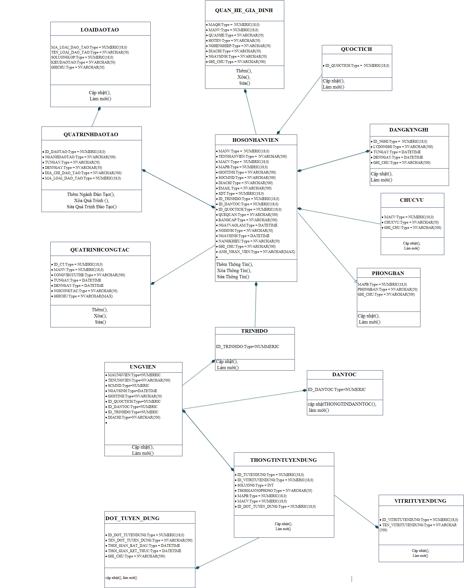

## Allocation Diagram

# Appendix A: Glossary

|  |  |
| --- | --- |
| BC | Business Constraint |
| TC | Technical Constraint |
| FR | Functional Requirement |
| QA | Quality Attribute |
| UC | Use case |
| BR | Business rule |