Practice - Learn Docker In A Month Of Lunches
Author: Elton Stoneman & Bret Fisher

Chapter 1: Understanding Docker Container and Image

Docker Containers

The CLI interactive with containers
Command line | Explaination | More details
docker run diamol/ch02-hello-diamol:2e | Run a container from image
docker run --interactive --tty diamol/base:e2 | Run a container and associate access the container  + interactive: tells with docker set up a connection to container.  + tty: connect to terminal session inside container | This command access directly into container with command promp and you can use CLI the same on your host machine like Linux or Window server. using CLI like this  / # hostname  / # date
docker container ls | Listing the container is running with stats hedaer information. Use flag ls to do that. | Just only to shows the container is running.
docker container top <Container-ID> | Shows process details container specified with top flag | You can use ContainerID with fitst characters to short it without take full Id.
docker container logs <Container-ID> | Show logs specified container with args logs | You can use ContainerID with fitst characters to short and without take full Id.
docker container inspect <Container-ID> | Show the whole information containers as Json type with arg inspect | You can use ContainerID with fitst characters to short and without take full Id.
docker container ls --all | Show all containers with full state running or exited by using flag --all
docker container run --detach --publish <PORT:PORT> image-name | Run a container as background with flags --detach.  + --detach: Starts the container in the background and shows the container ID  + --publish: Publishes a port from the container to the computer | docker container run --detach --publish <8088:80> diamol/ch02-hello-diamol-web:2e  This command to run the web servver inside the container with port 80.
docker container rm $(docker container ls --all --quiet)  docker container rm --force $(docker container ls --all --quiet) | This command to remove an container is stoped. If you want to remove container is running you can use flag  --force.
docker container exec <Container-ID> ls | This command execute command line directly inside container is running with arguments exec. | This command you can devide 2 parts like this:  - The first, with docker container exec <ContainerID>  Docker access container with ID containers  - The second ls: Docker execute ls ccommand after go inside the container.
docker container cp <HostFile> \ <ContainerID>:<Target-Dir> | This command tells with Docker copy file on local machine go inside the container workdir you want store, including:  - HostFile: file on your local machine.  - Container:Target-Dir is folder where you want to store file copy inside container. | docker container cp ./desktop/index.html 661f:/usr/local/apache2/htdocs  this command tells with Docker as copy file index.html at the ./desktop machines go inside the path /usr/local/apache2/htdocs for id 661f containers.  So, when containner is running and you want to interactive directly with it, using commnad docker container <args> or you can docker container to review instruxtions

You think about Container like VM, they have own process, filesystems like VM. But, which is using resource OS, meawhile VM must be have own OS and resources for that.

when you interactive with container, this feel like you remoting ssh on the another machine (Host)….something like this, but it diffference a little bit container is which is on your machine.

In the Chapter 1 - Understanding Docker Container to help you to covers the concepts what is Docker Container and it workflows and also you known interactive, manages container or an specified container.

Docker Image

Docker Image like of if a big zip file stored small files inside it, when you pulling an image (if image have not yet locally on your machine), you can see various processes to handling, those are called image layers and which is created from INSTRUCTIONS in Dockerfile.

Beacause image stored as lots of smaller files, Docker auto assemble them together to create completely containers filesystem. When all the layers have been pulled, the full Image is available to use.

Example:
Docker command
docker run --d --name web-ping diamol/ch03-web-ping:2e

Output: 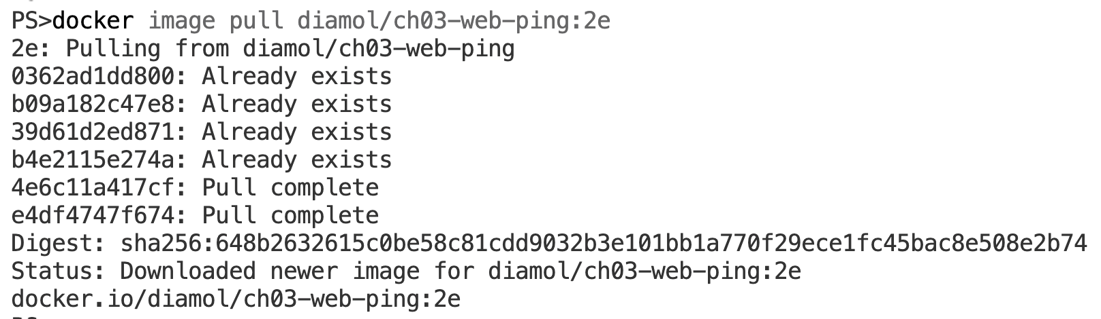

Explains:
You can see output result with key like Pull/Already and exists/complete, this states when you pull an image from Docker Hub. If the small files inside Image has bean already on your machine, docker notice this file is exists, and if not already file is download until Docker notice that complete.

After the layers download is done, Docker assemble them together create container filesystem for the completely Image.

