**ASSIGNMENT 1 FRONT SHEET**

|  |  |  |  |
| --- | --- | --- | --- |
| **Qualification** | **BTEC Level 5 HND Diploma in Business** | | |
| **Unit number and title** | **Unit 30: Application Development** | | |
| **Submission date** | Monday, October 10, 2022 | **Date Received 1st submission** |  |
| **Re-submission Date** |  | **Date Received 2nd submission** |  |
| **Student Name** | Hoang Thi Thuy Duong | **Student ID** | GCH200621 |
| **Class** | GCH0907 | **Assessor name** | Nguyen Dinh Tran Long |
| **Student declaration**  I certify that the assignment submission is entirely my own work and I fully understand the consequences of plagiarism. I understand that making a false declaration is a form of malpractice. | | | |
|  |  | **Student’s signature** |  |

**Grading grid**

|  |  |  |  |  |  |
| --- | --- | --- | --- | --- | --- |
| **P1** | **P2** | **P3** | **M1** | **M2** | **D1** |
|  |  |  |  |  |  |

|  |  |  |
| --- | --- | --- |
| **❒ Summative Feedback: ❒ Resubmission Feedback:** | | |
| **Grade:** | **Assessor Signature:** | **Date:** |
| **Internal Verifier’s Comments:** | | |
| **Signature & Date:** | | |

Software Requirements Specification

for

FPT Book System

**Version 1.0**

**Prepared by**

**Group Name:**

|  |  |  |
| --- | --- | --- |
| **Hoang Thi Thuy Duong** | **GCH200621** | **duonghttgch200621@fpt.edu.vn** |
| **Luu Thi Minh** | **GCH200250** | **minhltgch200250@fpt.edu.vn** |
| **Le Thi Phuong Anh** | **GCH200052** | **anhltpgch200052@fpt.edu.vn** |
|  |  |  |
|  |  |  |

|  |  |
| --- | --- |
| **Instructor:** | ***Nguyen Dinh Tran Long*** |
| **Course:** | **Application Development (1670)** |
| **Date:** | **10/10/2022** |

Table of Contents

Revisions 1

**1. Introduction (P1)** 2

**1.1 Document purpose** 2

**1.2 Product scope** 2

**1.3 Intended audience and document overview** 2

**1.4 Definitions, acronyms and abbreviations** 3

1.5 References and acknowledgments 3

**2. Overall description (P1)** 4

2.1 Product overview 4

2.2 Product functionality 5

**3. Specific requirements (P1 & M1)** 6

3.1 Functional requirements (P1) 6

3.2 Use case model (P1) 8

3.3 Wireflow (P1) 9

**4. Technical design (M1)** 10

4.1 Entity relationship diagram (ERD) 10

4.2 Class diagram 11

4.3 Activity diagram 12

4.4 Gantt chart 13

**5. Risk assessment (P2)** 14

5.1 Risk Assessment 14

**6. Evaluation Report** 18

6.1. Design Tools 18

6.2. Front End technology stack 22

6.3. Back End technology stack 28

6.4. Tools for source control management 38

6.5. Software Development Models 40

Conclusion 42

References 44

Table of Figures

Figure 1 – System FPT Book 5

Figure 2 - Use case 8

Figure 3 – Wire flow 9

Figure 4 – ERD (Entity relationship diagram) 10

Figure 5 – Class diagram 11

Figure 6 – Activity diagram 12

Figure 7 -Gantt chart 13

Figure 8: UML diagrams(Source: Microsoft) 18

Figure 9: Lucidchart Logo 19

Figure 10: Gleek.io 20

Figure 11: Draw.io 20

Figure 12: Figma 21

Figure 13: Sketch 21

Figure 14: Visual paradigm 22

Figure 15: JavaScript 22

Figure 16: HTML 23

Figure 17: CSS 24

Figure 18: Vue.js 25

Figure 19: React.js 26

Figure 20: Angular 26

Figure 21: Bootstrap 27

Figure 22: tailwindcss 28

Figure 23: Java programming 28

Figure 24: Python 29

Figure 25: PHP 29

Figure 26: C Sharp 30

Figure 27: Linux 31

Figure 28: Nginx 32

Figure 29: Apache 33

Figure 30: IIS 33

Figure 31: MySQL 34

Figure 32: SQLServer 34

Figure 33: MongoDB 35

Figure 34: Azure 35

Figure 35: AWS 36

Figure 36: Google Cloud 37

Figure 37: Laravel 37

Figure 38: Expressjs 38

Figure 39: ASP.NET Core MVC 38

Figure 40: Agile Model 40

Figure 41: Waterfall Model 41

Figure 42: Spiral Model 42

Table of Tables

Table 1- Risk Assessment 17

Table 2: Technologies use 42

# Revisions

| Version | Primary Author(s) | Description of Version | Date Completed |
| --- | --- | --- | --- |
| Draft Type and Number | Full Name | Information about the revision. This table does not need to be filled in whenever a document is touched, only when the version is being upgraded. | 00/00/00 |

# **1. Introduction (P1)**

Today, when society enters the period of industrialization and modernization of the country, the application of technology in the management of fields such as healthcare, education, and industry has been promoted. And FPT Company is not an exception. The company intends to develop a book management software. that is FPTBook - a web-based software system to help customers and bookstore owners manage their book purchases, simplifying and speeding up the process of selecting, ordering and purchasing books for their customers. customers as well as manage user databases and product databases for bookstore owners.

## **1.1 Document purpose**

The Software Requirements Specification (SRS) document will be thoroughly presented, with the main purpose of providing an in-depth description of the FPTBook System. The system's purpose, characteristics, and interface, as well as how the system works and controls, will be clearly explained. This document is intended for system stakeholders and developers. Functional requirements are primarily discussed, along with the documentation's mentions of reliability, security, and maintainability.

## **1.2 Product scope**

We designed a software like an e-commerce website to sell books called FPTBook. The software will be deployed in stores and can use the store's website. FPTBook software will be marketed as a sales software at a bookstore allowing to organize sales at the bookstore effectively. There are three different types of users in the system, including administrators, employees, and customers. Each type of user has certain roles and functions. The goal is to make store management more convenient and flexible.

## **1.3 Intended audience and document overview**

The document serves as an introduction to the FPTBook system for potential developers, project managers, testers, and users. Hardware and software requirements, as well as user documentation, are all part of the documentation.

Developers who want to create, read, update, and delete products, register, login accounts as well as assign permissions to each type of user, should first read this article and update the requirements. Furthermore, users of this program examine the diagrams and specifications provided in the documentation to determine whether the software meets all of the necessary requirements and whether or not the web designer has completed all of them. In the event of a misunderstanding, he can consult the user manual for clarification. This document is required for testers to build their test cases to ensure that the original project requirements are actually implemented in the results.

## **1.4 Definitions, acronyms and abbreviations**

In this section of the SRS document, s list of all abbreviations and acronyms used in this document is provided as follows:

**ASP.NET MVC**

The .Net Framework is a software framework that runs primarily on Microsoft Windows developed by Microsoft. It has language interoperability across many programming languages ​​and includes a large class library called Framework Class Library – FCL for short (Freeman, 2014). It executes programs in a software environment called Common Language Runtime – CLR for short. This is an application virtual machine that provides services such as: memory management, security, and exception handling.

According to Freeman (2014) ASP.NET Core is a new version of ASP.NET, released by Microsoft and open source on GitHub. ASP.NET Core is used to develop website frameworks and can adapt to many different browsers such as Windows, Mac or Linux even on the MVC platform.

According to Freeman (2014) MVC is a design pattern that separates the user interface (view), the data (model), and the application logic (controller). This pattern aids in the separation of concerns. Requests for websites using the MVC pattern are routed to a Controller, who is responsible for working with the Model to perform actions and/or retrieve data. The Controller selects the View to display and passes it the Model. Based on the data in the Model, the View generates the final page.

**C#**

C# (“C sharp”) is a pure object-oriented programming language developed by Microsoft. Built on the foundation of the two most powerful programming languages, C++ and Java. Therefore C# is described as a language with a balance between C++, Visual Basic, Delphi and Java (Deitel and Deitel, 2012).

C# With strong support of .NET Framework makes it possible to create a Windows Forms or WPF (Windows Presentation Foundation) application, . . . becomes very easy.

**GitHub**

GitHub is a project management and code versioning system that acts like a social network for developers. It is used to collaborate many people together, plan, track and work on a project (w3schools. n.d). This means it enables programmers and others to collaborate on projects from anywhere.

## 1.5 References and acknowledgments

Freeman, A., 2014. *Pro ASP.NET MVC 5*. p.3.

Deitel, P. and Deitel, H., 2012. *C# 2012 for Programmers*. p.2.

w3schools. n.d. *What is GitHub?*. [online] Available at: <https://www.w3schools.com/whatis/whatis_github.asp> [Accessed 10 October 2022].

# **2. Overall description (P1)**

## 2.1 Product overview

Previously, FPT Book operated a store where they sold books directly to customers. Customers must go directly to the store to purchase the desired books as they will be displayed there. The store owner will update the same database on the sales computer at the store after the purchase and sale to reflect the customer's information, the books they have purchased, and the specifics of the orders they have placed.

In the age of sophisticated digital technology, such direct book sales generate only a small amount of revenue for the retailer. Directly purchasing books from the retailer will decrease the number of customers who want to purchase books but are unable to do so due to distance, saving them the time it would take to travel and purchase their preferred book products. Along with other expenses, the store also has monthly and yearly rent, employee salaries, and other expenses. It will be challenging for store owners to manage data if book sales and customer information are stored in a single database.

Therefore, it's crucial to suggest a vending software system to a bookstore. A web-based software program called FPTBook assists customers in searching for, choosing, and ordering books online. A database for book management and customer management can also help the store owner manage the purchase and sale of books with customers more simply and effectively.

Following are the main functions in the FPTBook system:

* User account: The system allows users to register and log in to the system with a registered account. The login account will be authorized and have the corresponding functions. The functionality of the user, admin, and store owner accounts will be different.
* Search: Search for books based on the keywords entered.
* Add: For each type of user can add accounts for other users, or add books.
* Edit: For each type of user, modify the account information for other users, or modify the book information.
* Delete: For each type of user can delete other users' accounts, or delete books.

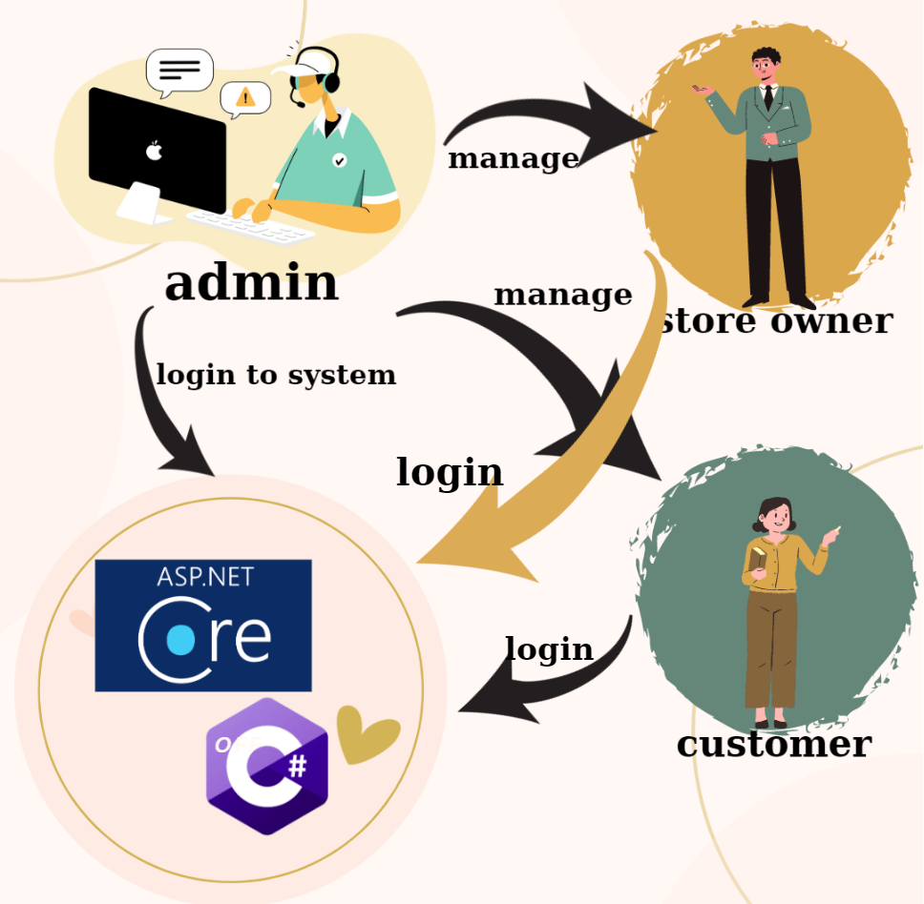

Figure 1 – System FPT Book

Using ASP.NET Core and the C# programming language, we will create the system based on the example above. A system administrator can access it and control both customer and store owner accounts. Owners of businesses can access the system and manage their books. Online orders and book purchases can be made by users who sign in to the system.

## 2.2 Product functionality

The key responsibilities that the product must fulfill in order for the user to be able to use it are outlined in this section.

* Client: May create a user account and access the program. Direct ordering and purchases of books are possible through the store's system.
* Store owner: Using the account that has been given permission to use the system, you can register and log in. Books can be managed by store owners using the tasks add, edit, and delete.
* Admin: You can access the system using an admin account that has been given permission to perform the necessary tasks. Admin can manage customer and store owner accounts by adding, editing, and deleting them.

# **3. Specific requirements (P1 & M1)**

## 3.1 Functional requirements (P1)

* **Customer:**

F1: The system shall display the homepage (navigation bar, search box, image of each book, logo of the FPTBook) of the website.

F2: The system shall display a list of book categories. The categories in my shop may be IT Book, Maketing Book, Design Book, Bussiness Book... The details of the categories are id, name, description, and image.

F3: The system shall display all books on the website so that customers can know how many books are in the store. In each book, name, image, and price will be displayed.

F4: The system will display book details so that customers can know more information about each book in the store, from which they can decide to buy or not to buy. When a customer chooses a book, the details of that book will be displayed (id, name, price, description, quantity, image).

F5: The system shall search for a book by its name, then books with the same names will be displayed. Easily find a book and view its information. The system shall display a list of books with the information of the book's name, images and price.

F6: The system shall have a purchase function, customers just need to click on the cart and add the book they want to buy by entering the id of that book.

F7: The system will have a function for customers to register for an account when the customer does not have an account to log in. When registering, customers need to enter a username and password, and personal information of customers to serve in sending goods to customers.

F8: The system will have a login function for customers so that customers can log in when they already have an account.

F9: The system shall display the footer at the end of the website. Footer includes all information of the shop (The address, the fanpage, phone number).

F10: The system will display a help page, when customers have problems, they will get help on this page from the store staff.

* **Store owner:**

F11: The system shall create the categories of books. The categories in the shop may be IT book, Maketing Book, Bussiness Book, Desgin Book. The details of the categories are id, name, quantity descriptions. So that admin can add more book categories to sell for customers.

F12: The system shall display all of the categories in the store with delete and edit buttons. So that the admin can easily manage the books category in the shop.

F13: The system shall display the update interface of all the categories in the store so that the admin can change the name or the description of all categories in the store.

F14: The system shall delete the category in the store if the admin wants. The details of the categories are id, name, quantity descriptions will be deleted.

F15: The system shall create new books in the store. The books must belong to one category. The details of the books are name, price, quantity, descriptions, images.

F16: The system shall display all books in the store with delete and edit buttons. so that the admin can know how many books there are in my store and view all details of each (name, images, quantity, descriptions, price)

F17: The system shall update all books in the store so that the admin can change the (name, images, quantity, descriptions, price) of all books in the store.

F18: The system shall delete the book in the store, so that if the admin doesn’t want to sell that book, or when it's sold out, or the book is defective, the admin will delete it from the store.

* **Admin:**

F19: The system will display all user accounts including customers and store owners. The accounts will include personal information: full name, email, phone, address, username, password, ...

F20: The system will update the information of the accounts when the admin makes a change, in case the user's account needs some change in the information data.

F21: The system will delete the account of the customer or the shop owner when there is a change in the store owner or the customer is no longer a potential customer.

## 3.2 Use case model (P1)

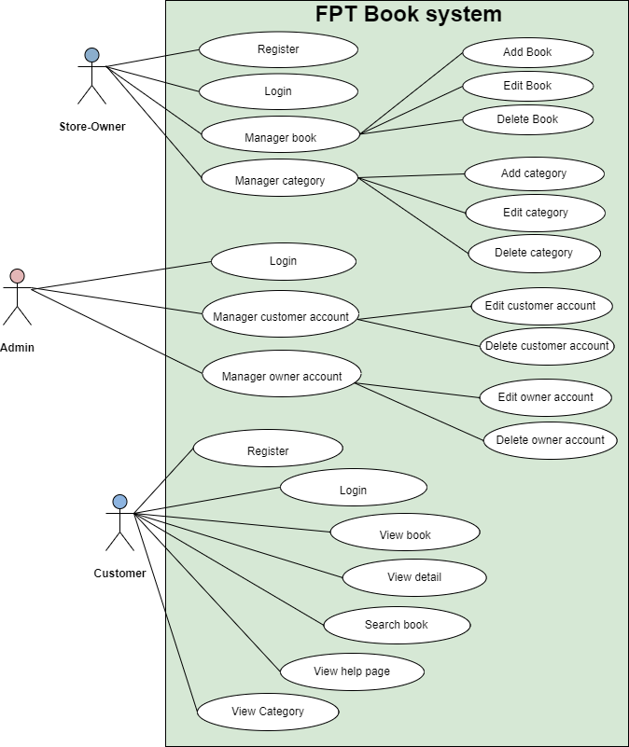

Figure 2 - Use case

## 3.3 Wireflow (P1)

Wireflow is a representation of screen flow made up of related wireframes arranged in the order they appear in the flow. The use of decision (shape) in a wireflow allows for the presentation of multiple navigation paths in a single flow. The FPTBook system's screen flow is shown below.

Customer

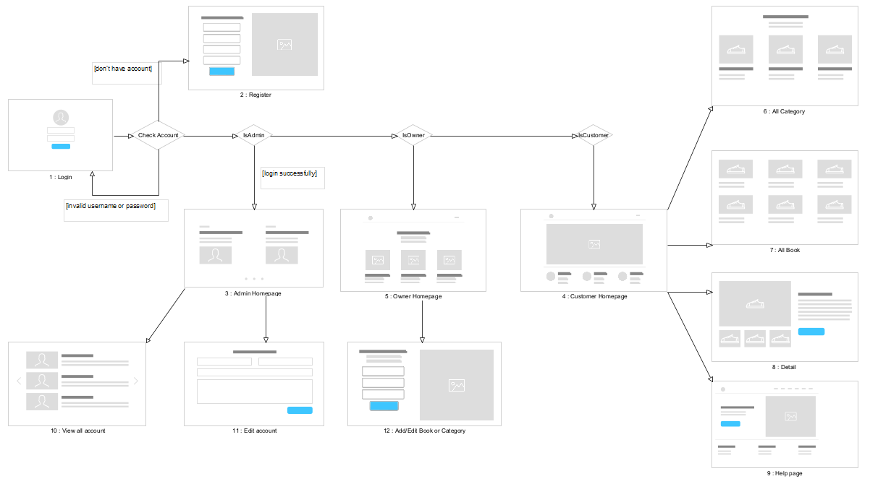

Figure 3 – Wire flow

# **4. Technical design (M1)**

## 4.1 Entity relationship diagram (ERD)

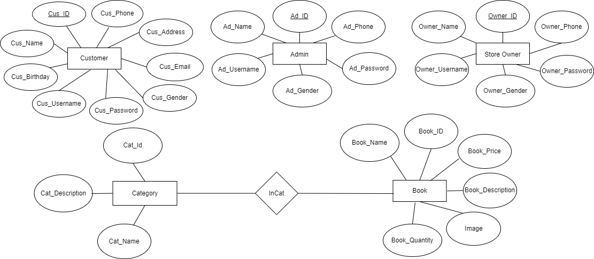

## 

Figure 4 – ERD (Entity relationship diagram)

## 

## 4.2 Class diagram

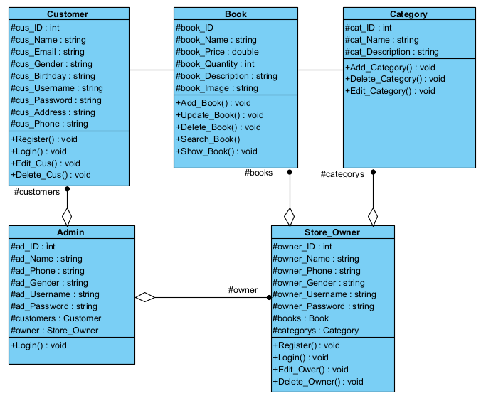

Figure 5 – Class diagram

## 4.3 Activity diagram

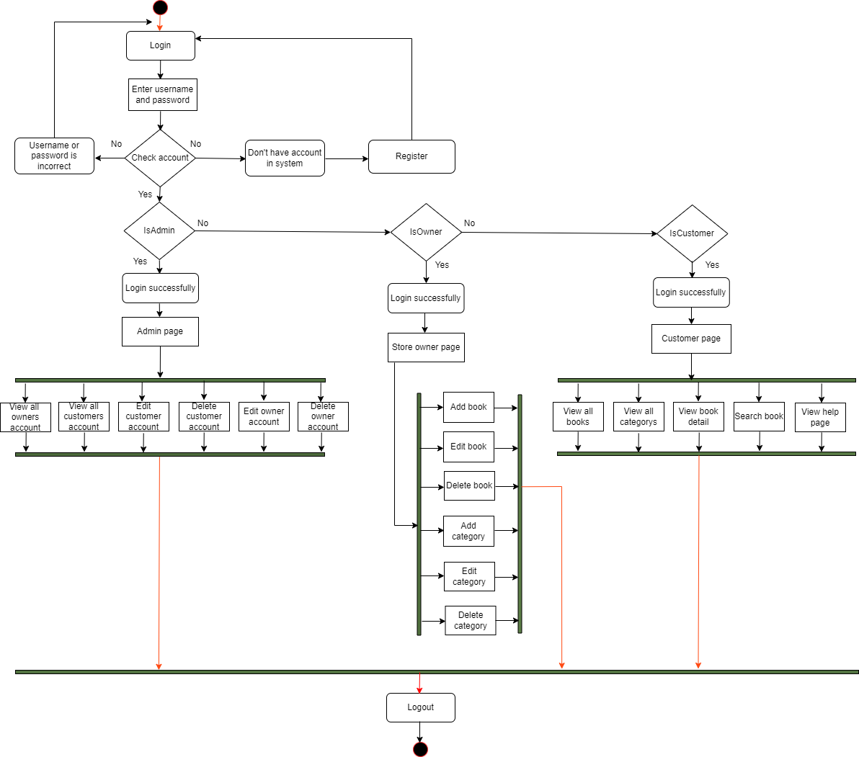

Figure 6 – Activity diagram

## 4.4 Gantt chart

The Gantt chart below describes the activities involved in the formation of the FPTShop System. The time scale starts on October 9 and ends on November 20. Each bar in the chart represents an activity assigned to system production team members, along with the date they started. start and end the activity. Besides, the length of the bar represents the duration of an activity.

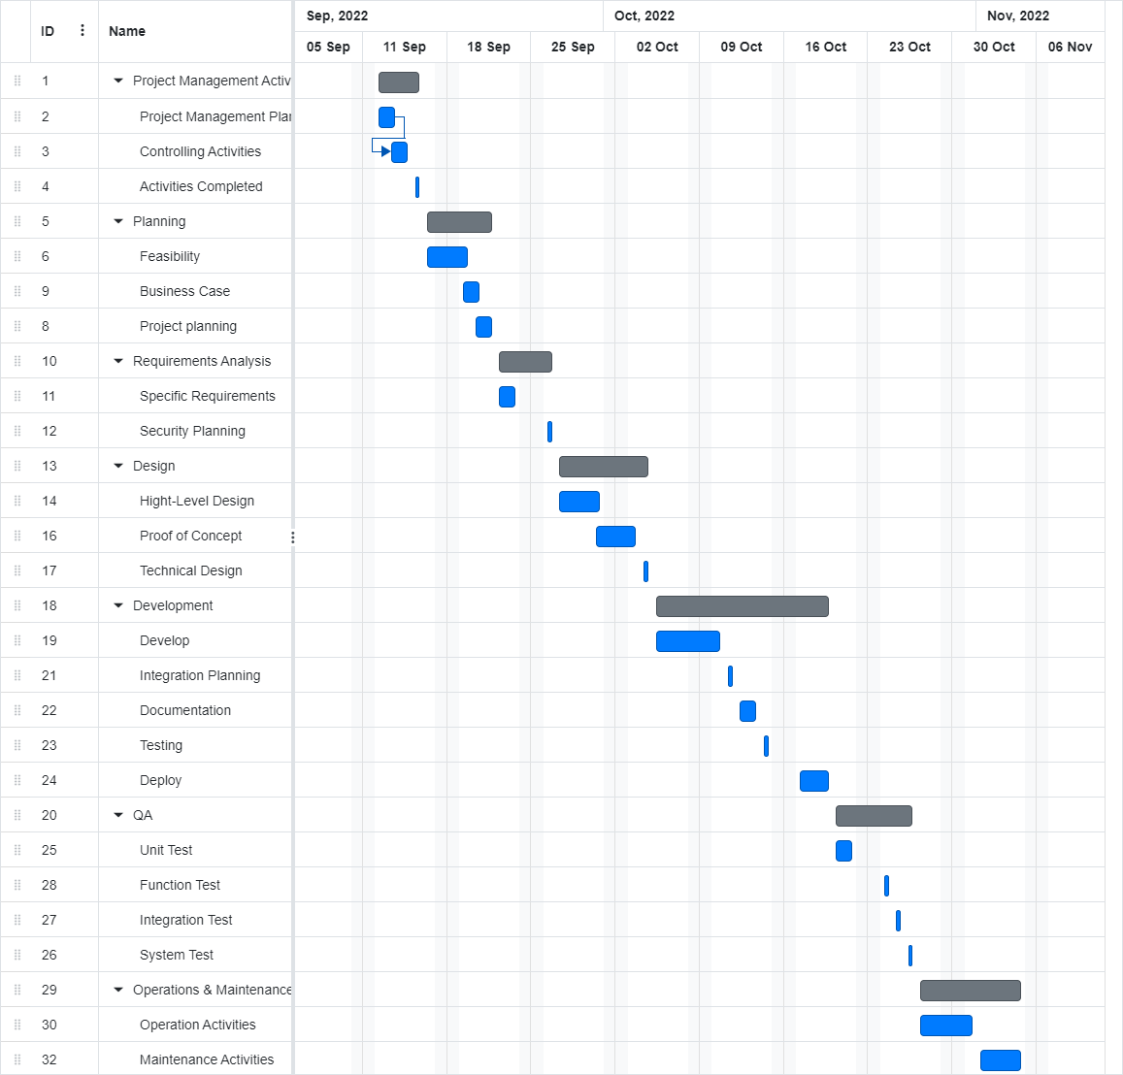

Figure 7 -Gantt chart

# **5. Risk assessment (P2)**

## 5.1 Risk Assessment

|  |  |  |  |  |  |  |  |  |  |  |
| --- | --- | --- | --- | --- | --- | --- | --- | --- | --- | --- |
| **NAME** | **Hoang Thi Thuy Duong**  **Luu Thi Minh**  **Le Thi Phuong Anh** | | | | **OBJECTIVE** |  | | | | |
|  |  |  |  |  |  |  |  |  |  |  | |
| **REF / ID** | **P R E - M I T I G A T I O N** | | | | **DEPARTMENT / LOCATION** | **MITIGATIONS / WARNINGS / REMEDIES** | **P O S T - M I T I G A T I O N** | | | |
| **RISK** | **RISK SEVERITY** | **RISK LIKELIHOOD** | **RISK LEVEL** | **RISK SEVERITY** | **RISK LIKELIHOOD** | **RISK LEVEL** | **ACCEPTABLE TO PROCEED?** | |
|  |  | **ACCEPTABLE**  **TOLERABLE**  **UNDESIRABLE**  **INTOLERABLE** | **IMPROBABLE**  **POSSIBLE**  **PROBABLE** | **LOW**  **MEDIUM**  **HIGH**  **EXTREME** |  |  | **ACCEPTABLE**  **TOLERABLE**  **UNDESIRABLE**  **INTOLERABLE** | **IMPROBABLE**  **POSSIBLE**  **PROBABLE** | **LOW**  **MEDIUM HIGH EXTREME** | **YES / NO** | |
| **1** | Risk Management with Inefficient Quality | UNDESIRABLE | PROBABLE | MEDIUM |  | 3 members all have expertise to do the job. However, due to the complexity of the product, there may be defects in various parts of the software. Stacked errors make it difficult to repair, affecting the schedule. | UNDESIRABLE | PROBABLE | MEDIUM | YES | |
| **2** | Losing an Important Team Member | UNDESIRABLE | IMPROBABLE | MEDIUM |  | When the plan is in place and in the process of being developed, an important member of the team needs to be away for a short period of time with an unexpected emergency. That member's workload is delayed for a while and the remaining members have to wait to agree on the remaining work. | UNDESIRABLE | IMPROBABLE | HIGH | YES | |
| **3** | Incorrect Requirements | INTOLERABLE | PROBABLE | EXTREME |  | 3 members discussed the user's request, but we identified the request deviation during the initial discussion. After investigating and re-analyzing we found out. The misidentification of the requirements cost us a lot of time to stay on track with the project. | INTOLERABLE | PROBABLE | EXTREME | YES | |
| **4** | Cross-platform compatibility | ACCEPTABLE | POSSIBLE | LOW |  | It is very difficult for a website to look and work perfectly on all versions of all browsers (old and new) on any screen size and orientation (portrait or landscape). When we optimize for a particular combination can cause unoptimization for another combination. | ACCEPTABLE | POSSIBLE | LOW | YES | |

Table 1- Risk Assessment

# **6. Evaluation Report**

## 6.1. Design Tools

Design tools are materials, media, or software that may be utilized in the design process. They should be used carefully since they have the potential to influence the creation, expression, and perception of design concepts (Wikipedia contributors, 2022).

1. **Tools to design UML**

Unified Modeling Language is known as UML. In each project involving the creation of software, UML remains crucial. UML establishes a common format for system visualization.

Development teams have access to a robust set of tools using UML to build a range of charts. Structured diagrams and behavioral diagrams make up the two primary categories. The architectural, static components of a system are depicted in structural diagrams. The dynamic components of the system or how the system reacts to input are displayed in behavioral diagrams.

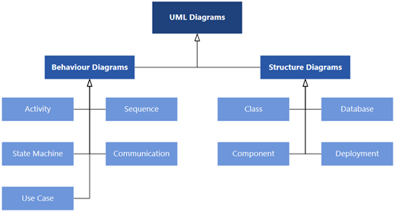

Figure 8: UML diagrams(Source: Microsoft)

**Lucidchart**



Figure 9: Lucidchart Logo

For many developers, Lucidchart serves as their first diagramming tool since it offers a basic set of features. Thanks to HTML 5, Lucidchart operates in real time across several platforms and can handle everything from mind maps to intricate system diagrams.

Lucidchart input type:

* Drag-and-drop

UML diagram types where lucidchart shines:

* Class diagrams
* Sequence diagrams
* Activity diagrams

**Gleek.io**

Sequence diagrams, class diagrams, and object diagrams are just a few of the UML diagram types that Gleek.io can produce. Additionally, teams may utilize Gleek.io to make mind maps, flowcharts, and org charts. Developers work more quickly using Gleek.io than they would with drag-and-drop mapping applications because of its keyboard-based interface. In case you get lost, Gleek.io includes syntactic assistance right in the diagram window (greg, 2020).

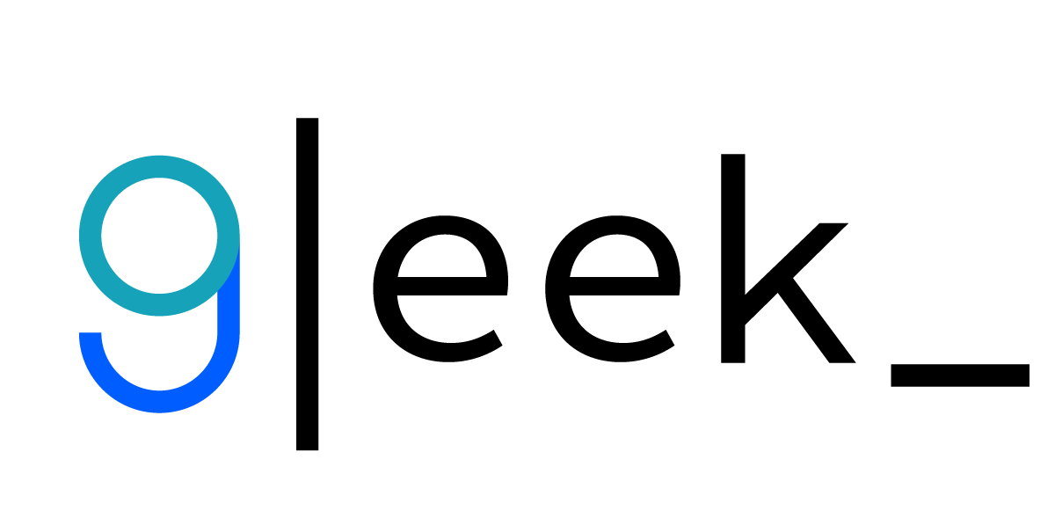

Figure 10: Gleek.io

**Draw.io**

In addition to supporting UML, Diagrams.net (formerly draw.io) offers a straightforward drag-and-drop interface for diagrams and graphs. Although Diagrams.net is effective for many different jobs, some users might find it lacking in specific features. Draw.io offers the same simplicity of use for average people and is somewhat less expensive than Lucidchart if you're searching for a drag and drop UML solution.



Figure 11: Draw.io

1. **Tools to design User Interface**

**Figma**

One of the most widely used UI design tools, Figma has pioneered many of the features you'll find in others. Co-editing, or "multiplayer design" as Figma refers to it, is the most significant of them since it effectively allows designers, developers, and other stakeholders to work together in real-time on the same Figma file (Carl Cahill & May, 2022).

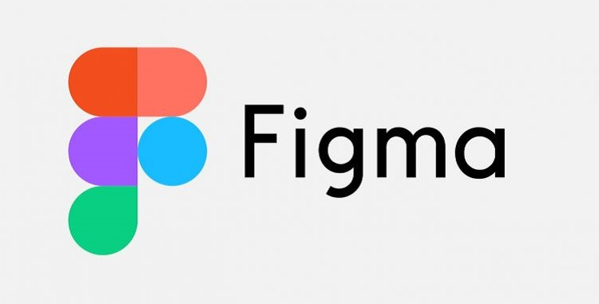

Figure 12: Figma

**Sketch**

Even if it no longer leads the industry, Sketch is still a strong contender and the second most popular user interface design tool today. It was a pioneer in the field ten years ago.

We've discovered that Sketch makes it easy to produce high-fidelity prototypes, variables, and symbols (components), as well as deliver them in real time. However, it can be sluggish to adopt new capabilities compared to other tools.



Figure 13: Sketch

**Visual Paradigm**

The Object Management Group's Visual Paradigm (VP-UML) is a UML CASE tool that supports UML 2, SysML, and Business Process Modeling Notation (BPMN) (OMG). It offers report generation, code engineering capabilities, including code generation, and modeling assistance in addition to these other features. It offers round-trip engineering for several programming languages and can deduce diagrams from code.

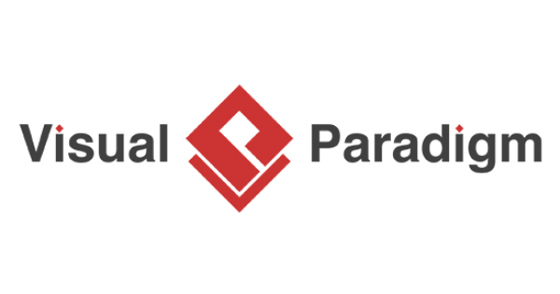

Figure 14: Visual paradigm

## 6.2. Front End technology stack

1. **Frontend UI**

**JavaScript**

A small, interpreted, or just-in-time compiled programming language containing first-class functions is called JavaScript (JS). Although JavaScript is best known for being the scripting language for Web pages, several applications other than browsers, like Node.js, Apache CouchDB, and Adobe Acrobat, also utilize it. JavaScript is a dynamic, prototype-based language that supports object-oriented, declarative (like functional programming), and imperative programming paradigms (MDN contributors, 2022).

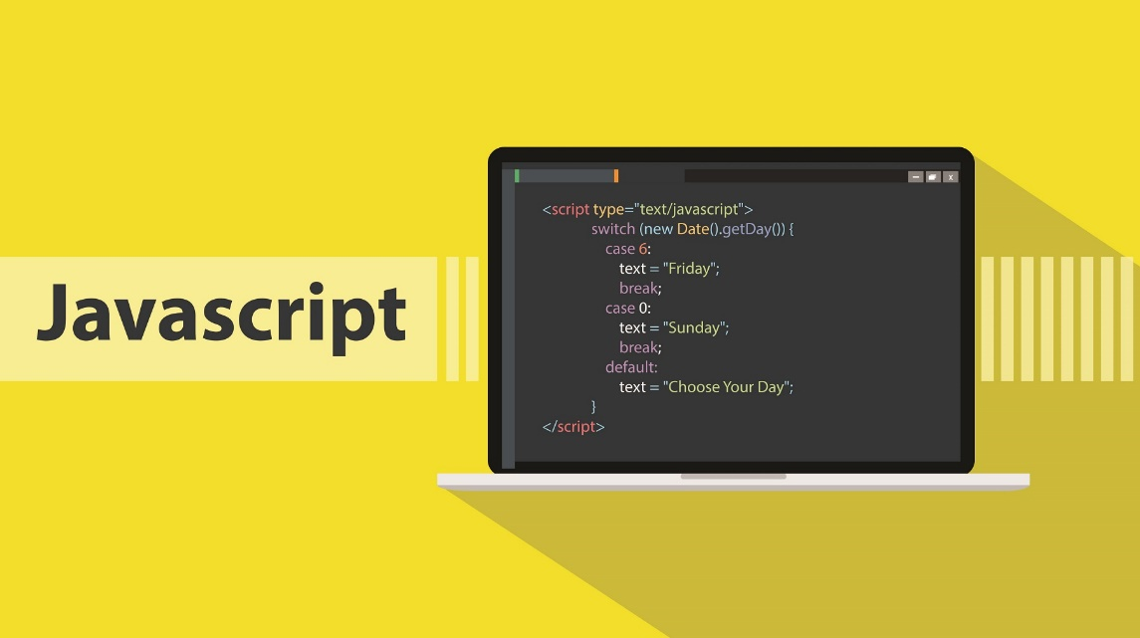

Figure 15: JavaScript

Helps improve interactivity on the web. The script runs on the user's browser instead of having to run on the server. JS often uses a 3rd party library to add functionality to the web without having to re-code it from scratch.

**HTML**

The most fundamental component of the Web is HTML (HyperText Markup Language). It describes the purpose and organization of web content.

Links that join online pages together, either inside a single website or between websites, are referred to as "hypertext." An essential component of the Web are links. You may participate actively in the World Wide Web by publishing content online and linking it to other people's web pages (MDN contributors, 2022).

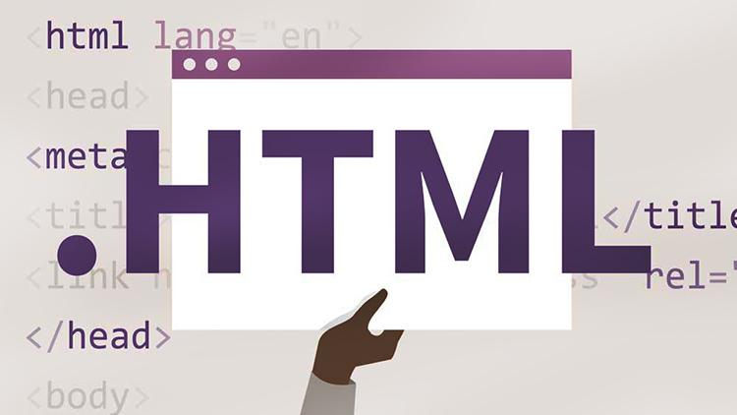

Figure 16: HTML

**CSS**

A style sheet language called Cascading Style Sheets (CSS) is used to specify how documents written in HTML or XML are presented (including XML dialects such as SVG, MathML, or XHTML). CSS specifies how elements will appear in various media, including speech, paper, the screen, and other media.

According to W3C guidelines, CSS is one of the fundamental languages of the open web and is standardized on Web browsers. The CSS specification's many components used to be developed synchronously in the past, which allowed versioning of the most recent suggestions (MDN contributors, 2022).

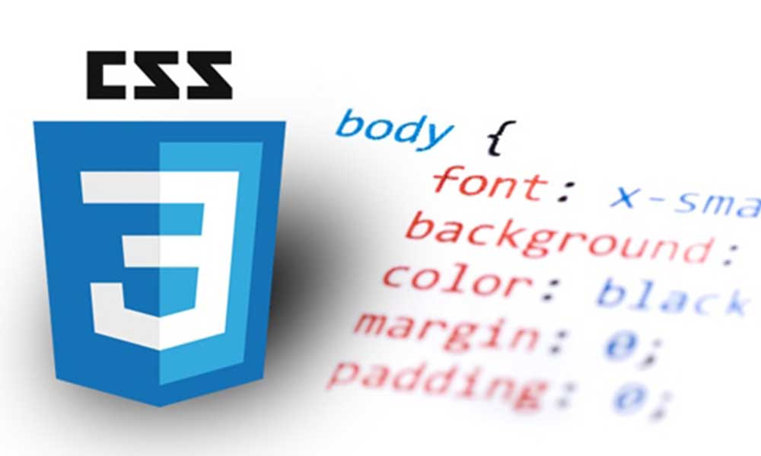

Figure 17: CSS

separating the content of the Web page and the display format, making the source code of the Web page neater, and making it easier to change the content are all ways to reduce the messing up of the HTML code of the Web page with style-specific elements (bold, italic, underlined, and colored text).

To prevent having to repeat formatting for the same Web sites, create styles that can be used on different Web pages.

1. **Frontend frameworks**

**Vue**

Vue is a JavaScript framework for creating user interfaces, and it is pronounced similarly to view (/vju/). It provides a declarative and component-based programming approach that enables you to effectively create user interfaces, whether they are straightforward or complicated. It works on top of industry-standard HTML, CSS, and JavaScript (vuejs, n.d.).

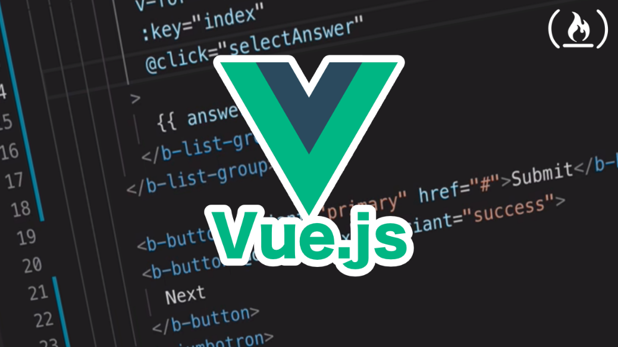

Figure 18: Vue.js

The majority of the typical functionality required in frontend development are covered by the framework and ecosystem known as vue. The web, though, is incredibly diverse, and the things we create there may differ greatly in scale and shape. In light of this, Vue is made to be adaptable and gradually adopted. Vue has a variety of uses that you may choose from according on your use case:

* Static HTML improvement without a build step
* Web components may be embedded on any page.
* Application with Just One Page (SPA)
* Server-Side Rendering / Full Stack (SSR)
* Static site generation with Jamstack (SSG)
* targeting the terminal, WebGL, mobile, and even desktop

**React**

A JavaScript package called React is used to create user interfaces. Visit our site or the tutorial to learn more about React. You may use as little or as much React as you need because it was created from the ground up with progressive adoption in mind. The resources in this part will assist you in getting started, whether you want to learn more about React, add interaction to a straightforward HTML page, or launch a sophisticated React-powered program (reactjs, n.d.).



Figure 19: React.js

**Angular**

A programming environment based on TypeScript is called Angular. Angular's platform features include:

* a framework based on components for creating scalable web apps
* a group of carefully combined libraries that provide support for a wide range of functions, such as routing, form management, client-server communication, and more
* a set of tools for developers that let you create, test, and update your code

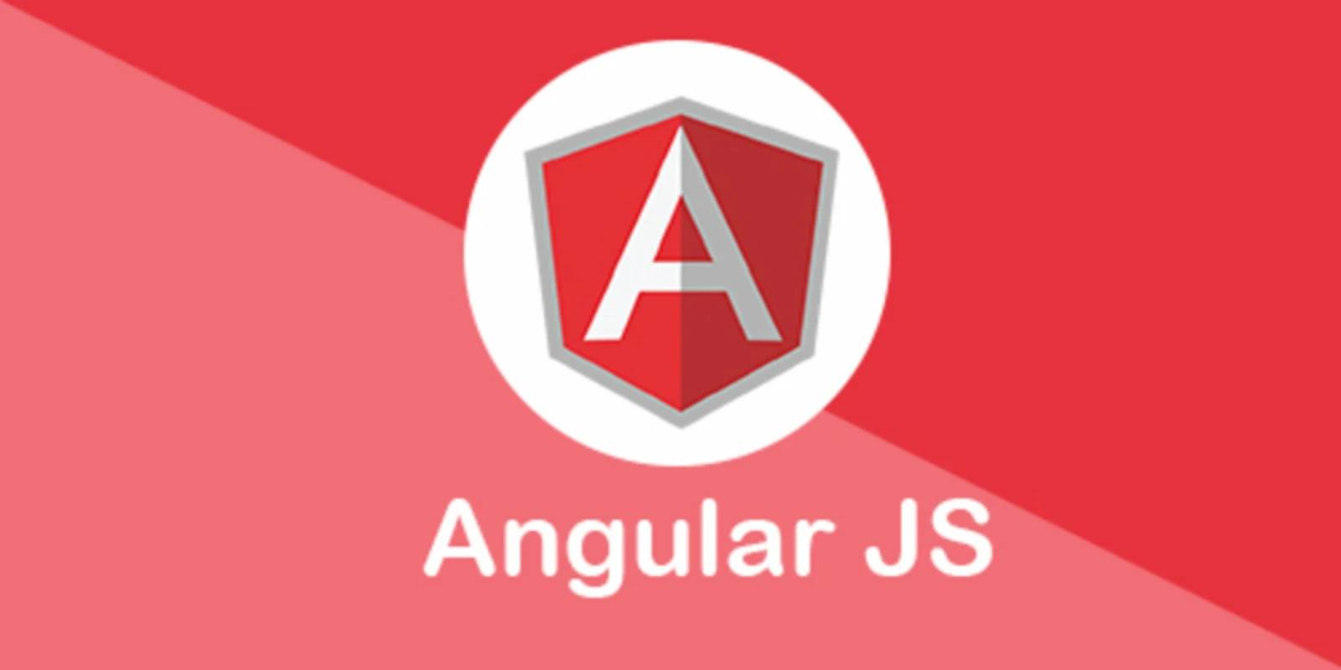

Figure 20: Angular

With Angular, you can benefit from a platform that scales from projects with a single developer to enterprise-level apps. Take advantage of the most recent advancements with the least amount of effort possible because Angular is made to make upgrading as simple as possible. The Angular ecosystem is made up of a varied community of more than 1.7 million developers, library authors, and content producers, which is the best part (Angular, n.d.).

1. **Frontend styling**

**Bootstrap**

A free front-end framework called Bootstrap makes web development quicker and simpler. In addition to optional JavaScript plugins, Bootstrap comes with HTML and CSS-based design templates for typography, forms, buttons, tables, navigation, modals, picture carousels, and many other things. You can also simply develop responsive designs with Bootstrap (w3schools, n.d.).

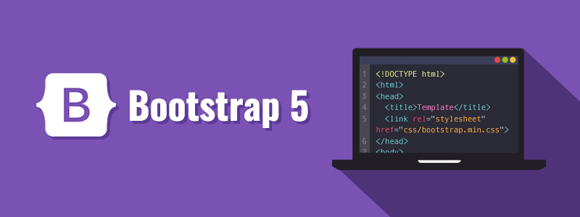

Figure 21: Bootstrap

Benefits of Bootstrap:

* Simple to use Anyone can start using Bootstrap with just a basic understanding of HTML and CSS.
* Features that respond: The responsive CSS in Bootstrap adapts to mobile devices, tablets, and desktops.
* Mobile-first strategy: Mobile-first styles are a fundamental component of Bootstrap 3's framework.
* Compatibility with browsers All current browsers are compatible with Bootstrap (Chrome, Firefox, Internet Explorer, Edge, Safari, and Opera)

**Tailwind**

Tailwind CSS works by scanning all HTML files, JavaScript elements, and any other templates for class names, generating the styles accordingly, and then writing them to a static CSS file.

It's fast, flexible and reliable - no runtime (tailwindcss, n.d.).

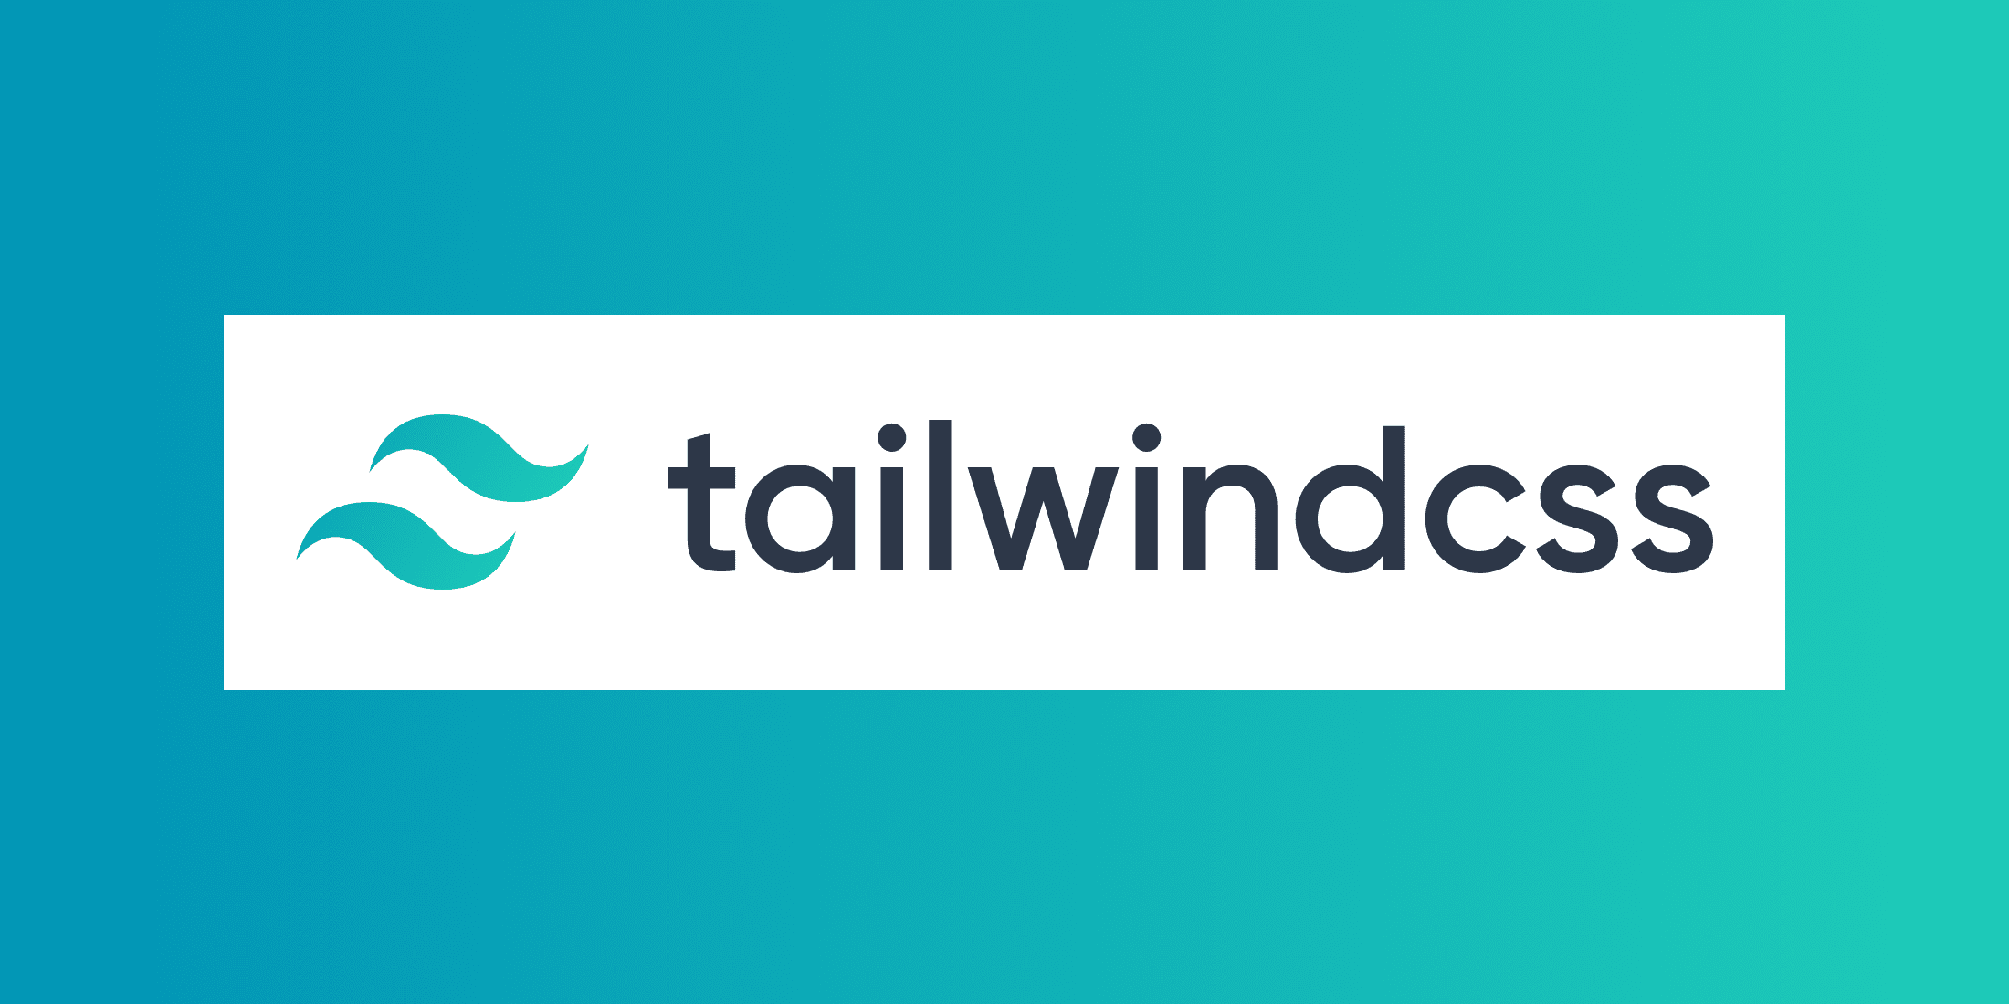

Figure 22: tailwindcss

## 6.3. Back End technology stack

1. **Programming language**

**Java**

Java was created to have as few implementation dependencies as feasible. It is a class-based, object-oriented programming language. Because it is a general-purpose programming language, compiled Java code can run on any Java-enabled systems without compiling, allowing application developers to write once and run anywhere. once again translate Regardless of the underlying computer architecture, Java programs are often converted to bytecode that can run on any Java virtual machine (JVM).

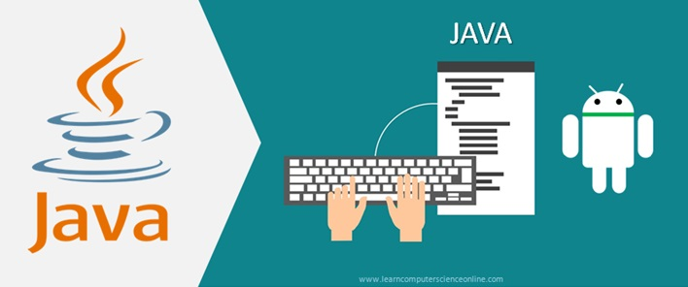

Figure 23: Java programming

**Python**

Python is a popular programming language used for machine learning, data research, and online applications (ML). Python is popular among developers because it is effective, simple to learn, and compatible with a wide range of platforms. Free to download, compatible with all kinds of platforms, and hastening development is Python software.

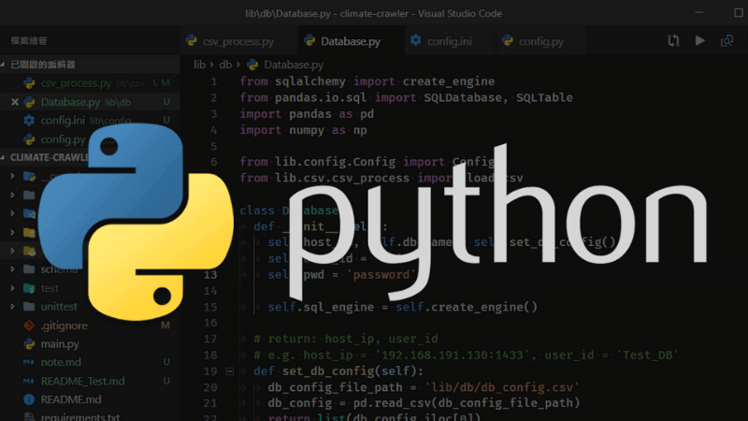

Figure 24: Python

**PHP**

PHP is a programming language for servers that is used to create Web applications. The popularity of PHP implies that a large number of programmers utilize it to create projects for their own use or the use of their clients. Additionally, PHP has the advantage of having a large number of frameworks and CMSs that speed up the process of building a website, which is why many programmers like it.

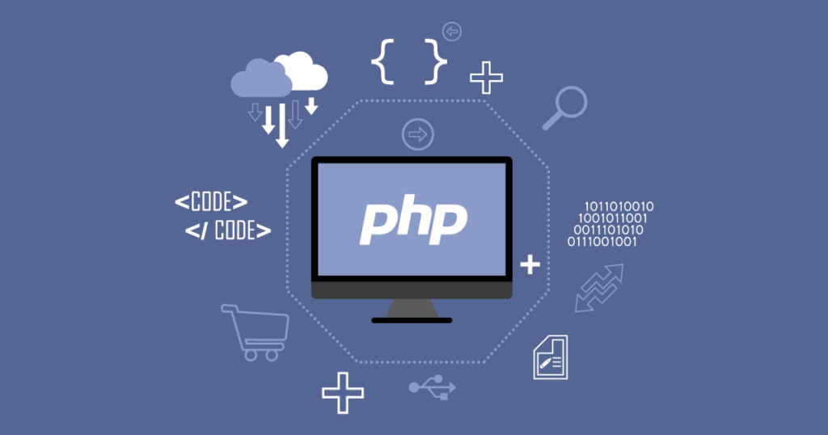

Figure 25: PHP

**C#**

Microsoft created the sophisticated, all-purpose object-oriented programming language C# as the first step in the development of their.NET platform. According to Microsoft, the language's name contains the pound symbol, whereas ECMA calls it C#, which only uses lowercase numerals. Microsoft creates C# using Java and C++. According to some, C# strikes a balance between C++, Visual Basic, Delphi, and Java.

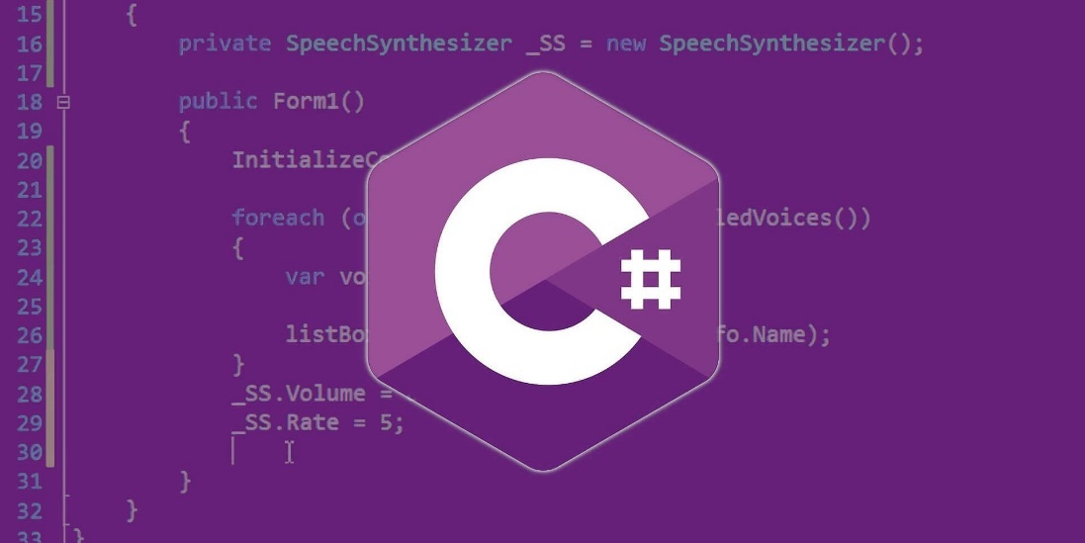

Figure 26: C Sharp

C# is a programming language that, in some aspects, most closely resembles the.NET Foundation, which underlies all.NET projects, and it significantly depends on this framework. The.NET runtime features class, delegate, interface, exception, and many more abstractions are all clearly represented in the fact that all underlying data is an object that is created and destroyed by the garbage collector (GC).

1. **Operating system**

**Linux**

Based on the Linux kernel, which Linus Torvalds initially published on September 17, 1991, Linux is an open-source Unix-like operating system. The most common way to package Linux is as a distribution. Linux has been ported to more platforms than any other operating system since it was first created for personal computers using Intel x86 architecture (Wikipedia contributors, 2022).

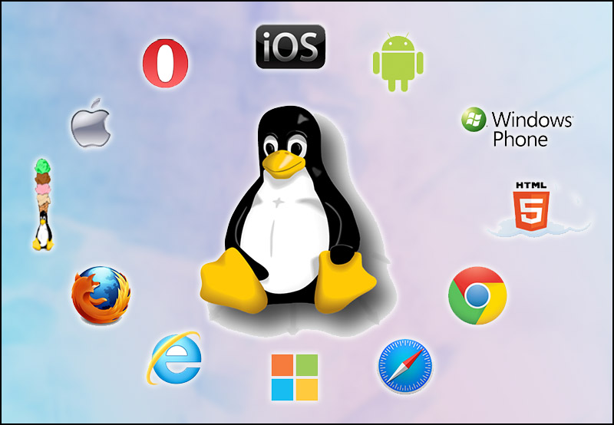

Figure 27: Linux

Advantages

* LibreOffice and OpenOffice are supported, free office suites.
* high level of security
* On PCs with minimal setup, there is no need to worry about latency, jerky, inactivity, etc.

Disadvantages

* Current software developers have not yet paid attention to this extremely potential operating system, so the number of supported software at the present time is still limited.
* Some of the current manufacturers still do not develop drivers to support the Linux platform.

**Windows**

Microsoft Windows (or simply Windows) is a family of graphical user interface-based operating systems developed and distributed by Microsoft. It includes several lines of operating systems, each of which serves a certain part of the computer industry.

Advantages

* High compatibility - Most manufacturers invest in building software as well as manufacturing supporting hardware for Windows operating systems.
* Ease of use - Subsequent versions of Windows operating system always inherit the basic features of their predecessors, making it easy for users to get used to and use;
* Security - Although not comprehensive security such as: Linux, Mac OS ... but Microsoft always provides users with free upgrade and update packages to optimize the stability and security of the device;
* Application richness - The large number of Windows users always attracts application writers, so compared to other operating systems, the number of applications of Windows is always at a higher level of richness.
* Maximum support for touch screens (Windows 8 and above)
* From Windows 8 version onwards, the Windows platform has been designed to well support touch screen devices.

1. **Web Server**

**Nginx**

The open-source Web server software Nginx (pronounced "engine x") also provides reverse proxy, load balancing, email proxy, and HTTP caching capabilities. Igor Sysoev initially developed the program as a solution to the C10k problem, which included managing 10,000 concurrent user connections (TechTarget Contributor, n.d.).

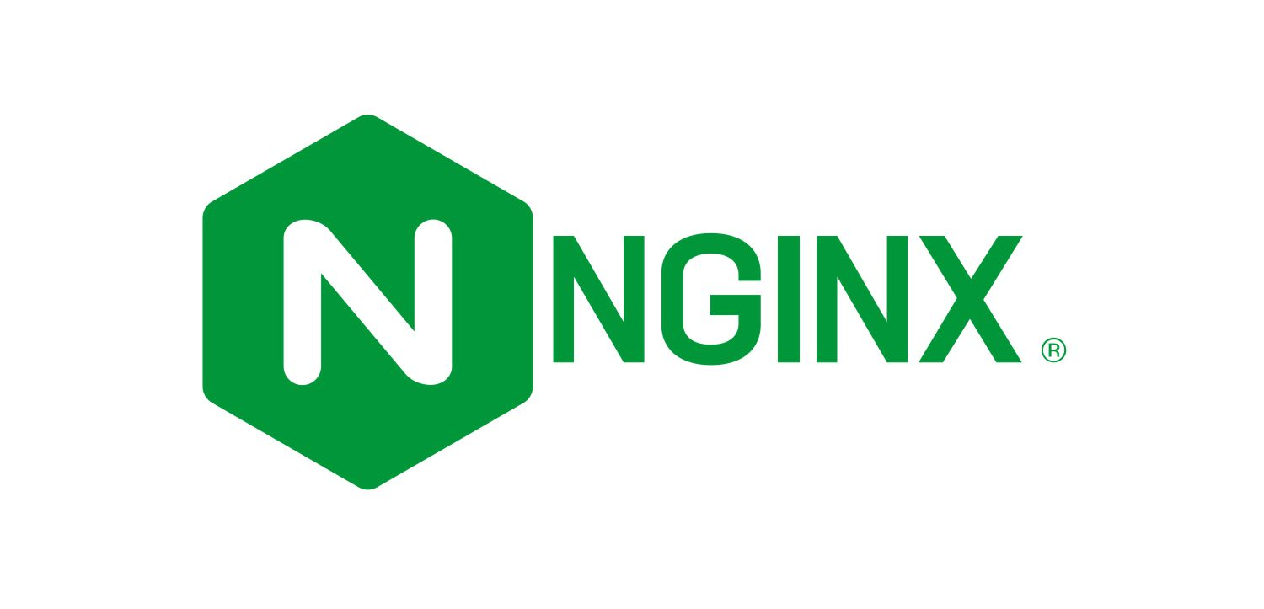

Figure 28: Nginx

High performance for Web servers with large scalability is provided by Nginx. Nginx can operate at rapid speeds while carrying more weight. A single website can offer compiled information sources as though they were all pulled together onto a single page thanks to the reverse proxy capability. Through its load balancer, loads may be distributed among various resources, such as servers.

**Apache**

A project called the Apache HTTP Server Project aims to create and support an open-source HTTP server for contemporary operating systems like UNIX and Windows. A safe, effective, and extendable server that offers HTTP services in accordance with current HTTP standards is what this project aims to deliver (Apache, n.d.).

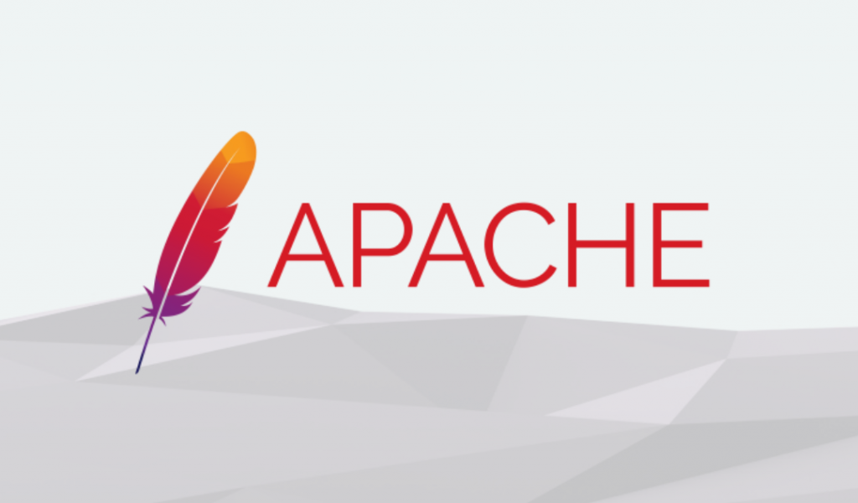

Figure 29: Apache

**IIS**

IIS for Windows® Server is an adaptable, safe, and managed Web server for hosting anything on the Internet. IIS's scalable and open design is equipped to handle the most demanding activities, from video streaming to web applications (IIS, n.d.). It can be used to publish the content of Web pages to the Internet/Intranet using the "Hypertext Transport Protocol" (HTTP).



Figure 30: IIS

Making an ASP.NET-based web application is one of IIS's most frequently utilized functions. Additionally, IIS can fully function with websites created in other languages like PHP, Perl, etc.

Other security features include SSL/TLS support, Server Name Indication (SNI), security settings for FTP servers, and more. IIS also supports a number of authentication types, including Basic access authentication, Digest access authentication, Windows Authentication, Certificate authentication, etc.

With a modular architecture, it is possible to open, disable, and install certain functionalities to satisfy user requests and improve the web server's speed and security.

1. **Database**

**MySQL**

The most widely used free and open source database management system in the world is MySQL, which is also highly well-liked among programmers who create applications. Because MySQL is a portable database management system with great performance, stability, and ease of use that runs on a variety of operating systems, it offers a wide range of extremely potent utility functions. MySQL is a great choice for apps that access online databases because of its quick performance and security. On the webpage, users may download MySQL without charge. The Win32 version of MySQL is available for Windows, Linux, Mac OS X, Unix, FreeBSD, NetBSD, Novell NetWare, SGI Irix, Solaris, SunOS, and other operating systems.

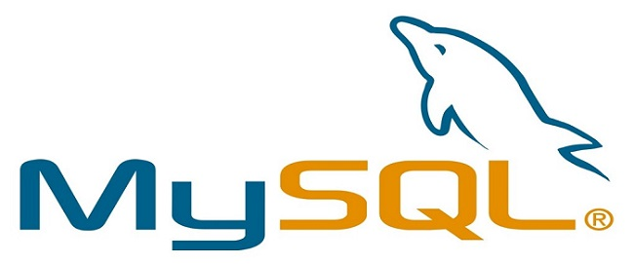

Figure 31: MySQL

**SQL Server**

Microsoft created the relational database management system known as Microsoft SQL Server. It is a piece of software known as a database server, and its main job is to store and retrieve data needed by other software programs. can function on the same computer or a different one connected to a network (including the Internet).



Figure 32: SQLServer

**MongoDB**

MongoDB is an open source database and the leading NoSQL(*) database, used by millions of people. MongoDB is written in C++. In addition, MongoDB is a cross-platform database, working on Collection and Document concepts, it provides high performance, high availability and easy scalability.



Figure 33: MongoDB

1. **Hosting**

**Azure**

Microsoft Azure is an integrated system of cloud computing services, and of course, all provided by Microsoft. Microsoft is a technology corporation famous for its Windows operating system and countless other applications in electronics and computers. This system is made up of 3 basic architectures: IAAS, PAAS and SAAS.

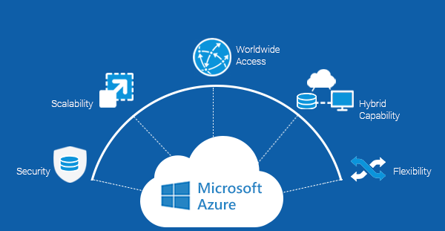

Figure 34: Azure

Advantages

* Application development: You can create any web application in Azure.
* Testing: After developing the application, you can test it right on Azure.
* Application hosting: After testing is complete, Azure can help you host applications.
* Create virtual machines: You can create virtual machines in any configuration you want with the help of Azure.
* Integrate and sync features: Azure allows you to integrate and sync virtual devices and folders.
* Collect and store metrics: Azure allows you to collect and store metrics, which can help you find what's working.
* Virtual hard drives: These are extensions of virtual machines; they provide a huge amount of data storage.

**AWS**

AWS is an Amazon company that offers governments, businesses, and people access to on-demand cloud computing platforms and APIs on a metered pay-per-use basis. Through AWS server farms, these cloud computing web services offer software tools and distributed computer processing capability.

(Wikipedia contributors, 2022).



Figure 35: AWS

Customers that use AWS services receive them through a global network of AWS server farms. The "Pay-as-you-go" approach of charging is based on consumption as well as subscriber-selected hardware, operating systems, software, and networking characteristics that must be available, redundant, secure, and offer a range of service alternatives. Subscribers have the option of paying for a single physical or virtual AWS machine, a cluster of either, or both.

**Google Cloud**

A collection of cloud computing services called Google Cloud Platform (GCP), powered by Google, operate on the same internal architecture as Google's consumer products including Google Search and YouTube. It provides a variety of modular cloud services, including as computation, data storage, data analytics, and machine learning, in addition to a set of management tools. An account number or credit card are needed for registration. A Serverless computing environment, a Platform as a Service, and Infrastructure as a Service are all offered by Google Cloud Platform.

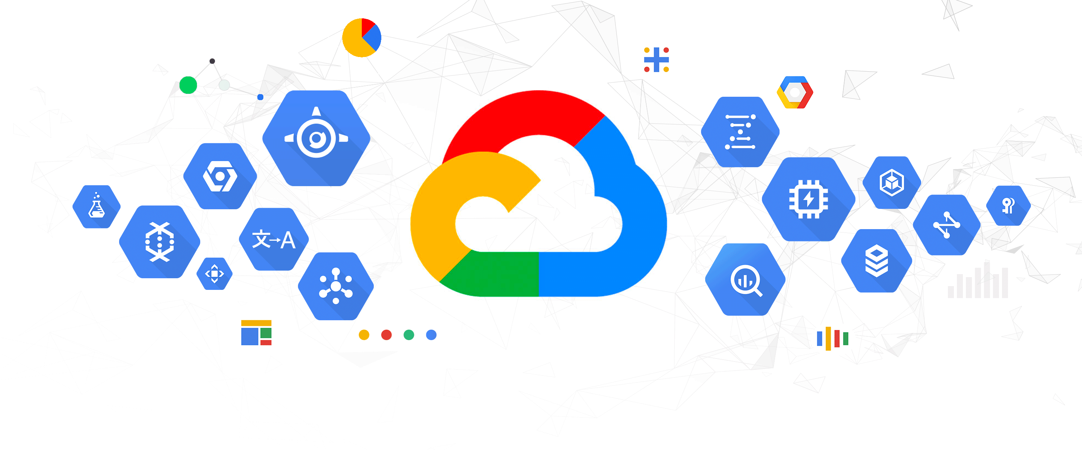

Figure 36: Google Cloud

1. **Frameworks**

**Laravel**

A web application framework with expressive and beautiful syntax is called Laravel. A web framework gives your application structure and a place to start, allowing you to concentrate on making something wonderful without sweating the details.



Figure 37: Laravel

While offering strong features like complete dependency injection, an expressive database abstraction layer, queues and scheduled jobs, unit and integration testing, and more, Laravel aims to offer an exceptional developer experience (Laravel, n.d.).

**Express**

Express js is a small, yet flexible framework built on top of Nodejs. It provides powerful features for web or mobile development. About support packages: Expressjs has a multitude of support packages, so you don't have to worry about working with this Framework. About performance: Express provides more features for better developers. It does not reduce the speed of NodeJS. And above all, the famous frameworks of NodeJS now all use ExpressJS as a core function, such as: SailsJS, MEAN,....

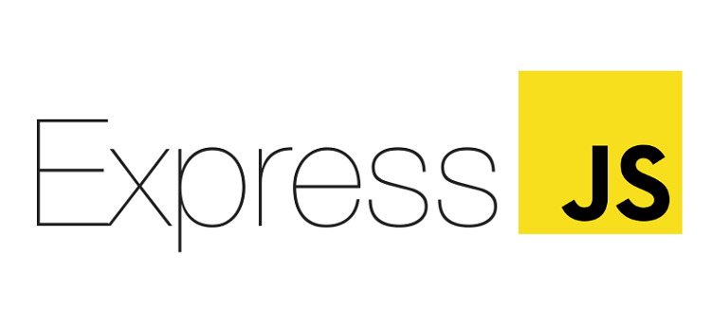

Figure 38: Expressjs

**ASP.NET Core MVC**

When there is an internet connection, ASP.NET Core is a set of libraries that can be used to create online apps. It is a Microsoft product that is now relatively well-known in the programming world due to the abundance of blogs and vlogs about it. Technology acknowledges and is interested in it. There were several tutorials, comparative pieces, tutorials, and conversations around ASP.NET Core as soon as it was released.

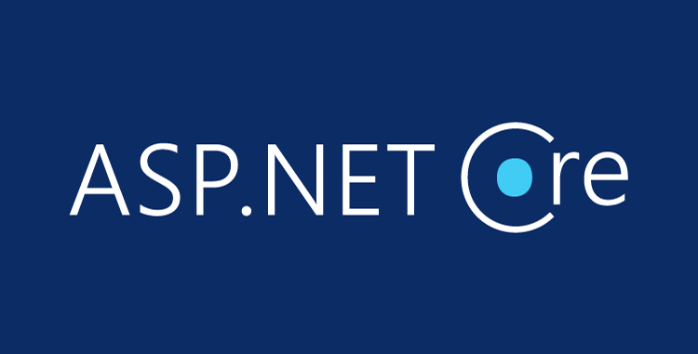

Figure 39: ASP.NET Core MVC

Using ASP.NET, you can build web apps, services, IoT applications, and mobile backend components while using your choice development tools on Windows, macOS, and Linux. either on-premises or in the cloud.

## 6.4. Tools for source control management

1. **GitHub**

Favorable for distributed version control across various teams. allows for the collaboration, evaluation, and management of software/application code by big development teams. integrates with bug tracking software. Permissions and access control are already supported.

Advantages

* supports mobile devices, Macs, and Windows.
* supports deployment on the cloud.
* able to precisely handle various projects and permissions.
* great assistance and documentation.

Disadvantages

* Github is a cloud-based platform, thus security for high-value intellectual property projects or scripts may be a problem.
* Large pull requests can take a lot of time and effort to review.

1. **CVS**

Best for teams of any size who just need basic versioning requirements. Teams nowadays, however, choose cutting-edge versioning solutions like Git since it is so outdated. Concurrent Version Control Systems is how they are known. capability for both basic and complex version control.

Advantages

* the necessities for version control.
* Resolution of disputes is simple.

Disadvantages

* Given that most contemporary solutions include all these capabilities and that it was among the earliest version control systems available, it is a little antiquated.
* Sometimes merging numerous commits might be unpleasant.

1. **Apache Subversion**

The Apache Software Foundation created Apache Subversion (SVN), a free and open-source program that serves as a control system for monitoring changes to files, folders, and directories. It is employed to help with data recovery and keep track of changes over time. It was created to replace the Concurrent Versions System (CVS), a software with several built-in faults and functional problems that was made to save and retrieve multiple source code updates. Best for small to mid-sized teams who are looking for basic versioning features.

Advantages

* Well documented and maintained.
* Visual Highlighting helps with quick conflict resolution.

Disadvantages

* Does not support basic features like Pull requests.
* Can’t be used as a distributed system.

## 6.5. Software Development Models

1. **Agile**

The SDLC agile model combines iterative and incremental process models with an emphasis on customer satisfaction and process adaptation through quick software product delivery. The program is in use. The product is divided into tiny incremental builds using agile approaches. These builds are made available on various occasions. Typically, a repeat lasts one to three weeks. Customers and important stakeholders are presented a functional product at the conclusion of the iterative phase (tutorialspoint, n.d.). Here is a graphical illustration of the Agile Model

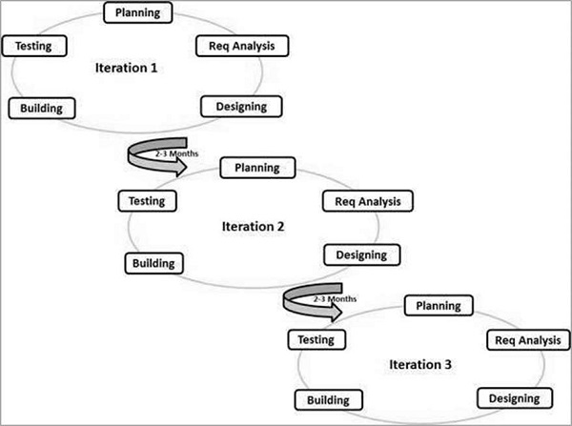

Figure 40: Agile Model

1. **Waterfall**

The first widely used SDLC model in software engineering to assure project success was the waterfall approach. The entire software development process is separated into various phases using "The Waterfall" technique. In this waterfall approach, the output from one step often serves as the sequential input for the following stage (tutorialspoint, n.d.).

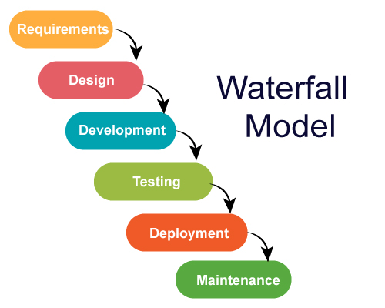

Figure 41: Waterfall Model

The progression is regarded as flowing slowly downward (like a waterfall) through the phases, cascading together throughout. The following phase doesn't begin until the previous stage's established set of objectives has been completed and been signed, hence the term "Waterfall Model." The phases do not overlap in this model.

1. **Spiral**

One of the most significant models for the Software Development Life Cycle that supports risk handling is the spiral model. In diagrammatic form, it resembles a spiral with several loops. The spiral's precise number of loops is unclear and varies from project to project. A phase of the software development process is referred to as each spiral loop. The project manager might alter the precise number of phases required to build the product depending on the project's risks. The project manager plays a crucial role in the spiral model of product development since they dynamically set the number of stages (geeksforgeeks, 2022).

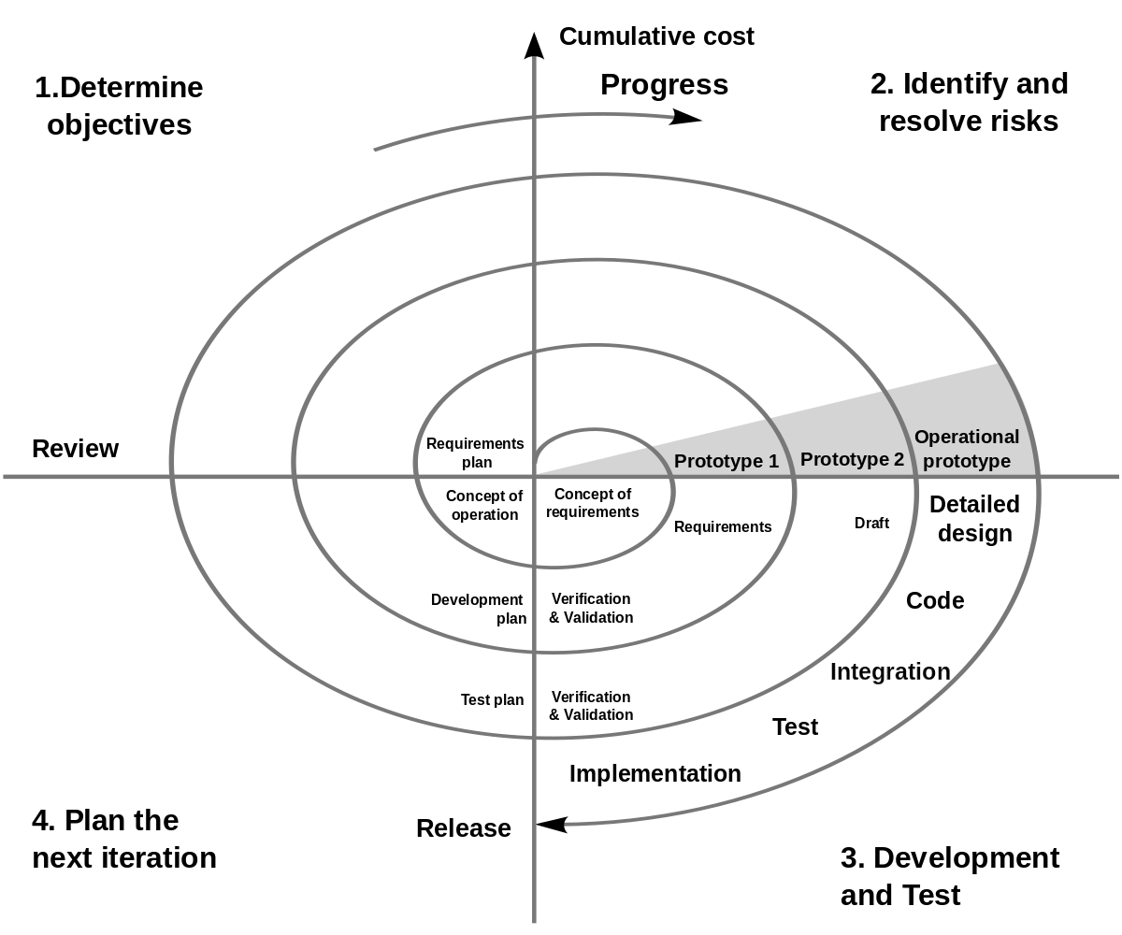

Figure 42: Spiral Model

# Conclusion

Based on the presentation and preliminary research on technologies, I have evaluated and selected the most suitable tools and technologies to develop the system for FPT Book.

Table 2: Technologies use

|  |  |  |
| --- | --- | --- |
| Technologies | Use | Reason |
| Design tools | Draw.io, Visual Paradigm | * A big plus for me choosing Draw.io to design UMLs is that because it's free, I can create drawings instantly just by visiting their website. In addition, Draw.io also has ready-made templates, which saved me a lot of time. Draw.io can also create a more beautiful graphic style than the rest of the software. * I choose Visual Paradigm to design User Interface, such as drawing Wireframe, Wireflow because VP has very detailed support when I draw WireFlow. WireFrame templates are available, diverse, thus saving time. Moreover, the operations are easy and understandable. In addition, with the visual paradigm that can be used to design UML genres easily and quickly, everything is explained with notes. |
| Front End | HTML, CSS, Bootstrap | I choose HTML, CSS and Bootstrap as the main languages to be able to create the most eye-catching and beautiful interface. Because at present, these languages are the most popular and popular, there are many people using them. And to program a website up to the present time all need HTML. Want to make the website more beautiful I choose CSS because it is quite simple to program and use Bootstrap to optimize interface design time. |
| Back End | Programming language: C# | I choose C# language to program FPT Book system because C# is a simple and modern language. At the same time it is also quite powerful and flexible. Besides, C# is also easy to use because it has few keywords and has all the strengths from its legacy software like C++ or Java… Moreover, C# runs on the .NET Framework. The compiler and debugger are also optimized to help programmers easily spot where the error is. |
| Operating system: Windows | I chose Windows operating system to do this project because Windows is very popular and has high compatibility. It is easy to use and rich in application treasures. So in the process of programming, if you need to install any software or application, most Windows operating systems can respond. |
| Web server: IIS | Choosing IIS is because it is developed by Microsoft, so some Windows features will be included in IIS (like Windows Authentication, …). It supports very well in languages or frameworks developed by Microsoft such as ASP.NET or .NET framework. |
| Database: SQLServer | I use SQL Server because it's portable. SQL can be used programmatically in PCs, servers, laptops, and even mobile phones. Easy to manage database without typing any code. |
| Hosting: Azure | I choose Azure because of its large capacity of storage and security, helping businesses cut infrastructure investment costs. Customers can extract data to work anywhere with Internet. Moreover it has a faster deployment time. Azure also has wide coverage, covering all over the world. This ensures the ability to serve the needs of users anytime, anywhere. |
| Framework: ASP.NET Core MVC | Due to the use of MVC model, ASP.Net MVC has separated the layers in the web programming model, thus helping to optimize the application and make it easy to write code and interfaces.  The interface in ASP.Net MVC uses HTML and CSS web design technology to make interface design easy and gives designers flexibility in designing.  ASP.Net MVC does not use view state so the web page is not increased in size and performance is not degraded. |
| Tools for source control management | GitHub | Because GitHub helps manage source code organized in the form of distributed data. Help synchronize the team's source code to 1 server.  Support operations to check source code during work (diff, check modifications, show history, merge source, ...). In addition, I can track other people's activities, thereby tracking the work progress of team members. |
| Software Development Models | Agile | I choose to use Agile model to develop this project. Since I can manage the requirements, the risk arises from the cycle of repeating steps. Moreover, applying Agile will soon produce a demo product, helping the team to shape the product they are working on. |

# References

1. Angular, n.d. *What is Angular?.* [Online]   
   Available at: https://angular.io/guide/what-is-angular  
   [Accessed 10 October 2022].
2. Apache, n.d. *Apache.* [Online]   
   Available at: https://httpd.apache.org/  
   [Accessed 10 October 2022].
3. Carl Cahill & May, T., 2022. *The best UI design tools in 2022.* [Online]   
   Available at: https://www.creativebloq.com/how-to/20-best-ui-design-tools  
   [Accessed 10 October 2022].
4. geeksforgeeks, 2022. *Software Engineering | Spiral Model.* [Online]   
   Available at: https://www.geeksforgeeks.org/software-engineering-spiral-model/  
   [Accessed 10 October 2022].
5. greg, 2020. *Best 7 UML tools to use in 2022.* [Online]   
   Available at: https://www.gleek.io/blog/best-uml-tools.html  
   [Accessed 10 October 2022].
6. IIS, n.d. *IIS.* [Online]   
   Available at: https://www.iis.net/  
   [Accessed 10 October 2022].
7. Laravel, n.d. *Installation.* [Online]   
   Available at: https://laravel.com/docs/9.x  
   [Accessed 10 October 2022].
8. MDN contributors, 2022. *CSS: Cascading Style Sheets.* [Online]   
   Available at: https://developer.mozilla.org/en-US/docs/Web/CSS  
   [Accessed 10 October 2022].
9. MDN contributors, 2022. *HTML: HyperText Markup Language.* [Online]   
   Available at: https://developer.mozilla.org/en-US/docs/Web/HTML  
   [Accessed 10 October 2022].
10. MDN contributors, 2022. *JavaScript.* [Online]   
    Available at: https://developer.mozilla.org/en-US/docs/Web/JavaScript#tools_resources  
    [Accessed 10 October 2022].
11. reactjs, n.d. *Getting Started.* [Online]   
    Available at: https://reactjs.org/docs/getting-started.html  
    [Accessed 10 October 2022].
12. tailwindcss, n.d. *Get started with Tailwind CSS.* [Online]   
    Available at: https://tailwindcss.com/docs/installation  
    [Accessed 10 October 2022].
13. TechTarget Contributor, n.d. *Nginx.* [Online]   
    Available at: https://www.techtarget.com/whatis/definition/Nginx#:~:text=Nginx%20(pronounced%20engine%20x)%20is,user%20connections%3A%20the%20C10k%20problem.  
    [Accessed 10 October 2022].
14. TechTarget Contributor, n.d. *Nginx.* [Online]   
    Available at: https://www.techtarget.com/whatis/definition/Nginx#:~:text=Nginx%20(pronounced%20engine%20x)%20is,user%20connections%3A%20the%20C10k%20problem.  
    [Accessed 10 October 2022].
15. tutorialspoint, n.d. *SDLC - Agile Model.* [Online]   
    Available at: https://www.tutorialspoint.com/sdlc/sdlc_agile_model.htm  
    [Accessed 10 October 2022].
16. tutorialspoint, n.d. *SDLC - Waterfall Model.* [Online]   
    Available at: https://www.tutorialspoint.com/sdlc/sdlc_waterfall_model.htm  
    [Accessed 10 October 2022].
17. vuejs, n.d. *Introduction.* [Online]   
    Available at: https://vuejs.org/guide/introduction.html  
    [Accessed 10 October 2022].
18. w3schools, n.d. *Bootstrap Get Started.* [Online]   
    Available at: https://www.w3schools.com/bootstrap/bootstrap_get_started.asp  
    [Accessed 10 October 2022].
19. Wikipedia contributors, 2022. *Amazon Web Services.* [Online]   
    Available at: https://en.wikipedia.org/w/index.php?title=Amazon_Web_Services&oldid=1114777203  
    [Accessed 10 October 2022].
20. Wikipedia contributors, 2022. *Design tool.* [Online]   
    Available at: https://en.wikipedia.org/w/index.php?title=Design_tool&oldid=1072308489  
    [Accessed 10 October 2022].
21. Wikipedia contributors, 2022. *Linux.* [Online]   
    Available at: https://en.wikipedia.org/w/index.php?title=Linux&oldid=1114205037  
    [Accessed 10 October 2022].