QA TEST REPORT
SPARK-197 | Admin Approve Owner Account — API Testing & UAT
EXECUTED SCOPE PASS • OVERALL JIRA ACCEPTANCE NOT YET SIGNED OFF
CONTROL | DETAIL
Jira / project | SPARK-197 — SmartParking / UserService
Implementation baseline | PR #9 / Fix2FA; commit 9952091294a9603ee53863fca2b454e6a11eb666
Execution date | 29/10/2026 (UTC+07); Newman timestamp 2026-10-29T11:50:31.192Z
Environment | Isolated spark197qa (User/Facility/Operations PostgreSQL); 5035/5045/5055 APIs; Vite 5173
Document status | QA execution draft — Leader review pending; no repository commit or Jira transition
Data handling | Synthetic Owner A and Owner B; personal emails/OTP/passwords and tokens excluded from report

1. Executive summary
Core live web workflow was completed end to end: business registration, required email OTP, Admin review, Approve/Reject, post-decision Owner sign-in control, site provisioning and delivered email notifications. Both decision paths PASSED on isolated QA data. The API automation evidence records 10/10 Newman requests and 17/17 assertions PASSED. This does NOT independently satisfy every negative, concurrency, dependency-failure, immutable-audit and resubmission acceptance criterion in Jira.
EVIDENCE GROUP | PASS | FAIL | NOT EXECUTED / LIMIT
Distinct live browser UAT cases | 10 | 0 | No independent multi-admin stress run
Newman API requests | 10 | 0 | 17/17 assertions; includes non-destructive zero-GUID PATCH denial
Additional planned feature cases | 0 | 0 | 9 untested in master Excel
Targeted .NET unit suite, earlier user logs | 5 | 0 | 0 skip; raw execution file not among 3 uploads
PostgreSQL integration suite, earlier user logs | 5 | 0 | 0 skip; prior run in conversation
FE auth regression, earlier user logs | 55 | 0 | 0 skip; NOT 55 SPARK-197 approval cases
Counting: 10 UAT + 10 Newman = 20 independently tracked executed QA cases, 9 planned (untested). One-off PowerShell API checks corroborate Newman and are deliberately NOT counted again. Historical 17 PR9 cases and 15 SPARK-177 planned cases remain distinct in the pre-existing workbook.

2. Requirements and traceability
REQUIREMENT / CONTRACT | RECORDED EVIDENCE | STATUS
SPARK-197 — Authorized Admin list/detail and review | SP197-API-01..10; controller/Service authorization; active Admin GET | PASS for tested paths
FR-AUTH-05/06; UC-AUTH-02 — Pending → approved, Owner access | SP197-UAT-01..06; site ACTIVE; Admin review metadata | PASS for tested path
Owner rejection/access and decision notification | SP197-UAT-07..10; real mailbox; rejected sign-in error | PASS for tested extension
Actor/time and notification independent status | Newman detail A/B: reviewedBy/reviewedAt and deliveryStatus=sent | PARTIAL audit evidence
Duplicate/retry and remote provisioning failures | Developer coordination test assertions reviewed; earlier unit/integration runs | UNIT/INTEGRATION only
Concurrency, revoke, disable, notification outage, audit history | SP197-GAP-01..09 in master Excel | UNTESTED / clarification

3. Executed Web UAT
Owner A: approved application SPARK197 QA Parking A; Admin status APPROVED and review note persisted. Owner signed in and reached Owner Overview, with one ACTIVE site. The onboarding entry recorded 10 planned slots, while no physical backend slots were configured: 0 shown on dashboard/Structure. Product contract has NOT yet established automatic creation of physical slots; this is an observation, not a confirmed bug.
Owner B: separate verified application SPARK197 QA Parking B (20 declared slots) was REJECTED, review note persisted, and password login displayed the explicit application-rejected message. Neither Owner B nor any unrelated business record was approved.
Email: Real Gmail inbox contained both “Your application is approved.” and “Your application is rejected.” Admin delivery status reached sent for A and B. This confirms QA mailbox delivery; it does not establish production provider reliability.

4. Newman API execution
Source: SPARK-197-Newman-Sanitized-Result.json and SPARK-197-ReadOnly.postman_collection.json. Both supplied by tester; checked against each other. Newman reported 10 requests, 17 assertions, zero failures at 2026-10-29T11:50:31.192Z.
CASE / REQUEST | HTTP | ASSERTIONS | RESULT
01 · Anonymous list | 401 | 1 | PASS
02 · Anonymous detail | 401 | 1 | PASS
03 · Anonymous review denied | 401 | 1 | PASS
04 · Owner list denied | 403 | 1 | PASS
05 · Owner detail denied | 403 | 1 | PASS
06 · Owner review denied | 403 | 1 | PASS
07 · Admin list | 200 | 2 | PASS
08 · Admin detail A | 200 | 4 | PASS
09 · Admin detail B | 200 | 4 | PASS
10 · Admin nonexistent ID | 404 | 1 | PASS
Authorization details: unauthenticated list/detail/review returned 401; authenticated Owner list/detail/review returned 403; Admin list/detail returned 200 and missing application returned 404. Newman login used ephemeral local access tokens via process environment; the exported collection uses placeholders only. The two PATCH probes used zero GUID and an unauthorized principal, not actual QA application IDs. Login may create short-lived authentication sessions, but no Owner approval state was mutated by these Newman probes.

5. Developer test and implementation review
Code inspected at PR9 SHA: OwnerApplicationsController protects endpoints with role admin; OwnerRegistrationService.RequireAdmin also requires ACCOUNT_ADMIN plus IsActiveAdminAsync. Real Owner JWT was independently denied 403 on all three API endpoints; no evidence of a role/permission conflict from this test.
OwnerApprovalCoordinationTests assertions reviewed: repeated completed approval does not re-provision or queue another delivery; remote response loss preserves durable intent and reuse of operation ID on retry; local finalization failure retains intent; revoked Admin cannot replay successfully. OwnerRegistrationHttpTests checks anonymous 401, non-Admin 403, Admin GET 200, invalid review 400 and authorized review 200. The presence of assertions is evidence of coverage design, not proof of untested live races.
Earlier user-provided terminal outputs reported targeted .NET Unit 5 PASS / 0 FAIL / 0 SKIP, PostgreSQL Integration 5 PASS / 0 FAIL / 0 SKIP, FE auth regression 55 PASS, and Owner onboarding standalone test exit 0 (case count unknown). Those raw execution reports were not included in this three-file handoff; retain as prior-session evidence pending attachment, and do not inflate executed QA case totals.

6. Environment retest and unresolved observations
ITEM | OBSERVED FACT / QA DISPOSITION
Facility → Reservation dependency | Parking Structure showed COMMITMENTS_UNAVAILABLE while ReservationService 5055 was stopped. After adding isolated Operations DB/ReservationService, health 200 and pressing Retry loaded Layout. ENVIRONMENT RESOLVED, no Developer bug filed.
Declared vs physical slot count | Lot A declared 10 slots, Owner physical capacity 0. Structure explicitly said no backend slots configured; contract to auto-create slots after approval not verified. OPEN CLARIFICATION, not FAIL.
Audit durability | reviewedBy/reviewedAt present on A and B; immutable audit trail and repeated attempts not read from ledger. PARTIAL.
Authorization revocation and race | Live token after permission revocation / approval-vs-lock / two-Admin race not executed. UNTESTED.
Notification outage | Normal delivery succeeded; outage/failure after approval not exercised in live environment. UNTESTED.
Reject/resubmit detail | Jira explicitly labels evidence criteria and reject/resubmit extension unresolved; no fabricated behavior expected.

7. Acceptance status and handoff
Disposition: PARTIAL ACCEPTANCE / REVIEW REQUIRED. All 20 executed SPARK-197-specific cases PASSED; 9 additional cases remain UNTESTED. Do not mark Jira Done or claim full acceptance until open decisions, audit/concurrency/dependency cases and reviewer approval are recorded. No linked new bug is justified by present evidence; any future confirmed defect should receive its own Jira issue and explicit retest.
Artifacts: updated persistent SmartParking_User_Master_TestCases.xlsx; this QA report; sanitized Postman collection; blank-token example environment; sanitized Newman JSON; redacted screenshot excerpts. Suggested repository destinations: docs/04-testing/test-cases, docs/04-testing/reports, docs/04-testing/postman. The current Git HEAD on tester PC was reported as detached PR9 SHA with clean tree. Do not switch branches, commit or push until local diff and master identity are verified and Leader reviews the handoff.

Appendix A. Redacted browser evidence
Screenshots are derived from the tester-provided 29/10/2026 UAT capture. Full-screen originals and OTPs are not included. These images complement, but do not replace, server logs and Newman JSON.
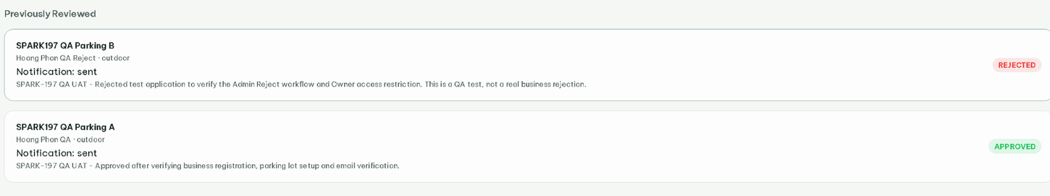
EV-UAT-01 · Admin retained both APPROVED and REJECTED decisions (QA records)
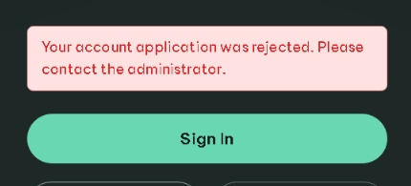
EV-UAT-02 · Rejected Owner blocked at sign-in (credential fields excluded)
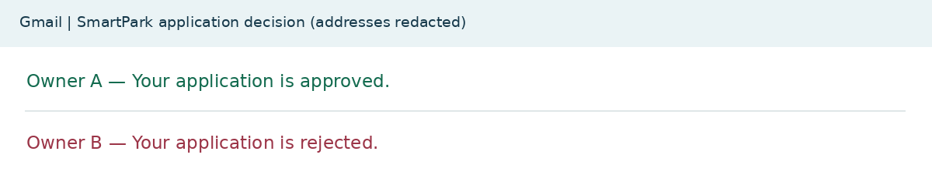
EV-UAT-03 · Two real decision emails; only the decision text is reproduced

Appendix B. Provisioned Owner & dependency recovery
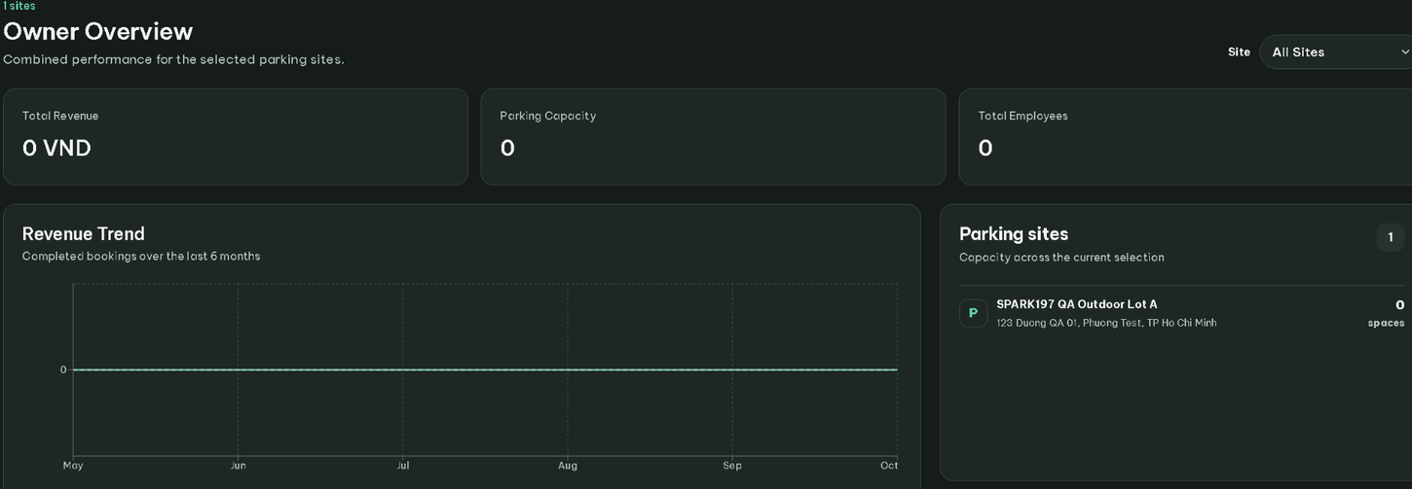
EV-UAT-04 · Approved Owner dashboard (1 site; physical capacity still 0)
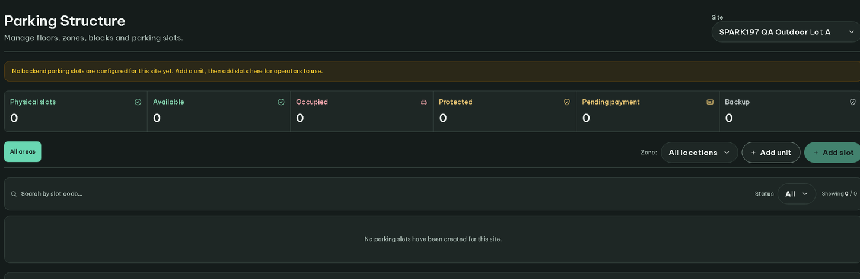
EV-UAT-05 · Parking Structure loads after ReservationService recovery; zero backend slots
Evidence index: EV-UAT-01..05 are cropped/redacted images packaged alongside this report. Test case evidence references in the master correspond to original chat screenshot filenames. No personally identifying inbox addresses, OTP values, passwords or JWTs are intentionally reproduced here.

