 

**ASSIGNMENT 1 FRONT SHEET**

|  |  |  |  |
| --- | --- | --- | --- |
| **Qualification** | **BTEC Level 5 HND Diploma in Business** | | |
| **Unit number and title** | **Unit 30: Application Development** | | |
| **Submission date** | 11/10/2022 | **Date Received 1st submission** | 11/10/2022 |
| **Re-submission Date** | 25/10/2022 | **Date Received 2nd submission** | 25/10/2022 |
| **Student Name** | Le Trong Duc | **Student ID** | GBH200218 |
| **Class** | GCH0907 | **Assessor name** | Nguyen Dinh Tran Long |
| **Student declaration**  I certify that the assignment submission is entirely my own work and I fully understand the consequences of plagiarism. I understand that making a false declaration is a form of malpractice. | | | |
|  | | **Student’s signature** |  |

### Grading grid

|  |  |  |  |  |  |
| --- | --- | --- | --- | --- | --- |
| **P1** | **P2** | **P3** | **M1** | **M2** | **D1** |
|  |  |  |  |  |  |

|  |  |  |
| --- | --- | --- |
| * **Summative Feedback:**  **Resubmission Feedback:** | | |
| **Grade:** | **Assessor Signature:** | **Date:** |
| **Internal Verifier’s Comments:** | | |
| **Signature & Date:** | | |

Software Requirements Specification

**Prepared by**

**Group Name: <>**

|  |  |  |
| --- | --- | --- |
| **<name>** | **Nguyen Le Hoang Anh** | **<e-mail>** |
| **<name>** | **Le Trong Duc** | **<e-mail>** |
| **<name>** | **<student #>** | **<e-mail>** |
| **<name>** | **<student #>** | **<e-mail>** |
| **<name>** | **<student #>** | **<e-mail>** |

|  |  |
| --- | --- |
| **Instructor:** | **Nguyen Dinh Tran Long** |
| **Course:** | **1670** |
| **Date:** | **10/10/2022** |

Table of Contents

Task 1 – Software Requirements Specifications and Software Design 5

1. Introduction 6
   1. Document Purpose 6
   2. Product Scope 6
   3. Intended Audience and Document Overview 6
   4. Definitions, Acronyms and Abbreviations 7
   5. References and Acknowledgments 7
2. Overall Description 8
   1. Product Overview 8
   2. Product Functionality 8
3. Specific requirements 9
   1. Functional Requirements 9
   2. Use case model 11
   3. Wireflow 12
4. Technical Design 16
   1. Entity Relationship Diagram (ERD) 16
   2. Class Diagram 17
   3. Activity Diagram 18
   4. Gantt Chart 22
5. Risk Assessment 23
   1. Risk Assessment 23

Task 2 – Technologies evaluation 25

1. Design tools 25
   1. UML design tool 25
   2. User interface design tool 25
   3. Conclude which tools will be used for the design of the application 26
2. Front End technology stack 26
   1. Front End Programming Language 26
   2. HTML/CSS 27
   3. JavaScript/Framework 29
   4. CSS Framework 29

2.4 Conclude which Front End technologies will be used for the development 30

1. Back End technology stack 30
   1. Back End Programming Language 30
   2. Operating System 31
   3. Web Server 32
   4. Database 32
   5. Host 33
   6. Frameworks 33
   7. Conclude which Back End technologies will be used for the development 34
2. Tools for source control management 34
   1. Tools 34
   2. Conclude which tools will be used for the development 35
3. Software Development Models 35

References 39

Figure 1 General Flow 8

Figure 2 Use case diagram 11

Figure 3 Admin Wireflow 12

Figure 4 Customer Wireflow 13

Figure 5 Store Owner Wireflow 14

Figure 6 Login Wireflow 15

Figure 7 ERD 16

Figure 8 Class Diagram 17

# Task 1 – Software Requirements Specifications and Software Design

## Introduction

* 1. Document Purpose

The purpose of the Software Requirements Specification is to define the specifications that FPT Corporation must meet in order to provide a platform that helps customers and bookshop owners manage book purchases. For the purpose of streamlining and accelerating the process of choosing, buying, and purchasing books for consumers as well as the maintenance of a user database and a product database for bookstore owners, it is crucial to develop a web-based system for managing and selling books online. The revenue of the business is also increased.

Users who make an account and log in to the website can browse all books that are available online, look over extensive information about books, and perform keyword or phrase searches for books. The system can be used to manage and sell books. Replace and include the desired books in the basket. The staff can add, update, and delete books while the administrator has authority over the account list.

* 1. Product Scope

FPTBook will be a web-based software program that will help book store patrons and proprietors manage their book purchases and sales by streamlining and accelerating the process of book selection, ordering, and purchase for patrons as well as managing a user database and a product database for store proprietors.

* 1. Intended Audience and Document Overview

The target audience for this project is the users of FPTBook. Three team members finished this project procedure. This material is also utilized by professors.

|  |  |
| --- | --- |
| Object | Description |
| Customer | This document helps customers to know the features of the website, it also gives them an overview of how the website works |
| Professor | We required a professor or competent mentor to guide us through the development and solve the site's flaws in order to establish a major feature- packed website. As a result, this paper will aid the professor in better understanding the project and providing the development team with the appropriate direction. |

This document explains some crucial components of research, such as the use of tools and technologies to create a website. Describe the technology and tools chosen for the project's development. The objective, scope, and participants and potential users of the product are discussed. This paper also covers the functions, features, and operations of the product. The following category of product constraints includes user requirements, software, and hardware. Additionally presented and listed are diagrams, user interfaces, and project implementation risks.

Reading order for documents:

Start with the overview

* + - The reader should concentrate on the functional components and the range of activities for the consumer.
    - For teachers, the reader should pay close attention to the diagrams and created interfaces in addition to the function.
    - For project managers or developers, thoroughly read the entire paper. Note: Go through the document slowly and highlight key passages.
  1. Definitions, Acronyms and Abbreviations

|  |  |  |
| --- | --- | --- |
| Abbreviations  and acronyms | Full meaning | Define |
| ERD | Entity Relationship Diagram | An overview of these relationships is given by an entity relationship diagram. You may think of it as the architectural blueprint for your business, showing the connections between  various data types in a visual manner (entities). |
| HTML | Hypertext Markup Language | HTML is not a programming language; it is used to build and organise elements in a web page or application, such as paragraphs, headings, titles, and block quotations. |
| CSS | Cascading Style Sheets | Is there a language that can be used to locate and reformat items produced by markup languages? (HTML). Briefly, the website's styling language. You can easily comprehend that if HTML is responsible for structuring website elements like paragraphs, headings, tables, etc., then CSS will assist us in giving the elements styling. That HTML, such as altering the  structure, page color, text color, and font... |

* 1. References and Acknowledgments

## Overall Description

* 1. Product Overview

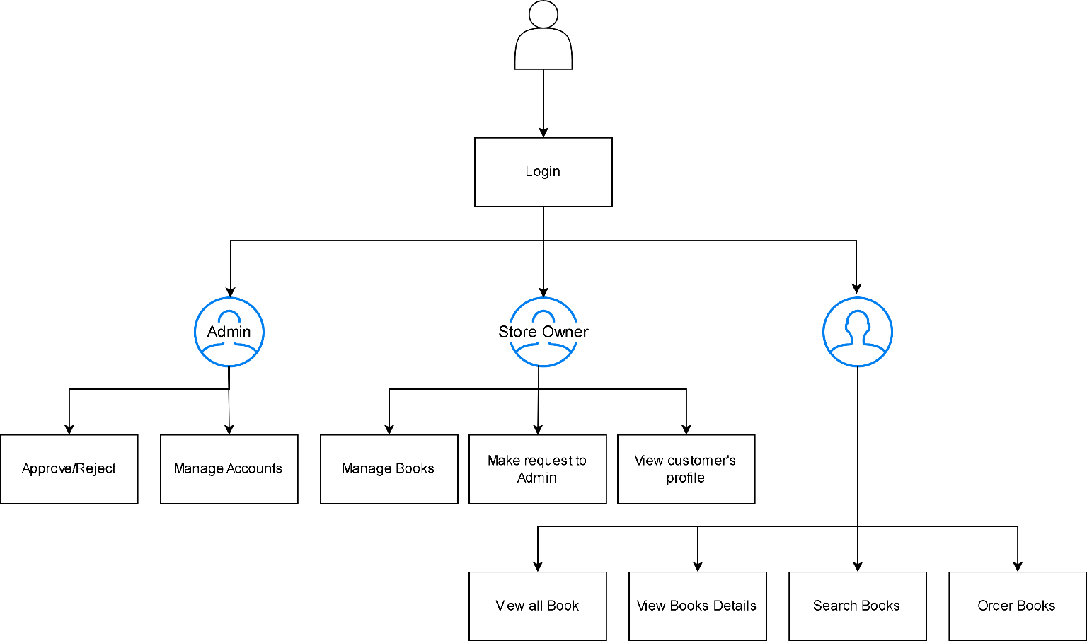

*Figure 1 General Flow*

Through an online bookshop website, FPT Company hopes to help customers and bookstore owners manage their book purchases. This website makes it simpler for bookshop owners to manage their book inventory while also helping customers find and buy books. This system can be used to manage a book collection, find and browse book information, buy books, view, add, modify, and remove books, as well as manage books and employee accounts (for admin). In this system, there are three positions available: administrator, employee, and user (customer)

* 1. Product Functionality

The program will be created as a book-selling e-commerce website. Stores will have the software installed, and customers will be able to access the store's website. The program FPTBook will be promoted as a book store sales tool that facilitates effectively managing book store sales.

Major junction of system Admin

* + - Admin can login, logout
    - Admin can update their information
    - Admin can view customer’s profile
    - Admin can change customer’s password (if it is needed)
    - Admin can delete customer’s accounts
    - Admin can view store owners’ profile
    - Admin can change store owners’ password (if it is needed)
    - Admin can approve or reject the new book category request made by the Store Owner Customer
    - Customer can login, logout or register their account
    - Customer can send request to admin to change password
    - Customer can view categories’ product
    - Customer can view the product list
    - Customer can view product’s detail (Name, image, price, categories, description, …)
    - Customer can view their purchase history

Store Owner

* + - Store Owner can add, edit, search, delete products
    - Store owner can login, logout or register their account
    - Store Owner can search customer information by email.
    - Store Owner can add a new category by sending request to admin.
    - Store Owner can edit exited categories’ name.

## Specific requirements

* 1. Functional Requirements

|  |  |  |  |
| --- | --- | --- | --- |
| ID | As a | I want to | So that I can |
| 1 | Admin | View customer’s profile | More convenient management |
| 2 | Admin | Show all admins in the system | See who has admin permission and their information to contact  when needed |
| 3 | Admin | Update my account | Change my password or contact  information |
| 4 | Admin | Log in to the system | Access the system with admin  permission |

|  |  |  |  |
| --- | --- | --- | --- |
| 5 | Admin | Log out | Exit the system |
| 6 | Admin | Update customer’s password | Proactively deal with problems if  necessary |
| 7 | Admin | View store owner’s profile | More convenient management |
| 8 | Admin | Update store owner’s password | Proactively deal with problems if necessary |
| 9 | Admin | View all the products in the store | See them all |
| 10 | Admin | View all the categories | See all kind of books in the store |
| 11 | Admin | Approve or reject the new book category  request made by the Store Owner | do not accept nonconforming  products |
| 12 | Customer | Log in the system | Access the system with customer  permission |
| 13 | Customer | Log out | Exit the system |
| 14 | Customer | Show the HomePage | See the store’s name, list of  categories, list of books  and contact information. |
| 15 | Customer | Show product list following category | See all types of books are selling  in the store |
| 16 | Customer | View product’s detail | See all information like name,  images, price, category, description |
| 17 | Customer | Search for book by name | Find the specific uniform I’m  looking for |
| 18 | Customer | View my purchase history | More convenient to manage my  purchased products |
|  |  |  |  |
| 19 | Customer | Send request to admin | Change my password if i forgot |
| 20 | Store Owner | Add new category | properly categorized product to make it easier to choose the right type like name, images, price,  description. |
| 21 | Store Owner | View all the categories | See all kind of books in the store |
| 22 | Store Owner | View all the products in the store | See them all |
| 23 | Store Owner | Edit category | Update name or description of the  category |
| 24 | Store Owner | Delete category | Remove unnecessary category |
| 25 | Store Owner | Add new product | The site has more products for  customers to choose |
| 26 | Store Owner | Edit product | Update name or description of the  product |
| 27 | Store Owner | Delete product | Remove unnecessary product |
| 28 | Store Owner | Log in the system | Access the system with Store Owner permission |

|  |  |  |  |
| --- | --- | --- | --- |
| 29 | Store Owner | Log out | Exit the system |
| 30 | Store Owner | Register | Create customer account |
| 31 | Store Owner | Search for customer by name | More convenient management |

* 1. Use case model

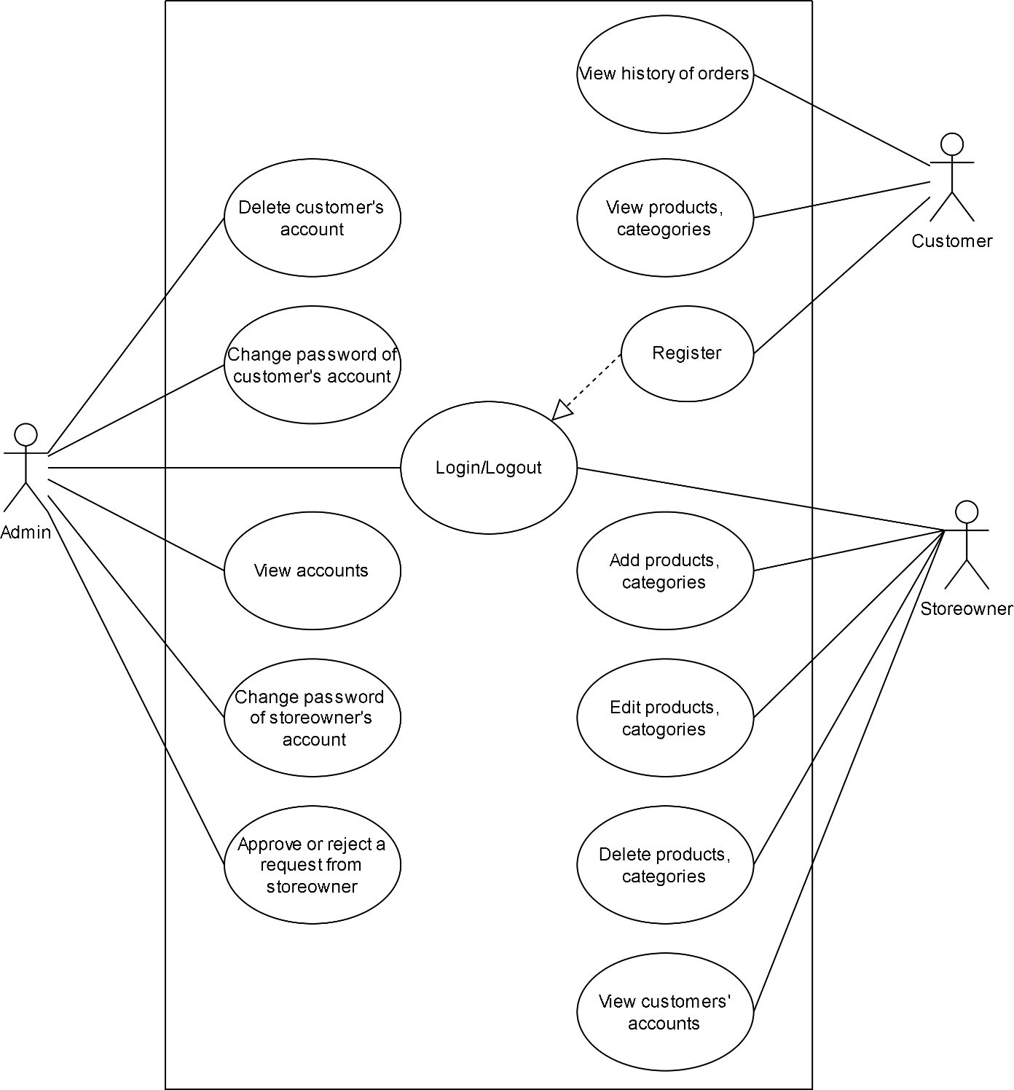

*Figure 2 Use case diagram*

There are 3 main users: admin, storeowner and customer. Admin and storeowner can login with existed accounts, customer need to register a new account if they don’t have one. Admin has functions of managing the accounts of storeowner and customers. Admin can change password of accounts or delete accounts. Storeowner’s function is managing the products. Storeowner can add, edit, delete and view all the products and categories. Customer can view the products, categories, and history of their orders.

* 1. 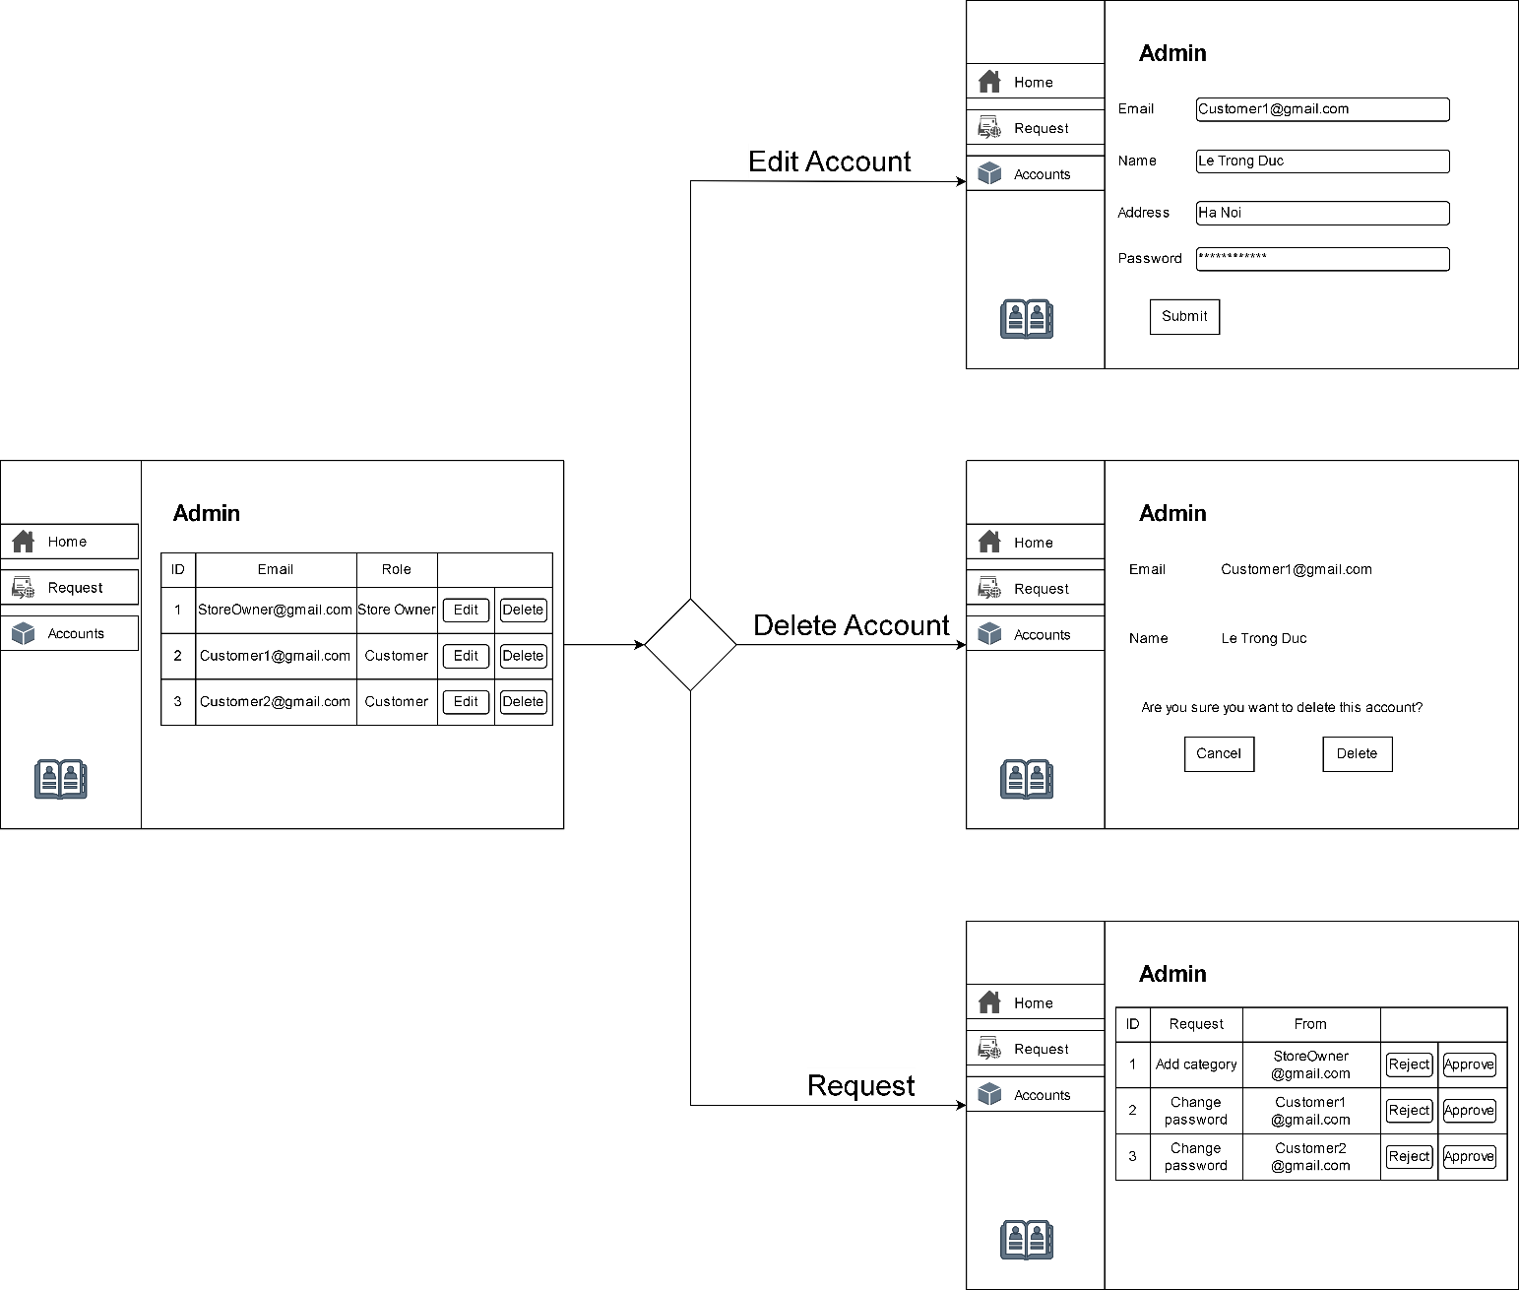Wireflow

*Figure 3 Admin Wireflow*

When logging in by an admin account, the admin page will view all the existed accounts in the database. Admin can edit profile and change password of store owner and customer accounts. Admin can also

delete accounts. There are requests sent to admin from store owners and customers, admin can approve or reject that request.

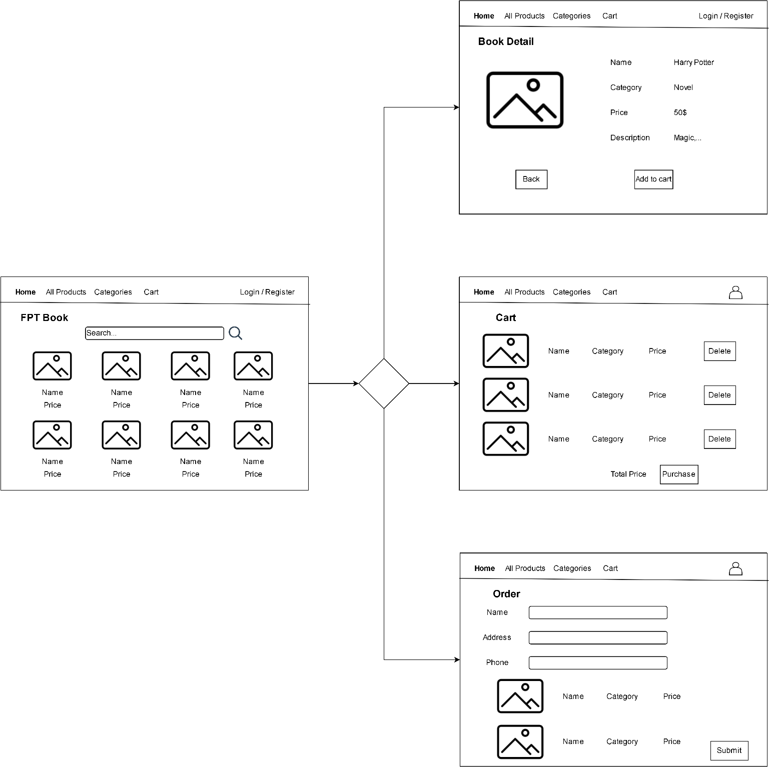

*Figure 4 Customer Wireflow*

When accessing the website as a customer, products and product details will be displayed. To be able to add products to the cart, the website will require customers to log in to an account or register for a new account. Once the products are in the cart, the customer can submit the order.

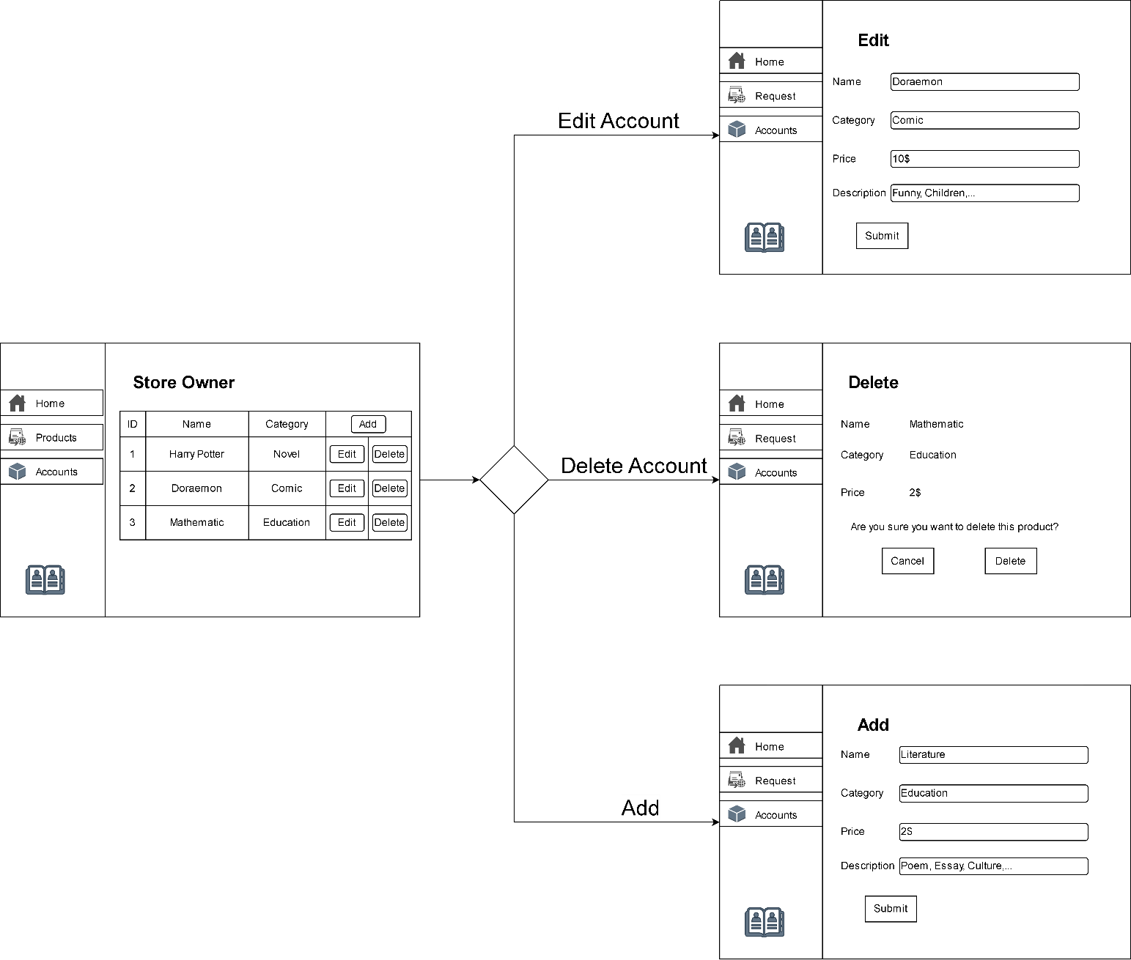

*Figure 5 Store Owner Wireflow*

After logging in as a store owner, the user can display all the products. In addition, store owners can add, edit, and delete products. Customer accounts can also be viewed by the store owner.

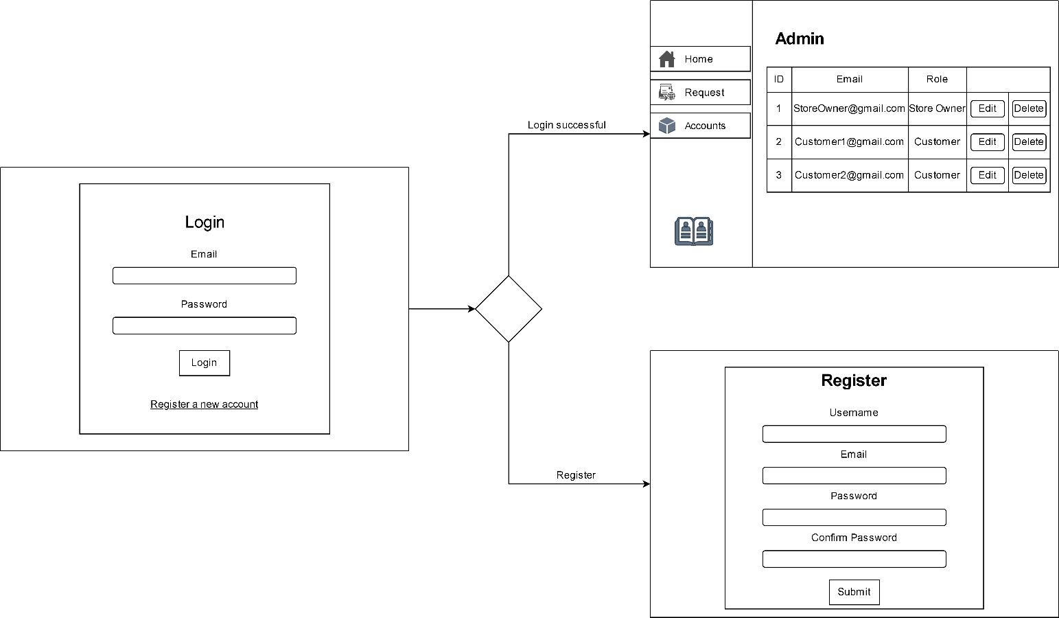

*Figure 6 Login Wireflow*

To access the admin or store owner page, the user needs to be logged in. When successfully logged in with admin account or store owner, the website will switch to the interface of admin or store owner. For customers, users need to log in to use the add to cart and order functions.

## Technical Design

* 1. 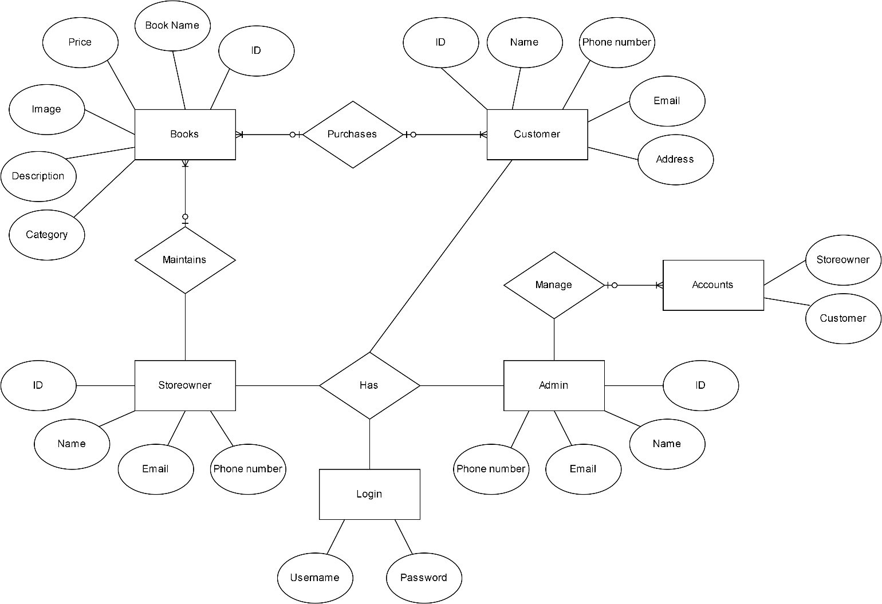Entity Relationship Diagram (ERD)

*Figure 7 ERD*

To ensure that the data of the objects submitted into the system will be ideal for the management of the database of FPT Book, the data fields stated in the ERD are predefined fields.

The basis for linking entities in the ERD is the existence of a primary key and a foreign key for each entity.

The link between the Admin entity and the Accounts entity is a one-to-many association. Because an admin can manage many owner and user accounts.

The link between the StoreOwner entity and the Books entity is a one-to-many association. Because a book owner can manage many books.

The link between the Books entity and the Customer entity is a many to many association. Because a customer can buy many books and each book can be bought by many customers.

* 1. Class Diagram

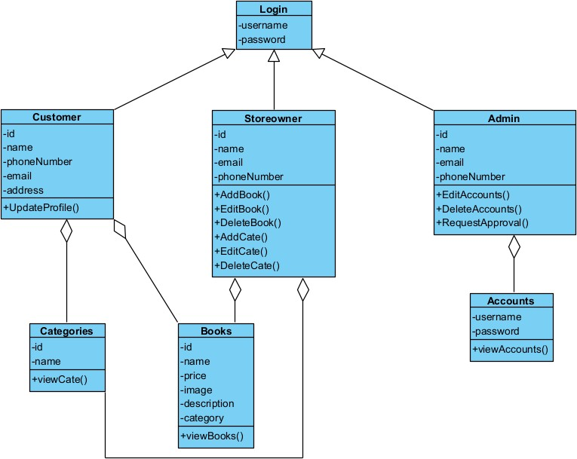

*Figure 8 Class Diagram*

In this Diagram, there are 7 classes. The Login class is used to access to each role including customer, store owner, and admin represent to Customer, Storeowner and Admin classes. For the Customer class, user have the following function: Update Profile, View all books, View all Category. The Customer class is associated to Books class and Categories class. For the Storeowner class, there are book management and category management functions including Add, Edit, Delete, View and send request to Admin. As an admin, user can manage customers and store owners account with functions Edit, Delete and View. An admin can also approve or reject request from store owners.

* 1. Activity Diagram

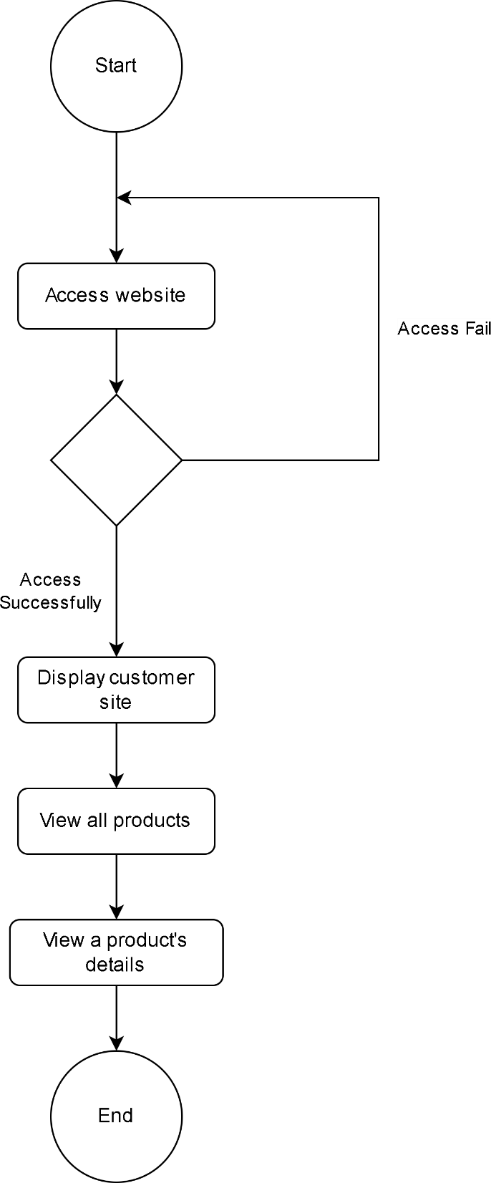

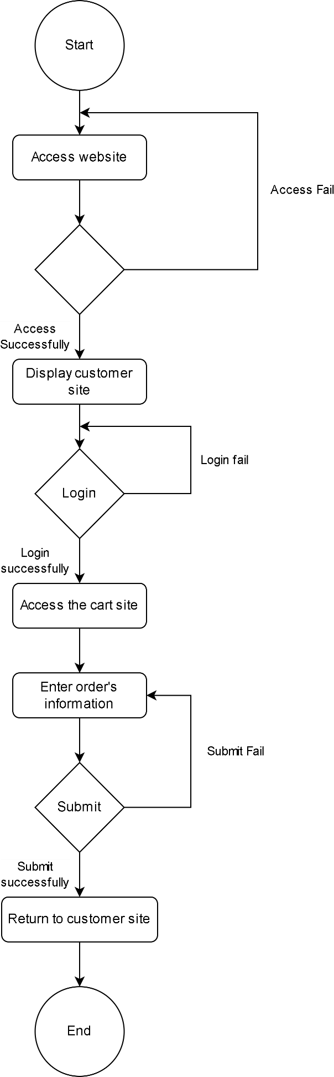

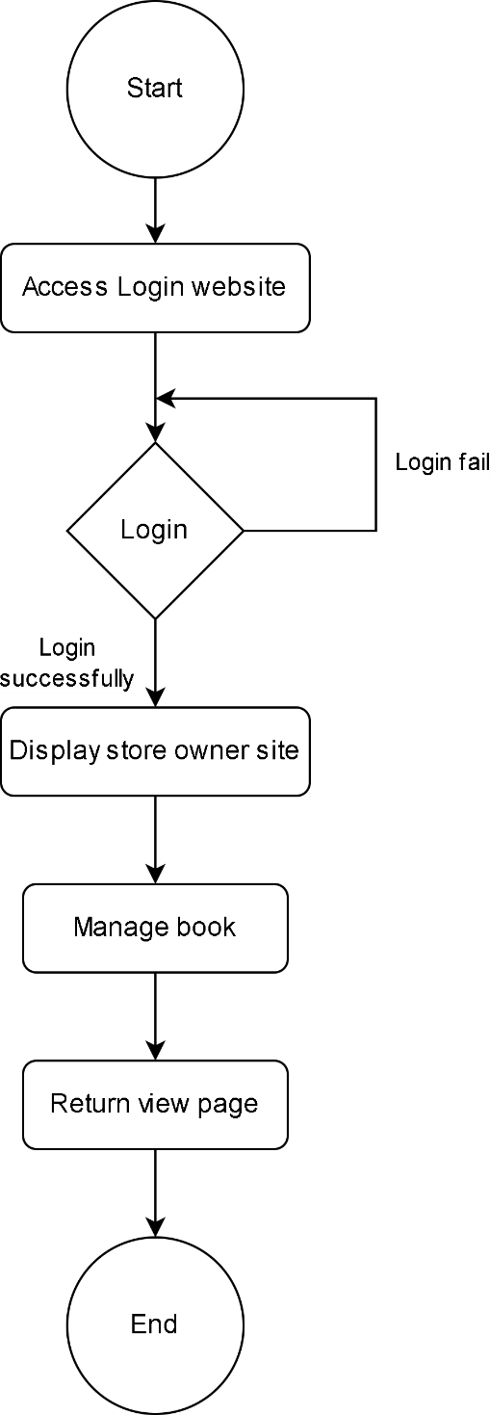

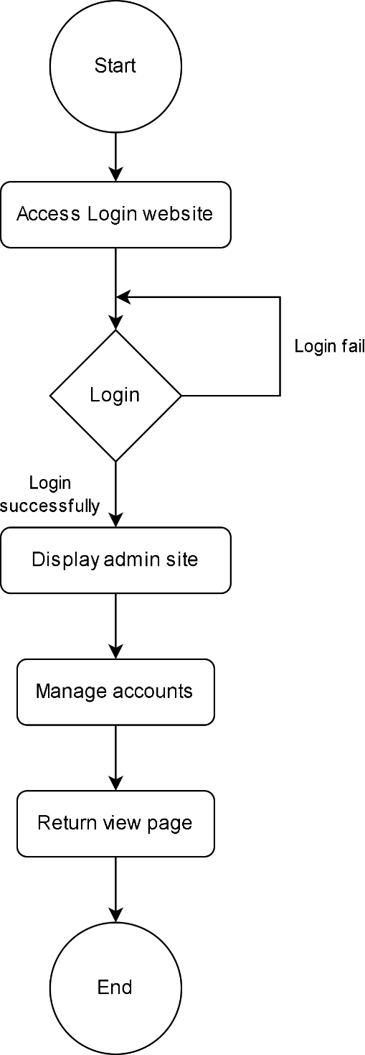

* 1. 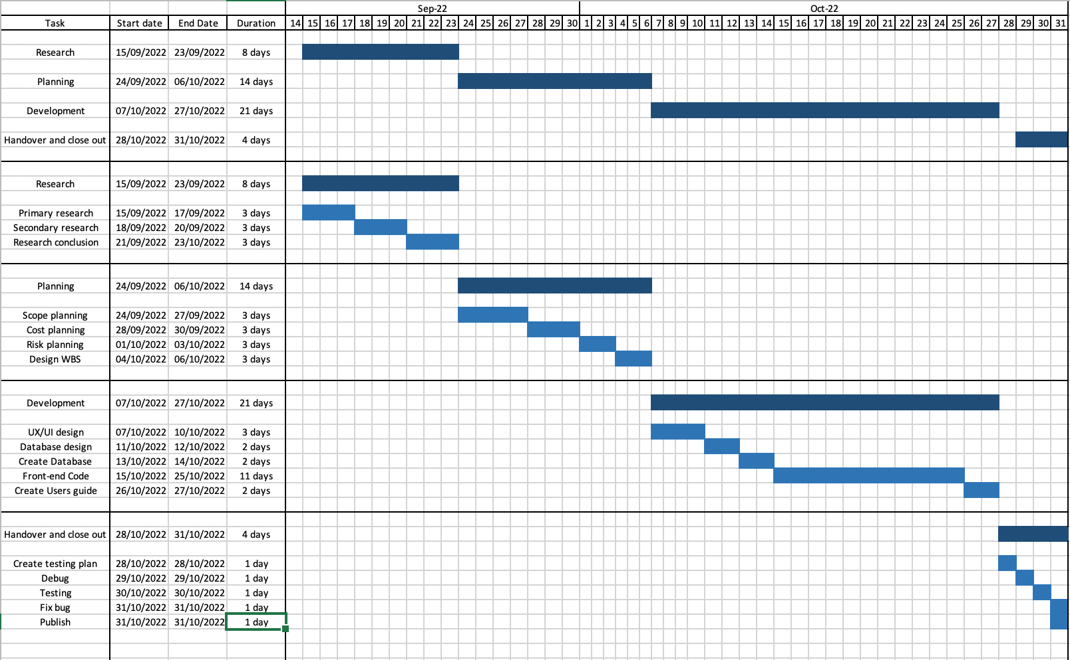Gantt Chart

## Risk Assessment

* 1. Risk Assessment

|  |  |  |  |  |  |  |  |  |  |  |
| --- | --- | --- | --- | --- | --- | --- | --- | --- | --- | --- |
| No | Pre-Mitigation | | | | Location | Mitigations / Warnings | Post-Mitigation | | | |
| Risk | Risk Severity | Risk  Likelihood | Risk  Level | Risk Severity | Risk  Likelihood | Risk Level | Acceptable  to proceed |
|  |  | -Acceptable  -Tolerable  -Undesirable  -Intolerable | -Improbable  -Possible  -Probable | -Low  -Medium  -High  -Extreme |  |  | -Acceptable  -Tolerable  -Undesirable  -Intolerable | -Improbable  -Possible  -Probable | -Low  -Medium  -High  -Extreme | Yes / No |
| 1 | Lack of HR | Acceptable | Possible | Medium | Project | Team members' assistance is necessary to complete difficult tasks and can enhance human  resources. | Acceptable | Probable | Low | Yes |
| 2 | Changing requirements | Undesirable | Possible | High | Project | Review customer requirements carefully and make any necessary changes right away to avoid delaying  the project. | Acceptable | Probable | Low | Yes |
| 3 | Delayed project complete time | Tolerable | Possible | Medium | Project | Reduce the time needed to complete the remaining tasks and improve team communication to identify and resolve  issues that are | Acceptable | Possible | Low | Yes |

|  |  |  |  |  |  |  |  |  |  |  |
| --- | --- | --- | --- | --- | --- | --- | --- | --- | --- | --- |
|  |  |  |  |  |  | causing the project to be delayed. |  |  |  |  |
| 4 | Natural disasters | Intolerable | Possible | Extreme | Project | Data backups are necessary, and disaster recovery plans should be in  place. | Undesirable | Possible | Extreme | No |
| 5 | Exceed budget | Tolerable | Possible | Medium | Project | More investors in the project are necessary, and the client must be informed of the cause for the  budget overrun. | Acceptable | Possible | Low | Yes |

# Task 2 – Technologies evaluation

## Design tools

* 1. UML design tool

### Visual Paradigm

Because it has several features and functionalities for various diagrams, visual paradigm is a tool for creating class diagrams and entity relationship diagrams; its only drawbacks are weight and complexity.



* 1. User interface design tool

### Draw.io

Draw.io is the best tool for designing user interfaces because it is free and simple to use. It also has a rich collection of predefined shapes for all kinds of different diagramming needs, can integrate with Google Drive, and easily exports to a variety of formats. However, there are some drawbacks as well, such as the fact that if I forget to save and download all of my drafts in several different formats before turning off my device, I will have unpleasant problems recovering my data.



* 1. Conclude which tools will be used for the design of the application

Each tool has advantages and disadvantages, but draw.io and the visual paradigm are particularly strong in the design class. I will use both tools in my project to capitalize on each one's advantages as they are each great in terms of user interface design and are lightweight and adaptable.

## Front End technology stack

* 1. Front End Programming Language

### JavaScript

The widely used programming language JavaScript enables users to add complex features to web sites. It can be activated whenever a page performs a dynamic action, such as displaying recurring changes to the content, animated two- and three-dimensional graphics, interactive maps, video boxes, and more.

Advantages:

* Server load: JavaScript, a client-side language, can dynamically lower server demands. Some applications may also run properly without a server.
* Rich interfaces: JavaScript can be used to create features like slider drag and drop operations. This can significantly enhance a website's user interface and user experience.
* Extended functionality: JavaScript developers can create JavaScript snippets for numerous third-party add-ons to extend the functionality of web pages.

Disadvantages:

* Client-side security: When JavaScript code is run on a user's computer, security issues frequently arise as a result of illicit activity. Due of this, many developers have JavaScript disabled.
* Browser support: Depending on how the browser interprets JavaScript, it may be read differently. As a result, some developers may find it difficult to write cross-browser code.

(Rawoof, 2022)

### React

Facebook created the programming language React to build quick and innovative web user interfaces. A superb choice for full stack development, it is now one of the most popular JavaScript frameworks for building web front ends. React is a computer language that may be used to build visual user interfaces and render data for browsers. Check out the main characteristics, benefits, and ease of front end web development with React below.

Advantages:

* React has a ton of documentation, online training materials, and tutorials, making it a simple language to learn and use. React is easy to comprehend for developers who are already familiar with JavaScript in a short amount of time.
* One of the main advantages of the React programming language is virtual DOM. Developers can improve the structure of an application to achieve the best performance when it is focused on user interactions and receives frequent data updates.

Disadvantages:

* Dynamic technology: ReactJS is a well-liked programming option, but it is also constantly evolving. The standard is raised for developers who must invest the time and effort necessary to understand new modifications.
* Poor documentation - Some developers find it difficult to keep up with the regular updates to the React documentation and tools with each upgrade. If the most recent documentation is unavailable for particular tools, updating oneself might be challenging and can cause problems with development.
  1. HTML/CSS

(Baranowski, 2021)

**Hypertext Markup Language**, or HTML, is a programming language used to create electronic texts known as pages that are displayed on websites. Each page has numerous hyperlinks or links to other pages.

Every web page on the Internet has been created using HTML in some capacity. Understanding how to display texts or carry out the loading of various elements is a must for browsers.

Advantages:

* The majority of developers consider HTML to be one of the simplest programming languages to learn and utilize. HTML is frequently taught to developers before any other language, and it is an essential component of all development courses. HTML is straightforward to learn since it uses basic tags, and case insensitivity is not a problem.
* HTML is free - Since HTML is a free language, programmers can use it without having to invest in any additional software. Users can access major aspects of the language without using any other plugins or software. This is why a large number of companies utilize HTML to meet their website design needs. Complete websites could be created in HTML.
* The majority of commonly used browsers accept HTML, which allows support for many browsers. So, if a website is created in HTML, there is no need to worry about browser compatibility. For the many browsers from which they can be loaded, HTML websites can be optimized.

Disadvantages:

* Not Enough for Dynamic Pages - Many of the capabilities that contemporary websites provide to their customers cannot be supported by using only basic HTML. HTML may make it challenging for developers to add dynamic information to web sites. They must master additional languages like JavaScript, PHP, or ASP.
* Limited for Content Presentation - HTML is also not the best option for visually appealing content display. The majority of developers are aware of this restriction. To make the content of HTML pages more aesthetically pleasing, they must rely on CSS, or Cascading Style Sheets. In some circumstances, it is necessary for web designers and developers to generate and maintain two distinct file sets.

(Agarwal, 2022)

**CSS** is a programming language used to specify the layout and presentation of documents provided to users. A document is typically a text file structure that makes use of a markup language, such as the popular HTML and others like XML or SVG. A document is transformed into a format that audiences may use using CSS. This is especially important for browsers like Chrome, Firefox, and Edge that are designed to graphically transmit content to screens, printers, and projectors.

Advantages:

* CSS saves time because only one CSS file needs to be created and can be applied to several HTML pages. Each HTML element has a defined style that a user can utilize to apply to other web pages as needed.
* Simple upkeep: CSS code is simple to upkeep, and users can easily modify the style globally. All web pages are automatically updated after modifications are made.
* Web standards are evolving; less and less people are using HTML attributes while more and more people are choosing to utilize CSS. It is advised that programmers utilize it across HTML pages to guarantee compatibility with upcoming browser updates.

Disadvantages:

* Cross-browser issues - For developers, changing the CSS on a website might be a simple operation. After the modifications have been made, however, it is important to maintain CSS compatibility since the user must verify that the changes are shown consistently across all browsers. It's crucial to test across browsers because CSS behaves differently in each one.
* Multiple levels cause confusion — The CSS programming language contains a number of levels, which some developers find confusing. These include the slightly differing CSS, CSS 2, and CSS 3 specifications.

(Agarwal, 2020)

* 1. JavaScript/Framework

### jQuery

A fast, lightweight, and feature-rich traditional JavaScript library is jQuery. At BarCamp NYC in 2006, John Resig constructed it. With a license from MIT, jQuery is free and open-source software.

Benefits:

* It employs CSS3 selectors to detect and manipulate style properties, and it offers a simple, straightforward API.
* jQuery supports an AMD module and is lightweight, requiring only 30 kb to gzip and minify.
* Since its syntax is relatively close to CSS's, learning it is simple for beginners.
* Plugins allow for extension.
* Flexibility thanks to an API that works with several different browsers, including Chrome and Firefox.

(Roomi, 2022)

### ReactJS

React.js is an open-source front-end JavaScript library also referred to as ReactJS or React. Jordan Walke, a software engineer for Facebook, developed it in 2013.

Benefits:

* With the use of a React DOM library, components or entities in the React code must be rendered to a particular element in the DOM.
* By building an in-memory cache in a data structure, calculating the difference, and quickly updating the display DOM in the browser, it makes use of a virtual DOM.
* The efficiency of the program improves as a result of this selective rendering, saving the developers' time from having to recalculate the page layout, CSS styles, and full-page rendering.
* To enable code execution at particular times throughout an entity's lifetime, it makes use of lifecycle methods like render and componentDidMount.
* It supports JavaScript XML (JSX), a JS and HTML hybrid. With nested elements, attributes, JS expressions, and conditional statements, it aids in component rendering.
  1. CSS Framework

### Bootstrap

Over the course of the past ten years, Bootstrap has been steadily developed. It was initially created by Twitter developers but has now developed into a popular Open Source CSS framework. The integration of HTML, CSS, SASS, and JavaScript is the main focus.

Benefits:

* Horizontal and vertical layouts
* Powered by SASS
* Properly documented

### Tailwind CSS

Tailwind as a low-level, utility-first, and robust option, CSS is a very popular CSS framework and is quickly rising to the top of the list. The framework itself can serve as the basis for your whole design and user interface (UI).

Benefits:

* No set style or concept to adhere to
* Just CSS classes, no imposed structure or templating
* If you choose to use it, there is a built-in UI and element library.

2.4 Conclude which Front End technologies will be used for the development

I'll program the front end of my website using html, css, javascript, and bootstrap based on the programming languages, frameworks, and advantages I outlined above.

## Back End technology stack

* 1. Back End Programming Language

### PHP

PHP is a veteran player in the world of web development. This open-source server-side scripting language was created in 1994 and is used specifically for web development. Since it is an interpreted language - it also requires no compiler and it can also run on almost any major operating system like Windows, Linux, macOS, Unix, etc. Talking about the rich features of PHP, there are many such as ease of learning, cross-platform compatibility, OOP features, support for various standard databases like MySQL, SQLite, etc., huge community support, and many other facilities. Also, PHP is very secure as a server-side scripting language because there are a lot of hash functions available in PHP to encrypt users' data.

Especially if you are a beginner - you can choose to use PHP for backend web development.

### Java

Java is another exemplary programming language for backend web development. Object-oriented programming language is widely used to develop enterprise-scale web applications along with the development of android applications, desktop applications, scientific applications, etc. The main advantage of using Java is that it works on the principle of Write Once Run Anywhere, i.e., compiled Java code can be executed on any platform that supports Java without recompiling. . To be more specific, Java code is first compiled into machine-independent bytecode and then this bytecode runs on JVM regardless of the underlying architecture. Besides, Java supports multithreading which allows the simultaneous execution of two or more threads for maximum CPU usage. Other additional features of Java are - platform independence, following OOP concepts, rich open-source libraries, automatic memory allocation & garbage collection, portability, etc.

### C#

C# is one of the few languages that has consistently ranked in the top 5 programming languages in various benchmarks over the past few years. You should know though, that this general-purpose language was originally developed by Microsoft primarily for the .Net framework. Along with backend web development, now C# is being widely used in many fields like Windows application development, game development, etc. & structured languages, and many more. In addition, C# provides a rich set of libraries to help developers have a faster and more efficient development process. Therefore, if you are looking for a programming language for a backend web developer - you can also try C#.

* 1. Operating System

### Window

Windows is an operating system designed by Microsoft. The operating system is what allows you to use the computer. Windows comes pre-installed on most new personal computers (PCs), making it the most popular operating system in the world. Windows makes it possible for you to get all kinds of everyday tasks done on your computer. For example, you can use Windows to browse the Internet, check email, edit digital photos, listen to music, play games, and more.

### Mac OS

Mac OS is the operating system that powers every Mac. It allows you to do things that you simply cannot do with other computers. That's because it's specifically designed for the hardware it runs on - and conversely, macOS comes with a whole suite of beautifully designed apps. It works in conjunction with iCloud to keep your photos, documents, and more up to date across all of your devices. It makes your Mac work like magic with your iPhone and other Apple devices. And it was built from the ground up with privacy and security in mind.

* 1. Web Server

A web server is software and hardware that uses HTTP (Hypertext Transfer Protocol) and other protocols to respond to client requests made over the World Wide Web. The main job of a web server is to display website content through storing, processing, and delivering the web page to users. Besides HTTP, web servers also support SMTP (Simple Mail Transfer Protocol) and FTP (File Transfer Protocol), which are used for emailing, file transfer, and storage.

### Apache HTTP Server

Developed by the Apache Software Foundation, it is a free and open-source web server for Windows, Mac OS X, Unix, Linux, Solaris, and other operating systems; it needs an Apache license.

### Microsoft Internet Information Services (IIS)

It was created by Microsoft for Microsoft platforms; while being extensively used, it is not open sourced.

### Nginx

A well-liked open-source web server among administrators due to its scalability and little resource consumption. Its event-driven architecture enables it to support numerous concurrent sessions. Nginx can also be used as a load balancer and proxy server.

* 1. Database

A database is a planned grouping of material that has been arranged and is often kept electronically in a computer system. A database management system often oversees a database (DBMS). The term "database system," which is frequently abbreviated to "database," refers to the combination of the data, the DBMS, and the applications that are connected to it.

### MySql

One of the most well-known technologies in the current big data ecosystem is MySQL. Given that MySQL is sometimes referred to as the most popular database and is currently being used widely and successfully across all industries, it is obvious that anyone working with enterprise data or general IT should at the very least strive to become something familiar with MySQL.

### SQL Server

SQL Server is a relational database management system, or RDBMS, developed and marketed by Microsoft. Similar to other RDBMS software, SQL Server is built on top of SQL, a standard programming language for interacting with relational databases. SQL Server is linked to Transact-SQL or T-SQL, Microsoft's implementation of SQL that adds a set of proprietary programming constructs. SQL Server has operated exclusively on Windows environments for over 20 years. In 2016, Microsoft made it

available on Linux. SQL Server 2017 is generally available October 2016, running on both Windows and Linux.

* 1. Host

Hosting, in its most general sense, is a service through which computing and storage resources are provided to an individual or organization to host and maintain one or more websites and related services. mandarin. While hosting does not need to be IP-based, most of the cases are web-based services that allow a website or web service to be globally accessible from the Internet. Hosting is also known as web hosting or website hosting.

### Firebase

Firebase Hosting is a fully managed hosting for static and dynamic content as well as microservices. The service is supported by SSD storage and a global CDN (content delivery network). Unconfigured SSL is built into Firebase Storage, so content is always delivered securely.

### Azure

Azure is a cloud computing platform and an online portal that allows you to access and manage cloud resources and services provided by Microsoft. These services and resources include the storage and transformation of your data, depending on your requirements.

### AWS

AWS (Amazon Web Services) is an evolving, comprehensive cloud computing platform provided by Amazon that includes a combination of infrastructure as a service (IaaS), platform as a service ( PaaS) and packaged software as a service-a-service (SaaS). AWS services can provide tools to organizations such as compute power, database storage, and content delivery services.

* 1. Frameworks

### Laravel

A web application framework with expressive and beautiful syntax is called Laravel. We've already set the groundwork in place, allowing you to focus on creating instead of worrying about minutiae.

### ASP.NET Core

ASP.NET Core is a new open-source and cross-platform framework for building modern cloud-based internet-connected applications, such as web applications, IoT applications, and mobile backends.

ASP.NET Core applications can run on .NET Core or on the full .NET Framework. It is architected to provide an optimized development framework for applications that are deployed in the cloud or run on- premises. It includes modular components at minimal cost, so you retain flexibility while building your solutions.

* 1. Conclude which Back End technologies will be used for the development

In this project, we will use asp.net core as the back-end programming language because it supports many operating systems like Windows, macOS, or Linux. It also has a powerful view engine Razor, high performance and we can host ASP.NET Core applications not only on IIS but can self-hosted or use an Nginx web server on Linux.

## Tools for source control management

* 1. Tools

### Google drive

With the help of Google Drive, you may save files in the cloud and access them from any computer, tablet, or smartphone.

Benefits:

* Works nicely with a variety of devices.
* It is inexpensive.
* Storage is made easier by its integration with drag and drop.

### GitHub

A platform for collaboration and version control is called GitHub. GitHub enables collaboration on projects between you and others.

GitHub essentials:

* Repository: A development project can be kept in a GitHub repository.
* GitHub branches are used to simultaneously work on various versions of a repository.
* Changes on GitHub are referred to as commits. A description that explains the rationale for a change is included with each commit.
* Requests for Pull The center of GitHub collaboration is pull requests. You can ask for your changes to be integrated (pulled in) with the master by submitting a pull request.

Git is a DevOps tool used for source code management. It is a free and open-source version control system used to handle small to very large projects efficiently. Git is used to tracking changes in source code, allowing multiple developers to work together during non-linear development. Linus Torvalds created Git in 2005 for the development of the Linux kernel.

Git Features:

* Free and Open Source Tracking History
* Support non-linear development
* Make a backup
* Can be expanded
* Collaboration support
* Branching is easier
* Distributed development
  1. Conclude which tools will be used for the development

Because of the advantages Git and GitHub have, we chose to use them in this project to manage our source code.

## Software Development Models

### Waterfall Model

The waterfall model is a classical model used in the system development life cycle to create a system with a linear and sequential approach. It is called a waterfall because of the pattern of systematic development from one stage to another in a downward fashion. The model is divided into different stages and the output of one stage is used as the input of the next stage. Every stage must be completed before the next stage begins and there is no overlap of stages.

* Feasibility study: The main goal of this phase is to determine if the software development is financially and technically feasible.
* Requirements Analysis and Specification: The purpose of the requirements specification and analysis phase is to understand the exact customer requirements and document those requirements appropriately.
* Design: The goal of this phase is to convert the requirements obtained in the SRS into a format that can be coded in a programming language. It includes high-level and detailed design as well as the overall software architecture. The software design document used to document all this effort (SDD)
* Coding and Unit testing: During the coding phase, the software design is translated into source code in any suitable programming language. So every designed module is coded. The purpose of unit testing phase is to check if each module is working properly or not.
* System Integration and Testing: Integration of different modules is done as soon as they are coded and unit tested. Integration of different modules is done step by step through several steps. In each integration step, previously planned modules are added to the partially integrated system and the resulting system is tested. Finally, after all, modules have been successfully integrated and tested, a fully working system is collected and system testing is performed on it.
* Maintenance: Maintenance is the most important phase of the software life cycle. The effort spent on maintenance is 60% of the total effort spent developing a full software.

Advantages of the classical waterfall model

* This model is very simple and easy to understand.
* The stages in this model are processed one by one.
* Each stage in the model is clearly defined.
* This model has milestones that are very clear and easy to understand.
* The process, actions and results are very well documented.
* Reinforce good habits: define before design, design before code.
* This model works well for smaller projects and projects where the requirements are well understood.

### Scrum Model

Scrum is a kind of Agile framework. It's a framework in which people can tackle complex issues of adaptability while being productive and creative in delivering the highest possible value. Scrum uses an iterative process.

* Sprint: Sprint is a period that lasts one month or less. A new Sprint begins immediately after the completion of the previous Sprint.
* Release: Once the product is completed it moves to the Release stage.
* Sprint Summary: If the product still has some unattainable features, it is tested in this phase and then the product is moved to the Sprint Improvement phase.
* Sprint Retrospective: During this phase, the quality or status of the product is checked.
* Product Backlog: According to the priority features the product is sorted by.
* Sprint Backlog: The Sprint Backlog is divided into two sections The Product Assigned Features for the Sprint and the Sprint Planning Meeting.

Advantages of using the Scrum framework

* Scrum framework moves fast and is money efficient.
* The Scrum framework works by breaking the big product into small sub-products. It's like a divide- and-conquer strategy
* In Scrum, customer satisfaction is very important.
* Scrum is adaptive in nature because it has a short sprint time.
* Since the Scrum framework relies on continuous feedback, the product quality increases with less quantity
* of time

Disadvantages of using the Scrum framework:

* Scrum framework does not allow them to change their sprint.
* The Scrum framework is not a fully described model. If you want to apply it, you need to fill the box with your own details like Extreme Programming (XP), Kanban, and DSDM.
* Scrum can be difficult to plan, structure, and organize a project without a clear definition.
* Daily Scrum meetings and regular reviews require significant resources.

### V-Model

V-model is a type of SDLC model in which the process executes sequentially in a V-shape. It is also known as Verification and Validation model. It is based on the association of a test phase for each respective development phase. The development of each step is directly linked to the testing phase. The next phase starts only after the completion of the previous one, i.e. for each development activity there is a corresponding test activity.

* Requirements Analysis: This phase includes detailed communication with the customer to understand their requirements and expectations. This phase is called Claims Collection.
* System Design: This phase includes system design and complete hardware and communication setup for product development.
* Architectural Design: System design is further broken down into modules that take on different functions. Data transfer and communication between internal and external modules world (other systems) is clearly understood.
* Modular design: In this phase, the system breaks down into small modules. Detailed design of specified modules, also known as Low Level Design (LLD).
* Unit Testing: Unit test plans are developed during the module design phase. These Unit Test Plans are made to eliminate bugs at the code or unit level.
* Integration Testing: After completion of unit testing Integration testing is done. In integration testing, modules are integrated and the system is tested. Integration testing is done during the Architecture design phase. This test verifies the communication of the modules between them.
* System Testing: System testing tests the complete application with its functionality, interdependencies and communication. It checks the functional and non-functional requirements of the developed application.
* User Acceptance Testing (UAT): UAT is performed in a user environment similar to a production environment. UAT verifies that the delivered system meets the user's requirements and that the system is ready for real-world use.

Advantages

* This is a highly disciplined pattern and the stages are completed one at a time.
* V-Model is used for small projects where the project requirements are clear.
* Simple and easy to understand and use.
* This model focuses on verification and validation activities early in the life cycle thus enhancing
* the probability of building a product that is error-free and of good quality.
* It allows project managers to track progress accurately. Disadvantages
* High risk and uncertainty.
* It's not good for complex and object-oriented projects.
* It is not suitable for projects where the requirements are unclear and there is a high risk of change.
* This model does not support repeating stages.
* It doesn't easily handle concurrent events.

Each model has its own pros and cons and in this case, I decided to use the Waterfall Model because it is very simple but ideal and each stage in the waterfall model can only begin after completion. to the previous stage, which means it cannot be duplicated.

# References

Agarwal, P., 2020. *Advantages and Disadvantages of CSS.* [Online]

Available at: https://[www.geeksforgeeks.org/advantages-and-disadvantages-of-css/](http://www.geeksforgeeks.org/advantages-and-disadvantages-of-css/) [Accessed 25 October 2022].

Agarwal, P., 2022. *Advantages and Disadvantages of HTML.* [Online]

Available at: https://[www.geeksforgeeks.org/advantages-and-disadvanatges-of-html/](http://www.geeksforgeeks.org/advantages-and-disadvanatges-of-html/) [Accessed 25 October 2022].

Baranowski, W., 2021. *React JS: Advantages and Disadvantages.* [Online] Available at: https://massivepixel.io/blog/react-advantages-disadvantages/ [Accessed 25 October 2022].

Charles Lane and Nico Krüger, 2021. [Online]

Available at: https://[www.perforce.com/blog/alm/how-write-software-requirements-specification-srs-](http://www.perforce.com/blog/alm/how-write-software-requirements-specification-srs-) document

[Accessed 10 October 2022].

Rawoof, A., 2022. *Advantages and Disadvantages of JavaScript - Tutorialspoint.* [Online] Available at: https://[www.tutorialspoint.com/advantages-and-disadvantages-of-javascript](http://www.tutorialspoint.com/advantages-and-disadvantages-of-javascript) [Accessed 25 October 2022].

Roomi, M., 2022. *6 Advantages and Disadvantages of jQuery | Drawbacks & Benefits of jQuery.* [Online] Available at: https://[www.hitechwhizz.com/2022/07/6-advantages-and-disadvantages-drawbacks-](http://www.hitechwhizz.com/2022/07/6-advantages-and-disadvantages-drawbacks-) benefits-of-jquery.html

[Accessed 25 October 2022].

Rosencrance, L., 2020. [Online]

Available at: https://[www.techtarget.com/searchsoftwarequality/definition/software-requirements-](http://www.techtarget.com/searchsoftwarequality/definition/software-requirements-) specification

[Accessed 10 October 2022].