document

目录

MD Converter Sample Document
Table of Contents
Document Metadata
Headings
Heading Level 1
Heading Level 2
Heading Level 3
Text Formatting
Basic Formatting
Combined Formatting
Strikethrough
Underline
Lists
Unordered Lists
Ordered Lists
Mixed Lists
Task Lists
Tables
Simple Table
Table with Alignment
Table with Formatting
Table with Mixed Content
Code Blocks
Python Code
JavaScript Code
HTML Code
SQL Code
Blockquotes
Simple Blockquote
Nested Blockquotes
Blockquote with Formatting
Blockquote with List
Blockquote with Code Block
Links
External Links
Internal Links (Anchor Links)
Links with Formatting
Reference Links
Images
Simple Image
Image with Caption
Image with Link
Horizontal Rules
ASCII Diagrams
Simple Box Diagram
Flowchart
Database Schema Diagram
System Architecture Diagram
Component Interaction Diagram
Complex Nested Structures
Nested Lists with Formatting
Nested Tables in Lists
List Inside Table
Complex Blockquote with Everything
Quote Heading
Sub-quote Heading
Edge Cases
Empty Elements
Whitespace and Line Breaks
Unicode and Special Characters
Escaped Characters
HTML Entities
Long Text Wrapping
Conclusion

MD Converter Sample Document
Version: 1.0.0
Date: 2024-01-15
Author: MD Converter Team

Table of Contents
• Document Metadata
• Headings
• Text Formatting
• Lists
• Tables
• Code Blocks
• Blockquotes
• Links
• Images
• Horizontal Rules
• ASCII Diagrams
• Complex Nested Structures
• Edge Cases

Document Metadata
---
title: MD Converter Sample Document
author: MD Converter Team
date: 2024-01-15
tags: [sample, test, markdown, converter, documentation]
version: 1.0.0
status: draft
---

Headings

Heading Level 1
The main document title.

Heading Level 2
Major section heading.

Heading Level 3
Subsection heading.

Heading Level 4
Detailed subsection heading.

Heading Level 5
Minor heading.

Heading Level 6
Smallest heading.

Text Formatting

Basic Formatting
This is bold text and this is italic text.
This is bold and italic text.
This is inline code text.

Combined Formatting
• Bold with italic inside
• Italic with bold inside
• Bold with code inside
• Italic with code inside

Strikethrough
This text is crossed out (if supported).

Underline
<u>This text is underlined</u> (if supported).

Lists

Unordered Lists

Basic Unordered List
• First item
• Second item
• Third item

Nested Unordered List
• Level 1 item
◦ Level 2 item
▪ Level 3 item
▫ Level 4 item
◦ Another level 2 item
• Back to level 1

Unordered List with Formatting
• Bold list item
• Italic list item
• Code list item
• Bold and italic list item

Ordered Lists

Basic Ordered List
1. First item
2. Second item
3. Third item

Nested Ordered List
1. Level 1 item
1. Level 2 item
1. Level 3 item
1. Level 4 item
2. Another level 2 item
2. Back to level 1

Ordered List with Start Attribute
1. Item one
2. Item two
3. Item three

Mixed Lists
1. First level 1 item
◦ Sub-item 1.1
◦ Sub-item 1.2
2. Second level 1 item
1. Sub-item 2.1
2. Sub-item 2.2
3. Third level 1 item

Task Lists
• [x] Completed task
• [x] Another completed task
• [ ] Pending task
• [ ] Task with bold text
• [x] Task with italic text

Tables

Simple Table
Header 1 | Header 2 | Header 3
Cell 1.1 | Cell 1.2 | Cell 1.3
Cell 2.1 | Cell 2.2 | Cell 2.3
Cell 3.1 | Cell 3.2 | Cell 3.3

Table with Alignment
Left Align | Center Align | Right Align
Left 1 | Center 1 | Right 1
Left 2 | Center 2 | Right 2
Left 3 | Center 3 | Right 3

Table with Formatting
Bold Header | Italic Header | Code Header
Bold Cell | Italic Cell | Code Cell
Italic Cell | Bold Cell | Code Cell
Code Cell | Code Cell | Bold Cell

Table with Mixed Content
Feature | Description | Example | Status
Bold | Makes text bold | **text** | ✅
Italic | Makes text italic | *text* | ✅
Code | Inline code | `code` | ✅
Link | Creates a link | [text](url) | ✅
Image | Inserts an image | ![alt](url) | ✅

Code Blocks

Python Code
#!/usr/bin/env python3
"""
Fibonacci sequence generator with caching.
"""
from functools import lru_cache
@lru_cache(maxsize=128)
def fibonacci(n: int) -> int:
"""
Calculate the nth Fibonacci number.
Args:
n: The position in the Fibonacci sequence.
Returns:
The nth Fibonacci number.
"""
if n < 2:
return n
return fibonacci(n - 1) + fibonacci(n - 2)
def generate_sequence(n: int) -> list:
"""Generate Fibonacci sequence up to n."""
return [fibonacci(i) for i in range(n)]
if __name__ == "__main__":
print(generate_sequence(10))

JavaScript Code
/**
* Fibonacci sequence generator
* @param {number} n - The position in the sequence
* @returns {number} The nth Fibonacci number
*/
function fibonacci(n) {
if (n < 2) return n;
return fibonacci(n - 1) + fibonacci(n - 2);
}
/**
* Generate Fibonacci sequence
* @param {number} n - Number of terms
* @returns {number[]} Fibonacci sequence
*/
function generateSequence(n) {
const result = [];
for (let i = 0; i < n; i++) {
result.push(fibonacci(i));
}
return result;
}
console.log(generateSequence(10));

HTML Code
<!DOCTYPE html>
<html lang="en">
<head>
<meta charset="UTF-8">
<meta name="viewport" content="width=device-width, initial-scale=1.0">
<title>Fibonacci Calculator</title>
<style>
body { font-family: Arial, sans-serif; margin: 40px; }
.container { max-width: 600px; margin: 0 auto; }
.result { font-weight: bold; color: #2F5496; }
</style>
</head>
<body>
<div class="container">
<h1>Fibonacci Calculator</h1>
<p>Enter a number to calculate the Fibonacci sequence:</p>
<input type="number" id="input" min="0" max="20">
<button onclick="calculate()">Calculate</button>
<div id="result" class="result"></div>
</div>
<script>
function calculate() {
const n = parseInt(document.getElementById('input').value);
// ... calculation logic
}
</script>
</body>
</html>

SQL Code
-- ============================================================
-- Fibonacci Sequence Generator (PostgreSQL)
-- ============================================================
CREATE OR REPLACE FUNCTION fibonacci(n INTEGER)
RETURNS INTEGER AS $$
DECLARE
a INTEGER := 0;
b INTEGER := 1;
c INTEGER := 0;
i INTEGER := 1;
BEGIN
IF n < 2 THEN
RETURN n;
END IF;
WHILE i < n LOOP
c := a + b;
a := b;
b := c;
i := i + 1;
END LOOP;
RETURN c;
END;
$$ LANGUAGE plpgsql;
-- Generate sequence
SELECT
generate_series(0, 10) AS n,
fibonacci(generate_series(0, 10)) AS fib;

Blockquotes

Simple Blockquote
This is a simple blockquote.
It can span multiple lines.
And include multiple paragraphs.

Nested Blockquotes
Level 1 quote
Level 2 quote
Level 3 quote
Level 4 quote

Blockquote with Formatting
This blockquote contains bold and italic text.
It also contains inline code and links.

Blockquote with List
Here's a list inside a blockquote:
• Item 1 with bold
• Item 2 with italic
• Item 3 with code
◦ Nested item 3.1
◦ Nested item 3.2

Blockquote with Code Block
Here's a code block inside a blockquote:
def hello():
print("Hello from inside a blockquote!")

Links

External Links
• GitHub
• Python Documentation
• Markdown Guide
• Stack Overflow

Internal Links (Anchor Links)
• Back to Top
• Headings
• Lists
• Tables

Links with Formatting
• Bold Link
• Italic Link
• Bold and Italic Link
• Code Link

Reference Links
This is a reference link.

Images

Simple Image

[Image: https://via.placeholder.com/150x150/2F5496/FFFFFF?text=MD]

Image with Caption

[Image: https://via.placeholder.com/300x100/2F5496/FFFFFF?text=MD+Converter]
Figure 1: MD Converter Logo

Image with Link

[Image: https://via.placeholder.com/200x80/2F5496/FFFFFF?text=MD+Converter]

Horizontal Rules

___

ASCII Diagrams

Simple Box Diagram

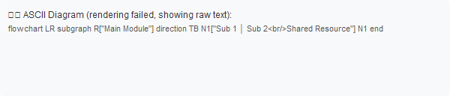

Flowchart

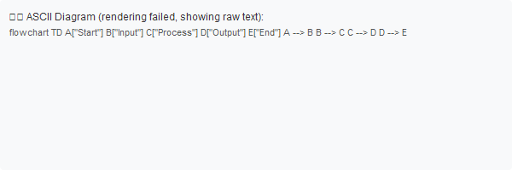

Database Schema Diagram

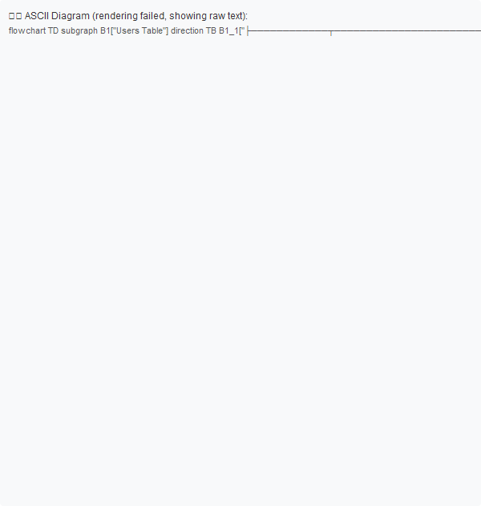

System Architecture Diagram
┌─────────────────────────────────────────────────────────────────┐
│ Web Application │
├─────────────────────────────────────────────────────────────────┤
│ │
│ ┌─────────────────────┐ ┌─────────────────────────────┐ │
│ │ Frontend │ │ Backend │ │
│ │ ┌───────────────┐ │ │ ┌───────────────────────┐ │ │
│ │ │ React.js │ │ │ │ Node.js / Express │ │ │
│ │ │ Redux │ │ │ │ REST API │ │ │
│ │ │ Tailwind │ │ │ │ WebSocket │ │ │
│ │ └───────────────┘ │ │ └───────────────────────┘ │ │
│ │ │ │ │ │
│ │ ┌───────────────┐ │ │ ┌───────────────────────┐ │ │
│ │ │ Mobile App │ │ │ │ Authentication │ │ │
│ │ │ React Native │ │ │ │ JWT / OAuth2 │ │ │
│ │ └───────────────┘ │ │ └───────────────────────┘ │ │
│ └─────────────────────┘ └─────────────────────────────┘ │
│ │
├─────────────────────────────────────────────────────────────────┤
│ │
│ ┌─────────────────────────────────────────────────────────┐ │
│ │ Database Layer │ │
│ │ ┌─────────────────┐ ┌─────────────────────────────┐ │ │
│ │ │ PostgreSQL │ │ Redis (Cache) │ │ │
│ │ │ - Users │ │ - Sessions │ │ │
│ │ │ - Orders │ │ - Rate Limiting │ │ │
│ │ │ - Products │ │ - Queues │ │ │
│ │ └─────────────────┘ └─────────────────────────────┘ │ │
│ └─────────────────────────────────────────────────────────┘ │
│ │
└─────────────────────────────────────────────────────────────────┘

Component Interaction Diagram

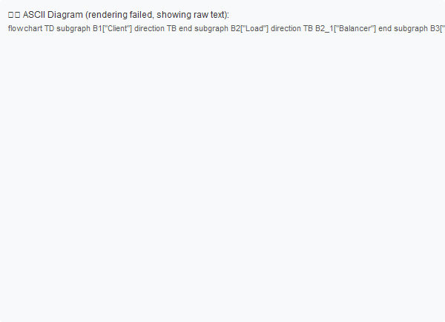

Complex Nested Structures

Nested Lists with Formatting
1. Level 1 Item 1
◦ Level 2 Item 1.1
▪ Level 3 Item 1.1.1
▫ Level 4 Item 1.1.1.1
▫ Level 5 Item 1.1.1.1.1
◦ Level 2 Item 1.2 with bold
2. Level 1 Item 2
◦ Level 2 Item 2.1 with italic
▪ Level 3 Item 2.1.1 with code
3. Level 1 Item 3 with bold and italic

Nested Tables in Lists
1. Level 1 item
◦ Level 2 item with table:
2. Level 1 item with another table:

List Inside Table
Column 1 | Column 2 | Column 3
Text 1 | List: | Text 3
 | - Item 1
 | - Item 2
 | - Item 3
Text 4 | Text 5 | Text 6

Complex Blockquote with Everything

Quote Heading
This is a blockquote that contains bold and italic text.

Sub-quote Heading
Nested blockquote with code and links.
• List item 1
• List item 2
◦ Nested list item 2.1
print("Hello from nested quote!")
Back to main quote level.

Edge Cases

Empty Elements
<!-- Empty paragraph above -->
<!-- Empty paragraph below -->

Whitespace and Line Breaks
This paragraph has multiple spaces.
This line has a trailing space after it.
This text
has a line break
in the middle.

Unicode and Special Characters

Mathematical Symbols
α β γ δ ε ζ η θ ι κ λ μ ν ξ ο π ρ σ τ υ φ χ ψ ω
Σ Π Ω Δ Θ Λ Ξ Ψ Φ Γ

Currency Symbols
$ € £ ¥ ₽ ₹ ₩ ₪ ₫ ₦ ₱ ₴ ₸

Punctuation
— – ― ‐ ‑ ‒ ‐
‘ ’ “ ” « » ‹ ›
© ® ™ ° ± × ÷

Emoji
🎉 🚀 💡 ⭐ 🔥 ✅ ❌ ⚠️ 📊 📝 📈 📉 💎 🏆 🎯

Language Characters
中文 日本語 한국어 Español Français Deutsch
Русский العربية हिन्दी ภาษาไทย

Escaped Characters
*This is not italic*
_This is not italic_
# Not a heading
- Not a list item
`Not code`

HTML Entities
& < > " ' © ® ™

Long Text Wrapping
Lorem ipsum dolor sit amet, consectetur adipiscing elit. Sed do eiusmod tempor incididunt ut labore et dolore magna aliqua. Ut enim ad minim veniam, quis nostrud exercitation ullamco laboris nisi ut aliquip ex ea commodo consequat. Duis aute irure dolor in reprehenderit in voluptate velit esse cillum dolore eu fugiat nulla pariatur. Excepteur sint occaecat cupidatat non proident, sunt in culpa qui officia deserunt mollit anim id est laborum.

Conclusion
This sample document demonstrates all the features supported by the MD Converter MVP:
Feature | Status | Notes
Headings | ✅ | Level 1-6 supported
Paragraphs | ✅ | Basic and formatted
Lists | ✅ | Ordered, unordered, nested, task
Tables | ✅ | Simple, aligned, formatted
Code Blocks | ✅ | Multiple languages
Inline Formatting | ✅ | Bold, italic, code
Links | ✅ | External, internal, formatted
Images | ✅ | Basic image support
Blockquotes | ✅ | Single, nested, with content
Horizontal Rules | ✅ | Multiple styles
ASCII Diagrams | ✅ | Converted to SVG
Nested Structures | ✅ | Complex nesting supported
Unicode | ✅ | International characters
Special Characters | ✅ | Proper escaping

End of Document

