Initial testing of the Z80 CPU.
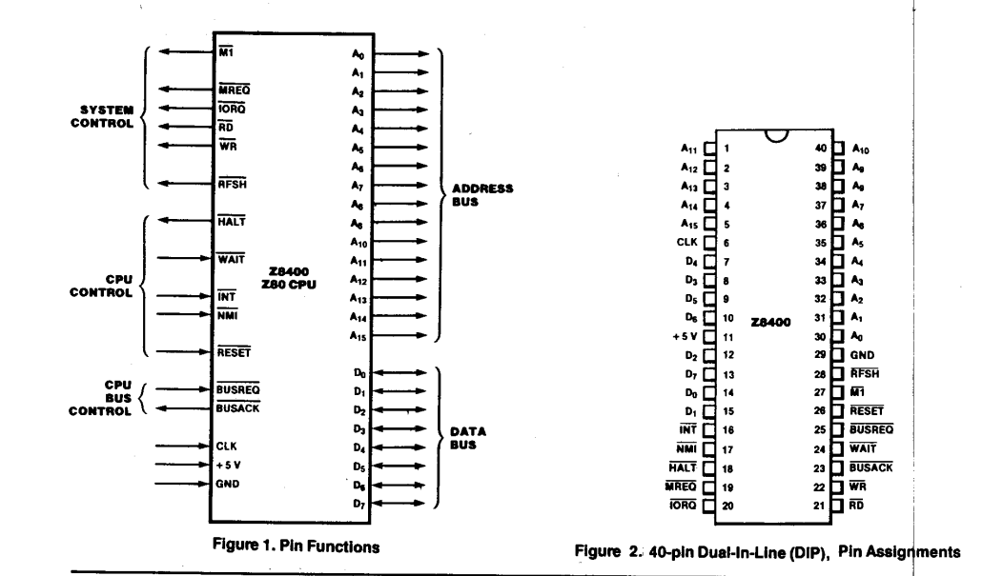
The task is to start power the processor and watch as it iterates through all the address 0x0000
to 0xFFFF. To do this few controls need to be pulled down to deactivate them.

INT, NMI, HALT, WAIT corresponding to pins 16,17,18 and 24 respectively.

