SHAP Interpretability Report
Member D: Explanation and Analysis of the GRU Model
1. Objective
This section aims to provide an interpretability analysis of the GRU model trained by Member C, with a particular focus on identifying which input variables contribute most to Bitcoin direction prediction. Compared with conventional performance metrics such as accuracy, F1 score, and AUC, SHAP analysis offers additional evidence on why the model produces a certain prediction, thereby strengthening the interpretability of the empirical results and improving the completeness of the final presentation.
2. Methodology
First, the saved model outputs and configuration files from Member C were used to recover the final modeling setup, including the selected eight input features, the sequence length (seq_len = 10), and the hidden dimension (hidden_size = 32). This ensures that the SHAP analysis remains fully consistent with the actual training configuration of the GRU model.
Second, the formal dataset processed/final_dataset_v2_plus.csv was adopted as the unified input source, and the preprocessing pipeline followed the same logic as the original training stage. The data were sorted chronologically, the prediction target was reconstructed based on the next-day close movement, and the StandardScaler was fitted only on the training subset before being applied to the full sample. The feature matrix was then transformed into rolling sequences of length 10 to match the GRU input structure.
On this basis, background samples and explained samples were drawn from the test-set sequences, and SHAP DeepExplainer was applied to estimate the marginal contribution of each feature. The final outputs include a summary plot, a dependence plot, and a feature-importance table based on mean absolute SHAP values, which jointly describe both the global interpretation pattern and the local effect of the most influential variable.
3. Feature Importance Overview
According to the ranking of mean absolute SHAP values, the three most influential variables in the current GRU model are active_addresses_change (mean |SHAP| = 0.0134), volume_change (mean |SHAP| = 0.0047), and ret_3d (mean |SHAP| = 0.0036). This result suggests that the model does not rely solely on price-based information. Instead, it is especially sensitive to on-chain activity dynamics, trading-volume changes, and short-term return signals. Among them, active_addresses_change stands out clearly as the dominant explanatory variable.
4. Analysis of the Summary Plot
The SHAP summary plot provides a global view of how each feature affects the model output. The horizontal axis represents the SHAP value, where positive values indicate that a feature pushes the prediction toward an upward movement, while negative values pull the prediction toward a downward movement. Features are ordered vertically by mean absolute SHAP value, so variables appearing higher in the figure have greater overall explanatory importance.
The plot shows that active_addresses_change is ranked first and exhibits the widest spread along the SHAP axis, indicating that it has the strongest influence on the GRU output. volume_change and ret_3d follow as the second and third most important variables, respectively, and both display visible explanatory ranges. By contrast, fees and fees_per_tx remain tightly clustered around zero, which implies that their marginal contributions are relatively limited in the current specification.
The color distribution also reveals how feature magnitude is associated with prediction direction. For active_addresses_change and volume_change, high feature values are more frequently located in the positive SHAP region, implying that larger increases in on-chain activity and trading volume tend to push the model toward an upward prediction. In comparison, ret_3d displays a more nonlinear pattern, suggesting that the model processes short-term return information in a state-dependent manner rather than through a simple monotonic rule.
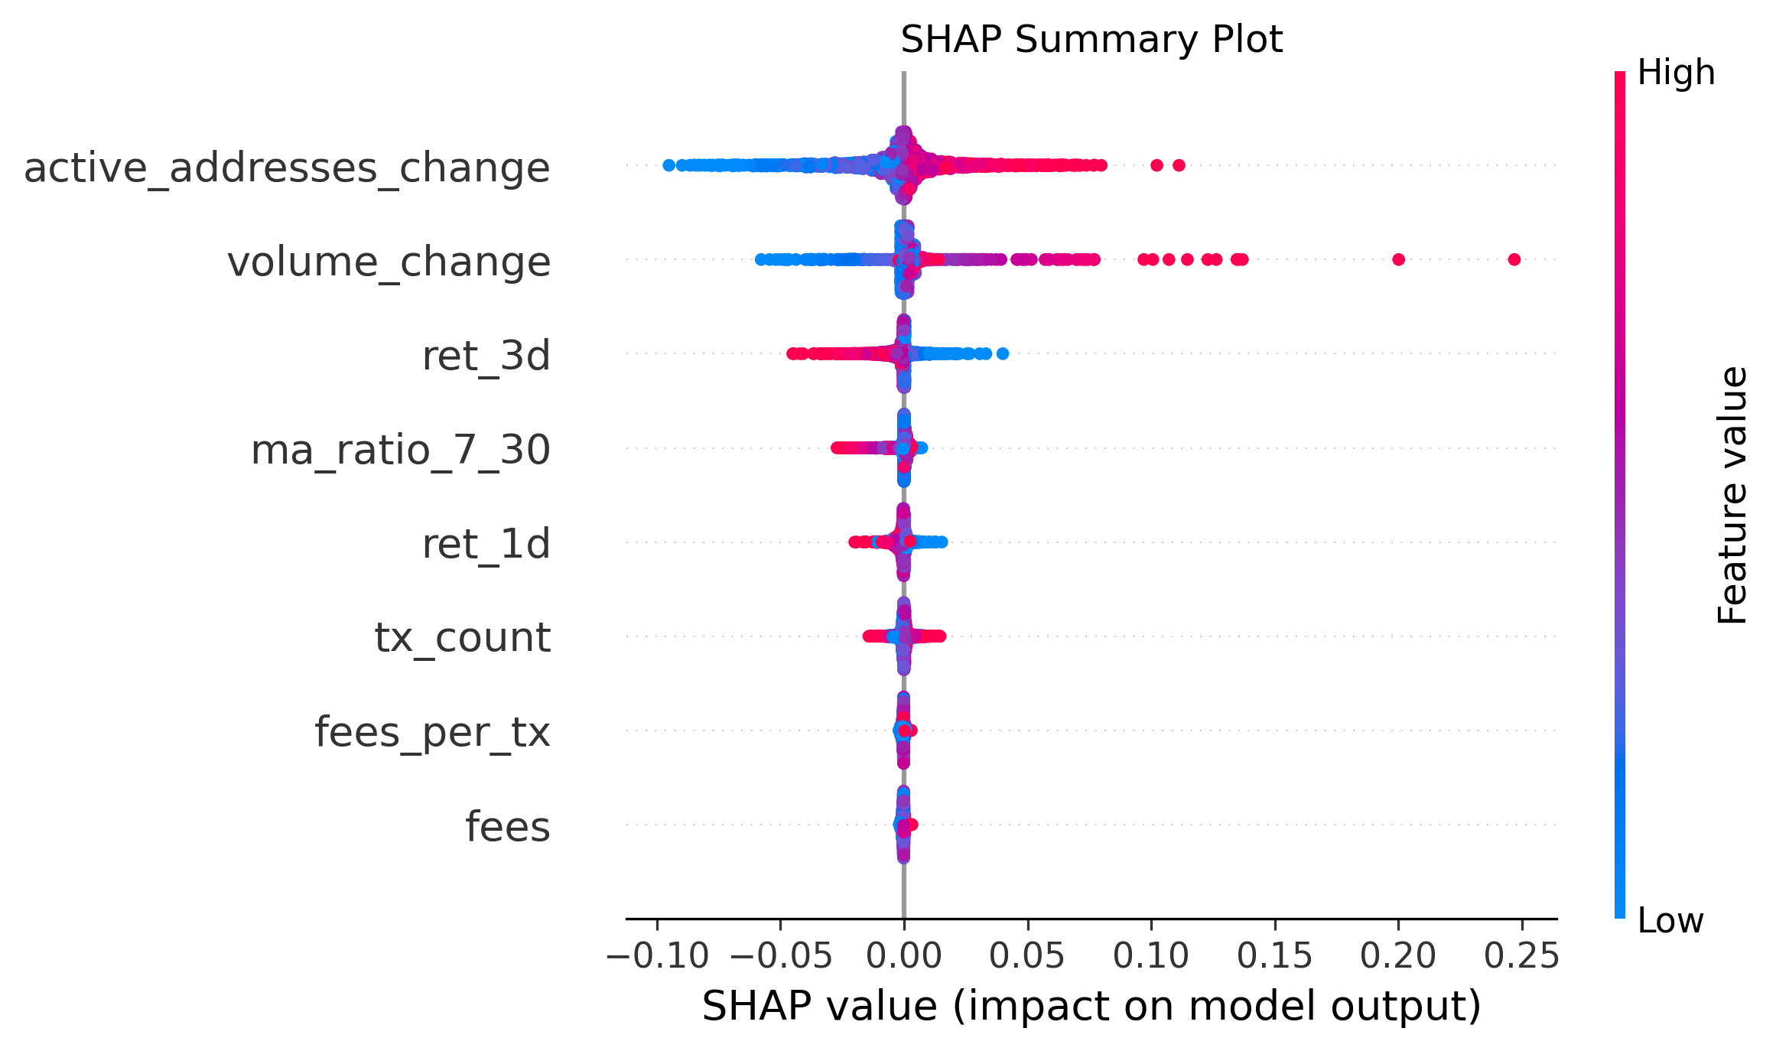
Figure 1. SHAP Summary Plot
5. Analysis of the Dependence Plot
The SHAP dependence plot focuses on active_addresses_change, the most influential variable identified in the global ranking. The horizontal axis shows the standardized feature value, the vertical axis reports the corresponding SHAP contribution, and the color scale represents the value of ret_1d. This figure therefore helps examine both the directional effect of the key variable and its potential interaction with another short-term market signal.
A clear positive relationship can be observed between active_addresses_change and its SHAP contribution. When the variable is relatively low, its SHAP values are mostly negative, indicating that the model is more likely to move toward a bearish prediction. As the variable increases, the SHAP values gradually become positive, which means that higher growth in active addresses tends to strengthen the model's expectation of upward price movement. This pattern implies that on-chain participation dynamics are an important signal in the GRU-based forecasting framework.
The fan-shaped spread of the points further suggests that the effect is not perfectly linear and may vary across market states. The color pattern does not show a strict separation, which indicates that ret_1d interacts with active_addresses_change to some extent, although it does not dominate the relationship entirely. For a sequence model such as GRU, this type of local explanation pattern is reasonable and supports the conclusion that active address dynamics play a central role in the model's decision process.
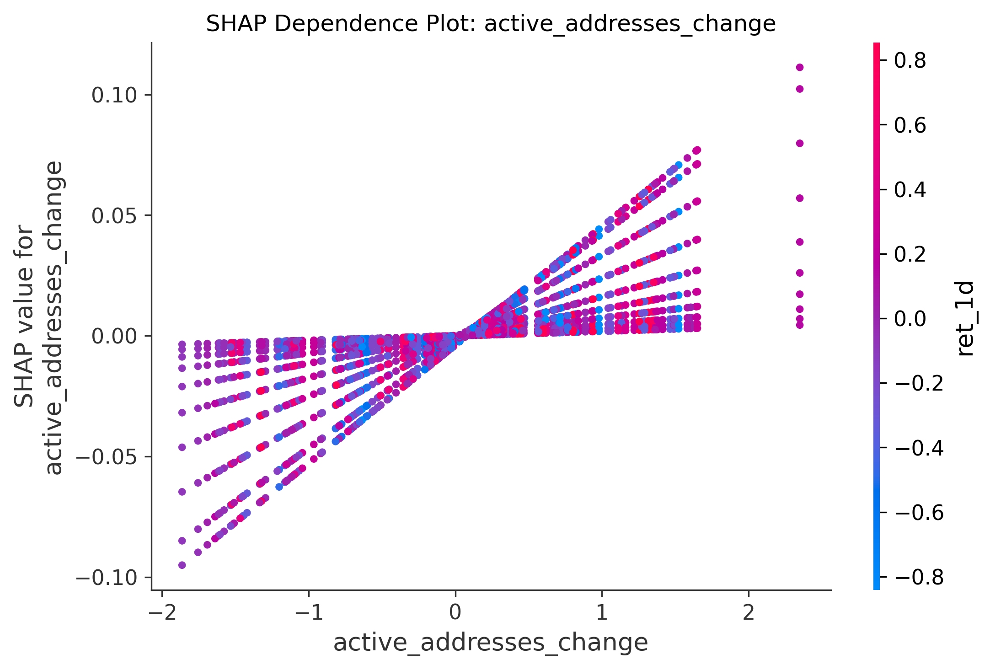
Figure 2. SHAP Dependence Plot of active_addresses_change
6. Conclusion
Overall, the SHAP results indicate that the current GRU model does not depend primarily on price levels alone. Instead, it places greater weight on a combination of on-chain activity, trading dynamics, and short-term market conditions. Among all candidate features, active_addresses_change consistently emerges as the most influential explanatory factor in both global and local analyses. Therefore, this SHAP-based interpretation not only complements the predictive performance metrics, but also provides empirical support for incorporating on-chain indicators into Bitcoin direction forecasting.

