- 财务困境、管理者激励与信息
既然存在债务的税盾效应，为什么企业没有大量举债？
When a firm has trouble meeting its debt obligations we say the firm is in financial distress.
在此，我们将探讨，由于市场缺陷的存在，公司的资本结构选择将如何影响财务困境成本，改变管理者的激励，以及向投资者传递了什么样的信息。上述资本结构决策的后果（consequences），将可能显著地抵消债务的税盾收益。换言之，考虑市场缺陷有助于我们理解所观察到的公司资本结构水平。而且，上述后果对于不同类型的企业的影响是不同的，因而这易于解释各行业的资本结构差异。
- 在完美市场中的违约和破产
Debt financing puts an obligation on a firm. A firm that fails to make the required interest or principal payments on the debt is in default. After the firm defaults, debt holders are given certain rights to the assets of the firm. In the extreme case, the debt holders take legal ownership of the firm’s assets through a process called bankruptcy.
在完美资本市场中，尽管企业因杠杆而引起违约风险，但MM定理仍然成立。
If it is a hit, revenues and profits will grow, and Armin will be worth $150 million at the end of the year. If it fails, Armin will be worth only $80 million. Armin Industries may employ one of two alternative capital structures: (1) It can use all-equity financing or (2) it can use debt that matures at the end of the year with a total of $100 million due. Let’s look at the consequences of these capital structure choices when the new product succeeds, and when it fails, in a setting of perfect capital markets.
设想的事件1：新产品成功
If the new product is successful, Armin is worth $150 million. Without leverage, equity holders own the full amount. With leverage, Armin must make the $100 million debt payment, and Armin’s equity holders will own the remaining $50 million.
但是，如果在年末公司没有$100 million现金的话，将会怎样？即使公司的资产，价值$150 million，但是其价值的主要部分取决（来自）于新产品的预期未来利润的资本化，价值并不是以银行里的现金形式存在。在这种情形下，如果公司有债务，是否会被迫违约？
With perfect capital markets, the answer is no.
As long as the value of the firm’s assets exceeds its liabilities, Armin will be able to repay the loan.
Even if it does not have the cash immediately available, it can raise the cash by obtaining a new loan or by issuing new shares.
For example, suppose Armin currently has 10 million shares outstanding. Because the value of its equity is $50 million, these shares are worth $5 per share.
At this price, Armin can raise $100 million by issuing 20 million new shares and use the proceeds to pay off the debt. After the debt is repaid, the firm’s equity is worth $150 million. Because there is now a total of 30 million shares, the share price remains $5 per share.
结论：
This scenario shows that if a firm has access to capital markets and can issue new securities at a fair price, then it need not default as long as the market value of its assets exceeds its liabilities. That is, whether default occurs depends on the relative values of the firm’s assets and liabilities, not on its cash flows.
Many firms experience years of negative cash flows yet remain solvent.
设想的事件2：新产品失败
If the new product fails, Armin is worth only $80 million. If the company has all-equity financing, equity holders will be unhappy but there is no immediate legal consequence for the firm.
In contrast, if Armin has $100 million in debt due, it will experience financial distress. The firm will be unable to make its $100 million debt payment and will have no choice except to default. In bankruptcy, debt holders will receive legal ownership of the firm’s assets, leaving Armin’s shareholders with nothing.
Because the assets the debt holders receive have a value of $80 million, they will suffer a loss of $20 million relative to the $100 million they were owed. Equity holders in a corporation have limited liability, so the debt holders cannot sue Armin’s shareholders for this $20 million—they must accept the loss.
Value of Debt and Equity with and without Leverage ($ million)
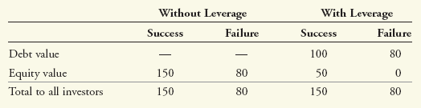
若产品失败，股东与债权人都遭遇损失，若无杠杆，则股东损失：Without leverage, if the product fails equity holders lose $150 million － $80 million ＝ $70 million. With leverage, equity holders lose $50 million, and debt holders lose $20 million, but the total loss is the same—$70 million.
Overall, if the new product fails, Armin’s investors are equally unhappy whether the firm is levered and declares bankruptcy or whether it is unlevered and the share price declines.
这一点非常重要。公司一宣布破产，往往成为头条消息。更多关注的是企业这一不如人意的结果以及带给投资者的损失. 但是价值的损失不是由于破产引起的：不管公司是否有杠杆，价值的减少都是一样的。也就是说，如果新产品失败，公司将遭遇经济困境（economic distress），不论企业是否会因为杠杆而导致财务困境，企业资产价值都将因为遭遇经济困境而显著减少。
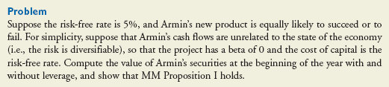
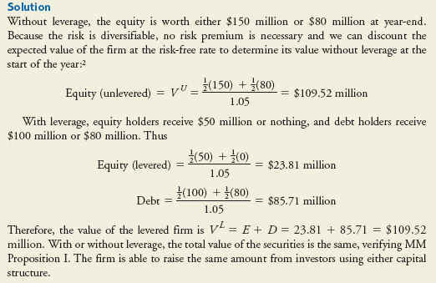
注：这与有杠杆股权的回报率大于无杠杆股权的回报率不同。
破产只是导致控制权转移而已。
- 破产成本与财务困境
With perfect capital markets, the risk of bankruptcy is not a disadvantage of debt—bankruptcy simply shifts the ownership of the firm from equity holders to debt holders without changing the total value available to all investors.
事实上，破产是一个长期而复杂的过程，它将给公司和投资者带来直接和间接的成本，而在完美资本市场假设下这些成本被忽略。
破产法：
liquidation，reorganization
破产的直接成本：
the process is still complex, time-consuming, and costly. When a corporation becomes financially distressed, outside professionals, such as legal and accounting experts, consultants, appraisers, auctioneers, and others with experience selling distressed assets, are generally hired. Investment bankers may also assist with a potential financial restructuring. These outside experts are costly.
其他的直接成本
破产的间接成本：
Loss of Customers，Loss of Suppliers，Loss of Employees，
Loss of Receivables，Fire Sales of Assets：救火式出售资产，低价，Costs to Creditors
- 财务困境成本与企业价值
Value of Debt and Equity with and without Leverage ($ million)
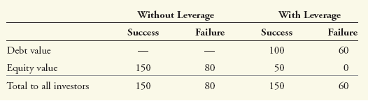
we assume debt holders receive only $60 million after accounting for the costs of financial distress
项目失败时，有杠杆情形下的企业价值要比无杠杆情形下的企业价值减少20（由于破产成本），价值不再守恒，MM定理不成立。
利用上表中的数据，计算下面例题：
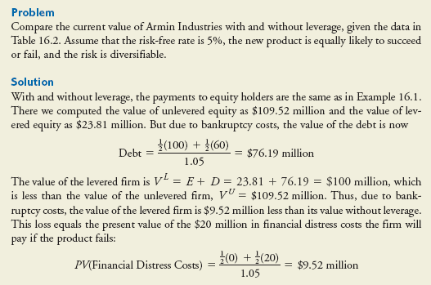
谁来支付财务困境成本？
The financial distress costs reduce the payments to the debt holders when the new product has failed. In that case, the equity holders have already lost their investment and have no further interest in the firm. It might seem as though these costs are irrelevant from the shareholders’ perspective. Why should equity holders care about costs borne by debt holders?
It is true that after a firm is in bankruptcy, equity holders care little about bankruptcy costs. But debt holders are not foolish—they recognize that when the firm defaults, they will not be able to get the full value of the assets. As a result, they will pay less for the debt initially. How much less? Precisely the amount they will ultimately give up—the present value of the bankruptcy costs. But if the debt holders pay less for the debt, there is less money available for the firm to pay dividends, repurchase shares, and make investments.
That is, this difference is money out of the equity holders’ pockets. This logic leads to the following general result:
When securities are fairly priced, the original shareholders of a firm pay the present value of the costs associated with bankruptcy and financial distress.

财务困境成本与股价
假如在年初，公司有10 million 流通股，没有债务。公司宣布发行面值为100 million的债务，并回购股票。数据如下表所示：
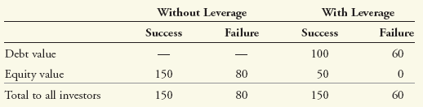
那么，回购后新的股价将为多少？此外，假如系统风险可以分散，无风险利率为5％，项目成功与失败的概率相等。
解答：
无杠杆时：
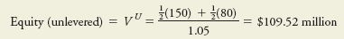
于是，初始股价为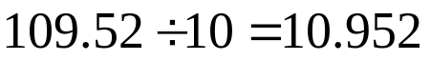；
有杠杆时：
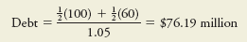
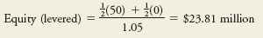
企业价值为：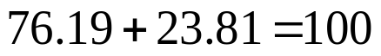
因为事先预测到企业价值的下降，于是，在宣布资本重整之时，股价将下降至10元每股。
- 验证上述结论：
由于破产成本，新发行的债务价值76.19，企业只能实际收到价值76.19的现金，尽管面值为100，给定股价为10，则回购的股票数量为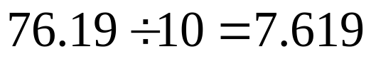，仍在流通的股票数量为2.381,由于股权价值为23.81,所以每股价格为：
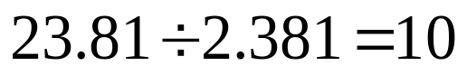，于是，资本重整使得每股股价降低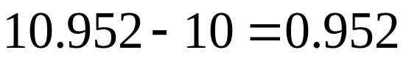，总额降低9.52,恰好为财务困境成本现值。
Thus, although debt holders bear these costs in the end, shareholders pay the present value of the costs of financial distress upfront.

- 最优资本结构：权衡理论
Two key qualitative factors determine the present value of financial distress costs: (1) the probability of financial distress and (2) the magnitude of the costs after a firm is in distress.
高科技公司有形资产少，人力资本密集，破产成本高；
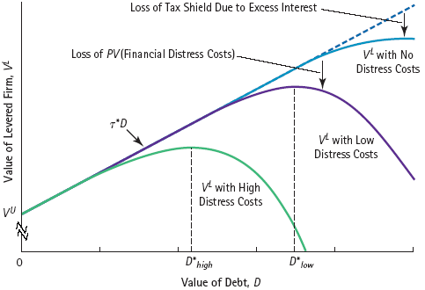
- 对债权人的剥削：杠杆的代理成本
In this section, we consider another way that capital structure can affect a firm’s cash flows: It can alter managers’ incentives and change their investment decisions. If these changes have a negative NPV, they will be costly for the firm.
In some circumstances, managers may take actions that benefit shareholders but harm the firm’s creditors and lower the total value of the firm.
- 过度投资
1 million 元贷款，年末到期，年末资产价值为90万元，将违约。
管理者目前在考虑一个新的战略，结果如下：

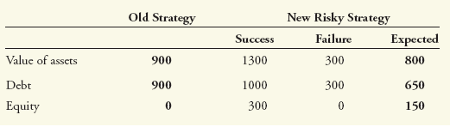
股东将从新战略中获利。
显然，新项目的总体期望支付为800，低于旧项目的总体期望支付900，降低了100。即使总的期望支付降低更多，股东也可能冒险。这是因为，股东却因为新的高风险项目而增加了支付150，债权人则因此损失了250。
债权人损失的250，包含了股东得到的150 ，以及项目风险加大带来的预期损失100。股东在运用债权人的钱赌博。
When a firm faces financial distress, shareholders can gain by making sufficiently risky investments, even if they have negative NPV.
This problem is also referred to as asset substitution: After issuing debt, equity holders have an incentive to substitute risky investments for safe ones. See Michael Jensen and William Meckling, “Theory of the Firm: Managerial Behavior, Agency Costs and Ownership Structure.”
This result leads to an over-investment problem: Shareholders have an incentive to invest in risky negative-NPV projects. But a negative-NPV project destroys value for the firm overall. Anticipating this bad behavior, security holders will pay less for the firm initially. This cost is likely to be highest for firms that can easily increase the risk of their investments.
- 投资不足
Suppose Baxter does not pursue the risky strategy. Instead, the firm’s managers consider an attractive investment opportunity that requires an initial investment of $100,000 and will generate a risk-free return of 50%. That is, it has the following cash flows (in thousands of dollars):
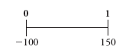
If the current risk-free rate is 5%, this investment clearly has a positive NPV. The only problem is that Baxter does not have the cash on hand to make the investment.
Could Baxter raise the $100,000 by issuing new equity? Unfortunately, it cannot. Suppose equity holders were to contribute the $100,000 in new capital required. Their payoff at the end of the year is shown in Table below:
Outcomes for Baxter’s Debt and Equity with and without the New Project ($ thousand)
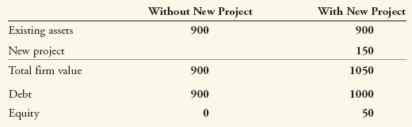
Thus, if equity holders contribute $100,000 to fund the project, they get back only $50,000. The other $100,000 from the project goes to the debt holders, whose payoff increases from $900,000 to $1 million. Because the debt holders receive most of the benefit, this project is a negative-NPV investment opportunity for equity holders($50,000- $100,000=-50,000), even though it offers a positive NPV for the firm(150-100=50).
结论：
When a firm faces financial distress, it may choose not to finance new, positive-NPV projects.
这一债务成本，有时被迈尔斯称作：债务悬挂（Debt Overhang）。
an under-investment problem: Shareholders choose to not invest in a positive-NPV project. This failure to invest is costly for debt holders and for the overall value of the firm, because it is giving up the NPV of the missed opportunities. The cost is highest for firms that are likely to have profitable future growth opportunities requiring large investments.

财务困境企业的出售资产行为（即使导致企业未来价值下降也不惜）：
因为股东认为在财务困境下，价值下降的成本由债权人承担。
接前面的例子，假如公司在年初有一台设备可以25000的价格出售，但该设备在生产中必须，出售该设备将不得不关闭部分业务，那么年末企业的价值将由900,000下降为800,000.
尽管出售设备导致企业的价值减少100,000，如果在年末企业违约，这一成本将由债权人承担。于是，股东通过出售设备得到现金25,000来支付现金股利而获利。这种以低于公允价值清算资产的动机，是公司在财务困境时投资不足的另一种表现形式。
- 代理成本与杠杆价值
These examples illustrate how leverage can encourage managers and shareholders to act in ways that reduce firm value. In each case, the equity holders benefit at the expense of the debt holders. But, as with financial distress costs, it is the shareholders of the firm who ultimately bear these agency costs.
解释：
When a firm initially chooses to add leverage to its capital structure, the decision has two effects on the share price.
First, the share price benefits from equity holders’ ability to exploit debt holders in times of distress（对股价的正向影响）.
Second, the debt holders recognize this possibility and pay less for the debt when it is issued, reducing the amount the firm can distribute to shareholders. （对股价的负面影响）
Because debt holders lose more than shareholders gain from these activities（债权人预期自己的损失更大，于是债务的折价更大，股票价格下降更大，对股价的负面影响更大）, the net effect is a reduction in the initial share price of the firm.

The amount of this reduction will correspond to the negative NPV of the decisions. These agency costs of debt can arise only if there is some chance the firm will default and impose losses on its debt holders. The magnitude of the agency costs increases with the risk, and therefore the amount, of the firm’s debt. Agency costs, therefore, represent another cost of increasing the firm’s leverage that will affect the firm’s optimal capital structure choice.
代理成本例题分析：
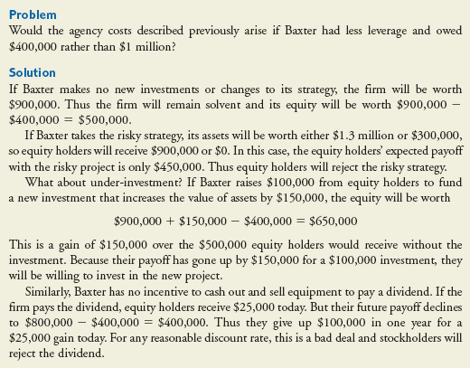
如何降低债务的代理成本：
（1）减少债务期限
（2）施加严格的债务契约约束条件

- 对经理人的激励：杠杆的代理收益
前面我们假设经理人与股东利益协调一致，有侵占债权人利益的动机。但两权分离下的经理人的个人私利，与股东的目标冲突，带来management entrenchment问题。
facing little threat of being fired and replaced, managers are free to run the firm in their own best interests. As a result, managers may make decisions that benefit themselves at investors’ expense.（巩固自己的地位，构筑堑壕，守成）
杠杆对于抑止经理人的私利起到一定作用。
所有权的集中：发行债务不会导致所有权被分散。股权分散（稀释）将改变运营企业的激励和努力程度。发行股权融资还会导致在职消费的增加。发行债务不会稀释股权，因而不会导致努力程度下降和在职消费上升（也是一种代理成本）。
减少浪费性的投资
现金盈余，建立公司帝国
managers prefer to run large firms rather than small ones, so they will take on investments that increase the size—rather than the profitability—of the firm.
One potential reason for this preference is that managers of large firms tend to earn higher salaries, and they may also have more prestige and garner（聚集） greater publicity than managers of small firms. As a result, managers may expand (or fail to shut down) unprofitable divisions, pay too much for acquisitions, make unnecessary capital expenditures, or hire unnecessary employees.
Jensen 的 自由现金流假设，债务，小心翼翼地经营，约束和压力，破产威胁。
free cash flow hypothesis, the view that wasteful spending is more likely to occur when firms have high levels of cash flow in excess of what is needed to make all positive-NPV investments and payments to debt holders.
代理成本与权衡理论：
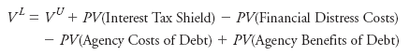
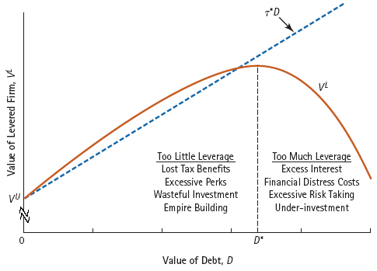
行业资本结构考察：
- R&D-Intensive Firms.
Firms with high R&D costs and future growth opportunities typically maintain low debt levels. These firms tend to have low current free cash flows, so they need little debt to provide a tax shield or to control managerial spending. In addition, they tend to have high human capital, so there will be large costs as a result of financial distress.
Also, these firms may find it easy to increase the risk of their business strategy (by pursuing a riskier technology) and often need to raise additional capital to fund new investment opportunities. Thus their agency costs of debt are also high. Biotechnology and technology firms often maintain less than 10% leverage.
- Low-Growth, Mature Firms
Mature, low-growth firms with stable cash flows and tangible assets often fall into the high-debt category. These firms tend to have high free cash flows with few good investment opportunities. Thus the tax shield and incentive benefits of leverage are likely to be high. With tangible assets, the financial distress costs of leverage are likely to be low, as the assets can be liquidated for close to their full value. Examples of low-growth industries in which firms typically maintain greater than 20% leverage include real estate, utilities, and supermarket chains.

现实中的负债（杠杆）水平选择：
基于经理人的动机，多种力量约束交叉影响。
- 不对称信息与资本结构
Managers’ information about the firm and its future cash flows is likely to be superior to that of outside investors—there is asymmetric information between managers and investors.
当经理人确信公司价值被低估时，通过行动传递信息，向市场发送信号。

Claims in one’s self-interest are credible only if they are supported by actions that would be too costly to take if the claims were untrue.

Actions speak louder than words.

One strategy is to commit the firm to large future debt payments. If Smith (manager) is right, then the company will have no trouble making the debt payments. But if Smith is making false claims and the firm does not grow, the firm will have trouble paying its creditors and will experience financial distress. This distress will be costly for the firm and also for Smith, who will likely lose her job. Thus Smith can use leverage as a way to convince investors that she does have information that the firm will grow, even if she cannot provide verifiable details about the sources of growth. Investors know that the firm would be at risk of defaulting without growth opportunities, so they will interpret the additional leverage as a credible signal of the CEO’s confidence. The use of leverage as a way to signal good information to investors is known as the signaling theory of debt。
信号传递的置信性
例题：
Suppose that Beltran currently uses all-equity financing, and that Beltran’s market value in one year’s time will be either $100 million or $50 million depending on the success of the new strategy. Currently, investors view the outcomes as equally likely, but Smith has information that success is virtually certain. Will leverage of $25 million make Smith’s claims credible? How about leverage of $55 million?
解答：
If leverage is substantially less than $50 million, Beltran will have no risk of financial distress regardless of the outcome. As a result, there is no cost of leverage even if Smith does not have positive information. Thus leverage of $25 million would not be a credible signal of strength to investors.
However, leverage of $55 million is likely to be a credible signal. If Smith has no positive information, there is a significant chance that Beltran will face bankruptcy under this burden of debt. Thus Smith would be unlikely to agree to this amount of leverage unless she is certain about the firm’s prospects.

股权发行与逆向选择
柠檬市场理论（2001年诺奖）
关于市场崩溃的一个例子
假设企业价值为0－100的均匀分布

lemons principle: When a seller has private information about the value of a good, buyers will discount the price they are willing to pay due to adverse selection.
Suppose the owner of a start-up company tells you that his firm is a wonderful investment opportunity—and then offers to sell you 70% of his stake in the firm. He states that he is selling only because he wants to diversify. Although you appreciate this desire, you also suspect the owner may be eager to sell such a large stake because he has negative information about the firm’s future prospects. That is, he may be trying to cash out before the bad news becomes known.
As with the used-car dealer, a firm owner’s desire to sell equity may lead you to question how good an investment opportunity it really is.
Based on the lemons principle, you therefore reduce the price you are willing to pay.
This discount of the price due to adverse selection is a potential cost of issuing equity, and it may make owners with good information refrain（忍住、克制） from issuing equity.
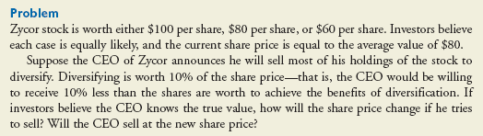
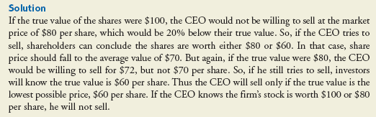
进一步考察一个简单的例子：
某生物科技公司，无债务，流通股数20 million，每股10元，基于正在研发的某种新药的前景，管理者相信目前的公司价值应该为300 million（而不是200 million），相应地股价应该为15元。公司宣布，目前计划融资60 million建立实验室。依据当前股价，需要发行6 million 的新股。下一年，好消息（研发实验成功）公布后，则企业的价值为300（现有资产）＋60（实验室的价值）＝360，股数为26 million，消息公布后的新股价格为 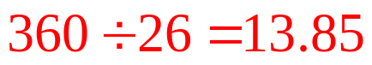。
但是，如果假设公司当前不发行新股，而是等待好消息公布后股价上涨到15元时再发行新股，则当时公司需要出售4 million 的新股，新的股价为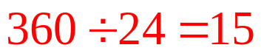。
Thus issuing new shares when management knows they are underpriced is costly for the original shareholders. Their shares will be worth only $13.85 rather than $15.
显然，如果管理者关注企业现有股东的价值的话，那么，在公司价值被低估时，管理者不愿意以被低估的价格发行新股，宁愿等待股价上升后再发行。
Managers who know securities have a high value will not sell, and those who know they have a low value will sell.
Due to this adverse selection, investors will be willing to pay only a low price for the securities.
The lemons problem creates a cost for firms that need to raise capital from investors to fund new investments. If they try to issue equity, investors will discount the price they are willing to pay to reflect the possibility that managers are privy（秘密参与的、藏匿的） to bad news.
- 若干启示
1. The stock price declines on the announcement of an equity issue.
被高估，发行股票
managers issuing equity have an incentive to delay the issue until any news that might positively affect the stock price becomes public. In contrast, there is no incentive to delay the issue if managers expect negative news to come out. These incentives lead to the following pattern：
2. The stock price tends to rise prior to the announcement of an equity issue.
3. Firms tend to issue equity when information asymmetries are minimized, such as immediately after earnings announcements.
4．排序理论
Managers who perceive the firm’s equity is underpriced will have a preference to fund investment using retained earnings, or debt, rather than equity.
The converse to this statement is also true: Managers who perceive the firm’s equity to be overpriced will prefer to issue equity, as opposed to issuing debt or using retained earnings, to fund investment.
Aggregate Sources of Funding for Capital Expenditures, U.S. Corporations
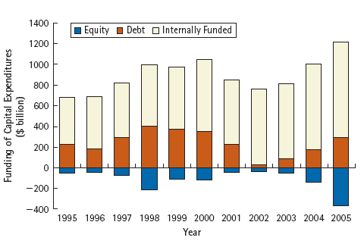
In aggregate, firms tend to repurchase equity （股票净发行金额为负数）and issue debt. But more than 70% of capital expenditures are funded from retained earnings. Source: Federal Reserve Flow of Funds.
排序理论从总体上得到了验证，但就公司资本结构实际而言，尚无显著的证据。
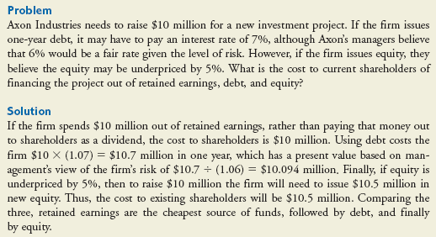
关于资本结构的简单总结
MM定理
市场缺陷：税收、财务困境、代理成本、信号传递、逆向选择
Finally, it is important to recognize that because actively changing a firm’s capital structure (for example, by selling or repurchasing shares or bonds) entails transactions costs, firms may be unlikely to change their capital structures unless they depart significantly from the optimal level.
As a result, most changes to a firm’s debt-equity ratio are likely to occur passively, as the market value of the firm’s equity fluctuates with changes in the firm’s stock price.

