**Egg Order and Oceanographic Factors Drive Egg Size Differences in Scripps’s Murrelets (*Synthliboramphus scrippsi*) at Santa Barbara Island, California, USA**

by

Marcela Todd Zaragoza

A Senior Thesis Submitted in Partial Fulfillment

of the Requirements for the Degree of

Bachelor of Science

(Wildlife Conservation)

School of Environmental and Forest Sciences

University of Washington

Box 352100

Seattle, Washington 98195-2100

2021

Approved by _______________________________

Date___________________

# **Abstract**

Oceanic conditions are known to affect a variety of life history parameters in seabirds, but the degree to which egg size responds to environmental conditions has been investigated only rarely (e.g., Bennett et al. 2017, Hipfner 2012). The resources available to an avian embryo have the potential to influence survival of the embryo and of the chick post-hatching. I investigated the effects of oceanographic conditions on Scripps's Murrelet (*Synthliboramphus scrippsi*) egg size at Santa Barbara Island, California, USA, using data from 2009-2017. Environmental covariates that characterize the marine environment at various spatial and temporal scales were evaluated for their effect on egg size. Large-scale oceanographic indices evaluated included the Pacific Decadal Oscillation (PDO) index, the Oceanic Niño Index (ONI), and the North Pacific Gyre Oscillation (NPGO) index. Larval anchovy catch-per-unit-effort indices and the Biologically Effective Upwelling Transport Index (BEUTI) were used as a region-wide covariate, and sea surface temperature (SST) as a local covariate. I used linear mixed models with 12-month averaged data for all covariates, a one year-lag for BEUTI and PDO. I also accounted for egg order (egg 1 or egg 2) as a fixed effect and plot as a random effect. The top two best-fitting models, based on AIC, showed a negative relationship between egg size and BEUTI, NPGO, and ONI and a positive relationship between egg size and egg order and SST.

*I need to add a couple of sentences about what this means for murrelets*

This analysis has revealed that there is value in collecting egg measurement data for murrelets in order to understand the physical processes that are driving egg size differences.

# **Introduction**

Seabirds have previously been identified as reliable indicators of marine ecosystem health (Mallory et al. 2010; Cairns, 1986; Velarde et al. 2019). Fluctuating marine conditions that affect prey availability can impact the demography of seabirds due to their dependence on marine ecosystems for foraging. For example, Cassin’s Auklets (*Ptychoramphus aleuticus*) at Triangle Island (British Columbia, Canada), have shown reduced offspring survival and fledging mass in years of warm sea surface temperatures (SSTs) due to limited prey availability (Hipfner, 2008). Changes in marine conditions have also been linked to declines in growth rate and fledging success of Tufted Puffins (*Fratercula cirrhata*) off the coast of British Columbia (Gjerdrum, 2003) as well as changes in clutch size of Scripps’s Murrelets (*Synthliboramphus scrippsi)* off the coast of California, United States(Roth et al. 2005).

Interannual and interdecadal oceanographic variation also plays an important role in determining the egg size of some seabird species, though this relationship has been only rarely investigated. In general, egg size varies with the amount of energy invested in egg production, and the energy available to invest can be a function of environmental conditions (Williams, 2005). In Norway, Atlantic Puffin (*Fratercula arctica*) populations at two separate colonies (1980-2011) showed an annual decrease in population size and parallel decrease in egg volume (Barrett et al. 2012). Egg volume was modeled as a function of regional (e.g., winter North Atlantic Oscillation) and local (e.g., April SST) oceanographic conditions, and results indicated that low food availability prior to egg-laying leads to decreases in egg size. In contrast, Hipfner (2012) found that egg size increased with SST for Glaucous-winged Gulls (*Larus glaucescen*s) at Triangle Island, but the effect was small and limited to one and three-egg clutches.

Scripps’s Murrelets (hereafter murrelets) are a small seabird in the Alcidae family that breeds along the west coast of southern California, United States and Baja California, Mexico. Investigation of the relationships between marine conditions and murrelet breeding success have been limited to an analysis of the effects of ocean productivity on murrelet clutch initiation timing and size (Roth et al. 2005). That analysis revealed that higher ocean productivity leads to earlier clutch initiation dates and larger clutch sizes. However, there has not been any analysis of the relationship between oceanographic conditions and egg size. Murrelet eggs represent, on average, 23.7% of the female body mass, making them one of the largest eggs relative to body weight in the Alcidae family (Sealy, 1975). Females lay one egg and, typically, a second egg ~8 days later (Murray et al. 1983). Murrelet chicks are precocial, departing the nest ~1-2 days after hatching. This precociality requires large eggs and females must forage several days before laying each egg in order to obtain the necessary nutrients (Murray et al. 1983).

The largest US-based breeding colony of murrelets occurs at Santa Barbara Island (SBI), the smallest island in Channel Islands National Park, California (Carter et al. 1992; Figure 1). SBI is located in the Southern California Bight, which is highly dynamic and experiences interannual fluctuations in ocean productivity (Checkley and Barth, 2009) and therefore provides an opportunity to investigate the ways in which these factors may influence murrelet egg size. By looking at large-scale, regional, and local oceanographic patterns in the Northeast Pacific Ocean, I will determine whether environmental factors are important for predicting murrelet egg size. I have four specific research objectives, including:

1. Examine the relationship between murrelet egg size and environmental conditions at Santa Barbara Island.
2. Investigate inherent differences in the size of the first and second egg laid in a clutch.
3. Determine whether egg size measurements vary substantially due to plot (indicating small-scale geographic variation) or observer (indicating observation error in measurements).
4. Evaluate the value of collecting egg size information in Channel Islands National Park’s murrelet monitoring protocol.

I hypothesize that environmental conditions that lead to higher ocean productivity will result in larger egg sizes. Specifically, I hypothesize that cool, nutrient-rich marine conditions will lead to higher ocean productivity that provides optimal foraging conditions for murrelets, and thus larger egg sizes. This includes negative Oceanic Niño Index values, positive values of the Biologically Effective Upwelling Transport Index that lead to upwelling, positive NPGO values, high larval anchovy catch-per-unit-effort values, and low sea surface temperatures. I also hypothesize there will be inherent differences between the first and second egg laid and that both plot and observer will have an influence on observed egg size. Lastly, I predict this research will reveal new information about the importance of egg monitoring at SBI, which will provide valuable information to prioritize murrelet population monitoring activities in the future.

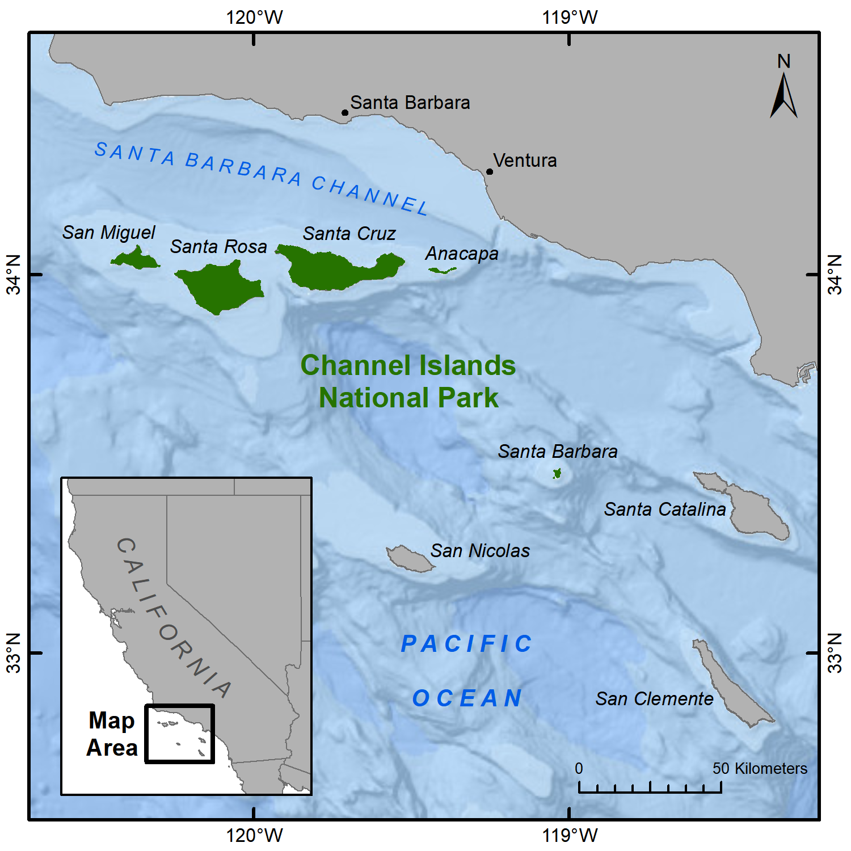

**Figure 1**. The Channel Islands, California, USA. Credit: Amelia J. DuVall.

# **Methods**

## ***Data Collection***

Santa Barbara Island (33.4756° N, 119.0373° W) is the smallest (2.6) of the eight California Channel Islands and it hosts the largest breeding colony for murrelets in the region. The data used for this analysis were part of a larger project funded primarily by the Montrose Settlements Restoration Program at Channel Islands National Park. Data were collected from 2009-2017 during the breeding season, which lasts from March to June and peaks in April (Murray et al. 1983). In order to obtain egg measurements, eggs were first deemed accessible if they were within safe reach of the observer and no adult bird was present at the site. Eggs were then removed from the nest and measured using Vernier calipers. Egg length and width (at the widest point) were obtained to the nearest millimeter. After measurements were obtained, the egg was returned to its original position and orientation. Eggs were only measured once at each nest. If both eggs were present upon first encounter, egg order was indeterminable, but if the nest was encountered between the laying of the first and second eggs, eggs were labeled with a marker to indicate egg order. Egg size data were obtained from eight monitoring plots for this analysis: Arch Point North Cliffs (APNC), Bunkhouse (BH), Boxthorn (BT), Cat Canyon (CC), Dock (DO), Elephant Seal Cove (ESC), Landing Cove (LC), and West Cliffs (WC) (Figure 2).

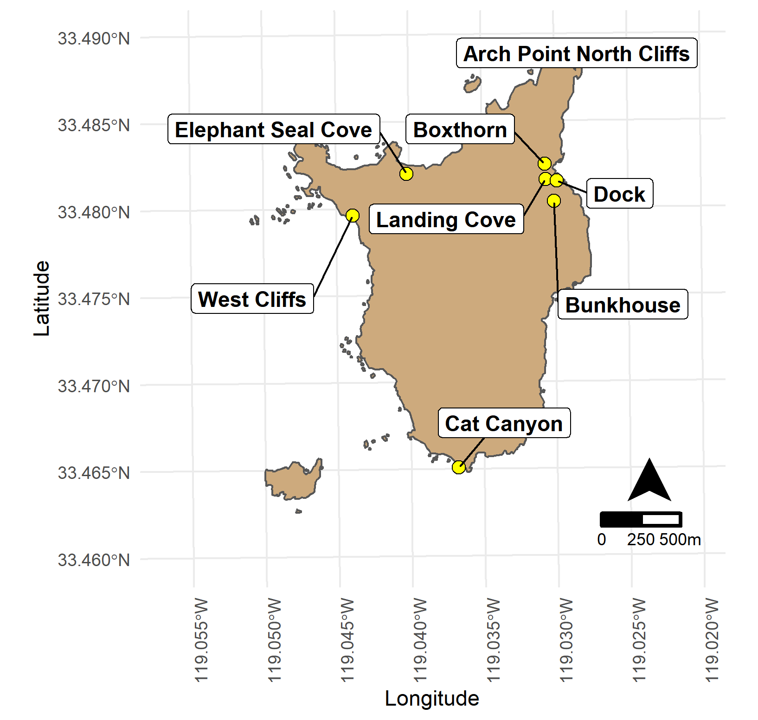

**Figure 2**. Santa Barbara Island monitoring plots used in this analysis. Credit: Amelia J. Duvall.

## 

## ***Model Formulation and Selection***

I developed a set of models to investigate the relationship between environmental covariates and egg size, calculated as egg length*egg width. Egg size was modeled using a linear mixed model with normal errors and random processes. By using random effects, I accounted for the variability that may be associated with the location, accessibility, and microclimate of different plots.

~

~ ()

where is the size of egg *i,*  is the intercept*, k* is the number of predictors in a given model, are model coefficients for covariates (including egg order), is the random effect of plot, with variance , and is the error for egg *i*, with model variance .

Data for the environmental covariates used for this analysis were obtained from the California Current Integrated Ecosystem Assessment Program, as part of NOAA’s interdisciplinary research effort along the U.S. West Coast (California Current Integrated Ecosystem Assessment, n.d.). Environmental covariates used to characterize large-scale oceanographic conditions included the Pacific Decadal Oscillation (PDO) index, the Oceanic Niño Index (ONI), and the North Pacific Gyre Oscillation (NPGO) index. Larval anchovy catch-per-unit-effort indices and the Biologically Effective Upwelling Transport Index (BEUTI) were used as region-wide covariates, and sea surface temperature (SST) was used as a local covariate. The PDO is the dominant mode of SST anomalies in the North Pacific, indicating shifts in ocean temperatures (Chenillat et al. 2012). ONI is a measure of air pressure fluctuations and sea surface temperature anomalies in the El Niño 3.4 region. NPGO is the second dominant mode of sea surface height anomalies in the North Pacific (Chenillat et al. 2012). BEUTI estimates vertical nitrate flux, which is the amount of nitrate upwelled/downwelled, near the U.S. West Coast at a latitude of 39 degrees north (Jacox et al. 2018). Larval anchovy data were collected in the spring by the California Cooperative Oceanic Fisheries Investigations (CalCOFI) lines 76.7-93.3, stations 28.0-120.0 and represent catch-per-unit sampling effort. SST data were collected by the National Oceanic and Atmospheric Administration's buoy station 46025 (33.758° N, 119.044° W), approximately 31 km north from SBI.

I used a series of single-variable models to evaluate the appropriate temporal scale for different predictors. For predictors with monthly sampling data (all except larval anchovy), I evaluated the support for a covariate based on predictor values averaged from January through June in year *y* to model egg size in year *y*, in order to capture the variability of environmental conditions up to three months before the breeding season until two months after the peak of the breeding season as described by Murray et al. (1983). This 6-month averaged covariate for a given predictor was evaluated against a covariate for that predictor with data averaged over an entire year, i.e., July of year *y*-1through June of year *y* to model egg size in year *y*. For the NPGO data, I also tested averaged values from December in year *y*-1 to March in year *y* to model egg size in year *y,* to capture the 1-2 month lag of the onset of the upwelling season as described by Chenillat et al. (2012). Based on the best covariate form for each predictor in terms of months covered, I then used single covariate models to test the support for one-year lagged covariates versus non-lagged covariates, given uncertainty in the temporal match between environmental covariates and prey availability in the marine system. All the environmental covariates were Z-scored before evaluation. The single variable models were compared using Akaike’s Information Criterion (AIC) = , where is the maximum value of the likelihood function for the model and *k* is number of parameters in the model.

Once the single best covariate was identified for each of the predictors, these covariates were combined in multi-predictor models. All possible combinations of covariates were conssidered, except that covariates with a correlation coefficient that had an absolute value ≥ 0.65 were not included in the same model. These correlated covariates included larval anchovy and PDO, larval anchovy and SST, larval anchovy and NPGO, BEUTI and PDO, NPGO and ONI, NPGO and SST, NPGO and PDO. Egg order was also included to understand whether order is a determinant of egg size. Again, models were compared based on AIC. Models were fit in the lme4 package in R, with function lmer (CITATION).

To formally test the support for inclusion of random effects of plot and observer, I performed bootstrapped likelihood ratio tests (function exactRLRT or exactLRT in the RLRsim package (CITATION) in R (CITATION). My intention was to test the random effects in the context of a “global” or fully parameterized fixed effects structure, i.e., with the maximum number of fixed parameters. However, because of correlations in predictors, there was no single model that had all the covariates included, and the maximum number of fixed effect covariates in any single model was 4 (i.e., 5 parameters given the intercept). Therefore, I tested for the random effects in the context of the 5-parameter model that had the lowest AIC.

Model diagnostics were performed on the AIC-best 5-parameter model, as above, to evaluate the degree to which model assumptions were met. These diagnostics included Q-Q plots to evaluate the normality of residuals, autocorrelation function plots to evaluate the independence of residuals, and residual plots along with Levene’s test to evaluate the equality of variances in residuals.

## ***Inference***

Marginal prediction plots for the covariates included in the best-fitting models were obtained based on predictions that were model-averaged across the best-fitting models (those models with an AIC within X points of the top model). This was accomplished by first selecting a model based on a categorical random draw of the top models, with probabilities equal to the AIC weights, then – conditional on that model – bootstrapping the model errors, refitting the model, and predicting to a dataset in which one covariate in the model was varied at a time while holding all other covariates constant. Predictions were based on 10,000 repetitions; 95% confidence intervals were obtained from the appropriate quantiles of the resulting predictions.

# **Results**

## ***Data collection***

There were 7 egg measurement records for 2009, 161 for 2010, 104 for 2011, 133 for 2012, 120 for 2013, 119 for 2014, 135 for 2015, 153 for 2016, and 84 for 2017. There were 767 values for egg 1 size and 249 values for egg 2 size (*n* = 1,016 total samples). There were a total of X different plots with egg measurements, with the number of eggs per plot varying between X and 305. There were a total of 27 different observers who measured eggs, with the number of eggs per observer varying between X and X. There were two outliers from the plot “LC” in which egg size was particularly small. These outliers were kept in the analysis as they represented egg measurements made in 2016 from the same nest but by different observers on different dates, indicating that both eggs in the clutch were truly unusual rather than that a measurement error was made.

## ***Model Formulation and Selection***

I found that the 12-month averaged covariates had lower AIC values for larval anchovy, SST, ONI, and PDO than covariates averaged across January to June (AIC >2 in all cases). The BEUTI 12-month averaged and January-June averaged covariates showed near-equal support (AIC = 0.259). The NPGO full-year covariate had more support than the December-March averaged covariate (AIC = 3.88) and the January-June averaged covariate (AIC =1.66). Therefore, the full-year covariate for all predictors was selected, including for BEUTI. I then evaluated the full-year covariate with and without a one-year lag based on single-variable models. There was support for a one-year lag for BEUTI and PDO and no lag for larval anchovy, SST, ONI, and NPGO.

Likelihood ratio tests showed support for inclusion of a plot random effect (*p* = 0.0198), but no support for inclusion of an observer random effect (*p* = 1.0). Thus, all candidate models included only plot as a random effect. Using the 7 potential fixed effects (6 environmental covariates and egg order), I identified a total model set of 128 candidate models. Of this full model set, there were 92 models that had correlated predictors, resulting in a reduced model set of 36 models. Final model selection was performed using AIC (Table 1). Parameter estimates for the two top competitive models are shown in Table 2. Both top models included egg order and BEUTI as covariates.

**Table 1. Top 6 models fitted to the data.**

|  |  |  |  |  |
| --- | --- | --- | --- | --- |
| **Fixed effects** | **Random effects** | **AIC** | **AIC** | **AICw** |
| Egg order, BEUTI1[1], NPGO0 | Plot | 10674.35 | 0.00 | 0.52 |
| Egg order, BEUTI1, ONI0, SST0 | Plot | 10675.69 | 1.35 | 0.26 |
| Egg order, NPGO0 | Plot | 10677.95 | 3.61 | 0.08 |
| Egg order, ANCHL0, BEUTI1, ONI0 | Plot | 10677.96 | 3.61 | 0.08 |
| Egg order, BEUTI1, SST0 | Plot | 10679.71 | 5.37 | 0.04 |
| Egg order, ANCHL0, BEUTI1 | Plot | 10681.19 | 6.86 | 0.02 |

**Table 2. Parameter estimates of the two best-fitting models.**

|  |  |  |  |
| --- | --- | --- | --- |
| **Model** | **Parameter** | **Estimate** | **Standard error** |
| Egg order, BEUTI1, NPGO0 | Egg order | 32.597 | 9.154 |
| BEUTI1 | -3.820 | 4.791 |
| NPGO0 | -16.540 | 3.970 |
| Egg order, BEUTI1, ONI0, SST0 | Egg order | 32.729 | 9.178 |
| BEUTI1 | -11.450 | 4.921 |
| ONI0 | -4.894 | 5.123 |
| SST0 | 15.358 | 4.715 |

## ***Model Diagnostics***

Model diagnostics indicated generally good agreement with model assumptions (Figure 3, Figure 4). The test of homogenous variance via the Levene's Test, showed no evidence of unequal variances (*p* = 0.742). Two noticeable outliers are apparent in Figure 4 (left panel) – these correspond with the two eggs measured in 2016 where egg size was unusually small.

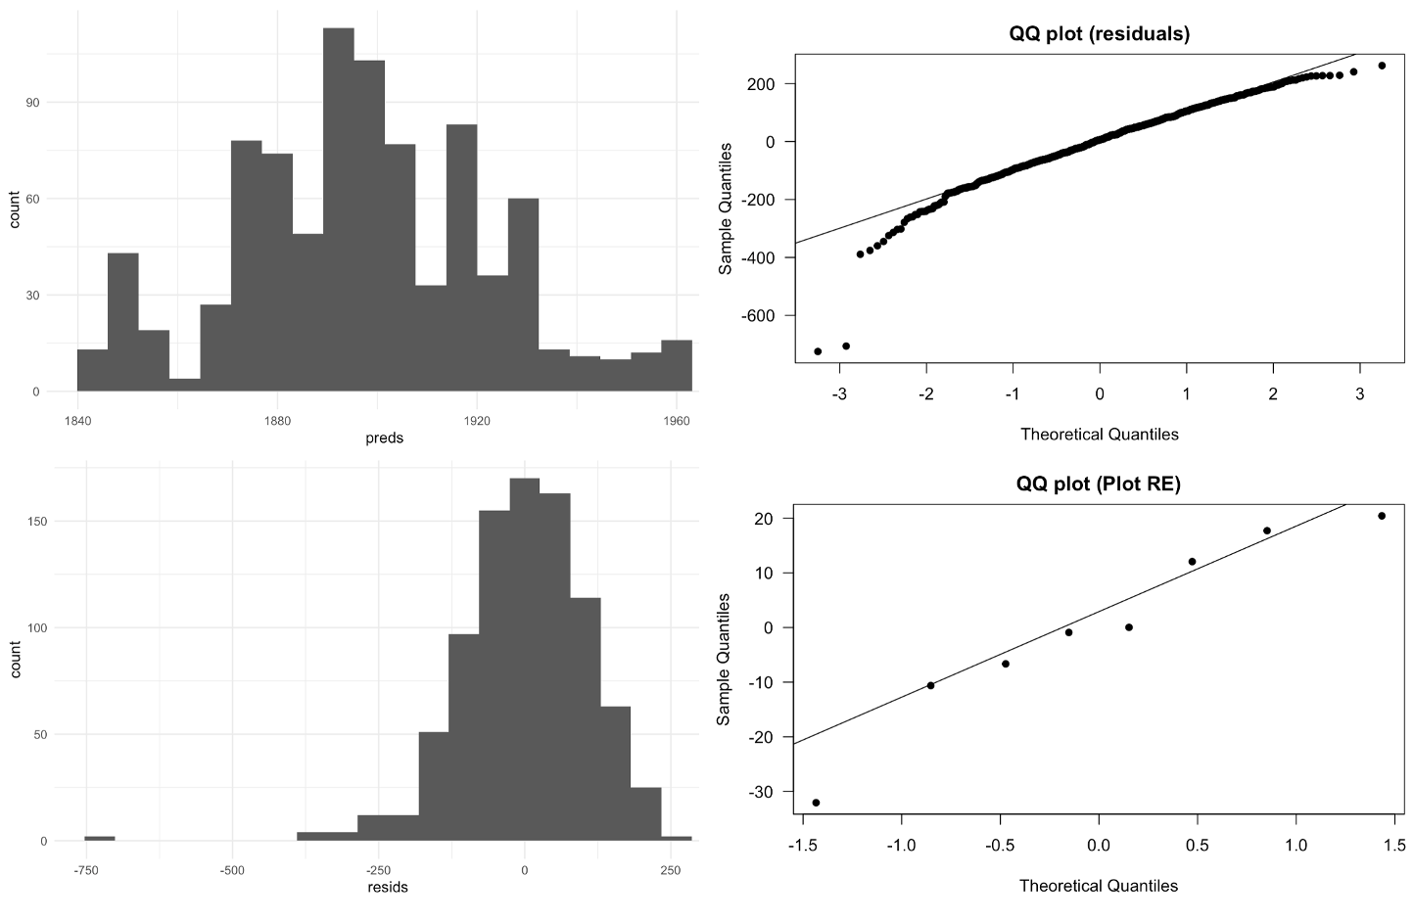

## 

**Figure 3**. Distribution of the predictors (top left) and residuals (bottom left) for the global model. Q-Q plots of residuals (top right) and plot random effect (bottom right).

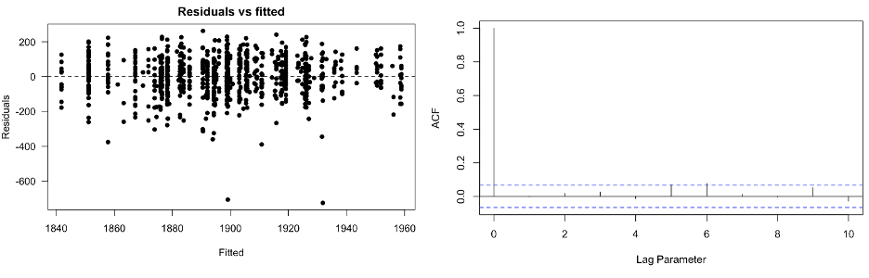

**Figure 4**. Fitted vs residuals of the global model (left) and the autocorrelation of residuals (right).

## ***Predictions***

Marginal prediction plots for the covariates included in the best-fitting models and their 95% confidence intervals are shown in Figure 5. The slope for all of the predictors is not very steep. As BEUTI increases, egg size decreases. As NPGO increases, egg size decreases. As ONI increases, egg size increases. As SST increases, egg size increases.

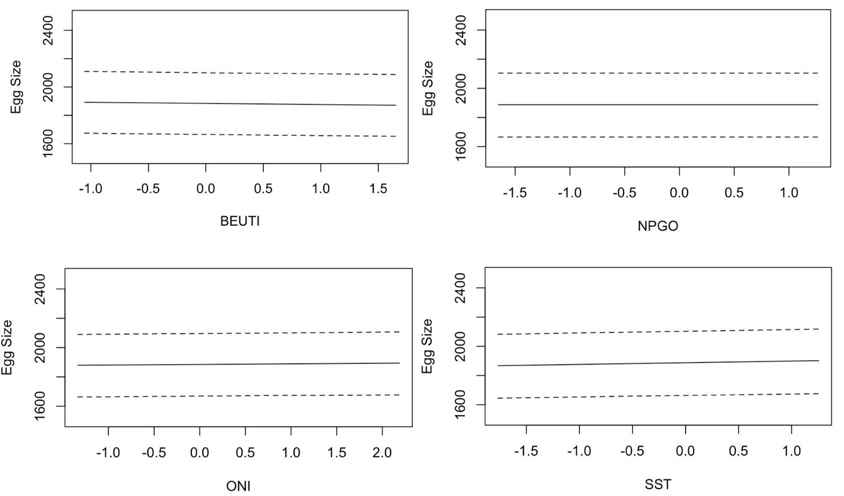

**Figure 5.** Predictions egg size as a function of the marginal effects of BEUTI, NPGO, ONI, and SST, across the two best-fitting models.

# **Discussion**

Understanding the relationship between environmental drivers and physiological responses is crucial to advance our biological knowledge of murrelets. This analysis revealed that large-scale, region-wide, and local oceanographic processes as well as egg order drive egg size differences in murrelets. However, some of the relationships that were found were opposite to what was expected. As indicated by the top two competitive models, I found a negative relationship between one-year lagged BEUTI values and egg size. As BEUTI aims to capture the bottom-up dynamics of productivity, a positive value indicates the drawing of nutrient-rich water toward the surface, and a negative value the opposite effect through downwelling (Jacox et al. 2016). Additional driving forces could be impacting the direct relationship between upwelling and biological responses, which are not being captured solely by BEUTI. These could include variable light levels and availability of nutrients other than nitrate that are driving productivity and therefore foraging opportunities for murrelets (Jacox et al. 2018).

The positive relationship between SST and egg size in the second best model indicates that warmer sea temperatures are associated with larger egg sizes. Although the opposite relationship is expected where lower SSTs lead to more ocean productivity, and therefore larger eggs, this relationship has been found before. Barrett et al. (2012) found similar results with an Atlantic puffin population in Norway; the authors suggested that such a relationship can be a result of decreased thermoregulatory costs. By reducing the costs associated with countercurrent heat exchange, the female can then have more energy to channel towards egg production (Stevenson & Bryant, 2000). It is possible that physiological mechanisms like may be having a larger effect on egg size than ocean productivity changes caused by differences in SST.

The relationship indicated by the second-best model, between ONI and egg size, indicates that eggs tend to be larger when ONI is negative, indicating a cool phase along the Pacific coast with colder and more nutrient-rich waters. Anchovy, the main prey for murrelets, are strongly affected by oceanographic factors such as ONI and show wide population fluctuations as a function of ONI(Velarde et al. 2004). Furthermore, during positive phases of the oscillation, juvenile and adult anchovy abundances have been shown to decline in areas off Southern California (Fiedler et al. 1986). Given this relationship between the effects of ONI and the main prey for murrelets, it is not surprising to observe larger egg sizes in relation to negative ONI values, although notably I was not able to document a relationship between egg size and anchovy themselves.

The finding that negative NPGO values lead to larger egg size is contrary to what has been found for murrelet nest success, although it has not been characterized directly for egg size. Thomsen and Green (2018) found that when the NPGO is positive, murrelet nest success is high, resulting in stable population growth. A positive phase of NPGO leads to a more productive planktonic ecosystem in the California region throughout the spring and summer (Chenillat et al. 2012). Therefore, it is interesting that a model without a lag was supported for NPGO as the relationship between NPGO and upwelling-favorable winds is the strongest during the wintertime (December to March) and there is a 1-2 month in the onset of the upwelling season.

For egg order, I found that the second egg was substantially larger than the first egg,. Murray et al. (1983) found that, on average, the second egg of the clutch was 1 g heavier than the first. This indicates that murrelets are allocating more resources towards the second egg, which is consistent with the life history of this species. Murrelet females abandon the nest for 8 days after laying the first egg in order to procure additional resources for themselves (Murray et al. 1980). This extended period of inter-egg foraging allows murrelets to produce a larger second egg.

I found support for the inclusion of a plot random effect, indicating micro-scale variation in egg size Adaptations that occur at very fine spatial scales can lead to microgeographic adaptive divergence that can explain fine scale differences in fitness (Richardson et al. 2014). Habitat selection can be a possible mechanism driving these microgeographic adaptations, such that areas offering higher fitness through proximity to better foraging opportunities could be driving physiological differences in murrelets. Given that murrelets show high site fidelity, future studies could investigate differences in foraging habitat used by birds in different plots to assess whether foraging habitat differences might explain egg size variation across plots.

**Management Implications**

Egg measurements have been collected at Santa Barbara Island since the 1990s without any indication of its relative importance for various research and conservation priorities of murrelets. My analysis has revealed that there is value in collecting this data and that we can begin to understand the physical processes that are driving egg size differences. Given the large relative size of eggs produced by murrelets, necessary to support precociality, investment in egg production requires a large amount of nutrient and energy requirements (Robins 1981; Williams, 2005; Nager, 2006). As murrelets rely on their dynamic marine environment to gain the necessary resources, fluctuations in the marine conditions most likely reflect fluctuations in egg size. Egg size can have influences on offspring fitness and survival, making it an important avenue for future population monitoring (Krist 2011; Lee et al. 2012). Continued monitoring and measurement collection is important. An area of research that might be prioritized in future investigations is the relationship between egg size and hatching success or chick survival.

# **Literature Cited**

Barrett, R., Nilsen, E., & Anker-Nilssen, T. (2012). Long-term decline in egg size of Atlantic puffins (*Fratercula arctica*) is related to changes in forage fish stocks and climate conditions. *Marine Ecology Progress Series*, *457*, 1–10.<https://doi.org/10.3354/meps09813>

Bennett, J. L., Jamieson, E. G., Ronconi, R. A., & Wong, S. N. P. (2017). Variability in egg size and population declines of Herring Gulls in relation to fisheries and climate conditions. *Avian Conservation and Ecology*, *12*(2), art16.<https://doi.org/10.5751/ACE-01118-120216>

Burkett, E.E., N.A. Rojek, A.E. Henry, M.J. Fluharty, L. Comrack, P.R. Kelly, A.C. Mahaney, and K.M. Fien. (2003). Report to the California Fish and Game Commission: Status Review of Xantus’s Murrelet (Synthliboramphus hypoleucus) in California. Calif. Dept. of Fish and Game, Habitat Conservation Planning Branch Status Report 2003-03. 96 pp. + appendices.

Checkley, D. M., & Barth, J. A. (2009). Patterns and processes in the California Current System. *Progress in Oceanography*, *83*(1), 49–64.<https://doi.org/10.1016/j.pocean.2009.07.028>

Gjerdrum, C., Vallée, A. M. J., Clair, C. C. S., Bertram, D. F., Ryder, J. L., & Blackburn, G. S. (2003). Tufted puffin reproduction reveals ocean climate variability. Proceedings of the National Academy of Sciences, 100(16), 9377–9382. https://doi.org/10.1073/pnas.1133383100

Harvey, A.L., J.A. Howard, R.R. Robison, D.M. Mazurkiewicz, M.E. Jacques, S.A. Auer, C.A. Carter, K.W. Barnes, A.A. Yamagiwa and S.J. Kim. (2014). Scripps’s Murrelet, Cassin’s Auklet, and Ashy Storm-Petrel reproductive monitoring and restoration activities on Santa Barbara Island, California in 2012. Unpublished report, California Institute of Environmental Studies. 38 pages.

Hipfner, J. (2008). Matches and mismatches: Ocean climate, prey phenology and breeding success in a zooplanktivorous seabird. *Marine Ecology Progress Series*, *368*, 295–304.<https://doi.org/10.3354/meps07603>

Hipfner, J. M. (2012). Effects of Sea-surface Temperature on Egg Size and Clutch Size in the Glaucous-winged Gull. Waterbirds, 35(3), 430–436. https://doi.org/10.1675/063.035.0307

Mallory, M. L., Robinson, S. A., Hebert, C. E., & Forbes, M. R. (2010). Seabirds as indicators of aquatic ecosystem conditions: A case for gathering multiple proxies of seabird health. *Marine Pollution Bulletin*, *60*(1), 7–12.<https://doi.org/10.1016/j.marpolbul.2009.08.024>

Murray, K., Winnett-Murray, K., & Hunt, G. (1980). Egg Neglect in Xantus' Murrelet. Proceedings of the Colonial Waterbird Group, 3, 186-195. Retrieved March 17, 2021, from http://www.jstor.org/stable/4626713

Murray, K. G., Winnett-Murray, K., Eppley, Z. A., Hunt, G. L., & Schwartz, D. B. (1983). Breeding Biology of the Xantus’ Murrelet. The Condor, 85(1), 12–21. <https://doi.org/10.2307/1367880>

Piatt, I., & Sydeman, W. (2007). Seabirds as indicators of marine ecosystems. Marine Ecology Progress Series, 352, 199–204. https://doi.org/10.3354/meps07070

Piatt, J. F., Harding, A. M. A., Shultz, M., Speckman, S. G., van Pelt, T. I., Drew, G. S., & Kettle, A. B. (2007). Seabirds as indicators of marine food supplies: Cairns revisited. Marine Ecology Progress Series, 352, 221–234. https://doi.org/10.3354/meps07078

Roth, J. E., Sydeman, W. J., & Martin, P. L. (2005). Xantus's Murrelet breeding relative to prey abundance and oceanographic conditions in the Southern California Bight. https://www.marineornithology.org/PDF/33_2/33_2_115-121.pdf

Sealy, S. G. (1975). Egg Size of Murrelets. *The Condor*, *77*(4), 500.<https://doi.org/10.2307/1366104>

Sydeman, W., Thompson, S., & Kitaysky, A. (2012). Seabirds and climate change: Roadmap for the future. *Marine Ecology Progress Series*, *454*, 107–117.<https://doi.org/10.3354/meps09806>

Williams, Tony D. (2005). Mechanisms Underlying the Costs of Egg Production. *BioScience*, *55*(1), 39. [https://doi.org/10.1641/0006-3568(2005)055[0039:MUTCOE]2.0.CO;2](https://doi.org/10.1641/0006-3568(2005)055%5b0039:MUTCOE%5d2.0.CO;2)

1. The subscript indicates a lagged (1) versus a non-lagged (0) covariate.