The modified Beverton holt for one stream and life history is :

$J_{y}=\frac{α_{ }S_{y}^{γ_{ }}}{1+α_{ }S_{y}^{γ_{ }}/J_{ }^{max}}e^{ϵ_{y}}$

where $J$ is juvenile emigrants/kilometer of stream, $S$ is female spawners/ kilometer of stream, $γ_{ }$ controls the extent of positive density dependence if >1 and negative DD if <1, and $J_{ }^{max}$ is the asymptotic maximum expected juvenile emigrant abundance.

If $γ$ = 1 this reduces to a Beverton Holt and as $J_{ }^{max}$ approaches infinity it reduces to a power function. If $γ$ = 1 and $J_{ }^{max}$ approaches infinity it reduces to a straight line through the origin with slope determined by $α$.

There is not enough information to fit unique $α,$ $γ$, and $J_{ }^{max}$ parameters for each life history in each stream. Specifically, most of the years of data in Nason Creek and the White River had relatively similar numbers of spawners, providing little information on the model parameters. Therefore, I propose to assume that $γ$, and $J_{ }^{max}$ are common across streams for a given life history. This assumes that density dependent dispersal and natality act similarly in each stream for a given life history. $α$ will be allowed to vary among streams and life histories to allow for some stream-specific differences in productivity.

Here is what that model looks like:

$$J_{h,y,a}=\frac{α_{h,a}S_{y,a}^{γ_{h}}}{1+α_{h,a}S_{y,a}^{γ_{h}}/J_{h}^{max}}e^{ϵ_{h,y,a}}$$

And the fit (AIC = 402.09)

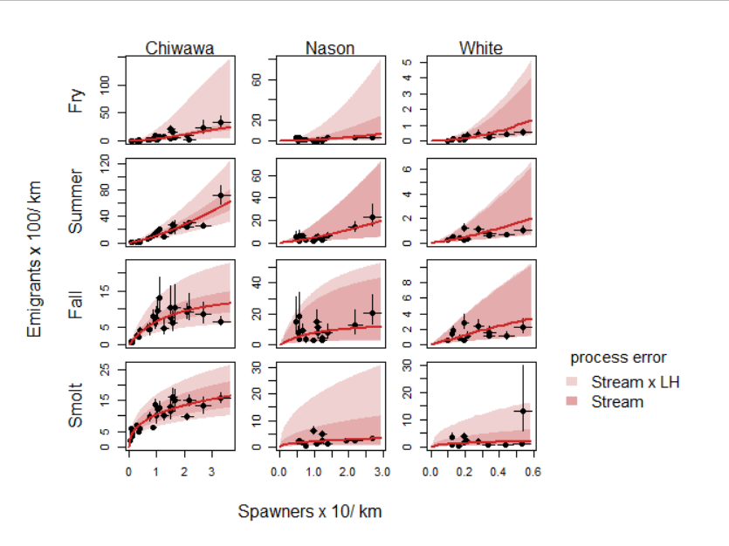

Power function (AIC=397.19)

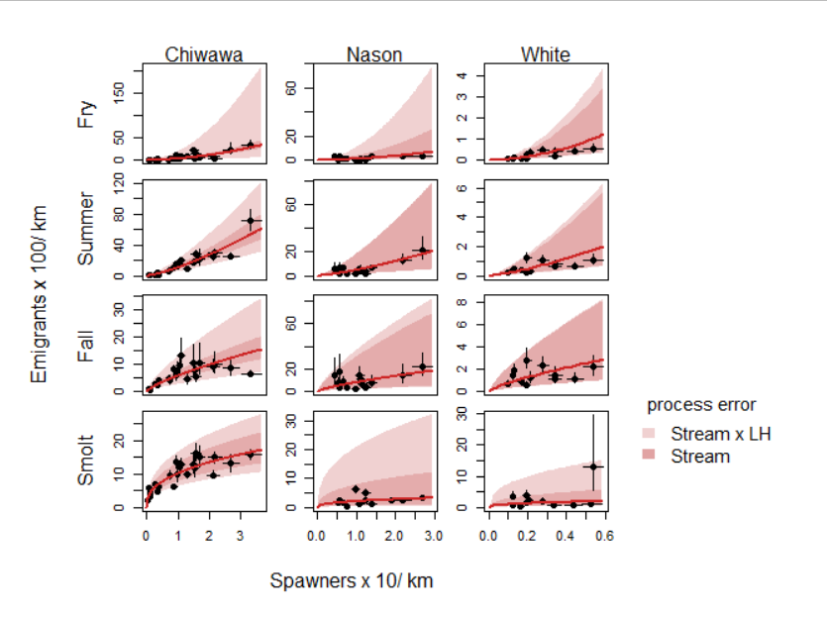

Beverton Holt (AIC = 428.01)

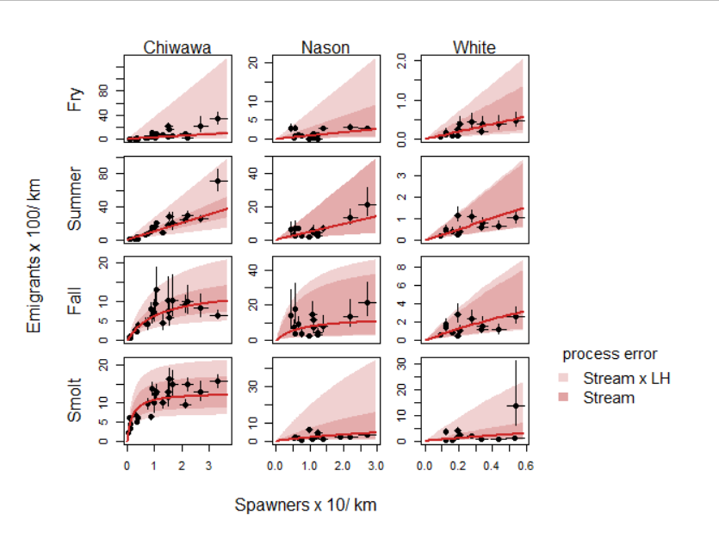

Straight line through origin (AIC = 482.28)

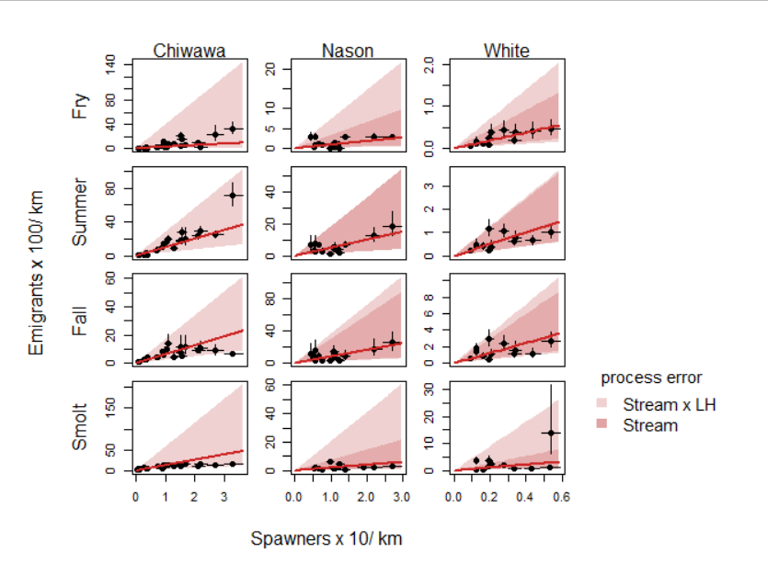

These models are nested (mostly) so perhaps an LRT could be used. With the penalties it seems like the model basically reduces to a power function for all streams by life histories. This has me thinking that maybe it makes the most sense to just do model selection, which seems to favor the power function.

I could see using the full model and penalizing Jmax based on some estimate of a reasonably large carrying capacity derived based on prior information (e.g., max spawners observed \* fecundity \* optimistic survival from egg to emigrant (e.g., 0.5) \* largest reasonable proportion of one life history (e.g. 0.5). But that seems like something we would do for the IPM rather than this paper, where we are trying to learn about productivity, density dependence, and variability based on the data.