# **Chapter 2: Sharing is caring - The evolution of communal roosting behaviour in birds**

**Introduction**

Understanding why species differ in their social behavior has fascinated biologists for years (Wrangham & Rubenstein, 2014). From mating to foraging, there are diverse examples of social behavior across taxa encompassing fish, mammals, and birds. Several hypotheses have been proposed to explain the origins of sociality in animals. Yet, regardless of its specific origins, there’s evidence that sociality plays an important role in shaping learning, and that this learning can create local cultures in a population (Aplin, 2019) , with behaviors that may persist several hundreds of years (e.g. evidence of stone tool use in chimpanzees, *Pan troglodytes* (Haslam et al., 2009; Luncz et al., 2015; Mercader et al., 2007).

One interesting form of social behavior in many animals is that of communal roosting (hereon CR). Communal roosting is seen in species across many taxa, including fish (Clough and Ladle 1997), mammals (Kunz, 1982) and birds (Eiserer 1984). In birds, communal roosts are aggregations of unrelated individuals (either con- or heterospecific) that spend the resting period (either diurnal or nocturnal) together (Laughlin et al. 2014). The prevalence of this behaviour is striking given the apparent little benefits of sharing space and resources with individuals that in many cases are not family. Despite this, the frequency and diverse range of species in which communal roosting occurs suggest that it has evolved independently on numerous occasions, and that there should be an underlying mechanism that support(s) this seemingly paradoxical behaviour.

Several hypotheses have been proposed to explain the origins of communal roosting. One idea that has support from the literature is protection from weather. It’s been suggested that several species use communal roosts to huddle together as a way to find protection from extreme environmental temperatures (Farquhar et al., 2018; Gilbert et al., 2010, Chaplin, 1982). However, if this was the case, the behavior will be more likely to occur in areas with extreme cold weather such like higher latitudes, although this is not what we see in the current observed patterns (Beauchamp, 1999; Gyllin et al., 1977). Another well-supported idea is that communal roosting behaviour acts as a mechanism for predator avoidance (Weatherhead, 1983). Although this idea is reasonably documented for some species (McGowan et al., 2006; Williams, 1994), it has contradicting evidence in the case of species that do not have ecological predators like large birds or raptors (Coleman and Fraser, 1986), thus it cannot fully support the evolution of this behaviour in all the taxa in which it is observed.

A third explanation for the evolution of communal roosting behaviour is related to foraging efficiency. It has been argued that these roosts are sites where naïve individuals can potentially exchange information with more experienced individuals on the location of food sources. This concept is formalized by Ward and Zahavi (1973) via the Information Center Hypothesis (ICH). This hypothesis states that there is a difference in knowledge between informed individuals and naïve individuals on the location of food sources, and that when roosting together there is a signal transfer (either intentional or inadvertently) such that naïve individuals can follow informed ones to feeding sites. If there is enough food for individuals to share, the cost of being a follower has an overall positive payoff than exploring for food individually (Mock 1988).

If the ICH holds true, individuals that exhibit communal roosting behaviour are expected to have increased foraging efficiency than those who do not (e.g., Harel et al. 2017). While the evidence is still inconclusive, this is the most supported hypothesis. Following the ICH, this behaviour would undoubtedly be beneficial for a wide array of species given the inherent relevance of feeding. However, not every bird species would benefit equally from the presence of CRB. Some biological traits may have favoured the evolution of this behaviour to promote more successful foraging. For instance, some trophic guilds may benefit from this behavior more than others. Scavengers are a notable example given the nature of their unpredictable food sources (Harel et al. 2017). Even within scavengers, there might be a differential pattern between obligate and facultative scavengers where the former would critically benefit from since the competition of these pulsed food resources is higher (Van Overveld et al. 2022). Similarly, dispersal ability may also determine CRB. If a species has a high capacity to disperse, it would acquire more information from feeding areas in the landscape while scouting, and therefore may be able to gain information worth sharing in a roost (Buckley 1997). But gaining instantaneous information from the landscape is not enough for information transfer later in a roost. For this information to be useful for efficient foraging, memory is also crucial. Hence, it would be expected that species with greater spatial memory will be able to retain information better, making several successful foraging trips, and therefore pass on this information at a roost (G Hernández-Montero et al. 2020). Perhaps less evident would be the influence of mass. Larger species usually have a longer lifespan and bigger clutch sizes. Because these species tend to have higher energetic demands, their foraging efficiency needs to be crucially high to meet these demands. Although this may suggest that they would benefit more from roosting communally, this relationship may be less clear given that other strategies can also increase foraging efficiency such as high territoriality. However, all the aforementioned variables combined could be acting together to promote the evolution of this behavior. A question arises, then: Can the evolution of communal roosting behavior in landbirds be explained from these specific biological variables?

In an attempt to understand the evolution of communal roosting in birds, Beauchamp (1999) tested ecological variables that might drive the evolution of CRB in birds. He selected mass, diet type, and territoriality in 437 bird species on different taxa. His findings suggested that increased foraging efficiency was the most likely cause for communal roosting behaviour. Other studies on specific species support this idea (Curk et al., 2025; Dermody et al. 2011, Harel et al., 2017; Sassi et al., 2024). Despite his comprehensive study, his work focused on all birds whose phylogeny had been widely documented at the time, and therefore he worked with a limited sample size. He also included waterbirds. While this may not be a problem per se, waterbirds’ feeding ecology differ in nature than those of terrestrial birds (e.g. Twining et al., 2019), and resource dynamics such as resource pulses may have a greater effect in terrestrial ecosystems than aquatic ones (Liem, 1990; Nowlin et al., 2008). Thus, this group should be studied separately to prevent the patterns from being obscured. Noteworthy, at the time of Beauchamp’s study, information on feeding guild, social behavior and phylogeny were still limited. Access to new information offers the possibility to answer a similar yet more extensive research question to understand the evolutionary origins of this behavior across different phylogenies.

Even after Beauchamp’s robust study, the evidence for foraging efficiency as the main driver of communal roosting has been stated as not conclusive for some of the species in which it has been tested. However, there is a caveat to this statement. Most of these studies have been conducted in a single species only, and most cases in a limited timeframe. While these approaches help us understand the mechanistic of the ICH itself, it limits the scope to understand the overarching drivers underpinning CRB. From an evolutionary perspective, the latter is important because it gives us information on the reliance of this behavior for the fitness of a species. Despite the seemingly importance of understanding the evolution of CRB, to the date, this question has not been tested yet on a broader taxonomic scale after Beauchamp’s study. These remaining unknowns open a new avenue for research, which are the aim of the present thesis. Using the comparative method, this chapter will focus on answering the following research question: Are mass, trophic guild, memory and dispersal ability strong explanatory drivers of communal roosting behaviour in landbirds?

**Methods**

*Biological variables*

To test for the biological variables driving the evolution of communal roosting behaviour, I selected four main traits: body mass (kg) following Beauchamp (1999), Hand-wing index (HWI) as a measure of dispersal ability (Arango et al., 2022), trophic guild and residuals of body size to brain size ratio (as a proxy for memory, van Overbeld et al. 2022).

Hand-wing Index, Mass and Trophic guild were obtained from AVONET, and brain size (mass and volume) values were obtained from several databases from the literature, including published papers and private databases (e.g., Franklin et al., 2014; Guay & Iwaniuk, 2008, Supplementary material).

*Communal roosting behaviour*

To evaluate the relationship between biological variables and the evolution of communal roosting behaviour in landbirds (Brusatte et al. 2015), I first collected data on communal roosting behaviour.

To do so, I used Python's BeautifulSoup to web scrape Wikipedia for the number of literature references for all the selected species. I then classified the species in three main clusters based on the number of references found for each of them in their Wikipedia profile: not enough information (0-2 references), medium amount of information (3-5 references), and a lot of information (6-10). Clusters 2 and 3 were then used with web scraping tools to extract data on communal roosting behavior from Wikipedia, OpenAlex, and Scopus. The references in the output were then used to streamline the information search on communal roosting behaviour for these species. This step also accelerated the search by dismissing species for which the number of references is negligible (cluster 1).

For clusters 2 and 3 (and above), I gathered information on each species profile in Birds of the World, as it is the most comprehensive centralized database for birds’ natural history. I especially thoroughly read information on social behavior, foraging, and non-breeding sections. When the information was not available for a given species in this database, I used online databases and research papers using the following keywords in Google Scholar: ‘*species name AND communal roosting*’, ‘*species name AND social roosting*’, and ‘*species name and social behaviour*’. I then used the first five pages in the google scholar search for each of the combinations to look for publications on the topic and the selected species in combination with the outputs of the web-scraping search. The publications were then accessed and read to extract the information.

Communal roosting behaviour was classified as a discrete binary variable where 0 is non-roosting behaviour (absence), and 1 is evidence of communal roosting behaviour (presence). For some species, the behavior has been widely studied and documented, in which case I assigned it as 1. For other species, the behavior has not been properly studied, but there is scattered evidence of individuals being observed roosting together in a given population. This was classified as a 1 for CRB as well. For other species, it is clearly stated that they do not exhibit the behavior (e.g. highly territorial), or that they do so only when they are breeding for mating purposes. In these cases, they were treated as a 0. Finally, for some other species the behaviour is not properly documented or has confusing information. For instance, some species indicate they flock together when foraging, but there is no explicit evidence or suggestion that they roosted together before gathering in flocks. In these cases, I classified them as data deficient, and were therefore excluded from the analysis. After curating the information, the dataset comprised of 946 species that were used for subsequent analyses.

*Phylogenetic data*

I used the comparative method to explore the evolutionary relationship between physiological and biological traits and the communal roosting behaviour in landbirds (*sensu* Felsenstein 1985) comprising roughly 9076 species. To access phylogenetic data and relationships between species, I used Trees from VertLife (Jetz et al., 2012). We generated 100 trees and the information was then used to construct a consensus tree using the function ls.consensus from the phytools package.

*Biological variables*

To test for the biological variables driving the evolution of communal roosting behaviour, I selected four main traits: body mass (kg) following Beauchamp (1999), Hand-wing index (HWI) as a proxy for dispersal ability, trophic guild and residuals of body size to brain size ratio (as a proxy for memory).

*Statistical analyses*

The evolutionary relationship between communal roosting behaviour (CRB) and was modelled using Equation 1.

Eq. 1

Where CRB is the Communal Roosting Behaviour, and is the regression coefficient that determines the relationship between the variables. Phylogeny was included as a random effect as the evolution of this behavior may have evolved differently in each guild. The model was fitted in R using the *brms* package as it allows for flexibility to handle binary data and includes phylogenetic structure as a random effect. I used a Bernoulli family distribution and the *logit link* function for the response variable as the probability of CRB should saturate at 1 despite increases in the predictors. The model was run with eight chains and 1000000 iterations. Given the large sample size in our model (946), we used default priors only so that the data informed the model without introducing biases.

*Global model*

To test for the importance of biological variables on Communal Roosting Behaviour, I tested five different models. The first set of models used all data available (946 species), and I compared the null hypothesis – in which CRB is only explained by phylogenetic relatedness, and the biological variables model (HWI, mass, trophic guild).

*Subset models*

The second set of models used only a subset of species (300), which include only the species for which we have brain size data. Brain size was obtained in volume (mm3) and mass (kg) from different sources. Because brain size and brain volume were highly correlated (0.9), brain volume was dropped to avoid collinearity. Brain mass was selected over brain volume as it had more raw data available. A linear model was fitted between both variables using the ‘lm’ function and used to predict brain mass for those species for which only brain volume was available. To correct for collinearity between brain mass and body mass, I fitted a linear model between the two variables. The residuals of the model were used as the predictor rather than brain mass itself (Van Overveld et al., 2022). The first model was the same model than before but only on a smaller sample size. The second model was ran adding the residuals of brain mass against body mass as a predictor variable. A third model was ran using an additional interaction term between brain mass and body mass instead of the residuals. Models were compared using DIC. (Table 1).

|  |  |  |
| --- | --- | --- |
| Model name | Predictor variables included | Number of species |
| Null_model | phylogeny | 946 |
| Model_1 | HWI, body mass, trophic guild, phylogeny | 946 |
| Model_2 | HWI, body mass, trophic guild, phylogeny | 300 |
| Model_3 | HWI, body mass, trophic guild, phylogeny, residuals brainmass/bodymass | 300 |
| Model_4 | HWI, body mass, trophic guild, phylogeny, brain mass, brainmass:bodymass | 300 |

**Results**

*Web Scraping and Communal Roosting Behaviour*

OpenAlex had approximately a 14% accuracy, compared to SCOPUS which had a 15% accuracy to the manually checked list of species.

*The distribution of Communal Roosting*

Of all 8373 bird species that were originally chosen for the analysis, I used a conservative approach and therefore only 946 species were used for the analysis since those were the ones for which enough information was available to confirm (1) or discard communal (0) roosting behaviour. For the remaining 946 species for which Communal Roosting Behaviour was classified, 42.1% showed 0 and 57.9% showed 1 which means my sample was fairly evenly distributed. Communal roosting was predominant in families Psittacidae, Accipitridae and Corvidae. Figure 2.2 shows the evolution of CRB in different taxonomic groups. These results highlight that the evolution of CRB evolved in several clades that do not share a direct common ancestor, suggesting convergence evolution of the trait.

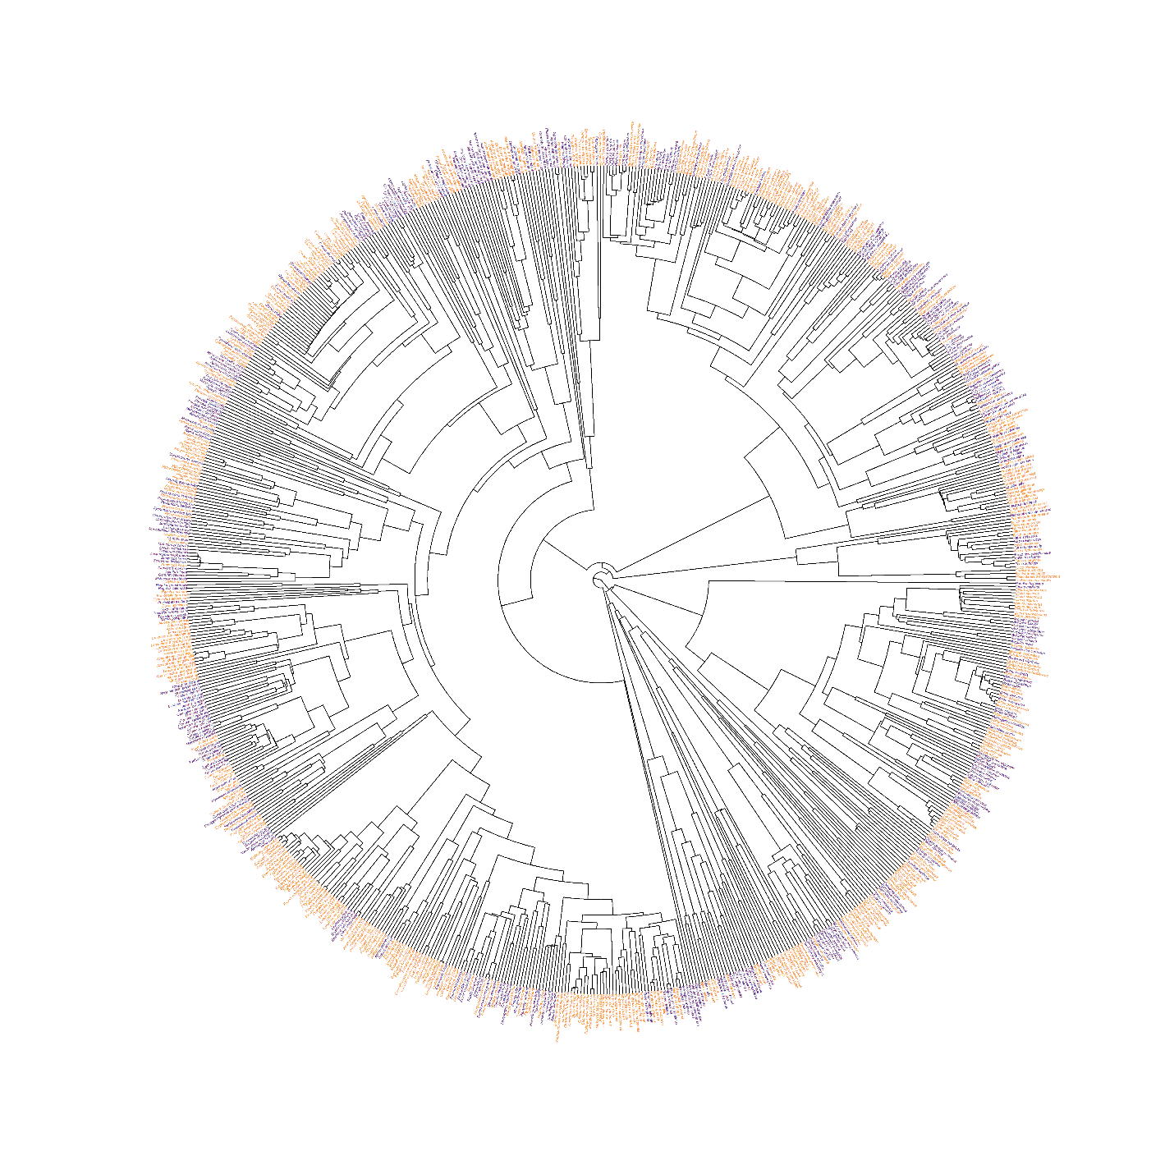

Figure 2.2. Evolution of Communal Roosting Behaviour in Core Land Birds

*Biological variables and CRB*

The first set of models favored the model with biological variables over the null model (259.5 Model_1 over null model, Figure 2.3). These suggests that overall, phylogeny alone cannot explain the evolution of this behaviour. However, Rhat values in my model are currently greater than 1(Figure 2.4), which suggest the model has not converged properly so results of the model should be cautiously interpreted.

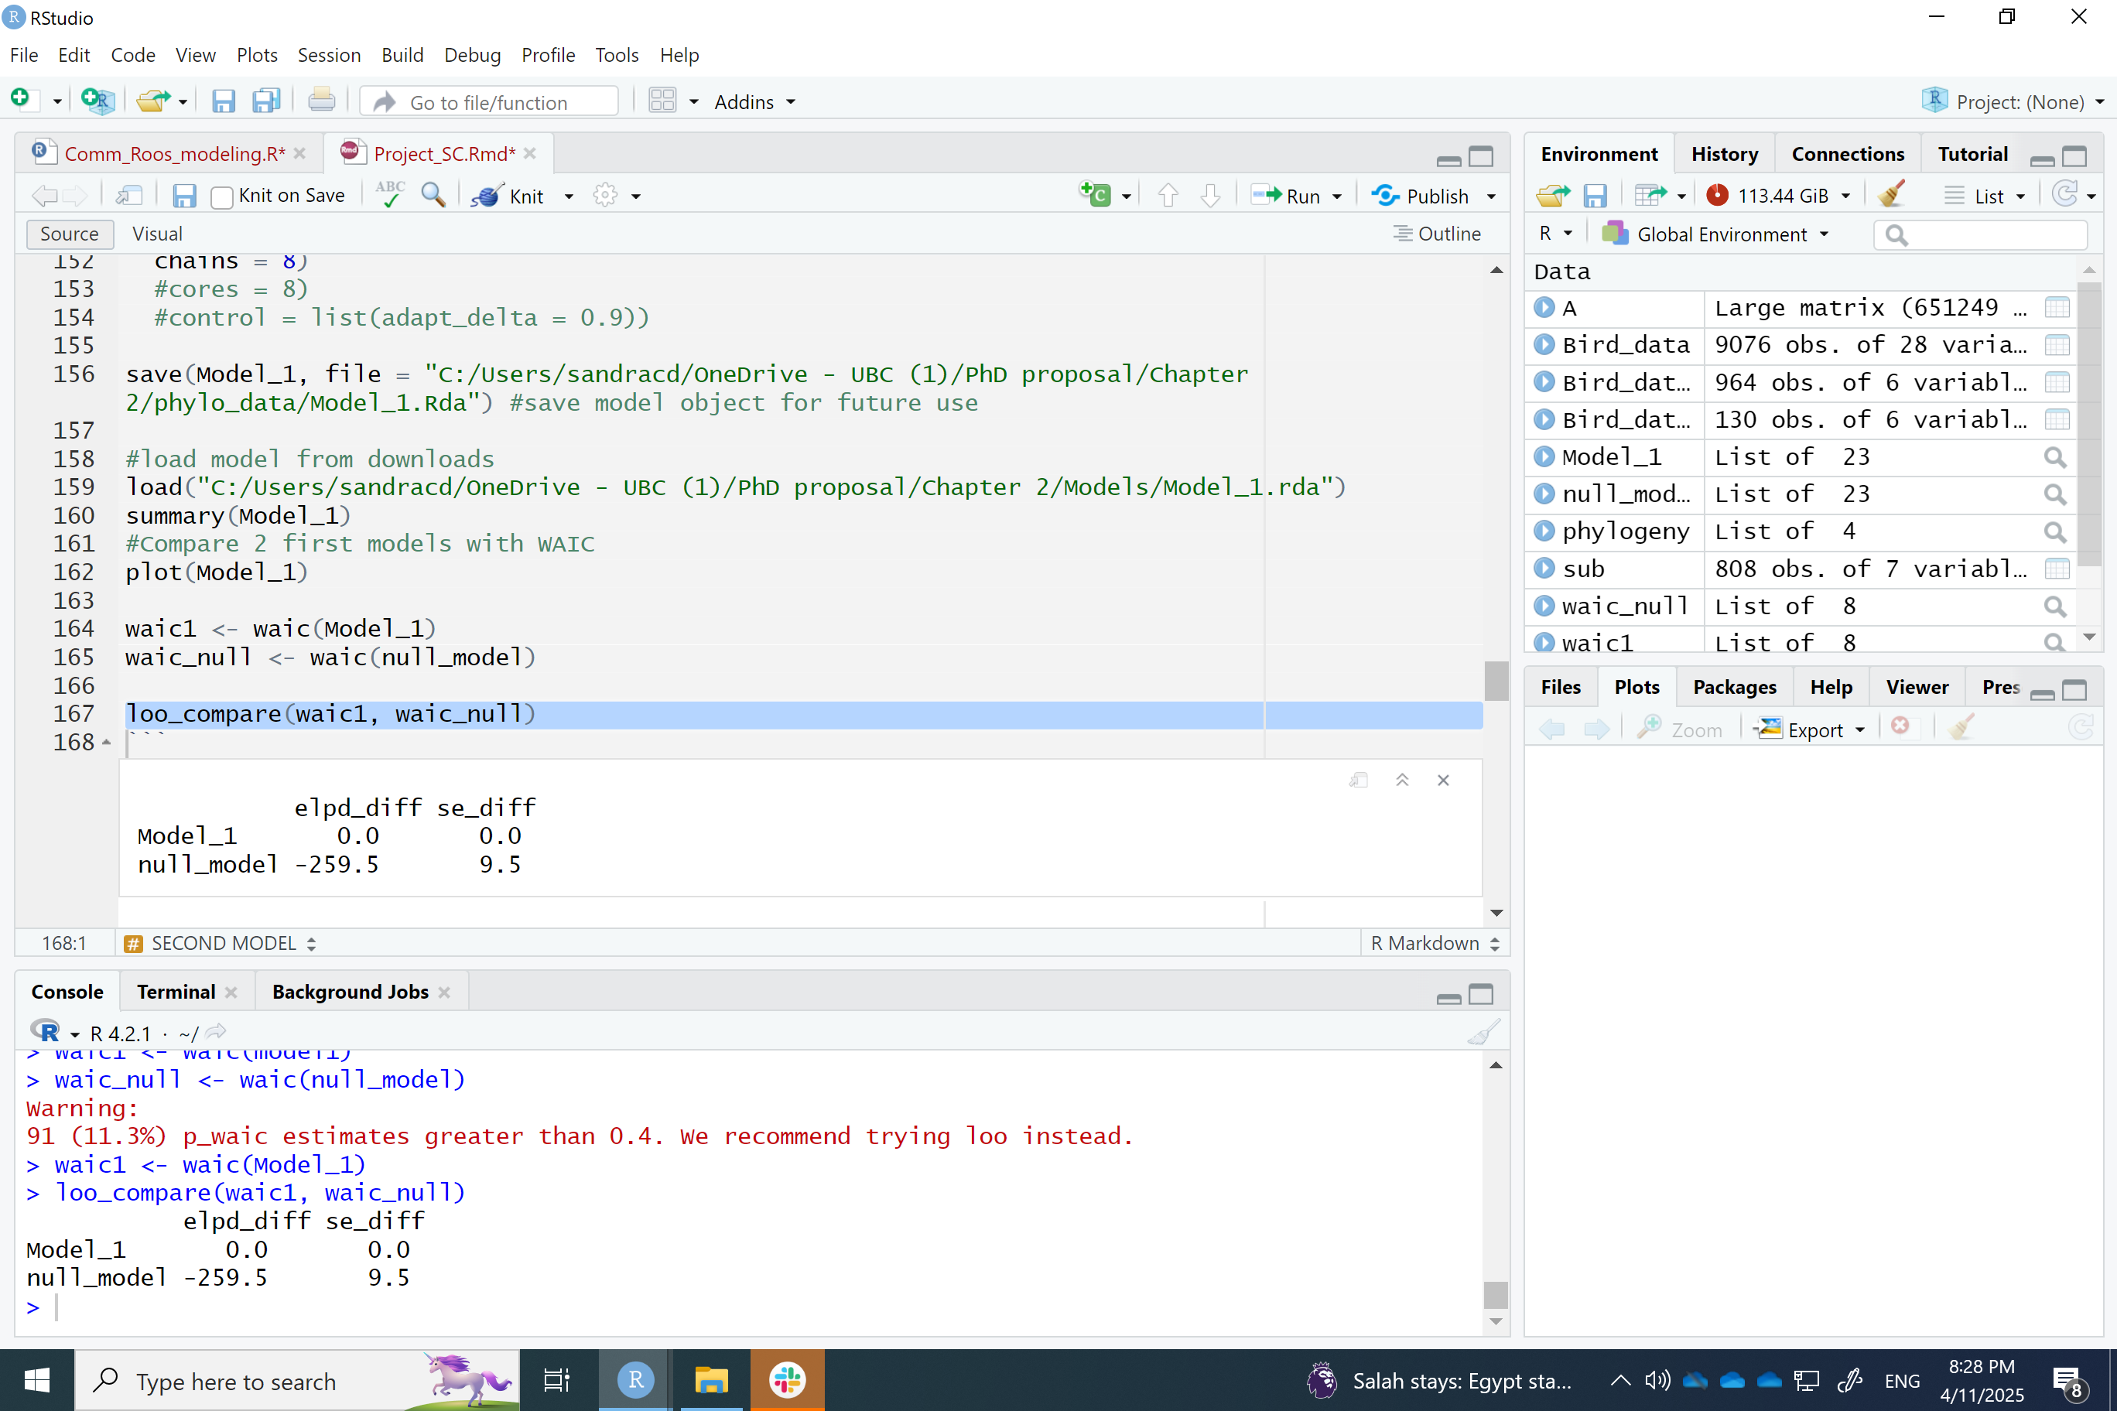

Figure 2.3 Model comparison between global (all data model) and null model.

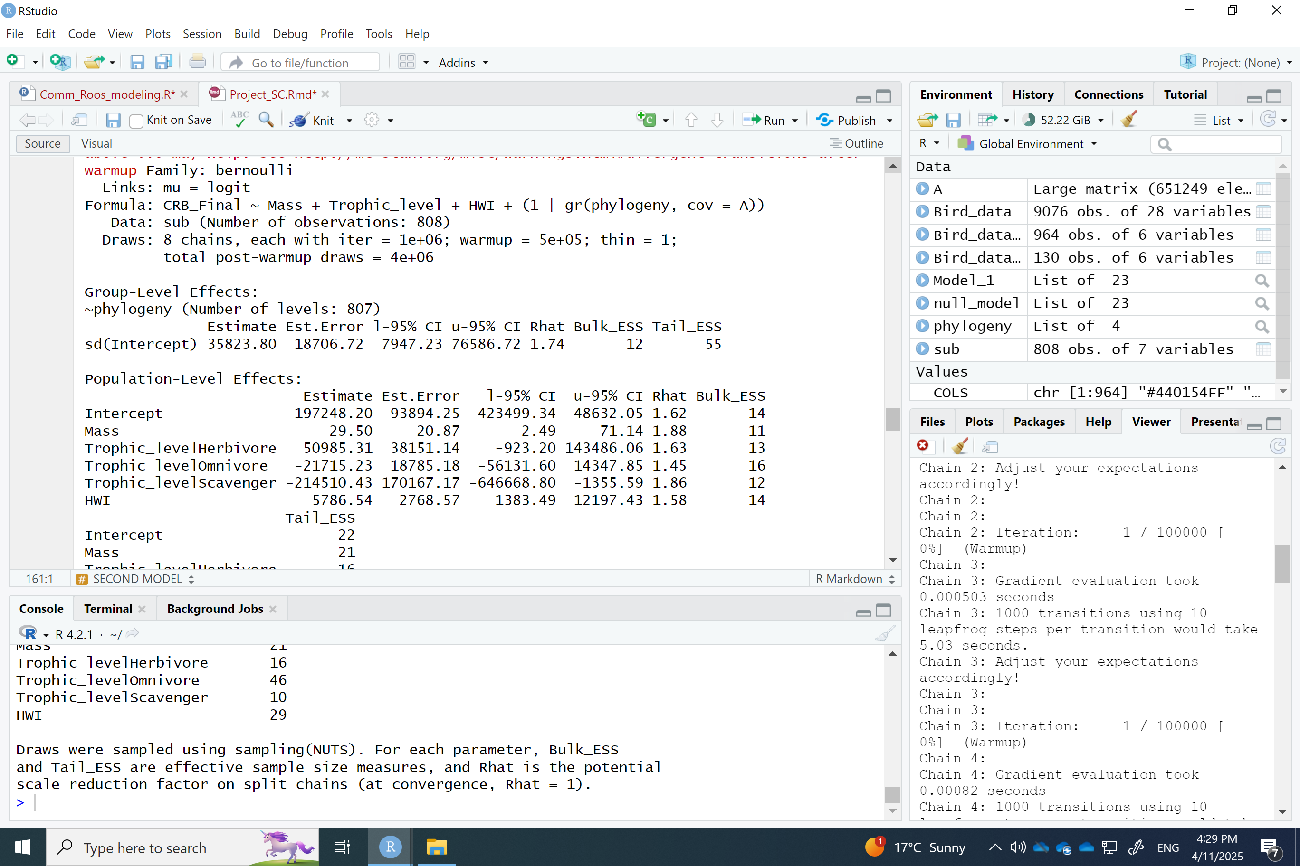

Figure 2.4. Summary of global model.

*Transition to CRB -* Section on ancestry of the behaviour

Include in the discussion

*Model assumptions*

* The model assumes that the probability of CRB follows a binomial distribution (hence the Bernoulli family in the link function).
* HWI, mass and trophic guild are fixed effects and there are no changes in the slopes of each of these predictors (no interaction terms).
* There is no collinearity between the predictor variables – this has been tested and therefore validated.
* The only random effect in the data structure is phylogeny, and that the phylogenetic structure is properly modeled.
* The variables follow a linear function (e.g., not polynomial)

**Discussion**

Communal Roosting Behaviour has been widely documented in different taxa with several explanations for this behaviour. Our results suggest that the ICH is the most likely hypothesis to explain this behaviour given its predominance on species across all taxa and that inhabit a wide array of environments with contrasting weather conditions (e.g., Mindt et al., 2024, Preston, 2005; Saldanha et al., 2019).

*Hand Wing Index and Communal Roosting Behaviour*

Our results supported the idea of a positive relationship between HWI and pCRB. These findings support the hypothesis of dispersing ability to promote this form of behaviour, which has been discussed by other authors. For example, a study done by (Caccamise & Morrison, 1986)) suggests that European starlings (*Sturnus vulgaris*) gather in aggregations near supplementary feeding areas (SFA) to reduce the energetic cost of traveling to food sources. The rationale is that even if the individuals can commute long distances to feed in distant areas, they may benefit from roosting near the SFA. Hence, it is plausible to suggest that species that have high dispersal ability used to find food sources have evolved communal roosting behaviour to reduce the energetic cost of feeding. Indeed, the sole idea of having supplemental feeding areas rests on the assumption that species can and have to disperse further away from their territories. In this study, the authors propose that individuals are more faithful to roosts near SFA rather than a stable communal roost. Nevertheless, the benefits of roosting (regardless of which type of roost) are inherently the same (e.g., Sonerud et al. 2002) support this hypothesis. In a recent study, Weeks et al. (2022) reported a strong correlation in birds between species with aerial lifestyle and HWI, arguing that species that rely highly on aerial lifestyles (e.g., commuting between roosting sites and foraging areas) have developed more efficient flight. Although they suggest that aerial lifestyle and efficient flight coevolve, here I propose that efficient flight mode is the driver of aerial lifestyle (e.g., Reliance on CRB) and not vice versa.

*Mass and Communal Roosting Behaviour*

Body mass has long been recognized to affect lifespan (Healy et al., 2014) and therefore metabolic rate (Kleiber 1932; Peters, 1983); Hudson et al., 2013; Nagy et al., 1999). A comprehensive literature review done by (Hudson et al., 2013) outlines the studies done on this matter, highlighting the idea that there is variation on how the relationship scales between clades (e.g., birds, mammals, amphibians). While the scale at which body mass and metabolic rate relate is still being debated, it is reasonable to say that the greater the body size, the higher metabolic rates needed to sustain that amount of mass (Gillooly et al., 2001). For instance, high metabolic rates has been correlated to behaviours like torpor in hummingbirds, and food hoarding in several birds and mammals (Day & Bartness, 2003). The results of this study show that communal roosting behaviour is positively correlated to body mass, perhaps since by increasing foraging efficiency, communal roosting acts as a mechanism to reduce energetic costs (metabolic rate). There is evidence that suggests that communal roosting behaviour is positively related to longevity in parrots (Munshi-South & Wilkinson, 2006). Likewise, longevity is positively related to body mass (Healy et al., 2014). Therefore, it is possible to extend these results to suggest communal roosting is positively correlated to body mass as shown by my results. An extension of this idea could be tested by measuring metabolic rate in particular, rather than body mass. Specifically, mass-specific metabolic rate (Suarez & Gass, 2002) could shed light into more accurate relationship. However, these measures are not available for the vast majority of species.

*Trophic level and Communal Roosting Behaviour*

My model shows that trophic level scavenger has a significant effect on CRB (although not any of the other trophic levels). This is not surprising considering the vast number of scavengers that have been documented to exhibit communal roosting (e.g., ravens, vultures). Because communal roosting has been found to increase foraging efficiency, it is reasonable to suggest that species that rely on ephemeral and unpredictable spatial-temporal food sources are particularly prone to take advantage of communal roosting (Kohles et al., 2022). However, communal roosting has evolved in other trophic levels as well. For instance, several seed parrots also show communal roosting (Munshi-South & Wilkinson, 2006). This may be indeed to increase group-foraging efficiency, but additional benefits may arise from this behaviour. A study conducted on starlings (*Sturnus vulgaris*) where access to food was manipulated showed that receivers (naïve individuals) reacted to senders (e.g., individuals with access to food) by changing their foraging effort, as well as their vigilant activity. Therefore, species that have natural predators also benefit from CRB (Fern�ndez-Juricic & Kacelnik, 2004).

*Brain size and Communal Roosting Behaviour*

Social behaviours that rely on memory have been widely documented for birds (e.g., Boeckle & Bugnyar, 2012; Penndorf et al., 2023). The results of this study suggest that memory is positively correlated with Communal Roosting Behaviour. Memory, in particular spatial memory, is important for individuals to be able to benefit from CRB efficiently since they require the capacity to remember the locations of food items, and return to those sits on subsequent foraging trips (Ward and Zahavi 1973, Dywer et al. 2018), as well as returning back to their communal roosts. A study conducted on bats showed that spatial memory together with social cues were key for individuals to track the resources efficiently (Lourie et al., 2024). Other study in bats showed how they relied on spatial memory to find their communal roosts (Hernández-Montero et al., 2020). Clearly, spatial memory has been well established as a mechanism for food finding in wildlife (Brodbeck, 1994; Marzluff, 2010; McGREGOR & Healy, 1999). Testing for this relationship requires a measure of memory that can be obtained and compared across a wide range of taxa. Unfortunately, direct measures of memory are challenging to obtain, and typically require some form of recall experiments (Brady et al. 2023) or data that might not be available for all species. For instance, it has been suggested that hippocampus volume is a good proxy for spatial memory in birds (Garamszegi and Ens 2004). However, data on hippocampus volume for all bird species are not readily available, which limits the scope of its application. Because lab experimentation was not feasible for the scope of this work, I used the residuals of the brain mass to body mass relationship as a proxy for memory. Residuals were chosen over brain size due to the strong correlation between brain size and body size (Smaers et al. 2021). Though not an explicit measure of memory, these residuals have been showed to correlate with individual cognitive capacity under experimental settings (Burns et al. 2008, Benson-Amram et al. 2016), and also relate to food caching in birds (Garamszegi and Ens 2004). Collectively, these lines of evidence support the use of the brain mass to body mass residuals as a robust proxy for memory in birds.

*Alternative predictors: Predictability of food sources and food abundance*

Access to regular food sources is a determinant factor on populations fitness. It is not surprising therefore that species that feed on ephemeral food sources tend to exhibit communal roosting behaviour. This can be explained to the fact that their food source is limited and unpredictable, which makes it impossible for these species to defend a territory. Therefore, as proposed by the ICH, sharing information on food sources is especially beneficial for such species. This phenomenon has been observed in species with different feeding strategies. For instance, a study by (Farquhar et al., 2018) showed that the increase in probability in communal roosting (huddling) of Chimney swifts (*Chaetura pelagica*) was associated to higher temperatures, which was correlated to lower prey availability. Similarly, Brown & Brown (1996) showed that cliff swallows (*Petrochelidon pyrrhonota*) tend to form large aggregations near ephemeral but abundant insect patches. Predictability of food sources expands beyond the nature of the trophic guild itself and suggests that for example, for a given scavenger species, if their food source is predictable (e.g., dumpsites), the need to exhibit communal roosting might decrease. Yet, using opportunistic more reliable food sources has seldom evolved in geologic timescales. Thus, while some plasticity of CRB may be observed in recent years for some species, the origin of the behaviour or lack thereof cannot be attributed to these human-induced scenarios.

Similarly, food abundance may have an effect on CRB. A wider amount of available food sources effectively means less need to defend a territory. From a cost-benefit perspective, greater abundance of food sources means there are more benefits of sharing location of food sources than defending a territory for a widely available resource (as long as all individuals can access the resource). For example, it has been documented that food availability may induce communal roosting behaviour in highly territorial species (Great-Horned Owl). This is because high availability of food in a farm location makes it easy for everyone to access resources without the need to compete for it ((Robinson & Davis, 2014). One could argue that a greater amount of food resources may mean less need to communal roost since the food is available for everyone. This may hold true to some extent, in which case perhaps communal roosting is favored only after a threshold is reached in which every individual has enough access to the resource (e.g., Buckley, 1997), and in which case communal roosting may be bringing other benefits than information sharing (e.g., a quadratic relationship). A comprehensive review was done by Kohles et al. (2022) and they propose a framework in which social information benefits can be tested as a function of the type or abundance and predictability of resource that was tested on bats. This framework may be useful to test birds’ sociality in the same fashion to complement my research.

Noteworthy, ambient temperature seems to be an important predictor variable as well, where CRB might be beneficial during the winter in higher latitudes for temperature regulation. For instance, when there is food scarcity, communal roosting might be induced as a way to reduce heat loss (Lubbe et al., 2018). Hence, food availability may also be confounded with ambient temperature. While it is possible that in these scenarios, the evolution of CRB could be driven by environmental rather than biological factors, the likelihood is low given that habitats have been subject to dramatic climate variabilities in the last 10 000 years (Alley & Agustsdottir, 2005), so we cannot assume that current environmental conditions drove the evolution of CRB in species seen today.

Finally, while communal roosting has most likely evolved to increase foraging efficiency in flock-living birds (Sonerud et al., 2002), we cannot discard that the behaviour has been maintained because it also may decrease predation risk (Gilbert et al., 2010), thermal stress (e.g., Wojciechowski et al., 2011), and the cost of mate assessment (Beauchamp 1999; Blanco and Tella 1999) as suggested by other alternative hypothesis.

*Limitations*

Although the aforementioned variables are suggested important drivers of CRB, other confounding variables may influence in the evolution of this behaviour. For instance, while it is true that the ICH may hold true for several scavenger species, prey species may also benefit from this phenomenon to share information of potential predators. Similarly, a major challenge of memory as a predictor is that it could be correlated to trophic guild, another predictor variable that has been proposed for the model. In particular, several vultures and corvids have good memory and cognitive abilities for problem solving (Weir et al. 2002, Lefebvre et al. 2004, Van Overveld et al. 2022). Because all vultures and many corvids (e.g., ravens, crows, magpies) are also scavengers, the coincidence (or correlation) between trophic guild and cognitive abilities may hinder my capacity to link memory and communal roosting behaviour.

Another limiting factor is the use of brain size residuals as a proxy for memory since these are also related to other aspects such as cognition (Biegler et al. 2001, Burns et al. 2008, Benson-Amram et al. 2016), intelligence (Dickie & Roth 2016) or other biological traits like life expectancy (Smeele et al. 2022). Thus, there is a risk that a relationship between brain size residuals and roosting behaviour may be due to correlates with other variables other than memory *per se*. Alternatively, other patterns could obscure the relationship between the proposed variables. For instance, research has suggested that neuronal connections are more accurately related to cognitive abilities than is brain volume (Logan et al. 2018). Nonetheless, neuronal connections might not necessarily be positively correlated with brain mass to body mass residuals, which would limit the use of the latter as a proxy. Albeit, the density of neuronal connections is significantly more complicated to measure and it requires an invasive approach far beyond the scope of my research. Similarly, memory may lead to other behaviours that are not necessarily communal roosting under the foraging efficiency hypothesis. For instance, greater memory could lead to food hoarding (Clayton & Krebs 1995). Here, individuals do not rely on sociality to successfully access foraging sites, although they do rely on memory. Alternatively, memory (or intelligence) could increase the ability to rely on local enhancement (Everding & Jones, 2006), where individuals don’t exhibit communal roosting but rather loose aggregation that rely on visual cues of conspecifics to find food. Hence, greater memory might not necessarily correlate to communal roosting behaviour alone. Further research should expand on this hypothesis using the data collected as part of this research.

Finally, there is a limitation in my ability to detect CRB. For instance, a study conducted in fish showed that their social cohesion varied depending on the state of hunger. Individuals that were food-deprived were less likely to join shoals, possibly to reduce competition with conspecifics (Killen et al., 2016). This suggests that the tendency to exhibit a social behaviour state that increases foraging efficiency (e.g., communal roosting) may also be determined by the degree of urgency of feeding. A study conducted on American Robins found that the patterns of communal roosting behaviour were consistent with food finding (more communal roosting by juveniles, more communal roosting later in the season, foraging areas used on consecutive days were farther apart after robins roosted communally, and home ranges were bigger for robins that used the communal roost more, Benson et al., 2012). It is worth noting that this condition does not suffice to drive the evolution of the behaviour itself in a species, but instead affect the frequency of the behaviour, which may hinder ability to detect it, which would ultimately impact the outcome of my model. In my model, CRB was classified as a binary response variable (0,1), however, as data becomes more available, it would be interesting to test biological (and ecological) variables against the frequency of CRB (as a percentage). Yet again, this information is not currently available for the vast majority of species.

*Future work*

One of the major limitations of this study is the available information on communal roosting for several bird species. A large volume of research is conducted on a handful few species only. Conducting more field observations on understudied species may help to bridge that information gap. Another approach to do so would be the use of weather radar data (e.g., Cheng et al., 2020), but this approach is limited to where weather radars are available.

Additionally, whilst the current research shed light on relevant drivers of CRB, further examination of the proposed variables should be tested to increase the accuracy of the predictions and better understand the biological processes behind the correlation. For instance, we acknowledge that the proxy used for memory is a limiting factor. Assessing the same correlation with other measures of memory (e.g., hippocampus size) may provide more accurate results. Furthermore, testing these models with empirical data from a random sample of species may also help to validate the models proposed. Significant work has been done on corvids and parrots, but other species remain underrepresented in the study of memory.

Testing the effects of ecological drivers (e.g., food abundance and predictability) is also a relevant task. Although terrestrial productivity at a global scale can be measured through NDVI and this measure can act as a proxy for abundance of food sources, that measure is seldom useful for the current research since several species exist on a vast geographic range with contrasting productivities. For instance, Peregrine falcons (*Falco peregrinus*) exist in every continent except Antarctica (Birdlife International, 2021). This makes it impossible to model their associated habitat productivity without oversimplifying the model. Thus, adopting a conservative approach, this variable was not considered here. However, doing a more detailed analysis at a local scale could take this into consideration. Moreover, coupled with weather, productivity of habitats has changed over time, often at geological scales. Hence, using current productivity might not be representable to determine the evolution of CRB. Even if we establish a correlation, causation could not be concluded.

Abundance of food sources has another challenge: number or resources and dietary breadth. A question arises of whether resource abundance of number of different items is more important. For instance, is it more important for Great-Horned Owls to have more mice or different prey sources despite low numbers of each? In addition, measuring dietary breadth poses its own challenges given that the level at which we group the diet items has a direct impact on the estimation of dietary breadth. Take, for example, a seed eater. Are seeds an item in the diet, or are each type of seed important? Although from a nutritional point of view these are important questions to consider, that is beyond the scope of the current research. From a conceptual and empirical point of view, this measurement is not feasible at a global scale.

Finally, testing the idea that species exhibiting communal roosting behaviour are more efficient at finding food sources would provide valuable information to expand the current research. This can be feasibly done with movement data using ballistic length scales as a proxy for foraging efficiency, or experimental designs placing feeding stations in the landscape coupled with movement data.

**Bibliography**

Alley, R., & Agustsdottir, A. (2005). The 8k event: Cause and consequences of a major Holocene abrupt climate change. *Quaternary Science Reviews*, *24*(10–11), 1123–1149. https://doi.org/10.1016/j.quascirev.2004.12.004

Anderson, J. R. (1998). Sleep, sleeping sites, and sleep-related activities: Awakening to their significance. *American Journal of Primatology*, *46*(1), 63–75. https://doi.org/10.1002/(SICI)1098-2345(1998)46:1<63::AID-AJP5>3.0.CO;2-T

Aplin, L. M. (2019). Culture and cultural evolution in birds: A review of the evidence. *Animal Behaviour*, *147*, 179–187. https://doi.org/10.1016/j.anbehav.2018.05.001

Arango, A., Pinto-Ledezma, J., Rojas-Soto, O., Lindsay, A. M., Mendenhall, C. D., & Villalobos, F. (2022). Hand-Wing Index as a surrogate for dispersal ability: The case of the Emberizoidea (Aves: Passeriformes) radiation. *Biological Journal of the Linnean Society*, *137*(1), 137–144. https://doi.org/10.1093/biolinnean/blac071

Beauchamp, G. (1999). The evolution of communal roosting in birds: Origin and secondary losses. *Behavioral Ecology*, *10*(6), 675–687. https://doi.org/10.1093/beheco/10.6.675

Benson, T. J., Ward, M. P., Lampman, R. L., Raim, A., & Weatherhead, P. J. (2012). Implications of Spatial Patterns of Roosting and Movements of American Robins for West Nile Virus Transmission. *Vector-Borne and Zoonotic Diseases*, *12*(10), 877–885. https://doi.org/10.1089/vbz.2011.0902

Boeckle, M., & Bugnyar, T. (2012). Long-Term Memory for Affiliates in Ravens. *Current Biology*, *22*(9), 801–806. https://doi.org/10.1016/j.cub.2012.03.023

Brodbeck, D. R. (1994). Memory for spatial and local cues: A comparison of a storing and a nonstoring species. *Animal Learning & Behavior*, *22*(2), 119–133. https://doi.org/10.3758/BF03199912

Buckley, N. J. (1997). Spatial‐Concentration Effects and the Importance of Local Enhancement in the Evolution of Colonial Breeding in Seabirds. *The American Naturalist*, *149*(6), 1091–1112. https://doi.org/10.1086/286040

Caccamise, D. F., & Morrison, D. W. (1986). Avian Communal Roosting: Implications of Diurnal Activity Centers. *The American Naturalist*, *128*(2), 191–198. https://doi.org/10.1086/284553

Cheng, Z., Gabriel, S., Bhambhani, P., Sheldon, D., Maji, S., Laughlin, A., & Winkler, D. (2020). Detecting and Tracking Communal Bird Roosts in Weather Radar Data. *Proceedings of the AAAI Conference on Artificial Intelligence*, *34*(01), 378–385. https://doi.org/10.1609/aaai.v34i01.5373

Curk, Te., Rast, W., Portas, R., Kohles, J., Shatumbu, G., Cloete, C., Curk, Ti., Radchuk, V., Aschenborn, O., & Melzheimer, J. (2025). Advantages and disadvantages of using social information for carcass detection–A case study using white-backed vultures. *Ecological Modelling*, *499*, 110941. https://doi.org/10.1016/j.ecolmodel.2024.110941

Day, D. E., & Bartness, T. J. (2003). Fasting-induced increases in food hoarding are dependent on the foraging-effort level. *Physiology & Behavior*, *78*(4–5), 655–668. https://doi.org/10.1016/S0031-9384(03)00052-0

Everding, S. E., & Jones, D. N. (2006). Communal roosting in a suburban population of Torresian crows (Corvus orru). *Landscape and Urban Planning*, *74*(1), 21–33. https://doi.org/10.1016/j.landurbplan.2004.09.024

Farquhar, M. L., Morin, A., & Nocera, J. J. (2018). High ambient temperatures induce aggregations of chimney swifts *Chaetura pelagica* inside a roost. *Journal of Avian Biology*, *49*(8), e01754. https://doi.org/10.1111/jav.01754

Fern�ndez-Juricic, E., & Kacelnik, A. (2004). Information transfer and gain in flocks: The effects of quality and quantity of social information at different neighbour distances. *Behavioral Ecology and Sociobiology*, *55*(5), 502–511. https://doi.org/10.1007/s00265-003-0698-9

Franklin, D. C., Garnett, S. T., Luck, G. W., Gutierrez-Ibanez, C., & Iwaniuk, A. N. (2014). Relative brain size in Australian birds. *Emu*. https://doi.org/10.1071/MU13034

Gilbert, C., McCafferty, D., Le Maho, Y., Martrette, J., Giroud, S., Blanc, S., & Ancel, A. (2010). One for all and all for one: The energetic benefits of huddling in endotherms. *Biological Reviews*, *85*(3), 545–569. https://doi.org/10.1111/j.1469-185X.2009.00115.x

Gillooly, J. F., Brown, J. H., West, G. B., Savage, V. M., & Charnov, E. L. (2001). Effects of Size and Temperature on Metabolic Rate. *Science*, *293*(5538), 2248–2251. https://doi.org/10.1126/science.1061967

Guay, P.-J., & Iwaniuk, A. N. (2008). CAPTIVE BREEDING REDUCES BRAIN VOLUME IN WATERFOWL (ANSERIFORMES). *The Condor*, *110*(2), 276–284. https://doi.org/10.1525/cond.2008.8424

Gyllin, R., Källander, H., & Sylvén, M. (1977). THE MICROCLIMATE EXPLANATION OF TOWN CENTRE ROOSTS OF JACKDAWS *CORVUS MONEDULA*. *Ibis*, *119*(3), 358–361. https://doi.org/10.1111/j.1474-919X.1977.tb08255.x

Harel, R., Spiegel, O., Getz, W. M., & Nathan, R. (2017). Social foraging and individual consistency in following behaviour: Testing the information centre hypothesis in free-ranging vultures. *Proceedings of the Royal Society B: Biological Sciences*, *284*(1852), 20162654. https://doi.org/10.1098/rspb.2016.2654

Haslam, M., Hernandez-Aguilar, A., Ling, V., Carvalho, S., De La Torre, I., DeStefano, A., Du, A., Hardy, B., Harris, J., Marchant, L., Matsuzawa, T., McGrew, W., Mercader, J., Mora, R., Petraglia, M., Roche, H., Visalberghi, E., & Warren, R. (2009). Primate archaeology. *Nature*, *460*(7253), 339–344. https://doi.org/10.1038/nature08188

Healy, K., Guillerme, T., Finlay, S., Kane, A., Kelly, S. B. A., McClean, D., Kelly, D. J., Donohue, I., Jackson, A. L., & Cooper, N. (2014). Ecology and mode-of-life explain lifespan variation in birds and mammals. *Proceedings of the Royal Society B: Biological Sciences*, *281*(1784), 20140298. https://doi.org/10.1098/rspb.2014.0298

Hernández-Montero, J. R., Reusch, C., Simon, R., Schöner, C. R., & Kerth, G. (2020). Free-ranging bats combine three different cognitive processes for roost localization. *Oecologia*, *192*(4), 979–988. https://doi.org/10.1007/s00442-020-04634-8

Hudson, L. N., Isaac, N. J. B., & Reuman, D. C. (2013). The relationship between body mass and field metabolic rate among individual birds and mammals. *Journal of Animal Ecology*, *82*(5), 1009–1020. https://doi.org/10.1111/1365-2656.12086

Jetz, W., Thomas, G. H., Joy, J. B., Hartmann, K., & Mooers, A. O. (2012). The global diversity of birds in space and time. *Nature*, *491*(7424), 444–448. https://doi.org/10.1038/nature11631

Killen, S. S., Fu, C., Wu, Q., Wang, Y., & Fu, S. (2016). The relationship between metabolic rate and sociability is altered by food deprivation. *Functional Ecology*, *30*(8), 1358–1365. https://doi.org/10.1111/1365-2435.12634

Kohles, J. E., O’Mara, M. T., & Dechmann, D. K. N. (2022). A conceptual framework to predict social information use based on food ephemerality and individual resource requirements. *Biological Reviews*, *97*(6), 2039–2056. https://doi.org/10.1111/brv.12881

Kunz, T. H. (Ed.). (1982). *Ecology of Bats*. Springer US. https://doi.org/10.1007/978-1-4613-3421-7

Lewis, S. E. (1995). Roost Fidelity of Bats: A Review. *Journal of Mammalogy*, *76*(2), 481–496. https://doi.org/10.2307/1382357

Liem, K. F. (1990). Aquatic *Versus* Terrestrial Feeding Modes: Possible Impacts on the Trophic Ecology of Vertebrates. *American Zoologist*, *30*(1), 209–221. https://doi.org/10.1093/icb/30.1.209

Lourie, E., Shamay, T., Toledo, S., & Nathan, R. (2024). Spatial memory obviates following behaviour in an information centre of wild fruit bats. *Philosophical Transactions of the Royal Society B: Biological Sciences*, *379*(1912), 20240060. https://doi.org/10.1098/rstb.2024.0060

Lubbe, N., Czenze, Z. J., Noakes, M. J., & McKechnie, A. E. (2018). The energetic significance of communal roosting and insulated roost nests in a small arid-zone passerine. *Ostrich*, *89*(4), 347–354. https://doi.org/10.2989/00306525.2018.1538061

Luncz, L. V., Wittig, R. M., & Boesch, C. (2015). Primate archaeology reveals cultural transmission in wild chimpanzees ( *Pan troglodytes verus* ). *Philosophical Transactions of the Royal Society B: Biological Sciences*, *370*(1682), 20140348. https://doi.org/10.1098/rstb.2014.0348

Marzluff, J. M. (with Balda, R. P.). (2010). *The Pinyon Jay: Behavioral Ecology of a Colonial and Cooperative Corvid*. Bloomsbury Publishing Plc.

McGowan, A., Sharp, S. P., Simeoni, M., & Hatchwell, B. J. (2006). Competing for position in the communal roosts of long-tailed tits. *Animal Behaviour*, *72*(5), 1035–1043. https://doi.org/10.1016/j.anbehav.2006.02.020

McGREGOR, A., & Healy, S. D. (1999). Spatial accuracy in food-storing and nonstoring birds. *Animal Behaviour*, *58*(4), 727–734. https://doi.org/10.1006/anbe.1999.1190

Mercader, J., Barton, H., Gillespie, J., Harris, J., Kuhn, S., Tyler, R., & Boesch, C. (2007). 4,300-Year-old chimpanzee sites and the origins of percussive stone technology. *Proceedings of the National Academy of Sciences*, *104*(9), 3043–3048. https://doi.org/10.1073/pnas.0607909104

Munshi-South, J., & Wilkinson, G. S. (2006). Diet Influences Life Span in Parrots (Psittaciformes). *The Auk*, *123*(1), 108–118. https://doi.org/10.1093/auk/123.1.108

Nagy, K. A., Girard, I. A., & Brown, T. K. (1999). ENERGETICS OF FREE-RANGING MAMMALS, REPTILES, AND BIRDS. *Annual Review of Nutrition*, *19*(1), 247–277. https://doi.org/10.1146/annurev.nutr.19.1.247

Nowlin, W. H., Vanni, M. J., & Yang, L. H. (2008). COMPARING RESOURCE PULSES IN AQUATIC AND TERRESTRIAL ECOSYSTEMS. *Ecology*, *89*(3), 647–659. https://doi.org/10.1890/07-0303.1

Penndorf, J., Farine, D. R., Martin, J. M., & Aplin, L. M. (2023). *Parrot politics: Social decision-making in wild parrots relies on both individual recognition and intrinsic markers*. https://doi.org/10.1101/2023.10.02.560599

Peters, R. H. (1983). *The Ecological Implications of Body Size* (1st ed.). Cambridge University Press. https://doi.org/10.1017/CBO9780511608551

Preston, M. I. (2005). FACTORS AFFECTING WINTER ROOST DISPERSAL AND DAILY BEHAVIOUR OF COMMON RAVENS (CORVUS CORAX) IN SOUTHWESTERN ALBERTA. *Northwestern Naturalist*, *86*(3), 123–130. https://doi.org/10.1898/1051-1733(2005)086[0123:FAWRDA]2.0.CO;2

Robinson, B., & Davis, C. (2014). A Communal Roosting of the Great Horned Owl ( *Bubo virginianus* ). *Journal of Raptor Research*, *48*(1), 88–89. https://doi.org/10.3356/JRR-13-47.1

Saldanha, S., Taylor, P. D., Imlay, T. L., & Leonard, M. L. (2019). Biological and environmental factors related to communal roosting behavior of breeding Bank Swallow (Riparia riparia). *Avian Conservation and Ecology*, *14*(2), art21. https://doi.org/10.5751/ACE-01490-140221

Sassi, Y., Nouzières, B., Scacco, M., Tremblay, Y., Duriez, O., & Robira, B. (2024). The use of social information in vulture flight decisions. *Proceedings of the Royal Society B: Biological Sciences*, *291*(2018), 20231729. https://doi.org/10.1098/rspb.2023.1729

Sonerud, G., Hansen, H., & Smedshaug, C. (2002). Individual roosting strategies in a flock-living bird: Movement and social cohesion of hooded crows ( Corvus corone cornix ) from pre-roost gatherings to roost sites. *Behavioral Ecology and Sociobiology*, *51*(4), 309–318. https://doi.org/10.1007/s00265-001-0440-4

Suarez, R. K., & Gass, C. L. (2002). Hummingbird foraging and the relation between bioenergetics and behaviour. *Comparative Biochemistry and Physiology Part A: Molecular & Integrative Physiology*, *133*(2), 335–343. https://doi.org/10.1016/S1095-6433(02)00165-4

Twining, C. W., Brenna, J. T., Lawrence, P., Winkler, D. W., Flecker, A. S., & Hairston, N. G. (2019). Aquatic and terrestrial resources are not nutritionally reciprocal for consumers. *Functional Ecology*, *33*(10), 2042–2052. https://doi.org/10.1111/1365-2435.13401

Van Overveld, T., Sol, D., Blanco, G., Margalida, A., De La Riva, M., & Donázar, J. A. (2022). Vultures as an overlooked model in cognitive ecology. *Animal Cognition*, *25*(3), 495–507. https://doi.org/10.1007/s10071-021-01585-2

Weatherhead, P. J. (1983). Two Principal Strategies in Avian Communal Roosts. *The American Naturalist*, *121*(2), 237–243. https://doi.org/10.1086/284053

Weeks, B. C., O’Brien, B. K., Chu, J. J., Claramunt, S., Sheard, C., & Tobias, J. A. (2022). Morphological adaptations linked to flight efficiency and aerial lifestyle determine natal dispersal distance in birds. *Functional Ecology*, *36*(7), 1681–1689. https://doi.org/10.1111/1365-2435.14056

Wilkinson, G. S. (1985). The social organization of the common vampire bat: II. Mating system, genetic structure, and relatedness. *Behavioral Ecology and Sociobiology*, *17*(2), 123–134. https://doi.org/10.1007/BF00299244

Williams, J. B. (1994). Communal Cavity Roosting in Green Woodhoopoes: Consequences for Energy Expenditure and the Seasonal Pattern of Mortality. *The Auk*, *111*(2), 292–299. https://doi.org/10.2307/4088594

Wojciechowski, M. S., Jefimow, M., & Pinshow, B. (2011). Heterothermy, and the Energetic Consequences of Huddling in Small Migrating Passerine Birds. *Integrative and Comparative Biology*, *51*(3), 409–418. https://doi.org/10.1093/icb/icr055

Benson-Amram, S., Dantzer, B., Stricker, G., Swanson, E. M., & Holekamp, K. E. (2016). Brain size predicts problem-solving ability in mammalian carnivores. Proceedings of the National Academy of Sciences, 113(9), 2532–2537. <https://doi.org/10.1073/pnas.1505913113>

Biegler, R., McGregor, A., Krebs, J. R., & Healy, S. D. (2001). A larger hippocampus is associated with longer-lasting spatial memory. *Proceedings of the National Academy of Sciences*, *98*(12), 6941–6944. https://doi.org/10.1073/pnas.121034798

Brady, T. F., Robinson, M. M., Williams, J. R., & Wixted, J. T. (2023). Measuring memory is harder than you think: How to avoid problematic measurement practices in memory research. Psychonomic Bulletin & Review, 30(2), 421-449.

Burns, J. G., & Rodd, F. H. (2008). Hastiness, brain size and predation regime affect the performance of wild guppies in a spatial memory task. Animal Behaviour, 76(3), 911-922.

Clayton, N. S., & Krebs, J. R. (1995). Memory in food-storing birds: From behaviour to brain. *Current Opinion in Neurobiology*, *5*(2), 149–154. https://doi.org/10.1016/0959-4388(95)80020-4

Dicke, U., & Roth, G. (2016). Neuronal factors determining high intelligence. *Philosophical Transactions of the Royal Society B: Biological Sciences*, *371*(1685), 20150180. https://doi.org/10.1098/rstb.2015.0180

Dormann, C. F., Elith, J., Bacher, S., Buchmann, C., Carl, G., Carré, G., ... & Lautenbach, S. (2013). Collinearity: a review of methods to deal with it and a simulation study evaluating their performance. Ecography, 36(1), 27-46.

Dwyer, J. F., Fraser, J. D., & Morrison, J. L. (2018). Evolution of Communal Roosting: A Social Refuge–Territory Prospecting Hypothesis. *Journal of Raptor Research*, *52*(4), 407–419. https://doi.org/10.3356/JRR-17-101.1

Garamszegi, L. Z., & Eens, M. (2004). The evolution of hippocampus volume and brain size in relation to food hoarding in birds. Ecology letters, 7(12), 1216-1224.

Gould, S. J., & Vrba, E. S. (1982). Exaptation—a missing term in the science of form. Paleobiology, 8(1), 4-15.

Lefebvre L, Reader SM, Sol D (2004). Brains, innovations and evolution in birds and primates. Brain Behav Evol 63:233–246

Logan, C. J., Avin, S., Boogert, N., Buskell, A., Cross, F. R., Currie, A., Jelbert, S., Lukas, D., Mares, R., Navarrete, A. F., Shigeno, S., & Montgomery, S. H. (2018). Beyond brain size: Uncovering the neural correlates of behavioural and cognitive specialization. *Comparative Cognition & Behaviour Reviews*, *13*, 55–89. <https://doi.org/10.3819/CCBR.2018.130008>

Mindt, L. P., Catitti, B., Steiner, F. M., Schlick-Steiner, B. C., Grüebler, M. U., & Kormann, U. G (2024). Ontogeny of communal roosting behaviour in a long-lived raptor. *Carry-Over Effects across Life Stages in Red Kites Milvus milvus*, 86.

Smaers, J. B., Rothman, R. S., Hudson, D. R., Balanoff, A. M., Beatty, B., Dechmann, D. K. N., De Vries, D., Dunn, J. C., Fleagle, J. G., Gilbert, C. C., Goswami, A., Iwaniuk, A. N., Jungers, W. L., Kerney, M., Ksepka, D. T., Manger, P. R., Mongle, C. S., Rohlf, F. J., Smith, N. A., … Safi, K. (2021). The evolution of mammalian brain size. *Science Advances*, *7*(18), eabe2101. <https://doi.org/10.1126/sciadv.abe2101>

Smeele, S. Q., Conde, D. A., Baudisch, A., Bruslund, S., Iwaniuk, A., Staerk, J., Wright, T. F., Young, A. M., McElreath, M. B., & Aplin, L. (2022). Coevolution of relative brain size and life expectancy in parrots. *Proceedings of the Royal Society B: Biological Sciences*, *289*(1971), 20212397. https://doi.org/10.1098/rspb.2021.2397

Van Overveld, T., Sol, D., Blanco, G., Margalida, A., De La Riva, M., & Donázar, J. A. (2022). Vultures as an overlooked model in cognitive ecology. Animal Cognition, 25(3), 495–507.

Weir, A. A., Chappell, J., & Kacelnik, A. (2002). Shaping of hooks in New Caledonian crows. Science, 297(5583), 981-981.

Kleiber, M. (1932) Body size and metabolism. *Hilgardia*, **6**, 315–351.

SUPPLEMENTARY MATERIAL

A TABLE WITH ALL THE REFERENCES USED FOR BRAIN SIZE

Chaplin, S. B. (1982). The energetic significance of huddling behavior in common bushtits (Psaltriparus minimus). The Auk, 424-430.

Crile, G., & Quiring, D. P. (1940). A record of the body weight and certain organ and gland weights of 3690 animals. Ohio Journal of Science

MacMillen, R. E., Whittow, G. C., Christopher, E. A., & Ebisu, R. J. (1977). Oxygen consumption, evaporative water loss, and body temperature in the sooty tern. The Auk, 72-79.

Mlíkovský, J. (1990). Brain size in birds: 4. Passeriformes. Acta Soc Zool Bohem, 54, 27-37.

Mlíkovský, J. (2003). Brain size and forearmen magnum area in crows and allies (Aves: Corvidae). Acta Soc Zool Bohem, 67(1-4), 203-211.

Susan B. Chaplin (1982). The Energetic Significance of Huddling Behavior in Common Bushtits (*Psaltriparus minimus*), *The Auk*, Volume 99, Issue 3, July 1982, Pages 424–430, <https://doi.org/10.1093/auk/99.3.424>

Coleman JS and Fraser JD (1986). Predation on black and turkey vultures. Wilson Bull 98:600–601

Wrangham, R.W., & Rubenstein, D.I. (2014). *Ecological Aspects of Social Evolution*: *Birds and Mammals*. (Course Book ed.). Princeton: Princeton University Press. <https://muse.jhu.edu/book/34368>.