

**THE ORIGINS OF COMMUNAL ROOSTING BEHAVIOUR IN BIRDS**

MSc. research proposal

Submitted by Sandra Cuadros

Supervised by Dr. Michael Noonan

Committee Members

Dr. Adam Ford, Dr. Autumn-Lynn Harrison, & Dr. Karen Hodges

Department of Biology

University of British Columbia Okanagan

March2025

# **Abstract**

# **Lay Summary**

# **Preface**

**Table of Contents**

**Abstract** 2

**Lay Summary** 3

**Preface** 4

**List of Tables** 6

**List of Figures** 7

**List of Abbreviations** 8

**Acknowledgments** 9

**Dedication** 10

**Chapter 1: Movement ecology and foraging behaviour** 11

**1.1 Movement ecology in wildlife – an overview** 11

**1.2 The unique nature of avian foraging ecology** 13

**1.3 Movement ecology and bird foraging behaviour** 14

**1.4 Predictability of resources and foraging behaviour** 15

**1.5 Sociality and foraging behaviour** 15

**1.6 Memory and foraging behaviour** 16

**1.7 Foraging ecology and conservation implications** 17

**1.8 Knowledge gaps and future directions** 18

**1.9 Thesis aims and structure** 19

**Chapter 2: Sharing is caring - The evolution of communal roosting behaviour in birds** 20

**2.1 Introduction** 20

**2.2 Methods** 23

**2.2.1 Biological variables** 23

**2.2.2 Communal roosting behaviour** 24

**2.2.3 Phylogenetic data** 26

**2.2.4 Statistical analyses** 26

**2.3 Results** 27

**2.3.1 The distribution of Communal Roosting** 27

**2.3.3 Biological variables and CRB** 28

**2.4 Discussion**  33

**2.4.1 Hand Wing Index and Communal Roosting Behaviour** 33

**2.4.2 Mass and Communal Roosting Behaviour** 34

**2.4.3 Trophic level and Communal Roosting Behaviour** 34

**2.4.4. Brain size and Communal Roosting Behaviour** 35

**2.4.5 Alternative predictors: Predictability of food sources and food abundance** 36

**2.4.6 Limitations** 37

**2.4.7 Future work** 39

**Chapter 3: The need for ecological studies in social species** 41

**3.1 Introduction** 41

**3.2 Why vultures?** 42

**3.3 A note on the Information Center Hypothesis** 42

**3.4 Size matters: The Andean Condor – A peculiar case study** 43

**Bibliography** 44

# **List of Tables**

# **List of Figures**

***Figure 0‑1Figure 2.1*** *Evolution of Communal Roosting Behaviour in Core Land Birds across different taxa. Data shows the convergence evolution of this behaviour. Data was collected through Birds of the World and a Google scholar search.* 29

# **List of Abbreviations**

|  |  |
| --- | --- |
| CRB | Communal Roosting Behaviour |
| DIC | Deviance Information Criteria |
| HWI | Hand-wing Index |
| ICH | Information Center Hypothesis |
| UBCO | University of British Columbia, Okanagan Campus |
| pCRB | Probability of Communal Roosting Behaviour |
|  |  |

# **Acknowledgments**

# **Dedication**

# **Chapter 1: The benefits of being a social butterfly – Evolution of Communal Roosting Behaviour in Birds**

## **1.1 Introduction**

Understanding why species differ in their social behaviour has fascinated biologists for years (Wrangham & Rubenstein, 2014). Sociality is documented not only in several taxa (e.g., fish, mammals, birds) but also in different aspects of their ecology (e.g., birds mating in leks, kettle of raptors migrating together, lions hunting and foraging together). The occurrence of the wide array of social behaviours in wildlife suggests there are set benefits to socializing with conspecifics. For instance, it has been discussed in the literature that one possible benefit from breeding in colonies is enhanced efficiency in exploiting an unevenly distributed food supply (Fisher 1954), which is supported by findings in Brewer’s Blackbird (*Euphagus cyanocephalus)* (Horn 1968). Similarly, collective sensing in massive flocks of passenger pigeons (*Ectopistes migratorius*) may have helped birds locate spatially and temporally unpredictable food patches (Guiry et al. 2020, Aikens et al. 2022). The benefits of sociality are also widely documented in colonial seabirds, where hundreds of breeding pairs gather on islands for breeding and chick-rearing, and search for food around the colonies as proposed by the central-place foraging model (Ashmole, 1963; Houston, 1985; Monier, 2024). Research has shown how individuals from a colony use information from others to find feeding sites (Camphuysen et al., 2006, Bairos-Novak et al., 2015) , and there is empirical evidence that demonstrates the benefits of such behaviour (Thiebault et al., 2014a; Thiebault et al., 2014b). Whether intentional or inadvertent (e.g., (Bijleveld et al., 2010), there is a transfer of information from informed to naïve individuals in the colony such that the latter benefit from being in the group (Weimerskirch et al., 2010). In time, roles could change, and the naïve can gain new information. In this way, remaining social benefits the group collectively.

Other aspects of the ecology of wildlife have also been studied through the lens of social behaviour. For example, during migration animals need to make complex decisions about where and when to migrate. These decisions may have a direct impact on survival and fitness, and hence it is a challenging process even for adult experienced individuals. During migration, individuals can guide themselves through previous personal experience (asocial learning, sensu Laland, 2004), but to gain such experience individuals need to invest significant amount of time and energy (Németh & Moore, 2014). More importantly, the information gained through time can be outdated when navigating in unpredictable environments. To reduce the risk and uncertainties of these new surroundings, individuals need to constantly gather information about the immediate and changing environment. In this context, observing other individuals and their behaviour (social learning) provides a shortcut to acquiring information (Németh & Moore, 2014). This transfer of information may reduce predation risk, increase foraging efficiency, and therefore play an important role in the collective decision-making (Aikens et al. 2022). Despite its evident benefits during migration, this information transfer mechanism can also be seen in local movements. A study conducted by Kano et al. (2021) shows how homing pigeons (*Columbia livia domestica*) increase reliance on social cues during collective navigation likely to reduce predation risk. Altogether, these examples provide insight into how individuals leverage sociality to gain information outside of their perceptual range to make more accurate or efficient decisions.

One interesting form of social behaviour is that of communal roosting (hereon CR). Communal roosts are aggregations of unrelated individuals (either con- or heterospecific) that spend the resting period (either diurnal or nocturnal) together (Laughlin et al. 2014). Communal roosting is seen in species across many taxa, including fish (Clough and Ladle 1997), mammals (Kunz, 1982) and birds (Eiserer 1984). In birds, communal roosting is seen in species like crows and ravens, vultures, eagles, parrots, swallows, some falcons, etc. Communal roosts aggregations vary in size, and while there is not a specific threshold value to classify a roost, the values usually fluctuate from tens to millions of individuals (Everding & Jones, 2006; Laughlin et al., 2014). Composition of a roost may also vary between species and even populations. Some studies report individuals remain faithful to one particular roosting site (Everding & Jones, 2006; Laughlin et al., 2014; Leyrer et al., 2006), whereas others report fluid compositions of the roosts (Conklin & Colwell, 2007). The composition may vary in different populations as well. For instance, a study by Caccamise & Morrison (1986) showed that some individuals of European Starlings  (*Sturnus vulgaris*) showed high fidelity for their roost sites whereas others shifted between a major and a minor roost. What constitutes a roost is also variable. Some species roost on one or a patch of trees close to each other (Seixas & Mourão, 2018), others roost along cliffsides (Donázar & Feijóo, 2002), and in some cases even in human structures (Novaes & Cintra, 2013). Similarly, sizes also vary. For instance, a study done in Snow Geese (*Chen caerulescens*) considered a communal roost of a size of 5km2 (Béchet et al., 2010). For the purpose of this research, because I am not collecting behavioural data myself but instead relying on secondary data, I will use communal roosting as referred by the authors in the literature, which frequently refers to aggregations of 10 or more individuals.

The frequency and diverse range of species in which communal roosting occurs suggest that it has evolved independently on numerous occasions, and that there should be an underlying mechanism that support(s) the evolution this seemingly paradoxical behaviour (see Waser1981). At a first glance, the prevalence of this behaviour may appear striking given the apparent little benefits of sharing space and resources with individuals that in many cases – unlike colonial seabirds- are not family. Yet, as discussed above, there clear examples of how sociality -through information transfer- benefits individuals in a group when acting cohesively. A question is raised: what are the benefits of CR?

Several hypotheses have been proposed to explain the origins of communal roosting. First, it has been suggested that several species use communal roosts to huddle together as a way to find protection from extreme environmental temperatures (Farquhar et al., 2018; Gilbert et al., 2010, Chaplin, 1982). For instance, a classic study on Common Bushtits (*Psaltriparus minimus*) showed that with colder temperatures, individuals tend to gather together with and reduce their metabolism, which is associated to energy conservation (Chaplin, 1982). Gilbert et al., (2010) provide a comprehensive summary on the energetic benefits of huddling (or communal roosting), with concrete examples from the literature. While there might be energetic benefits of huddling in a roost site, the evidence is inconclusive. In fact, one study done with Chimney Swifts (*Chaetura pelagica*) found the opposite pattern – high ambient temperatures seemed to intensify huddling (Farquhar et al., 2018), which they argued could be a consequence of a reduction of insect abundance (correlated with high temperatures). Other studies have even observed that communal roosting implied traveling far to communal roosts instead of roosting locally, which uses more energy than that gained from possible thermoregulation (Beauchamp, 1999; Gyllin et al., 1977). Furthermore, if thermoregulation was the primary benefit of CR; one would expect it to occur mostly in areas with cold weather such like higher latitudes. Nonetheless, several studies demonstrate the use of communal roosts in mild (Moleón et al., 2011) or even warm weather conditions (Jaggard et al., 2015; Seixas & Mourão, 2018). Noteworthy, most of the examples summarized by Gilbert et al., (2010) of the benefits of huddling due to cold temperatures come from studies with penguins in Antarctica, which experience extreme weather conditions. In particular, the studies done on Emperor Penguins (*Aptenodytes forsteri*) show that the increase in huddling occurs not only in the winter, but that it also coincides during the breeding period, in which males undergo a four-month fast. While these examples can clearly explain the need for huddling during the winter, penguins have a unique and distinct ecology from landbirds, thus, these findings might not be scalable to the majority of species.

A second hypothesis is that CRB acts as a mechanism for predator avoidance (Weatherhead, 1983). Although this idea is reasonably documented for some species (McGowan et al., 2006; J. B. Williams, 1994), it doesn’t have conclusive evidence for others. For instance, a study done on Whimbrels (*Numenius phaeopus*) suggested that the selection of roosting sites was best explained by access to feeding resources and isolation from potential predators (Johnston‐González & Abril, 2019). Although predator avoidance is suggested as one mechanism, foraging efficiency was still an important one, and therefore they cannot be disentangled. Another study by Rosa et al., (2006) showed that in their study area, for some species of waders, predator avoidance was the main driver for roost selection. It is worth mentioning that in their study, the two potential roost sites had low prey availability overall. Even more important, their assessment of prey availability was done within less than 1m2 from the roosting site. Hence, the scope of this study is very local and limited in interpretation. To introduce more controversy, research also supports the idea that larger groups (due to sociality in a roost) can increase detectability for predators (Ward & Webster, 2016), suggesting that being cryptic may be a more beneficial tactic to reduce predator avoidance. In addition, this hypothesis is not well supported in the case of species that do not have ecological predators like large birds, raptors (e.g., Swainson hawk *Buteo swaisoni*) or vultures (Coleman and Fraser, 1986), thus it cannot fully support the evolution of this behaviour in all the taxa in which it is observed. As outlined by Beauchamp (2010) in his review, the benefits of predator avoidance might be acting in conjunction with increased foraging efficiency, rather than acting alone.

A third explanation for the evolution of communal roosting behaviour is related to foraging efficiency. The ideas of colonial breeding and central-place foraging observed in seabirds were extended to the sociality of communal roosts, where non-breeding individuals gather with conspecifics to spend the resting period (Ward & Zahavi 1973, Wright et al. 2003). It has been argued that these roosts are sites where naïve individuals can potentially exchange information with more experienced individuals on the location of food sources. This concept was formalized by Ward and Zahavi (1973) via the Information Center Hypothesis (ICH). This hypothesis states that there is a difference in knowledge between informed individuals and naïve individuals on the location of food sources, and that when roosting together there is a signal transfer (either intentional or inadvertently) such that naïve individuals can follow informed ones to feeding sites. If there is enough food for individuals to share, the cost of being a follower has an overall positive payoff than exploring for food individually (Mock 1988). Since its proposal, the ICH has raised controversy in the literature (Barta, 2001). Some studies seem to support this hypothesis (Harel et al., 2017; Papageorgiou et al., 2024; Wright et al., 2003), while others have found no evidence (e.g., Mock et al., 1988). Conversely, these latter studies have found other mechanisms by which individuals share information like local enhancement (e.g., Cortés-Avizanda et al., 2014). During local enhancement, information is transferred when an individual cues on another already feeding individual. A study done on Torresian Crows (*Corvus orru*) found that this was the most likely main mechanism for information transfer given that the feeding areas were located close to the roost (Everding & Jones, 2006). While there are intricacies to the different mechanisms by which information is transferred, they may be acting together in some cases (Dermody et al., 2011). Ultimately, it is well documented in the literature that information transfer to increase foraging efficiency is a sound explanation for the evolution of communal roosting.

If the foraging hypothesis (regardless of the specific mechanism) holds true, and indeed communal roosting increases foraging efficiency for individuals, one may ask why don’t all species incur in this behaviour? While CRB brings benefits for foraging, there are trade-offs associated with this behaviour. In terms of foraging, the main trade-off is the need to share the resource with others. As such, not every bird species would benefit equally from the presence of CRB. Some biological traits may have favoured the evolution of this behaviour to promote more successful foraging. For instance, some ***trophic guilds*** may benefit from this behaviour more than others. Scavengers are a notable example given the nature of their unpredictable food sources (Harel et al. 2017). The lack of predictability of when and where a resource may appear makes it hard for them to defend territories. In these cases, using information already available to others may significantly reduce their time searching. In fact, not coincidentally, several studies of communal roosting have been done on scavengers. Even within scavengers, there might be a differential pattern between obligate and facultative scavengers where the former would critically benefit from since the competition of these pulsed food resources is higher (Van Overveld et al. 2022).

Similarly, ***dispersal ability*** may also determine CRB. Species that have a high dispersal have larger home-ranges. Thus, their search for food in the landscape requires a larger time and energy investment. For such species, relying on social information from conspecifics may be more beneficial than actively defending a territory against them. Indeed, Sheard et al. (2020) found that dispersal ability (as measured through the Hand-Wing Index) was negatively correlated with territoriality. By navigating larger areas, species also acquire more information from feeding areas (Buckley 1997), which may be useful for them to assess which are the most profitable ones. But gaining instantaneous information from the landscape is not enough for information transfer later in a roost. For this information to be useful for efficient foraging, ***memory*** is also crucial, especially if the main mechanism for information is via the ICH and not local enhancement. In the former, individuals need to remember the location of food patches to return to them so that the information gained is valuable for other members (Weimerskirch et al., 2010). Hence, it would be expected that species with greater spatial memory will be able to retain information better, making several successful foraging trips, which can give cues to others at a roost (G Hernández-Montero et al. 2020).

Perhaps less evident would be the influence of ***mass.*** Because larger species tend to have higher energetic demands, their foraging efficiency needs to be crucially high to meet these requirements. An interesting study by Blumstein & Møller (2008) investigated the relationship between sociality and longevity- which is well-known to be correlated with mass. Their results didn’t support the idea that these two variables are correlated. However, their proxy for sociality was cooperative breeding only, and their sample size limited to birds of North America only. It is worth replicating these efforts on a larger scale research, and using other forms of sociality such as that of CRB.

Certainly, there are within-species variables that may also affect the persistence of CRB such as age-class. From the lens of foraging efficiency, juveniles are much more prone to roost communally as they are less experienced in finding food. However, those variations occur at a population level, at thus are beyond the scope of the current research. At a species level, however, all the aforementioned variables (***trophic level, dispersal ability, memory and mass***) combined could be acting together to promote the evolution of this behaviour as hinted by the literature.

In an attempt to understand the evolution of communal roosting in birds, Beauchamp (1999) tested ecological variables that might drive the evolution of CRB in this group. He selected mass, diet type, and territoriality in 437 bird species on different taxa. His findings suggested that increased foraging efficiency was the most likely cause for communal roosting behaviour. Other studies on specific species support this idea (Curk et al., 2025; Dermody et al. 2011, Harel et al., 2017; Sassi et al., 2024). Despite his comprehensive study, his work focused on all birds whose phylogeny had been widely documented at the time, and therefore his sample size comprised less than 5% of the total bird’s species in the world. More importantly, his study also included waterbirds. While this may not be a problem *per se*, waterbirds’ feeding ecology differ in nature than those of terrestrial birds (e.g. Twining et al., 2019). For instance, aquatic birds like waterfowl feed primarily on fish. Fish are constrained in movement within a lake, which makes their occurrence more predictable. Research has also suggested that resource dynamics such as resource pulses may have a greater effect in terrestrial ecosystems than aquatic ones (Liem, 1990; Nowlin et al., 2008). Although communal roosting is seen in aquatic bird species like herons and egrets, the driver for CRB in these groups may be less driven by foraging only (e.g., Youcefi et al., 2019). These difference in dynamic of their feeding role and ecology make the results hard to extrapolate to landbirds. Noteworthy, at the time of Beauchamp’s study, information on feeding guild, social behaviour and phylogeny were still limited. Access to new information offers the possibility to answer a similar yet more extensive research question to understand the evolutionary origins of this behaviour across different phylogenies.

Even after Beauchamp’s study, the evidence for foraging efficiency as the main driver of communal roosting has been stated as not conclusive for some of the species in which it has been tested. However, there is a caveat to this statement. Most of these studies have been conducted in a single species only, and most cases in a limited timeframe. Furthermore, several studies have focused their attention in using the ICH as the main mechanistic pathway of benefitting from CRB to increase foraging efficiency. While these approaches help us understand the mechanistic of the ICH itself, it limits the scope to understand the overarching drivers underpinning CRB. From an evolutionary perspective, the latter is important because it gives us information on the reliance of this behaviour for the fitness of individuals regardless of how they achieve it. Despite the seemingly importance of understanding the evolution of CRB, to the date, this question has not been tested yet on a broader taxonomic scale after Beauchamp’s study. These remaining unknowns open a new avenue for research, which are the aim of the present thesis.

## **1.2 The unique nature of avian foraging ecology**

A relevant question remains unanswered – why are birds an interesting study system to study communal roosting behaviour? The answer has both ecological and pragmatic rationales. Firstly, the frequency of occurrence of communal roosting behaviour is among the highest than any other taxa. Birds, unlike most mammals (with the exception of bats), have a greater capacity to navigate the landscape without being limited by terrestrial anthropogenic barriers. In fact, many birds rely on thermals or updrafts to gain elevation and velocity which allows them to travel long distances with little energy expenditure (Williams et al., 2020). This aided movement implies that flying long distances to feeding sources may not be an important limiting factor as compared to other terrestrial wildlife. Why, then, the need for communal roosting instead of defending a territory? It is inevitable to think that there are overlooked benefits to this behaviour.

Yet, despite their dispersal ability, birds cannot forage relentlessly. If birds exceeded in their food intake, the increased amount of fat would increase metabolic costs of flying since additional muscles are being used (Carrascal & Polo, 2006). Thus, excessive foraging would compromise their flying abilities. As such, cost-benefits of when and where to eat need to be carefully assessed before engaging in foraging. While actively defending a territory for foraging gives the individuals exclusive access to a resource, it implies a high cost at all times, even when the resource is not being used. Thus, the use of social information to find foraging patches is an appealing low-cost strategy without the need to compromise fly abilities, which ultimately would also increase predation risk (Bonter et al., 2013). Perhaps the paradox of communal roosting lies in the proposed counterintuitive advantages of group foraging, as opposed to looking for resources individually.

In addition, birds have radiated to inhabit a wide array of regions and habitats, and have also adopted a diversity of diets and feeding strategies. While CRB is observed in many sister species and clades, there are several examples of highly related species that have not evolved the same behaviour. CRB is also observed in species from different feeding guilds, strategies, dietary types, and regions, however, the persistence of the behaviour in each of these groups may not be at random but instead have a biologic foundation. In fact, this behaviour has evolved in species that do not share a common ancestor (e.g., Old World and New World vultures). Altogether, these lines of evidence suggest that there are factors that are favoring the evolution of this behaviour.

## **1.3 Movement ecology and CRB**

The advance of tracking technology has significantly enhanced our opportunity to study wildlife movement ecology and behaviour (Kays et al., 2015). For example, in mammals GPS data have been used to determine foraging based on velocities of movement (see Owen-Smith et al. 2012). Furthermore, using long-term data allows us to make predictions of important feeding grounds, especially for territorial species. Another study done with storks (*Ciconia ciconia*) confer information on the feeding areas during their life cycle and estimated the frequency of landfill use by the studied populations (Flack et al. 2016) using tracking data. Alternatively, a research paper on Andean Condors by Perrig et al. (2020) used GPS locations to identify probable foraging areas based on distance from roosting sites, velocity values and time of the day. The list goes on, with countless examples on how tracking data has not only generated knowledge of the ecology of species but also provided strong foundations for conservation.

## **1.4 Biological variables as potential explanations of the origins of CRB**

## **1.4.1 Memory and CRB**

To navigate the landscape successfully, animals use cues in their environments like odor, sound, location and attributes in the landscape to guide their movement (e.g., Berberi et al. 2023). The process of acquiring this information, processing it and use it to make decisions is referred to as learning (Rolls, 2014; Anderson, 2015; Dukas, 2017, Kashetsky et al. 2021), and the term used for information retention is called memory (Rolls, 2014; Anderson, 2015; Dukas, 2017). This acquisition of knowledge is then used to evaluate whether to execute specific actions. For instance, an individual may decide whether or not to access a foraging area based on an assessment of the costs and benefits of doing so. Repeating this process and assessing the decision based on these costs or benefits suggest a learning process. Only recently has the field of movement ecology increased consideration of learning as part of animal decision-making when navigating the landscape (Fagan et al., 2013, 2017; Avgar et al., 2015; Lewis et al., 2021). For example, a study by Ranc et al. 2020 showed that memory played an important role in movement patterns for reintroduced roe deer (*Capreolus capreolus*) within their home range; the deer showed a higher preference for areas that were previously visited. Another study in blue whales showed that they rely highly on memory for migration and foraging areas (Abrahms et al. 2019). Models have been also developed to suggest how memory can play a role in establishing boundaries of a home range (Van Moorter et al. 2009, Börger et al. 2008). Furthermore, a study by Potts and Lewis (2016) proposes a model to approach how animal movement can lead to territoriality determined by memory processes.

Evidently, memory determines an important part of animal behaviour, especially for long-lived species (Fagan et al. 2013). It is therefore reasonable to suggest that foraging is partially driven by learning processes as well. A classic example is that of feeding stations for vultures in Africa and Europe. For many vulture species that are in peril, supplementary feeding stations have been implemented to reduce poisoning threats. Once a group of individuals finds a feeding station, they will come back to use it frequently, given that the food is reliably there. This is a clear example of a memory process in foraging behaviour. However, in a more complex scenario, with natural food availability, learning processes may function differently as food sources are usually scattered in the landscape, thus, animals might need to remember not one but many potential feeding grounds. One question arises, though: how does memory affect foraging efficiency for those species that feed on unpredictable food sources? If the food cannot be predicted, is memory all that relevant in finding them? Here, it can be argued that for scavengers that exhibit communal roosting behaviour, short-term memory plays a role when finding and then sharing information with other individuals. Exploring the relationship between these two variables could open the door for further research questions in terms of the role of communal roosting in foraging success of a population, which ultimately has conservation implications.

## **1.4.2 Hand Wing Index and CRB**

Dispersal plays a key role in several ecological processes, and it is a major factor driving community assembly (MacArthur & Wilson, 1967). Despite its importance, little has been studied around the underpinning drivers of dispersal variation in birds (Dieckmann et al., 1999). Because studying dispersal from standard methods is so time-consuming, they are difficult to scale up to larger number of species (Sheard et al., 2020). Thus, indices are the most useful way to estimate dispersal. One of the most used indices in bird research is Hand-Wing index. HWI is a metric of bird wings’ aspect and its ratio, and it is used as a proxy for flight efficiency and dispersal ability (as summarized by Sheard et al., 2020).

In his study of the ICH, Ward & Zahavi (1973) proposed that communal roosting can be correlated to dispersion for foraging which has been supported by other studies. For instance, a study done by Caccamise & Morrison (1986) suggests that European starlings (*Sturnus vulgaris*) gather in aggregations near supplementary feeding areas (SFA) to reduce the energetic cost of traveling to food sources. In a recent study, Weeks et al. (2022) reported a strong correlation in birds between species with aerial lifestyle and HWI, arguing that species that rely highly on aerial lifestyles (e.g., commuting between roosting sites and foraging areas) have developed more efficient flight. Although they suggest that aerial lifestyle and efficient flight coevolve, it could also be argued that an efficient flight mode is the driver of aerial lifestyle (e.g., Reliance on CRB) and not vice versa. Using HWI to understand how dispersal ability relates to CRB could provide a more comprehensive understanding of the drivers of this form of sociality.

### 1.4.3 Mass and CRB

Body mass has long been recognized to affect lifespan (Healy et al., 2014) and therefore metabolic rate (Kleiber 1932; Peters, 1983, Hudson et al., 2013; Nagy et al., 1999). A comprehensive literature review done by Hudson et al., (2013) outlines the studies done on this matter, highlighting the idea that there is variation on how the relationship between body mass and metabolic rate scales between clades (e.g., birds, mammals, amphibians). While the scale at which body mass and metabolic rate relate is still being debated, it is reasonable to say that the greater the body size, the higher metabolic rates needed to sustain that amount of mass (Gillooly et al., 2001).

There is evidence that suggests that communal roosting behaviour is positively related to longevity in parrots (Munshi-South & Wilkinson, 2006). Likewise, longevity is positively related to body mass (Healy et al., 2014). Therefore, it is possible to extend these ideas to suggest communal roosting is positively correlated to body mass. Theoretically, a precise measure of metabolic rate would be more accurate to explore the relationship between energetic demands and the need for communal roosting. However, just like with dispersal ability, these measurements are costly and invasive, and these measurements are not currently available for the vast majority of species. Using mass as a proxy for energetic demands is useful for research done at larger scales, as proposed by the scope of this thesis.

### 1.4.3 Trophic guild and CRB

Trophic guild is inherently tightly related to foraging strategies. All of the trophic guilds, carnivores are notorious actively hunting their prey. Because they feed on organisms that are in higher levels of the food chain as compared to herbivores, more energy is lost to the environment as entropy in the process (Golley, 1960), which means they need more food supply constantly. For this reason, they are usually highly territorial. Scavengers, on the contrary, do not hunt for food, and instead they feed on carrion. This characteristic makes it hard for them to defend a territory, as the regeneration of the resource is hard to predict. Scavengers can be further divided into facultative and obligate scavengers (Aguilera-Alcalá et al., 2020), with the latter feeding exclusively on dead carrion (less foraging plasticity).

Although CRB has been widely documented in a vast array of species, it is interesting to note that the vast majority of scavengers exhibit this behaviour (e.g. ravens, crows, several vultures), whereas the behavior is less predominant in carnivores. Because communal roosting has been found to increase foraging efficiency, it is reasonable to suggest that species that rely on ephemeral and unpredictable spatial-temporal food sources are particularly prone to take advantage of communal roosting (Kohles et al., 2022). Indeed, most studies done on CRB and the ICH focus on scavengers. Obligate scavengers are of particular interest in the study of communal roosting, as they are the guild that would most evidently benefit the most from this behaviour. Although this thesis will not focus the efforts on this guild solely, further research may want to focus on this group to further disentangle the drivers and intricacies of this behaviour.

## **1.7 CRB and conservation implications**

Understanding how animals navigate the landscape for foraging is especially important for vulnerable and threatened species like top predators (e.g., raptors and species of conservation concern in general). For instance, predicting when and where an eagle is likely to hunt can help to design effective conservation strategies that work for the species under threat and the people whose livestock is predated. This can then be transformed into management strategies to reduce predation that would otherwise lead to human-wildlife conflict (Allen & Singh 2016).

Other scenarios where foraging behaviour is relevant for conservation strategies are seen in highly social species like vultures. Worldwide, vultures are one of the most threatened groups within birds (McClure et al. 2018). One of the major threats for this group is the persistence of toxic substances in the carcasses they feed on. For example, it has been well-documented that poisoned baits represent a pressing concern to Andean Condors (*Vultur gryphus*) throughout its distribution. Another classic example is the iconic problem of lead poisoning in California Condors (Finkelstein et al. 2012). For old-world vultures, the main threat remains the use of toxic baits containing drugs used for cattle and poisoning (Green et al. 2004). This is particularly sensitive because given the nature of scavengers feeding ecology, they rely on patchy and unpredictable food sources. Thus, if the unevenly distributed food sources available pose a threat, these species have few alternative options to obtain their energy from, and the metabolic cost of living can be unaffordable. Under this scenario, communal roosting behaviour is critical to exchange information on both food availability and threats in the area, such that protecting these roosting areas might be key to long-term survival of different populations. Noteworthy, these communal roost sites are relevant not only as habitat *per se*, but also as social-hubs that might be crucial for decision-making of the population. This is especially true for highly social species that have evolved this behaviour over evolutionary timescales and who, as outlined by (Monier, 2024), are disproportionately at risk to declines given their social nature. Here, the proposed idea is that for a social population to remain functional, the networks of the social construct need to be conserved as well. Hence, high-quality communal roosts and healthy population numbers are essential to sustain a viable long-term population.

## **1.8 Knowledge gaps and future directions**

It is well-documented in the scientific literature that birds have been widely studied under the foraging ecology lens. Some recent studies have looked into the relationship of communal roosting behaviour and foraging ecology. In spite of this progress in our understanding of the role of sociality in ecological foraging, assessing these relationships at a global scale remains unaddressed. While I will build on Beauchamp’s work, this thesis aims to greatly extend the scope of the work by increasing the dataset and the predictor variables, as well as updating the knowledge on CRB. Hence, this thesis breaks new ground by answering this overarching question.

Here, I will compile biological variables (HWI, mass, trophic guild and brain size) and test the relationship between these and communal roosting behaviour. While I will not be able to prove causation, the research will provide a starting point for future studies to build on, where causation can be explored. This database will also provide the grounds for future studies to test how Communal Roosting Behaviour (CRB) impacts foraging efficiency with the aid of tracking data. In addition, it could also be explored if the prevalence of CRB is also related to possible weather variables to tease apart the competing hypotheses.

## **1.9 Thesis aims and structure**

The overall aim of my thesis is to discuss drivers of communal roosting behaviour and the potential implications on foraging efficiency in land birds. The present section (Chapter 1) provides the general framework for this thesis. Each chapter is designed to function independently while responding to the overarching research question. Consequently, repetitive elements will appear throughout this thesis as a result of the stand-alone nature of each chapter for later publication. For example, the introduction sections of Chapter 2 and Chapter 3, contain elements from Chapter 1 as an introductory chapter.

*Chapter 1* includes a literature review on movement ecology of wildlife, with particular focus on bird foraging behaviour. *Chapter 2* is focused on understanding variables that affect the prevalence of communal roosting behaviour (CRB) in birds. *Chapter 3* uses the previous chapters to highlight the value of sociality for foraging efficiency through the lens of Andean Condor (*Vultur gryphus*) conservation.

# **Chapter 2: Sharing is caring - The evolution of communal roosting behaviour in birds**

## **2.1 Introduction**

Understanding why species differ in their social behaviour has fascinated biologists for years (Wrangham & Rubenstein, 2014). Sociality is documented in several taxa (e.g., fish, mammals, birds) as well as different aspects of their ecology (e.g., birds mating in leks, kettle of raptors migrating together, lions hunting and foraging together). The occurrence of the wide array of social behaviours in wildlife suggests there are set benefits to socializing with conspecifics. The benefits of sociality are also widely documented in colonial seabirds, where hundreds of breeding pairs gather on islands for breeding and chick-rearing, and search for food around the colonies as proposed by the central-place foraging model (Ashmole, 1963; Houston, 1985; Monier, 2024). Research has shown how individuals from a colony use information from others to find feeding sites (Camphuysen et al., 2006, Bairos-Novak et al., 2015), and there is empirical evidence that demonstrates the benefits of such behaviour (Thiebault et al., 2014a; Thiebault et al., 2014b).

One interesting form of social behaviour is that of communal roosting (hereon CR). Communal roosts are aggregations of unrelated individuals (either con- or heterospecific) that spend the resting period (either diurnal or nocturnal) together (Laughlin et al. 2014). In birds, communal roosting is seen in species like crows and ravens, vultures, eagles, parrots, swallows, some falcons, etc. Communal roosts aggregations vary in size, and while there is not a specific threshold value to classify a roost, the values usually fluctuate from tens to millions of individuals (Everding & Jones, 2006; Laughlin et al., 2014). Composition of a roost may also vary between species and even populations. Some studies report individuals remain faithful to one particular roosting site (Everding & Jones, 2006; Laughlin et al., 2014; Leyrer et al., 2006), whereas others report fluid compositions of the roosts (Conklin & Colwell, 2007). What constitutes a roost is also variable. Some species roost on one or a patch of trees close to each other (Seixas & Mourão, 2018), others roost along cliffsides (Donázar & Feijóo, 2002), and in some cases even in human structures (Novaes & Cintra, 2013). Similarly, sizes also vary. For instance, a study done in Snow Geese (*Chen caerulescens*) considered a communal roost of a size of 5km2 (Béchet et al., 2010).

Several hypotheses have been proposed to explain the origins of communal roosting. First, it has been suggested that several species use communal roosts to huddle together as a way to find protection from extreme environmental temperatures (Gilbert et al., 2010, Chaplin, 1982), although the evidence is inconclusive Moleón et al., 2011, Jaggard et al., 2015; Seixas & Mourão, 2018). A second hypothesis is that CRB acts as a mechanism for predator avoidance (Weatherhead, 1983). Although this idea is reasonably documented for some species (McGowan et al., 2006; J. B. Williams, 1994), it doesn’t have conclusive evidence for others. For instance, a study done on Whimbrels (*Numenius phaeopus*) suggested that the selection of roosting sites was best explained by access to feeding resources and isolation from potential predators (Johnston‐González & Abril, 2019). Although predator avoidance is suggested as one mechanism, foraging efficiency was still an important one, and therefore they cannot be disentangled. This hypothesis is not well supported in the case of species that do not have ecological predators like large birds, raptors (e.g., Swainson hawk *Buteo swaisoni*) or vultures (Coleman and Fraser, 1986), thus it cannot fully support the evolution of this behaviour in all the taxa in which it is observed. As outlined by Beauchamp (2010) in his review, the benefits of predator avoidance might be acting in conjunction with increased foraging efficiency, rather than acting alone.

A third explanation for the evolution of communal roosting behaviour is related to foraging efficiency. The ideas of colonial breeding and central-place foraging observed in seabirds were extended to the sociality of communal roosts, where non-breeding individuals gather with conspecifics to spend the resting period (Ward & Zahavi 1973, Wright et al. 2003). It has been argued that these roosts are sites where naïve individuals can potentially exchange information with more experienced individuals on the location of food sources. This concept was formalized by Ward and Zahavi (1973) via the Information Center Hypothesis (ICH). Since its proposal, the ICH has raised controversy in the literature (Barta, 2001). Some studies seem to support this hypothesis (Harel et al., 2017; Papageorgiou et al., 2024; Wright et al., 2003), while others have found no evidence (e.g., Mock et al., 1988). Conversely, these latter studies have found other mechanisms by which individuals share information like local enhancement (e.g., Cortés-Avizanda et al., 2014). During local enhancement, information is transferred when an individual cues on another already feeding individual. A study done on Torresian Crows (*Corvus orru*) found that this was the most likely main mechanism for information transfer given that the feeding areas were located close to the roost (Everding & Jones, 2006). While there are intricacies to the different mechanisms by which information is transferred, they may be acting together in some cases (Dermody et al., 2011). Ultimately, it is well documented in the literature that information transfer to increase foraging efficiency is a sound explanation for the evolution of communal roosting.

In an attempt to understand the evolution of communal roosting in birds, Beauchamp (1999) tested ecological variables that might drive the evolution of CRB in this group. He selected mass, diet type, and territoriality in 437 bird species on different taxa. His findings suggested that increased foraging efficiency was the most likely cause for communal roosting behaviour. Other studies on specific species support this idea (Curk et al., 2025; Dermody et al. 2011, Harel et al., 2017; Sassi et al., 2024). Despite his comprehensive study, his work focused on all birds whose phylogeny had been widely documented at the time, and therefore his sample size comprised less than 5% of the total bird’s species in the world. Noteworthy, at the time of Beauchamp’s study, information on feeding guild, social behaviour and phylogeny were still limited. Access to new information offers the possibility to answer a similar yet more extensive research question to understand the evolutionary origins of this behaviour across different phylogenies.

Even after Beauchamp’s study, the evidence for foraging efficiency as the main driver of communal roosting has been stated as not conclusive for some of the species in which it has been tested. However, there is a caveat to this statement. Most of these studies have been conducted in a single species only, and most cases in a limited timeframe. Furthermore, several studies have focused their attention in using the ICH as the main mechanistic pathway of benefitting from CRB to increase foraging efficiency. While these approaches help us understand the mechanistic of the ICH itself, it limits the scope to understand the overarching drivers underpinning CRB. From an evolutionary perspective, the latter is important because it gives us information on the reliance of this behaviour for the fitness of individuals regardless of how they achieve it. Despite the seemingly importance of understanding the evolution of CRB, to the date, this question has not been tested yet on a broader taxonomic scale after Beauchamp’s study. These remaining unknowns open a new avenue for research, which are the aim of the present thesis.

**2.2 Methods**

### 2.2.1 Communal roosting behaviour

To evaluate the relationship between biological variables and the evolution of communal roosting behaviour in landbirds (Brusatte et al. 2015), I first collected data on communal roosting behaviour.

Because this data is not centralized in one database, I proposed a process to increase the efficiency of the search given the large volume of data. To do so, I used Python's BeautifulSoup to web scrape Wikipedia for the number of literature references for all the selected species. I then classified the species in three main clusters based on the number of references found for each of them in their Wikipedia profile: not enough information (0-2 references), medium amount of information (3-5 references), and a lot of information (6-10). Clusters 2 and 3 were then used with web scraping tools to extract data on communal roosting behaviour from Wikipedia, OpenAlex, and Scopus. The references in the output were then used to streamline the information search on communal roosting behaviour for these species. This step also accelerated the search by dismissing species for which the number of references is negligible (cluster 1).

For clusters 2 and 3 (and above), I gathered information on each species profile in Birds of the World, as it is the most comprehensive centralized database for birds’ natural history. I especially thoroughly read information on social behaviour, foraging, and non-breeding sections. When the information was not available for a given species in this database, I used online databases and research papers using the following keywords in Google Scholar: ‘*species name AND communal roosting*’, ‘*species name AND social roosting*’, and ‘*species name and social behaviour*’. I then used the first five pages in the Google scholar search for each of the combinations to look for publications on the topic and the selected species in combination with the outputs of the web-scraping search. The publications were then accessed and read to extract the information.

Communal roosting behaviour was classified as a discrete binary variable where 0 is non-roosting behaviour (absence), and 1 is evidence of communal roosting behaviour (presence). For some species, the behaviour has been widely studied and documented, in which case I assigned it as 1. For other species, the behaviour has not been properly studied, but there is scattered evidence of individuals being observed roosting together in a given population. This was classified as a 1 for CRB as well. For other species, it is clearly stated that they do not exhibit the behaviour (e.g. highly territorial), or that they do so only when they are breeding for mating purposes. In these cases, they were treated as a 0. Finally, for some other species the behaviour is not properly documented or has confusing information. For instance, some species indicate they flock together when foraging, but there is no explicit evidence or suggestion that they roosted together before gathering in flocks. In these cases, I classified them as data deficient using a conservative approach, and were therefore excluded from the analysis. After curating the information, the dataset comprised of 946 species that were used for subsequent analyses.

### 2.2.2 Biological variables

To test for the biological variables driving the evolution of communal roosting behaviour, I selected four main traits: body mass (kg) following Beauchamp (1999), Hand-wing index (HWI) as a measure of dispersal ability (Arango et al., 2022), trophic guild and residuals of body size to brain size ratio (as a proxy for memory, van Overbeld et al. 2022).

Hand-wing Index, Mass and Trophic guild were obtained from AVONET, and brain size (mass and volume) values were obtained from several databases from the literature, including published papers and private databases (e.g., Franklin et al., 2014; Guay & Iwaniuk, 2008, Supplementary material S1).

### 2.2.3 Phylogenetic data

To account for the effect of phylogenetic relatedness, I used the comparative method (*sensu* Felsenstein 1985) to explore the evolutionary relationship between physiological and biological traits and the communal roosting behaviour in landbirds comprising roughly 9076 species. The comparative method provides a framework to use evolutionary branches instead of species as the datapoints to leverage autocorrelation.

To incorporate phylogenetic relationships between species in the regression models, I obtained 100 phylogenies from VertLife (Jetz et al., 2012). From these 100 trees, I then constructed a consensus tree via least squares using the function ls.consensus (Lapointe & Cucumel, 1997) from the phytools package (Revell, 2012). To estimate the phylogenetic signal (Pagel’s λ ) of the trait data in the phylogenetic tree, I used the phylosig function from the phytools package. This value was then used to rescale the variance-covariance matrix constructed using the function vcv.phylo. The rescaled matrix was then used for posterior modeling.

The tip labels associated to the phylogenetic data from the computed trees was compared against my dataset from AVONET and I only kept the species for which there was phylogenetic data available. When names didn’t match but referred to the same species, I manually reviewed the names in AviBase (Lepage et al., 2014) to review for changes in the nomenclature and changed them accordingly to match the phylogenetic dataset. The remaining species (8354) were used for posterior analysis.

### 2.2.4 Statistical analyses

The evolutionary relationship between communal roosting behaviour (CRB) and was modelled using Equation 1.

Eq. 1

Where CRB is the Communal Roosting Behaviour, and is the regression coefficient that determines the relationship between the variables. Phylogeny was included as a random effect as the evolution of this behaviour may have evolved differently in each guild. To calculate the phylogenetic signal of the trait in the evolutionary tree, I first calculated the variance-covariance

The model was fitted in R using the *brms* package as it allows for flexibility to handle binary data and includes phylogenetic structure as a random effect. I used a Bernoulli family distribution and the *logit link* function for the response variable as the probability of CRB should saturate at 1 despite increases in the predictors. The model was run with eight chains and 1000 000 iterations. Because of the large sample size of my data (946), I used priors to help initial guesses of the model. I used the coefficient estimates of the model without phylogenetic as a random effect. The mean values obtained were then used as priors in the final model. I used a t-student distribution for the parameters probability as it has heavy tails thereby relaxing the assumption and weight of the priors, but allow weight around the mean.

###### **2.2.4.1 Global and null model**

To test for the importance of biological variables on Communal Roosting Behaviour, I tested five different models. The first set of models used all data available (946 species), and all the biological variables (HWI, mass, trophic guild). I also ran a null model with all the species in which CRB is only explained by phylogenetic relatedness.

###### **2.2.4.2 Subset models**

The second set of models used only a subset of species (300), which include only the species for which we have brain size data. Brain size was obtained in volume (mm3) and mass (kg) from different sources (Supplementary S2). Because brain size and brain volume were highly correlated (0.9), brain volume was dropped to avoid collinearity. Brain mass was selected over brain volume as it had more raw data available. A linear model was fitted between both variables using the ‘lm’ function and used to predict brain mass for those species for which only brain volume was available. To correct for collinearity between brain mass and body mass, I fitted a linear model between the two variables. The residuals of the model were used as the predictor rather than brain mass itself (Van Overveld et al., 2022). The first model was the same model than before but only on a smaller sample size. This was done to make test this model against one including brain size as a predictor using the same data.

The second model was fitted adding the residuals of brain mass against body mass as a predictor variable. A third model was ran using an additional interaction term between brain mass and body mass instead of the residuals. Models were compared using DIC. (Table 1).

Table 1. Predictor variables included in each model tested and size of data used for each model

|  |  |  |
| --- | --- | --- |
| Model name | Predictor variables included | Number of species |
| Null_model | phylogeny | 946 |
| Global model | HWI, body mass, trophic guild, phylogeny | 946 |
| Subset_global_model | HWI, body mass, trophic guild, phylogeny | 300 |
| Subset_global_model_brainsize | HWI, body mass, trophic guild, phylogeny, residuals brainmass/bodymass | 300 |
| Model_4 | HWI, body mass, trophic guild, phylogeny, brain mass, brainmass:bodymass | 300 |

**2.2.5 Ancestry Analysis**

To determine the ancestral state of landbirds, we used local state reconstruction under the all rates different (ARD) model from the phytools package. We then calculated the number of transitions from the ancestral state to current states.

## **2.3 Results**

### 2.3.1 The distribution of Communal Roosting

Of the 946 species for which Communal Roosting Behaviour was classified, 42.1% showed absence of CRB and 57.9% showed presence of CRB which means my sample was evenly distributed. Communal roosting was predominant in families Sturnidae, Psittacidae, Accipitridae and Corvidae (Figure 2.1). Figure 2.2 shows the evolution of CRB in different taxonomic groups.

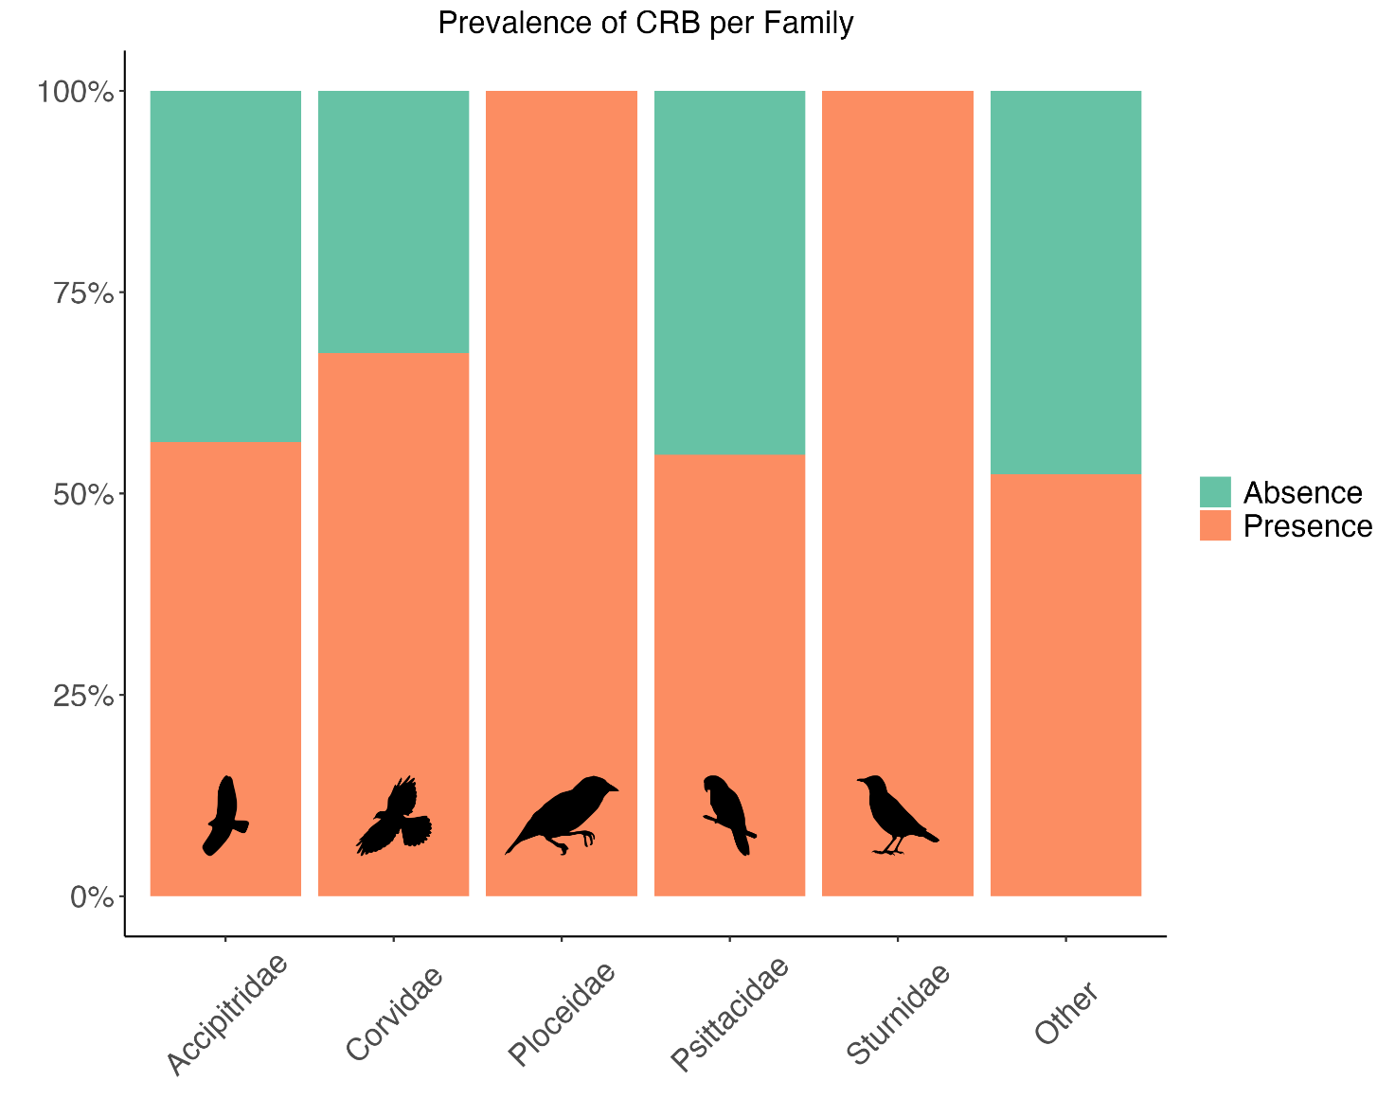

***Figure 2.1*** *Prevalence of Communal Roosting Behaviour in Families with greater representation (25> species).*

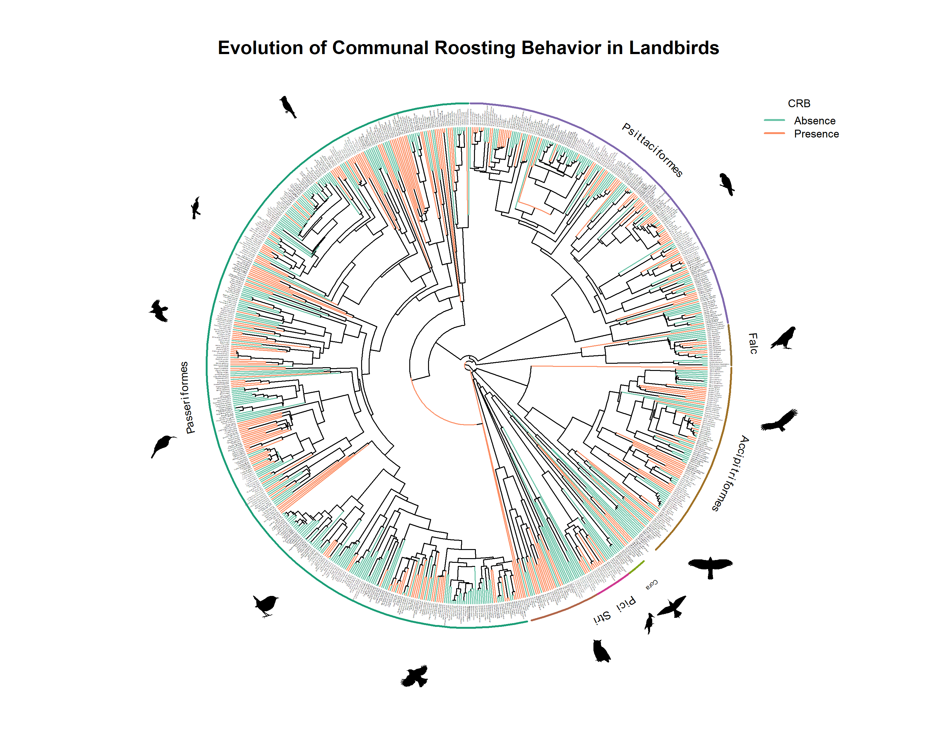

***Figure 2.2*** *Evolution of Communal Roosting Behaviour in Core Land Birds across different taxa. Data show the convergence evolution of this behaviour. Data were collected through Birds of the World and a Google scholar search.*

2.3.3 Biological variables and CRB

Overall, mass showed a positive effect but with wide credible intervals, suggesting no clear strong effect (β =0.31, CI: -0.1, -0.86). Alternatively, HWI showed a positive and strong effect on CRB (β= 0.22, CI: 0.09, 0.51). For trophic level, the only group that had a significant effect on CRB were Carnivores, with less probability of CRB (β= -1.24, CI: -2.69, -0.16). Every other group didn’t have a clear effect (Figure 2.3). When plotting proportion of CRB per trophic guild, scavengers show a great percentage of them as compared to other groups (Figures 2.3-2.5, Appendix 1). However, our model didn’t show clear effect on this group, probably due to a small sample size (n=16). Our model also showed that phylogeny explains a large portion of the data, with a positive and strong effect (β= 1.10, CI: 0.49, 2.54). The model shows high convergence (Rhat =1), which suggests the results are reliable in the context of the model.

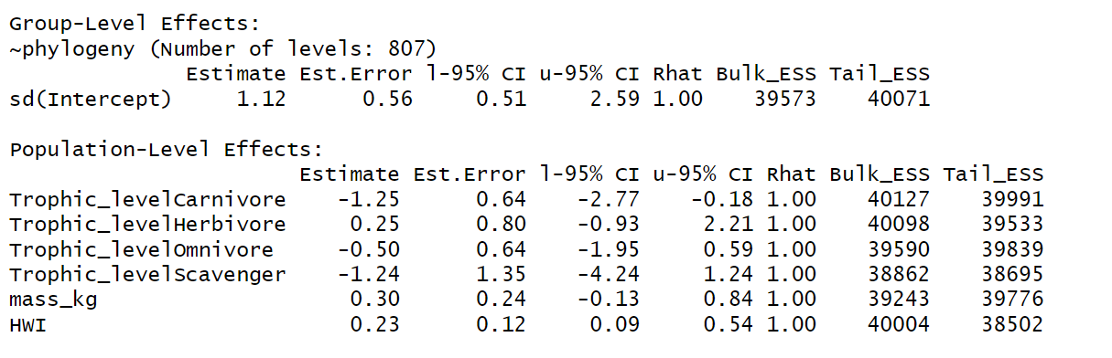***Figure 2.3*** *Global model results including parameter estimates and 95% credible intervals.*

Our second model on a subset of variables showed that brain mass to body mass residuals have a positive but not significant effect on CRB (Figure 2.4).

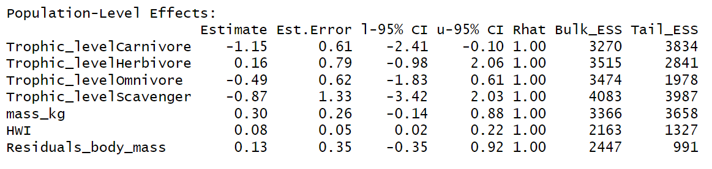

***Figure 2.4*** *Global model results including parameter estimates and 95% credible intervals on a subset of species.*

#### **2.3.4 Transition to CRB**

My phylogenetic reconstruction of the ancestral state shows that in the common ancestor of all landbird species, communal roosting behaviour was most likely absent. Solitary living seems to be the ancestral condition for several clades that evolved after, with communal roosting evolving in more recent species (Figure 2.5). Overall, closely related species show similarities in the presence of CRB. Pagel’s lambda (λ) was estimated as 0.78, which suggests a strong phylogenetic signal in the distribution of this behaviour. Parsimonious reconstructions from our model suggests that there were 190 transitions from solitary to CRB to explain the current distribution of the behaviour.

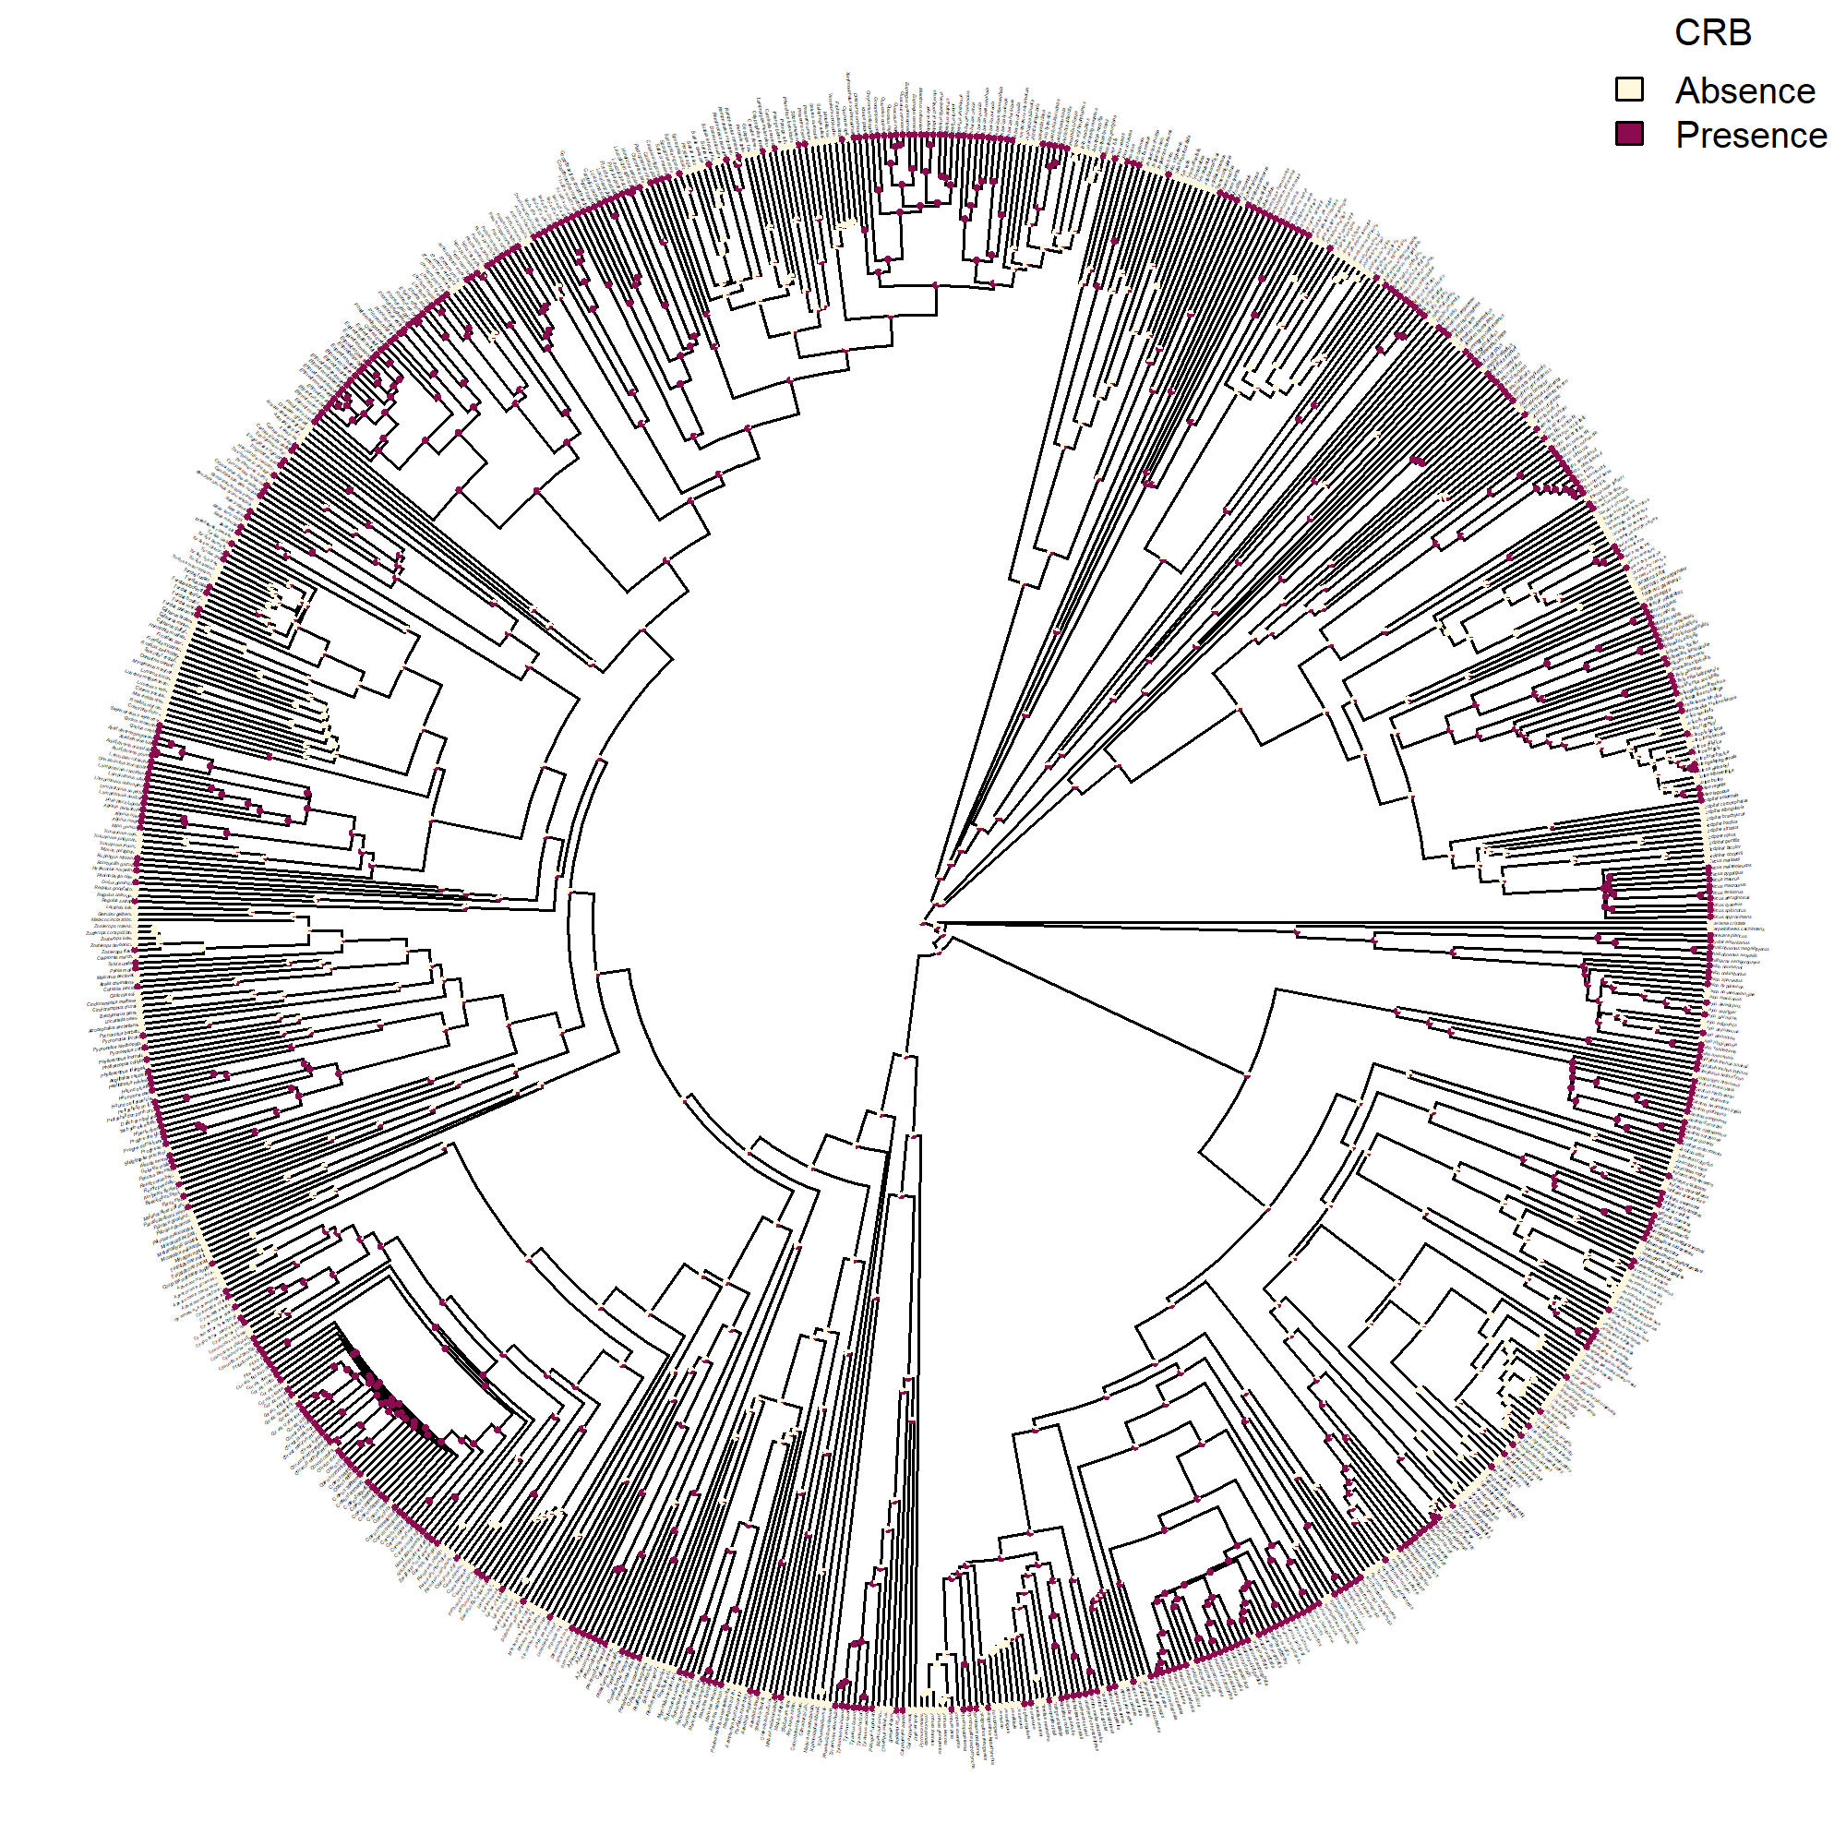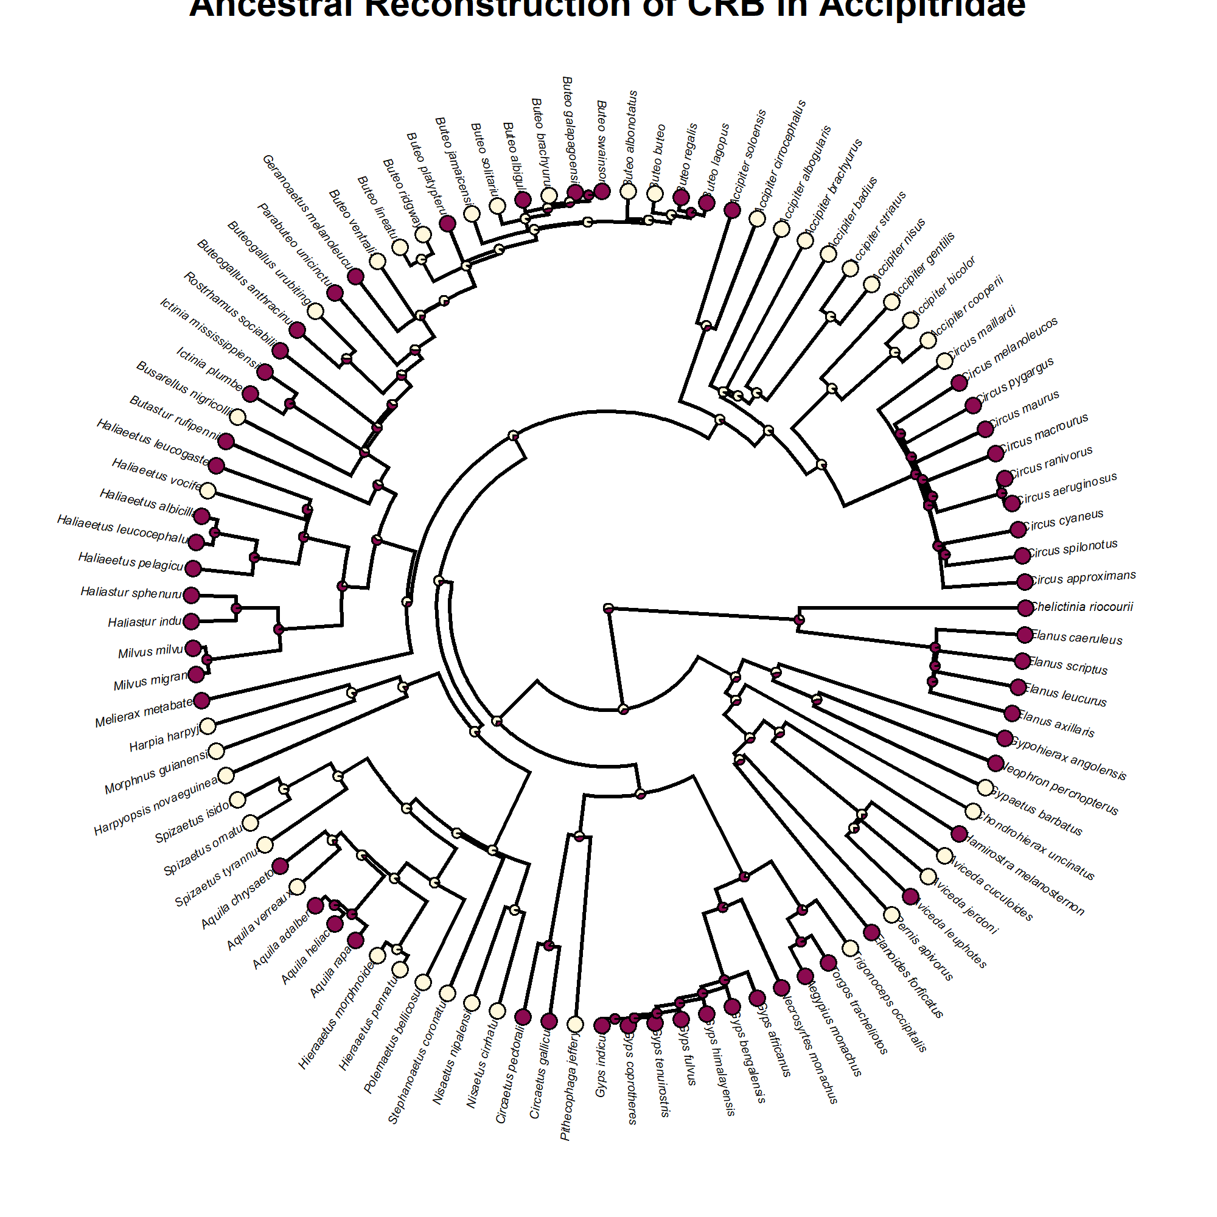

***Figure 2.5*** *Ancestral state reconstruction of CRB for all landbirds and Accipitridae subset*

## **2.4 Discussion**

Several hypotheses have been proposed to explain the evolution of Communal Roosting Behavior. Our results support the idea that CRB has a strong phylogenetic signal, implying that evolutionary relatedness explains a large proportion of the evolution of CRB. We also show that the most likely ancestral state was solitary, and that there were several transitions to CRB in clades that do not share a direct common ancestor and that inhabit a wide array of environments with contrasting weather conditions (e.g., Mindt et al., 2024, Preston, 2005; Saldanha et al., 2019), suggesting that there are biological variables that can drive the convergence evolution of the trait.

### 2.4.1 Mass and Communal Roosting Behaviour

Body mass has long been recognized to affect lifespan (Healy et al., 2014) and therefore metabolic rate (Kleiber 1932; Peters, 1983; Hudson et al., 2013; Nagy et al., 1999). A comprehensive literature review done by (Hudson et al., 2013) outlines the studies done on this matter, highlighting the idea that there is variation on how the relationship scales between clades (e.g., birds, mammals, amphibians). While the scale at which body mass and metabolic rate relate is still being debated, it is reasonable to say that the greater the body size, the higher metabolic rates needed to sustain that amount of mass (Gillooly et al., 2001). In parallel, there is evidence that suggests that communal roosting behaviour is positively related to longevity in parrots (Munshi-South & Wilkinson, 2006). Likewise, longevity is positively related to body mass (Healy et al., 2014). In line with these ideas, we proposed that an increase in body mass (associated to an increase in metabolic rate) is positively correlated to an increase in probability of CRB given the increase in foraging efficiency gained from CRB.

However, contrary to our hypothesis, the results of this study did not show a significant effect of mass on CRB. This could be explained given that increased mass does not necessarily mean increased metabolic rate, with the latter being more biologically meaningful. For instance, hummingbirds are well-known for their high metabolic rates despite small body size. These high metabolic rates are associated to behaviours like torpor, and food hoarding in other birds and mammals (Day & Bartness, 2003), presumably to reduce energetic costs. An extension of this idea could be tested by measuring metabolic rate in particular, rather than body mass alone. Specifically, mass-specific metabolic rate (Suarez & Gass, 2002) could shed light into more accurate relationship. However, these measures are not available for the vast majority of species.

### 2.4.2 Hand Wing Index and Communal Roosting Behaviour

The results supported the idea of a positive relationship between HWI and pCRB. These findings support the hypothesis of dispersing ability to promote this form of behaviour, which has been discussed by other authors. For example, a study done by (Caccamise & Morrison, 1986) suggests that European starlings (*Sturnus vulgaris*) gather in aggregations near supplementary feeding areas (SFA) to reduce the energetic cost of traveling to food sources. Hence, it is plausible to suggest that species that have high dispersal ability are biologically able to fly further looking for food sources, however, they evolved communal roosting behaviour to reduce the energetic costs of flying long distances for feeding. Indeed, the sole idea of having supplemental feeding areas rests on the assumption that species can and have to disperse further away from their territories to forage. In their study, the authors propose that European starlings are more faithful to roosts near SFA rather than a stable communal roost. Nevertheless, the benefits of roosting (regardless of which type of roost) are inherently the same (e.g., Sonerud et al. 2002). In a recent study, Weeks et al. (2022) reported a strong correlation in birds between species with aerial lifestyle and HWI, arguing that species that rely highly on aerial lifestyles (e.g., commuting between roosting sites and foraging areas) have developed more efficient flight. The results of the present study support this idea. Although they suggest that aerial lifestyle and efficient flight coevolve, here I propose that efficient flight mode is the driver of aerial lifestyle (e.g., Reliance on CRB) and not vice versa.

### 2.4.3 Trophic level and Communal Roosting Behaviour

When included in the model, trophic level scavenger didn’t have a significant effect on CRB. This is surprising considering the vast number of scavengers that have been documented to exhibit communal roosting (e.g., ravens, vultures). Noteworthy, when including trophic level as a predictor variable the model did not converge. Thus, the results of this model are not strong to make inferences from it. Furthermore, the database used for the model has an important limitation by classifying corvids as omnivores rather than scavengers, and considering scavengers only as those that are obligate scavengers (e.g., vultures). While several corvids are omnivores indeed, it is likely their facultative scavenger behaviour that gave rise to CRB. Thus, our model is not able to capture this trend at a fine scale.

Because communal roosting has been found to increase foraging efficiency, it is reasonable to suggest that species that rely on ephemeral and unpredictable spatial-temporal food sources are particularly prone to take advantage of communal roosting (Kohles et al., 2022). To look in detail at the transition to CRB we selected the Accipitridae family, as they are notoriously carnivores, which, according to our model results, will be less likely to roost communally. For this clade, most species that transitioned into CRB feed on pulsed and ephemeral resources (e.g., *Elanus* kites (Negro et al., 2006), vultures, *Halieatus* eagles). Thus, although not captured in our global model likely has an effect on the evolution of CRB when assessed at a finer scale.

Our results show communal roosting has evolved in other trophic levels as well. For instance, several seed parrots also show communal roosting (Munshi-South & Wilkinson, 2006). This may be indeed to increase group-foraging efficiency, but additional benefits may arise from this behaviour. A study conducted on starlings (*Sturnus vulgaris*) where access to food was manipulated showed that receivers (naïve individuals) reacted to senders (e.g., individuals with access to food) by changing their foraging effort, as well as their vigilant activity. Therefore, species that have natural predators also benefit from CRB (Fern�ndez-Juricic & Kacelnik, 2004).

### 2.4.4. Brain size and Communal Roosting Behaviour

Social behaviours that rely on memory have been widely documented for birds (e.g., Boeckle & Bugnyar, 2012; Penndorf et al., 2023). Memory, in particular spatial memory, is important for individuals to be able to benefit from CRB efficiently since they require the capacity to remember the locations of food items, and return to those sits on subsequent foraging trips (Ward and Zahavi 1973, Dywer et al. 2018), as well as returning back to their communal roosts. A study conducted on bats showed that spatial memory together with social cues were key for individuals to track the resources efficiently (Lourie et al., 2024). Other study in bats showed how they relied on spatial memory to find their communal roosts (Hernández-Montero et al., 2020). Clearly, spatial memory has been well established as a mechanism for food finding in wildlife (Brodbeck, 1994; Marzluff, 2010; McGREGOR & Healy, 1999).

Residuals were chosen over brain size due to the strong correlation between brain size and body size (Smaers et al. 2021). Though not an explicit measure of memory, these residuals have been showed to correlate with individual cognitive capacity under experimental settings (Burns et al. 2008, Benson-Amram et al. 2016), and also relate to food caching in birds (Garamszegi and Ens 2004). Collectively, these lines of evidence support the use of the brain mass to body mass residuals as a robust proxy for memory in birds. Despite the literature, the results of my model are not strong enough to support the idea that brain to body size residuals have an effect on CRB. This may be explained due to a fairly small sample size (n=341) or to the fact that brain to body size residuals may not be an accurate proxy for spatial memory in pparticular. Unfortunately, direct measures of memory are challenging to obtain, and typically require some form of recall experiments (Brady et al. 2023) or data that might not be available for all species. For instance, it has been suggested that hippocampus volume is a good proxy for spatial memory in birds (Garamszegi and Ens 2004). However, data on hippocampus volume for all bird species are not readily available, which limits the scope of its application.

### 2.4.5 Alternative predictors: Predictability of food sources and food abundance

Access to regular food sources is a determinant factor on individuals’ fitness. It is not surprising therefore that species that feed on ephemeral food sources tend to exhibit communal roosting behaviour. This can be explained to the fact that their food source is limited and unpredictable, which makes it impossible for these species to defend a territory. Therefore, as proposed by the ICH, sharing information on food sources is especially beneficial for such species. This phenomenon has been observed in species with different feeding strategies. For instance, a study by (Farquhar et al., 2018) showed that the increase in probability in communal roosting (huddling) of Chimney swifts (*Chaetura pelagica*) was associated to higher temperatures, which was correlated to lower prey availability. Similarly, Brown & Brown (1996) showed that cliff swallows (*Petrochelidon pyrrhonota*) tend to form large aggregations near ephemeral but abundant insect patches. Predictability of food sources expands beyond the nature of the trophic guild itself and suggests that for example, for a given scavenger species, if their food source is predictable (e.g., dumpsites), the need to exhibit communal roosting might decrease. Yet, using opportunistic more reliable food sources has seldom evolved in geologic timescales. Thus, while some plasticity of CRB may be observed in recent years for some species, the origin of the behaviour or lack thereof cannot be attributed to these human-induced scenarios.

Similarly, food abundance may have an effect on CRB. A wider amount of available food sources effectively means less need to defend a territory. From a cost-benefit perspective, greater abundance of food sources means there are more benefits of sharing location of food sources than defending a territory for a widely available resource (as long as all individuals can access the resource). For example, it has been documented that food availability may induce communal roosting behaviour in highly territorial species (Great-Horned Owl). This is because high availability of food in a farm location makes it easy for everyone to access resources without the need to compete for it (Robinson & Davis, 2014). It could be argued that a greater amount of food resources may mean less need to communal roost since the food is available for everyone. This may hold true to some extent, in which case perhaps communal roosting is favored only after a threshold is reached in which every individual has enough access to the resource (e.g., a quadratic relationship, Buckley, 1997), and in which case communal roosting may be bringing other benefits than increasing foraging efficiency. Another example of highly territorial species engaging in CRB is seen in several raptor species (e.g., Golden eagle, Bonelli’s eagle). In these cases, individuals that roost communally are mostly juveniles, which is the life stage when individuals are less efficient at foraging and therefore need to stay together to acquire experience (Moleón et al., 2011). An interesting hypothesis was proposed by (Dwyer et al., 2018) to explain communal roosting behaviour in non-breeding Crested caracara. In their study, they suggested CRB would be a way to do territory prospecting rather than food searching. However, they also acknowledge that they did not measure food availability during their study, which weakens their hypothesis. A comprehensive review was done by Kohles et al. (2022) and they propose a framework in which social information benefits can be tested as a function of the type or abundance and predictability of resource that was tested on bats. This framework may be useful to test birds’ sociality in the same fashion to complement this research.

Noteworthy, ambient temperature seems to be an important predictor variable as well, where CRB might be beneficial during the winter in higher latitudes for temperature regulation. For instance, during winters, when there is food scarcity, communal roosting might be induced as a way to reduce heat loss (Lubbe et al., 2018). Hence, food availability may also be confounded with ambient temperature. While it is possible that in these scenarios, the evolution of CRB could be driven by environmental rather than biological factors, the likelihood is low given that habitats have been subject to dramatic climate variabilities in the last 10 000 years (Alley & Agustsdottir, 2005), so we cannot assume that current environmental conditions drove the evolution of CRB in currently extant species.

At a population level, it would be interesting to test which populations within a species are more likely to roost communally depending on the temperatures they are exposed to. For instance, a global study done on communal signaling outlined how for house wren (*Troglodytes aedon*), communal signaling was more common in tropical areas presumably due to higher territoriality in this region (Tobias et al., 2016). At a species level, testing this idea is not possible given that several species occur in a wide latitude gradient with several contrasting environments and temperatures.

Finally, while communal roosting has most likely evolved to increase foraging efficiency in flock-living birds (Sonerud et al., 2002), we cannot discard that the behaviour has been maintained because it also may decrease predation risk (Gilbert et al., 2010), thermal stress (e.g., Wojciechowski et al., 2011), and the cost of mate assessment (Beauchamp 1999; Blanco and Tella 1999) as suggested by other alternative hypotheses.

### 2.4.6 Limitations

A major challenge in my research is the use of brain size residuals as a proxy for memory since these are also related to other aspects such as cognition (Biegler et al. 2001, Burns et al. 2008, Benson-Amram et al. 2016), intelligence (Dickie & Roth 2016) or other biological traits like life expectancy (Smeele et al. 2022). Thus, there is a risk that a relationship between brain size residuals and roosting behaviour may be due to correlates with other variables other than memory *per se*. Alternatively, other patterns could obscure the relationship between the proposed variables. For instance, research has suggested that neuronal connections are more accurately related to cognitive abilities than is brain volume (Logan et al. 2018). Nonetheless, neuronal connections might not necessarily be positively correlated with brain mass to body mass residuals, which would limit the use of the latter as a proxy. Albeit, the density of neuronal connections is significantly more complicated to measure and it requires an invasive approach far beyond the scope of my research. Similarly, memory may lead to other behaviours that are not necessarily communal roosting under the foraging efficiency hypothesis. For instance, greater memory could lead to food hoarding (Clayton & Krebs 1995). Here, individuals do not rely on sociality to successfully access foraging sites, although they do rely on memory.

Alternatively, memory (or intelligence) could increase the ability to rely on local enhancement (Everding & Jones, 2006), where individuals don’t exhibit communal roosting but rather loose aggregation that rely on visual cues of conspecifics to find food. Hence, greater memory might not necessarily correlate to communal roosting behaviour alone. Further research should expand on this hypothesis using the data collected as part of this research. Similarly, the use of memory as a predictor could be correlated to trophic guild, another predictor variable that has been proposed for the model. In particular, several vultures and corvids have good memory and cognitive abilities for problem solving (Weir et al. 2002, Lefebvre et al. 2004, Van Overveld et al. 2022). Because all vultures and many corvids (e.g., ravens, crows, magpies) are also scavengers, the coincidence (or correlation) between trophic guild and cognitive abilities may hinder the capacity to link memory and communal roosting behaviour.

Finally, there is a limitation in my ability to detect CRB in some species. For instance, a study conducted in fish showed that their social cohesion varied depending on the state of hunger. Individuals that were food-deprived were less likely to join shoals, possibly to reduce competition with conspecifics (Killen et al., 2016). This suggests that the tendency to exhibit a social behaviour state that increases foraging efficiency (e.g., communal roosting) may also be determined by the degree of urgency of feeding. A study conducted on American Robins found that the patterns of communal roosting behaviour were consistent with food finding (more communal roosting by juveniles, more communal roosting later in the season, foraging areas used on consecutive days were farther apart after robins roosted communally, and home ranges were bigger for robins that used the communal roost more, Benson et al., 2012). It is worth noting that this condition does not suffice to drive the evolution of the behaviour itself in a species, but instead affect the frequency of the behaviour, which may hinder ability to detect it, which would ultimately impact the outcome of my model. In my model, CRB was classified as a binary response variable (0,1), however, as data becomes more available, it would be interesting to test biological (and ecological) variables against the frequency of CRB (as a percentage). Yet again, this information is not currently available for the vast majority of species.

### 2.4.7 Future work

One of the major limitations of this study is the available information on communal roosting for several bird species. A large volume of research is conducted on a handful few species only. Conducting more field observations on understudied species may help to bridge that information gap. Another approach to do so would be the use of weather radar data (e.g., Cheng et al., 2020), but this approach is limited to where weather radars are available.

Additionally, whilst the current research shed light on relevant drivers of CRB, further examination of the proposed variables should be tested to increase the accuracy of the predictions and better understand the biological processes behind the correlation. For instance, we acknowledge that the proxy used for memory is a limiting factor. Assessing the same correlation with other measures of memory (e.g., hippocampus size) may provide more accurate results. Furthermore, testing these models with empirical data from a random sample of species may also help to validate the models proposed. Significant work has been done on corvids and parrots, but other species remain underrepresented in the study of memory.

Testing the effects of ecological drivers (e.g., food abundance and predictability) is also a relevant task. Although terrestrial productivity at a global scale can be measured through NDVI and this measure can act as a proxy for abundance of food sources, that measure is seldom useful for the current research since several species exist on a vast geographic range with contrasting productivities. For instance, Peregrine falcons (*Falco peregrinus*) exist in every continent except Antarctica (Birdlife International, 2021). This makes it impossible to model their associated habitat productivity without oversimplifying the model. Thus, adopting a conservative approach, this variable was not considered here. However, doing a more detailed analysis at a local scale could take this into consideration. Moreover, coupled with weather, productivity of habitats has changed over time, often at geological scales. Hence, using current productivity might not be representable to determine the evolution of CRB. Even if we establish a correlation, causation could not be concluded.

Abundance of food sources has another challenge: number or resources and dietary breadth. A question arises of whether resource abundance of number of different items is more important. For instance, is it more important for Great-Horned Owls to have more mice or different prey sources despite low numbers of each? In addition, measuring dietary breadth poses its own challenges given that the level at which we group the diet items has a direct impact on the estimation of dietary breadth. Take, for example, a seed eater. Are seeds an item in the diet, or are each type of seed important? Although from a nutritional point of view these are important questions to consider, that is beyond the scope of the current research. From a conceptual and empirical point of view, this measurement is not feasible at a global scale.

Finally, testing the idea that species exhibiting communal roosting behaviour are more efficient at finding food sources would provide valuable information to expand the current research. This can be feasibly done with movement data using ballistic length scales as a proxy for foraging efficiency, or experimental designs placing feeding stations in the landscape coupled with movement data.

# **Chapter 3: The need for ecological studies in social species**

## **3.1 Introduction**

Sociality is widely observed in the animal kingdom, and it has been documented that social behaviour enhances learning (Aikens et al. 2022). From migration to mating and chick-rearing, sociality seems to bring benefits to all individuals in the group. While the role of sociality in grouping is still not fully understood, is increasingly recognized that many birds and mammals live in social systems that are structured by long-term affiliative and agonistic relations (Kappeler, 2019; Massen, 2018). Feeding in groups is a foraging strategy that brings numerous benefits to group members, such as increasing the likelihood of locating food and enhancing vigilance for predator detection (Marinero et al., 2018). These benefits may increase survival of individuals and overall fitness.

Among animals, social grouping has been mainly studied in mammals. Conversely, in birds, these studies are somewhat limited. Among birds, most studies have been conducted in corvids given their notably sociality and cognitive skills (Emery et al., 2007; Emery & Clayton, 2004). Corvids establish strong social relationships and social hierarchies, and they show sophisticated reasoning and problem-solving abilities. These fascinating features, however, have not been studied in other bird species.

Vultures, just like corvids, are scavengers. Similarly, vultures are also highly social species. Among this group, several species have been documented using communal roosts where several individuals gather for the resting period (Campbell, 2015; Van Overveld, Gangoso, et al., 2020), as well as individuals gathering around carcasses when foraging. Beyond this example of sociality, there is also research done in despotic behaviour and hierarchies within and across species. For instance, a study conducted in East Africa with seven types of scavenger species showed that there is niche partitioning between the species in the study system (Kendall, 2013). In concrete, the author found that species that have greatest search efficiency or greater sociality (e.g. Bateleurs, Ruppell’s, Lappet-faced, and White-backed vultures) had access to patches of better quality than their counterparts, hence establishing dominance. Likewise, a study done on Andean Condors (*Vultur gryphus*) shows that sex, age and pigmentation drive hierarchy in this highly despotic species. As seen above, while sociality may benefit individuals in a group, it may also increase competition in the group for food resources, which is particularly important when resources are limited (Moreno-Opo et al., 2020).

## **3.2 Why vultures?**

Vultures, unlike corvids (and every other species), are obligate scavengers. This means that they depend entirely on carrion for their energy supply. Carrion is an ephemeral resource heterogeneously distributed and often limited in space and time (Barton et al., 2013; DeVault et al., 2003; Ostfeld & Keesing, 2000). Because of its scattered and unpredictable nature, competition at these feeding sites is high with agonistic behaviour and hierarchies established. Interestingly, this high competition has in turn led to the evolution of specific behaviours to reduce competition for resources such that the community finds balance. Such mechanisms include niche segregation among the different species (Savolainen et al., 1988; Schuette et al., 2013). Albeit, when dominance is established in individuals of the same species, niche partitioning becomes less likely. From a conservation point of view, this is important two reasons. First, if resources are limited, population may select in favor of adult individuals, which may decrease juvenile recruitment thereby impacting the population fitness. Second, if resource partitioning does not occur within a species or a guild and individuals are forced to gather around one resource, a significant portion of the population may be prone to threats while feeding.

## **3.3 A note on the Information Center Hypothesis**

In Chapter 2, I highlighted the importance of communal roosts as a place where individuals gain access to location of food sources, as explained by the Information Center Hypothesis or local enhancement hypothesis. It is important to say that the information transfer is usually unintentional. This is relevant because transferring information about a food source location does not inform about the quality of the resource itself. If individuals are foraging on suboptimal food sources and other individuals in the roost follow, this could have a severe impact at a population level. Several roosts for vultures are located near anthropogenic food sources like garbage dumps given their greater predictability such that it is less energetically costly to access food, despite its poor quality. Noteworthy, vultures are among the most threatened group of birds in the world, most species showing steep declines in their population (McClure et al., 2018). Notably, these declines are exacerbated due to their gregarious behaviour. When individuals follow others and forage together at a single carcass, it amplifies the risk of mass mortality when the carcass is poisoned (D. Ogada et al., 2016; D. L. Ogada, 2014; Santangeli et al., 2016)). Thus, the use of social information when feeding may become an ecological trap (Curk et al., 2025) with cascading effects.

## **3.4 Size matters: The Andean Condor – A peculiar case study**

Given their obligate scavenging nature, old and new world vultures rely highly on communal roosting behaviour. In black vultures, for instance, individuals may roost up to 200 individuals together. These large roosts provide several opportunities to access foraging sites by increasing accuracy of the food location by following more knowledgeable individuals (Sassi et al., 2024), leading to more cost-efficient movement (Rafacz & Templeton, 2003; H. J. Williams & Safi, 2021). Evidently, the larger the size of the roost, the greater probabilities to find communal food sources. In the wild, however, these opportunities are constrained by population sizes of the species in question.

With a wingspan of 320 cm, females weighting up to 11 kg and males up to 15 kg (Houston et al. 2020), the Andean Condor (*Vultur gryphus*) is the heaviest extant soaring bird. It is an obligate scavenger, and a highly social species (Donázar et al. 1999), that uses communal roosts when they are not breeding, with aggregations adding up to 50 individuals. Despite their widespread distribution, large portions of the population are concentrated in specific locations, where these communal roosts exist.

Like other vultures, Andean Condors are also obligate soarers. This means they rely on thermal updrafts to search for carcasses. When foraging, these birds gain altitude by riding a thermal updraft (hot air masses created as a consequence of heated surface that rises), and they use it to move in the landscape in search for food (Sassi et al., 2024). This remarkably energy-efficient flight mode allows them to reduce energy expenditure. Given their size and feeding guild, Andean Condors highly benefit from this flight strategy. Some geographical features promote the occurrence of thermals like cliffs and slope inclination and aspect (Scacco et al., 2019). It is likely that when selecting a communal roosting site, they select roosts that will allow them to exploit these thermals to commute to and from foraging grounds. In fact, a study by Sassi et. al (2024) shows that vultures movement decisions relied highly on social information.

Collectively, all of these lines of evidence suggest that communal roosting sites are crucial for the population structure and dynamics in Andean Condors. Much has been hypothesized about the importance of communal roosts for information sharing and feeding resources. Nonetheless, more research is needed to understand how the information transfer operates in these roosts, and how valuable each connection is for information transfer. As concluded by Curk et al., (2025), the value of social information was only evident with a large number of vultures in the area. These findings stress the need to have healthy populations that can self-sustain (Van Overveld, Blanco, et al., 2020), especially as natural food becomes more limited.

Undoubtedly, communal roosts are areas of high conservation priority (Dermody et al., 2011). Noteworthy, these communal roost sites are relevant not only as habitat *per se*, but also as social-hubs that might be crucial for decision-making of the population. This is especially true for highly social species that have evolved this behaviour over evolutionary timescales and who, as outlined by (Monier, 2024), are disproportionately at risk to declines given their social nature. As with many other vultures, Andean Condor populations are decreasing throughout its range, with all major threats being anthropogenic. In particular, habitat loss, poisoning due to human-wildlife conflict and wind power development are of greater concern, which frequently act synergistically. Because of their size, ecology (e.g., long lifespan, low reproductive rates, obligate soaring species – which requires longer learning periods (Hertel et al., 2023)), scavengers), behaviour (social species), and conservation status (globally Vulnerable), this emblematic Andean species is a peculiar study system and good model (Poessel et al., 2018) to test the hypotheses on the effects of sociality on foraging efficiency as they represent an extreme in the spectrum of extant flying birds.

# **Bibliography**

Abrahms, B., Hazen, E. L., Aikens, E. O., Savoca, M. S., Goldbogen, J. A., Bograd, S. J., ... & Mate, B. R. (2019). Memory and resource tracking drive blue whale migrations. Proceedings of the National Academy of Sciences, 116(12), 5582-5587.

Aikens, E. O., Bontekoe, I. D., Blumenstiel, L., Schlicksupp, A., & Flack, A. (2022). Viewing animal migration through a social lens. *Trends in Ecology & Evolution*, *37*(11), 985–996.

Beauchamp, G. (1999). The evolution of communal roosting in birds: Origin and secondary losses. *Behavioural Ecology*, *10*(6), 675–687.

Benhamou, S. (2014). Of scales and stationarity in animal movements. *Ecology Letters*, *17*(3), 261–272.

Berberi, I., Miller, E. T., & Dakin, R. (2023). The effect of sociality on competitive interactions among birds. *Proceedings of the Royal Society B: Biological Sciences*, *290*(1994), 20221894.

Brusatte, S. L., O’Connor, J. K., & Jarvis, E. D. (2015). The Origin and Diversification of Birds. *Current Biology*, *25*(19), R888–R898.

Buckley, N. J. (1997). Experimental tests of the information-center hypothesis with black vultures (Coragyps atratus) and turkey vultures (*Cathartes aura*). *Behavioural Ecology and Sociobiology*, *41*(4), 267–279.

Burt, W. H. (1943). Territoriality and Home Range Concepts as Applied to Mammals. *Journal of Mammalogy*, *24*(3), 346.

Clough S, Ladle M. 1997. Diel migrations and site fidelity in a stream dwelling cyprinid, Leuciscus leuciscus. J Fish Biol. 50:1117–1119.

Dermody, B. J., Tanner, C. J., & Jackson, A. L. (2011). The Evolutionary Pathway to Obligate Scavenging in Gyps Vultures. *PLoS ONE*, *6*(9), e24635.

Dukas, R. (2017). Cognitive innovations and the evolutionary biology of expertise. *Philosophical Transactions of the Royal Society B: Biological Sciences*, *372*(1735), 20160427.

Eiserer, L. A. (1984). Communal roosting in birds. Bird Behaviour, 5(2-3), 61–80.

Felsenstein, J. (1985). Phylogenies and the Comparative Method. The American Naturalist, 125(1), 1–15. Fisher, J.B. (1954). Evolution and bird sociality. *Evolution as a Process*, 71-83.

Flack, A., Fiedler, W., Blas, J., Pokrovsky, I., Kaatz, M., Mitropolsky, M., Aghababyan, K., Fakriadis, I., Makrigianni, E., Jerzak, L., Azafzaf, H., Feltrup-Azafzaf, C., Rotics, S., Mokotjomela, T. M., Nathan, R., & Wikelski, M. (2016). Costs of migratory decisions: A comparison across eight white stork populations. *Science Advances*, *2*(1), e1500931.

Fortin, D., Beyer, H. L., Boyce, M. S., Smith, D. W., Duchesne, T., & Mao, J. S. (2005). Wolves influence elk movements: behaviour shapes a trophic cascade in Yellowstone Pational Park. *Ecology*, *86*(5), 1320–1330.

Grant, J. W. A. (1993). Whether or not to defend? The influence of resource distribution. *Marine Behaviour and Physiology*, *23*(1–4), 137–153.

Gregory, S. C., Haegen, W. M. V., Chang, W. Y., & West, S. D. (2010). Nest Site Selection by Western Gray Squirrels at Their Northern Range Terminus. *The Journal of Wildlife Management*, *74*(1), 18–25.

Guigueno, M. F., Shoji, A., Elliott, K. H., & Aris-Brosou, S. (2019). Flight costs in volant vertebrates: A phylogenetically-controlled meta-analysis of birds and bats. *Comparative Biochemistry and Physiology Part A: Molecular & Integrative Physiology*, *235*, 193–201.

Harel, R., Spiegel, O., Getz, W. M., & Nathan, R. (2017). Social foraging and individual consistency in following behaviour: Testing the information centre hypothesis in free-ranging vultures. *Proceedings of the Royal Society B: Biological Sciences*, *284*(1852), 20162654.

Hayward, M. W., & Slotow, R. (2009). Temporal Partitioning of Activity in Large African Carnivores: Tests of Multiple Hypotheses. *South African Journal of Wildlife Research*, *39*(2), 109–125.

Hengeveld, G. M. (2007). *Moving to eat: Animal foraging movements in a heterogeneous environment*.

Hernández-Montero, J. R., Reusch, C., Simon, R., Schöner, C. R., & Kerth, G. (2020). Free-ranging bats combine three different cognitive processes for roost localization. *Oecologia*, *192*(4), 979–988.

Hertel, A. G., Efrat, R., Reznikov, K., Sapir, N., Berger-Tal, O., & Mueller, T. (2023). Time constraints may pace the ontogeny of movement behaviour. *Proceedings of the Royal Society B: Biological Sciences*, *290*(1996), 20222429.

Horn, H. S. (1968). The Adaptive Significance of Colonial Nesting in the Brewer’s Blackbird (Euphagus Cyanocephalus). *Ecology*, *49*(4), 682–694.

Houston, D., G. M. Kirwan, D. A. Christie, and C. J. Sharpe (2020). Andean Condor (*Vultur gryphus*). Version 1.0. In Birds of the World (J. del Hoyo, A. Elliott, J. Sargatal, D. A. Christie, and E. de Juana, Editors). Cornell Lab of Ornithology, Ithaca, NY, USA.

Johnson DH (1980) The comparison of usage and availability measurements for evaluating resource preference. Ecology 61:65–71

Johnson, M. D. (2007). Measuring Habitat Quality: A Review. *The Condor*, *109*(3), 489–504.

Kano, F., Sasaki, T., & Biro, D. (2021). Collective attention in navigating homing pigeons: Group size effect and individual differences. *Animal Behaviour*, *180*, 63–80.

Kays, R., Crofoot, M. C., Jetz, W., & Wikelski, M. (2015). Terrestrial animal tracking as an eye on life and planet. *Science*, *348*(6240), aaa2478.

Kunz T, H. (1982). Roosting ecology of bats. In: Kunz TH, editor. Ecology of bats. New York: Plenum Press. p. 1–55.

Laughlin, A. J., Sheldon, D. R., Winkler, D. W., & Taylor, C. M. (2014). Behavioural drivers of communal roosting in a songbird: A combined theoretical and empirical approach. *Behavioural Ecology*, *25*(4), 734–743.

Mallon, J. M., Tucker, M. A., Beard, A., Bierregaard, R. O., Bildstein, K. L., Böhning‐Gaese, K., Brzorad, J. N., Buechley, E. R., Bustamante, J., Carrapato, C., Castillo‐Guerrero, J. A., Clingham, E., Desholm, M., DeSorbo, C. R., Domenech, R., Douglas, H., Duriez, O., Enggist, P., Farwig, N., … Fagan, W. F. (2020). Diurnal timing of nonmigratory movement by birds: The importance of foraging spatial scales. *Journal of Avian Biology*, *51*(12), jav.02612.

Mock, D. W., Lamey, T. C., & Thompson, D. B. A. (1988). Falsifiability and the Information Centre Hypothesis. *Ornis Scandinavica*, *19*(3), 231.

Mueller, T., & Fagan, W. F. (2008). Search and navigation in dynamic environments – from individual behaviours to population distributions. *Oikos*, *117*(5), 654–664.

Nathan, R., Getz, W. M., Revilla, E., Holyoak, M., Kadmon, R., Saltz, D., & Smouse, P. E. (2008). A movement ecology paradigm for unifying organismal movement research. *Proceedings of the National Academy of Sciences*, *105*(49), 19052–19059.

Nauta, J., Khaluf, Y., & Simoens, P. (2020). Hybrid foraging in patchy environments using spatial memory. *Journal of The Royal Society Interface*, *17*(166), 20200026.

Nonacs, P., & Dill, L. M. (1993). Is Satisficing an Alternative to Optimal Foraging Theory? *Oikos*, *67*(2), 371.

Noonan, M. J., Martinez-Garcia, R., Fleming, C. H., De Figueiredo, B. G., Ali, A. H., Attias, N., Belant, J. L., Beyer, D. E., Berteaux, D., Bidner, L. R., Boone, R., Boutin, S., Brito, J., Brown, M., Carter, A., Castellanos, A., Castellanos, F. X., Chitwood, C., Darlington, S., … Calabrese, J. M. (2023). *The search behaviour of terrestrial mammals* [Preprint]. Ecology

Nussbaumer, R., Schmid, B., Bauer, S., & Liechti, F. (2022). Favorable winds speed up bird migration in spring but not in autumn. *Ecology and Evolution*, *12*(8).

Ord, T. J. (2021). Costs of territoriality: A review of hypotheses, meta-analysis, and field study. *Oecologia*, *197*(3), 615–631.

Owen-Smith, N., Goodall, V., & Fatti, P. (2012). Applying mixture models to derive activity states of large herbivores from movement rates obtained using GPS telemetry. *Wildlife Research*, *39*(5), 452.

Perrig, P. L., Lambertucci, S. A., Cruz, J., Alarcón, P. A. E., Plaza, P. I., Middleton, A. D., Blanco, G., Sánchez-Zapata, J. A., Donázar, J. A., & Pauli, J. N. (2020). Identifying conservation priority areas for the Andean condor in southern South America. *Biological Conservation*, *243*, 108494.

Pekarsky, S., Shohami, D., Horvitz, N., Bowie, R. C. K., Kamath, P. L., Markin, Y., Getz, W. M., & Nathan, R. (2023). *Cranes soar on thermal updrafts behind cold fronts as they migrate across the sea* [Preprint]. Ecology.

Pennycuick, C. J. (2008). Modelling the flying bird. Elsevier.Poessel, S. A., Brandt, J., Miller, T. A., & Katzner, T. E. (2018). Meteorological and environmental variables affect flight behaviour and decision-making of an obligate soaring bird, the California Condor *Gymnogyps californianus*. *Ibis*, *160*(1), 36–53.

Rolls, E. T. (2014). Emotion and decision-making explained: A précis. *Cortex*, *59*, 185–193.

Shipley, L. A., Spalinger, D. E., Gross, J. E., Hobbs, N. T., & Wunder, B. A. (1996). The Dynamics and Scaling of Foraging Velocity and Encounter Rate in Mammalian Herbivores. *Functional Ecology*, *10*(2), 234.

Smith, B. J., MacNulty, D. R., Stahler, D. R., Smith, D. W., & Avgar, T. (2023). Density‐dependent habitat selection alters drivers of population distribution in northern Yellowstone elk. *Ecology Letters*, *26*(2), 245–256.

Smith, R. V., Stafford, J. D., Yetter, A. P., Horath, M. M., Hine, C. S., & Hoover, J. P. (2012). Foraging Ecology of Fall-Migrating Shorebirds in the Illinois River Valley. *PLoS ONE*, *7*(9), e45121.

Southwood, T. R. E. (1977). Habitat, the Templet for Ecological Strategies? *The Journal of Animal Ecology*, *46*(2), 336.

Sutherland, W. J., Newton, I., & Green, R. (2004). *Bird Ecology and Conservation*. Oxford University Press.

Tobalske, B. W., Hedrick, T. L., Dial, K. P., & Biewener, A. A. (2003). Comparative power curves in bird flight. *Nature*, *421*(6921), 363–366.

Tucker, M. A., Alexandrou, O., Bierregaard Jr, R. O., Bildstein, K. L., Böhning‐Gaese, K., Bracis, C., ... & Mueller, T. (2019). Large birds travel farther in homogeneous environments. Global Ecology and Biogeography, 28(5), 576-587.

van Overveld T, Blanco G, Moleón M, Margalida A, Sanchez-Zapata JA, De la Riva M, Donázar JA (2020) Integration vulture sociality into conservation practice. Condor 122:duaa035

Van Overveld, T., Sol, D., Blanco, G., Margalida, A., De La Riva, M., & Donázar, J. A. (2022). Vultures as an overlooked model in cognitive ecology. *Animal Cognition*, *25*(3), 495–507.

Ward, P., & Zahavi, A. (1973). The importance of certain assemblages of birds as “information-centres” for food-finding. *Ibis*, *115*(4), 517–534.

Wright, J., Stone, R. E., & Brown, N. (2003). Communal roosts as structured information centres in the raven, Corvus corax. *Journal of Animal Ecology*, *72*(6), 1003–1014.

Zuberogoitia, I., González-Oreja, J. A., Martínez, J. E., Zabala, J., Gómez, I., & López-López, P. (2013). Foraging movements of Eurasian griffon vultures (Gyps fulvus): Implications for supplementary feeding management. *European Journal of Wildlife Research*, *59*(3), 421–429.

Aguilera-Alcalá, N., Morales-Reyes, Z., Martín-López, B., Moleón, M., & Sánchez-Zapata, J. A. (2020). Role of scavengers in providing non-material contributions to people. *Ecological Indicators*, *117*, 106643. https://doi.org/10.1016/j.ecolind.2020.106643

Alley, R., & Agustsdottir, A. (2005). The 8k event: Cause and consequences of a major Holocene abrupt climate change. *Quaternary Science Reviews*, *24*(10–11), 1123–1149. https://doi.org/10.1016/j.quascirev.2004.12.004

Anderson, J. R. (1998). Sleep, sleeping sites, and sleep-related activities: Awakening to their significance. *American Journal of Primatology*, *46*(1), 63–75. https://doi.org/10.1002/(SICI)1098-2345(1998)46:1<63::AID-AJP5>3.0.CO;2-T

Arango, A., Pinto-Ledezma, J., Rojas-Soto, O., Lindsay, A. M., Mendenhall, C. D., & Villalobos, F. (2022). Hand-Wing Index as a surrogate for dispersal ability: The case of the Emberizoidea (Aves: Passeriformes) radiation. *Biological Journal of the Linnean Society*, *137*(1), 137–144. https://doi.org/10.1093/biolinnean/blac071

Ashmole, N. P. (1963). THE REGULATION OF NUMBERS OF TROPICAL OCEANIC BIRDS. *Ibis*, *103b*(3), 458–473. https://doi.org/10.1111/j.1474-919X.1963.tb06766.x

Bairos-Novak, K. R., Crook, K. A., & Davoren, G. K. (2015). Relative importance of local enhancement as a search strategy for breeding seabirds: An experimental approach. *Animal Behaviour*, *106*, 71–78. https://doi.org/10.1016/j.anbehav.2015.05.002

Barta, Z. (2001). Breeding colonies as information centers: A reappraisal of information-based hypotheses using the producer--scrounger game. *Behavioral Ecology*, *12*(2), 121–127. https://doi.org/10.1093/beheco/12.2.121

Barton, P. S., Cunningham, S. A., Lindenmayer, D. B., & Manning, A. D. (2013). The role of carrion in maintaining biodiversity and ecological processes in terrestrial ecosystems. *Oecologia*, *171*(4), 761–772. https://doi.org/10.1007/s00442-012-2460-3

Beauchamp, G. (1999). The evolution of communal roosting in birds: Origin and secondary losses. *Behavioral Ecology*, *10*(6), 675–687. https://doi.org/10.1093/beheco/10.6.675

Beauchamp, G. (2010). Relaxed predation risk reduces but does not eliminate sociality in birds. *Biology Letters*, *6*(4), 472–474. https://doi.org/10.1098/rsbl.2009.1063

Béchet, A., Giroux, J.-F., Gauthier, G., & Bélisle, M. (2010). Why Roost at the Same Place? Exploring Short-Term Fidelity in Staging Snow Geese. *The Condor*, *112*(2), 294–303. https://doi.org/10.1525/cond.2010.090050

Benson, T. J., Ward, M. P., Lampman, R. L., Raim, A., & Weatherhead, P. J. (2012). Implications of Spatial Patterns of Roosting and Movements of American Robins for West Nile Virus Transmission. *Vector-Borne and Zoonotic Diseases*, *12*(10), 877–885. https://doi.org/10.1089/vbz.2011.0902

Bijleveld, A. I., Egas, M., van Gils, J. A., & Piersma, T. (2010). Beyond the information centre hypothesis: Communal roosting for information on food, predators, travel companions and mates? *Oikos*, *119*(2), 277–285. https://doi.org/10.1111/j.1600-0706.2009.17892.x

Blumstein, D. T., & Møller, A. P. (2008). Is sociality associated with high longevity in North American birds? *Biology Letters*, *4*(2), 146–148. https://doi.org/10.1098/rsbl.2007.0606

Boeckle, M., & Bugnyar, T. (2012). Long-Term Memory for Affiliates in Ravens. *Current Biology*, *22*(9), 801–806. https://doi.org/10.1016/j.cub.2012.03.023

Bonter, D. N., Zuckerberg, B., Sedgwick, C. W., & Hochachka, W. M. (2013). Daily foraging patterns in free-living birds: Exploring the predation–starvation trade-off. *Proceedings of the Royal Society B: Biological Sciences*, *280*(1760), 20123087. https://doi.org/10.1098/rspb.2012.3087

Brodbeck, D. R. (1994). Memory for spatial and local cues: A comparison of a storing and a nonstoring species. *Animal Learning & Behavior*, *22*(2), 119–133. https://doi.org/10.3758/BF03199912

Buckley, N. J. (1997). Spatial‐Concentration Effects and the Importance of Local Enhancement in the Evolution of Colonial Breeding in Seabirds. *The American Naturalist*, *149*(6), 1091–1112. https://doi.org/10.1086/286040

Caccamise, D. F., & Morrison, D. W. (1986). Avian Communal Roosting: Implications of Diurnal Activity Centers. *The American Naturalist*, *128*(2), 191–198. https://doi.org/10.1086/284553

Campbell, M. O. (2015). *Vultures: Their Evolution, Ecology and Conservation* (0 ed.). CRC Press. https://doi.org/10.1201/b18638

Carrascal, L. M., & Polo, V. (2006). Effects of wing area reduction on winter body mass and foraging behaviour in coal tits: Field and aviary experiments. *Animal Behaviour*, *72*(3), 663–672. https://doi.org/10.1016/j.anbehav.2005.11.027

Cheng, Z., Gabriel, S., Bhambhani, P., Sheldon, D., Maji, S., Laughlin, A., & Winkler, D. (2020). Detecting and Tracking Communal Bird Roosts in Weather Radar Data. *Proceedings of the AAAI Conference on Artificial Intelligence*, *34*(01), 378–385. https://doi.org/10.1609/aaai.v34i01.5373

Conklin, J. R., & Colwell, M. A. (2007). Diurnal and Nocturnal Roost Site Fidelity of Dunlin (Calidris Alpina Pacifica) at Humboldt Bay, California. *The Auk*, *124*(2), 677–689. https://doi.org/10.1093/auk/124.2.677

Cortés-Avizanda, A., Jovani, R., Donázar, J. A., & Grimm, V. (2014). Bird sky networks: How do avian scavengers use social information to find carrion? *Ecology*, *95*(7), 1799–1808. https://doi.org/10.1890/13-0574.1

Curk, Te., Rast, W., Portas, R., Kohles, J., Shatumbu, G., Cloete, C., Curk, Ti., Radchuk, V., Aschenborn, O., & Melzheimer, J. (2025). Advantages and disadvantages of using social information for carcass detection–A case study using white-backed vultures. *Ecological Modelling*, *499*, 110941. https://doi.org/10.1016/j.ecolmodel.2024.110941

Day, D. E., & Bartness, T. J. (2003). Fasting-induced increases in food hoarding are dependent on the foraging-effort level. *Physiology & Behavior*, *78*(4–5), 655–668. https://doi.org/10.1016/S0031-9384(03)00052-0

Dermody, B. J., Tanner, C. J., & Jackson, A. L. (2011). The Evolutionary Pathway to Obligate Scavenging in Gyps Vultures. *PLoS ONE*, *6*(9), e24635. https://doi.org/10.1371/journal.pone.0024635

DeVault, T. L., Rhodes, Jr., O. E., & Shivik, J. A. (2003). Scavenging by vertebrates: Behavioral, ecological, and evolutionary perspectives on an important energy transfer pathway in terrestrial ecosystems. *Oikos*, *102*(2), 225–234. https://doi.org/10.1034/j.1600-0706.2003.12378.x

Dieckmann, U., O’Hara, B., & Weisser, W. (1999). The evolutionary ecology of dispersal. *Trends in Ecology & Evolution*, *14*(3), 88–90. https://doi.org/10.1016/S0169-5347(98)01571-7

Donázar, J. A., & Feijóo, J. E. (2002). Social Structure of Andean Condor Roosts: Influence of Sex, Age, and Season. *The Condor*, *104*(4), 832–837. https://doi.org/10.1093/condor/104.4.832

Dwyer, J. F., Fraser, J. D., & Morrison, J. L. (2018). Evolution of Communal Roosting: A Social Refuge–Territory Prospecting Hypothesis. *Journal of Raptor Research*, *52*(4), 407–419. https://doi.org/10.3356/JRR-17-101.1

Emery, N. J., & Clayton, N. S. (2004). The Mentality of Crows: Convergent Evolution of Intelligence in Corvids and Apes. *Science*, *306*(5703), 1903–1907. https://doi.org/10.1126/science.1098410

Emery, N. J., Seed, A. M., Von Bayern, A. M. P., & Clayton, N. S. (2007). Cognitive adaptations of social bonding in birds. *Philosophical Transactions of the Royal Society B: Biological Sciences*, *362*(1480), 489–505. https://doi.org/10.1098/rstb.2006.1991

Everding, S. E., & Jones, D. N. (2006). Communal roosting in a suburban population of Torresian crows (Corvus orru). *Landscape and Urban Planning*, *74*(1), 21–33. https://doi.org/10.1016/j.landurbplan.2004.09.024

Farquhar, M. L., Morin, A., & Nocera, J. J. (2018). High ambient temperatures induce aggregations of chimney swifts *Chaetura pelagica* inside a roost. *Journal of Avian Biology*, *49*(8), e01754. https://doi.org/10.1111/jav.01754

Fern�ndez-Juricic, E., & Kacelnik, A. (2004). Information transfer and gain in flocks: The effects of quality and quantity of social information at different neighbour distances. *Behavioral Ecology and Sociobiology*, *55*(5), 502–511. https://doi.org/10.1007/s00265-003-0698-9

Franklin, D. C., Garnett, S. T., Luck, G. W., Gutierrez-Ibanez, C., & Iwaniuk, A. N. (2014). Relative brain size in Australian birds. *Emu*. https://doi.org/10.1071/MU13034

Gilbert, C., McCafferty, D., Le Maho, Y., Martrette, J., Giroud, S., Blanc, S., & Ancel, A. (2010). One for all and all for one: The energetic benefits of huddling in endotherms. *Biological Reviews*, *85*(3), 545–569. https://doi.org/10.1111/j.1469-185X.2009.00115.x

Gillooly, J. F., Brown, J. H., West, G. B., Savage, V. M., & Charnov, E. L. (2001). Effects of Size and Temperature on Metabolic Rate. *Science*, *293*(5538), 2248–2251. https://doi.org/10.1126/science.1061967

Golley, F. B. (1960). Energy Dynamics of a Food Chain of an Old‐Field Community. *Ecological Monographs*, *30*(2), 187–206. https://doi.org/10.2307/1948551

Guay, P.-J., & Iwaniuk, A. N. (2008). CAPTIVE BREEDING REDUCES BRAIN VOLUME IN WATERFOWL (ANSERIFORMES). *The Condor*, *110*(2), 276–284. https://doi.org/10.1525/cond.2008.8424

Gyllin, R., Källander, H., & Sylvén, M. (1977). THE MICROCLIMATE EXPLANATION OF TOWN CENTRE ROOSTS OF JACKDAWS *CORVUS MONEDULA*. *Ibis*, *119*(3), 358–361. https://doi.org/10.1111/j.1474-919X.1977.tb08255.x

Harel, R., Spiegel, O., Getz, W. M., & Nathan, R. (2017). Social foraging and individual consistency in following behaviour: Testing the information centre hypothesis in free-ranging vultures. *Proceedings of the Royal Society B: Biological Sciences*, *284*(1852), 20162654. https://doi.org/10.1098/rspb.2016.2654

Healy, K., Guillerme, T., Finlay, S., Kane, A., Kelly, S. B. A., McClean, D., Kelly, D. J., Donohue, I., Jackson, A. L., & Cooper, N. (2014). Ecology and mode-of-life explain lifespan variation in birds and mammals. *Proceedings of the Royal Society B: Biological Sciences*, *281*(1784), 20140298. https://doi.org/10.1098/rspb.2014.0298

Hernández-Montero, J. R., Reusch, C., Simon, R., Schöner, C. R., & Kerth, G. (2020). Free-ranging bats combine three different cognitive processes for roost localization. *Oecologia*, *192*(4), 979–988. https://doi.org/10.1007/s00442-020-04634-8

Hertel, A. G., Efrat, R., Reznikov, K., Sapir, N., Berger-Tal, O., & Mueller, T. (2023). Time constraints may pace the ontogeny of movement behaviour. *Proceedings of the Royal Society B: Biological Sciences*, *290*(1996), 20222429. https://doi.org/10.1098/rspb.2022.2429

Houston, A. (1985). Central-Place Foraging: Some Aspects of Prey Choice for Multiple-Prey Loaders. *The American Naturalist*, *125*(6), 811–826. https://doi.org/10.1086/284381

Hudson, L. N., Isaac, N. J. B., & Reuman, D. C. (2013). The relationship between body mass and field metabolic rate among individual birds and mammals. *Journal of Animal Ecology*, *82*(5), 1009–1020. https://doi.org/10.1111/1365-2656.12086

Jaggard, A. K., Smith, N., Torpy, F. R., & Munro, U. (2015). Rules of the roost: Characteristics of nocturnal communal roosts of rainbow lorikeets (Trichoglossus haematodus, Psittacidae) in an urban environment. *Urban Ecosystems*, *18*(2), 489–502. https://doi.org/10.1007/s11252-014-0416-6

Jetz, W., Thomas, G. H., Joy, J. B., Hartmann, K., & Mooers, A. O. (2012). The global diversity of birds in space and time. *Nature*, *491*(7424), 444–448. https://doi.org/10.1038/nature11631

Johnston‐González, R., & Abril, E. (2019). Predation risk and resource availability explain roost locations of Whimbrel *Numenius phaeopus* in a tropical mangrove delta. *Ibis*, *161*(4), 839–853. https://doi.org/10.1111/ibi.12678

Kano, F., Sasaki, T., & Biro, D. (2021). Collective attention in navigating homing pigeons: Group size effect and individual differences. *Animal Behaviour*, *180*, 63–80. https://doi.org/10.1016/j.anbehav.2021.08.004

Kappeler, P. M. (2019). A framework for studying social complexity. *Behavioral Ecology and Sociobiology*, *73*(1), 13. https://doi.org/10.1007/s00265-018-2601-8

Kays, R., Crofoot, M. C., Jetz, W., & Wikelski, M. (2015). Terrestrial animal tracking as an eye on life and planet. *Science*, *348*(6240), aaa2478. https://doi.org/10.1126/science.aaa2478

Kendall, C. J. (2013). Alternative strategies in avian scavengers: How subordinate species foil the despotic distribution. *Behavioral Ecology and Sociobiology*, *67*(3), 383–393. https://doi.org/10.1007/s00265-012-1458-5

Killen, S. S., Fu, C., Wu, Q., Wang, Y., & Fu, S. (2016). The relationship between metabolic rate and sociability is altered by food deprivation. *Functional Ecology*, *30*(8), 1358–1365. https://doi.org/10.1111/1365-2435.12634

Kohles, J. E., O’Mara, M. T., & Dechmann, D. K. N. (2022). A conceptual framework to predict social information use based on food ephemerality and individual resource requirements. *Biological Reviews*, *97*(6), 2039–2056. https://doi.org/10.1111/brv.12881

Kunz, T. H. (Ed.). (1982). *Ecology of Bats*. Springer US. https://doi.org/10.1007/978-1-4613-3421-7

Laland, K. N. (2004). Social learning strategies. *Learning & Behavior*, *32*(1), 4–14. https://doi.org/10.3758/BF03196002

Lapointe, F.-J., & Cucumel, G. (1997). The Average Consensus Procedure: Combination of Weighted Trees Containing Identical or Overlapping Sets of Taxa. *Systematic Biology*, *46*(2), 306–312. https://doi.org/10.1093/sysbio/46.2.306

Laughlin, A. J., Sheldon, D. R., Winkler, D. W., & Taylor, C. M. (2014). Behavioral drivers of communal roosting in a songbird: A combined theoretical and empirical approach. *Behavioral Ecology*, *25*(4), 734–743. https://doi.org/10.1093/beheco/aru044

Lepage, D., Vaidya, G., & Guralnick, R. (2014). Avibase – a database system for managing and organizing taxonomic concepts. *ZooKeys*, *420*, 117–135. https://doi.org/10.3897/zookeys.420.7089

Lewis, S. E. (1995). Roost Fidelity of Bats: A Review. *Journal of Mammalogy*, *76*(2), 481–496. https://doi.org/10.2307/1382357

Leyrer, J., Spaans, B., Camara, M., & Piersma, T. (2006). Small home ranges and high site fidelity in red knots (Calidris c. Canutus) wintering on the Banc d’Arguin, Mauritania. *Journal of Ornithology*, *147*(2), 376–384. https://doi.org/10.1007/s10336-005-0030-8

Liem, K. F. (1990). Aquatic *Versus* Terrestrial Feeding Modes: Possible Impacts on the Trophic Ecology of Vertebrates. *American Zoologist*, *30*(1), 209–221. https://doi.org/10.1093/icb/30.1.209

Lourie, E., Shamay, T., Toledo, S., & Nathan, R. (2024). Spatial memory obviates following behaviour in an information centre of wild fruit bats. *Philosophical Transactions of the Royal Society B: Biological Sciences*, *379*(1912), 20240060. https://doi.org/10.1098/rstb.2024.0060

Lubbe, N., Czenze, Z. J., Noakes, M. J., & McKechnie, A. E. (2018). The energetic significance of communal roosting and insulated roost nests in a small arid-zone passerine. *Ostrich*, *89*(4), 347–354. https://doi.org/10.2989/00306525.2018.1538061

Marinero, N. V., Cailly-Arnulphi, V. B., Lambertucci, S. A., & Borghi, C. E. (2018). Pigmentation and not only sex and age of individuals affects despotism in the Andean condor. *PLOS ONE*, *13*(10), e0205197. https://doi.org/10.1371/journal.pone.0205197

Marzluff, J. M. (with Balda, R. P.). (2010). *The Pinyon Jay: Behavioral Ecology of a Colonial and Cooperative Corvid*. Bloomsbury Publishing Plc.

Massen, J. J. M. (2018). Friendships in Animals. In J. Vonk & T. Shackelford (Eds.), *Encyclopedia of Animal Cognition and Behavior* (pp. 1–6). Springer International Publishing. https://doi.org/10.1007/978-3-319-47829-6_1899-1

McClure, C. J. W., Westrip, J. R. S., Johnson, J. A., Schulwitz, S. E., Virani, M. Z., Davies, R., Symes, A., Wheatley, H., Thorstrom, R., Amar, A., Buij, R., Jones, V. R., Williams, N. P., Buechley, E. R., & Butchart, S. H. M. (2018). State of the world’s raptors: Distributions, threats, and conservation recommendations. *Biological Conservation*, *227*, 390–402. https://doi.org/10.1016/j.biocon.2018.08.012

McGowan, A., Sharp, S. P., Simeoni, M., & Hatchwell, B. J. (2006). Competing for position in the communal roosts of long-tailed tits. *Animal Behaviour*, *72*(5), 1035–1043. https://doi.org/10.1016/j.anbehav.2006.02.020

McGREGOR, A., & Healy, S. D. (1999). Spatial accuracy in food-storing and nonstoring birds. *Animal Behaviour*, *58*(4), 727–734. https://doi.org/10.1006/anbe.1999.1190

Mock, D. W., Lamey, T. C., & Thompson, D. B. A. (1988). Falsifiability and the Information Centre Hypothesis. *Ornis Scandinavica*, *19*(3), 231. https://doi.org/10.2307/3676564

Moleón, M., Bautista, J., & Madero, A. (2011). Communal Roosting in Young Bonelli’s Eagles (A quila fasciata ). *Journal of Raptor Research*, *45*(4), 353–356. https://doi.org/10.3356/JRR-11-30.1

Monier, S. A. (2024). Social interactions and information use by foraging seabirds. *Biological Reviews*, *99*(5), 1717–1735. https://doi.org/10.1111/brv.13089

Moreno-Opo, R., Trujillano, A., & Margalida, A. (2020). Larger size and older age confer competitive advantage: Dominance hierarchy within European vulture guild. *Scientific Reports*, *10*(1). https://doi.org/10.1038/s41598-020-59387-4

Munshi-South, J., & Wilkinson, G. S. (2006). Diet Influences Life Span in Parrots (Psittaciformes). *The Auk*, *123*(1), 108–118. https://doi.org/10.1093/auk/123.1.108

Nagy, K. A., Girard, I. A., & Brown, T. K. (1999). ENERGETICS OF FREE-RANGING MAMMALS, REPTILES, AND BIRDS. *Annual Review of Nutrition*, *19*(1), 247–277. https://doi.org/10.1146/annurev.nutr.19.1.247

Negro, J. J., Pertoldi, C., Randi, E., Ferrero, J. J., López-Caballero, J. M., Rivera, D., & Korpimäki, E. (2006). CONVERGENT EVOLUTION OF ELANUS KITES AND THE OWLS. *Journal of Raptor Research*, *40*(3), 222–225. https://doi.org/10.3356/0892-1016(2006)40[222:ceoeka]2.0.co;2

Németh, Z., & Moore, F. R. (2014). Information acquisition during migration: A social perspective. *The Auk*, *131*(2), 186–194. https://doi.org/10.1642/AUK-13-195.1

Novaes, W. G., & Cintra, R. (2013). Factors influencing the selection of communal roost sites by the Black Vulture Coragyps atratus (Aves: Cathartidae) in an urban area in Central Amazon. *Zoologia (Curitiba)*, *30*(6), 607–614. https://doi.org/10.1590/S1984-46702013005000014

Nowlin, W. H., Vanni, M. J., & Yang, L. H. (2008). COMPARING RESOURCE PULSES IN AQUATIC AND TERRESTRIAL ECOSYSTEMS. *Ecology*, *89*(3), 647–659. https://doi.org/10.1890/07-0303.1

Ogada, D., Botha, A., & Shaw, P. (2016). Ivory poachers and poison: Drivers of Africa’s declining vulture populations. *Oryx*, *50*(4), 593–596. https://doi.org/10.1017/S0030605315001209

Ogada, D. L. (2014). The power of poison: Pesticide poisoning of Africa’s wildlife. *Annals of the New York Academy of Sciences*, *1322*(1), 1–20. https://doi.org/10.1111/nyas.12405

Ostfeld, R. S., & Keesing, F. (2000). Pulsed resources and community dynamics of consumers in terrestrial ecosystems. *Trends in Ecology & Evolution*, *15*(6), 232–237. https://doi.org/10.1016/s0169-5347(00)01862-0

Papageorgiou, D., Cherono, W., Gall, G., Nyaguthii, B., & Farine, D. R. (2024). Testing the information centre hypothesis in a multilevel society. *Journal of Animal Ecology*, *93*(8), 1147–1159. https://doi.org/10.1111/1365-2656.14131

Penndorf, J., Farine, D. R., Martin, J. M., & Aplin, L. M. (2023). *Parrot politics: Social decision-making in wild parrots relies on both individual recognition and intrinsic markers*. https://doi.org/10.1101/2023.10.02.560599

Peters, R. H. (1983). *The Ecological Implications of Body Size* (1st ed.). Cambridge University Press. https://doi.org/10.1017/CBO9780511608551

Poessel, S. A., Brandt, J., Miller, T. A., & Katzner, T. E. (2018). Meteorological and environmental variables affect flight behaviour and decision-making of an obligate soaring bird, the California Condor *Gymnogyps californianus*. *Ibis*, *160*(1), 36–53. https://doi.org/10.1111/ibi.12531

Preston, M. I. (2005). FACTORS AFFECTING WINTER ROOST DISPERSAL AND DAILY BEHAVIOUR OF COMMON RAVENS (CORVUS CORAX) IN SOUTHWESTERN ALBERTA. *Northwestern Naturalist*, *86*(3), 123–130. https://doi.org/10.1898/1051-1733(2005)086[0123:FAWRDA]2.0.CO;2

Rafacz, M., & Templeton, J. J. (2003). Environmental Unpredictability and the Value of Social Information for Foraging Starlings. *Ethology*, *109*(12), 951–960. https://doi.org/10.1046/j.0179-1613.2003.00935.x

Revell, L. J. (2012). phytools: An R package for phylogenetic comparative biology (and other things). *Methods in Ecology and Evolution*, *3*(2), 217–223. https://doi.org/10.1111/j.2041-210X.2011.00169.x

Robinson, B., & Davis, C. (2014). A Communal Roosting of the Great Horned Owl ( *Bubo virginianus* ). *Journal of Raptor Research*, *48*(1), 88–89. https://doi.org/10.3356/JRR-13-47.1

Rosa, S., Encarnação, A. L., Granadeiro, J. P., & Palmeirim, J. M. (2006). High water roost selection by waders: Maximizing feeding opportunities or avoiding predation? *Ibis*, *148*(1), 88–97. https://doi.org/10.1111/j.1474-919X.2006.00497.x

Saldanha, S., Taylor, P. D., Imlay, T. L., & Leonard, M. L. (2019). Biological and environmental factors related to communal roosting behavior of breeding Bank Swallow (Riparia riparia). *Avian Conservation and Ecology*, *14*(2), art21. https://doi.org/10.5751/ACE-01490-140221

Santangeli, A., Arkumarev, V., Rust, N., & Girardello, M. (2016). Understanding, quantifying and mapping the use of poison by commercial farmers in Namibia – Implications for scavengers’ conservation and ecosystem health. *Biological Conservation*, *204*, 205–211. https://doi.org/10.1016/j.biocon.2016.10.018

Sassi, Y., Nouzières, B., Scacco, M., Tremblay, Y., Duriez, O., & Robira, B. (2024). The use of social information in vulture flight decisions. *Proceedings of the Royal Society B: Biological Sciences*, *291*(2018), 20231729. https://doi.org/10.1098/rspb.2023.1729

Savolainen, R., Vepsäläinen, K., & Vepsalainen, K. (1988). A Competition Hierarchy among Boreal Ants: Impact on Resource Partitioning and Community Structure. *Oikos*, *51*(2), 135. https://doi.org/10.2307/3565636

Scacco, M., Flack, A., Duriez, O., Wikelski, M., & Safi, K. (2019). Static landscape features predict uplift locations for soaring birds across Europe. *Royal Society Open Science*, *6*(1), 181440. https://doi.org/10.1098/rsos.181440

Schuette, P., Wagner, A. P., Wagner, M. E., & Creel, S. (2013). Occupancy patterns and niche partitioning within a diverse carnivore community exposed to anthropogenic pressures. *Biological Conservation*, *158*, 301–312. https://doi.org/10.1016/j.biocon.2012.08.008

Seixas, G. H. F., & Mourão, G. (2018). Communal roosts of the Blue-fronted Amazons (Amazona aestiva) in a large tropical wetland: Are they of different types? *PLOS ONE*, *13*(10), e0204824. https://doi.org/10.1371/journal.pone.0204824

Sheard, C., Neate-Clegg, M. H. C., Alioravainen, N., Jones, S. E. I., Vincent, C., MacGregor, H. E. A., Bregman, T. P., Claramunt, S., & Tobias, J. A. (2020). Ecological drivers of global gradients in avian dispersal inferred from wing morphology. *Nature Communications*, *11*(1), 2463. https://doi.org/10.1038/s41467-020-16313-6

Sonerud, G., Hansen, H., & Smedshaug, C. (2002). Individual roosting strategies in a flock-living bird: Movement and social cohesion of hooded crows ( Corvus corone cornix ) from pre-roost gatherings to roost sites. *Behavioral Ecology and Sociobiology*, *51*(4), 309–318. https://doi.org/10.1007/s00265-001-0440-4

Suarez, R. K., & Gass, C. L. (2002). Hummingbird foraging and the relation between bioenergetics and behaviour. *Comparative Biochemistry and Physiology Part A: Molecular & Integrative Physiology*, *133*(2), 335–343. https://doi.org/10.1016/S1095-6433(02)00165-4

Thiebault, A., Mullers, R. H. E., Pistorius, P. A., & Tremblay, Y. (2014). Local enhancement in a seabird: Reaction distances and foraging consequence of predator aggregations. *Behavioral Ecology*, *25*(6), 1302–1310. https://doi.org/10.1093/beheco/aru132

Thiebault, A., Mullers, R., Pistorius, P., Meza-Torres, M. A., Dubroca, L., Green, D., & Tremblay, Y. (2014). From colony to first patch: Processes of prey searching and social information in Cape Gannets. *The Auk*, *131*(4), 595–609. https://doi.org/10.1642/AUK-13-209.1

Tobias, J. A., Sheard, C., Seddon, N., Meade, A., Cotton, A. J., & Nakagawa, S. (2016). Territoriality, Social Bonds, and the Evolution of Communal Signaling in Birds. *Frontiers in Ecology and Evolution*, *4*. https://doi.org/10.3389/fevo.2016.00074

Twining, C. W., Brenna, J. T., Lawrence, P., Winkler, D. W., Flecker, A. S., & Hairston, N. G. (2019). Aquatic and terrestrial resources are not nutritionally reciprocal for consumers. *Functional Ecology*, *33*(10), 2042–2052. https://doi.org/10.1111/1365-2435.13401

Van Overveld, T., Blanco, G., Moleón, M., Margalida, A., Sánchez-Zapata, J. A., De La Riva, M., & Donázar, J. A. (2020). Integrating vulture social behavior into conservation practice. *The Condor*, *122*(4), duaa035. https://doi.org/10.1093/condor/duaa035

Van Overveld, T., Gangoso, L., García-Alfonso, M., Bouten, W., De La Riva, M., & Donázar, J. A. (2020). Seasonal grouping dynamics in a territorial vulture: Ecological drivers and social consequences. *Behavioral Ecology and Sociobiology*, *74*(2). https://doi.org/10.1007/s00265-020-2807-4

Van Overveld, T., Sol, D., Blanco, G., Margalida, A., De La Riva, M., & Donázar, J. A. (2022). Vultures as an overlooked model in cognitive ecology. *Animal Cognition*, *25*(3), 495–507. https://doi.org/10.1007/s10071-021-01585-2

Ward, A., & Webster, M. (2016). Social Foraging and Predator-Prey Interactions. In A. Ward & M. Webster, *Sociality: The Behaviour of Group-Living Animals* (pp. 55–87). Springer International Publishing. https://doi.org/10.1007/978-3-319-28585-6_4

Waser, P. M. (1981). Sociality or territorial defense? The influence of resource renewal. *Behavioral Ecology and Sociobiology*, *8*(3), 231–237. https://doi.org/10.1007/BF00299835

Weatherhead, P. J. (1983). Two Principal Strategies in Avian Communal Roosts. *The American Naturalist*, *121*(2), 237–243. https://doi.org/10.1086/284053

Weeks, B. C., O’Brien, B. K., Chu, J. J., Claramunt, S., Sheard, C., & Tobias, J. A. (2022). Morphological adaptations linked to flight efficiency and aerial lifestyle determine natal dispersal distance in birds. *Functional Ecology*, *36*(7), 1681–1689. https://doi.org/10.1111/1365-2435.14056

Weimerskirch, H., Bertrand, S., Silva, J., Marques, J. C., & Goya, E. (2010). Use of Social Information in Seabirds: Compass Rafts Indicate the Heading of Food Patches. *PLoS ONE*, *5*(3), e9928. https://doi.org/10.1371/journal.pone.0009928

Wilkinson, G. S. (1985). The social organization of the common vampire bat: II. Mating system, genetic structure, and relatedness. *Behavioral Ecology and Sociobiology*, *17*(2), 123–134. https://doi.org/10.1007/BF00299244

Williams, H. J., & Safi, K. (2021). Certainty and integration of options in animal movement. *Trends in Ecology & Evolution*, *36*(11), 990–999. https://doi.org/10.1016/j.tree.2021.06.013

Williams, H. J., Shepard, E. L. C., Holton, M. D., Alarcón, P. A. E., Wilson, R. P., & Lambertucci, S. A. (2020). Physical limits of flight performance in the heaviest soaring bird. *Proceedings of the National Academy of Sciences*, *117*(30), 17884–17890. https://doi.org/10.1073/pnas.1907360117

Williams, J. B. (1994). Communal Cavity Roosting in Green Woodhoopoes: Consequences for Energy Expenditure and the Seasonal Pattern of Mortality. *The Auk*, *111*(2), 292–299. https://doi.org/10.2307/4088594

Wojciechowski, M. S., Jefimow, M., & Pinshow, B. (2011). Heterothermy, and the Energetic Consequences of Huddling in Small Migrating Passerine Birds. *Integrative and Comparative Biology*, *51*(3), 409–418. https://doi.org/10.1093/icb/icr055

Wright, J., Stone, R. E., & Brown, N. (2003). Communal roosts as structured information centres in the raven, Corvus corax. *Journal of Animal Ecology*, *72*(6), 1003–1014. https://doi.org/10.1046/j.1365-2656.2003.00771.x

Youcefi, A., Baaloudj, A., Zebsa, R., Mahdjoub, H., Bensakhri, Z., Bensouilah, S., Amari, H., Si Bachir, A., & Khelifa, R. (2019). Weather conditions affect the collective roosting behaviour of the Cattle Egret *Bubulcus ibis*. *Bird Study*, *66*(3), 413–419. https://doi.org/10.1080/00063657.2019.1694487

Benson-Amram, S., Dantzer, B., Stricker, G., Swanson, E. M., & Holekamp, K. E. (2016). Brain size predicts problem-solving ability in mammalian carnivores. Proceedings of the National Academy of Sciences, 113(9), 2532–2537. <https://doi.org/10.1073/pnas.1505913113>

Biegler, R., McGregor, A., Krebs, J. R., & Healy, S. D. (2001). A larger hippocampus is associated with longer-lasting spatial memory. *Proceedings of the National Academy of Sciences*, *98*(12), 6941–6944. https://doi.org/10.1073/pnas.121034798

Brady, T. F., Robinson, M. M., Williams, J. R., & Wixted, J. T. (2023). Measuring memory is harder than you think: How to avoid problematic measurement practices in memory research. Psychonomic Bulletin & Review, 30(2), 421-449.

Burns, J. G., & Rodd, F. H. (2008). Hastiness, brain size and predation regime affect the performance of wild guppies in a spatial memory task. Animal Behaviour, 76(3), 911-922.

Clayton, N. S., & Krebs, J. R. (1995). Memory in food-storing birds: From behaviour to brain. *Current Opinion in Neurobiology*, *5*(2), 149–154. https://doi.org/10.1016/0959-4388(95)80020-4

Dicke, U., & Roth, G. (2016). Neuronal factors determining high intelligence. *Philosophical Transactions of the Royal Society B: Biological Sciences*, *371*(1685), 20150180. https://doi.org/10.1098/rstb.2015.0180

Dormann, C. F., Elith, J., Bacher, S., Buchmann, C., Carl, G., Carré, G., ... & Lautenbach, S. (2013). Collinearity: a review of methods to deal with it and a simulation study evaluating their performance. Ecography, 36(1), 27-46.

Dwyer, J. F., Fraser, J. D., & Morrison, J. L. (2018). Evolution of Communal Roosting: A Social Refuge–Territory Prospecting Hypothesis. *Journal of Raptor Research*, *52*(4), 407–419. https://doi.org/10.3356/JRR-17-101.1

Garamszegi, L. Z., & Eens, M. (2004). The evolution of hippocampus volume and brain size in relation to food hoarding in birds. Ecology letters, 7(12), 1216-1224.

Gould, S. J., & Vrba, E. S. (1982). Exaptation—a missing term in the science of form. Paleobiology, 8(1), 4-15.

Lefebvre L, Reader SM, Sol D (2004). Brains, innovations and evolution in birds and primates. Brain Behav Evol 63:233–246

Logan, C. J., Avin, S., Boogert, N., Buskell, A., Cross, F. R., Currie, A., Jelbert, S., Lukas, D., Mares, R., Navarrete, A. F., Shigeno, S., & Montgomery, S. H. (2018). Beyond brain size: Uncovering the neural correlates of behavioural and cognitive specialization. *Comparative Cognition & Behaviour Reviews*, *13*, 55–89. <https://doi.org/10.3819/CCBR.2018.130008>

Mindt, L. P., Catitti, B., Steiner, F. M., Schlick-Steiner, B. C., Grüebler, M. U., & Kormann, U. G (2024). Ontogeny of communal roosting behaviour in a long-lived raptor. *Carry-Over Effects across Life Stages in Red Kites Milvus milvus*, 86.

Smaers, J. B., Rothman, R. S., Hudson, D. R., Balanoff, A. M., Beatty, B., Dechmann, D. K. N., De Vries, D., Dunn, J. C., Fleagle, J. G., Gilbert, C. C., Goswami, A., Iwaniuk, A. N., Jungers, W. L., Kerney, M., Ksepka, D. T., Manger, P. R., Mongle, C. S., Rohlf, F. J., Smith, N. A., … Safi, K. (2021). The evolution of mammalian brain size. *Science Advances*, *7*(18), eabe2101. <https://doi.org/10.1126/sciadv.abe2101>

Smeele, S. Q., Conde, D. A., Baudisch, A., Bruslund, S., Iwaniuk, A., Staerk, J., Wright, T. F., Young, A. M., McElreath, M. B., & Aplin, L. (2022). Coevolution of relative brain size and life expectancy in parrots. *Proceedings of the Royal Society B: Biological Sciences*, *289*(1971), 20212397. https://doi.org/10.1098/rspb.2021.2397

Van Overveld, T., Sol, D., Blanco, G., Margalida, A., De La Riva, M., & Donázar, J. A. (2022). Vultures as an overlooked model in cognitive ecology. Animal Cognition, 25(3), 495–507.

Weir, A. A., Chappell, J., & Kacelnik, A. (2002). Shaping of hooks in New Caledonian crows. Science, 297(5583), 981-981.

Kleiber, M. (1932) Body size and metabolism. *Hilgardia*, **6**, 315–351.

Aguilera-Alcalá, N., Morales-Reyes, Z., Martín-López, B., Moleón, M., & Sánchez-Zapata, J. A. (2020). Role of scavengers in providing non-material contributions to people. *Ecological Indicators*, *117*, 106643. https://doi.org/10.1016/j.ecolind.2020.106643

Alley, R., & Agustsdottir, A. (2005). The 8k event: Cause and consequences of a major Holocene abrupt climate change. *Quaternary Science Reviews*, *24*(10–11), 1123–1149. https://doi.org/10.1016/j.quascirev.2004.12.004

Anderson, J. R. (1998). Sleep, sleeping sites, and sleep-related activities: Awakening to their significance. *American Journal of Primatology*, *46*(1), 63–75. https://doi.org/10.1002/(SICI)1098-2345(1998)46:1<63::AID-AJP5>3.0.CO;2-T

Arango, A., Pinto-Ledezma, J., Rojas-Soto, O., Lindsay, A. M., Mendenhall, C. D., & Villalobos, F. (2022). Hand-Wing Index as a surrogate for dispersal ability: The case of the Emberizoidea (Aves: Passeriformes) radiation. *Biological Journal of the Linnean Society*, *137*(1), 137–144. https://doi.org/10.1093/biolinnean/blac071

Ashmole, N. P. (1963). THE REGULATION OF NUMBERS OF TROPICAL OCEANIC BIRDS. *Ibis*, *103b*(3), 458–473. https://doi.org/10.1111/j.1474-919X.1963.tb06766.x

Bairos-Novak, K. R., Crook, K. A., & Davoren, G. K. (2015). Relative importance of local enhancement as a search strategy for breeding seabirds: An experimental approach. *Animal Behaviour*, *106*, 71–78. https://doi.org/10.1016/j.anbehav.2015.05.002

Barta, Z. (2001). Breeding colonies as information centers: A reappraisal of information-based hypotheses using the producer--scrounger game. *Behavioral Ecology*, *12*(2), 121–127. https://doi.org/10.1093/beheco/12.2.121

Barton, P. S., Cunningham, S. A., Lindenmayer, D. B., & Manning, A. D. (2013). The role of carrion in maintaining biodiversity and ecological processes in terrestrial ecosystems. *Oecologia*, *171*(4), 761–772. https://doi.org/10.1007/s00442-012-2460-3

Beauchamp, G. (1999). The evolution of communal roosting in birds: Origin and secondary losses. *Behavioral Ecology*, *10*(6), 675–687. https://doi.org/10.1093/beheco/10.6.675

Beauchamp, G. (2010). Relaxed predation risk reduces but does not eliminate sociality in birds. *Biology Letters*, *6*(4), 472–474. https://doi.org/10.1098/rsbl.2009.1063

Béchet, A., Giroux, J.-F., Gauthier, G., & Bélisle, M. (2010). Why Roost at the Same Place? Exploring Short-Term Fidelity in Staging Snow Geese. *The Condor*, *112*(2), 294–303. https://doi.org/10.1525/cond.2010.090050

Benson, T. J., Ward, M. P., Lampman, R. L., Raim, A., & Weatherhead, P. J. (2012). Implications of Spatial Patterns of Roosting and Movements of American Robins for West Nile Virus Transmission. *Vector-Borne and Zoonotic Diseases*, *12*(10), 877–885. https://doi.org/10.1089/vbz.2011.0902

Bijleveld, A. I., Egas, M., van Gils, J. A., & Piersma, T. (2010). Beyond the information centre hypothesis: Communal roosting for information on food, predators, travel companions and mates? *Oikos*, *119*(2), 277–285. https://doi.org/10.1111/j.1600-0706.2009.17892.x

Blumstein, D. T., & Møller, A. P. (2008). Is sociality associated with high longevity in North American birds? *Biology Letters*, *4*(2), 146–148. https://doi.org/10.1098/rsbl.2007.0606

Boeckle, M., & Bugnyar, T. (2012). Long-Term Memory for Affiliates in Ravens. *Current Biology*, *22*(9), 801–806. https://doi.org/10.1016/j.cub.2012.03.023

Bonter, D. N., Zuckerberg, B., Sedgwick, C. W., & Hochachka, W. M. (2013). Daily foraging patterns in free-living birds: Exploring the predation–starvation trade-off. *Proceedings of the Royal Society B: Biological Sciences*, *280*(1760), 20123087. https://doi.org/10.1098/rspb.2012.3087

Brodbeck, D. R. (1994). Memory for spatial and local cues: A comparison of a storing and a nonstoring species. *Animal Learning & Behavior*, *22*(2), 119–133. https://doi.org/10.3758/BF03199912

Buckley, N. J. (1997). Spatial‐Concentration Effects and the Importance of Local Enhancement in the Evolution of Colonial Breeding in Seabirds. *The American Naturalist*, *149*(6), 1091–1112. https://doi.org/10.1086/286040

Caccamise, D. F., & Morrison, D. W. (1986). Avian Communal Roosting: Implications of Diurnal Activity Centers. *The American Naturalist*, *128*(2), 191–198. https://doi.org/10.1086/284553

Campbell, M. O. (2015). *Vultures: Their Evolution, Ecology and Conservation* (0 ed.). CRC Press. https://doi.org/10.1201/b18638

Carrascal, L. M., & Polo, V. (2006). Effects of wing area reduction on winter body mass and foraging behaviour in coal tits: Field and aviary experiments. *Animal Behaviour*, *72*(3), 663–672. https://doi.org/10.1016/j.anbehav.2005.11.027

Cheng, Z., Gabriel, S., Bhambhani, P., Sheldon, D., Maji, S., Laughlin, A., & Winkler, D. (2020). Detecting and Tracking Communal Bird Roosts in Weather Radar Data. *Proceedings of the AAAI Conference on Artificial Intelligence*, *34*(01), 378–385. https://doi.org/10.1609/aaai.v34i01.5373

Conklin, J. R., & Colwell, M. A. (2007). Diurnal and Nocturnal Roost Site Fidelity of Dunlin (Calidris Alpina Pacifica) at Humboldt Bay, California. *The Auk*, *124*(2), 677–689. https://doi.org/10.1093/auk/124.2.677

Cortés-Avizanda, A., Jovani, R., Donázar, J. A., & Grimm, V. (2014). Bird sky networks: How do avian scavengers use social information to find carrion? *Ecology*, *95*(7), 1799–1808. https://doi.org/10.1890/13-0574.1

Curk, Te., Rast, W., Portas, R., Kohles, J., Shatumbu, G., Cloete, C., Curk, Ti., Radchuk, V., Aschenborn, O., & Melzheimer, J. (2025). Advantages and disadvantages of using social information for carcass detection–A case study using white-backed vultures. *Ecological Modelling*, *499*, 110941. https://doi.org/10.1016/j.ecolmodel.2024.110941

Day, D. E., & Bartness, T. J. (2003). Fasting-induced increases in food hoarding are dependent on the foraging-effort level. *Physiology & Behavior*, *78*(4–5), 655–668. https://doi.org/10.1016/S0031-9384(03)00052-0

Dermody, B. J., Tanner, C. J., & Jackson, A. L. (2011). The Evolutionary Pathway to Obligate Scavenging in Gyps Vultures. *PLoS ONE*, *6*(9), e24635. https://doi.org/10.1371/journal.pone.0024635

DeVault, T. L., Rhodes, Jr., O. E., & Shivik, J. A. (2003). Scavenging by vertebrates: Behavioral, ecological, and evolutionary perspectives on an important energy transfer pathway in terrestrial ecosystems. *Oikos*, *102*(2), 225–234. https://doi.org/10.1034/j.1600-0706.2003.12378.x

Dieckmann, U., O’Hara, B., & Weisser, W. (1999). The evolutionary ecology of dispersal. *Trends in Ecology & Evolution*, *14*(3), 88–90. https://doi.org/10.1016/S0169-5347(98)01571-7

Donázar, J. A., & Feijóo, J. E. (2002). Social Structure of Andean Condor Roosts: Influence of Sex, Age, and Season. *The Condor*, *104*(4), 832–837. https://doi.org/10.1093/condor/104.4.832

Dwyer, J. F., Fraser, J. D., & Morrison, J. L. (2018). Evolution of Communal Roosting: A Social Refuge–Territory Prospecting Hypothesis. *Journal of Raptor Research*, *52*(4), 407–419. https://doi.org/10.3356/JRR-17-101.1

Emery, N. J., & Clayton, N. S. (2004). The Mentality of Crows: Convergent Evolution of Intelligence in Corvids and Apes. *Science*, *306*(5703), 1903–1907. https://doi.org/10.1126/science.1098410

Emery, N. J., Seed, A. M., Von Bayern, A. M. P., & Clayton, N. S. (2007). Cognitive adaptations of social bonding in birds. *Philosophical Transactions of the Royal Society B: Biological Sciences*, *362*(1480), 489–505. https://doi.org/10.1098/rstb.2006.1991

Everding, S. E., & Jones, D. N. (2006). Communal roosting in a suburban population of Torresian crows (Corvus orru). *Landscape and Urban Planning*, *74*(1), 21–33. https://doi.org/10.1016/j.landurbplan.2004.09.024

Farquhar, M. L., Morin, A., & Nocera, J. J. (2018). High ambient temperatures induce aggregations of chimney swifts *Chaetura pelagica* inside a roost. *Journal of Avian Biology*, *49*(8), e01754. https://doi.org/10.1111/jav.01754

Fern�ndez-Juricic, E., & Kacelnik, A. (2004). Information transfer and gain in flocks: The effects of quality and quantity of social information at different neighbour distances. *Behavioral Ecology and Sociobiology*, *55*(5), 502–511. https://doi.org/10.1007/s00265-003-0698-9

Franklin, D. C., Garnett, S. T., Luck, G. W., Gutierrez-Ibanez, C., & Iwaniuk, A. N. (2014). Relative brain size in Australian birds. *Emu*. https://doi.org/10.1071/MU13034

Gilbert, C., McCafferty, D., Le Maho, Y., Martrette, J., Giroud, S., Blanc, S., & Ancel, A. (2010). One for all and all for one: The energetic benefits of huddling in endotherms. *Biological Reviews*, *85*(3), 545–569. https://doi.org/10.1111/j.1469-185X.2009.00115.x

Gillooly, J. F., Brown, J. H., West, G. B., Savage, V. M., & Charnov, E. L. (2001). Effects of Size and Temperature on Metabolic Rate. *Science*, *293*(5538), 2248–2251. https://doi.org/10.1126/science.1061967

Golley, F. B. (1960). Energy Dynamics of a Food Chain of an Old‐Field Community. *Ecological Monographs*, *30*(2), 187–206. https://doi.org/10.2307/1948551

Guay, P.-J., & Iwaniuk, A. N. (2008). CAPTIVE BREEDING REDUCES BRAIN VOLUME IN WATERFOWL (ANSERIFORMES). *The Condor*, *110*(2), 276–284. https://doi.org/10.1525/cond.2008.8424

Gyllin, R., Källander, H., & Sylvén, M. (1977). THE MICROCLIMATE EXPLANATION OF TOWN CENTRE ROOSTS OF JACKDAWS *CORVUS MONEDULA*. *Ibis*, *119*(3), 358–361. https://doi.org/10.1111/j.1474-919X.1977.tb08255.x

Harel, R., Spiegel, O., Getz, W. M., & Nathan, R. (2017). Social foraging and individual consistency in following behaviour: Testing the information centre hypothesis in free-ranging vultures. *Proceedings of the Royal Society B: Biological Sciences*, *284*(1852), 20162654. https://doi.org/10.1098/rspb.2016.2654

Healy, K., Guillerme, T., Finlay, S., Kane, A., Kelly, S. B. A., McClean, D., Kelly, D. J., Donohue, I., Jackson, A. L., & Cooper, N. (2014). Ecology and mode-of-life explain lifespan variation in birds and mammals. *Proceedings of the Royal Society B: Biological Sciences*, *281*(1784), 20140298. https://doi.org/10.1098/rspb.2014.0298

Hernández-Montero, J. R., Reusch, C., Simon, R., Schöner, C. R., & Kerth, G. (2020). Free-ranging bats combine three different cognitive processes for roost localization. *Oecologia*, *192*(4), 979–988. https://doi.org/10.1007/s00442-020-04634-8

Hertel, A. G., Efrat, R., Reznikov, K., Sapir, N., Berger-Tal, O., & Mueller, T. (2023). Time constraints may pace the ontogeny of movement behaviour. *Proceedings of the Royal Society B: Biological Sciences*, *290*(1996), 20222429. https://doi.org/10.1098/rspb.2022.2429

Houston, A. (1985). Central-Place Foraging: Some Aspects of Prey Choice for Multiple-Prey Loaders. *The American Naturalist*, *125*(6), 811–826. https://doi.org/10.1086/284381

Hudson, L. N., Isaac, N. J. B., & Reuman, D. C. (2013). The relationship between body mass and field metabolic rate among individual birds and mammals. *Journal of Animal Ecology*, *82*(5), 1009–1020. https://doi.org/10.1111/1365-2656.12086

Jaggard, A. K., Smith, N., Torpy, F. R., & Munro, U. (2015). Rules of the roost: Characteristics of nocturnal communal roosts of rainbow lorikeets (Trichoglossus haematodus, Psittacidae) in an urban environment. *Urban Ecosystems*, *18*(2), 489–502. https://doi.org/10.1007/s11252-014-0416-6

Jetz, W., Thomas, G. H., Joy, J. B., Hartmann, K., & Mooers, A. O. (2012). The global diversity of birds in space and time. *Nature*, *491*(7424), 444–448. https://doi.org/10.1038/nature11631

Johnston‐González, R., & Abril, E. (2019). Predation risk and resource availability explain roost locations of Whimbrel *Numenius phaeopus* in a tropical mangrove delta. *Ibis*, *161*(4), 839–853. https://doi.org/10.1111/ibi.12678

Kano, F., Sasaki, T., & Biro, D. (2021). Collective attention in navigating homing pigeons: Group size effect and individual differences. *Animal Behaviour*, *180*, 63–80. https://doi.org/10.1016/j.anbehav.2021.08.004

Kappeler, P. M. (2019). A framework for studying social complexity. *Behavioral Ecology and Sociobiology*, *73*(1), 13. https://doi.org/10.1007/s00265-018-2601-8

Kays, R., Crofoot, M. C., Jetz, W., & Wikelski, M. (2015). Terrestrial animal tracking as an eye on life and planet. *Science*, *348*(6240), aaa2478. https://doi.org/10.1126/science.aaa2478

Kendall, C. J. (2013). Alternative strategies in avian scavengers: How subordinate species foil the despotic distribution. *Behavioral Ecology and Sociobiology*, *67*(3), 383–393. https://doi.org/10.1007/s00265-012-1458-5

Killen, S. S., Fu, C., Wu, Q., Wang, Y., & Fu, S. (2016). The relationship between metabolic rate and sociability is altered by food deprivation. *Functional Ecology*, *30*(8), 1358–1365. https://doi.org/10.1111/1365-2435.12634

Kohles, J. E., O’Mara, M. T., & Dechmann, D. K. N. (2022). A conceptual framework to predict social information use based on food ephemerality and individual resource requirements. *Biological Reviews*, *97*(6), 2039–2056. https://doi.org/10.1111/brv.12881

Kunz, T. H. (Ed.). (1982). *Ecology of Bats*. Springer US. https://doi.org/10.1007/978-1-4613-3421-7

Laland, K. N. (2004). Social learning strategies. *Learning & Behavior*, *32*(1), 4–14. https://doi.org/10.3758/BF03196002

Lapointe, F.-J., & Cucumel, G. (1997). The Average Consensus Procedure: Combination of Weighted Trees Containing Identical or Overlapping Sets of Taxa. *Systematic Biology*, *46*(2), 306–312. https://doi.org/10.1093/sysbio/46.2.306

Laughlin, A. J., Sheldon, D. R., Winkler, D. W., & Taylor, C. M. (2014). Behavioral drivers of communal roosting in a songbird: A combined theoretical and empirical approach. *Behavioral Ecology*, *25*(4), 734–743. https://doi.org/10.1093/beheco/aru044

Lepage, D., Vaidya, G., & Guralnick, R. (2014). Avibase – a database system for managing and organizing taxonomic concepts. *ZooKeys*, *420*, 117–135. https://doi.org/10.3897/zookeys.420.7089

Lewis, S. E. (1995). Roost Fidelity of Bats: A Review. *Journal of Mammalogy*, *76*(2), 481–496. https://doi.org/10.2307/1382357

Leyrer, J., Spaans, B., Camara, M., & Piersma, T. (2006). Small home ranges and high site fidelity in red knots (Calidris c. Canutus) wintering on the Banc d’Arguin, Mauritania. *Journal of Ornithology*, *147*(2), 376–384. https://doi.org/10.1007/s10336-005-0030-8

Liem, K. F. (1990). Aquatic *Versus* Terrestrial Feeding Modes: Possible Impacts on the Trophic Ecology of Vertebrates. *American Zoologist*, *30*(1), 209–221. https://doi.org/10.1093/icb/30.1.209

Lourie, E., Shamay, T., Toledo, S., & Nathan, R. (2024). Spatial memory obviates following behaviour in an information centre of wild fruit bats. *Philosophical Transactions of the Royal Society B: Biological Sciences*, *379*(1912), 20240060. https://doi.org/10.1098/rstb.2024.0060

Lubbe, N., Czenze, Z. J., Noakes, M. J., & McKechnie, A. E. (2018). The energetic significance of communal roosting and insulated roost nests in a small arid-zone passerine. *Ostrich*, *89*(4), 347–354. https://doi.org/10.2989/00306525.2018.1538061

Marinero, N. V., Cailly-Arnulphi, V. B., Lambertucci, S. A., & Borghi, C. E. (2018). Pigmentation and not only sex and age of individuals affects despotism in the Andean condor. *PLOS ONE*, *13*(10), e0205197. https://doi.org/10.1371/journal.pone.0205197

Marzluff, J. M. (with Balda, R. P.). (2010). *The Pinyon Jay: Behavioral Ecology of a Colonial and Cooperative Corvid*. Bloomsbury Publishing Plc.

Massen, J. J. M. (2018). Friendships in Animals. In J. Vonk & T. Shackelford (Eds.), *Encyclopedia of Animal Cognition and Behavior* (pp. 1–6). Springer International Publishing. https://doi.org/10.1007/978-3-319-47829-6_1899-1

McClure, C. J. W., Westrip, J. R. S., Johnson, J. A., Schulwitz, S. E., Virani, M. Z., Davies, R., Symes, A., Wheatley, H., Thorstrom, R., Amar, A., Buij, R., Jones, V. R., Williams, N. P., Buechley, E. R., & Butchart, S. H. M. (2018). State of the world’s raptors: Distributions, threats, and conservation recommendations. *Biological Conservation*, *227*, 390–402. https://doi.org/10.1016/j.biocon.2018.08.012

McGowan, A., Sharp, S. P., Simeoni, M., & Hatchwell, B. J. (2006). Competing for position in the communal roosts of long-tailed tits. *Animal Behaviour*, *72*(5), 1035–1043. https://doi.org/10.1016/j.anbehav.2006.02.020

McGREGOR, A., & Healy, S. D. (1999). Spatial accuracy in food-storing and nonstoring birds. *Animal Behaviour*, *58*(4), 727–734. https://doi.org/10.1006/anbe.1999.1190

Mock, D. W., Lamey, T. C., & Thompson, D. B. A. (1988). Falsifiability and the Information Centre Hypothesis. *Ornis Scandinavica*, *19*(3), 231. https://doi.org/10.2307/3676564

Moleón, M., Bautista, J., & Madero, A. (2011). Communal Roosting in Young Bonelli’s Eagles (A quila fasciata ). *Journal of Raptor Research*, *45*(4), 353–356. https://doi.org/10.3356/JRR-11-30.1

Monier, S. A. (2024). Social interactions and information use by foraging seabirds. *Biological Reviews*, *99*(5), 1717–1735. https://doi.org/10.1111/brv.13089

Moreno-Opo, R., Trujillano, A., & Margalida, A. (2020). Larger size and older age confer competitive advantage: Dominance hierarchy within European vulture guild. *Scientific Reports*, *10*(1). https://doi.org/10.1038/s41598-020-59387-4

Munshi-South, J., & Wilkinson, G. S. (2006). Diet Influences Life Span in Parrots (Psittaciformes). *The Auk*, *123*(1), 108–118. https://doi.org/10.1093/auk/123.1.108

Nagy, K. A., Girard, I. A., & Brown, T. K. (1999). ENERGETICS OF FREE-RANGING MAMMALS, REPTILES, AND BIRDS. *Annual Review of Nutrition*, *19*(1), 247–277. https://doi.org/10.1146/annurev.nutr.19.1.247

Negro, J. J., Pertoldi, C., Randi, E., Ferrero, J. J., López-Caballero, J. M., Rivera, D., & Korpimäki, E. (2006). CONVERGENT EVOLUTION OF ELANUS KITES AND THE OWLS. *Journal of Raptor Research*, *40*(3), 222–225. https://doi.org/10.3356/0892-1016(2006)40[222:ceoeka]2.0.co;2

Németh, Z., & Moore, F. R. (2014). Information acquisition during migration: A social perspective. *The Auk*, *131*(2), 186–194. https://doi.org/10.1642/AUK-13-195.1

Novaes, W. G., & Cintra, R. (2013). Factors influencing the selection of communal roost sites by the Black Vulture Coragyps atratus (Aves: Cathartidae) in an urban area in Central Amazon. *Zoologia (Curitiba)*, *30*(6), 607–614. https://doi.org/10.1590/S1984-46702013005000014

Nowlin, W. H., Vanni, M. J., & Yang, L. H. (2008). COMPARING RESOURCE PULSES IN AQUATIC AND TERRESTRIAL ECOSYSTEMS. *Ecology*, *89*(3), 647–659. https://doi.org/10.1890/07-0303.1

Ogada, D., Botha, A., & Shaw, P. (2016). Ivory poachers and poison: Drivers of Africa’s declining vulture populations. *Oryx*, *50*(4), 593–596. https://doi.org/10.1017/S0030605315001209

Ogada, D. L. (2014). The power of poison: Pesticide poisoning of Africa’s wildlife. *Annals of the New York Academy of Sciences*, *1322*(1), 1–20. https://doi.org/10.1111/nyas.12405

Ostfeld, R. S., & Keesing, F. (2000). Pulsed resources and community dynamics of consumers in terrestrial ecosystems. *Trends in Ecology & Evolution*, *15*(6), 232–237. https://doi.org/10.1016/s0169-5347(00)01862-0

Papageorgiou, D., Cherono, W., Gall, G., Nyaguthii, B., & Farine, D. R. (2024). Testing the information centre hypothesis in a multilevel society. *Journal of Animal Ecology*, *93*(8), 1147–1159. https://doi.org/10.1111/1365-2656.14131

Penndorf, J., Farine, D. R., Martin, J. M., & Aplin, L. M. (2023). *Parrot politics: Social decision-making in wild parrots relies on both individual recognition and intrinsic markers*. https://doi.org/10.1101/2023.10.02.560599

Peters, R. H. (1983). *The Ecological Implications of Body Size* (1st ed.). Cambridge University Press. https://doi.org/10.1017/CBO9780511608551

Poessel, S. A., Brandt, J., Miller, T. A., & Katzner, T. E. (2018). Meteorological and environmental variables affect flight behaviour and decision-making of an obligate soaring bird, the California Condor *Gymnogyps californianus*. *Ibis*, *160*(1), 36–53. https://doi.org/10.1111/ibi.12531

Preston, M. I. (2005). FACTORS AFFECTING WINTER ROOST DISPERSAL AND DAILY BEHAVIOUR OF COMMON RAVENS (CORVUS CORAX) IN SOUTHWESTERN ALBERTA. *Northwestern Naturalist*, *86*(3), 123–130. https://doi.org/10.1898/1051-1733(2005)086[0123:FAWRDA]2.0.CO;2

Rafacz, M., & Templeton, J. J. (2003). Environmental Unpredictability and the Value of Social Information for Foraging Starlings. *Ethology*, *109*(12), 951–960. https://doi.org/10.1046/j.0179-1613.2003.00935.x

Revell, L. J. (2012). phytools: An R package for phylogenetic comparative biology (and other things). *Methods in Ecology and Evolution*, *3*(2), 217–223. https://doi.org/10.1111/j.2041-210X.2011.00169.x

Robinson, B., & Davis, C. (2014). A Communal Roosting of the Great Horned Owl ( *Bubo virginianus* ). *Journal of Raptor Research*, *48*(1), 88–89. https://doi.org/10.3356/JRR-13-47.1

Rosa, S., Encarnação, A. L., Granadeiro, J. P., & Palmeirim, J. M. (2006). High water roost selection by waders: Maximizing feeding opportunities or avoiding predation? *Ibis*, *148*(1), 88–97. https://doi.org/10.1111/j.1474-919X.2006.00497.x

Saldanha, S., Taylor, P. D., Imlay, T. L., & Leonard, M. L. (2019). Biological and environmental factors related to communal roosting behavior of breeding Bank Swallow (Riparia riparia). *Avian Conservation and Ecology*, *14*(2), art21. https://doi.org/10.5751/ACE-01490-140221

Santangeli, A., Arkumarev, V., Rust, N., & Girardello, M. (2016). Understanding, quantifying and mapping the use of poison by commercial farmers in Namibia – Implications for scavengers’ conservation and ecosystem health. *Biological Conservation*, *204*, 205–211. https://doi.org/10.1016/j.biocon.2016.10.018

Sassi, Y., Nouzières, B., Scacco, M., Tremblay, Y., Duriez, O., & Robira, B. (2024). The use of social information in vulture flight decisions. *Proceedings of the Royal Society B: Biological Sciences*, *291*(2018), 20231729. https://doi.org/10.1098/rspb.2023.1729

Savolainen, R., Vepsäläinen, K., & Vepsalainen, K. (1988). A Competition Hierarchy among Boreal Ants: Impact on Resource Partitioning and Community Structure. *Oikos*, *51*(2), 135. https://doi.org/10.2307/3565636

Scacco, M., Flack, A., Duriez, O., Wikelski, M., & Safi, K. (2019). Static landscape features predict uplift locations for soaring birds across Europe. *Royal Society Open Science*, *6*(1), 181440. https://doi.org/10.1098/rsos.181440

Schuette, P., Wagner, A. P., Wagner, M. E., & Creel, S. (2013). Occupancy patterns and niche partitioning within a diverse carnivore community exposed to anthropogenic pressures. *Biological Conservation*, *158*, 301–312. https://doi.org/10.1016/j.biocon.2012.08.008

Seixas, G. H. F., & Mourão, G. (2018). Communal roosts of the Blue-fronted Amazons (Amazona aestiva) in a large tropical wetland: Are they of different types? *PLOS ONE*, *13*(10), e0204824. https://doi.org/10.1371/journal.pone.0204824

Sheard, C., Neate-Clegg, M. H. C., Alioravainen, N., Jones, S. E. I., Vincent, C., MacGregor, H. E. A., Bregman, T. P., Claramunt, S., & Tobias, J. A. (2020). Ecological drivers of global gradients in avian dispersal inferred from wing morphology. *Nature Communications*, *11*(1), 2463. https://doi.org/10.1038/s41467-020-16313-6

Sonerud, G., Hansen, H., & Smedshaug, C. (2002). Individual roosting strategies in a flock-living bird: Movement and social cohesion of hooded crows ( Corvus corone cornix ) from pre-roost gatherings to roost sites. *Behavioral Ecology and Sociobiology*, *51*(4), 309–318. https://doi.org/10.1007/s00265-001-0440-4

Suarez, R. K., & Gass, C. L. (2002). Hummingbird foraging and the relation between bioenergetics and behaviour. *Comparative Biochemistry and Physiology Part A: Molecular & Integrative Physiology*, *133*(2), 335–343. https://doi.org/10.1016/S1095-6433(02)00165-4

Thiebault, A., Mullers, R. H. E., Pistorius, P. A., & Tremblay, Y. (2014). Local enhancement in a seabird: Reaction distances and foraging consequence of predator aggregations. *Behavioral Ecology*, *25*(6), 1302–1310. https://doi.org/10.1093/beheco/aru132

Thiebault, A., Mullers, R., Pistorius, P., Meza-Torres, M. A., Dubroca, L., Green, D., & Tremblay, Y. (2014). From colony to first patch: Processes of prey searching and social information in Cape Gannets. *The Auk*, *131*(4), 595–609. https://doi.org/10.1642/AUK-13-209.1

Tobias, J. A., Sheard, C., Seddon, N., Meade, A., Cotton, A. J., & Nakagawa, S. (2016). Territoriality, Social Bonds, and the Evolution of Communal Signaling in Birds. *Frontiers in Ecology and Evolution*, *4*. https://doi.org/10.3389/fevo.2016.00074

Twining, C. W., Brenna, J. T., Lawrence, P., Winkler, D. W., Flecker, A. S., & Hairston, N. G. (2019). Aquatic and terrestrial resources are not nutritionally reciprocal for consumers. *Functional Ecology*, *33*(10), 2042–2052. https://doi.org/10.1111/1365-2435.13401

Van Overveld, T., Blanco, G., Moleón, M., Margalida, A., Sánchez-Zapata, J. A., De La Riva, M., & Donázar, J. A. (2020). Integrating vulture social behavior into conservation practice. *The Condor*, *122*(4), duaa035. https://doi.org/10.1093/condor/duaa035

Van Overveld, T., Gangoso, L., García-Alfonso, M., Bouten, W., De La Riva, M., & Donázar, J. A. (2020). Seasonal grouping dynamics in a territorial vulture: Ecological drivers and social consequences. *Behavioral Ecology and Sociobiology*, *74*(2). https://doi.org/10.1007/s00265-020-2807-4

Van Overveld, T., Sol, D., Blanco, G., Margalida, A., De La Riva, M., & Donázar, J. A. (2022). Vultures as an overlooked model in cognitive ecology. *Animal Cognition*, *25*(3), 495–507. https://doi.org/10.1007/s10071-021-01585-2

Ward, A., & Webster, M. (2016). Social Foraging and Predator-Prey Interactions. In A. Ward & M. Webster, *Sociality: The Behaviour of Group-Living Animals* (pp. 55–87). Springer International Publishing. https://doi.org/10.1007/978-3-319-28585-6_4

Waser, P. M. (1981). Sociality or territorial defense? The influence of resource renewal. *Behavioral Ecology and Sociobiology*, *8*(3), 231–237. https://doi.org/10.1007/BF00299835

Weatherhead, P. J. (1983). Two Principal Strategies in Avian Communal Roosts. *The American Naturalist*, *121*(2), 237–243. https://doi.org/10.1086/284053

Weeks, B. C., O’Brien, B. K., Chu, J. J., Claramunt, S., Sheard, C., & Tobias, J. A. (2022). Morphological adaptations linked to flight efficiency and aerial lifestyle determine natal dispersal distance in birds. *Functional Ecology*, *36*(7), 1681–1689. https://doi.org/10.1111/1365-2435.14056

Weimerskirch, H., Bertrand, S., Silva, J., Marques, J. C., & Goya, E. (2010). Use of Social Information in Seabirds: Compass Rafts Indicate the Heading of Food Patches. *PLoS ONE*, *5*(3), e9928. https://doi.org/10.1371/journal.pone.0009928

Wilkinson, G. S. (1985). The social organization of the common vampire bat: II. Mating system, genetic structure, and relatedness. *Behavioral Ecology and Sociobiology*, *17*(2), 123–134. https://doi.org/10.1007/BF00299244

Williams, H. J., & Safi, K. (2021). Certainty and integration of options in animal movement. *Trends in Ecology & Evolution*, *36*(11), 990–999. https://doi.org/10.1016/j.tree.2021.06.013

Williams, H. J., Shepard, E. L. C., Holton, M. D., Alarcón, P. A. E., Wilson, R. P., & Lambertucci, S. A. (2020). Physical limits of flight performance in the heaviest soaring bird. *Proceedings of the National Academy of Sciences*, *117*(30), 17884–17890. https://doi.org/10.1073/pnas.1907360117

Williams, J. B. (1994). Communal Cavity Roosting in Green Woodhoopoes: Consequences for Energy Expenditure and the Seasonal Pattern of Mortality. *The Auk*, *111*(2), 292–299. https://doi.org/10.2307/4088594

Wojciechowski, M. S., Jefimow, M., & Pinshow, B. (2011). Heterothermy, and the Energetic Consequences of Huddling in Small Migrating Passerine Birds. *Integrative and Comparative Biology*, *51*(3), 409–418. https://doi.org/10.1093/icb/icr055

Wright, J., Stone, R. E., & Brown, N. (2003). Communal roosts as structured information centres in the raven, Corvus corax. *Journal of Animal Ecology*, *72*(6), 1003–1014. https://doi.org/10.1046/j.1365-2656.2003.00771.x

Youcefi, A., Baaloudj, A., Zebsa, R., Mahdjoub, H., Bensakhri, Z., Bensouilah, S., Amari, H., Si Bachir, A., & Khelifa, R. (2019). Weather conditions affect the collective roosting behaviour of the Cattle Egret *Bubulcus ibis*. *Bird Study*, *66*(3), 413–419. https://doi.org/10.1080/00063657.2019.1694487

SUPPLEMENTARY MATERIAL

A TABLE WITH ALL THE REFERENCES USED FOR BRAIN SIZE

Chaplin, S. B. (1982). The energetic significance of huddling behaviour in common bushtits (Psaltriparus minimus). The Auk, 424-430.

Crile, G., & Quiring, D. P. (1940). A record of the body weight and certain organ and gland weights of 3690 animals. Ohio Journal of Science

MacMillen, R. E., Whittow, G. C., Christopher, E. A., & Ebisu, R. J. (1977). Oxygen consumption, evaporative water loss, and body temperature in the sooty tern. The Auk, 72-79.

Mlíkovský, J. (1990). Brain size in birds: 4. Passeriformes. Acta Soc Zool Bohem, 54, 27-37.

Mlíkovský, J. (2003). Brain size and forearmen magnum area in crows and allies (Aves: Corvidae). Acta Soc Zool Bohem, 67(1-4), 203-211.

Susan B. Chaplin (1982). The Energetic Significance of Huddling Behaviour in Common Bushtits (Psaltriparus minimus), The Auk, Volume 99, Issue 3, July 1982, Pages 424–430, <https://doi.org/10.1093/auk/99.3.424>

Coleman JS and Fraser JD (1986). Predation on black and turkey vultures. Wilson Bull 98:600–601

Wrangham, R.W., & Rubenstein, D.I. (2014). *Ecological Aspects of Social Evolution*: *Birds and Mammals*. (Course Book ed.). Princeton: Princeton University Press. <https://muse.jhu.edu/book/34368>.

# **Appendices**

## **Appendix 1: Supplementary figures**

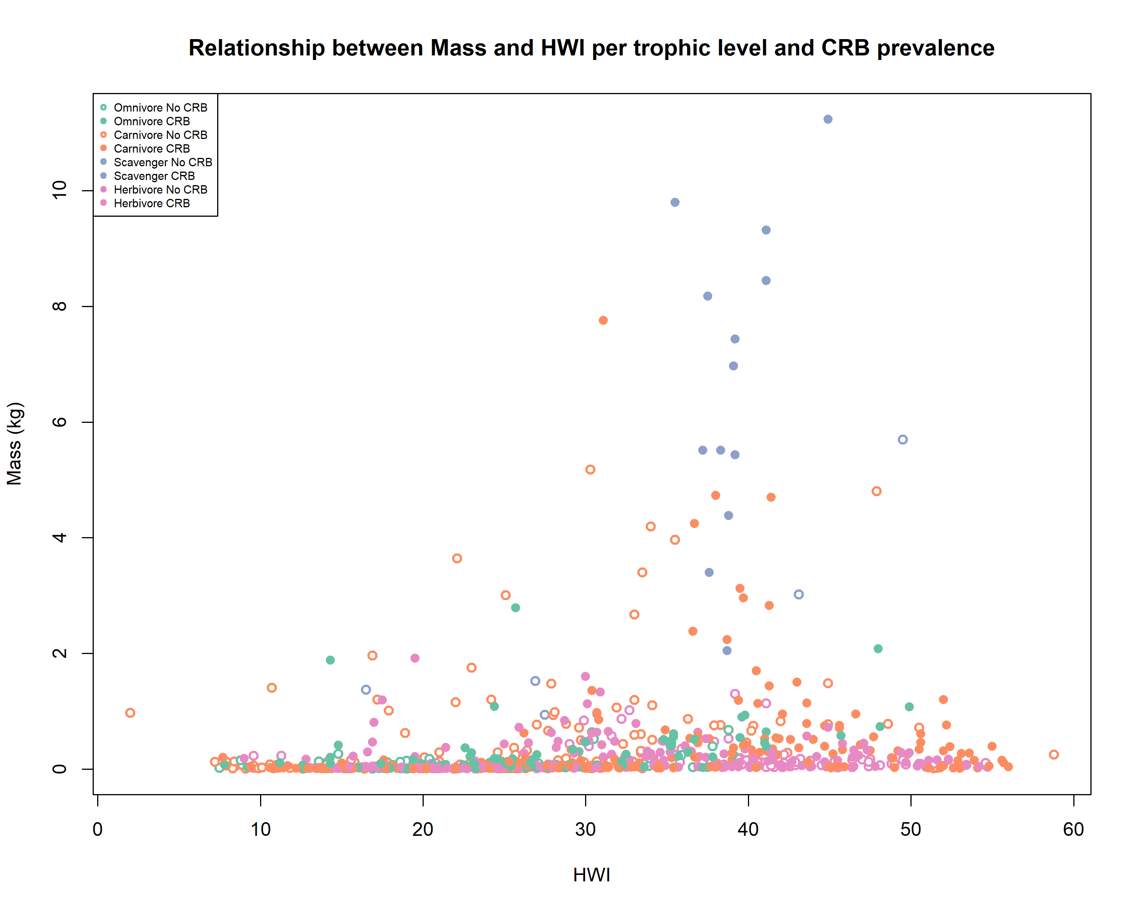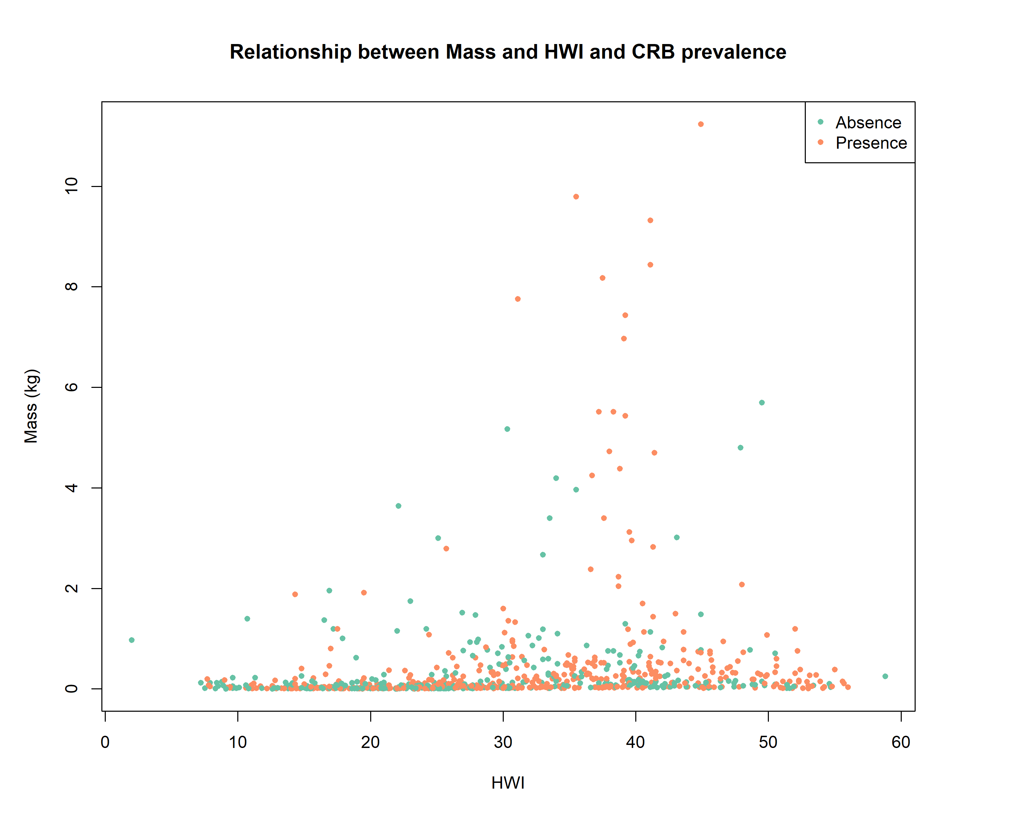

***Figure 2.3*** *Panel* ***a*** *show the Prevalence of Communal Roosting Behaviour in Core Land Birds in relation to HWI and mass. Data shows the convergence evolution of this behaviour. Panel* ***b*** *show the sane as above including trophic levels.*

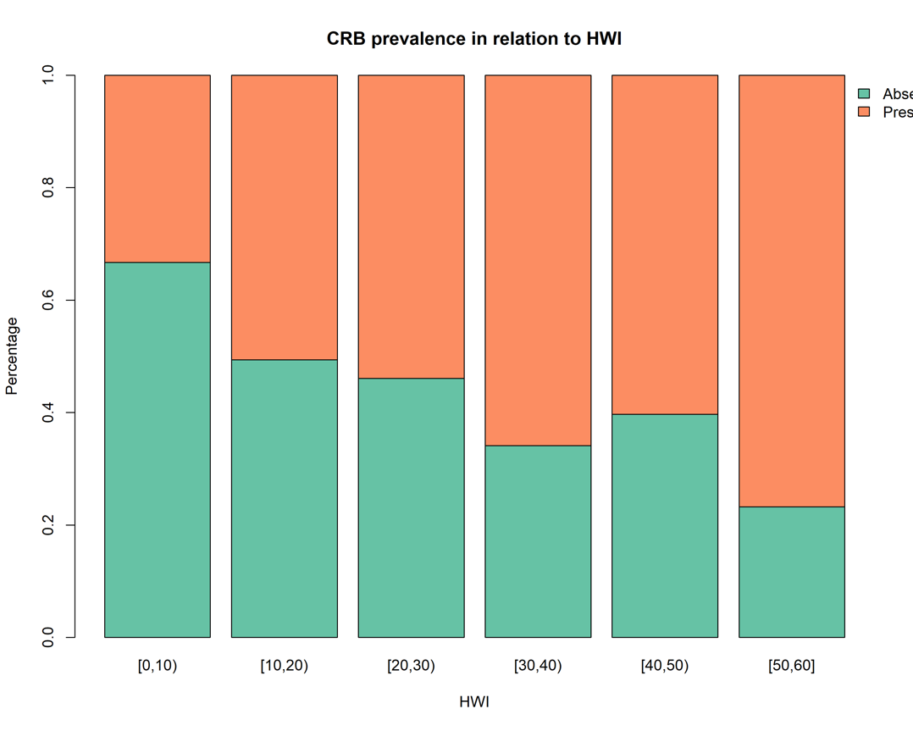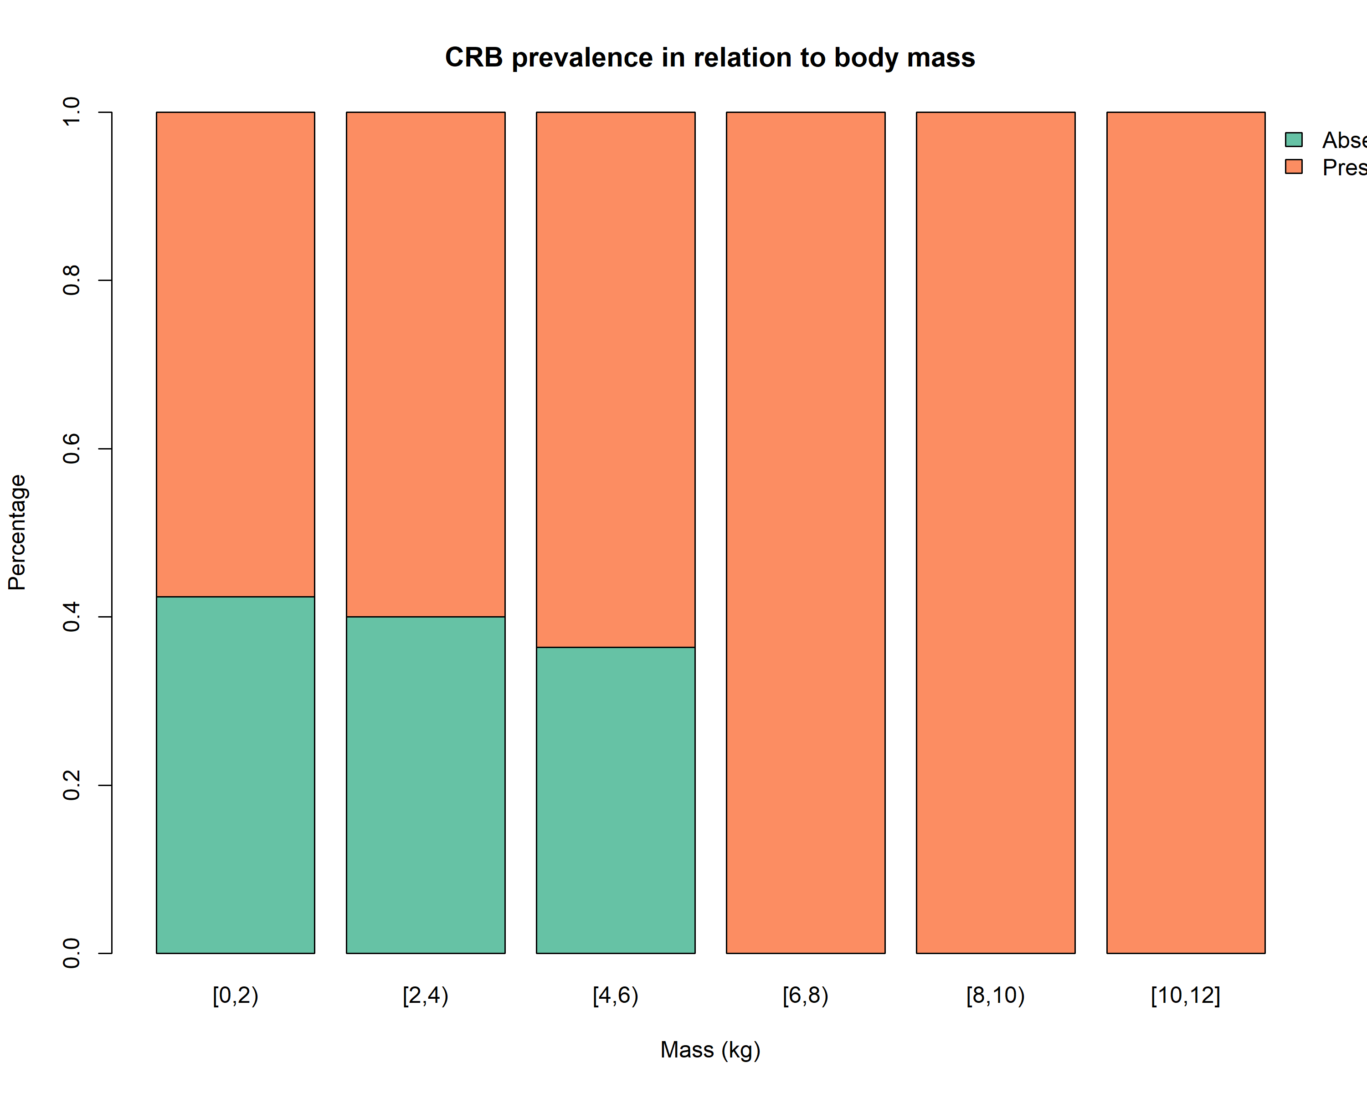

***Figure 2.4*** *Prevalence of Communal Roosting Behaviour in Core Land Birds in relation to HWI (****panel a****), and mass (****panel b****).*

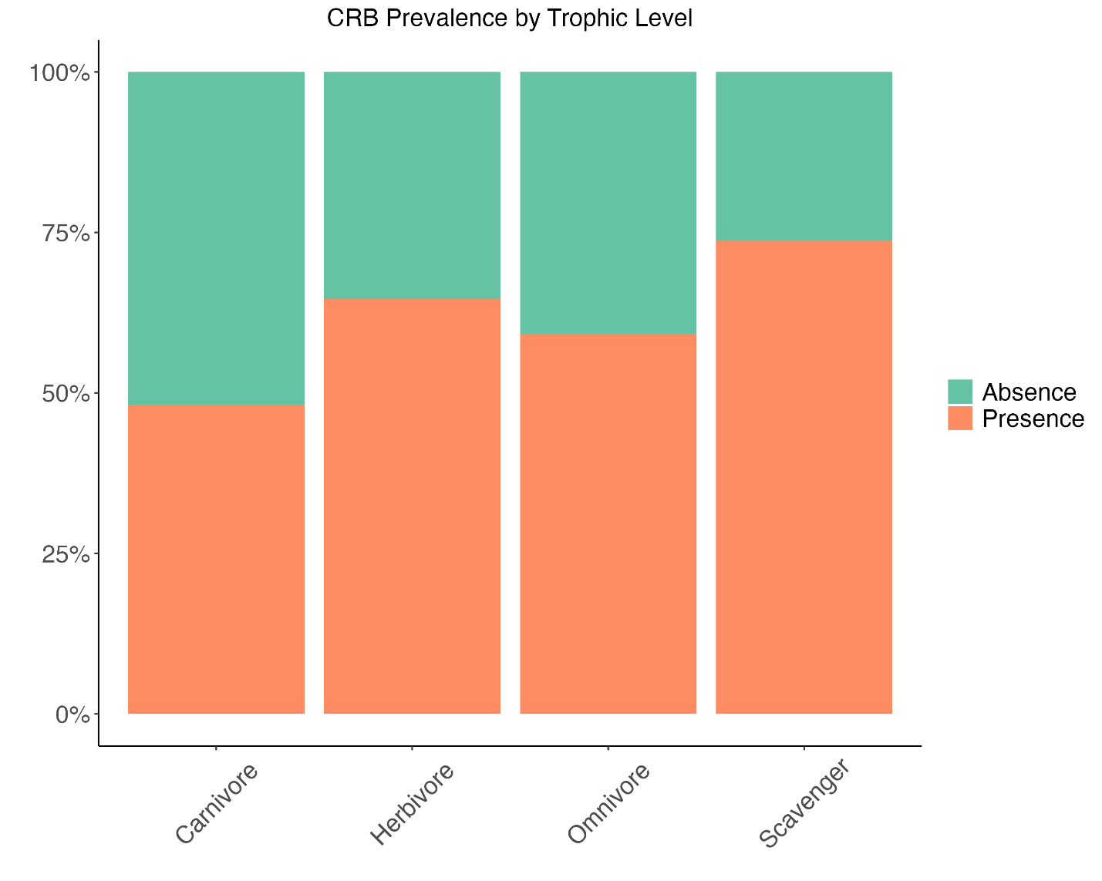***Figure 2.5*** *Prevalence of Communal Roosting Behaviour in Core Land Birds in relation to Trophic Level.*

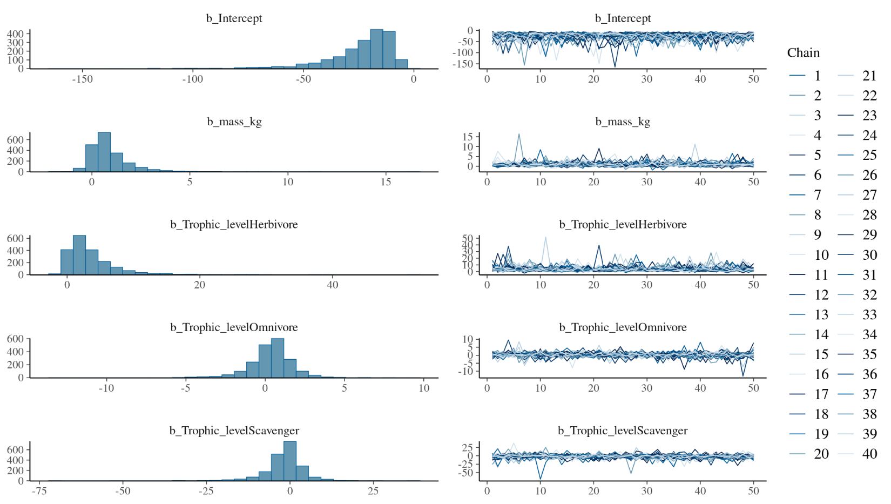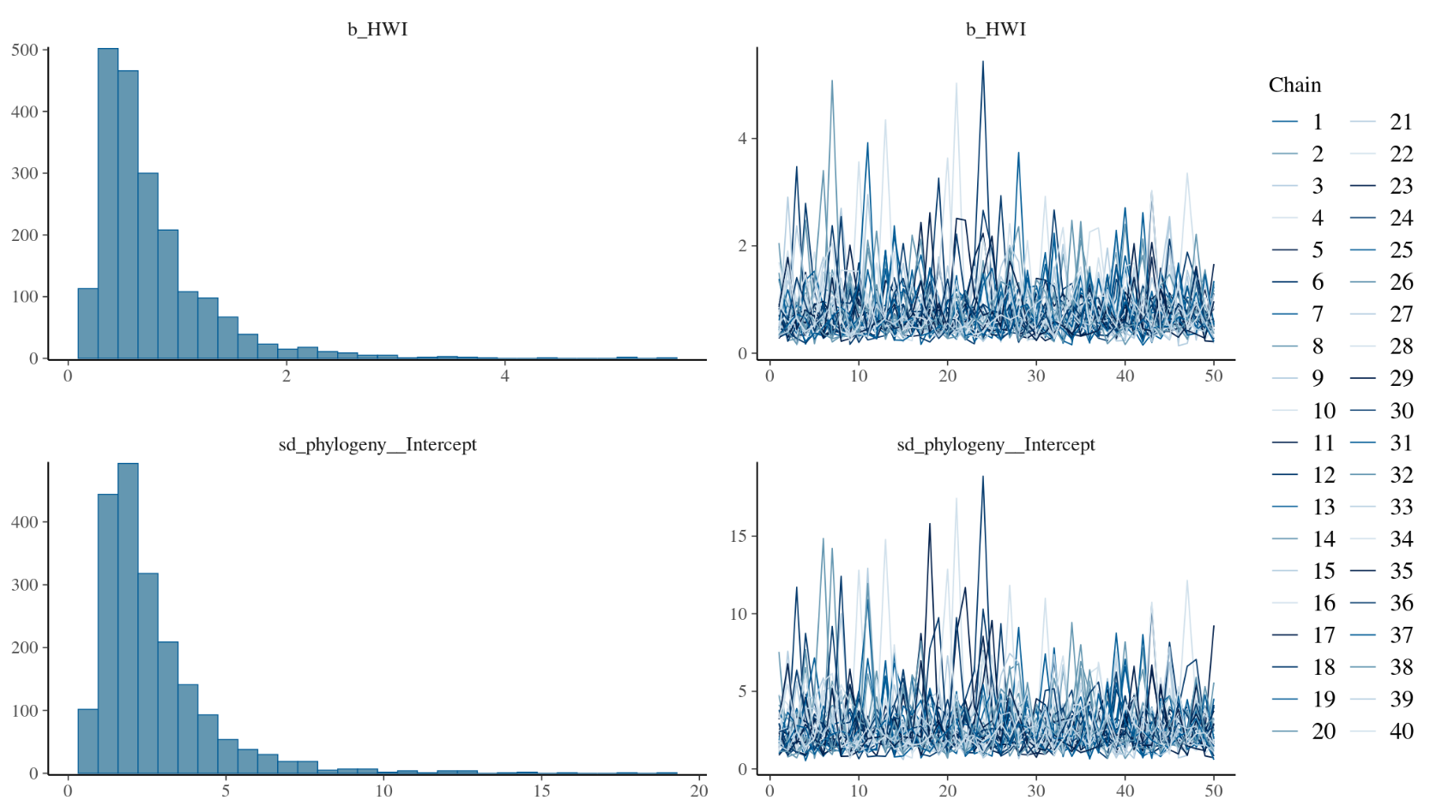

## **Appendix 2: Code**

All code and figures used for Chapter 2 of this thesis can be found on the GitHub repository at <https://github.com/QuantitativeEcologyLab/MSc.-Communal-roosting-behav>