Supporting Information
Table S1. Detailed description of the seven jaguars monitored with GPS collars in Maracá-Jipioca. One of the females, named Iemanjá, was recaptured during the second field campaign and fitted with a new collar (*).
Campaign | Name | Colar | Sex | Age  (years) | Weight  (kg) | Start | End | Interval  (min.) | Duration  (months) | Points
1 | Iemanja1 | 707821 | Female | 4 | 39 | 2019-10-04 | 2020-08-09 | 30 | 10.47 | 12,897
1 | Iara | 704795 | Female | 4 | 40 | 2019-10-09 | 2020-10-22 | 30 | 12.80 | 16,277
1 | Netuno | 704741 | Male | 6 | 55 | 2019-10-19 | 2020-10-08 | 30 | 12.03 | 14,988
2 | Iemanja2* | 696435 | Female | 9 | 38 | 2023-05-13 | 2024-07-06 | 60 | 14.19 | 7,010
2 | Iranildo | 696417 | Male | 4 | 55 | 2023-09-24 | 2024-11-04 | 60 | 13.77 | 8,260
3 | ID696490B | 696490 | Male | 6 | 70 | 2024-04-19 | 2024-11-04 | 60 | 6.73 | 3,775
3 | ID717047B | 717047 | Female | 5 | 35 | 2024-05-03 | 2024-07-16 | 30 | 2.49 | 1,478
3 | ID696469B | 696469 | Male | 6 | 70 | 2024-05-15 | 2025-01-24 | 60 | 8.59 | 4,249

Table S2. Details on the home-range size and movement of the seven jaguars monitored with GPS collars in Maracá-Jipioca. Home-range sizes are in km². The velocity autocorrelation timescales, τ_{velocity}, are a measure of directional persistence in units of minutes. The movement speeds are in unites of km/day. One of the females, named Iemanjá, was recaptured during the second field campaign and fitted with a new collar (*).
Name | Sex | Home-Range Area (95% CI) | τ_{velocity} (95% CI) | Speed (95% CI)
Iemanja1 | Female | 19.5 (15.9 - 23.3) | 17.7 (17.1 - 18.3) | 8.05 (7.97 - 8.13)
Iara | Female | 23.3 (18.5 - 28.6) | 17.0 (16.5 - 17.5) | 7.23 (7.14 - 7.32)
Netuno | Male | 86.3 (59.9 - 117.3) | 24.0 (23.4 - 24.7) | 10.36 (10.26 - 10.45)
Iemanja2* | Female | 16.7 (14.2 - 19.4) | 33.2 (31.7 - 34.8) | 5.59 (5.5 - 5.69)
Iranildo | Male | 128.8 (73.9 - 198.8) | 35.1 (33.6 - 36.6) | 6.72 (6.62 - 6.81)
ID696490B | Male | 51.4 (31.8 - 75.6) | 53.0 (50.1 - 56.0) | 3.92 (3.85 - 3.99)
ID717047B | Female | 27.8 (15.6 - 43.5) | 28.1 (25.7 - 30.8) | 10.03 (9.83 - 10.23)
ID696469B | Male | 66.3 (49.1 - 86.1) | 39.1 (37.0 - 41.4) | 6.5 (6.29 - 6.7)

Table S3. Details of home-range overlap and encounters between the 5 jaguars tracked simultaneously on Maracá-Jipioca Islands. Home range overlap was estimated via the Bhattacharyya Coefficient and ranges from [0-1]. We classified encounters as moments when a pair animals were within 100m of one another. The proximity ratio is a measure of how close a pair of jaguars were to one another on average, with values of 1 indicating independent movement; values >1 indicate the pair was further apart than what would be expected for independent movement and vice versa for values <1.
Jaguar 1 | Jaguar 2 | Sex Dyad | Overlap | Encounters | Proximity Ratio (95% CI)
Iranildo | Iemanja2 | Female - Male | 0.28 | 20 | 1.24 (0.6 - 2.26)
Iranildo | ID696469B | Male - Male | 0.05 | 0 | 0.68 (0.4 - 1.07)
Iranildo | ID696490B | Male - Male | 0.88 | 3 | 0.82 (0.42 - 1.43)
Iranildo | ID717047B | Female - Male | 0.08 | 0 | 0.42 (0.18 - 0.8)
Iemanja2 | ID696469B | Female - Male | 0.08 | 0 | 1.19 (0.56 - 2.09)
Iemanja2 | ID696490B | Female - Male | 0.19 | 0 | 1.87 (0.79 - 3.55)
Iemanja2 | ID717047B | Female - Female | 0.11 | 0 | 0.86 (0.46 - 1.47)
ID696469B | ID696490B | Male - Male | 0.02 | 0 | 0.86 (0.58 - 1.22)
ID696469B | ID717047B | Female - Male | 0.69 | 10 | 1.01 (0.5 - 1.73)
ID696490B | ID717047B | Female - Male | 0.03 | 0 | 1.65 (0.73 - 3.06)

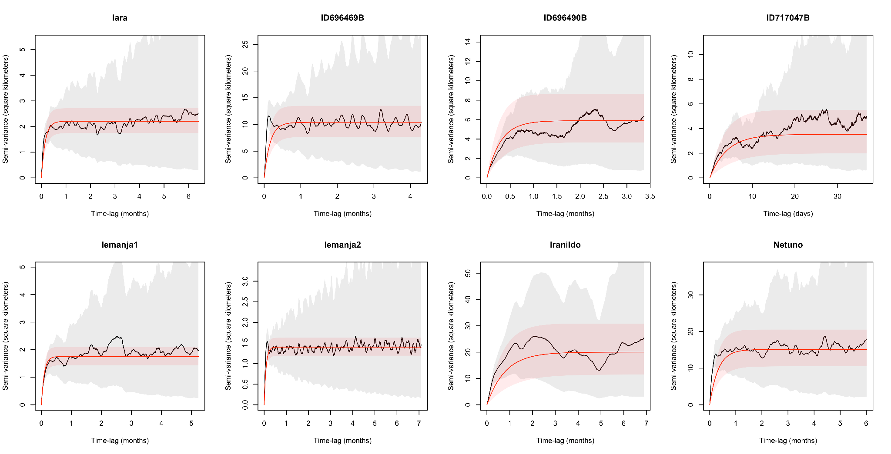
Fig S1. Semi-variograms and fitted movement models. The empirical semi-variograms (black lines) and 95% confidence intervals (grey shading), as well as the fitted movement models (red lines) and 95% confidence intervals (red shading) for each jaguar. Note how all of the empirical variograms have clear asymptotes, indicating range-residency, and the fitted models accurately capture trends in the data. The best-fit model for each animal was the Ornstein-Uhlenbeck with Foraging (OUF) model, which features correlated positions and velocities, as well as home-ranging behaviour.
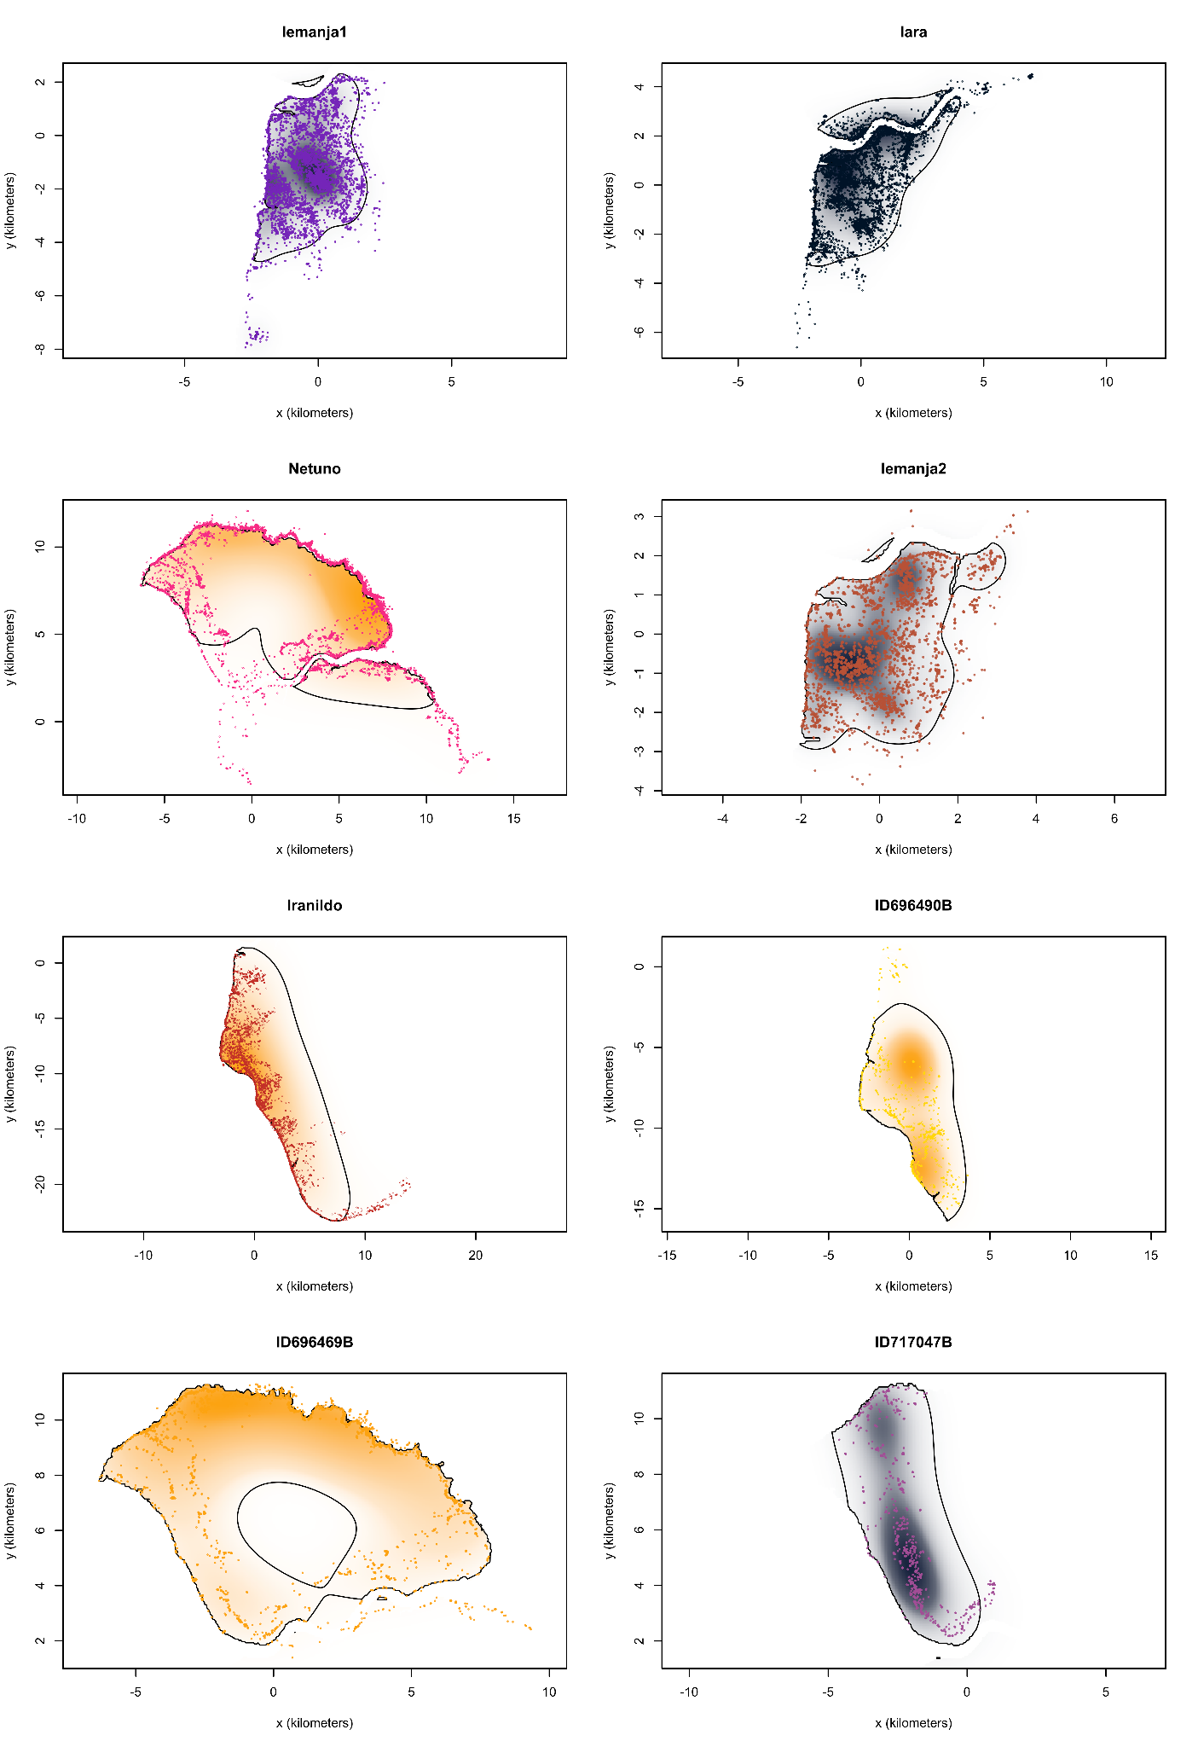
Fig S2. Jaguar home ranges. Figures showing the GPS location data and home-ranges for all 7 monitored animals that were tracked during the 2019-2020, and 2023-2024 monitoring periods. In all figures, the colours for the probability density functions are based on sex (male = orange, female = blue) and shaded by the intensity of use. The GPS points are coloured by individual, and correspond to the colours used in figures 1 and 2 the main text. The black contours delineate the 95% home-range areas.

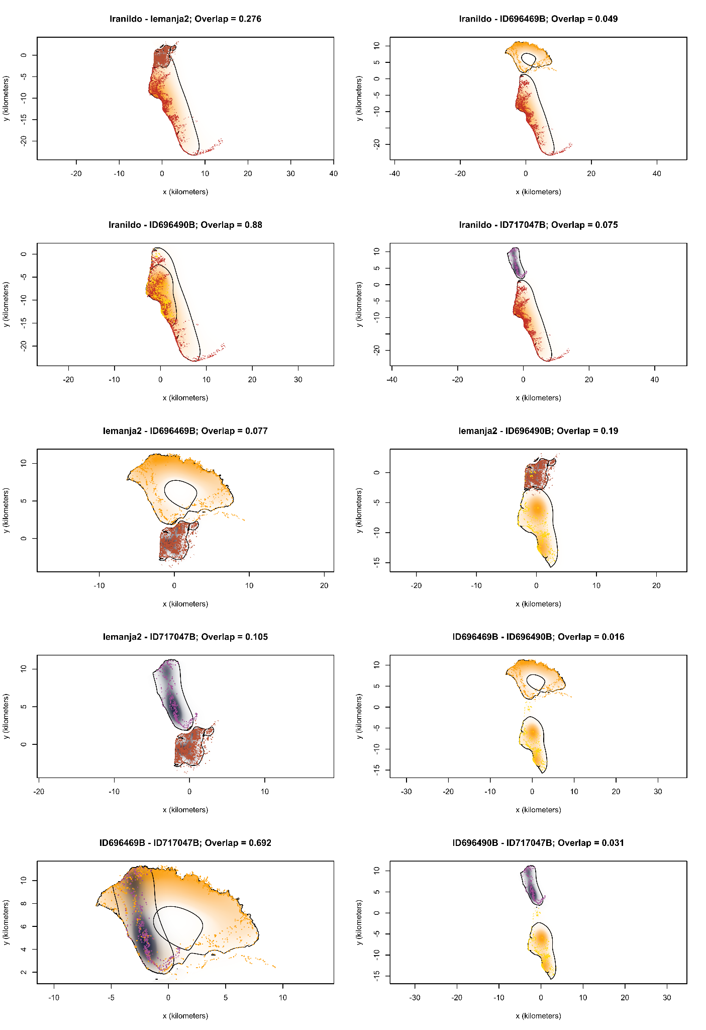
Fig S3. Pairwise home-range overlap. Figures showing the GPS location data and home-range overlap for all 10 dyads that were tracked simultaneously during the 2023-2024 monitoring period. In all figures, the colours for the probability density functions are based on sex (male = orange, female = blue) and shaded by the intensity of use. The GPS points are coloured by individual, and correspond to the colours used in the main text. The black contours delineate the 95% home-range areas.
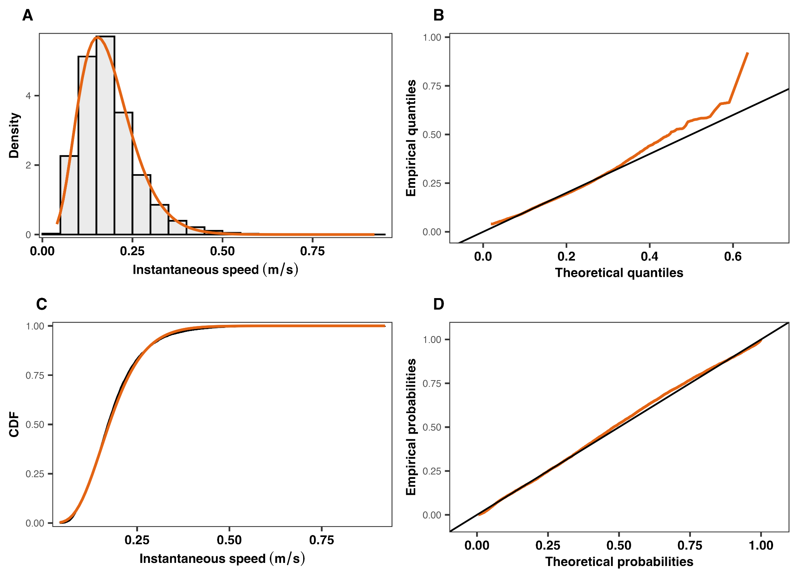
Fig S4. Distribution of instantaneous movement speeds. Diagnostic plots of the distribution of jaguars’ estimated instantaneous movement speed while they were characterised as being active (n = 10,701). The speed distribution was characterised via a Gamma distribution. Panel A contrasts the empirical histogram against the estimated distribution (orange). The Q-Q plot in B shows the expected (black) versus observed (orange) quantiles. Panel C shows the empirical (black) versus theoretical (orange) cumulative distribution functions (CDFs). The P-P plot in B shows the expected (black) versus observed (orange) probabilities.

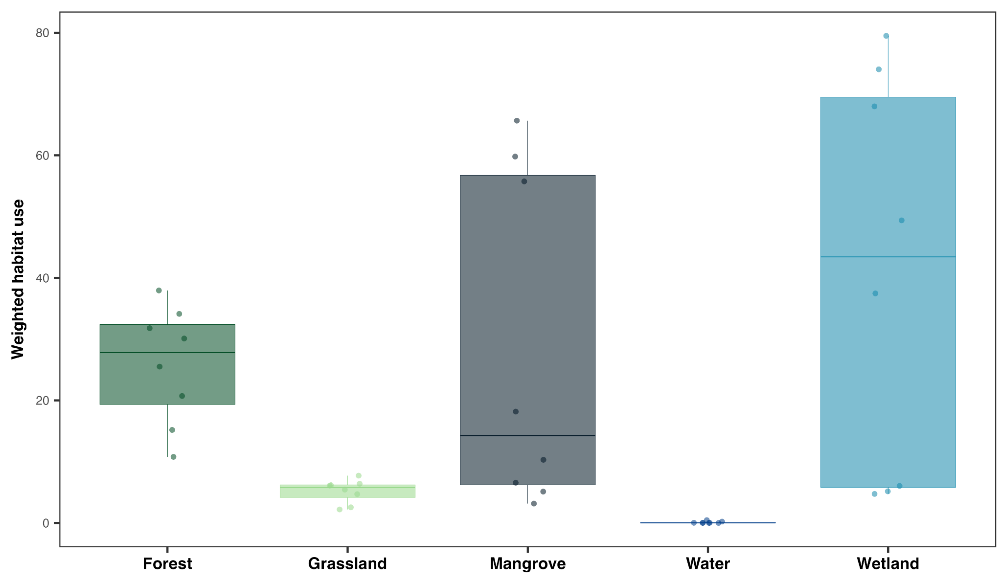Fig S5. Weighted habitat use. Boxplots depicting the probability weighted habitat use in each of Maraca’s five core habitat types. Weighted habitat use was calculated as a weighted mean using each estimated animal’s probability density function (or home-range utilisation distribution). Note that these boxplots depict habitat use, and do not account for availability. They are therefore not expected to reflect the selection results presented in the main text.

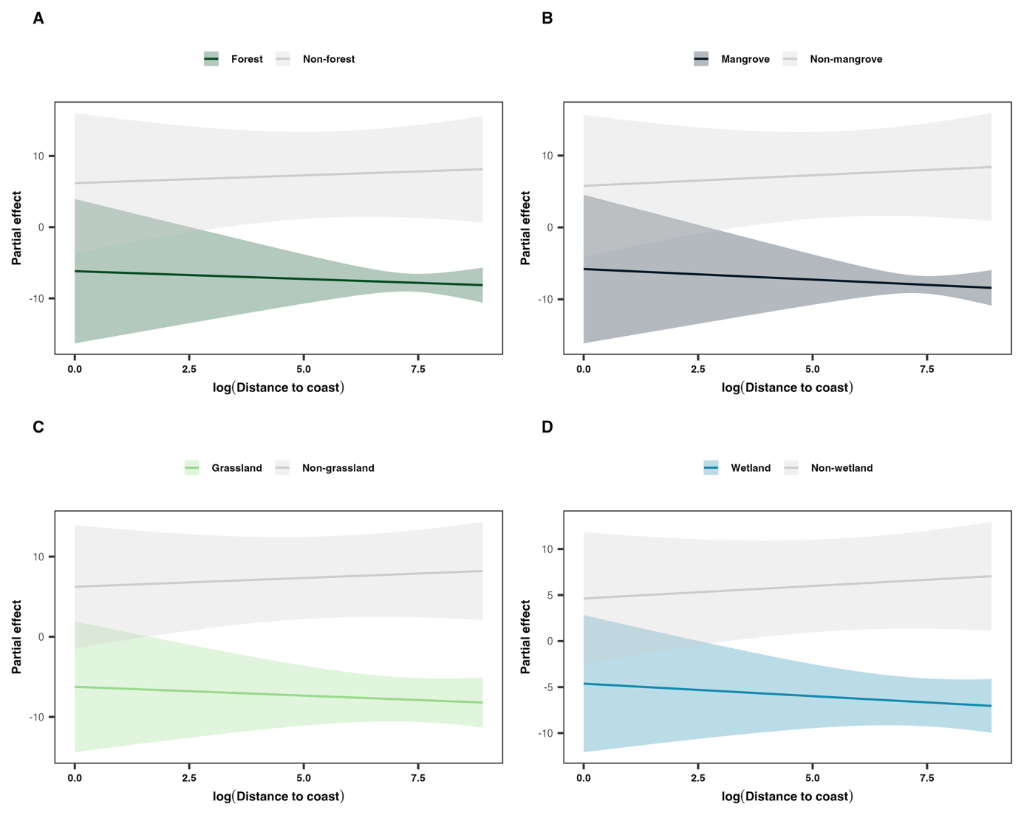Fig S6. Partial effects of the interactions between distance to coast and habitat type. Each panel shows the estimated habitat-specific deviation from the overall distance-to-coast effect based on a Hierarchical Generalised Additive Model (HGAM). The 95% confidence intervals extend well beyond the axis limits and are not shown for clarity. Note that the partial effects reflect deviations from the mean distance-to-coast effect rather than absolute selection values.

