**Results**

**Jaguar home ranges**

The average home-range size of jaguars on Maracá Island was 51.9 km2 (95% CI: 27.7 – 88.6 km2), ranging from 16.8 km2 (95% CI: 14.2 – 19.4 km2) to 128.8 km2 (95% CI: 73.9 – 198.8 km2). We estimated the male/female ratio of home-range areas to be 4.01 (3.23–4.88), which excludes 1, indicating males had significantly larger home-ranges than females (Fig. 1C). While there were differences between the sexes, there were no significant relationships between home-range size and weight (β = 0.001; 95% CI: -0.001 – 0.003; Fig. 1D), nor age (β = -0.008; 95% CI: -0.028 – 0.011; Fig. 1E).

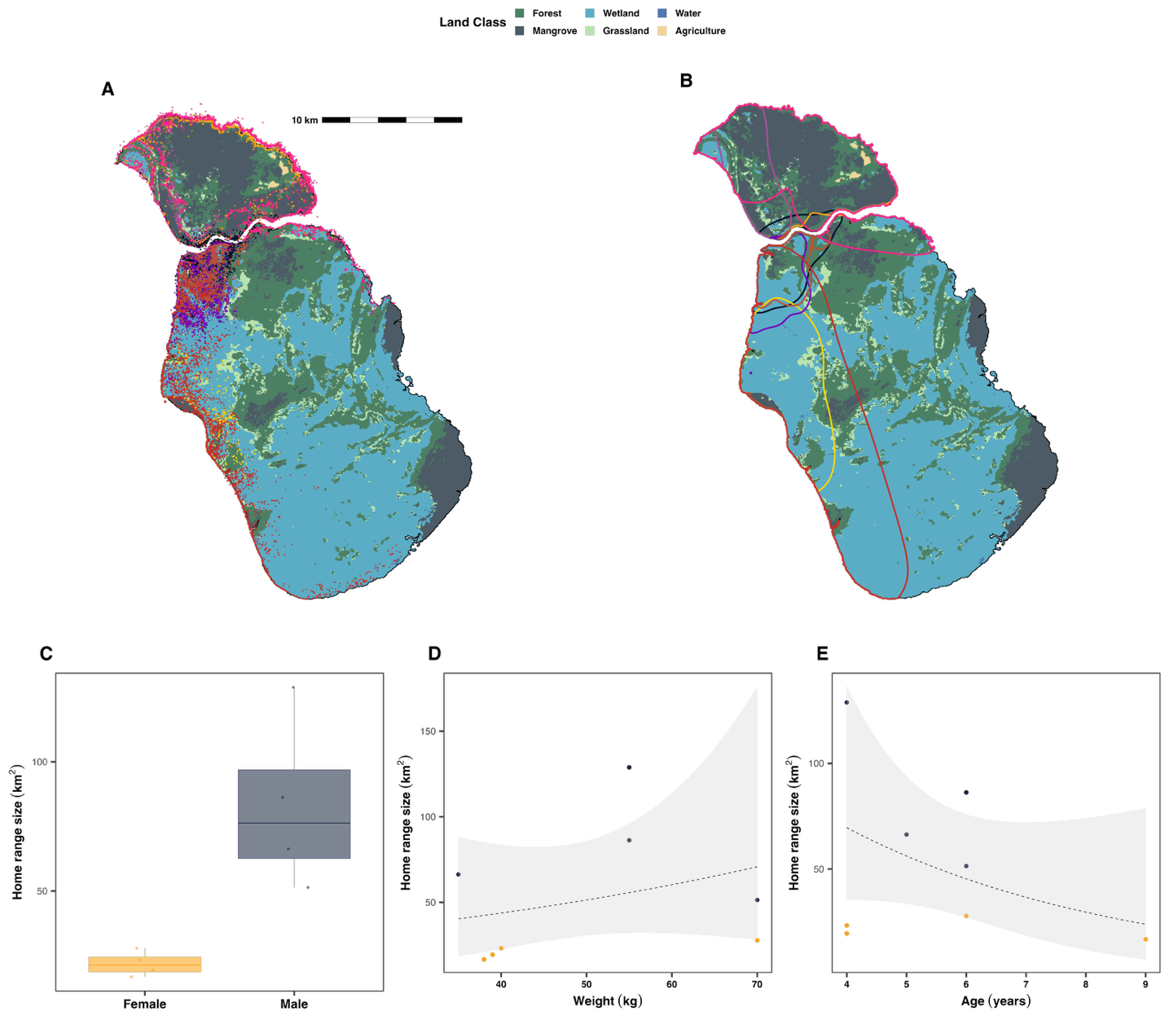

**Figure 1** (A) GPS locations, (B) Home ranges; (C) boxplots of home range size between the sexes; as well as scatterplot of home-range size versus (D) weight, and (E) age.

**Jaguar movement and habitat**

On average, the monitored jaguars moved at a speed of 7.30 km/day (95% CI: 5.81 – 9.06 km/day), ranging from 3.92 km/day (95% CI: 3.85 – 3.99 km/day) to 10.36 km/day (95% CI: 10.26 – 10.45 km/day). We estimated the male/female ratio of movement speeds to be 1.09 (0.65–1.64), which includes 1, indicating no significant difference (Fig. 2A). There were also no significant relationships between home-range size and weight (β < -0.001; 95% CI: -0.003 – 0.002; Fig. 2B), nor age (β = -0.0015; 95% CI: -0.022 – 0.019; Fig. 2C). Jaguars did, however, modulated their activity as a function of habitat. The monitored animals were stationary 78.7% of the time, and moving the remaining 21.3%, but their probability of moving differed significantly between habitats (ΛGLRT = 662.3, P < 0.001; Fig. 2D, Table 1). On average, the monitored animals tended to have a higher probability of moving in grasslands, water, and wetlands, and a greater probability of resting in forests and mangroves.

**Table 1.** The model estimated probability of a jaguar moving (P(moving)), and their movement speed, along with 95% confidence intervals in each of Maraca’s five core habitat types.

|  |  |  |  |  |  |
| --- | --- | --- | --- | --- | --- |
|  | **Forest** | **Grassland** | **Mangrove** | **Water** | **Wetland** |
| **P(moving)** | 0.17 | 0.24 | 0.14 | 0.24 | 0.25 |
| (0.14 - 0.21) | (0.20 - 0.30) | (0.11 - 0.17) | (0.17 - 0.35) | (0.21 - 0.30) |
| **Speed (m/s)** | 0.177 | 0.184 | 0.171 | 0.202 | 0.182 |
| (0.15 - 0.21) | (0.16 - 0.22) | (0.14 - 0.20) | (0.16 - 0.25) | (0.15 - 0.22) |

When active, the movement speed of the monitored jaguars also differed as a function of habitat (ΛGLRT = 5.19, P < 0.001; Fig. 2E, Table 1). Jaguars’ average instantaneous movement speed was 0.18 m/s (range: 0.04 – 0.92 m/s). Compared to forests, animals tended to move more quickly in grassland (β = 0.44, P < 0.001), wetlands (β = 0.49, P < 0.001), and water (β = 0.48, P = 0.034), but more slowly while moving through mangroves (β = -0.28, P < 0.0001).

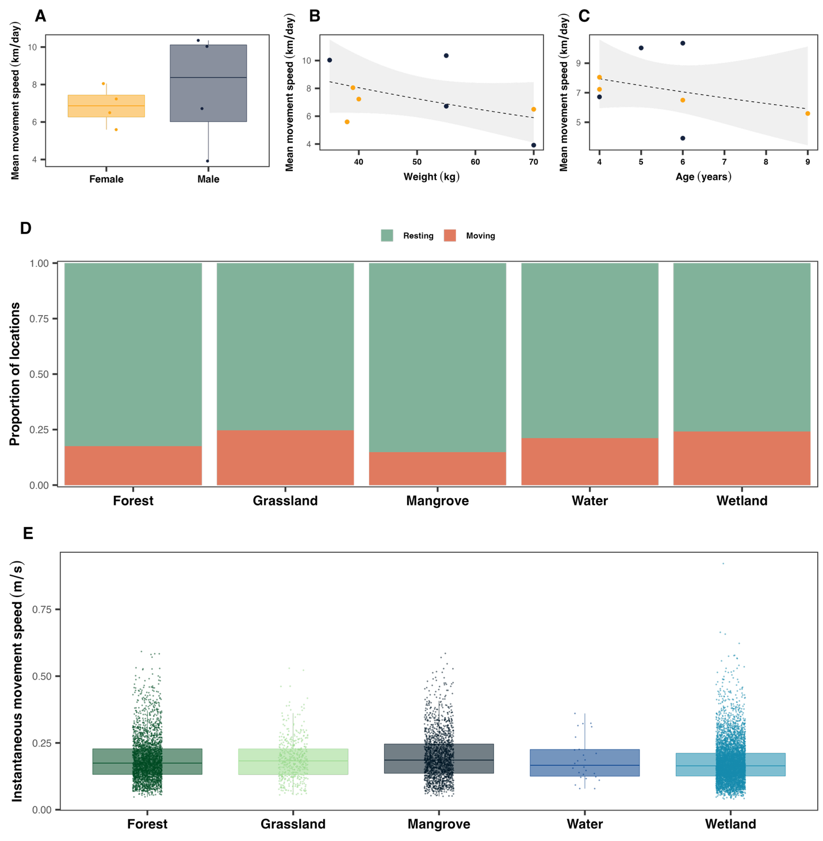

**Figure 2 Movement speed and activity.** Panel (A) depicts boxplots of movement speed between the sexes; as well as scatterplot of movement speed versus (B) weight, and (C) age. Panel (D) shows the distribution of locations classified of resting versus moving, based on the estimated movement speeds in each of Maraca’s five core habitat types. Panel E shows the eight monitored jaguars’ estimated instantaneous movement speeds while active in each in each of Maraca’s five core habitat types.