NCA of PK profile after single dose

Default Subtitle

**22-Jun-2022**

Table of contents

List of figures

Listing 2.1 Individual concentration data

**Listing 2.1-1 Individual concentration data of Plasma Drug B (Drug B) - Single IV Infusion Dose (SD) (1 of 2)**

|  |  |  |  |  |  |  |  |  |  |  |  |
| --- | --- | --- | --- | --- | --- | --- | --- | --- | --- | --- | --- |
|  |  | Nominal Time [h] |  |  |  |  |  |  |  |  |  |
|  |  | 0 | 0.5 | 2 | 8 | 24 | 48 | 72 | 168 | 240 | 336 |
| **Treatment** | **Subject** | **Concentration [ug/mL]** |  |  |  |  |  |  |  |  |  |
| 300mg/m2 | 1 | BLQ | 17.7 | 75.4 | 64 | 55.2 | 49.1 | 42.3 | 27.5 | 27.4 | 21.3 |
|  | 2 | BLQ | 33.3 | 157.2 | 97.7 | 94.3 | 91.7 | 80 | 62.1 | 52.8 | 42.8 |
|  | 3 | BLQ | 26.2 | 92.3 | 94.9 | 79.1 | 63.7 | 62.6 | 57.3 | 38.6 | 37.4 |

NS: No Sample.  
BLQ: Below lower limit of quantitation.  
Lower limit of quantitation is 5 ug/mL.  
IQnca version: 1.2.0  
Script: compliance  
Output: output/listings/listing_concentrations.rmd  
Execution date: 2022-06-22 14:22:28

**Listing 2.1-1 Individual concentration data of Plasma Drug B (Drug B) - Single IV Infusion Dose (SD) (2 of 2)**

|  |  |  |  |
| --- | --- | --- | --- |
|  |  | Nominal Time [h] |  |
|  |  | 672 | 1008 |
| **Treatment** | **Subject** | **Concentration [ug/mL]** |  |
| 300mg/m2 | 1 | 10.3 | 7.1 |
|  | 2 | 24.5 | 12.7 |
|  | 3 | 20.1 | 8.6 |

NS: No Sample.  
BLQ: Below lower limit of quantitation.  
Lower limit of quantitation is 5 ug/mL.  
IQnca version: 1.2.0  
Script: compliance  
Output: output/listings/listing_concentrations.rmd  
Execution date: 2022-06-22 14:22:28

**Listing 2.1-2 Individual concentration data of Plasma Drug B (Drug B) - Single IV Infusion Dose (SD) (1 of 2)**

|  |  |  |  |  |  |  |  |  |  |  |  |
| --- | --- | --- | --- | --- | --- | --- | --- | --- | --- | --- | --- |
|  |  | Nominal Time [h] |  |  |  |  |  |  |  |  |  |
|  |  | 0 | 0.5 | 2 | 8 | 24 | 48 | 72 | 168 | 240 | 336 |
| **Treatment** | **Subject** | **Concentration [ug/mL]** |  |  |  |  |  |  |  |  |  |
| 400mg/m2 | 4 | BLQ | 22.6 | 166.4 | 133 | 96.6 | 88.1 | 80.3 | 54.8 | 51.1 | 34.7 |
|  | 6 | BLQ | 21.2 | 145.8 | 125.4 | 89.8 | 82.6 | 87.9 | 62 | NS | 48 |

NS: No Sample.  
BLQ: Below lower limit of quantitation.  
Lower limit of quantitation is 5 ug/mL.  
IQnca version: 1.2.0  
Script: compliance  
Output: output/listings/listing_concentrations.rmd  
Execution date: 2022-06-22 14:22:28

**Listing 2.1-2 Individual concentration data of Plasma Drug B (Drug B) - Single IV Infusion Dose (SD) (2 of 2)**

|  |  |  |  |  |
| --- | --- | --- | --- | --- |
|  |  | Nominal Time [h] |  |  |
|  |  | 672 | 1008 | 1104 |
| **Treatment** | **Subject** | **Concentration [ug/mL]** |  |  |
| 400mg/m2 | 4 | 13.5 | BLQ | BLQ |
|  | 6 | 24.8 | BLQ | NS |

NS: No Sample.  
BLQ: Below lower limit of quantitation.  
Lower limit of quantitation is 5 ug/mL.  
IQnca version: 1.2.0  
Script: compliance  
Output: output/listings/listing_concentrations.rmd  
Execution date: 2022-06-22 14:22:28

Listing 2.3 Individual pharmacokinetic parameters

**Listing 2.3-1 Individual pharmacokinetic parameters of Plasma Drug B (Drug B)**

* USUBJID: 1
* Age: 35
* Gender: Female

|  |  |  |  |  |  |
| --- | --- | --- | --- | --- | --- |
| Profile | Group | Dose [mg] | Description | Parameter (Unit) | Value |
| Single IV Infusion Dose (SD) | 300mg/m2 | 540 | Number of Points for Lambda z | LAMZNPT (-) | 5 |
|  |  |  | R Squared Adjusted | R2ADJ (-) | 0.970477 |
|  |  |  | Half-Life Lambda z | LAMZHL (h) | 398.976 |
|  |  |  | Span | SPAN (-) | 2.10539 |
|  |  |  | Time of CMAX | TMAX (h) | 2 |
|  |  |  | Max Conc | CMAX (mg/L) | 75.4 |
|  |  |  | Max Conc Norm by Dose | CMAXD (mg/L/mg) | 0.13963 |
|  |  |  | Time of CMIN Observation | TMIN (h) | 0 |
|  |  |  | Min Conc | CMIN (mg/L) | 2.5 |
|  |  |  | Min Conc Norm by Dose | CMIND (mg/L/mg) | 0.00462963 |
|  |  |  | Time of Last Nonzero Conc | TLST (h) | 1008 |
|  |  |  | Last Nonzero Conc | CLST (mg/L) | 7.1 |
|  |  |  | Last Nonzero Conc Pred | CLSTP (mg/L) | 6.59407 |
|  |  |  | AUC All | AUCALL (mg/L*h) | 19367.2 |
|  |  |  | AUC Infinity Obs | AUCIFO (mg/L*h) | 23453.9 |
|  |  |  | AUC Infinity Obs Norm by Dose | AUCIFOD (mg/L*h/mg) | 43.4332 |
|  |  |  | AUC Infinity Pred | AUCIFP (mg/L*h) | 23162.7 |
|  |  |  | AUC Infinity Pred Norm by Dose | AUCIFPD (mg/L*h/mg) | 42.8939 |
|  |  |  | AUC to Last Nonzero Conc | AUCLST (mg/L*h) | 19367.2 |
|  |  |  | AUC to Last Nonzero Conc Norm by Dose | AUCLSTD (mg/L*h/mg) | 35.8651 |
|  |  |  | AUC %Extrapolation Obs | AUCPEO (%) | 17.4247 |
|  |  |  | AUC %Extrapolation Pred | AUCPEP (%) | 16.3865 |
|  |  |  | Total CL Obs | CLO (L/h) | 0.0230239 |
|  |  |  | Total CL Pred | CLP (L/h) | 0.0233133 |
|  |  |  | Vol Dist Steady State Obs | VSSO (L) | 12.6509 |
|  |  |  | Vol Dist Steady State Pred | VSSP (L) | 12.5071 |
|  |  |  | Vz Obs | VZO (L) | 13.2526 |
|  |  |  | Vz Pred | VZP (L) | 13.4192 |

NC: Not calculated.  
Number of significant digits: 6  
IQnca version: 1.2.0  
Script: compliance  
Output: output/listings/listing_pkparameter.rmd  
Execution date: 2022-06-22 14:22:32

**Listing 2.3-2 Individual pharmacokinetic parameters of Plasma Drug B (Drug B)**

* USUBJID: 2
* Age: 41
* Gender: Male

|  |  |  |  |  |  |
| --- | --- | --- | --- | --- | --- |
| Profile | Group | Dose [mg] | Description | Parameter (Unit) | Value |
| Single IV Infusion Dose (SD) | 300mg/m2 | 660 | Number of Points for Lambda z | LAMZNPT (-) | 5 |
|  |  |  | R Squared Adjusted | R2ADJ (-) | 0.997805 |
|  |  |  | Half-Life Lambda z | LAMZHL (h) | 374.402 |
|  |  |  | Span | SPAN (-) | 2.24358 |
|  |  |  | Time of CMAX | TMAX (h) | 2 |
|  |  |  | Max Conc | CMAX (mg/L) | 157.2 |
|  |  |  | Max Conc Norm by Dose | CMAXD (mg/L/mg) | 0.238182 |
|  |  |  | Time of CMIN Observation | TMIN (h) | 0 |
|  |  |  | Min Conc | CMIN (mg/L) | 2.5 |
|  |  |  | Min Conc Norm by Dose | CMIND (mg/L/mg) | 0.00378788 |
|  |  |  | Time of Last Nonzero Conc | TLST (h) | 1008 |
|  |  |  | Last Nonzero Conc | CLST (mg/L) | 12.7 |
|  |  |  | Last Nonzero Conc Pred | CLSTP (mg/L) | 12.8044 |
|  |  |  | AUC All | AUCALL (mg/L*h) | 39267.3 |
|  |  |  | AUC Infinity Obs | AUCIFO (mg/L*h) | 46127.2 |
|  |  |  | AUC Infinity Obs Norm by Dose | AUCIFOD (mg/L*h/mg) | 69.8897 |
|  |  |  | AUC Infinity Pred | AUCIFP (mg/L*h) | 46183.6 |
|  |  |  | AUC Infinity Pred Norm by Dose | AUCIFPD (mg/L*h/mg) | 69.9752 |
|  |  |  | AUC to Last Nonzero Conc | AUCLST (mg/L*h) | 39267.3 |
|  |  |  | AUC to Last Nonzero Conc Norm by Dose | AUCLSTD (mg/L*h/mg) | 59.496 |
|  |  |  | AUC %Extrapolation Obs | AUCPEO (%) | 14.8717 |
|  |  |  | AUC %Extrapolation Pred | AUCPEP (%) | 14.9756 |
|  |  |  | Total CL Obs | CLO (L/h) | 0.0143083 |
|  |  |  | Total CL Pred | CLP (L/h) | 0.0142908 |
|  |  |  | Vol Dist Steady State Obs | VSSO (L) | 7.47407 |
|  |  |  | Vol Dist Steady State Pred | VSSP (L) | 7.48283 |
|  |  |  | Vz Obs | VZO (L) | 7.72858 |
|  |  |  | Vz Pred | VZP (L) | 7.71914 |

NC: Not calculated.  
Number of significant digits: 6  
IQnca version: 1.2.0  
Script: compliance  
Output: output/listings/listing_pkparameter.rmd  
Execution date: 2022-06-22 14:22:32

**Listing 2.3-3 Individual pharmacokinetic parameters of Plasma Drug B (Drug B)**

* USUBJID: 3
* Age: 59
* Gender: Male

|  |  |  |  |  |  |
| --- | --- | --- | --- | --- | --- |
| Profile | Group | Dose [mg] | Description | Parameter (Unit) | Value |
| Single IV Infusion Dose (SD) | 300mg/m2 | 570 | Number of Points for Lambda z | LAMZNPT (-) | 3 |
|  |  |  | R Squared Adjusted | R2ADJ (-) | 0.984087 |
|  |  |  | Half-Life Lambda z | LAMZHL (h) | 316.887 |
|  |  |  | Span | SPAN (-) | 2.12063 |
|  |  |  | Time of CMAX | TMAX (h) | 8 |
|  |  |  | Max Conc | CMAX (mg/L) | 94.9 |
|  |  |  | Max Conc Norm by Dose | CMAXD (mg/L/mg) | 0.166491 |
|  |  |  | Time of CMIN Observation | TMIN (h) | 0 |
|  |  |  | Min Conc | CMIN (mg/L) | 2.5 |
|  |  |  | Min Conc Norm by Dose | CMIND (mg/L/mg) | 0.00438596 |
|  |  |  | Time of Last Nonzero Conc | TLST (h) | 1008 |
|  |  |  | Last Nonzero Conc | CLST (mg/L) | 8.6 |
|  |  |  | Last Nonzero Conc Pred | CLSTP (mg/L) | 8.9331 |
|  |  |  | AUC All | AUCALL (mg/L*h) | 31988.2 |
|  |  |  | AUC Infinity Obs | AUCIFO (mg/L*h) | 35919.9 |
|  |  |  | AUC Infinity Obs Norm by Dose | AUCIFOD (mg/L*h/mg) | 63.0174 |
|  |  |  | AUC Infinity Pred | AUCIFP (mg/L*h) | 36072.2 |
|  |  |  | AUC Infinity Pred Norm by Dose | AUCIFPD (mg/L*h/mg) | 63.2846 |
|  |  |  | AUC to Last Nonzero Conc | AUCLST (mg/L*h) | 31988.2 |
|  |  |  | AUC to Last Nonzero Conc Norm by Dose | AUCLSTD (mg/L*h/mg) | 56.1197 |
|  |  |  | AUC %Extrapolation Obs | AUCPEO (%) | 10.9457 |
|  |  |  | AUC %Extrapolation Pred | AUCPEP (%) | 11.3216 |
|  |  |  | Total CL Obs | CLO (L/h) | 0.0158686 |
|  |  |  | Total CL Pred | CLP (L/h) | 0.0158016 |
|  |  |  | Vol Dist Steady State Obs | VSSO (L) | 7.33203 |
|  |  |  | Vol Dist Steady State Pred | VSSP (L) | 7.36793 |
|  |  |  | Vz Obs | VZO (L) | 7.25468 |
|  |  |  | Vz Pred | VZP (L) | 7.22406 |

NC: Not calculated.  
Number of significant digits: 6  
IQnca version: 1.2.0  
Script: compliance  
Output: output/listings/listing_pkparameter.rmd  
Execution date: 2022-06-22 14:22:32

**Listing 2.3-4 Individual pharmacokinetic parameters of Plasma Drug B (Drug B)**

* USUBJID: 4
* Age: 55
* Gender: Female

|  |  |  |  |  |  |
| --- | --- | --- | --- | --- | --- |
| Profile | Group | Dose [mg] | Description | Parameter (Unit) | Value |
| Single IV Infusion Dose (SD) | 400mg/m2 | 866 | Number of Points for Lambda z | LAMZNPT (-) | 7 |
|  |  |  | R Squared Adjusted | R2ADJ (-) | 0.993182 |
|  |  |  | Half-Life Lambda z | LAMZHL (h) | 230.208 |
|  |  |  | Span | SPAN (-) | 2.81484 |
|  |  |  | Time of CMAX | TMAX (h) | 2 |
|  |  |  | Max Conc | CMAX (mg/L) | 166.4 |
|  |  |  | Max Conc Norm by Dose | CMAXD (mg/L/mg) | 0.192148 |
|  |  |  | Time of CMIN Observation | TMIN (h) | 1008 |
|  |  |  | Min Conc | CMIN (mg/L) | 0 |
|  |  |  | Min Conc Norm by Dose | CMIND (mg/L/mg) | 0 |
|  |  |  | Time of Last Nonzero Conc | TLST (h) | 672 |
|  |  |  | Last Nonzero Conc | CLST (mg/L) | 13.5 |
|  |  |  | Last Nonzero Conc Pred | CLSTP (mg/L) | 13.1882 |
|  |  |  | AUC All | AUCALL (mg/L*h) | 31197 |
|  |  |  | AUC Infinity Obs | AUCIFO (mg/L*h) | 33412.6 |
|  |  |  | AUC Infinity Obs Norm by Dose | AUCIFOD (mg/L*h/mg) | 38.5827 |
|  |  |  | AUC Infinity Pred | AUCIFP (mg/L*h) | 33309.1 |
|  |  |  | AUC Infinity Pred Norm by Dose | AUCIFPD (mg/L*h/mg) | 38.4631 |
|  |  |  | AUC to Last Nonzero Conc | AUCLST (mg/L*h) | 28929 |
|  |  |  | AUC to Last Nonzero Conc Norm by Dose | AUCLSTD (mg/L*h/mg) | 33.4053 |
|  |  |  | AUC %Extrapolation Obs | AUCPEO (%) | 13.419 |
|  |  |  | AUC %Extrapolation Pred | AUCPEP (%) | 13.1498 |
|  |  |  | Total CL Obs | CLO (L/h) | 0.0259184 |
|  |  |  | Total CL Pred | CLP (L/h) | 0.0259989 |
|  |  |  | Vol Dist Steady State Obs | VSSO (L) | 8.5267 |
|  |  |  | Vol Dist Steady State Pred | VSSP (L) | 8.49873 |
|  |  |  | Vz Obs | VZO (L) | 8.60802 |
|  |  |  | Vz Pred | VZP (L) | 8.63477 |

NC: Not calculated.  
Number of significant digits: 6  
IQnca version: 1.2.0  
Script: compliance  
Output: output/listings/listing_pkparameter.rmd  
Execution date: 2022-06-22 14:22:32

**Listing 2.3-5 Individual pharmacokinetic parameters of Plasma Drug B (Drug B)**

* USUBJID: 6
* Age: 45
* Gender: Male

|  |  |  |  |  |  |
| --- | --- | --- | --- | --- | --- |
| Profile | Group | Dose [mg] | Description | Parameter (Unit) | Value |
| Single IV Infusion Dose (SD) | 400mg/m2 | 748 | Number of Points for Lambda z | LAMZNPT (-) | 8 |
|  |  |  | R Squared Adjusted | R2ADJ (-) | 0.945808 |
|  |  |  | Half-Life Lambda z | LAMZHL (h) | 241.439 |
|  |  |  | Span | SPAN (-) | 4.14184 |
|  |  |  | Time of CMAX | TMAX (h) | 2 |
|  |  |  | Max Conc | CMAX (mg/L) | 145.8 |
|  |  |  | Max Conc Norm by Dose | CMAXD (mg/L/mg) | 0.19492 |
|  |  |  | Time of CMIN Observation | TMIN (h) | 0 |
|  |  |  | Min Conc | CMIN (mg/L) | 2.5 |
|  |  |  | Min Conc Norm by Dose | CMIND (mg/L/mg) | 0.00334225 |
|  |  |  | Time of Last Nonzero Conc | TLST (h) | 1008 |
|  |  |  | Last Nonzero Conc | CLST (mg/L) | 4.5 |
|  |  |  | Last Nonzero Conc Pred | CLSTP (mg/L) | 6.11658 |
|  |  |  | AUC All | AUCALL (mg/L*h) | 38875.7 |
|  |  |  | AUC Infinity Obs | AUCIFO (mg/L*h) | 40443.2 |
|  |  |  | AUC Infinity Obs Norm by Dose | AUCIFOD (mg/L*h/mg) | 54.0684 |
|  |  |  | AUC Infinity Pred | AUCIFP (mg/L*h) | 41006.3 |
|  |  |  | AUC Infinity Pred Norm by Dose | AUCIFPD (mg/L*h/mg) | 54.8212 |
|  |  |  | AUC to Last Nonzero Conc | AUCLST (mg/L*h) | 38875.7 |
|  |  |  | AUC to Last Nonzero Conc Norm by Dose | AUCLSTD (mg/L*h/mg) | 51.9729 |
|  |  |  | AUC %Extrapolation Obs | AUCPEO (%) | 3.87569 |
|  |  |  | AUC %Extrapolation Pred | AUCPEP (%) | 5.19565 |
|  |  |  | Total CL Obs | CLO (L/h) | 0.0184951 |
|  |  |  | Total CL Pred | CLP (L/h) | 0.0182411 |
|  |  |  | Vol Dist Steady State Obs | VSSO (L) | 6.5572 |
|  |  |  | Vol Dist Steady State Pred | VSSP (L) | 6.71784 |
|  |  |  | Vz Obs | VZO (L) | 6.44225 |
|  |  |  | Vz Pred | VZP (L) | 6.35379 |

NC: Not calculated.  
Number of significant digits: 6  
IQnca version: 1.2.0  
Script: compliance  
Output: output/listings/listing_pkparameter.rmd  
Execution date: 2022-06-22 14:22:32

Listing 2.2 Actual Sampling time

**Listing 2.2-1 Actual Sampling time of Drug B - Single IV Infusion Dose (SD) (1 of 2)**

|  |  |  |  |  |  |  |  |  |  |  |  |
| --- | --- | --- | --- | --- | --- | --- | --- | --- | --- | --- | --- |
|  |  | Nominal Time [h] |  |  |  |  |  |  |  |  |  |
|  |  | 0 | 0.5 | 2 | 8 | 24 | 48 | 72 | 168 | 240 | 336 |
| **Treatment** | **Subject** | **Actual Time [h]** |  |  |  |  |  |  |  |  |  |
| 300mg/m2 | 1 | -1.83 | 0.58 | 1.92 | 7.8 | 25.25 | 49.08 | 76.28 | 193.33 | 244.42 | 358.1 |
|  | 2 | -2.12 | 0.55 | 2.12 | 8 | 24.92 | 48.67 | 77.3 | 169.07 | 241.75 | 360.17 |
|  | 3 | -0.27 | 0.52 | 2.08 | 10.08 | 26.6 | 50.93 | 74.07 | 170.5 | 242.95 | 340.68 |

NS: No Sample.  
IQnca version: 1.2.0  
Script: compliance  
Output: output/listings/listing_times.rmd  
Execution date: 2022-06-22 14:22:28

**Listing 2.2-1 Actual Sampling time of Drug B - Single IV Infusion Dose (SD) (2 of 2)**

|  |  |  |  |
| --- | --- | --- | --- |
|  |  | Nominal Time [h] |  |
|  |  | 672 | 1008 |
| **Treatment** | **Subject** | **Actual Time [h]** |  |
| 300mg/m2 | 1 | 699.05 | 1055.4 |
|  | 2 | 694.02 | 1029.9 |
|  | 3 | 675.08 | 1014.4 |

NS: No Sample.  
IQnca version: 1.2.0  
Script: compliance  
Output: output/listings/listing_times.rmd  
Execution date: 2022-06-22 14:22:28

**Listing 2.2-2 Actual Sampling time of Drug B - Single IV Infusion Dose (SD) (1 of 2)**

|  |  |  |  |  |  |  |  |  |  |  |  |
| --- | --- | --- | --- | --- | --- | --- | --- | --- | --- | --- | --- |
|  |  | Nominal Time [h] |  |  |  |  |  |  |  |  |  |
|  |  | 0 | 0.5 | 2 | 8 | 24 | 48 | 72 | 168 | 240 | 336 |
| **Treatment** | **Subject** | **Actual Time [h]** |  |  |  |  |  |  |  |  |  |
| 400mg/m2 | 4 | -1.62 | 0.5 | 2.63 | 10.58 | 27.17 | 48.25 | 71.08 | 167.75 | 239.33 | 335.53 |
|  | 6 | -2.75 | 0.5 | 2.42 | 8 | 23 | 46.67 | 70.58 | 168.25 | NS | 360.5 |

NS: No Sample.  
IQnca version: 1.2.0  
Script: compliance  
Output: output/listings/listing_times.rmd  
Execution date: 2022-06-22 14:22:28

**Listing 2.2-2 Actual Sampling time of Drug B - Single IV Infusion Dose (SD) (2 of 2)**

|  |  |  |  |  |
| --- | --- | --- | --- | --- |
|  |  | Nominal Time [h] |  |  |
|  |  | 672 | 1008 | 1104 |
| **Treatment** | **Subject** | **Actual Time [h]** |  |  |
| 400mg/m2 | 4 | 671.5 | 1008 | 1103.6 |
|  | 6 | 698.33 | 1198.8 | NS |

NS: No Sample.  
IQnca version: 1.2.0  
Script: compliance  
Output: output/listings/listing_times.rmd  
Execution date: 2022-06-22 14:22:28

Geometric mean concentration with upper 95% CI vs. time curve - Linear scale

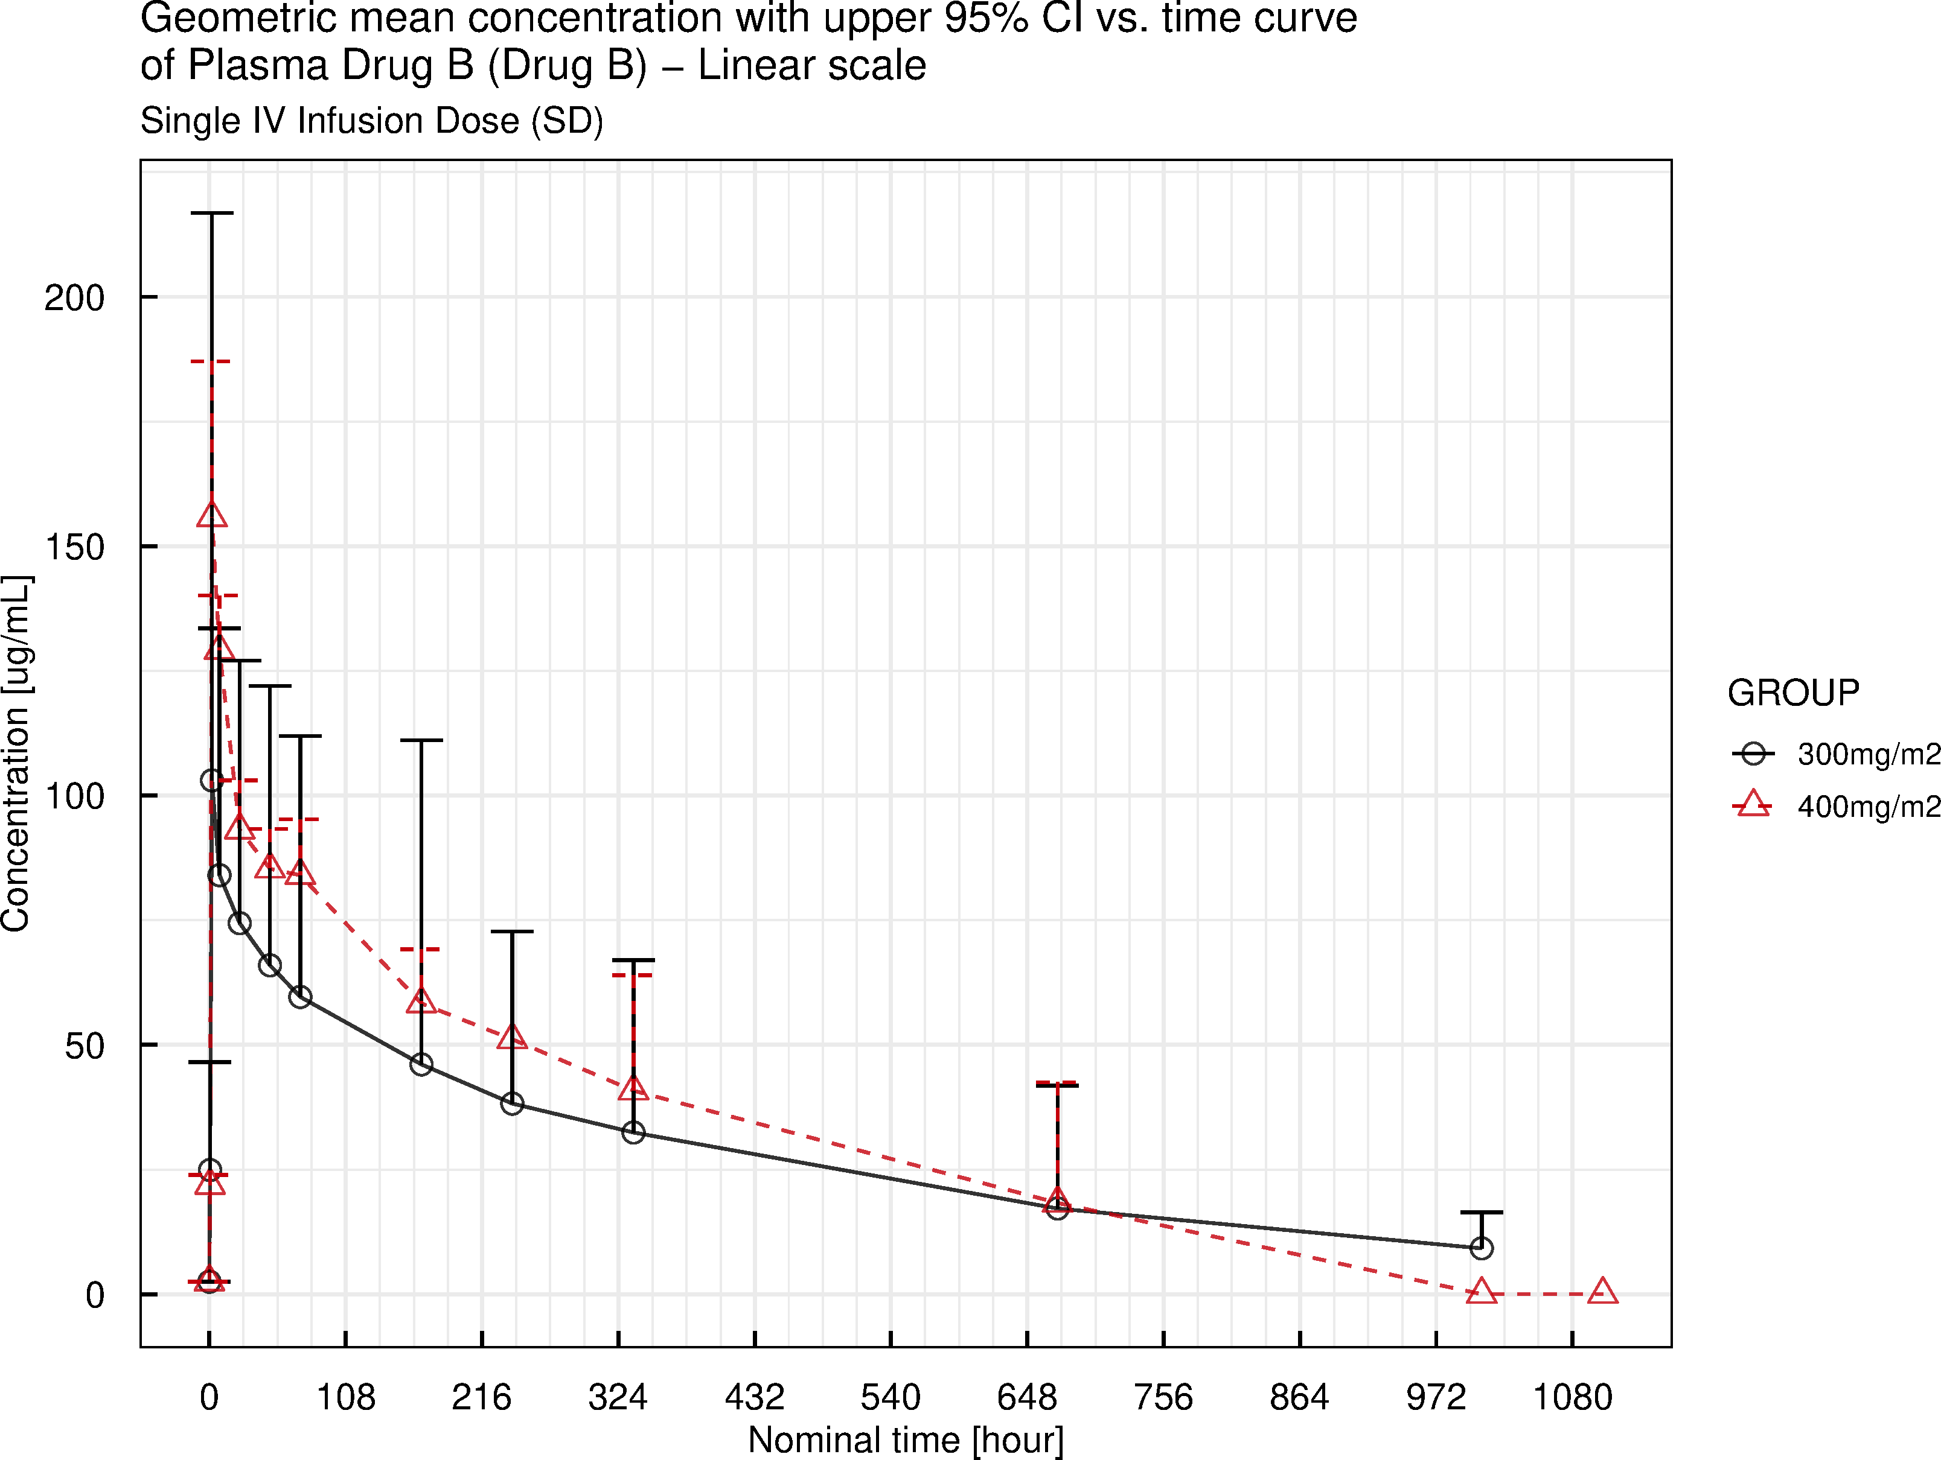

IQnca version: 1.2.0  
Script: compliance  
Output: output/figures/figure_geommean_1.pdf  
Execution date: 2022-06-22 14:22:31

Geometric mean concentration with upper 95% CI vs. time curve - Log scale

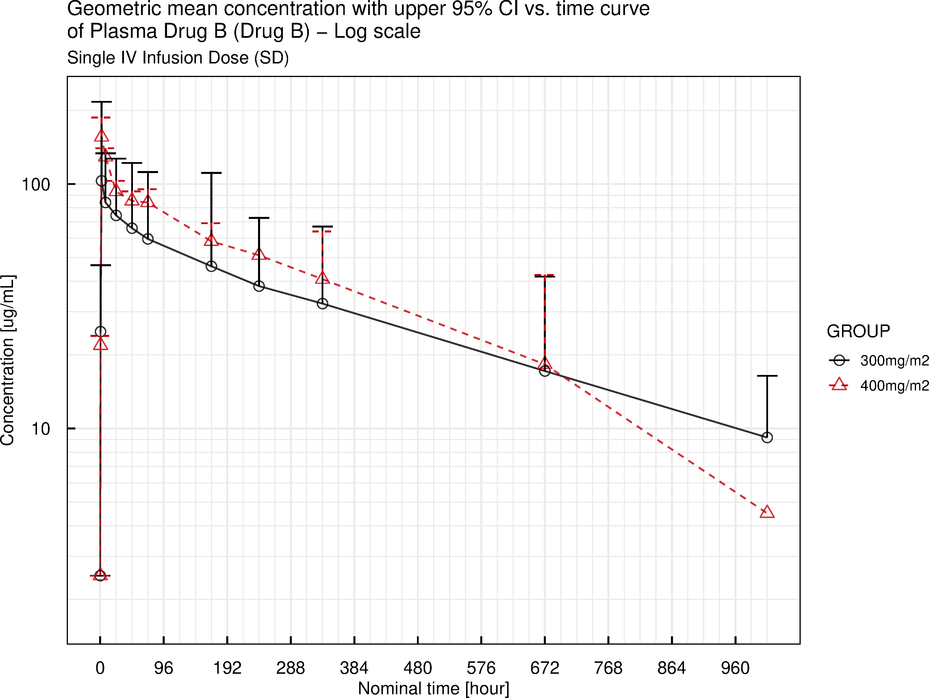

IQnca version: 1.2.0  
Script: compliance  
Output: output/figures/figure_geommean_2.pdf  
Execution date: 2022-06-22 14:22:32

Arithmetic mean (+SD) concentration vs. time - Linear scale

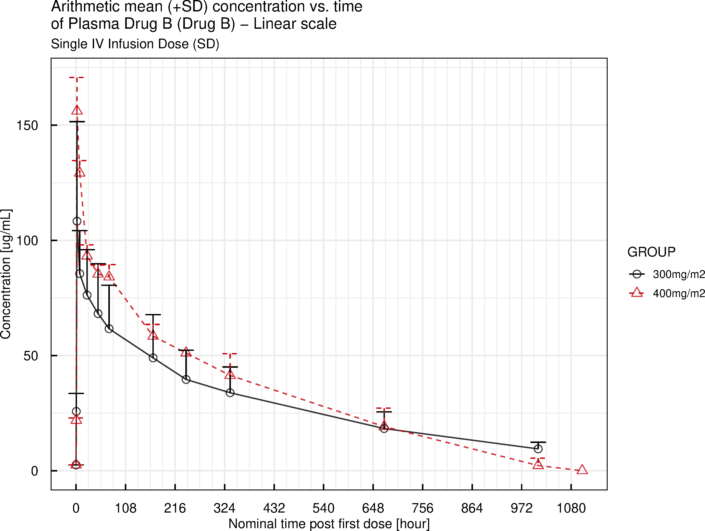

IQnca version: 1.2.0  
Script: compliance  
Output: output/figures/figure_mean_1.pdf  
Execution date: 2022-06-22 14:22:31

Individual observed values vs. time curve - Log scale

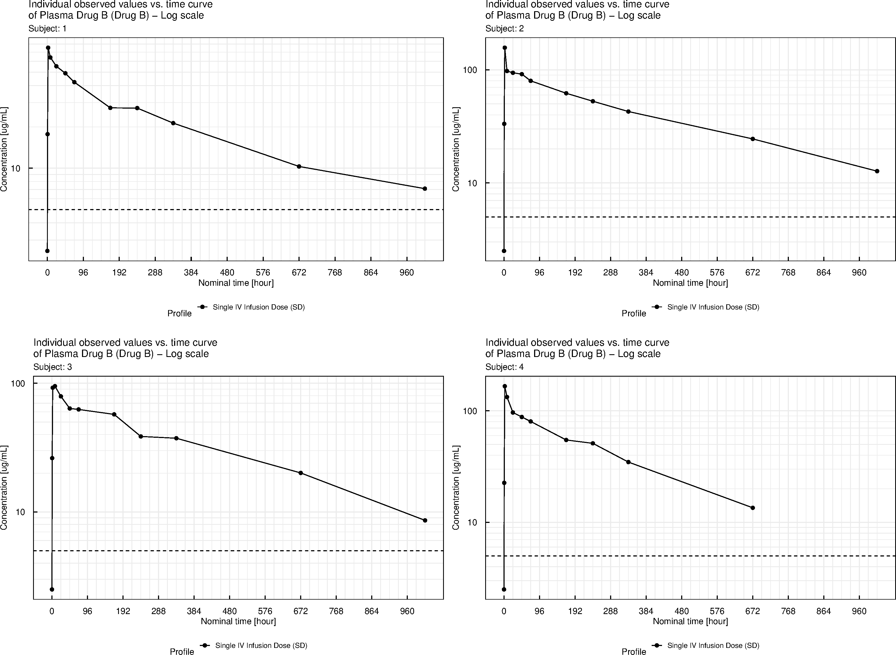

IQnca version: 1.2.0  
Script: compliance  
Output: output/figures/indiv_1.pdf  
Execution date: 2022-06-22 14:22:31

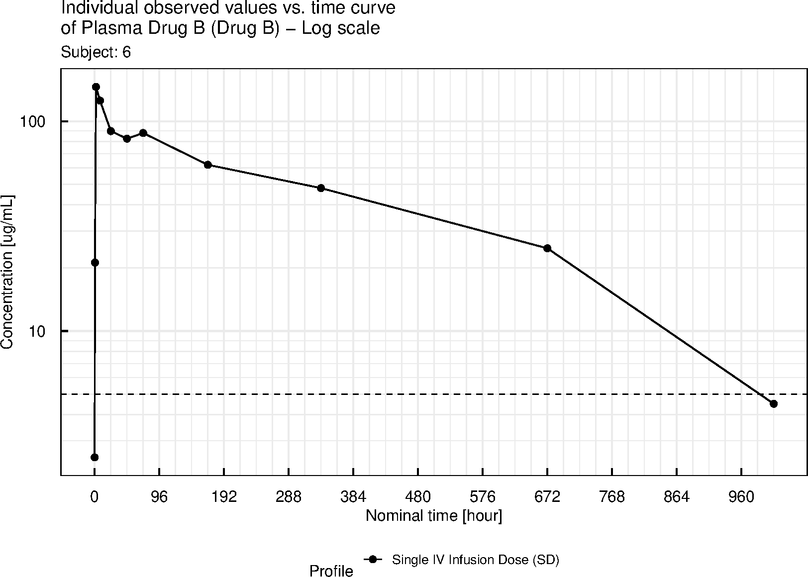

IQnca version: 1.2.0  
Script: compliance  
Output: output/figures/indiv_1.pdf  
Execution date: 2022-06-22 14:22:31

Spaghetti plot of individual observed values vs. time by dose group - Log scale

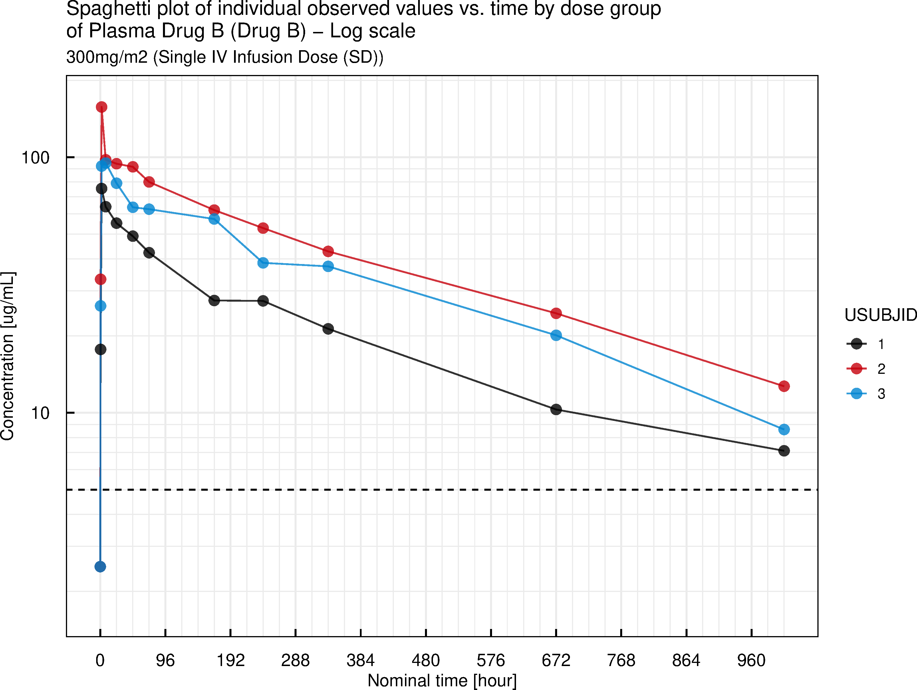

IQnca version: 1.2.0  
Script: compliance  
Output: output/figures/spaghetti_1.pdf  
Execution date: 2022-06-22 14:22:29

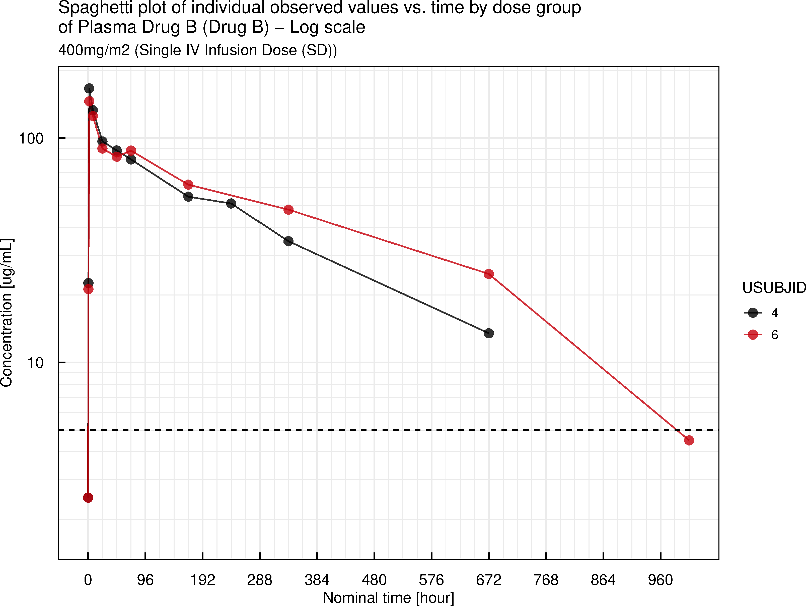

IQnca version: 1.2.0  
Script: compliance  
Output: output/figures/spaghetti_1.pdf  
Execution date: 2022-06-22 14:22:29

Spaghetti plot of dose-normalized individual observed values vs. time - stratified by SEX - Linear scale

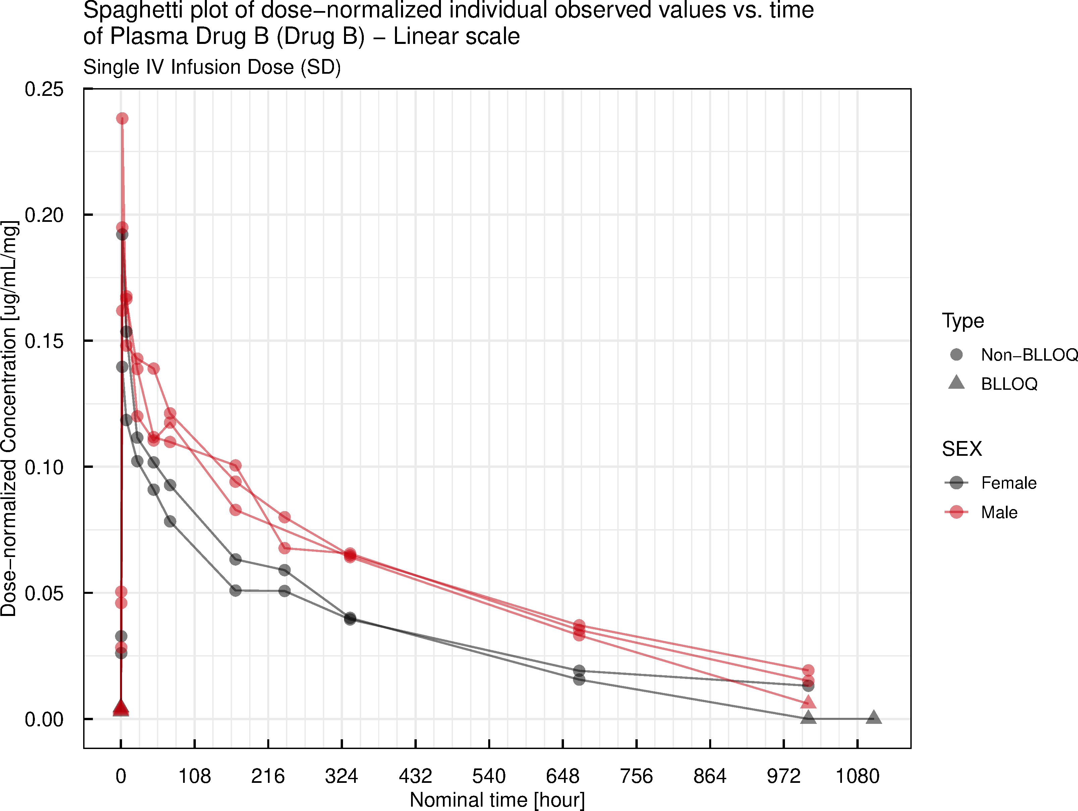

IQnca version: 1.2.0  
Script: compliance  
Output: output/figures/spaghetti_2.pdf  
Execution date: 2022-06-22 14:22:29

Spaghetti plot of dose-normalized individual observed values vs. time - stratified by AGE - Linear scale

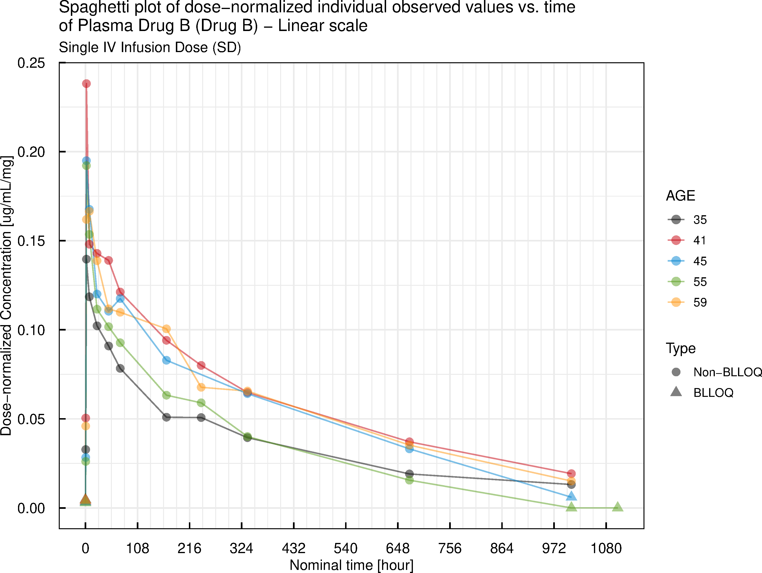

IQnca version: 1.2.0  
Script: compliance  
Output: output/figures/spaghetti_3.pdf  
Execution date: 2022-06-22 14:22:30

Table 2.1 Summary statistics for PK concentrations

**Table 2.1-1 Summary statistics for PK concentrations of Plasma Drug B (Drug B) - Single IV Infusion Dose (SD) (1 of 2)**

|  |  |  |  |  |  |  |  |  |  |  |  |
| --- | --- | --- | --- | --- | --- | --- | --- | --- | --- | --- | --- |
|  |  | Nominal Time [h] |  |  |  |  |  |  |  |  |  |
|  |  | 0 | 0.5 | 2 | 8 | 24 | 48 | 72 | 168 | 240 | 336 |
| **Treatment** | **Stats** | **Concentration [ug/mL]** |  |  |  |  |  |  |  |  |  |
| 300mg/m2 | N | 3 | 3 | 3 | 3 | 3 | 3 | 3 | 3 | 3 | 3 |
|  | Mean | 2.5 | 25.73 | 108.3 | 85.53 | 76.2 | 68.17 | 61.63 | 48.97 | 39.6 | 33.83 |
|  | SD | 0 | 7.81 | 43.18 | 18.7 | 19.71 | 21.65 | 18.87 | 18.74 | 12.73 | 11.18 |
|  | Min | 2.5 | 17.7 | 75.4 | 64 | 55.2 | 49.1 | 42.3 | 27.5 | 27.4 | 21.3 |
|  | Median | 2.5 | 26.2 | 92.3 | 94.9 | 79.1 | 63.7 | 62.6 | 57.3 | 38.6 | 37.4 |
|  | Geo-mean | 2.5 | 24.9 | 103 | 84.03 | 74.39 | 65.95 | 59.61 | 46.08 | 38.22 | 32.43 |
|  | Max | 2.5 | 33.3 | 157.2 | 97.7 | 94.3 | 91.7 | 80 | 62.1 | 52.8 | 42.8 |
|  | CV% mean | 0 | 30.35 | 39.87 | 21.86 | 25.87 | 31.76 | 30.61 | 38.28 | 32.15 | 33.06 |
|  | CV% geo-mean | 0 | 32.73 | 39.36 | 23.96 | 27.81 | 32.17 | 32.99 | 47.25 | 33.71 | 38.32 |

NC: Not calculated.  
Geo-mean: Geometric mean.  
CV% mean = coefficient of variation (%)=SD/mean * 100.  
CV% geo-mean=(sqrt (exp (variance for log transformed data)-1)) * 100.  
Lower limit of quantitation: 5 ug/mL. Pre-first dose <LLOQ values were handled as: LLOQ/2. <LLOQ values between >=LLOQ values were handled as: asis. First <LLOQ value post last >= LLOQ was handled as: 0. Second to last First <LLOQ value post last >= LLOQ was handled as: 0.  
Values in table are reported with 4 significant digits.  
IQnca version: 1.2.0  
Script: compliance  
Output: output/tables/summary_table_conc.rmd  
Execution date: 2022-06-22 14:22:28

**Table 2.1-1 Summary statistics for PK concentrations of Plasma Drug B (Drug B) - Single IV Infusion Dose (SD) (2 of 2)**

|  |  |  |  |
| --- | --- | --- | --- |
|  |  | Nominal Time [h] |  |
|  |  | 672 | 1008 |
| **Treatment** | **Stats** | **Concentration [ug/mL]** |  |
| 300mg/m2 | N | 3 | 3 |
|  | Mean | 18.3 | 9.467 |
|  | SD | 7.269 | 2.899 |
|  | Min | 10.3 | 7.1 |
|  | Median | 20.1 | 8.6 |
|  | Geo-mean | 17.18 | 9.187 |
|  | Max | 24.5 | 12.7 |
|  | CV% mean | 39.72 | 30.62 |
|  | CV% geo-mean | 47.85 | 30.3 |

NC: Not calculated.  
Geo-mean: Geometric mean.  
CV% mean = coefficient of variation (%)=SD/mean * 100.  
CV% geo-mean=(sqrt (exp (variance for log transformed data)-1)) * 100.  
Lower limit of quantitation: 5 ug/mL. Pre-first dose <LLOQ values were handled as: LLOQ/2. <LLOQ values between >=LLOQ values were handled as: asis. First <LLOQ value post last >= LLOQ was handled as: 0. Second to last First <LLOQ value post last >= LLOQ was handled as: 0.  
Values in table are reported with 4 significant digits.  
IQnca version: 1.2.0  
Script: compliance  
Output: output/tables/summary_table_conc.rmd  
Execution date: 2022-06-22 14:22:28

**Table 2.1-2 Summary statistics for PK concentrations of Plasma Drug B (Drug B) - Single IV Infusion Dose (SD) (1 of 2)**

|  |  |  |  |  |  |  |  |  |  |  |  |
| --- | --- | --- | --- | --- | --- | --- | --- | --- | --- | --- | --- |
|  |  | Nominal Time [h] |  |  |  |  |  |  |  |  |  |
|  |  | 0.0 | 0.5 | 2.0 | 8.0 | 24.0 | 48.0 | 72.0 | 168.0 | 240.0 | 336.0 |
| **Treatment** | **Stats** | **Concentration [ug/mL]** |  |  |  |  |  |  |  |  |  |
| 400mg/m2 | N | 2 | 2 | 2 | 2 | 2 | 2 | 2 | 2 | 1 | 2 |
|  | Mean | 2.50 | 21.90 | 156.10 | 129.20 | 93.20 | 85.35 | 84.10 | 58.40 | 51.10 | 41.35 |
|  | SD | 0 | 0.9899 | 14.57 | 5.374 | 4.808 | 3.889 | 5.374 | 5.091 | NC | 9.405 |
|  | Min | 2.5 | 21.2 | 145.8 | 125.4 | 89.8 | 82.6 | 80.3 | 54.8 | 51.1 | 34.7 |
|  | Median | 2.50 | 21.90 | 156.10 | 129.20 | 93.20 | 85.35 | 84.10 | 58.40 | 51.10 | 41.35 |
|  | Geo-mean | 2.50 | 21.89 | 155.80 | 129.10 | 93.14 | 85.31 | 84.01 | 58.29 | 51.10 | 40.81 |
|  | Max | 2.5 | 22.6 | 166.4 | 133.0 | 96.6 | 88.1 | 87.9 | 62.0 | 51.1 | 48.0 |
|  | CV% mean | 0 | 4.52 | 9.331 | 4.159 | 5.159 | 4.557 | 6.39 | 8.718 | NC | 22.74 |
|  | CV% geo-mean | 0 | 4.524 | 9.365 | 4.162 | 5.165 | 4.561 | 6.401 | 8.745 | NC | 23.25 |

NC: Not calculated.  
Geo-mean: Geometric mean.  
CV% mean = coefficient of variation (%)=SD/mean * 100.  
CV% geo-mean=(sqrt (exp (variance for log transformed data)-1)) * 100.  
Lower limit of quantitation: 5 ug/mL. Pre-first dose <LLOQ values were handled as: LLOQ/2. <LLOQ values between >=LLOQ values were handled as: asis. First <LLOQ value post last >= LLOQ was handled as: 0. Second to last First <LLOQ value post last >= LLOQ was handled as: 0.  
Values in table are reported with 4 significant digits.  
IQnca version: 1.2.0  
Script: compliance  
Output: output/tables/summary_table_conc.rmd  
Execution date: 2022-06-22 14:22:28

**Table 2.1-2 Summary statistics for PK concentrations of Plasma Drug B (Drug B) - Single IV Infusion Dose (SD) (2 of 2)**

|  |  |  |  |  |
| --- | --- | --- | --- | --- |
|  |  | Nominal Time [h] |  |  |
|  |  | 672 | 1008 | 1104 |
| **Treatment** | **Stats** | **Concentration [ug/mL]** |  |  |
| 400mg/m2 | N | 2 | 2 | 1 |
|  | Mean | 19.15 | 2.25 | 0.00 |
|  | SD | 7.99 | 3.182 | NC |
|  | Min | 13.5 | 0.0 | 0.0 |
|  | Median | 19.15 | 2.25 | 0.00 |
|  | Geo-mean | 18.3 | NC | NC |
|  | Max | 24.8 | 4.5 | 0.0 |
|  | CV% mean | 41.72 | 141.4 | NC |
|  | CV% geo-mean | 45.07 | NC | NC |

NC: Not calculated.  
Geo-mean: Geometric mean.  
CV% mean = coefficient of variation (%)=SD/mean * 100.  
CV% geo-mean=(sqrt (exp (variance for log transformed data)-1)) * 100.  
Lower limit of quantitation: 5 ug/mL. Pre-first dose <LLOQ values were handled as: LLOQ/2. <LLOQ values between >=LLOQ values were handled as: asis. First <LLOQ value post last >= LLOQ was handled as: 0. Second to last First <LLOQ value post last >= LLOQ was handled as: 0.  
Values in table are reported with 4 significant digits.  
IQnca version: 1.2.0  
Script: compliance  
Output: output/tables/summary_table_conc.rmd  
Execution date: 2022-06-22 14:22:28

Table 2.2 Summary statistics for PK parameters by dose group stratified by SEX

**Table 2.2-1-1 Summary statistics for PK parameters by dose group of Plasma Drug B (Drug B) - Single IV Infusion Dose (SD) (stratified by SEX)**

|  |  |  |  |  |  |  |  |  |  |  |
| --- | --- | --- | --- | --- | --- | --- | --- | --- | --- | --- |
| Profile | Group | Name (Unit) | SEX | Na | Mean (SD) | CV% mean | Geo-mean | CV% geo-mean | Median | [Min, Max] |
| Single IV Infusion Dose (SD) | 300mg/m2 | AUC %Extrapolation Obs (%) | Female | 1 | 17.42 (-b) | -c | -d | -d | 17.42 | [17.42, 17.42] |
|  |  |  | Male | 2 | 12.91 (2.776) | 21.51 | 12.76 | 21.93 | 12.91 | [10.95, 14.87] |
|  |  | AUC %Extrapolation Pred (%) | Female | 1 | 16.39 (-b) | -c | -d | -d | 16.39 | [16.39, 16.39] |
|  |  |  | Male | 2 | 13.15 (2.584) | 19.65 | 13.02 | 19.97 | 13.15 | [11.32, 14.98] |
|  |  | AUC All (mg/L*h) | Female | 1 | 19370 (-b) | -c | -d | -d | 19370 | [19370, 19370] |
|  |  |  | Male | 2 | 35630 (5147) | 14.45 | 35440 | 14.57 | 35630 | [31990, 39270] |
|  |  | AUC Infinity Obs (mg/L*h) | Female | 1 | 23450 (-b) | -c | -d | -d | 23450 | [23450, 23450] |
|  |  |  | Male | 2 | 41020 (7218) | 17.59 | 40700 | 17.82 | 41020 | [35920, 46130] |
|  |  | AUC Infinity Obs Norm by Dose (mg/L*h/mg) | Female | 1 | 43.43 (-b) | -c | -d | -d | 43.43 | [43.43, 43.43] |
|  |  |  | Male | 2 | 66.45 (4.859) | 7.313 | 66.36 | 7.329 | 66.45 | [63.02, 69.89] |
|  |  | AUC Infinity Pred (mg/L*h) | Female | 1 | 23160 (-b) | -c | -d | -d | 23160 | [23160, 23160] |
|  |  |  | Male | 2 | 41130 (7150) | 17.38 | 40820 | 17.61 | 41130 | [36070, 46180] |
|  |  | AUC Infinity Pred Norm by Dose (mg/L*h/mg) | Female | 1 | 42.89 (-b) | -c | -d | -d | 42.89 | [42.89, 42.89] |
|  |  |  | Male | 2 | 66.63 (4.731) | 7.1 | 66.55 | 7.115 | 66.63 | [63.28, 69.98] |
|  |  | AUC to Last Nonzero Conc (mg/L*h) | Female | 1 | 19370 (-b) | -c | -d | -d | 19370 | [19370, 19370] |
|  |  |  | Male | 2 | 35630 (5147) | 14.45 | 35440 | 14.57 | 35630 | [31990, 39270] |
|  |  | AUC to Last Nonzero Conc Norm by Dose (mg/L*h/mg) | Female | 1 | 35.87 (-b) | -c | -d | -d | 35.87 | [35.87, 35.87] |
|  |  |  | Male | 2 | 57.81 (2.387) | 4.13 | 57.78 | 4.133 | 57.81 | [56.12, 59.5] |
|  |  | Half-Life Lambda z (h) | Female | 1 | 399 (-b) | -c | -d | -d | 399 | [399, 399] |
|  |  |  | Male | 2 | 345.6 (40.67) | 11.77 | 344.4 | 11.83 | 345.6 | [316.9, 374.4] |
|  |  | Last Nonzero Conc (mg/L) | Female | 1 | 7.1 (-b) | -c | -d | -d | 7.1 | [7.1, 7.1] |
|  |  |  | Male | 2 | 10.65 (2.899) | 27.22 | 10.45 | 28.1 | 10.65 | [8.6, 12.7] |
|  |  | Last Nonzero Conc Pred (mg/L) | Female | 1 | 6.594 (-b) | -c | -d | -d | 6.594 | [6.594, 6.594] |
|  |  |  | Male | 2 | 10.87 (2.737) | 25.19 | 10.7 | 25.88 | 10.87 | [8.933, 12.8] |
|  |  | Max Conc (mg/L) | Female | 1 | 75.4 (-b) | -c | -d | -d | 75.4 | [75.4, 75.4] |
|  |  |  | Male | 2 | 126 (44.05) | 34.95 | 122.1 | 36.85 | 126 | [94.9, 157.2] |
|  |  | Max Conc Norm by Dose (mg/L/mg) | Female | 1 | 0.1396 (-b) | -c | -d | -d | 0.1396 | [0.1396, 0.1396] |
|  |  |  | Male | 2 | 0.2023 (0.05069) | 25.05 | 0.1991 | 25.73 | 0.2023 | [0.1665, 0.2382] |
|  |  | Min Conc (mg/L) | Female | 1 | 2.5 (-b) | -c | -d | -d | 2.5 | [2.5, 2.5] |
|  |  |  | Male | 2 | 2.5 (0) | 0 | 2.5 | 0 | 2.5 | [2.5, 2.5] |
|  |  | Min Conc Norm by Dose (mg/L/mg) | Female | 1 | 0.00463 (-b) | -c | -d | -d | 0.00463 | [0.00463, 0.00463] |
|  |  |  | Male | 2 | 0.004087 (0.0004229) | 10.35 | 0.004076 | 10.39 | 0.004087 | [0.003788, 0.004386] |
|  |  | Number of Points for Lambda z (-) | Female | 1 | 5 (-b) | -c | -d | -d | 5 | [5, 5] |
|  |  |  | Male | 2 | 4 (1.414) | 35.36 | 3.873 | 37.33 | 4 | [3, 5] |
|  |  | R Squared Adjusted (-) | Female | 1 | 0.9705 (-b) | -c | -d | -d | 0.9705 | [0.9705, 0.9705] |
|  |  |  | Male | 2 | 0.9909 (0.0097) | 0.9789 | 0.9909 | 0.9789 | 0.9909 | [0.9841, 0.9978] |
|  |  | Span (-) | Female | 1 | 2.105 (-b) | -c | -d | -d | 2.105 | [2.105, 2.105] |
|  |  |  | Male | 2 | 2.182 (0.08694) | 3.984 | 2.181 | 3.987 | 2.182 | [2.121, 2.244] |
|  |  | Time of CMAX (h) | Female | 1 | 2 (-b) | -c | -d | -d | 2 | [2, 2] |
|  |  |  | Male | 2 | 5 (4.243) | 84.85 | 4 | 127 | 5 | [2, 8] |
|  |  | Time of CMIN Observation (h) | Female | 1 | 0 (-b) | -c | -d | -d | 0 | [0, 0] |
|  |  |  | Male | 2 | 0 (0) | -c | -d | -d | 0 | [0, 0] |
|  |  | Time of Last Nonzero Conc (h) | Female | 1 | 1008 (-b) | -c | -d | -d | 1008 | [1008, 1008] |
|  |  |  | Male | 2 | 1008 (0) | 0 | 1008 | 0 | 1008 | [1008, 1008] |
|  |  | Total CL Obs (L/h) | Female | 1 | 0.02302 (-b) | -c | -d | -d | 0.02302 | [0.02302, 0.02302] |
|  |  |  | Male | 2 | 0.01509 (0.001103) | 7.313 | 0.01507 | 7.329 | 0.01509 | [0.01431, 0.01587] |
|  |  | Total CL Pred (L/h) | Female | 1 | 0.02331 (-b) | -c | -d | -d | 0.02331 | [0.02331, 0.02331] |
|  |  |  | Male | 2 | 0.01505 (0.001068) | 7.1 | 0.01503 | 7.115 | 0.01505 | [0.01429, 0.0158] |
|  |  | Vol Dist Steady State Obs (L) | Female | 1 | 12.65 (-b) | -c | -d | -d | 12.65 | [12.65, 12.65] |
|  |  |  | Male | 2 | 7.403 (0.1004) | 1.357 | 7.403 | 1.357 | 7.403 | [7.332, 7.474] |
|  |  | Vol Dist Steady State Pred (L) | Female | 1 | 12.51 (-b) | -c | -d | -d | 12.51 | [12.51, 12.51] |
|  |  |  | Male | 2 | 7.425 (0.08125) | 1.094 | 7.425 | 1.094 | 7.425 | [7.368, 7.483] |
|  |  | Vz Obs (L) | Female | 1 | 13.25 (-b) | -c | -d | -d | 13.25 | [13.25, 13.25] |
|  |  |  | Male | 2 | 7.492 (0.3351) | 4.473 | 7.488 | 4.477 | 7.492 | [7.255, 7.729] |
|  |  | Vz Pred (L) | Female | 1 | 13.42 (-b) | -c | -d | -d | 13.42 | [13.42, 13.42] |
|  |  |  | Male | 2 | 7.472 (0.3501) | 4.685 | 7.467 | 4.69 | 7.472 | [7.224, 7.719] |

a Number depends on (reliably) calculated parameters.  
CV% = coefficient of variation (%)=SD/mean*100.*  
*Geo-mean: Geometric mean.*  
*CV% geo-mean=(sqrt (exp (variance for log transformed data)-1))*100.  
b SD not presented when N=1.  
c CV% mean not presented when the mean is 0 or N=1.  
d Geo-mean and CV% geo-mean not presented when the minimum value is zero or N=1.  
Values in table are reported with 4 significant digits.  
IQRnca version: 1.2.0  
Script: compliance  
Output: output/tables/table_bygroup_PKparam.rmd  
Execution date: 2022-06-22 14:22:32

**Table 2.2-1-2 Summary statistics for PK parameters by dose group of Plasma Drug B (Drug B) - Single IV Infusion Dose (SD) (stratified by SEX)**

|  |  |  |  |  |  |  |  |  |  |  |
| --- | --- | --- | --- | --- | --- | --- | --- | --- | --- | --- |
| Profile | Group | Name (Unit) | SEX | Na | Mean (SD) | CV% mean | Geo-mean | CV% geo-mean | Median | [Min, Max] |
| Single IV Infusion Dose (SD) | 400mg/m2 | AUC %Extrapolation Obs (%) | Female | 1 | 13.42 (-b) | -c | -d | -d | 13.42 | [13.42, 13.42] |
|  |  |  | Male | 1 | 3.876 (-b) | -c | -d | -d | 3.876 | [3.876, 3.876] |
|  |  | AUC %Extrapolation Pred (%) | Female | 1 | 13.15 (-b) | -c | -d | -d | 13.15 | [13.15, 13.15] |
|  |  |  | Male | 1 | 5.196 (-b) | -c | -d | -d | 5.196 | [5.196, 5.196] |
|  |  | AUC All (mg/L*h) | Female | 1 | 31200 (-b) | -c | -d | -d | 31200 | [31200, 31200] |
|  |  |  | Male | 1 | 38880 (-b) | -c | -d | -d | 38880 | [38880, 38880] |
|  |  | AUC Infinity Obs (mg/L*h) | Female | 1 | 33410 (-b) | -c | -d | -d | 33410 | [33410, 33410] |
|  |  |  | Male | 1 | 40440 (-b) | -c | -d | -d | 40440 | [40440, 40440] |
|  |  | AUC Infinity Obs Norm by Dose (mg/L*h/mg) | Female | 1 | 38.58 (-b) | -c | -d | -d | 38.58 | [38.58, 38.58] |
|  |  |  | Male | 1 | 54.07 (-b) | -c | -d | -d | 54.07 | [54.07, 54.07] |
|  |  | AUC Infinity Pred (mg/L*h) | Female | 1 | 33310 (-b) | -c | -d | -d | 33310 | [33310, 33310] |
|  |  |  | Male | 1 | 41010 (-b) | -c | -d | -d | 41010 | [41010, 41010] |
|  |  | AUC Infinity Pred Norm by Dose (mg/L*h/mg) | Female | 1 | 38.46 (-b) | -c | -d | -d | 38.46 | [38.46, 38.46] |
|  |  |  | Male | 1 | 54.82 (-b) | -c | -d | -d | 54.82 | [54.82, 54.82] |
|  |  | AUC to Last Nonzero Conc (mg/L*h) | Female | 1 | 28930 (-b) | -c | -d | -d | 28930 | [28930, 28930] |
|  |  |  | Male | 1 | 38880 (-b) | -c | -d | -d | 38880 | [38880, 38880] |
|  |  | AUC to Last Nonzero Conc Norm by Dose (mg/L*h/mg) | Female | 1 | 33.41 (-b) | -c | -d | -d | 33.41 | [33.41, 33.41] |
|  |  |  | Male | 1 | 51.97 (-b) | -c | -d | -d | 51.97 | [51.97, 51.97] |
|  |  | Half-Life Lambda z (h) | Female | 1 | 230.2 (-b) | -c | -d | -d | 230.2 | [230.2, 230.2] |
|  |  |  | Male | 1 | 241.4 (-b) | -c | -d | -d | 241.4 | [241.4, 241.4] |
|  |  | Last Nonzero Conc (mg/L) | Female | 1 | 13.5 (-b) | -c | -d | -d | 13.5 | [13.5, 13.5] |
|  |  |  | Male | 1 | 4.5 (-b) | -c | -d | -d | 4.5 | [4.5, 4.5] |
|  |  | Last Nonzero Conc Pred (mg/L) | Female | 1 | 13.19 (-b) | -c | -d | -d | 13.19 | [13.19, 13.19] |
|  |  |  | Male | 1 | 6.117 (-b) | -c | -d | -d | 6.117 | [6.117, 6.117] |
|  |  | Max Conc (mg/L) | Female | 1 | 166.4 (-b) | -c | -d | -d | 166.4 | [166.4, 166.4] |
|  |  |  | Male | 1 | 145.8 (-b) | -c | -d | -d | 145.8 | [145.8, 145.8] |
|  |  | Max Conc Norm by Dose (mg/L/mg) | Female | 1 | 0.1921 (-b) | -c | -d | -d | 0.1921 | [0.1921, 0.1921] |
|  |  |  | Male | 1 | 0.1949 (-b) | -c | -d | -d | 0.1949 | [0.1949, 0.1949] |
|  |  | Min Conc (mg/L) | Female | 1 | 0 (-b) | -c | -d | -d | 0 | [0, 0] |
|  |  |  | Male | 1 | 2.5 (-b) | -c | -d | -d | 2.5 | [2.5, 2.5] |
|  |  | Min Conc Norm by Dose (mg/L/mg) | Female | 1 | 0 (-b) | -c | -d | -d | 0 | [0, 0] |
|  |  |  | Male | 1 | 0.003342 (-b) | -c | -d | -d | 0.003342 | [0.003342, 0.003342] |
|  |  | Number of Points for Lambda z (-) | Female | 1 | 7 (-b) | -c | -d | -d | 7 | [7, 7] |
|  |  |  | Male | 1 | 8 (-b) | -c | -d | -d | 8 | [8, 8] |
|  |  | R Squared Adjusted (-) | Female | 1 | 0.9932 (-b) | -c | -d | -d | 0.9932 | [0.9932, 0.9932] |
|  |  |  | Male | 1 | 0.9458 (-b) | -c | -d | -d | 0.9458 | [0.9458, 0.9458] |
|  |  | Span (-) | Female | 1 | 2.815 (-b) | -c | -d | -d | 2.815 | [2.815, 2.815] |
|  |  |  | Male | 1 | 4.142 (-b) | -c | -d | -d | 4.142 | [4.142, 4.142] |
|  |  | Time of CMAX (h) | Female | 1 | 2 (-b) | -c | -d | -d | 2 | [2, 2] |
|  |  |  | Male | 1 | 2 (-b) | -c | -d | -d | 2 | [2, 2] |
|  |  | Time of CMIN Observation (h) | Female | 1 | 1008 (-b) | -c | -d | -d | 1008 | [1008, 1008] |
|  |  |  | Male | 1 | 0 (-b) | -c | -d | -d | 0 | [0, 0] |
|  |  | Time of Last Nonzero Conc (h) | Female | 1 | 672 (-b) | -c | -d | -d | 672 | [672, 672] |
|  |  |  | Male | 1 | 1008 (-b) | -c | -d | -d | 1008 | [1008, 1008] |
|  |  | Total CL Obs (L/h) | Female | 1 | 0.02592 (-b) | -c | -d | -d | 0.02592 | [0.02592, 0.02592] |
|  |  |  | Male | 1 | 0.0185 (-b) | -c | -d | -d | 0.0185 | [0.0185, 0.0185] |
|  |  | Total CL Pred (L/h) | Female | 1 | 0.026 (-b) | -c | -d | -d | 0.026 | [0.026, 0.026] |
|  |  |  | Male | 1 | 0.01824 (-b) | -c | -d | -d | 0.01824 | [0.01824, 0.01824] |
|  |  | Vol Dist Steady State Obs (L) | Female | 1 | 8.527 (-b) | -c | -d | -d | 8.527 | [8.527, 8.527] |
|  |  |  | Male | 1 | 6.557 (-b) | -c | -d | -d | 6.557 | [6.557, 6.557] |
|  |  | Vol Dist Steady State Pred (L) | Female | 1 | 8.499 (-b) | -c | -d | -d | 8.499 | [8.499, 8.499] |
|  |  |  | Male | 1 | 6.718 (-b) | -c | -d | -d | 6.718 | [6.718, 6.718] |
|  |  | Vz Obs (L) | Female | 1 | 8.608 (-b) | -c | -d | -d | 8.608 | [8.608, 8.608] |
|  |  |  | Male | 1 | 6.442 (-b) | -c | -d | -d | 6.442 | [6.442, 6.442] |
|  |  | Vz Pred (L) | Female | 1 | 8.635 (-b) | -c | -d | -d | 8.635 | [8.635, 8.635] |
|  |  |  | Male | 1 | 6.354 (-b) | -c | -d | -d | 6.354 | [6.354, 6.354] |

a Number depends on (reliably) calculated parameters.  
CV% = coefficient of variation (%)=SD/mean*100.*  
*Geo-mean: Geometric mean.*  
*CV% geo-mean=(sqrt (exp (variance for log transformed data)-1))*100.  
b SD not presented when N=1.  
c CV% mean not presented when the mean is 0 or N=1.  
d Geo-mean and CV% geo-mean not presented when the minimum value is zero or N=1.  
Values in table are reported with 4 significant digits.  
IQRnca version: 1.2.0  
Script: compliance  
Output: output/tables/table_bygroup_PKparam.rmd  
Execution date: 2022-06-22 14:22:32