BLQ setting

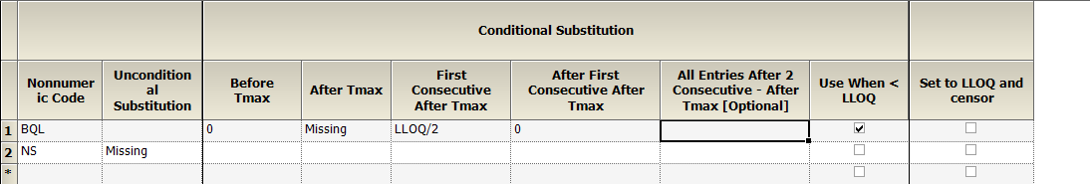

Rule above would result in Clast = ½ LLOQ

If LLOQ /2 is set to 0, then Clast will be actual observed Clast

See 2 different results to illustrate above points in the Example 1 for extravascular singe dose in 8 subjects.

What dose last 2 columns do?

|  |  |  |
| --- | --- | --- |
| Rule # | Snapshot | Results |
| 1 |  | 2nd last column if checked will ignore observed data which is < LLOQ and replace by LLOQ/2 |
| 2 |  | 2nd last column if checked will ignore observed data which is < LLOQ and replace by zero |
| 3 |  | If 2nd last column is unchecked, the actual observation will be used if data is < LLOQ (for example 1.8 ng/mL) |
| 4 |  | If last column is checked, all boxes under Conditional Substitution are disabled. A new data column will be added to original data set called CObsBQ (0 or 1 as data).   1. Zero (0) for all data with observation 2. One (1) for all data of BQL. |
|  |