

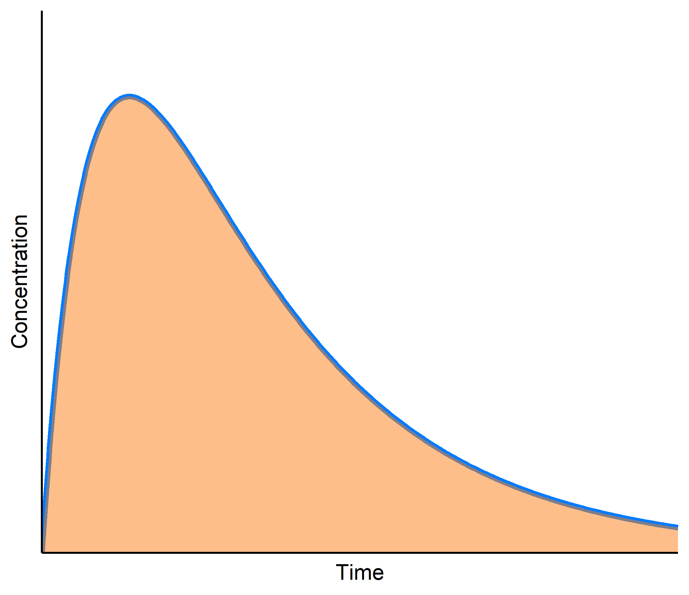

**Non-Compartmental Analysis (NCA)**

* NCA is a popular analysis that produces standard PK parameters (e.g. Cmax, AUC, t1/2) for regulatory submissions.
* NCA is a cost-effective tool allowing for a rapid readout of preclinical and early clinical data.
* The NCA outputs can be customized for rapid and efficient decision making. Tables, listings and figures can be tailored to the specific needs.
* Quality control (QC) of data and results is integrated in our process.
* We are delivering high quality, submission ready reports and CDISC complient PK data.
* When performed within the Quantmetrics Validated Environment, the NCA can rapidly be extended to a pharmacometric model as part of a long term clinical pharmacology strategy.

**www.quantmetrics.org info@quantmetrics.org +972-54-8886327**