

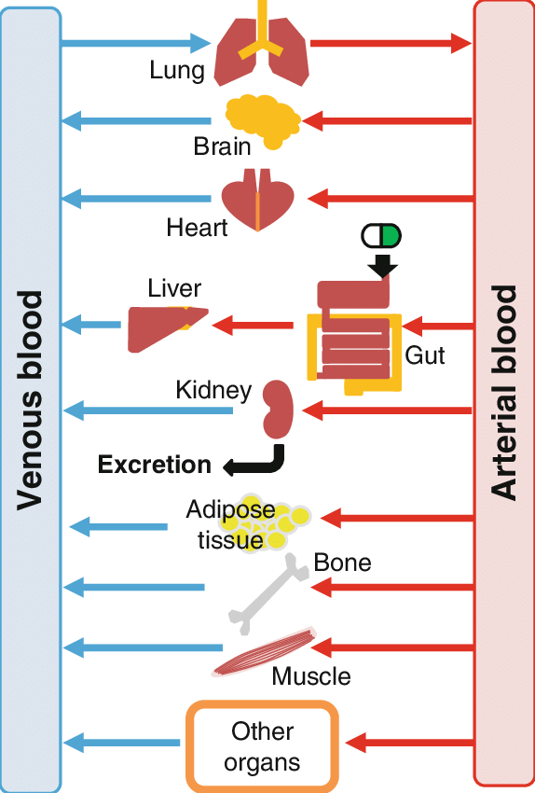

**Physiologically-based PK modeling (PBPK)**

* Mechanistic approach that integrates physicochemical, in vitro and physiological knowledge in a single model.
* PBPK is a very powerful tool for Animal-to-Human translational modeling.
* PBPK can simulate the impact of disease or organ impairment on the drug PK properties.
* PBPK models can be used to simulate Drug-Drug Interactions (DDIs) in place of conducting clinical study.
* PBPK modeling can support formulation development by simulating the impact of quality attributes (excipients, release rate, route of administration) on drug exposure.
* Bioequivalence can be demonstrated using PBPK-based simulation in virtual populations.

**www.quantmetrics.org info@quantmetrics.org +972-54-8886327**