

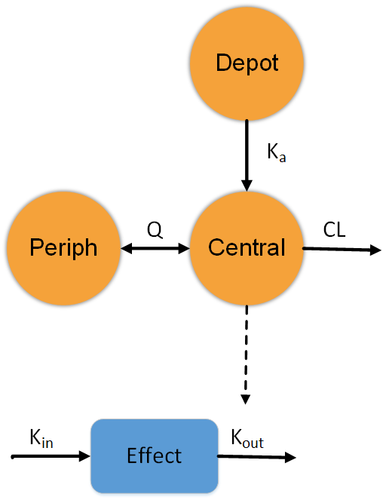

**Population Pharmacokinetics (PopPK/PD)**

* The Population approach characterizes PK and PD relationship and source of variability between group of subjects.
* The PopPK analysis assess the impact of covariates (bodyweight, age, sex, ethnicity, organ impairment) on the drug characteristics.
* PopPK-based Simulations used to inform dose selection rationale and optimize trial design.
* Mechanism-based PopPK modeling can describe any complex biological mechanism (enzyme induction/inhibition, target mediated disposition, complex absorption).
* PopPK model can be extended to Systems Pharmacology models in various therapeutic area (neuroscience, oncology, inflammation, infectious disease).
* “Gold standard” for regulatory submission.

**www.quantmetrics.org info@quantmetrics.org +972-54-8886327**