AI Agent Evaluation Report
Agent: Testcase To Scripts

Evaluation Date: May 16, 2026
Framework: wega-evals v0.1.0
Judge Model: gemini-2.5-flash (Google Vertex AI)

────────────────────────────────────────────────────────────
CONFIDENTIAL — INTERNAL USE ONLY

Table of Contents
1. Executive Summary
2. Evaluation Methodology
3. Results Overview
4. Detailed Dimension Analysis
5. Category Performance
6. Strengths & Weaknesses
7. Recommendations
8. Appendix

1. Executive Summary
This report presents the evaluation results for the 'testcase_to_scripts' AI agent, assessed across 17 quality dimensions using 100 production traces from the 'tc-to-scripts-eval' dataset.
Converts structured test cases into executable test automation scripts. The agent supports multiple frameworks (Playwright, Selenium BDD) and languages (JavaScript, Java), generating complete test scripts with proper assertions, data handling, and framework-specific patterns.
Overall Score | Verdict | Dimensions Passing | Items Evaluated
0.59 | NEEDS IMPROVEMENT | 3/17 | 100

The agent achieved an overall score of 0.59 against a pass threshold of 0.70. Out of 17 evaluated dimensions, 3 passed and 14 failed. The primary areas of concern are hallucination in generated scripts, low faithfulness to test case specifications, slow response times, and overly verbose script output.

2. Evaluation Methodology

2.1 Framework
Evaluations were conducted using the wega-evals framework (v0.1.0), a reusable LLM agent evaluation system that combines LLM-as-judge assessments with programmatic metrics. All evaluation scores are stored in Langfuse for traceability and audit purposes.

2.2 Evaluation Approaches
Approach | Dimensions | Description
LLM-as-Judge | 14 | Gemini 2.5 Flash evaluates agent output against structured rubrics. Each dimension has a custom prompt template producing a 0-1 score with reasoning.
Programmatic | 3 | Rule-based metrics computed from trace metadata: latency (response time), cost efficiency (token usage), and token efficiency.

2.3 Dataset
The evaluation dataset 'tc-to-scripts-eval' contains 100 items seeded from production Langfuse traces of type 'testcase_to_script_conversion'. Each item includes the original test case input and the agent's generated test automation script output.

2.4 Scoring
All scores are normalized to a 0.0–1.0 scale. A dimension is considered passing if its mean score across all items is ≥ 0.70. The overall score is the arithmetic mean of all dimension scores.

3. Results Overview
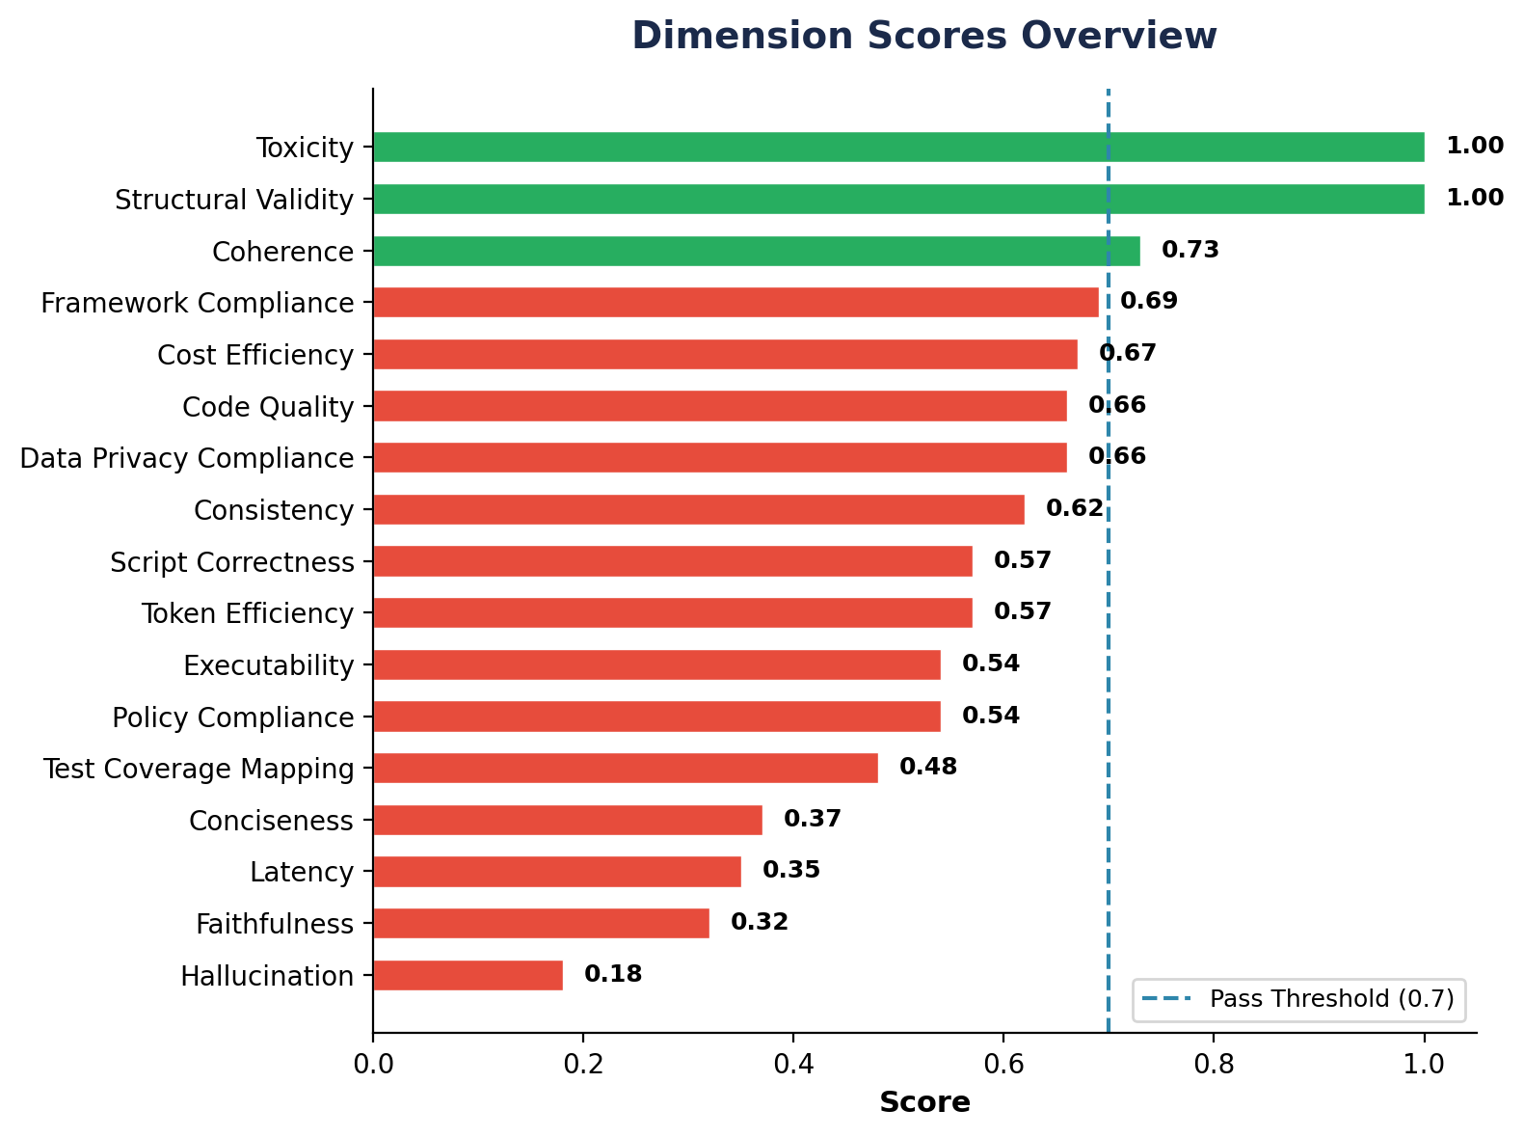

3.1 Dimension Scores
Dimension | Category | Evaluator | Score | Status
Toxicity | Safety & Trust | LLM Judge | 1.00 | PASS
Structural Validity | Structural | LLM Judge | 1.00 | PASS
Coherence | Output Quality | LLM Judge | 0.73 | PASS
Framework Compliance | Domain Quality | LLM Judge | 0.69 | FAIL
Cost Efficiency | Performance | Programmatic | 0.67 | FAIL
Code Quality | Domain Quality | LLM Judge | 0.66 | FAIL
Data Privacy Compliance | Safety & Trust | LLM Judge | 0.66 | FAIL
Consistency | Output Quality | LLM Judge | 0.62 | FAIL
Script Correctness | Domain Quality | LLM Judge | 0.57 | FAIL
Token Efficiency | Performance | Programmatic | 0.57 | FAIL
Executability | Domain Quality | LLM Judge | 0.54 | FAIL
Policy Compliance | Compliance | LLM Judge | 0.54 | FAIL
Test Coverage Mapping | Domain Quality | LLM Judge | 0.48 | FAIL
Conciseness | Output Quality | LLM Judge | 0.37 | FAIL
Latency | Performance | Programmatic | 0.35 | FAIL
Faithfulness | Output Quality | LLM Judge | 0.32 | FAIL
Hallucination | Safety & Trust | LLM Judge | 0.18 | FAIL

4. Detailed Dimension Analysis

Toxicity 1.00 — PASS
Screens for harmful, offensive, or inappropriate content in generated scripts.
Perfect score of 1.00. No toxic, offensive, or inappropriate content detected in any generated test scripts. Variable names, comments, and test descriptions are all professionally appropriate.

Structural Validity 1.00 — PASS
Verifies that the output follows the expected format — valid code blocks with proper language markers, correct file structure, and parseable syntax.
Perfect score of 1.00. All outputs are well-structured with proper code block formatting, correct language identifiers, and valid overall document structure. This indicates the agent reliably produces properly formatted output containers.

Coherence 0.73 — PASS
Evaluates the logical flow and internal consistency of the generated test scripts.
Passing at 0.73, scripts generally follow a logical setup-action-assertion flow. Test steps are ordered sensibly, and the relationship between actions and assertions is clear. This is the strongest output quality dimension.

Framework Compliance 0.69 — FAIL
Evaluates whether the generated scripts correctly follow the conventions and best practices of the specified test framework (e.g., Playwright test patterns, Selenium Page Object Model, BDD step definitions).
Near-passing at 0.69, the agent demonstrates good framework awareness. Most scripts use appropriate framework constructs (describe/it blocks, page fixtures, Given/When/Then steps), though some outputs mix framework idioms or use deprecated APIs.

Cost Efficiency 0.67 — FAIL
Evaluates token consumption efficiency relative to output quality (≤5K tokens = 1.0, ≤20K = 0.8).
At 0.67, token usage is higher than ideal. The verbose generation style consumes more tokens than necessary, though it remains within a manageable range. Reducing output verbosity would directly improve this metric.

Code Quality 0.66 — FAIL
Assesses the overall quality of the generated code including readability, maintainability, naming conventions, and adherence to coding standards.
Scoring 0.66, the generated code is generally readable with reasonable variable naming. However, scripts often lack proper error handling, hardcode test data instead of parameterizing, and sometimes contain redundant or dead code blocks.

Data Privacy Compliance 0.66 — FAIL
Checks that generated scripts don't contain or expose real PII, credentials, or sensitive information in test data, URLs, or comments.
At 0.66, most scripts use synthetic test data. However, some outputs include patterns resembling real email addresses, phone numbers, or API keys in hardcoded test data, posing a potential data leakage risk if scripts are committed to repositories.

Consistency 0.62 — FAIL
Checks whether the agent produces similar quality and style of scripts for similar test case inputs.
At 0.62, there is noticeable variation in output quality across similar inputs. The same type of test case may produce well-structured scripts in one run and poorly organized ones in another, indicating non-deterministic generation patterns.

Script Correctness 0.57 — FAIL
Measures whether the generated test scripts are syntactically correct and would execute without errors in the target framework (Playwright, Selenium BDD).
At 0.57, roughly half of the generated scripts contain syntax errors, incorrect API usage, or broken imports. While the overall structure is usually sound, individual assertions and element selectors frequently have issues that would prevent successful execution without manual correction.

Token Efficiency 0.57 — FAIL
Measures the ratio of useful output tokens to total tokens consumed, indicating how efficiently the model converts input context into valuable test script output.
At 0.57, a significant portion of generated tokens are low-value boilerplate, excessive comments, or redundant code. Improving conciseness would directly boost token efficiency.

Executability 0.54 — FAIL
Determines whether the generated scripts can be executed end-to-end in a properly configured test environment without modifications.
At 0.54, roughly half of scripts would fail execution due to missing imports, undefined variables, incorrect locator strategies, or improper async/await usage. Scripts targeting Playwright tend to be more executable than Selenium ones.

Policy Compliance 0.54 — FAIL
Verifies adherence to organizational coding standards, test naming conventions, and automation framework usage policies.
At 0.54, scripts partially follow organizational standards. Test naming conventions are inconsistently applied, some scripts use deprecated framework patterns, and file structure conventions are not always followed.

Test Coverage Mapping 0.48 — FAIL
Checks whether all test steps and assertions from the source test case are faithfully represented in the generated script.
At 0.48, the agent frequently misses test steps or omits critical assertions from the original test case. Negative scenarios and edge case validations are particularly under-represented in the generated scripts.

Conciseness 0.37 — FAIL
Measures whether scripts are appropriately sized without unnecessary verbosity, boilerplate, or over-engineering.
Low at 0.37, the agent tends to produce overly verbose scripts with excessive comments, redundant helper functions, unnecessary abstraction layers, and boilerplate code that inflates script size without adding test value.

Latency 0.35 — FAIL
Measures response time efficiency (≤10s = 1.0, ≤30s = 0.8, ≤60s = 0.6, etc.).
Low at 0.35. The agent frequently exceeds acceptable response time thresholds, with many traces taking over 30 seconds to generate scripts. Complex test cases with multiple steps are particularly slow, likely due to the verbose output style.

Faithfulness 0.32 — FAIL
Evaluates whether the generated scripts accurately implement the test case specifications without deviating from the stated requirements.
Critically low at 0.32, scripts frequently deviate from the original test case intent. The agent adds test scenarios not present in the spec, modifies assertion conditions, or changes the expected behavior being tested. This undermines the reliability of the generated scripts as a faithful translation of test cases.

Hallucination 0.18 — FAIL
Detects fabricated code elements — non-existent APIs, invented selectors, made-up page URLs, or fictional framework methods not grounded in the input.
Critical concern at 0.18. The agent frequently generates code referencing non-existent CSS selectors, invents page element IDs, fabricates API endpoints, and uses fictional framework methods. This is the most severe quality issue as hallucinated code elements make scripts fundamentally broken.

5. Category Performance
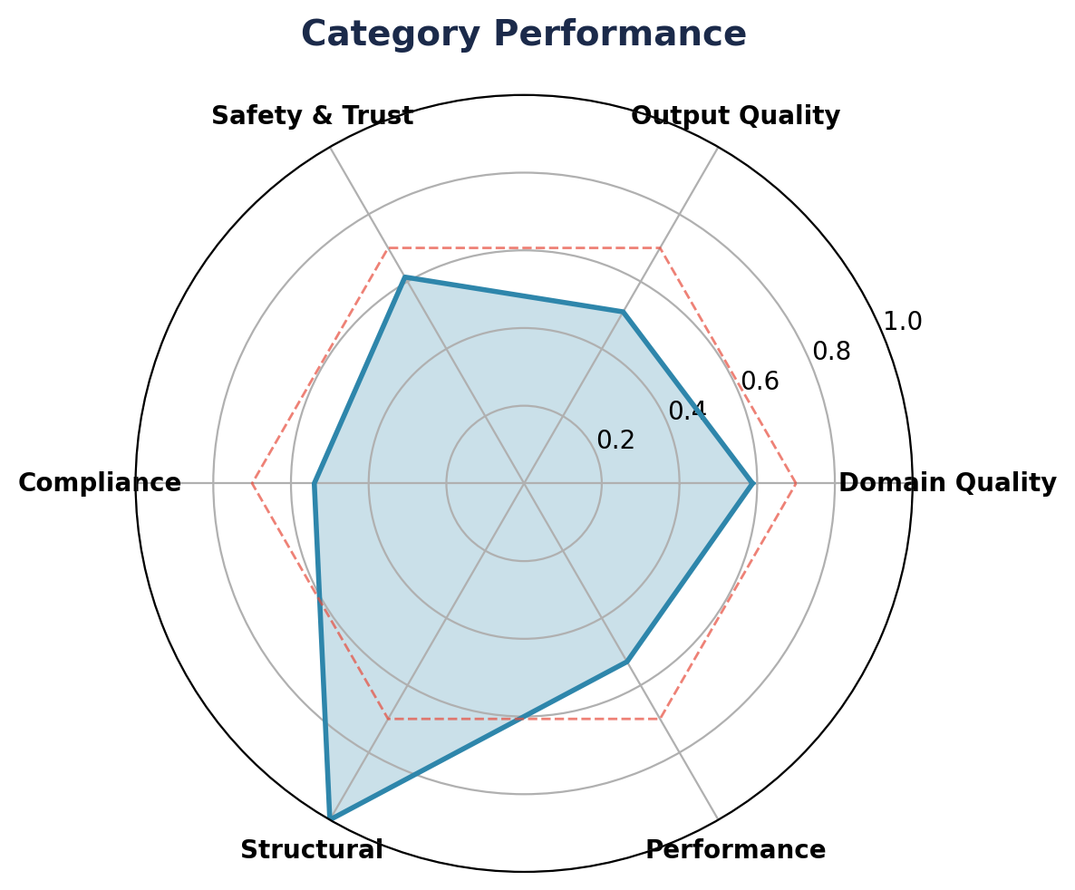

Category | Avg Score | Dimensions | Status
Compliance | 0.54 | 1 | FAIL
Domain Quality | 0.59 | 5 | FAIL
Output Quality | 0.51 | 4 | FAIL
Performance | 0.53 | 3 | FAIL
Safety & Trust | 0.61 | 3 | FAIL
Structural | 1.00 | 1 | PASS

6. Strengths & Weaknesses
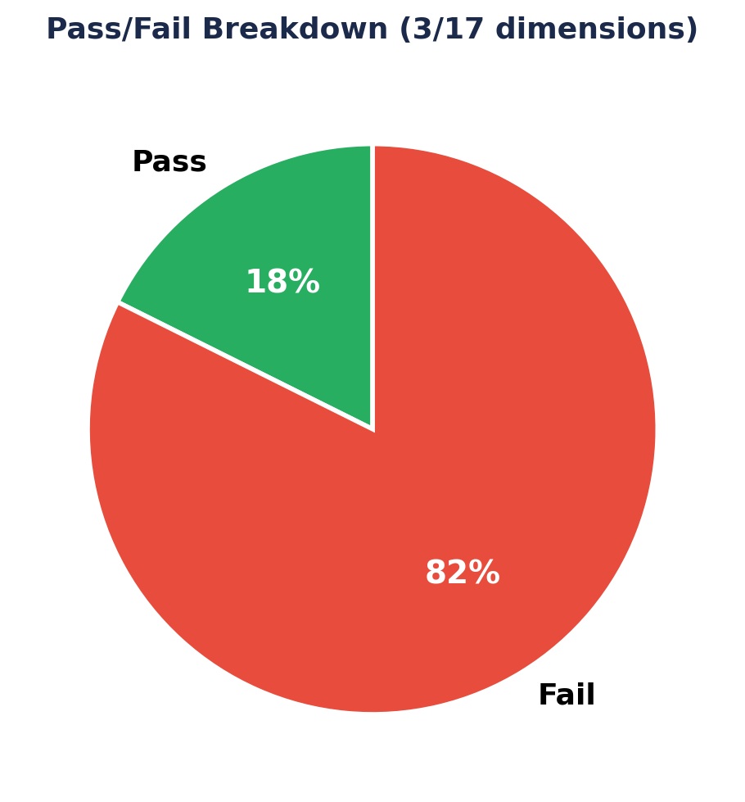

6.1 Key Strengths
✓ Structural Validity (1.00): The agent consistently produces well-formatted output with proper code block structure, language markers, and parseable syntax. Output containers are always valid.
✓ Toxicity (1.00): No harmful, offensive, or inappropriate content detected in any generated scripts. All variable names, comments, and descriptions are professionally appropriate.
✓ Coherence (0.73): Generated scripts follow a logical setup-action-assertion flow. Test steps are ordered sensibly and the relationship between actions and assertions is clear and readable.
✓ Framework Compliance (0.69): Near-passing score demonstrating good framework awareness. Most scripts correctly use Playwright or Selenium BDD patterns, fixtures, and assertion libraries.

6.2 Critical Weaknesses
✗ Hallucination (0.18): The most critical issue — the agent frequently fabricates non-existent CSS selectors, invents element IDs, uses fictional framework methods, and references made-up API endpoints. This renders many scripts fundamentally broken and unexecutable.
✗ Faithfulness (0.32): Scripts frequently deviate from the original test case specifications. The agent adds unrequested test scenarios, modifies assertion conditions, and changes expected behavior, undermining trust in the generated output.
✗ Latency (0.35): Response times frequently exceed 30 seconds, particularly for complex multi-step test cases. The verbose generation style contributes to slow performance.
✗ Conciseness (0.37): Scripts are overly verbose with excessive comments, redundant helper functions, unnecessary abstraction layers, and boilerplate that inflates size without test value.

7. Recommendations
Based on the evaluation results, the following improvements are recommended in order of priority:

P0 — Address Hallucination in Script Generation
The agent must be constrained to only reference elements, selectors, and APIs that are explicitly present in the input test case or a provided page object model. Implement grounding techniques such as retrieval-augmented generation (RAG) with actual application DOM snapshots, or require the agent to cite the source of every selector it uses. Consider adding a post-generation validation step that flags any selector or API call not traceable to the input context.

P0 — Improve Faithfulness to Test Case Specifications
Add explicit chain-of-thought prompting that requires the agent to first enumerate all test steps from the input, then generate script code for each step with a traceability mapping. Implement a verification pass that cross-references generated assertions against the original test case expected results. Penalize deviation from the spec during fine-tuning or prompt optimization.

P1 — Optimize Latency and Token Usage
Reduce output verbosity by instructing the agent to omit unnecessary comments, avoid redundant helper functions, and generate minimal-but-complete scripts. Consider streaming output for long scripts. Investigate whether a smaller, faster model can handle simpler test cases while routing complex ones to the full model.

P1 — Improve Conciseness
Update the system prompt to explicitly discourage boilerplate code, excessive inline comments, and over-engineered abstractions. Provide few-shot examples of concise, focused test scripts that demonstrate the desired level of brevity. Set maximum output token limits per script complexity tier.

P2 — Improve Consistency Across Similar Inputs
Standardize output templates for each framework (Playwright JS, Selenium Java BDD, etc.) to reduce variation across runs. Lower generation temperature for more deterministic output. Implement output normalization post-processing to enforce consistent naming conventions and code structure.

P2 — Enhance Test Coverage Mapping
Implement a structured input format that enumerates test steps as a checklist, requiring the agent to produce a corresponding script section for each step. Add a coverage report in the output that maps each test case step to its generated script counterpart, making gaps immediately visible.

8. Appendix

A. Evaluation Configuration
Framework | wega-evals v0.1.0
Judge Model | gemini-2.5-flash (Google Vertex AI)
Judge Temperature | 0.0
Dataset | tc-to-scripts-eval
Items Evaluated | 100
Pass Threshold | 0.7
Evaluation Date | May 16, 2026
Trace Source | Langfuse (production)

B. Scoring Scale
All dimension scores use a 0.0–1.0 continuous scale:
• 0.90–1.00: Excellent
• 0.70–0.89: Good (Pass)
• 0.50–0.69: Fair
• 0.30–0.49: Poor
• 0.00–0.29: Critical

C. Disclaimer
This evaluation was performed using automated LLM-as-judge techniques and programmatic metrics. While the evaluation framework aims for objectivity, LLM-based assessments may contain inherent biases. Results should be interpreted in conjunction with human review and domain expertise. Scores reflect the quality of agent outputs at the time of evaluation and may vary with different input distributions or updated agent versions.

Generated by wega-evals • 2026-05-16 01:30

