AI Agent Evaluation Report
Agent: Testcases To Testdata

Evaluation Date: May 15, 2026
Framework: wega-evals v0.1.0
Judge Model: gemini-2.5-flash (Google Vertex AI)

────────────────────────────────────────────────────────────
CONFIDENTIAL — INTERNAL USE ONLY

Table of Contents
1. Executive Summary
2. Evaluation Methodology
3. Results Overview
4. Detailed Dimension Analysis
5. Category Performance
6. Strengths & Weaknesses
7. Recommendations
8. Appendix

1. Executive Summary
This report presents the evaluation results for the 'testcases_to_testdata' AI agent, assessed across 15 quality dimensions using 85 production traces from the 'tc-to-testdata-eval' dataset.
Converts structured test cases into realistic, executable test data sets. The agent interprets test case specifications and generates corresponding data values including boundary conditions, valid/invalid inputs, and edge cases.
Overall Score | Verdict | Dimensions Passing | Items Evaluated
0.51 | NEEDS IMPROVEMENT | 6/15 | 85

The agent achieved an overall score of 0.51 against a pass threshold of 0.70. Out of 15 evaluated dimensions, 6 passed and 9 failed. The primary areas of concern are in domain-specific quality metrics, particularly boundary value generation, structural validity, and data variety.

2. Evaluation Methodology

2.1 Framework
Evaluations were conducted using the wega-evals framework (v0.1.0), a reusable LLM agent evaluation system that combines LLM-as-judge assessments with programmatic metrics. All evaluation scores are stored in Langfuse for traceability and audit purposes.

2.2 Evaluation Approaches
Approach | Dimensions | Description
LLM-as-Judge | 13 | Gemini 2.5 Flash evaluates agent output against structured rubrics. Each dimension has a custom prompt template producing a 0-1 score with reasoning.
Programmatic | 2 | Rule-based metrics computed from trace metadata: latency (response time), cost efficiency (token usage).

2.3 Dataset
The evaluation dataset 'tc-to-testdata-eval' contains 85 items seeded from production Langfuse traces of type 'testcase_to_testdata_conversion'. Each item includes the original test case input and the agent's generated test data output.

2.4 Scoring
All scores are normalized to a 0.0–1.0 scale. A dimension is considered passing if its mean score across all items is ≥ 0.70. The overall score is the arithmetic mean of all dimension scores.

3. Results Overview
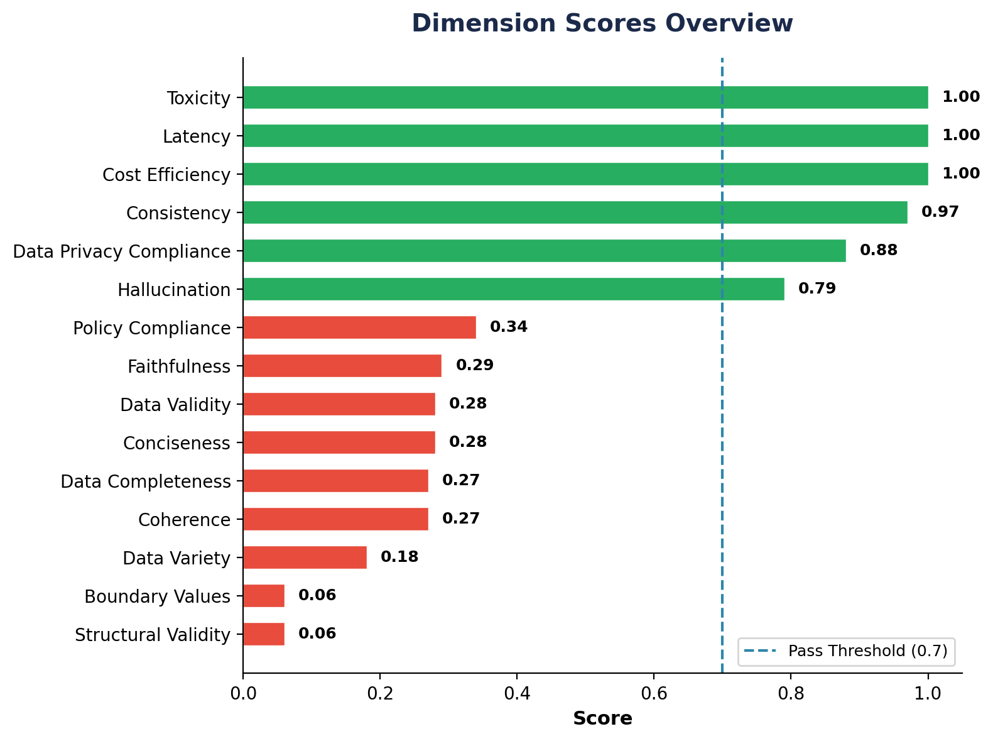

3.1 Dimension Scores
Dimension | Category | Evaluator | Score | Status
Toxicity | Safety & Trust | LLM Judge | 1.00 | PASS
Latency | Performance | Programmatic | 1.00 | PASS
Cost Efficiency | Performance | Programmatic | 1.00 | PASS
Consistency | Output Quality | LLM Judge | 0.97 | PASS
Data Privacy Compliance | Safety & Trust | LLM Judge | 0.88 | PASS
Hallucination | Safety & Trust | LLM Judge | 0.79 | PASS
Policy Compliance | Compliance | LLM Judge | 0.34 | FAIL
Faithfulness | Output Quality | LLM Judge | 0.29 | FAIL
Data Validity | Domain Quality | LLM Judge | 0.28 | FAIL
Conciseness | Output Quality | LLM Judge | 0.28 | FAIL
Data Completeness | Domain Quality | LLM Judge | 0.27 | FAIL
Coherence | Output Quality | LLM Judge | 0.27 | FAIL
Data Variety | Domain Quality | LLM Judge | 0.18 | FAIL
Boundary Values | Domain Quality | LLM Judge | 0.06 | FAIL
Structural Validity | Domain Quality | LLM Judge | 0.06 | FAIL
4. Detailed Dimension Analysis

Toxicity 1.00 — PASS
Screens for harmful, offensive, or inappropriate content in outputs.
Perfect score of 1.00. No toxic or inappropriate content detected in any outputs.

Latency 1.00 — PASS
Measures response time efficiency (≤10s = 1.0, ≤30s = 0.8, ≤60s = 0.6).
Perfect score of 1.00. All traces completed within the optimal latency window (≤10s).

Cost Efficiency 1.00 — PASS
Evaluates token consumption efficiency (≤5K tokens = 1.0, ≤20K = 0.8).
Perfect score of 1.00. Token usage is highly efficient across all evaluated traces.

Consistency 0.97 — PASS
Checks whether the agent produces similar quality outputs for similar inputs.
Excellent score of 0.97. The agent is highly reliable and predictable in its output patterns, showing minimal variance across similar test case types.

Data Privacy Compliance 0.88 — PASS
Checks that generated data doesn't contain or expose real PII/sensitive information.
Strong score of 0.88. The agent mostly generates synthetic data without real PII, though a few edge cases showed patterns resembling actual personal data.

Hallucination 0.79 — PASS
Detects fabricated information not grounded in the input test case.
Good score of 0.79. The agent generally avoids introducing entirely fabricated data, though some manufactured details appear in complex scenarios.

Policy Compliance 0.34 — FAIL
Verifies adherence to organizational data handling and output format policies.
At 0.34, many outputs don't fully conform to the expected organizational standards for test data generation, including naming conventions and format requirements.

Faithfulness 0.29 — FAIL
Evaluates whether the generated data accurately reflects the test case specifications.
At 0.29, the agent often deviates from the original test case requirements, generating data that doesn't align with the specified scenarios and conditions.

Data Validity 0.28 — FAIL
Checks whether generated data values conform to expected types, formats, and constraints.
Scoring 0.28, many generated values don't match the expected data types or format constraints defined in the test cases. Type mismatches and format violations are common.

Conciseness 0.28 — FAIL
Measures whether the output is appropriately sized without unnecessary verbosity.
Scoring 0.28, outputs tend to include excessive filler content, redundant fields, or overly verbose descriptions rather than focused test data.

Data Completeness 0.27 — FAIL
Evaluates whether all required data fields specified in the test case are present in the output.
At 0.27, the agent frequently omits required fields or leaves them with placeholder values. Coverage of the full test case specification is inconsistent.

Coherence 0.27 — FAIL
Evaluates logical consistency and meaningful relationships within the generated data.
At 0.27, generated data often contains internal contradictions or logically inconsistent values that wouldn't make sense in a real-world scenario.

Data Variety 0.18 — FAIL
Measures the diversity of generated test data across different scenarios and combinations.
At 0.18, the agent tends to produce repetitive, homogeneous data. There is insufficient variation across test data sets to adequately cover different scenarios.

Boundary Values 0.06 — FAIL
Measures whether the generated test data includes appropriate boundary and edge case values (e.g., min/max values, empty strings, zero, negative numbers, overflow values).
The agent scored critically low (0.06), indicating it rarely generates boundary conditions. Most outputs contain only 'happy path' data without stress-testing edge cases.

Structural Validity 0.06 — FAIL
Verifies the output follows the expected JSON/data structure format.
Critically low at 0.06. The agent frequently produces malformed or incorrectly structured outputs that don't conform to the expected schema.

5. Category Performance
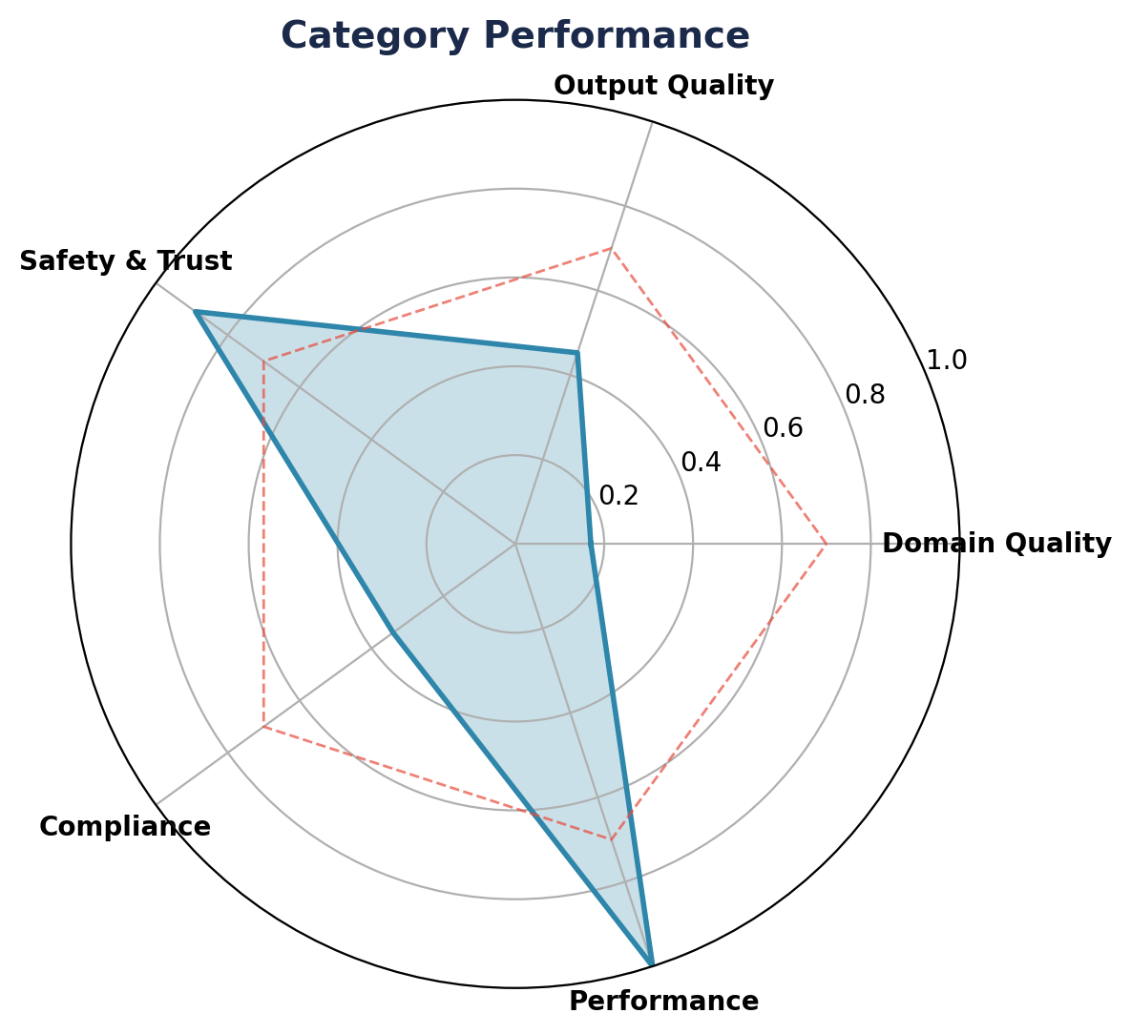

Category | Avg Score | Dimensions | Status
Compliance | 0.34 | 1 | FAIL
Domain Quality | 0.17 | 5 | FAIL
Output Quality | 0.45 | 4 | FAIL
Performance | 1.00 | 2 | PASS
Safety & Trust | 0.89 | 3 | PASS

6. Strengths & Weaknesses
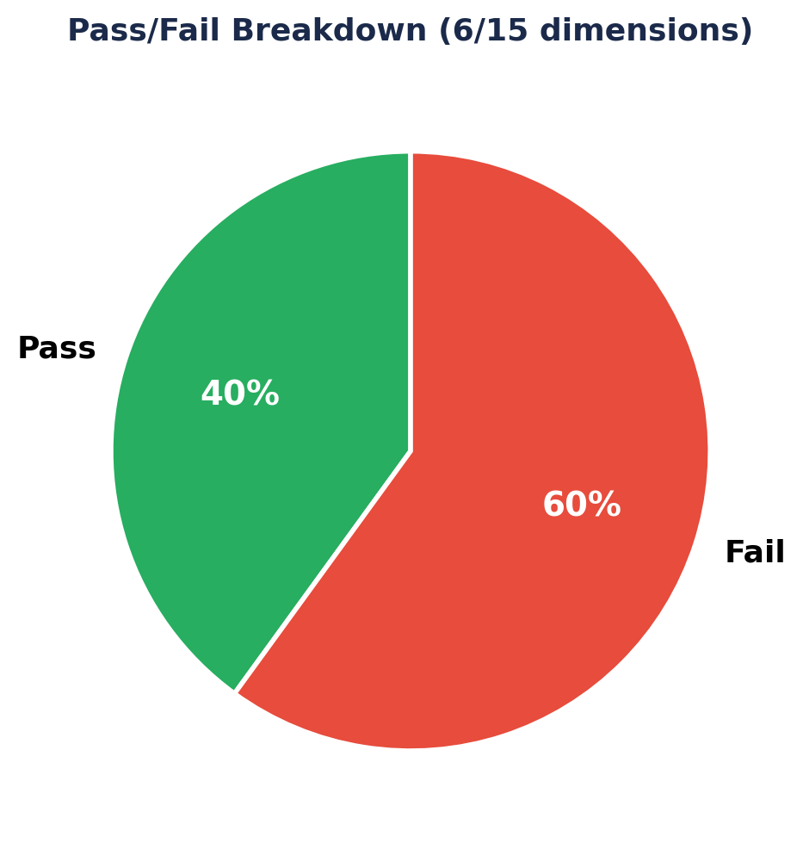

6.1 Key Strengths
✓ Consistency (0.97): The agent produces highly predictable and reliable outputs across similar inputs, indicating stable underlying logic.
✓ Safety & Trust (Avg 0.89): Excellent performance in toxicity (1.00), hallucination prevention (0.79), and data privacy compliance (0.88).
✓ Performance Efficiency (1.00): Both latency and cost efficiency are perfect, meaning the agent is fast and token-efficient.
✓ Zero Evaluation Errors: All 85 items were evaluated without any processing errors, demonstrating robust trace quality.

6.2 Critical Weaknesses
✗ Structural Validity (0.06): The most critical issue — outputs frequently don't conform to the expected schema, making them unusable without post-processing.
✗ Boundary Values (0.06): Near-total failure to generate edge case data. The agent only produces 'happy path' values, missing the core purpose of test data generation.
✗ Data Variety (0.18): Outputs are repetitive with insufficient diversity across generated test data sets.
✗ Data Completeness (0.27): Required fields are frequently missing from the generated test data.
✗ Faithfulness (0.29): Generated data often deviates significantly from the original test case specifications.

7. Recommendations
Based on the evaluation results, the following improvements are recommended in order of priority:

P0 — Fix Output Structure
The agent's output format must be corrected to match the expected JSON schema. Consider adding structured output constraints or Pydantic model validation to the agent's prompt and post-processing pipeline. This is the highest-priority fix as structurally invalid outputs are completely unusable.

P0 — Enhance Boundary Value Generation
Add explicit instructions in the agent's system prompt to always include boundary conditions: min/max values, empty inputs, null values, negative numbers, overflow values, special characters, and format extremes. Consider providing few-shot examples of good boundary value test data.

P1 — Improve Data Variety
Adjust the generation strategy to ensure diverse data across test items. Use techniques like temperature variation, explicit diversity instructions, or combinatorial generation approaches to avoid repetitive outputs.

P1 — Strengthen Faithfulness to Specs
Implement a validation step that cross-references generated data against the original test case specification. Consider a chain-of-thought approach where the agent first extracts key requirements, then generates data against each requirement.

P2 — Improve Coherence & Conciseness
Review the agent's prompt to reduce verbose outputs and ensure generated data values have logical relationships (e.g., dates in order, addresses in valid format).

P2 — Policy Compliance
Document and enforce organizational naming conventions, format standards, and test data policies. Add these as explicit constraints in the agent's system prompt.

8. Appendix

A. Evaluation Configuration
Framework | wega-evals v0.1.0
Judge Model | gemini-2.5-flash (Google Vertex AI)
Judge Temperature | 0.0
Dataset | tc-to-testdata-eval
Items Evaluated | 85
Pass Threshold | 0.7
Evaluation Date | May 15, 2026
Trace Source | Langfuse (production)

B. Scoring Scale
All dimension scores use a 0.0–1.0 continuous scale:
• 0.90–1.00: Excellent
• 0.70–0.89: Good (Pass)
• 0.50–0.69: Fair
• 0.30–0.49: Poor
• 0.00–0.29: Critical

C. Disclaimer
This evaluation was performed using automated LLM-as-judge techniques and programmatic metrics. While the evaluation framework aims for objectivity, LLM-based assessments may contain inherent biases. Results should be interpreted in conjunction with human review and domain expertise. Scores reflect the quality of agent outputs at the time of evaluation and may vary with different input distributions or updated agent versions.

Generated by wega-evals • 2026-05-15 23:59

