ALTER
Spectrum Analyzer
The frequency microscope for people who want to stop guessing.
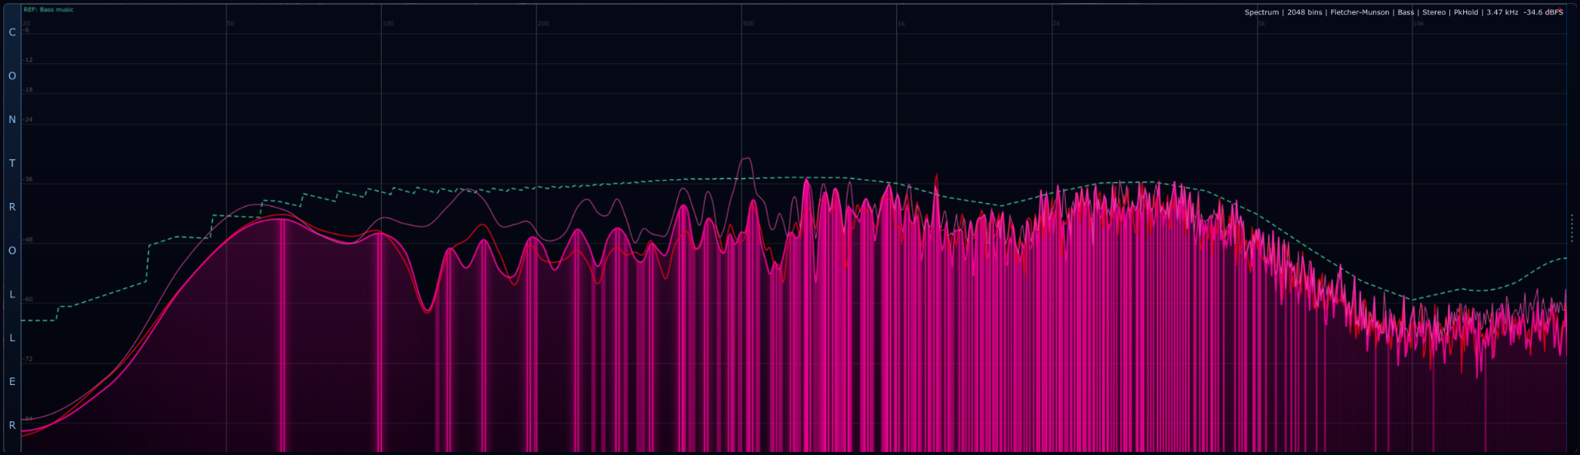
Stereo spectrum with peak hold and a Bass music reference curve: the analyzer becomes a frequency map, a stereo check and a tonal-balance compass at the same time.
A spectrum analyzer does not tell you if the track is good. It tells you where the energy is hiding, where it is lying, and where it is starting to act like an asshole.

Spectrum Analyzer turns incoming audio into a real-time frequency landscape. Instead of looking only at loudness, it shows how the signal is distributed from sub-bass to air. It is the module you open when something feels muddy, sharp, thin, boomy, unbalanced, or just weird as hell - and your ears need backup.
For DJs it helps compare tracks before transitions. For producers it reveals mud, harshness and weak drops. For audio engineers it supports EQ, referencing and export checks. For sound designers it exposes the harmonic skeleton of kicks, 808s, drones, impacts, vocals and synthetic monsters.
Visual overview
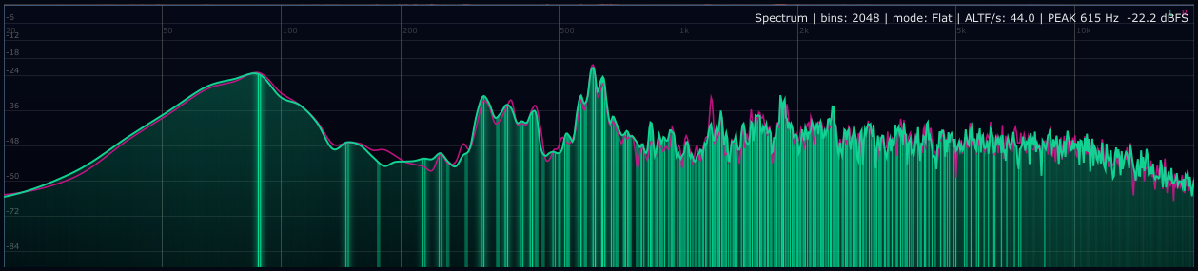
Flat spectrum view: 2048 bins, logarithmic frequency axis and live peak readout. This is the raw "where is the energy?" view.

Psychoacoustic/reference view: Fletcher-Munson curve, Bass music reference, stereo L/R overlay and peak hold enabled.
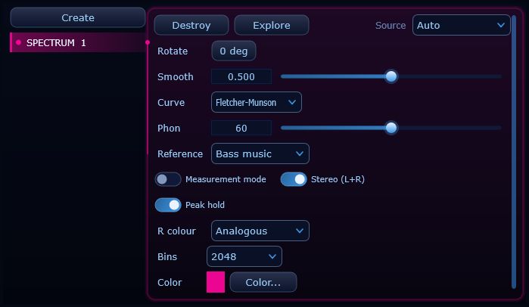
Controller settings: source, rotation, smoothing, psychoacoustic curve, phon level, reference genre, measurement mode, stereo mode, peak hold, Constant-Q and colour.
What the Spectrum Analyzer actually shows
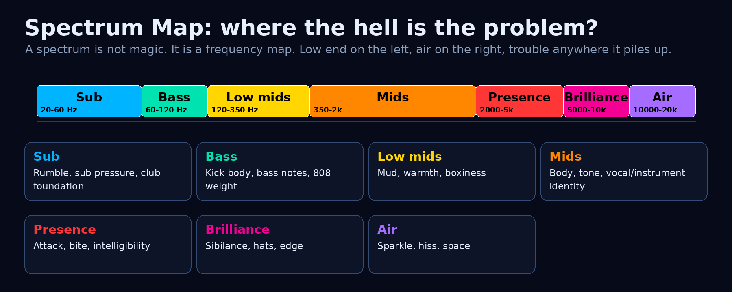
Frequency regions in practical music language. The labels are not prison walls. They are zones where problems usually show up.
The horizontal axis is frequency. Low frequencies live on the left, high frequencies on the right. ALTER displays this on a logarithmic scale, because musical pitch and human perception behave more like ratios than raw linear distance. One octave feels like one octave whether it is 50-100 Hz or 5-10 kHz.
The vertical axis is level in dBFS. 0 dBFS is the digital ceiling. Lower values mean quieter frequency content. The curve is built from FFT magnitude data: the audio is sliced into frequency bins, each bin gets a strength value, and ALTER draws the shape.
Simple translation: left side = weight, middle = character, right side = detail. If one area is screaming for attention, the mix is probably telling you something.

FFT and bins - the non-boring version
FFT means Fast Fourier Transform. It converts a waveform into frequency content. That sounds like wizard math, but the practical meaning is simple: instead of seeing "the wave went up and down", you see "there is energy around 60 Hz, 200 Hz, 3 kHz and 10 kHz".
ALTER receives FFT values normalized from silence floor to 0 dBFS and displays the full resolution the source provides - up to 8192 bins, selected by the global FFT Resolution setting (2048 / 4096 / 8192). More bins mean more detail. Detail is good when you hunt resonances; too much detail is chaos when you are performing live and the screen is vibrating like a caffeinated jellyfish.
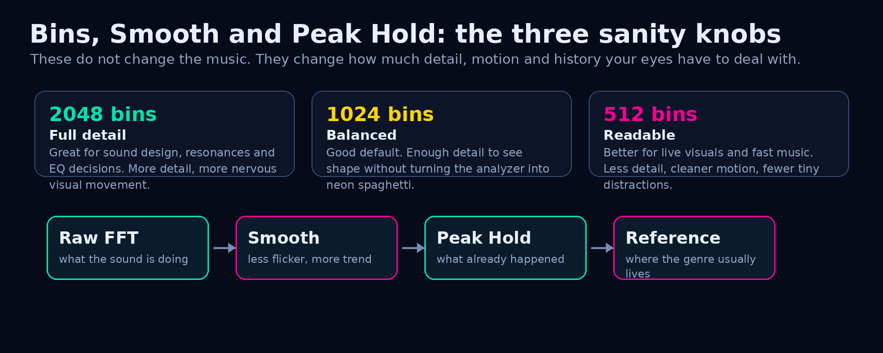
Smoothing and peak hold control how much movement and history the analyzer shows; the global FFT Resolution setting controls the detail.
Why the low end is not a laser pointer
Important truth: a Spectrum bin is not a tiny physical shelf where one exact frequency is stored. It is a finite-time frequency measurement. If you play one sine wave that lands between FFT bin centres, the analyzer does not pick one winner and throw the rest in the bin like a drunk referee. The energy spreads into a small hill around the real tone.
For example, with a 4096-sample FFT (2048 bins) at 48 kHz, raw bin spacing is about 11.7 Hz. Around 40 Hz, that is a big musical chunk; around 10 kHz, it is tiny. That is why the sub range cannot be read to the micrometer from this display. The analyzer is correct, but the ruler is naturally wider in the basement.
Measurement mode is still the right mode when you want serious reading. It removes the sexy curve overshoot and uses stricter averaging/interpolation, so the displayed bump is closer to what the FFT actually measured. But if the low-end peak looks like a hill, that is not ALTER roasting itself. That is FFT reality saying: the energy is around here.
Read low-end peaks as zones, not GPS coordinates. It’s not build or exact bass tuning, if you looking for that you should reach external tool which use a longer analysis window, a pitch-focused analyzer, or a future multi-resolution / Constant-Q style mode. More display pixels alone will not create new physics.
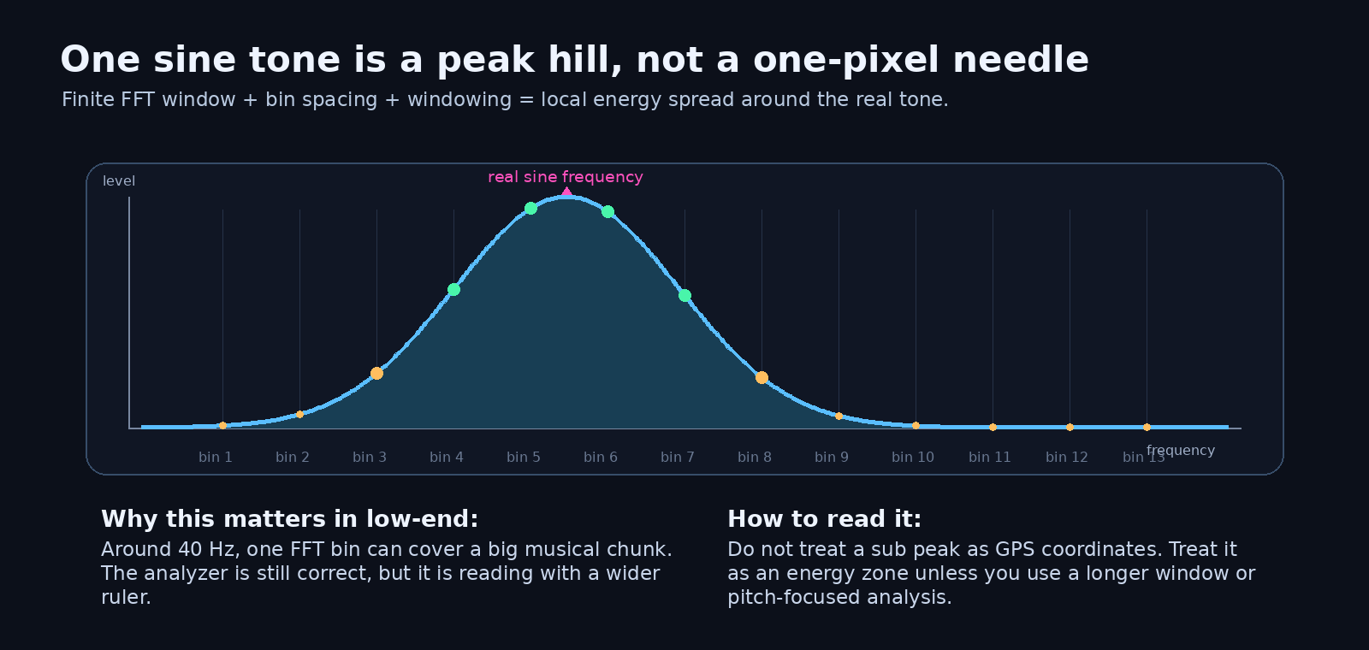
A single sine tone can appear as a local peak hill when it falls between FFT bin centres. In the low end, that hill is more visible because frequency resolution is coarser in musical terms.
How to actually use it
Situation | Best settings | What to look for | Do not do this
Mixing / EQ balance | Flat or A-weight, 1024-2048 bins, Measurement ON, moderate smooth | Mud around 120-350 Hz, harshness around 2-5 kHz, weak air above 10 kHz | Do not EQ every bump. Some bumps are the music, not a crime scene.
Mastering / reference check | Measurement ON, Peak Hold ON, reference genre ON, 2048 bins | Long-term tonal shape vs reference, exaggerated low end, missing mids, harsh top | Do not chase the reference curve like a GPS into a lake. Listen after level matching.
DJ prep / live sets | 1024 bins, smoother response, reference optional | Whether tracks have similar bass weight, brightness and midrange density | Do not trust peak loudness only. A track can peak high and still feel weak as hell.
Sound design | Flat, 2048 bins, Peak Hold ON, low smoothing | Fundamental, harmonics, resonances, noise bands, impact shape | Do not kill every resonance. Sometimes the nasty peak is literally the personality.
VJ / performance visual | Visual mode, 512-1024 bins, higher smooth, colour to taste | Readable movement and musical energy shape | Do not overload the audience with microscopic FFT spaghetti unless that is the aesthetic.

Frequency range cheat sheet
Range | Musical meaning | Typical problems | Useful move
20-60 Hz Sub | Sub pressure, club foundation, deepest 808/kick energy | Rumble, headroom loss, invisible bass that eats limiters | High-pass non-bass elements; check translation on systems that can actually play sub.
60-120 Hz Bass | Kick body, bass notes, weight | Kick and bass fighting, boomy low end | Choose who owns the fundamental. Kick and bass do not both need to be king.
120-350 Hz Low mids | Warmth, chest, body | Mud, boxiness, cloudy mix | Cut carefully. Too much cutting makes the track thin and sad.
350 Hz-2 kHz Mids | Instrument identity, vocal tone, musical information | Nasal tone, honk, crowded arrangements | Balance arrangements before murdering EQ.
2-5 kHz Presence | Attack, bite, intelligibility, edge | Harshness, ear fatigue, painful vocals/snares | Small moves matter. This zone can slap or stab.
5-10 kHz Brilliance | Hats, sibilance, synth shine, detail | Sharp cymbals, sibilance, brittle top | De-ess, tame hats, check loud playback.
10-20 kHz Air | Air, sparkle, space, hiss | Noise, fizzy distortion, fake brightness | Boost only if it improves the song, not because the curve looks empty.

Flat, A-weight and Fletcher-Munson
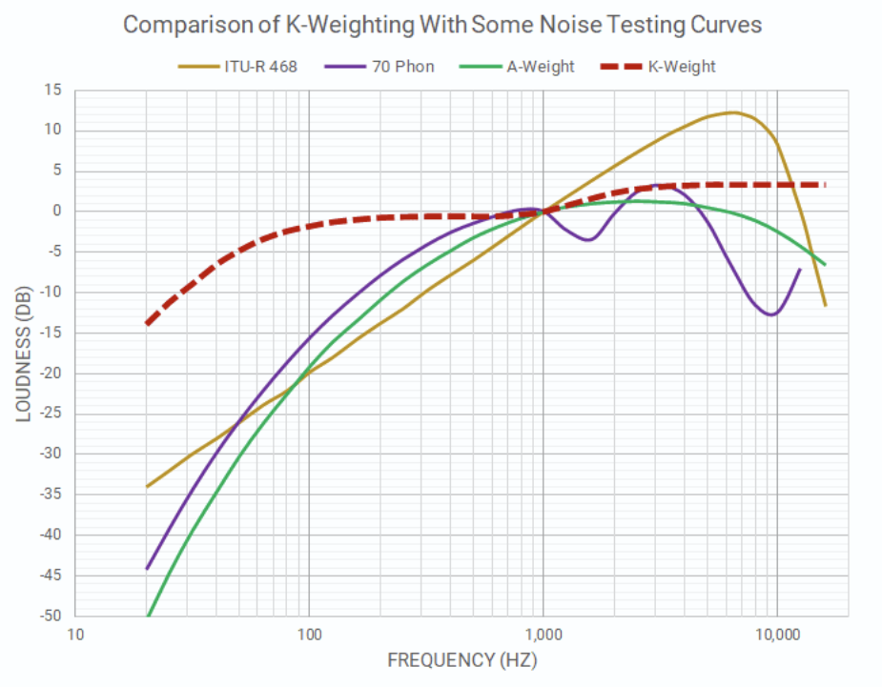
The psychoacoustic curve decides whether you want physics, ear-like weighting or equal-loudness perspective.

Flat mode shows raw physical energy (It is not on the graph...just imagine flat line man). Use it when you want to know what is actually in the signal. It is the most honest technical view and the best starting point for sound design, debugging and basic spectrum reading.
A-weighting applies a standardized ear-sensitivity weighting used in sound level measurement. It reduces low and very high frequencies compared with the midrange, which is useful when you want the analyzer to behave more like human hearing and less like a robot staring at electricity.
Fletcher-Munson / ISO 226 mode uses equal-loudness contour logic controlled by the Phon setting (The fuck is phon? A phon is a unit of measurement used in acoustics to quantify the subjective perceived loudness of a sound). Lower phon settings exaggerate how insensitive we are to very low and very high frequencies at softer listening levels (In other words you need less dB to hear 3kHz than 50Hz perceptually the same). Higher phon settings become flatter because loud sound feels more even across the spectrum.
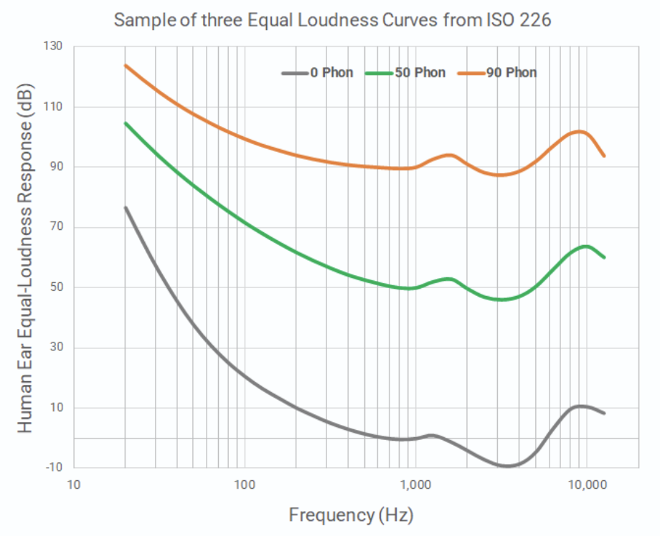
https://aes.org/resources/audio-topics/loudness-project/learn-more/

Translation: Flat says "what exists." A-weight says "what the ear tends to notice." Fletcher-Munson says "what feels equally loud at this listening level." Same sound, different truth.

Reference curves - useful, but do not worship them
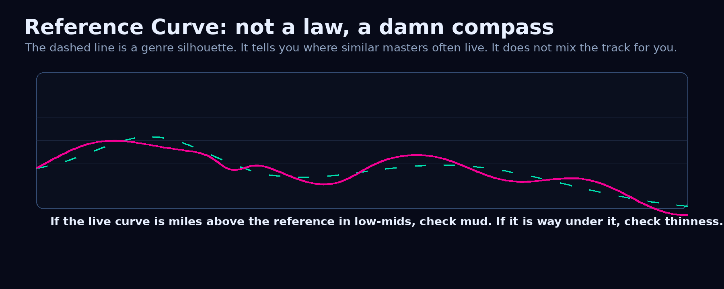
Reference curves are genre silhouettes. They help you compare, not obey.
ALTER includes reference curves for EDM, Bass music, House/Techno, Hip-Hop, Pop and Rock. These are broad tonal-balance silhouettes. They are not official standards, not mastering laws, and definitely not a replacement for ears.
Use the dashed reference curve to ask better questions: Is my bass way above typical bass music? Are my low-mids bloated? Is my presence region dead? Is the top end too nervous? The curve does not say "fix this now." It says "hey, maybe check this before you export that monster."
Reference | Usually expects | Watch for
EDM | Strong controlled low end, clean mids, energetic high-frequency detail | Over-limited drops, harsh 3-5 kHz leads, fake air.
Bass music | Heavy sub/bass shape with controlled top | Sub eating headroom, weak mid translation, chaotic 808 harmonics.
House / Techno | Stable kick-bass foundation, rhythmic mids, polished top | Kick and bass masking, low-mid mud, hat harshness.
Hip-Hop | 808/sub authority, vocal clarity, controlled brightness | Vocals buried by low mids, 808 too big for small speakers.
Pop | Balanced low end, forward vocal/presence, clean top | Vocal too sharp, chorus too flat, low end too polite.
Rock | Midrange density, guitars/vocals forward, controlled cymbals | Guitar wall masking vocals, cymbal wash, boxy low mids.

Measurement mode vs visual mode
Measurement mode is the serious engineer mode. It uses a more measurement-friendly rendering path: power-average grouping and linear interpolation. The result is less pretty, but more literal. Use it for EQ decisions, referencing and mastering checks. It does not magically turn low-end FFT bins into surgical pitch detectors; it shows the measured bin energy with less visual bullshit.
Visual mode is the performance mode. It uses a smoother visual curve and maximum-style grouping so important peaks remain exciting and visible. It looks better on stage, in fullscreen, and when the analyzer becomes part of the visual identity.
Translation: Measurement mode is the lab coat, but it is not a magic microscope. Visual mode makes the curve smoother and cooler; Measurement mode makes the existing FFT information less decorative. If a low sine draws a hill, the hill is the honest shape of the measurement, not a UI failure.
Constant-Q mode - musical resolution for the basement
A single FFT has one time window, so it must choose between bass precision and speed. Constant-Q mode refuses that compromise: it analyzes the signal with three window lengths at once - long for bass, medium for mids, short for highs - and reads every log-spaced band from the analysis that actually resolves it. The result: every semitone from the sub range up to 20 kHz is readable, lows stop being one wide hill, and the highs stay snappy. Use it for bass tuning, 808 pitch, chord voicings and any decision below 200 Hz. It is enabled globally (FFT Resolution menu), and the Spectrogram can use the same multi-resolution stream.
Measurement mode is the lab coat. Visual mode is the cyberpunk jacket. Both are useful. Wearing the wrong one just makes the job weird.

Stereo mode - left and right
When Stereo (L+R) is enabled, ALTER shows left and right spectra overlaid. This is not only cosmetic. It helps reveal whether the left and right sides of the mix carry different frequency energy.
Use it to find stereo problems: a hi-hat too bright on one side, a synth layer with asymmetric low mids, a stereo bass effect that should probably calm down, or a wide top end that looks cool but turns into soup in mono.
What you see | What it can mean | What to check
L/R curves almost identical in bass | Low end is centered and stable | Good for club translation.
One side much brighter above 5 kHz | Stereo hats, noise or FX are unbalanced | Check headphones and mono fold-down.
Wide low end below 120 Hz | Stereo bass or phase-heavy sub content | Probably dangerous for vinyl, clubs and mono systems.
One channel has a strong resonance | Panned instrument, room effect, stereo processing artifact | Solo or bypass stereo effects.

Peak Hold - the memory line
Peak Hold draws a slowly decaying maximum curve over the live spectrum. It is useful because fast peaks disappear before your brain can say "wait, what the hell was that at 3.47 kHz?"
Use Peak Hold for resonance hunting, sound design, cymbal control, harsh vocal consonants, kick tuning and checking how a drop behaves at its maximum energy. It shows what happened recently, not only what is happening in this exact frame.
Controller controls
Control | What it does | How to use it
Source | Selects the audio source or automatic routing. | Use Auto for normal work; choose a specific source when comparing plugin instances.
Rotate | Rotates the module visually. | Useful for custom layouts and stage visuals. Measurement labels stay readable.
Smooth | Controls response speed and visual stability. | Low = fast and nervous. High = smooth and elegant. Start around 0.5.
Curve | Flat, A-weight or Fletcher-Munson. | Flat for physics, A-weight for ear-like view, Fletcher-Munson for phon-based loudness perception.
Phon | Listening-level parameter for Fletcher-Munson mode. | Lower phon = stronger low/high correction. 60 phon is a good middle-ground start.
Reference | Shows a dashed genre tonal-balance curve. | Use as a compass, not a dictator.
Measurement mode | Switches to more literal measurement rendering. | Turn ON for engineering decisions. Turn OFF for smoother visuals.
Stereo (L+R) | Overlays left and right spectra. | Use for stereo balance, mix translation and wide effects.
Peak hold | Displays recent maximum frequency levels. | Turn ON when hunting peaks, resonances or harsh moments.
R colour | Sets right-channel colour relation. | Complementary = strong separation. Analogous = smoother visual blend.
Bins | 512, 1024 or 2048 displayed bins. | 2048 for detail, 1024 for balance, 512 for clean live readability.
Color | Sets the main spectrum colour. | Use for visual identity, module grouping or performance aesthetics.

Common mistakes
Mistake | Why it sucks | Better move
EQing every peak | Real instruments have peaks. Harmonics are not dirt by default. | Find repeated annoying peaks that survive context and level matching.
Ignoring the room | Your room may lie harder than the analyzer. | Use references and multiple playback systems.
Over-trusting low end visually | Sub can look huge but vanish on small speakers. | Check harmonics and translation, not only 40 Hz glory.
Chasing the reference curve | A reference is a silhouette, not a handcuff. | Use it to ask questions, then decide with ears.
Using too much smoothing for analysis | Problems get visually blurred. | Lower smoothing when hunting details.
Using too little smoothing for visuals | The display becomes anxious spaghetti. | Raise smoothing for live performance and readability.
Reading sub peaks as exact Hz coordinates | Low frequencies have long periods, so a short FFT window reads them with a wider brush. A clean sine can still draw a hill. | Treat the low end as an energy zone; use longer windows or pitch tools when exact tuning matters.

Final interpretation
Spectrum Analyzer is not an automatic mix judge. It is a frequency microscope. It shows the body, mud, bite, brightness, stereo imbalance and tonal shape that your ears might miss when the room, headphones, fatigue or excitement start lying to you.
The goal is not to make a perfect-looking curve. The goal is to understand why the sound feels the way it feels. When the spectrum and your ears agree, you are making decisions. When they disagree, investigate. That is where the useful shit usually starts.
Do not mix with your eyes. Use your eyes to catch what your ears might have missed.

Sources and technical basis
ALTER internal Spectrum module: real-time FFT spectrum visualization, logarithmic frequency grid, up to 8192 FFT bins (global resolution), Constant-Q multi-resolution mode, smoothing, measurement/visual rendering modes, peak hold, stereo L/R spectrum, psychoacoustic modes and reference curves.
ALTER shared FFT path: 4096-16384-sample Hann-windowed FFT (2048-8192 output magnitudes, global setting), log-frequency display mapping, measurement-mode power averaging and visual-mode smoothing. Finite-window FFTs can show one sine as a local peak hill when the tone does not land exactly on a bin centre; Constant-Q mode reduces this in the low end by using longer bass windows.
ISO 226:2003, Acoustics - Normal equal-loudness-level contours: basis for equal-loudness / Fletcher-Munson style interpretation.
IEC 61672-1:2013, Electroacoustics - Sound level meters: specifications for frequency-weighted sound level measurement including standardized weighting behaviour.
Rational Acoustics, Linear and Logarithmic Frequency Scales: practical explanation of why frequency is commonly viewed on octave/decade-related logarithmic scales.
Voxengo SPAN User Guide: real-time FFT spectrum analysis, smoothing, maximum/secondary spectrum views and professional spectrum-analyzer workflow reference.

