ALTER
Chladni Patterns
Where sound draws geometry in sand
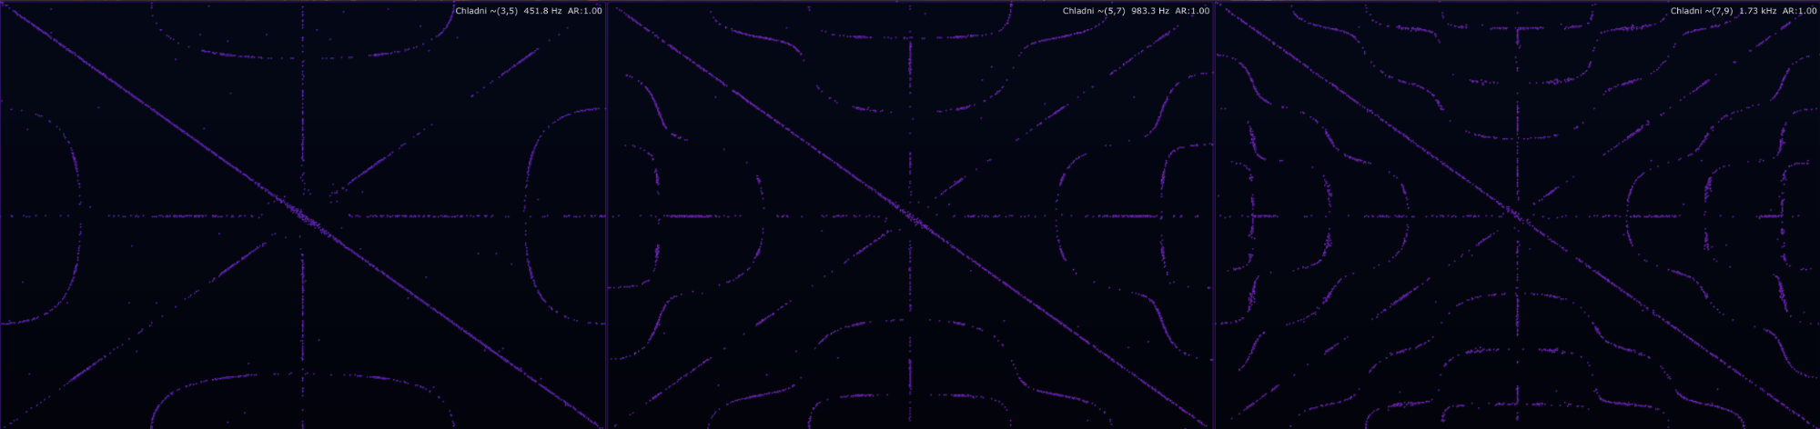
Three related Chladni modes: simple resonance geometry turns into denser nodal architecture as the mode numbers climb.
A Chladni pattern is not a random pretty particle effect. It is a standing-wave picture: the sand runs away from the shaking parts and settles where the plate is almost still. Tiny grains, big physics, organic and beautiful visually.

Chladni Patterns turns audio into a living sand plate. The module listens to the incoming signal, finds a dominant tonal component, selects a resonant plate mode and lets thousands of virtual grains settle into the nodal lines. For DJs and VJs it becomes a performance visual. For sound designers it becomes a tone-to-geometry instrument. For beginners it turns the invisible behaviour of resonance into something you can literally see.
This module is based on the classic Chladni idea: vibrate a plate, sprinkle sand on it, and the sand gathers along the still lines of the standing wave. ALTER does not require a bow, metal sheet, messy table or vacuum cleaner afterwards. The mess is virtual. Thankfully.

Visual overview
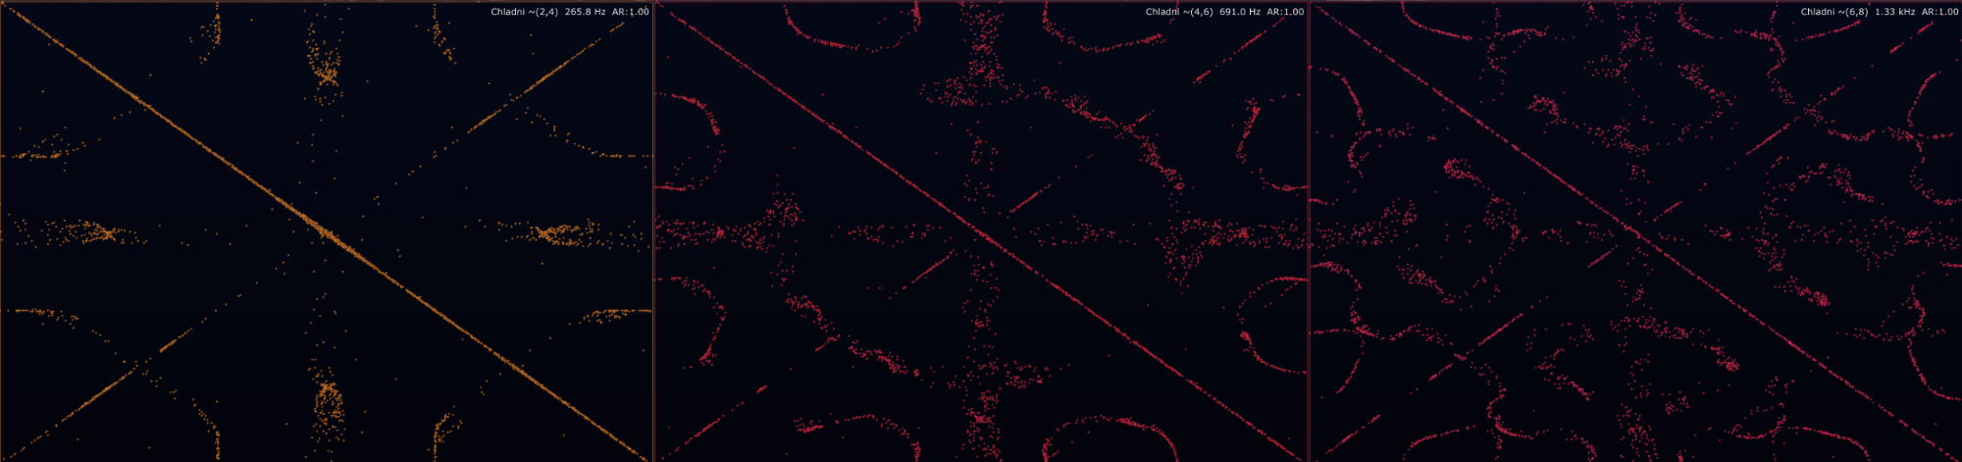
Different mode families and richer shifted patterns. The diagonal and curved nodal lines are the quiet zones of the virtual plate.
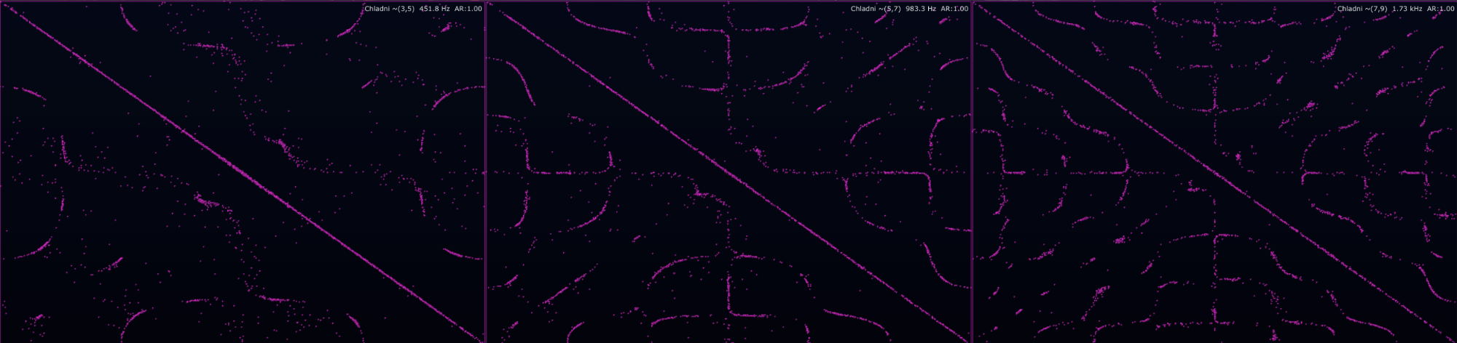
A denser visual state: same Chladni logic, more scattered detail and more complex particle settlement.

What a Chladni pattern actually is
A vibrating plate does not move everywhere equally. At certain resonant frequencies it forms standing-wave modes. Some areas move a lot. Some areas barely move at all. The still areas are called nodal lines.
In a physical Chladni plate, sand gets thrown away from the moving regions and accumulates along those nodal lines. So the beautiful line drawing is not the loudest part of the plate. It is the quietest part. That is the first mind-bender: the visible pattern is made of stillness.

Simple translation: the plate is dancing; the sand is lazy. It finds the places where the dance floor is calm and sits there.

The model: m, n and the nodal field
The module uses a rectangular plate-style modal field. Each pattern is described by two mode indices, m and n. Small mode numbers create broad, readable figures. Larger mode numbers create finer, denser geometry. If m and n are equal, this particular antisymmetric model cancels itself out, so the pattern becomes blank. That is expected behaviour, not the module having an existential crisis.
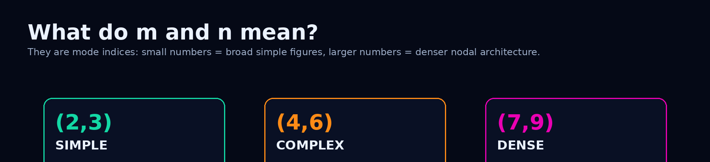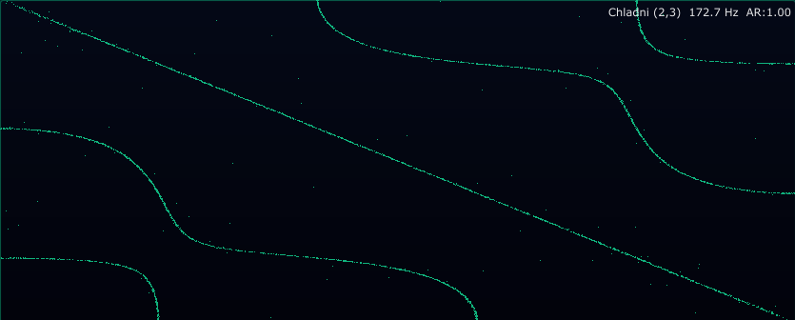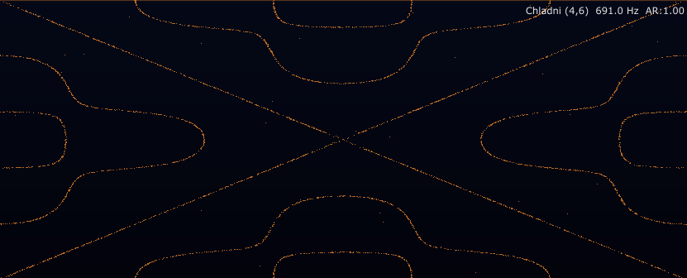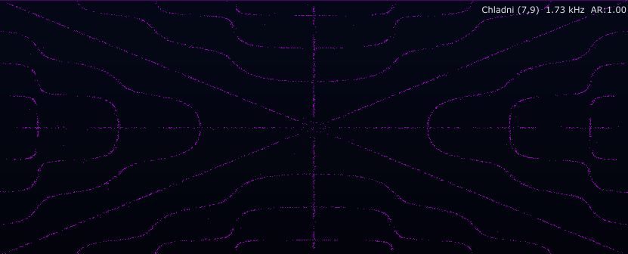
Mode indices control the complexity of the figure. Higher m/n values usually mean more nodal detail.
The core idea can be written as:
Z(x,y) = cos(n*pi*x) cos(m*pi*y / r) - cos(m*pi*x) cos(n*pi*y / r)

Do not panic. Read it like this: Z tells us how much the virtual plate is moving at each point. When Z is close to zero, that point is a nodal line, and the sand likes to settle there. m and n choose the type of standing-wave figure. r is the aspect ratio of the plate.
This is a real-time artistic plate model, not a million-element laboratory simulation. It gives you stable Chladni-style nodal geometry fast enough for live visuals, and that is the whole point: it should look alive, react musically and not cook your CPU like a cheap toaster, well, it´s homemade but I tried my best.

How Audio Reactive mode works
Audio Reactive mode does two different jobs at once, and this distinction matters:
Part of the audio | What it controls | Meaning
Dominant frequency | Which mode is selected | The strongest perceptually weighted tone chooses the nearest resonant plate mode.
RMS level | How hard / fast the sand moves | Quiet audio lets the grains rest. Loud passages shake them into motion.
Dominant pitch class | Optional Color by Tone | The detected tone can map to hue, so pitch becomes colour.

ALTER does not map the sound separately to m or separately to n. It does not say “bass controls m, brightness controls n” or anything like that. Instead, it treats (m,n) as one complete plate resonance mode — one physical shape. The audio first gives ALTER a dominant perceptual frequency, basically the tone that leads the pattern after ear-weighting. Then the module looks through the available Chladni modes and picks the full (m,n) pair whose theoretical resonance is closest to that frequency. Low tones tend to land on simpler, lower modes; higher tones tend to land on denser, more detailed figures. But one patern is not exactly made for one specific tone/frequency (look appendix at the end of the file). Simple enough: the sound does not grab one axis, it grabs the whole damn plate mode.
The Shift control then pushes that selected mode into a richer visual family. It does not change the detected tone and it does not remap only m or only n. It takes the matched pair and moves both indices upward together, so a simple detected shape can become a more complex cousin of itself. Think of it like this: Audio Reactive chooses the plate’s natural response, Shift tells the plate to draw a fancier version of that response. Material and Aspect Ratio change the resonance map itself, so the same sound can produce a different pattern on steel, glass, acrylic or a stretched plate — exactly the kind of beautiful physics nonsense that makes Chladni visuals worth watching.

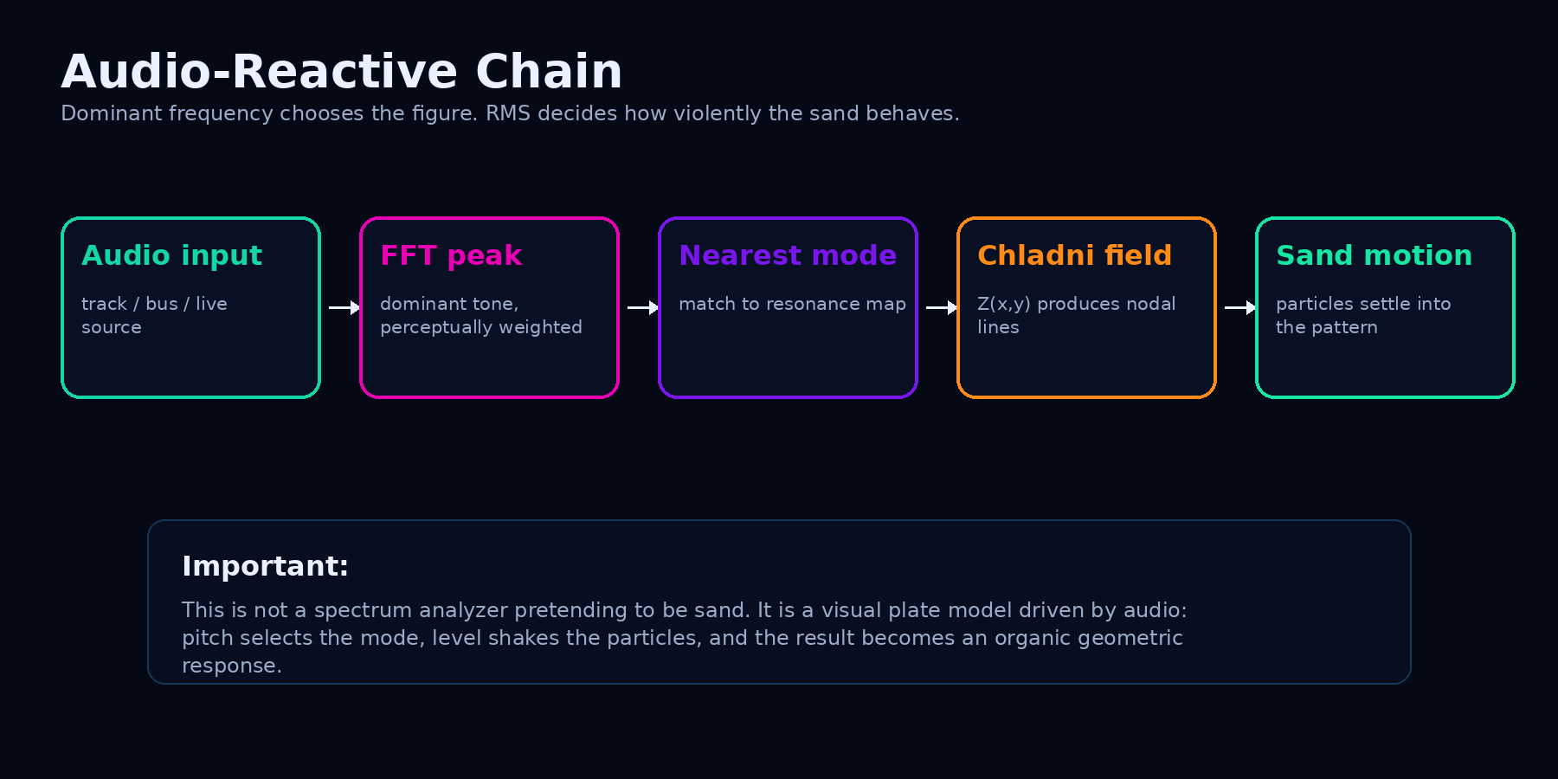
The reactive chain: audio chooses the mode, level drives motion, particles reveal the nodal lines.
The important part: loudness does not choose the figure by itself. A louder signal shakes harder, but the selected geometry follows the dominant tone. That is why a bass note, a synth lead and a bright resonant texture can produce different shapes even if the meter level looks similar.
If the audio contains a chord, noise, distorted bass or a full master bus, the module follows the component it interprets as dominant after perceptual weighting. It is not trying to identify every note in the universe. It picks the strongest visual driver. Otherwise the sand would have a nervous breakdown.

Where the full m/n mapping lives
The full audio-reactive mode-selection table is kept as Appendix A at the end of this document. That is intentional: in the main explanation we keep the idea readable, while the appendix gives engineers and curious nerds the complete default map without punching the story in the face with sixty rows of numbers.
Read the table as a selection map: the dominant perceptually weighted tone chooses the nearest pre-shift resonance family. Shift then moves both m and n upward together to draw a richer cousin of the same response.

How color by tone mode works
When Color by tone is enabled, Chladni listens for the dominant perceptually weighted spectral peak, converts that peak to the nearest musical note, and maps the note name to a target hue on a 12-step colour wheel. Same note name, same colour family: C in another octave still targets the C hue family.
This module is more “physical sand” than shader fireworks. It does not create secondary shader colours or octave colour layers. The particles are drawn with one current sand colour. That colour can glide, fade with RMS drive, and change when the dominant tone changes — but it is not painting a whole neon ecosystem per note.
Translation: the tone chooses the sand colour, the plate mode chooses the pattern, and RMS decides how hard the whole damn thing wakes up.

What is actually mapped?
Audio feature | What it controls | Meaning
Dominant weighted peak | Colour target + mode search | The loudest musically relevant peak drives hue and Chladni mode selection.
Pitch class | Target hue | C, C#, D… B map to 12 hue positions. Octave repeats the family.
RMS drive | Visibility + sand agitation | Quiet signal fades grains. Strong signal makes the plate feel alive.
Mode shift | Displayed m/n complexity | It shifts the matched visual mode; it does not change tone-colour mapping.

Exact Chladni tone colour targets
The table and wheel below show the exact target families used by Chladni: HSV hue = pitch class / 12, saturation = 80%, value = 100%. Live hue moves toward the target with circular smoothing, so transitions feel organic instead of snapping like a broken arcade machine.
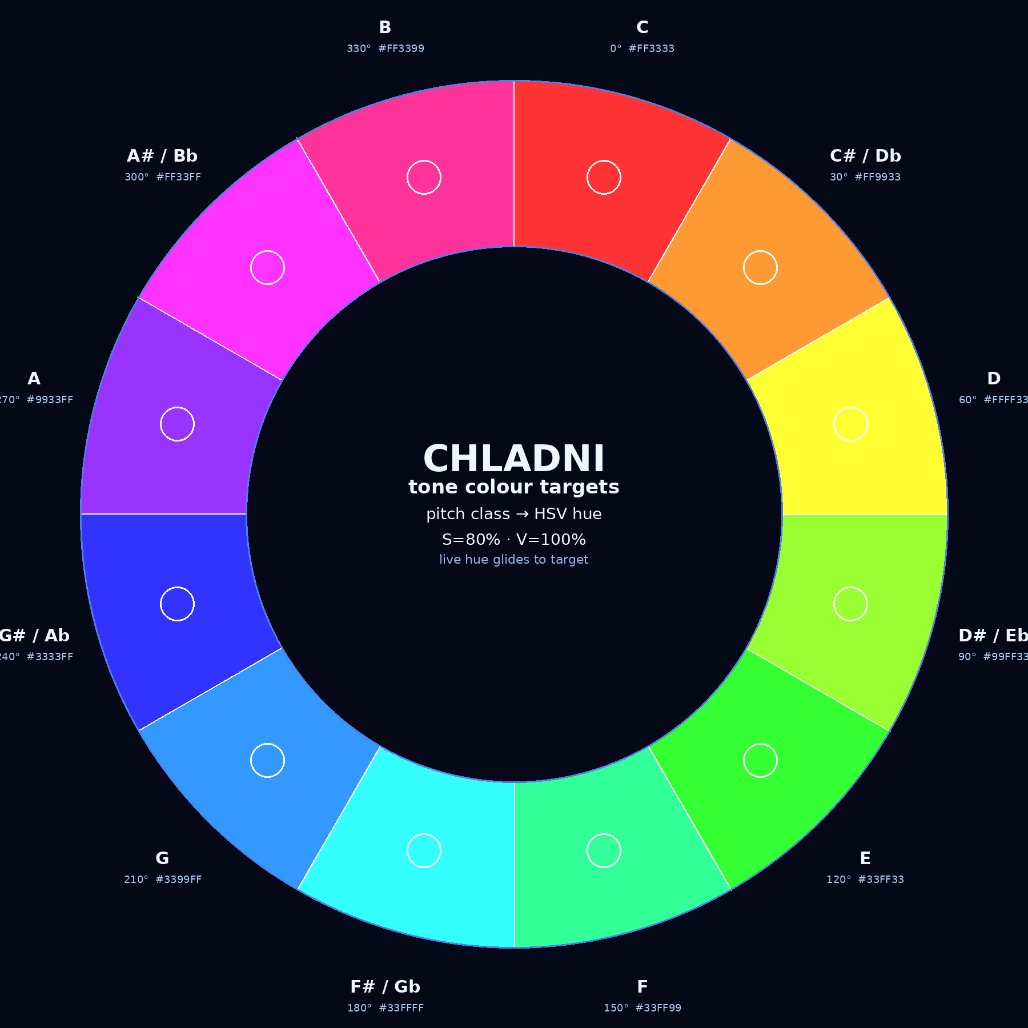
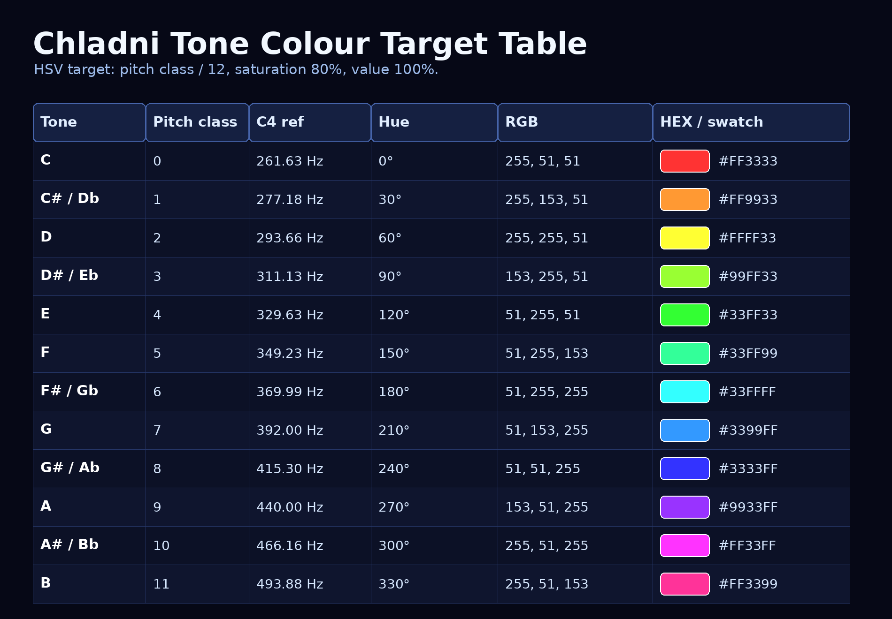
The wheel is a target map, not a frozen screenshot promise. If the dominant tone jumps from C to F#, the module moves the current hue toward F# smoothly. If the audio is weak, the hue holds instead of chasing garbage.

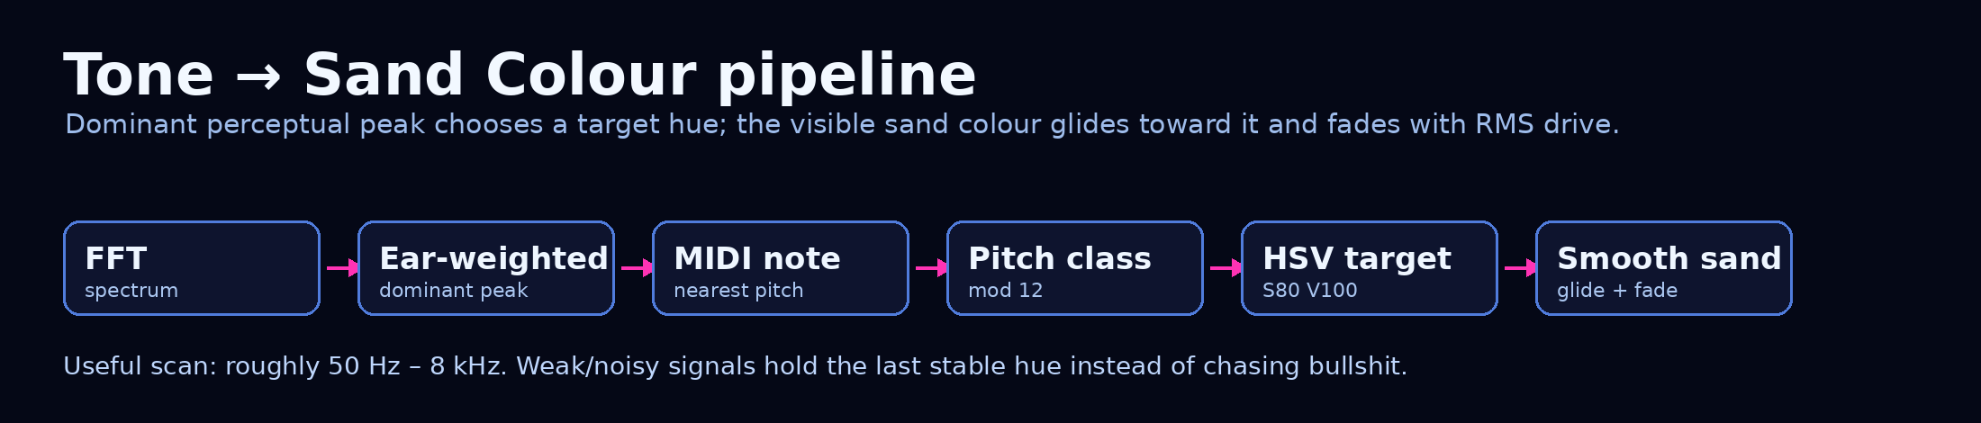
Basis: ALTER internal Chladni behaviour; standard 12-tone pitch-class mapping; perceptual peak weighting inspired by ISO 226 equal-loudness logic. This is product behaviour, not a delivery standard.

Chladni colour by tone sensitivity range
Chladni Tone Colour scans a practical musical window, not the entire frequency universe. The module searches for the dominant perceptually weighted peak roughly between 55 Hz and 8 kHz; if the signal is too weak or no clear peak exists, it holds the previous stable colour instead of letting random noise drive the sand like an idiot. The best tracking lives around 200 Hz–4 kHz, where pitch identity is usually clear and musically useful. Below that, the bass still works, but FFT resolution gets chunky, so note colour can feel less surgical. Above 4 kHz, the module may still react, but those peaks are often harmonics, hats, fizz, consonants or transient sparkle rather than clean fundamentals. In short: bass can be rough, mids are the money zone, highs are spicy but suspicious.

Material and aspect ratio: why the same note can become a different figure
A real plate does not resonate only because of pitch. Its material, stiffness, density, thickness and proportions matter. ALTER follows that idea: Material and Aspect Ratio change the resonance map, so the same audio frequency may land on a different mode.
Control | What it changes | Practical result
Material | The virtual plate stiffness / density / thickness relationship. | Same tone can choose a different mode. Aluminium, steel, glass and acrylic do not visually answer the same way.
Aspect Ratio | The plate proportions. | The geometry stretches and the resonance frequencies move. A square plate and a wide plate behave differently.
Mode Shift | A creative offset added to the audio-matched mode. | Keeps audio reactivity but pushes the figure into richer, higher-order patterns.

Mode Shift is not a new material and not a scientific delivery standard. It is a creative make-this-more-insane control. Use it when the audio is correct but the visual is too polite.

Real life mode: a real plate, not a formula
Everything above describes the classic model: one clean (m,n) figure, picked for you from a formula. Real life mode switches the formula off and puts a physically modelled plate on the table instead - the way the experiment is really done, with a tone generator, a shaker and a bag of sand.
The plate is a free square plate: all four edges free, exactly like a real Chladni plate. ALTER solves its vibration modes numerically - around 390 of them - with the Rayleigh-Ritz method, the same approach Walther Ritz used on Chladni's own plates in 1909. One frequency drives the plate at one point, and every single mode answers with its own resonance curve: loudly the modes whose resonance is close to the drive, quietly all the others. The sand then does what sand does - it runs from the motion and collects where the total movement is smallest.
This is the whole point of the mode: not every frequency makes a pretty picture. Exactly on a resonance you get a clean figure. A few cents off, it bends. Between resonances you get mixtures, smears, two lonely lines or restless noise. Finding the frequencies that draw something beautiful is the game - exactly like on the real plate.

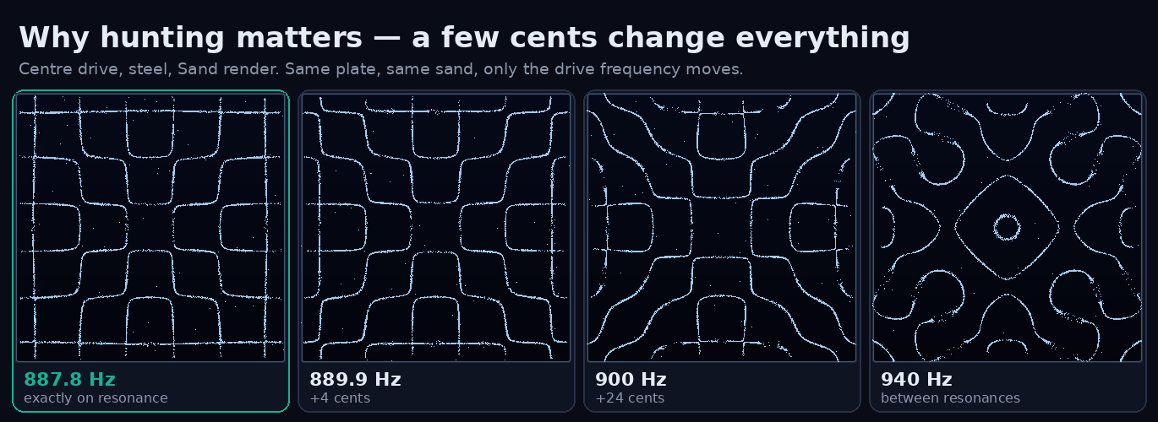
Same plate, same sand, only the drive frequency moves. On the resonance the figure is clean; a few cents away it starts to bend; between resonances it becomes a mixture of its neighbours.

The plate is always computed as a square. Stretch the module and the finished picture is simply stretched with it - the physics underneath does not change. That is also why Aspect Ratio, m, n, Preset and Shift disappear in this mode: they belong to the formula, not to the plate.
Translation: classic mode shows you the answer. Real life mode hands you the plate and the tone generator and lets you find the answers yourself.

Drive controls
Control | What it does | How to use it
Real life mode | Switches from the classic (m,n) formula to the physically modelled free square plate. | Off = classic figures chosen by the audio. On = the plate behaves like the real experiment.
Drive: Audio | The dominant, ear-weighted frequency of the audio drives the plate directly. It glides instead of snapping, so a glide in the music sweeps through the figures. | Sine tones, 808 slides, whistles and lead synths look great. A full mix gives a busy plate - just like a real plate would.
Drive: Manual | A virtual tone generator: Frequency plus Fine (+-50 cents). No audio needed - the plate keeps shaking on its own. | Pattern hunting, stills, screenshots, teaching.
< Resonance / Resonance > | Jumps to the previous / next resonance that the current drive point can actually excite (Manual drive). | The fastest way to browse the plate. Land on a resonance, then detune with Fine on purpose to watch the figure break.
Drive: Sweep | The plate hunts on its own: it glides up, stops for about 3 s on every resonance so the figure can form, moves on and wraps around at the top. | Self-running visual, background loop, or simply discovering which figures a plate has.
Drive point | Where the plate is excited: Centre (the classic shaker bolt), Off-centre, Edge (a violin bow - Chladni's own method) or Corner. | A mode with a nodal line running through the drive point cannot be excited there. Centre gives the symmetric classics; off-centre and corner unlock about four times as many resonances, many of them asymmetric.
Damping | How sharp the resonances are. Low = razor sharp, you must hit them exactly. High = soft resonances that bleed into their neighbours. | Start at 0.3. Go lower for purist hunting, higher when audio drives the plate and you want it smoother.
Material | Changes every resonance frequency (stiffness, density, thickness) and, through Poisson's ratio, slightly reshapes the figures too. | Glass sits roughly 4x higher than steel, aluminium and acrylic roughly 2x. Full lists in Appendix B.

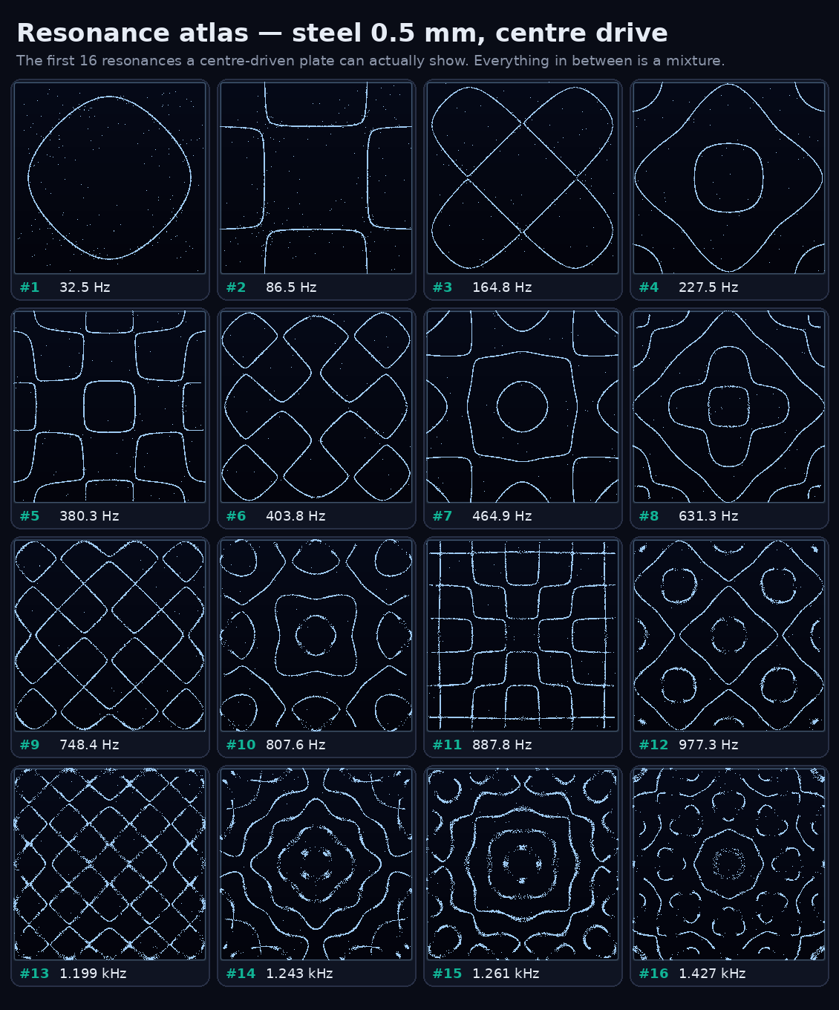
Resonance atlas: the first 16 figures a centre-driven steel plate can show. The full frequency lists for every material and drive point are in Appendix B.

Reading the overlay
In Real life mode the top-right overlay reads, for example, REAL manual 887.8 Hz res 887.8 Hz *. That is the drive source, the current drive frequency, the nearest resonance the drive point can excite, and how many cents you are away from it - a star means you are sitting right on it. If the overlay says above plate range, the drive frequency is higher than the model covers accurately (steel about 5.5 kHz, aluminium and acrylic about 11 kHz, glass about 22 kHz); the plate then holds its highest trustworthy state instead of inventing figures.

Render modes, grain size and brightness
Render decides how the plate is drawn, not how it behaves. The physics underneath is identical, and every render mode works in both the classic and the Real life model.
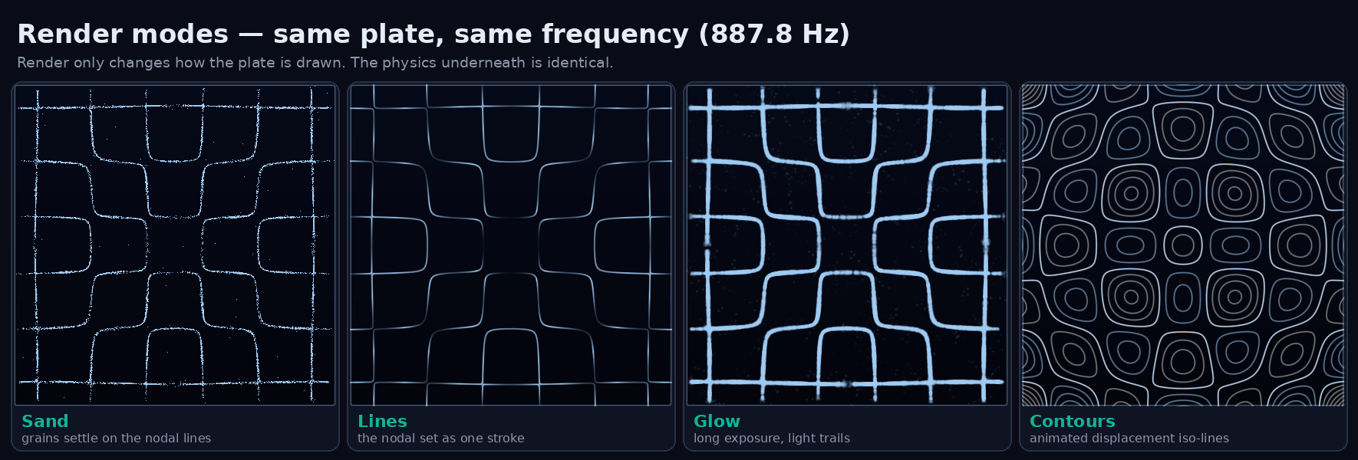
One plate, one frequency, four ways to draw it: Sand, Lines, Glow and Contours.

Control | What you see | When to use it
Render: Sand | One grain per particle, settling on the nodal lines. The original look. | Default. The most 'real experiment' feeling.
Render: Lines | The nodal lines as one continuous stroke, computed straight from the plate field - no particles. In Real life mode a line fades wherever the plate still moves out of phase, so it is clean on a resonance and broken off it. | Clean stage graphics, projection mapping, logo-like stills.
Render: Glow | Long exposure: the grains leave light trails that decay over about a second, so the figure builds up like a photo taken with an open shutter. | Moody, slower music; soft backgrounds.
Render: Contours | Iso-lines of the plate's displacement at this very instant, animated with the vibration - you watch the plate breathe. The zero line (the nodal line) is the brightest; positive and negative lobes get two tones. | Teaching: it shows the actual standing wave, not only where the sand ends up.
Grain size / Line width | 1-8 px. Grain diameter for Sand and Glow, stroke width for Lines and Contours (the label changes with the render mode). | 1 = the original single-pixel sand. 2-3 for projection or big screens.
Brightness | 0-2. Above 1 the colour also lifts toward white, and quiet passages still show the figure clearly. | Raise it for projectors and bright rooms; lower it when the module sits behind other visuals.

Particles and Sand Smooth only appear for Sand and Glow - Lines and Contours draw the field directly and have no grains to move.
Automation note: Real life mode, the drive controls, Render, Grain size and Brightness are controller-only for now - they are not exposed in the Creator plugin yet. The classic controls (Shift, Aspect Ratio, Sand Smooth, Particles, Material, m/n, colour) stay automatable as before.

How to actually use it
Situation | Best setup | What to watch | Do not do this
Live visuals / VJ set | Audio Reactive ON, Sand Smooth around 0.4-0.7, 5000-10000 particles, Color by Tone if the music is melodic. | Drops, builds and tonal changes should reshape the plate without turning into random glitter soup. | Do not crank particles to 15000 on every module and then act surprised when the computer starts sweating.
Sound design | Solo the source, lower Smooth, use fixed colour first, then try Color by Tone. | Fundamentals, filter sweeps and resonant peaks should move the mode family. | Do not treat it like a spectrum analyzer. It is a resonance visualizer, not an EQ microscope.
DJ prep / performance | Source Auto or selected track, Audio Reactive ON, moderate particles. | Track sections with different tonal centres will produce different geometric identities. | Do not expect every drum transient to create a new perfect figure. Chladni likes tone more than chaos.
Educational / beginner learning | Manual mode, presets, slow sand, lower particles. | Compare m/n pairs and notice how the line density changes. | Do not start with complex shifted modes. Learn the simple shapes first, then unleash the monster.
Audio engineering context | Use as visual energy/tone feedback beside Spectrum and Audio Meters. | Whether a sound is dominated by bass, mids or bright resonances. | Do not make mastering decisions from sand. Sand is poetic; LUFS is not.
Pattern hunting (Real life) | Real life mode ON, Drive Manual, Sand or Lines, Damping 0.2-0.4, then walk the plate with the Resonance buttons. | The star in the overlay, and the figure snapping clean when you land on a resonance. | Do not expect every frequency to draw something. That is not a bug - that is a plate.

But do whatever you like this is not a rule guideline just tips.

Reading the patterns
What you see | What it usually means | Useful action
Simple broad lines | Lower-order mode; usually a lower or simpler dominant tonal region. | Good for clean basses, simple tones and readable stage visuals.
Dense curved architecture | Higher-order mode or mode shift pushing complexity upward. | Good for aggressive synths, bright resonances and detailed visual texture.
Particles barely move | Low RMS drive or silence. | Raise source level, reduce smoothing, or accept the calm section. Not everything needs to scream.
Sand scatters then resettles | Mode change or strong audio movement. | This is the satisfying part. Let it breathe instead of smoothing it into soup.
Blank pattern | m = n in this model. | Choose a different m/n pair. The math cancelled itself, because math sometimes has attitude.
Permanent diagonal dominance | Square aspect ratios can make shared nodal structures visually strong. | Use mode shift, aspect ratio or particle refresh behaviour to keep the plate alive.
Real life: noise, smears or two stray lines | You are between resonances - several modes are mixing. | Press Resonance > / <, or nudge Fine until the overlay shows a star. Lower Damping for cleaner figures.
Real life: sand jitters everywhere, no lines | Very low frequency - the plate moves almost as one rigid piece. | Go up to the first resonances (see Appendix B).

Controls
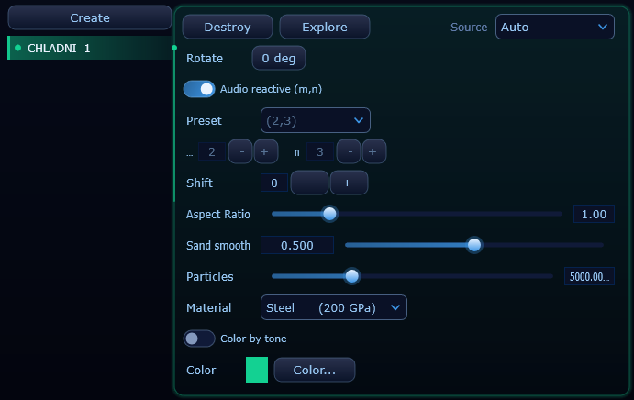
Controller view (classic mode): Audio Reactive, mode preset, m/n indices, Shift, Aspect Ratio, Sand Smooth, Particles, Material, Color by Tone and Color. Real life mode, Render, Grain size and Brightness sit in the same panel and are described in their own sections.

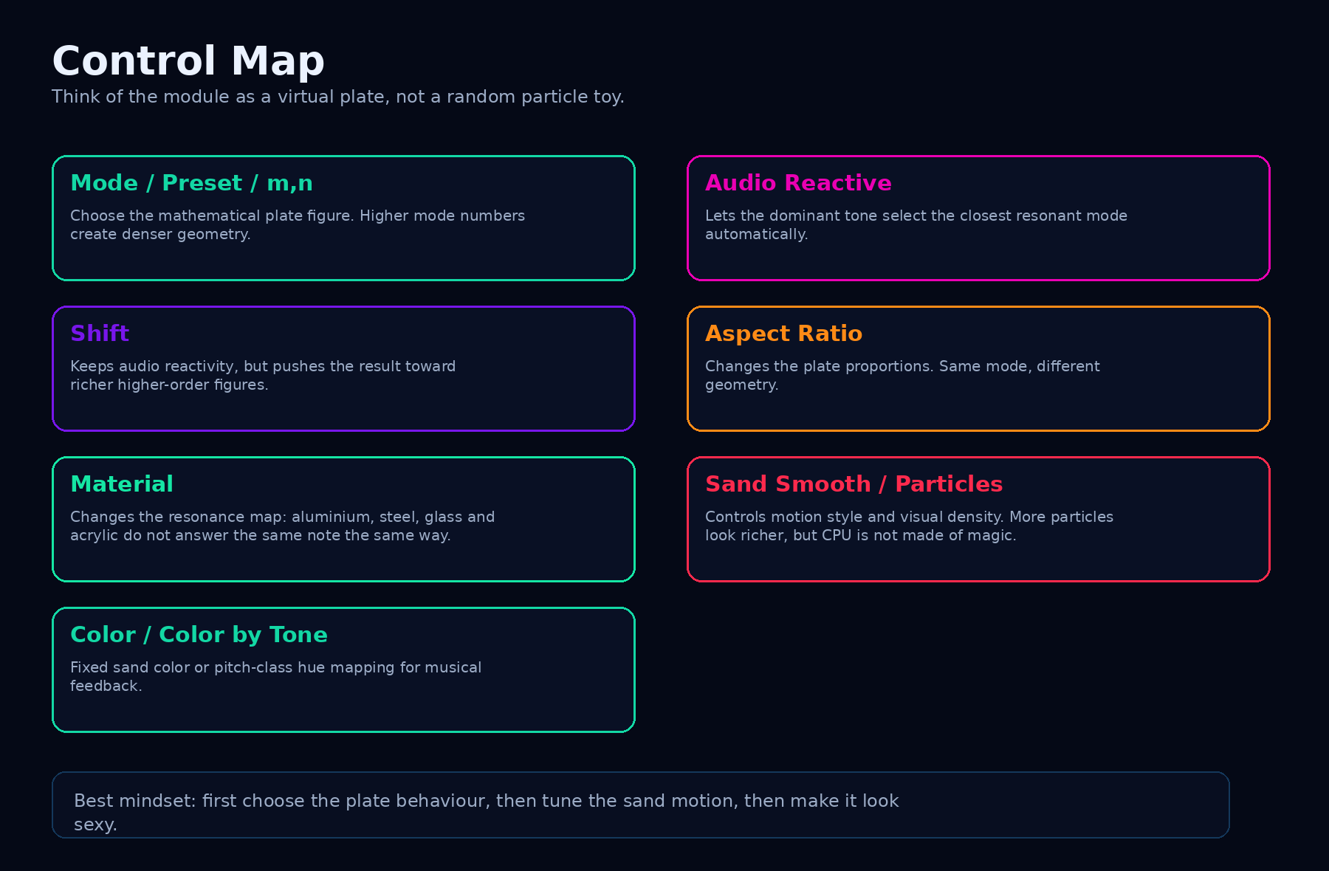
Every control changes one part of the virtual plate: mode, geometry, physical map, sand behaviour or colour response.

Control | What it does | How to use it
Source | Selects the audio source or automatic routing. | Use Auto for normal work. Choose a specific source when comparing plugin instances.
Rotate | Rotates the module visually. | Useful for custom layouts, stage projection and matching other modules.
Audio Reactive (m,n) | Automatically selects m/n based on the dominant audio frequency. | Keep ON for performance. Turn OFF when exploring manual figures.
Preset | Chooses classic m/n figures manually. | Use it for learning, screenshots and controlled visual design.
m / n | Manual mode indices from simple to complex patterns. | Higher values create denser figures. Avoid m = n unless you intentionally want blank.
Shift | Adds a creative offset to the matched mode in reactive mode. | Use it to make the same audio produce richer shapes.
Aspect Ratio | Changes the virtual plate proportions. | 1.00 is square. Wider or taller values change geometry and resonance mapping.
Sand Smooth | Controls grain movement style. | Low = fast nervous sand. High = slow elegant settling. Start around 0.5.
Particles | Sets grain count. | 1000-5000 for clean/cheap. 5000-10000 for rich visuals. 15000 when you want detail and can afford it.
Material | Changes the virtual resonance map. | Use as a character control: the same source can produce different figures.
Color by Tone | Maps the dominant pitch class to hue. | Great for melodic content and educational visuals. Less useful for noisy material.
Color | Fixed sand colour. | Use for visual identity, module grouping or a clean single-colour stage look.
Real life mode | Physically modelled free square plate instead of the (m,n) formula. | See the Real life mode section. Hides m/n, Preset, Shift and Aspect Ratio.
Drive / Frequency / Fine | What drives the real plate: audio, a manual tone generator, or an automatic sweep. | Manual + Resonance buttons for hunting; Sweep for a self-running visual.
Drive point / Damping | Where the plate is excited and how sharp its resonances are. | Change the drive point to unlock a new family of figures.
Render | Sand, Lines, Glow or Contours. | Pure look - does not change the physics.
Grain size / Line width | Grain diameter or stroke width, 1-8 px. | 1 for the classic fine sand.
Brightness | 0-2 visibility boost. | Above 1 for projection and quiet passages.

Scientific accuracy review
ALTER is not claiming to be a certified finite-element Chladni laboratory. It is a physically inspired, real-time rectangular plate model designed for visual performance and education.

ALTER now carries two plate models, and they deserve two different honest answers.
Classic mode uses a closed-form approximation (the Leissa-style cos-cos antisymmetric figure). It draws one pure (m,n) mode at a time and the audio chooses which. The shapes are genuine standing-wave geometry, but the frequencies come from a simplified resonance formula, and the figures of a real free plate are only approximated.
Real life mode is a genuine structural-mechanics model: a thin (Kirchhoff) free square plate, solved with the Rayleigh-Ritz method on a polynomial basis, driven at one point with a damped harmonic response summed over all modes. Its lowest frequencies match the published values for a free square plate, and the figures it draws are the ones the real experiment produces. What it does not know: the exact thickness tolerance of your plate, the mass and stiffness of a real shaker bolt, the air, or the sand bouncing off itself. Sand motion is modelled as grains hopping in proportion to the local vibration and drifting toward the nodal lines of the dominant standing wave - realistic behaviour, not a grain-collision simulation.
Accuracy limit: only the lowest ~30 % of the computed modes are kept, because the higher ones are artefacts of the truncated basis. That caps the trustworthy range at about 5.5 kHz for the 0.5 mm steel plate (higher for the other materials) - above it the overlay says so instead of inventing figures.

Common mistakes
Mistake | Why it sucks | Better move
Thinking the visible lines are the loudest places | They are nodal lines: low motion, not high motion. | Explain it as sand collecting where the plate is calm.
Using it as an EQ analyzer | It reacts to dominant tonal energy and plate modes, not exact tonal balance. | Use Spectrum for frequency decisions, Chladni for resonance visuals.
Expecting chords to produce one clean musical truth | A chord has multiple strong components. The module chooses a dominant driver. | Use it as a visual personality selector, not a music theory judge.
Over-cranking particles | More particles can look rich, but too many can become noisy or heavier on CPU. | Use the lowest count that still looks dense enough.
Ignoring material and aspect ratio | Those controls can completely change which mode a tone hits. | Use them as major creative controls, not tiny decorative settings.
Calling everything cymatics | The word is broader and less precise. | Use Chladni Patterns when talking about plate nodal-line figures.
Expecting every frequency to make a figure in Real life mode | A real plate only draws clean figures on its resonances. | Use the Resonance buttons, Sweep, or Appendix B to find them.

Final interpretation
Chladni Patterns is where ALTER stops behaving like a meter and starts behaving like a physical myth machine. The module takes real audio features - dominant frequency, level, pitch class - and translates them into a sand plate that breathes, scatters and settles.
For engineers, it is not a delivery standard. For artists, it is not random decoration. For beginners, it is one of the cleanest ways to understand resonance: sound can organize matter into shape. Or at least, in ALTER, it can organize thousands of glowing pixels into a very satisfying little sand ritual.
Use Spectrum when you need frequency truth. Use Audio Meters when you need level truth. Use Chladni Patterns when you want the sound to draw its own weird little sacred geometry - but with actual physics under the hood.

Sources and technical basis
ALTER internal Chladni Patterns module: real-time rectangular plate field, m/n mode selection, RMS-driven particle motion, perceptually weighted dominant frequency matching, material/aspect resonance mapping, mode shift, particle count, sand smoothing and colour-by-tone behaviour.
Ernst Chladni / Chladni figures: basis for the historical experiment where sand on a vibrating plate moves and concentrates along nodal lines at resonance.
A. W. Leissa, Vibration of Plates, NASA SP-160, 1969: reference basis for plate vibration modes and resonance behaviour in plate systems.
Plate vibration / Kirchhoff-Love plate theory: conceptual basis for treating thin vibrating plates as modal systems with standing-wave shapes and frequency-dependent modes.
ISO 226, Acoustics - Normal equal-loudness-level contours: basis for equal-loudness / Fletcher-Munson-style perceptual weighting used when deciding which spectral component should visually lead the mode selection.
W. Ritz, Theorie der Transversalschwingungen einer quadratischen Platte mit freien Rändern, Annalen der Physik 28 (1909): the original Rayleigh-Ritz solution of Chladni's free square plate - the method behind Real life mode.
M. J. Gander and G. Wanner, From Euler, Ritz, and Galerkin to Modern Computing, SIAM Review 54(4), 2012: modern walkthrough of Ritz's Chladni computation, including comparisons with Chladni's own drawings.
A. W. Leissa, Vibration of Plates (NASA SP-160), completely free square plate chapter: reference frequency parameters used to check the lowest computed modes.
Important limitation: this document describes ALTER product behaviour: a physically inspired real-time visualization model (classic mode) and a numerically solved thin-plate model (Real life mode). It is not a promise of laboratory calibration against a specific manufactured plate.

Appendix A - Audio-Reactive Chladni Mode Selection Table
Default reference: Steel 0.5 mm, Aspect Ratio 1.00, Shift 0. The table shows which matched (m,n) family is selected when the dominant perceptually weighted frequency falls into that range. This is the pre-shift selection: if Shift is +2, a matched (2,4) is displayed as approximately (4,6).
Important: this is not a musical-note law or a delivery standard. It is the default internal resonance map. Material and Aspect Ratio bend the map; audio level drives motion; dominant frequency chooses the family. In other words: pitch chooses the geometry, loudness shakes the sand.

Material multipliers
Material preset | Multiplier vs Steel | What it means
Steel 0.5 mm | x1.00 | Reference map
Aluminium 1.0 mm | x2.05 | Same mode family appears at about 2.05x the Steel frequency
Acrylic 3.0 mm | x2.02 | Same mode family appears at about 2.02x the Steel frequency
Glass 2.0 mm | x4.11 | Same mode family appears at about 4.11x the Steel frequency

Default Steel / AR 1.00 / Shift 0 selection ranges
Matched mode (m,n) | m^2+n^2 | Theoretical resonance | Dominant frequency range
(1,2) | 5 | 66.4 Hz | 55.0 Hz - 94.0 Hz
(1,3) | 10 | 133 Hz | 94.0 Hz - 152 Hz
(2,3) | 13 | 173 Hz | 152 Hz - 198 Hz
(1,4) | 17 | 226 Hz | 198 Hz - 245 Hz
(2,4) | 20 | 266 Hz | 245 Hz - 297 Hz
(3,4) | 25 | 332 Hz | 297 Hz - 339 Hz
(1,5) | 26 | 345 Hz | 339 Hz - 365 Hz
(2,5) | 29 | 385 Hz | 365 Hz - 417 Hz
(3,5) | 34 | 452 Hz | 417 Hz - 471 Hz
(1,6) | 37 | 492 Hz | 471 Hz - 511 Hz
(2,6) | 40 | 532 Hz | 511 Hz - 538 Hz
(4,5) | 41 | 545 Hz | 538 Hz - 571 Hz
(3,6) | 45 | 598 Hz | 571 Hz - 630 Hz
(1,7) | 50 | 664 Hz | 630 Hz - 678 Hz
(4,6) | 52 | 691 Hz | 678 Hz - 698 Hz
(2,7) | 53 | 704 Hz | 698 Hz - 737 Hz
(3,7) | 58 | 771 Hz | 737 Hz - 790 Hz
(5,6) | 61 | 811 Hz | 790 Hz - 837 Hz
(1,8), (4,7) | 65 | 864 Hz | 837 Hz - 883 Hz
(2,8) | 68 | 904 Hz | 883 Hz - 936 Hz
(3,8) | 73 | 970 Hz | 936 Hz - 977 Hz
(5,7) | 74 | 983 Hz | 977 Hz - 1.02 kHz
(4,8) | 80 | 1.06 kHz | 1.02 kHz - 1.08 kHz
(1,9) | 82 | 1.09 kHz | 1.08 kHz - 1.11 kHz
(2,9), (6,7) | 85 | 1.13 kHz | 1.11 kHz - 1.16 kHz
(5,8) | 89 | 1.18 kHz | 1.16 kHz - 1.19 kHz
(3,9) | 90 | 1.20 kHz | 1.19 kHz - 1.24 kHz
(4,9) | 97 | 1.29 kHz | 1.24 kHz - 1.31 kHz
(6,8) | 100 | 1.33 kHz | 1.31 kHz - 1.34 kHz
(1,10) | 101 | 1.34 kHz | 1.34 kHz - 1.36 kHz
(2,10) | 104 | 1.38 kHz | 1.36 kHz - 1.40 kHz
(5,9) | 106 | 1.41 kHz | 1.40 kHz - 1.43 kHz
(3,10) | 109 | 1.45 kHz | 1.43 kHz - 1.47 kHz
(7,8) | 113 | 1.50 kHz | 1.47 kHz - 1.52 kHz
(4,10) | 116 | 1.54 kHz | 1.52 kHz - 1.55 kHz
(6,9) | 117 | 1.55 kHz | 1.55 kHz - 1.59 kHz
(1,11) | 122 | 1.62 kHz | 1.59 kHz - 1.64 kHz
(2,11), (5,10) | 125 | 1.66 kHz | 1.64 kHz - 1.69 kHz
(3,11), (7,9) | 130 | 1.73 kHz | 1.69 kHz - 1.77 kHz
(6,10) | 136 | 1.81 kHz | 1.77 kHz - 1.81 kHz
(4,11) | 137 | 1.82 kHz | 1.81 kHz - 1.87 kHz
(1,12), (8,9) | 145 | 1.93 kHz | 1.87 kHz - 1.93 kHz
(5,11) | 146 | 1.94 kHz | 1.93 kHz - 1.95 kHz
(2,12) | 148 | 1.97 kHz | 1.95 kHz - 1.97 kHz
(7,10) | 149 | 1.98 kHz | 1.97 kHz - 2.01 kHz
(3,12) | 153 | 2.03 kHz | 2.01 kHz - 2.06 kHz
(6,11) | 157 | 2.09 kHz | 2.06 kHz - 2.11 kHz
(4,12) | 160 | 2.13 kHz | 2.11 kHz - 2.15 kHz
(8,10) | 164 | 2.18 kHz | 2.15 kHz - 2.21 kHz
(5,12) | 169 | 2.25 kHz | 2.21 kHz - 2.25 kHz
(7,11) | 170 | 2.26 kHz | 2.25 kHz - 2.32 kHz
(6,12) | 180 | 2.39 kHz | 2.32 kHz - 2.40 kHz
(9,10) | 181 | 2.41 kHz | 2.40 kHz - 2.43 kHz
(8,11) | 185 | 2.46 kHz | 2.43 kHz - 2.51 kHz
(7,12) | 193 | 2.56 kHz | 2.51 kHz - 2.62 kHz
(9,11) | 202 | 2.68 kHz | 2.62 kHz - 2.72 kHz
(8,12) | 208 | 2.76 kHz | 2.72 kHz - 2.85 kHz
(10,11) | 221 | 2.94 kHz | 2.85 kHz - 2.96 kHz
(9,12) | 225 | 2.99 kHz | 2.96 kHz - 3.11 kHz
(10,12) | 244 | 3.24 kHz | 3.11 kHz - 3.38 kHz
(11,12) | 265 | 3.52 kHz | 3.38 kHz - 8.00 kHz
How to read duplicate mode entries: families such as (1,8) and (4,7) share the same m^2+n^2 value at AR 1.00, so they live at the same theoretical resonance. In product language, treat them as one resonance family, not as two different pitch targets.
Why the first and last ranges are wide: the reactive detector listens roughly from 55 Hz to 8 kHz for a meaningful dominant driver. Below that, rumble can dominate without producing useful mode movement; above that, the pattern would turn into nervous glitter instead of readable Chladni geometry.
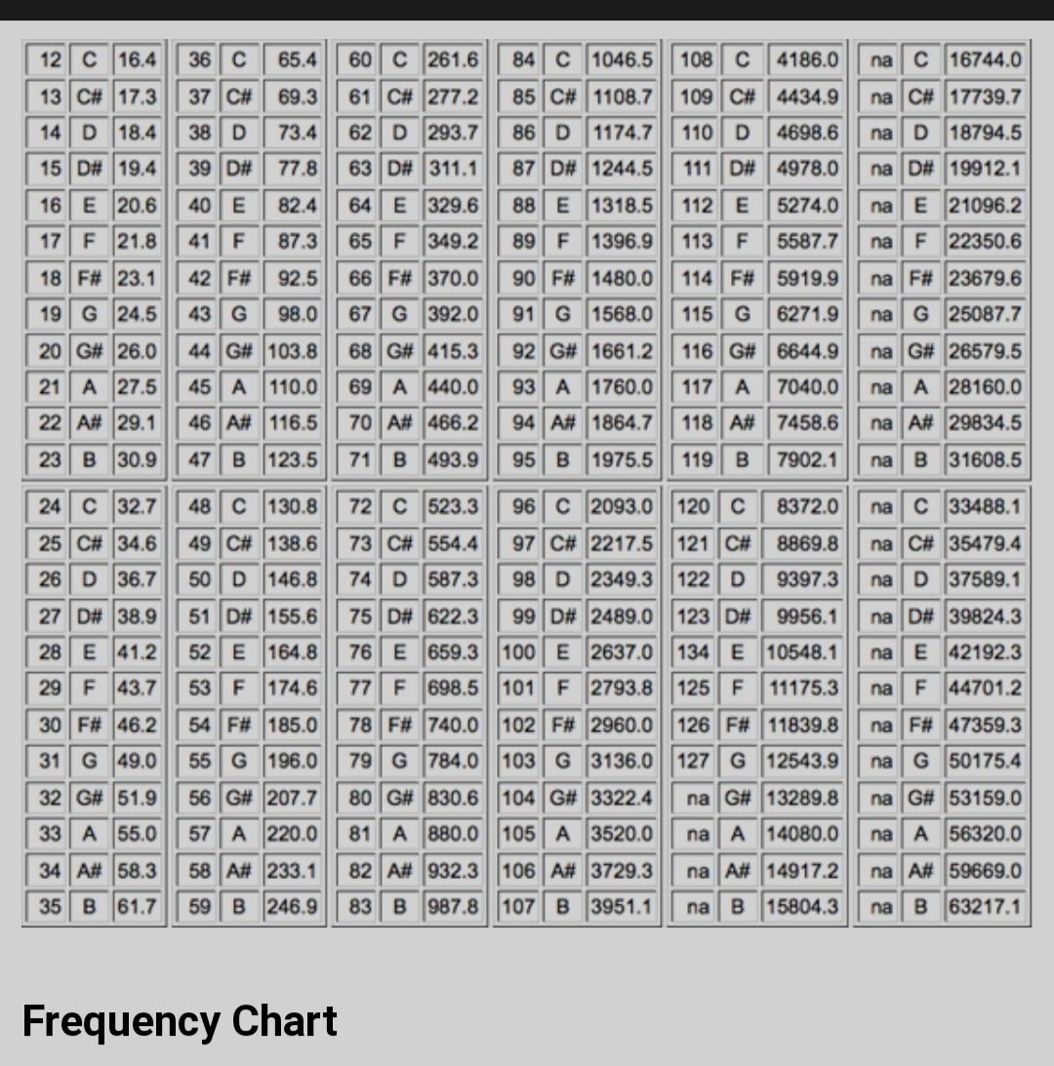

Appendix B - Real Life Mode Resonance Tables
Plate: free square plate, 30 x 30 cm, all edges free. Materials as in the Material control: Aluminium 1.0 mm, Steel 0.5 mm, Glass 2.0 mm, Acrylic 3.0 mm. Values are the resonances the given drive point can actually excite - modes with a nodal line through the drive point are left out, because on a real plate they would not appear there either. Nearly identical (degenerate) pairs are listed once.
How to use it: switch Drive to Manual, type the frequency into Frequency (or walk there with the Resonance buttons) and let the sand settle. Low entries are broad, simple figures; the figures get denser as you climb. Everything between two entries is a mixture - sometimes ugly, sometimes surprisingly beautiful.

Steel 0.5 mm - first 20 resonances per drive point
# | Centre | Off-centre | Edge | Corner
1 | 32.5 Hz | 18.4 Hz | 26.7 Hz | 18.4 Hz
2 | 86.5 Hz | 26.7 Hz | 32.5 Hz | 32.5 Hz
3 | 164.8 Hz | 32.5 Hz | 47.3 Hz | 47.3 Hz
4 | 227.5 Hz | 47.3 Hz | 82.4 Hz | 82.4 Hz
5 | 380.3 Hz | 82.4 Hz | 86.5 Hz | 86.5 Hz
6 | 403.8 Hz | 86.5 Hz | 143.0 Hz | 104.0 Hz
7 | 464.9 Hz | 104.0 Hz | 164.8 Hz | 143.0 Hz
8 | 631.3 Hz | 143.0 Hz | 177.5 Hz | 164.8 Hz
9 | 748.4 Hz | 158.2 Hz | 218.7 Hz | 177.5 Hz
10 | 807.6 Hz | 164.8 Hz | 227.5 Hz | 207.1 Hz
11 | 887.8 Hz | 177.5 Hz | 267.3 Hz | 227.5 Hz
12 | 977.3 Hz | 207.1 Hz | 291.4 Hz | 267.3 Hz
13 | 1.199 kHz | 218.7 Hz | 328.1 Hz | 288.2 Hz
14 | 1.243 kHz | 267.3 Hz | 380.3 Hz | 291.4 Hz
15 | 1.261 kHz | 276.0 Hz | 396.2 Hz | 328.1 Hz
16 | 1.427 kHz | 288.2 Hz | 403.8 Hz | 380.3 Hz
17 | 1.607 kHz | 291.4 Hz | 413.9 Hz | 403.2 Hz
18 | 1.700 kHz | 328.1 Hz | 454.4 Hz | 413.9 Hz
19 | 1.757 kHz | 380.3 Hz | 464.9 Hz | 464.9 Hz
20 | 1.814 kHz | 394.8 Hz | 492.1 Hz | 492.1 Hz

Centre drive - first 20 resonances per material
# | Aluminium 1.0 mm | Steel 0.5 mm | Glass 2.0 mm | Acrylic 3.0 mm
1 | 67.2 Hz | 32.5 Hz | 132.1 Hz | 66.7 Hz
2 | 173.0 Hz | 86.5 Hz | 364.2 Hz | 167.4 Hz
3 | 337.3 Hz | 164.8 Hz | 676.9 Hz | 332.6 Hz
4 | 461.6 Hz | 227.5 Hz | 943.9 Hz | 451.7 Hz
5 | 768.2 Hz | 380.3 Hz | 1.586 kHz | 749.2 Hz
6 | 825.8 Hz | 403.8 Hz | 1.661 kHz | 813.7 Hz
7 | 946.9 Hz | 464.9 Hz | 1.920 kHz | 929.8 Hz
8 | 1.281 kHz | 631.3 Hz | 2.619 kHz | 1.254 kHz
9 | 1.530 kHz | 748.4 Hz | 3.079 kHz | 1.507 kHz
10 | 1.647 kHz | 807.6 Hz | 3.330 kHz | 1.619 kHz
11 | 1.801 kHz | 887.8 Hz | 3.685 kHz | 1.764 kHz
12 | 1.988 kHz | 977.3 Hz | 4.042 kHz | 1.952 kHz
13 | 2.450 kHz | 1.199 kHz | 4.935 kHz | 2.412 kHz
14 | 2.527 kHz | 1.243 kHz | 5.147 kHz | 2.479 kHz
15 | 2.574 kHz | 1.261 kHz | 5.196 kHz | 2.532 kHz
16 | 2.908 kHz | 1.427 kHz | 5.891 kHz | 2.857 kHz
17 | 3.266 kHz | 1.607 kHz | 6.656 kHz | 3.203 kHz
18 | 3.460 kHz | 1.700 kHz | 7.030 kHz | 3.396 kHz
19 | 3.592 kHz | 1.757 kHz | 7.232 kHz | 3.539 kHz
20 | 3.704 kHz | 1.814 kHz | 7.472 kHz | 3.645 kHz

Model range and counts
Material | Accurate up to | Resonances (centre drive) | Resonances (off-centre)
Aluminium 1.0 mm | about 11.3 kHz | 50 | 208
Steel 0.5 mm | about 5.5 kHz | 51 | 210
Glass 2.0 mm | about 22.8 kHz | 48 | 204
Acrylic 3.0 mm | about 11.1 kHz | 50 | 216

Important: these are the model's resonances, not a promise about a specific manufactured plate. A real plate of the same size and material will land close, but thickness tolerance and the mounting shift real frequencies by a few percent. The order and the shapes of the figures are what stay the same.

