ALTER
Audio Meters
See the Sound Before It Breaks
Four metering modes, four different truths about the same signal.
RMS reads body. LUFS reads perceived loudness. True Peak reads the ceiling. Level History reads movement over time.

Audio Meters module is the diagnostic core of ALTER's visual system. It transforms raw audio energy into a readable, high-resolution visual trace, showing how your signal behaves over time - not only how loud it is, but what kind of loud it is.
A track can look safe but still clip. A master can feel loud but measure weak. A drop can sound massive, but its peaks may be hitting the ceiling like a brick thrown at glass.
Audio Meters gives you four different ways to understand that behaviour: RMS, LUFS, True Peak and Level History. These are not four different skins. They are four different ways of reading the same sound.

Visual Overview and What Audio Meters Actually Measure

RMS Mode - Average Energy / The Weight of the Signal
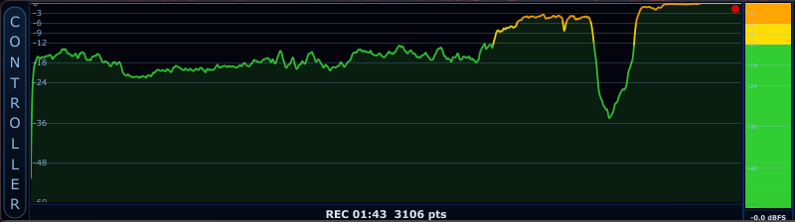
RMS mode visualizes the average energy of the signal - the continuous body and pressure of the sound.
RMS shows the continuous energy of the signal. It is not obsessed with tiny transient spikes. Instead, it tells you how strong the audio feels over time.
Ask RMS: "How much body does this sound have?"
For DJs, RMS helps reveal whether one track will feel weaker or stronger than the next. For producers, it shows whether a bassline, drum group or full mix has stable energy. For beginners, this is probably the easiest loudness concept to understand: RMS is the muscle of the sound.
RMS stands for Root Mean Square. The name sounds mathematical as hell, but the idea is simple: RMS measures the average energy of the waveform.
A waveform moves up and down very fast. If we simply averaged the raw waveform, the positive and negative parts would cancel each other out. RMS avoids that by measuring the signal's energy instead.
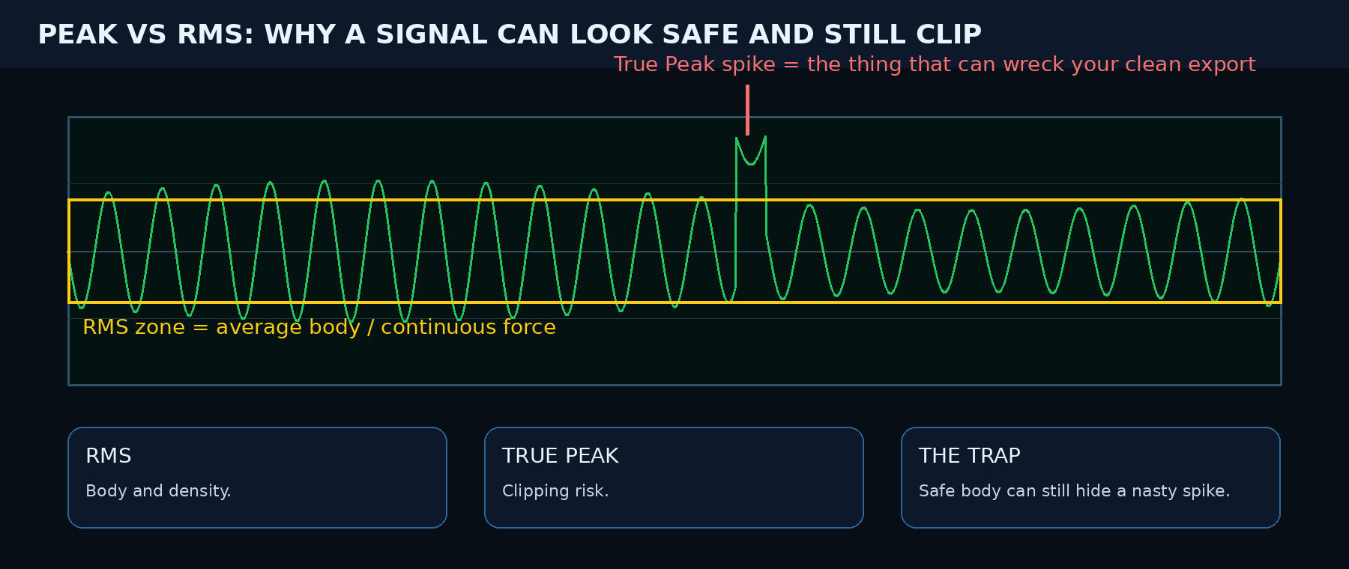
A short peak can be dangerous while the RMS body remains moderate. Peak and RMS can disagree. That disagreement is not a bug; it is the whole point of having multiple meters.
A short click can have a high peak but low RMS. A sustained bass drone can have high RMS because it keeps pushing energy for a long time. That is why RMS is excellent for understanding musical density.

LUFS Mode - Loudness the Way Humans Feel It
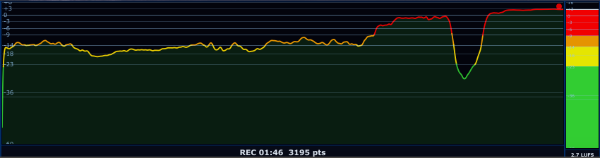
LUFS mode follows perceived loudness, helping you understand how loud the signal feels to human hearing.
LUFS means Loudness Units Full Scale…okay? It tries to answer a more human question: how loud does this actually feel to the ear?
This matters because human hearing is not linear. A low bass tone and a sharp midrange sound can have the same electrical level, but they will not feel equally loud. LUFS uses perceptual weighting to make loudness measurement closer to how we actually experience sound.
If the LUFS trace climbs into the red zone and stays there, that does not automatically mean better or more powerful. It may mean the mix is being smashed to hell and has no breathing room left.
ALTER uses a responsive loudness model based around perceptual weighting and a short loudness window. In simple language: the signal is filtered in a way that reflects how human ears respond to frequency, then its energy is measured over time.
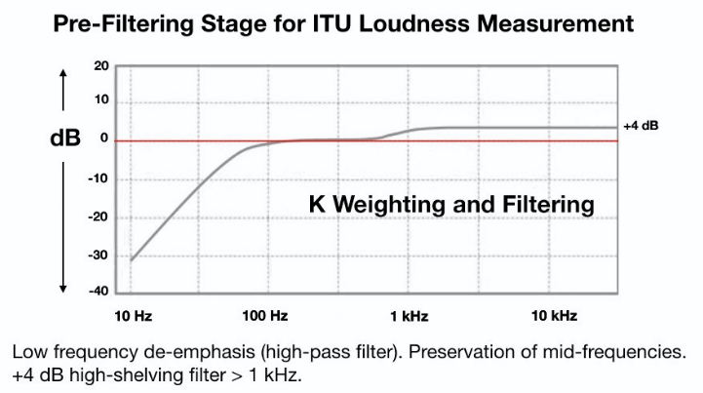

LUFS does not only ask how strong the waveform is. It asks how loud it will feel to a listener.
A track can have safe peaks and still feel painfully loud. Another track can peak high but feel quieter because the energy is not distributed in the same way. LUFS helps reveal that difference.

True Peak Mode - Maximum Peak / The Digital Ceiling Detection
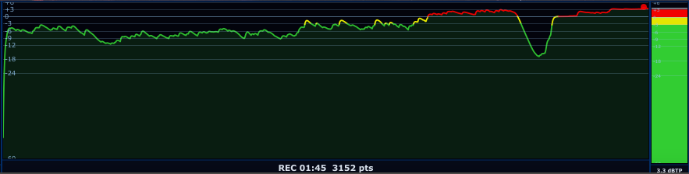
True Peak mode exposes dangerous peak behaviour and clipping risk before it becomes a problem.
True Peak shows the highest peak level in the signal (highest point of the waveform). This is the mode for the brutal truth.
Ask True Peak: "Is the signal hitting the digital ceiling?"
It does not care whether the track feels loud, warm, emotional, aggressive, cinematic or beautiful. It asks only whether the signal is at risk of clipping. Peak detection is critical because clipping can happen even when average loudness looks fine.
True Peak goes further by estimating peaks that can occur between digital samples when audio is reconstructed by converters, streaming encoders or playback systems. These are called inter-sample peaks.
That matters because a signal may look like it stays below 0 dBFS in the DAW, but after conversion or encoding, it can still clip.

Understanding the Color Zones
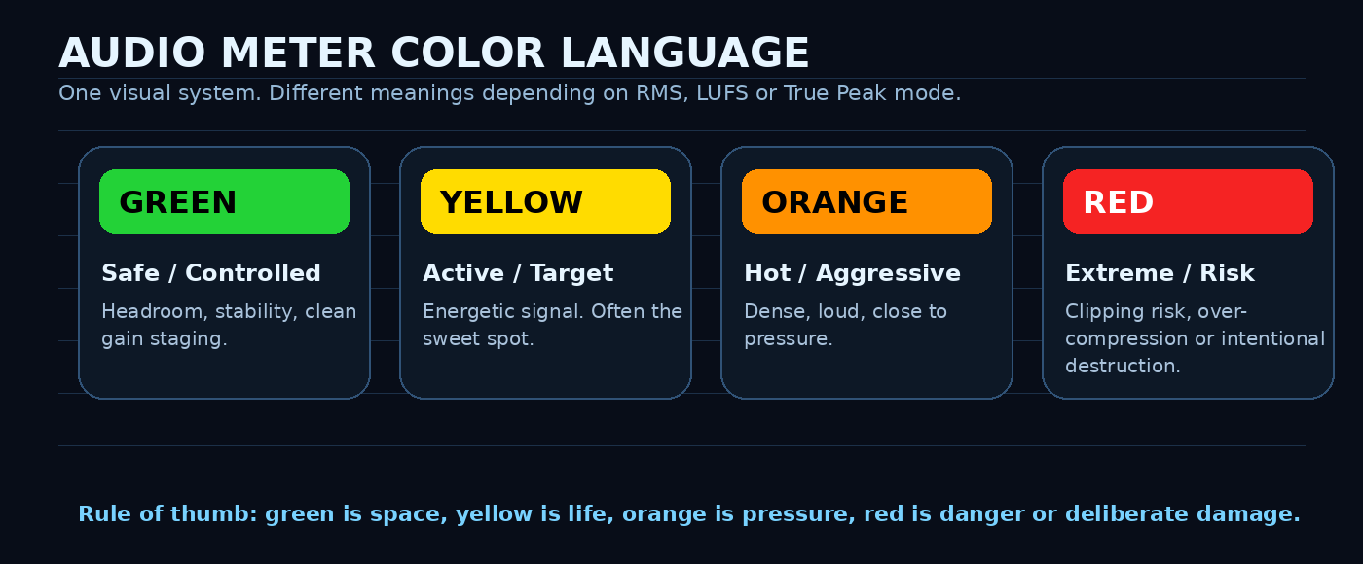
The color system turns technical level data into instant visual language.

Green - Safe / Controlled
Green means the signal is operating with comfortable headroom. In professional audio, green often means you still have space to shape the sound.

Yellow - Active / Target Zone
Yellow means the signal is becoming more intense. For many tracks, yellow is the sweet spot: present, alive and pushing forward.

Orange - Hot / Aggressive
Orange means the sound is getting loud, dense or close to the limit. This can be intentional, especially in EDM, techno, trap, industrial or aggressive sound design, but it should be watched carefully.

Red - Extreme / Clipping Risk
Red means danger. In LUFS mode, red can mean extreme loudness or over-compression. In RMS mode, red can mean very high average energy. In True Peak mode, red can mean clipping or near-clipping.
Red is not automatically forbidden. Sometimes you want destruction. But if the red zone is constantly active and you did not intend it, the sound is probably not big. It is probably just fucked.

How to actually use the meter

While producing
Watch RMS to see whether the part has real body. If the bass, pads or distorted layers keep pushing RMS up, they may be eating headroom even when they do not feel obvious in the room.

While mixing
Use RMS for density balance, LUFS for perceived loudness balance, True Peak for headroom safety and Level History for movement over time. Do not fix everything by turning it down. First ask what is causing the energy: sub, low-mid mud, compression, limiting, transient spikes or slow pumping across the phrase.

While mastering
LUFS and True Peak become the main pair. LUFS tells you how loud the master feels; True Peak tells you whether it survives export and encoding. A louder master that gets turned down by streaming can still sound worse if you destroyed the punch to get there.

While DJing or preparing live sets
Use RMS and LUFS to compare tracks before transitions, and switch to Level History when you want to see how the energy moves across the build, drop or breakdown. Two tracks can hit similar peaks while one feels weak as hell because the body is not there. That is exactly the kind of mismatch Audio Meters makes visible.

While sound designing
Use the meter as a force scanner. Impacts, risers, drones, distorted textures and cinematic hits all draw different energy shapes. If the sound is meant to punch, True Peak will show the strike. If it is meant to pressure the room, RMS and LUFS will show the weight.

Targets and working ranges
This is the part that matters in real work: not only what the meters are, but what the hell you should do with the numbers. Treat the exact broadcast and platform values as standards or platform references. Treat the genre values as working zones, not laws. A great master is not a spreadsheet achievement; it is a sound that keeps impact, clarity and emotion after playback normalization.

Platform and delivery references
Delivery context | Useful target | True Peak ceiling | Meaning
EBU broadcast / TV | -23 LUFS integrated | <= -1 dBTP | Compliance-oriented broadcast target. Clean, controlled, not club-loud.
Spotify normal playback reference | -14 LUFS | <= -1 dBTP | Spotify applies negative gain to louder masters and references normal playback around -14 LUFS.
Streaming-safe general master | around -14 LUFS | <= -1 dBTP | A safe cross-platform starting point. Not a creative law.
Very loud modern master | -10 to -6 LUFS depending on genre | often -1 to -2 dBTP | Can work for EDM, trap, metal and club music, but streaming will turn it down. If punch dies, you pushed too far.

Use standards for delivery, and genre zones for creative decisions. Never confuse the two.

Genre working zones
There is no official LUFS target for a genre. Anyone pretending there is one is selling you fake certainty. But genres do have real-world loudness habits. Use these as starting points, then listen after level matching. If the louder version loses punch when matched, it is not better - it is just louder before normalization.
Genre / use | LUFS working zone | RMS feeling | True Peak advice | What to watch
Classical / jazz / acoustic | -18 to -14 LUFS | Low to medium | <= -1 dBTP | Dynamics are the music. Do not crush the room and transients.
Ambient / cinematic / soundtrack | -20 to -13 LUFS | Varies widely | <= -1 dBTP | Silence and space matter. Watch huge impact peaks.
Pop / R&B / modern rock | -12 to -9 LUFS | Medium to high | <= -1 dBTP | Keep vocal forward without flattening the chorus.
Hip-hop / trap | -10 to -7 LUFS | High | -1 to -2 dBTP | 808/sub energy can lie to LUFS. Check translation on small speakers.
EDM / techno / DnB / club | -9 to -6 LUFS | Very high | -1 to -2 dBTP | If the drop loses punch after limiting, back the fuck off.
DJ tools / aggressive club masters | -8 to -5 LUFS | Extreme | -2 dBTP safer | Use intentionally. This is density warfare, not clean hi-fi mastering.

Important: streaming normalization is not a punishment
If your master is louder than the platform reference, the platform usually turns it down. The real penalty is not the gain reduction itself. The real penalty is when you destroy punch, transient detail and depth just to make the pre-normalized file look louder.

Level History Mode - peak outside, RMS inside
RMS tells you how heavy the sound is. LUFS tells you how loud it feels. True Peak tells you if it is about to break. Level History tells you how that whole mess moves across time.

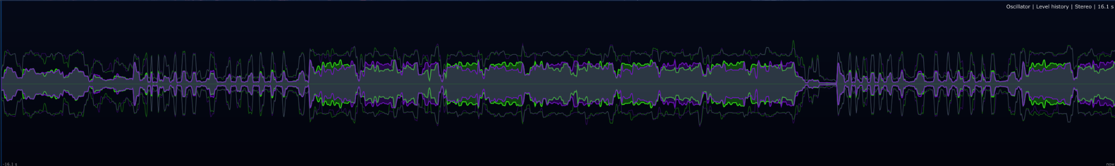
Level History visualizes how peak energy and body move across a selectable time window from 0.1 to 30 seconds. (The colors on picture are for L and R channel - stereo mode)
Level History is where the module becomes brutally useful for mixing and mastering. It shows two layers: the outer silhouette represents peak movement, while the inner body represents RMS energy. The visual gap between them is basically the story of punch versus density. Big gap = punch, Tiny gap = density and limiting.
When the peak outline is much larger than the RMS body, the sound has transients and headroom. When the outline and RMS body start hugging each other, the sound is getting dense, compressed or limited. That can be exactly what you want in club music. It can also mean you are building a beautiful sausage and calling it a master.
Ask Level History: "How does the energy move over the last moment, phrase or build-up?"
This is especially useful when a static number is not enough. A compressor can pump rhythmically. A limiter can clamp only during the drop. A breakdown can feel empty because the body disappears, not because the peak is low. Level History catches that motion. It is basically the meter saying: "look, the problem happened five seconds ago, not only right now."
What you see | Likely meaning | What to do
Big peak outline, smaller RMS core | Punchy material with transients and space. | Great for drums, impacts and dynamic masters. Just watch final peaks elsewhere.
Peak outline and RMS core close together | Dense or heavily limited signal. | Can work for aggressive genres. If punch died, back the limiter off.
Waveform constantly wide for the whole section | Sustained pressure, compression, distortion or low-end buildup. | Check bass, low-mids and bus compression. The room may be getting bullied.
Shape pumps up and down rhythmically | Compressor/limiter pumping or sidechain movement. | Good if intentional. Bad if the whole mix ducks like it is seasick.
One channel consistently larger | Stereo imbalance, panning issue, M/S artifact or intentional width. | Check balance and mono compatibility.

Important: Level History is not a new broadcast or streaming loudness standard. There is no official target like "-14 Level History". Here would be nonsense wearing a lab coat. Treat it as a visual behaviour mode: you are reading energy flow, not trying to hit a delivery number.
In one sentence, RMS tells you how much body exists and Level History tells you whether that body is breathing, fighting, collapsing or being crushed by a limiter with anger issues.

Summary

What the Meter Reveals Immediately
- hidden clipping
- unstable loudness
- over-compression
- weak drops
- excessive RMS buildup
- too much limiter pressure
- tracks that feel mismatched in DJ sets
- masters that are loud but lifeless
- transient spikes that eat headroom
- sections that collapse in energy

Controls

Mode
Switches between RMS, LUFS, True Peak and Level History. Each mode changes the meaning of the meter. RMS reads body, LUFS reads perceived loudness, True Peak reads the ceiling, and Level History reads how that energy moves through time.

Smooth
Controls how quickly the meter reacts. Low smoothing gives a faster, more nervous response. High smoothing gives a slower, more elegant movement. For technical monitoring, faster response can reveal details. For live visuals, smoother response often looks better.

Color Mode
Changes the visual color behaviour of the meter in the standard RMS / LUFS / True Peak views. When Level History is selected, the panel simplifies to its own timeline controls: Display, Window Length and Color.

Level History controls
When Mode is set to Level History, the control panel changes because you are no longer reading a single meter value. You are shaping a timeline view. The available controls become Display, Window Length and Color.
Control in Level History | Options / range | What it is for
Display | Mono / Stereo / Mirror / Mirror Stereo | Choose whether the history is technical, stereo-aware or performance-focused. Mono is clean; Stereo compares channels; Mirror looks stronger on stage; Mirror Stereo gives stereo movement with mirrored visual impact.
Window Length | 0.1 s to 30 s | Short windows show fast pumping and hits. Long windows show phrases, build-ups, breakdowns and track energy flow.
Color | Module color | Sets the visual identity of the timeline mode, useful when multiple meters are open or when building a live visual layout.

Final Interpretation
Audio Meters are not just a loudness meter. It is a translation layer between audio physics and visual perception.
It shows how the sound behaves, how it feels and when it becomes dangerous my friend. For DJs, it helps with track balance. For engineers, it protects headroom. For producers, it reveals density. For sound designers, it exposes the shape and force of sound.
You should not have to guess what your audio is doing. ALTER lets you see it.

Sources and basis for the numbers
The measurement explanations and target values in this document are based on standards, platform documentation and practical mastering references. Genre ranges are intentionally labelled as working zones, because genres do not have official LUFS laws.
- ITU-R BS.1770-5: algorithms for measuring audio programme loudness and true-peak audio level. This is the technical basis for modern LUFS/true-peak measurement.
- EBU Tech 3341 / EBU Mode: momentary loudness window of 0.4 s, short-term loudness window of 3 s, true-peak metering requirements, and EBU target/reference loudness of -23 LUFS.
- Spotify for Artists, Loudness Normalization: Spotify Normal playback references -14 dB LUFS; louder masters are turned down; softer masters are lifted only when headroom allows, leaving about 1 dB for lossy encoding.
- iZotope mastering guidance: a balanced master around -14 LUFS with -1 dBTP is a generally safe streaming starting point; LUFS uses K-weighting to reflect human frequency sensitivity.
- ALTER internal Audio Meter guide: practical zones for Peak, RMS and LUFS, including broadcast, streaming and loud modern masters.
- Genre ranges: practical editorial guidance, not official standards. Final decisions should be made by level-matched listening, not by chasing a number.

