ALTER
Geometry
A neon perspective tunnel built from triangles, squares and circles.
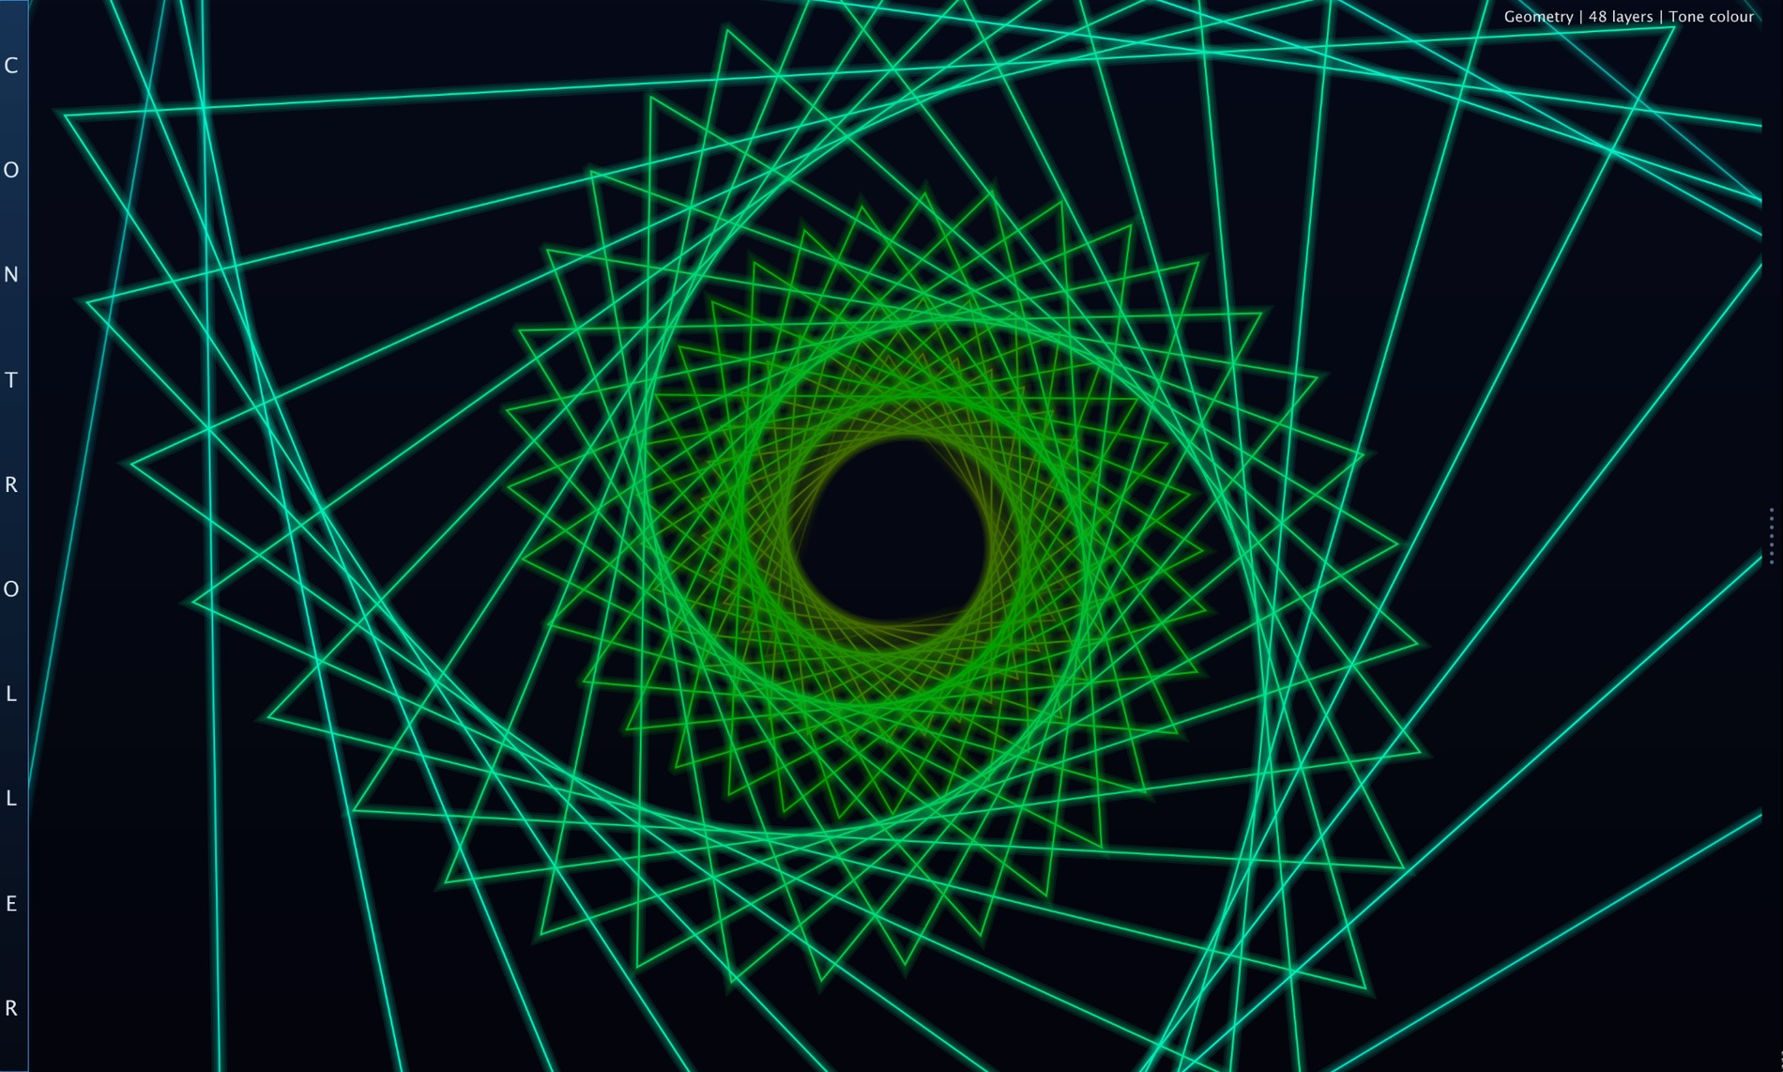
Geometry at high complexity: basic shapes rush through a perspective tunnel and create a living neon structure.
Translation: Geometry is not a meter. It is a shape engine. It takes musical energy, pitch colour and simple primitives, then turns them into a forward-moving tunnel that looks like your mind when you ate an LSD for breakfast.

What Geometry is
Geometry is a generative visual module built from the simplest possible visual ingredients: triangle, square and circle. The magic is not that the shapes are complicated. The magic is that they are born far away, grow through perspective, rush toward the viewer, then recycle into new shapes. Simple parts, heavy motion, serious cyber energy.
Think of it as a visual tunnel. Every layer is another shape travelling toward the camera. Complexity decides how many layers exist at the same time. Speed decides how fast they fall forward. Depth decides how far away they are born. Shape weights decide whether the tunnel feels sharp, architectural, circular, ritualistic or like a cursed geometry exam from the future.
The audio does not draw the shapes directly like a spectrum analyzer. Instead, it gives the tunnel life: signal level fades it in, React adds pulse and camera shake, and Tone Colour can make the whole colour family follow the dominant musical pitch.

Visual overview
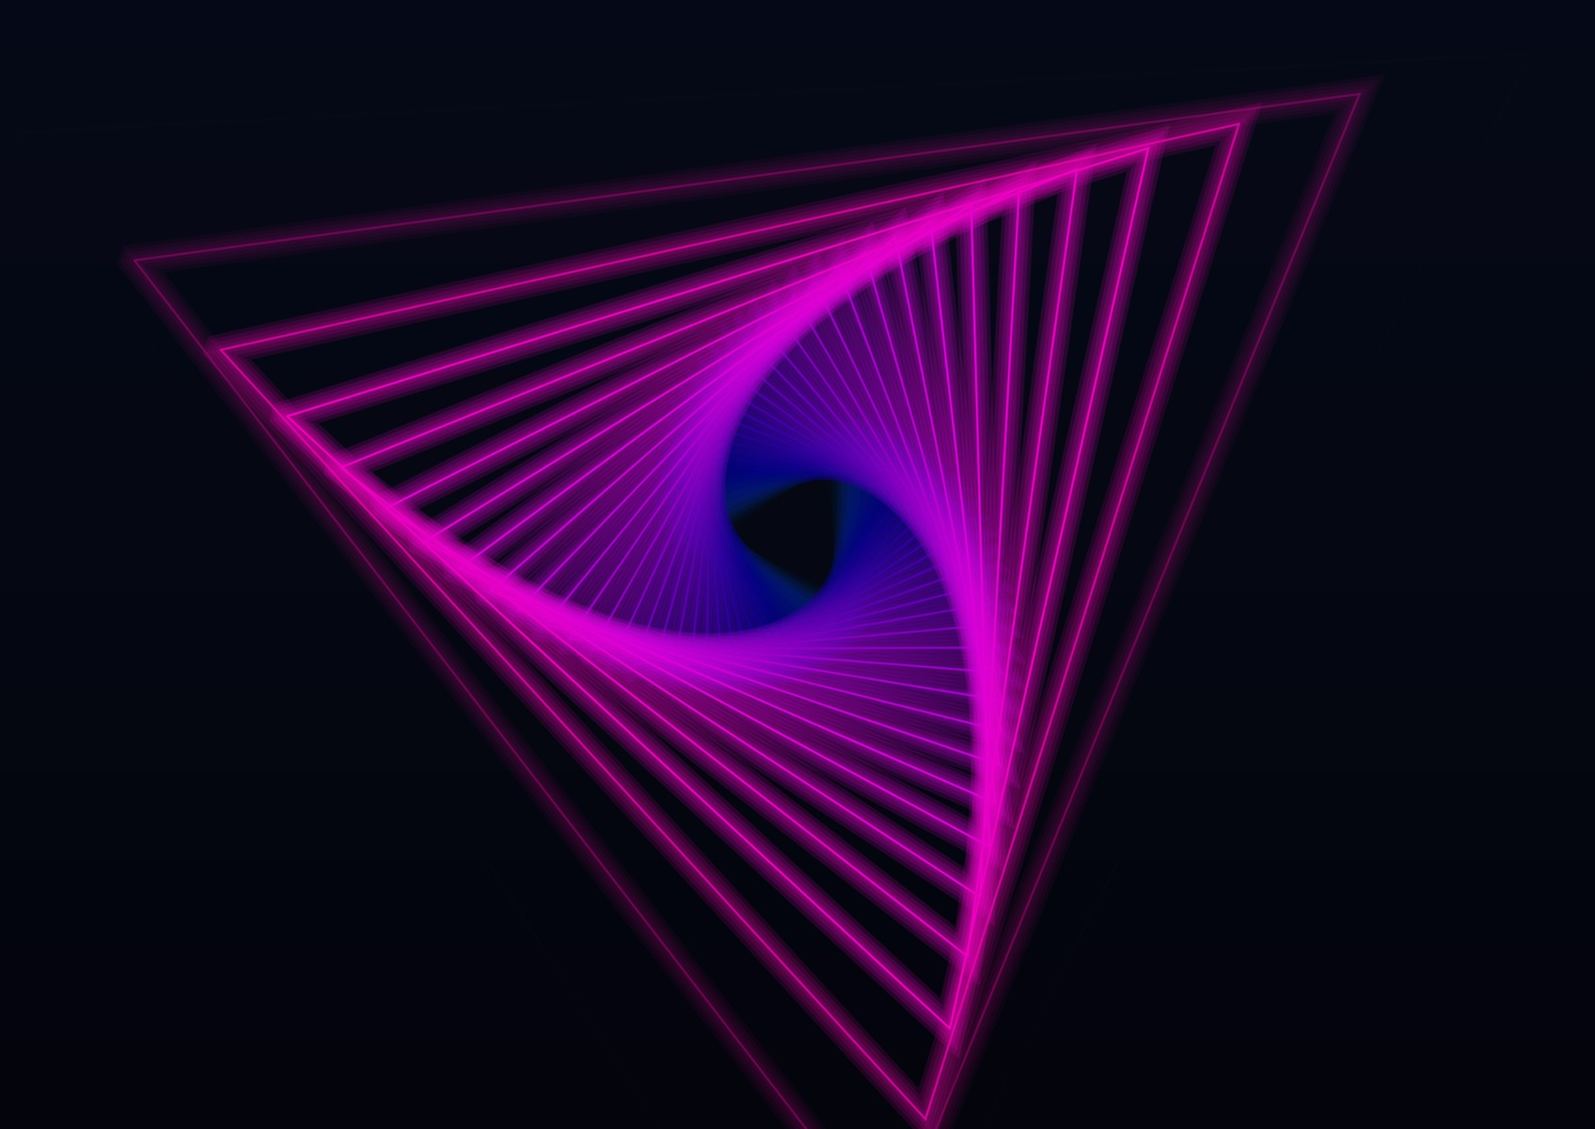
Triangle-dominant tunnel: one primitive shape can already create depth, rotation and visual pressure.
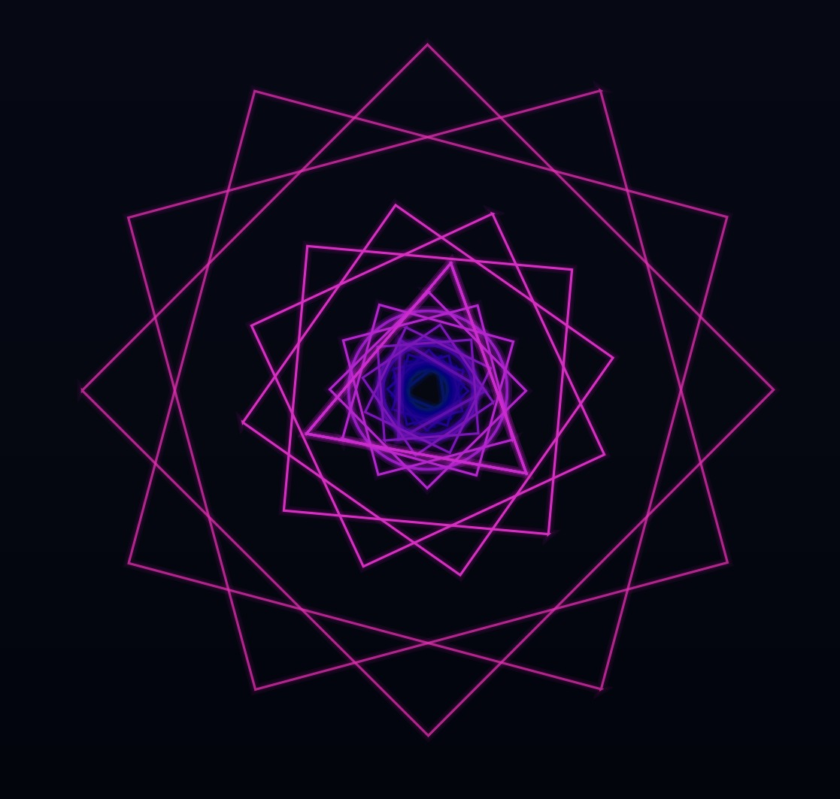
Low randomization and rotation can turn repeated shapes into clean spirals instead of chaotic scatter.
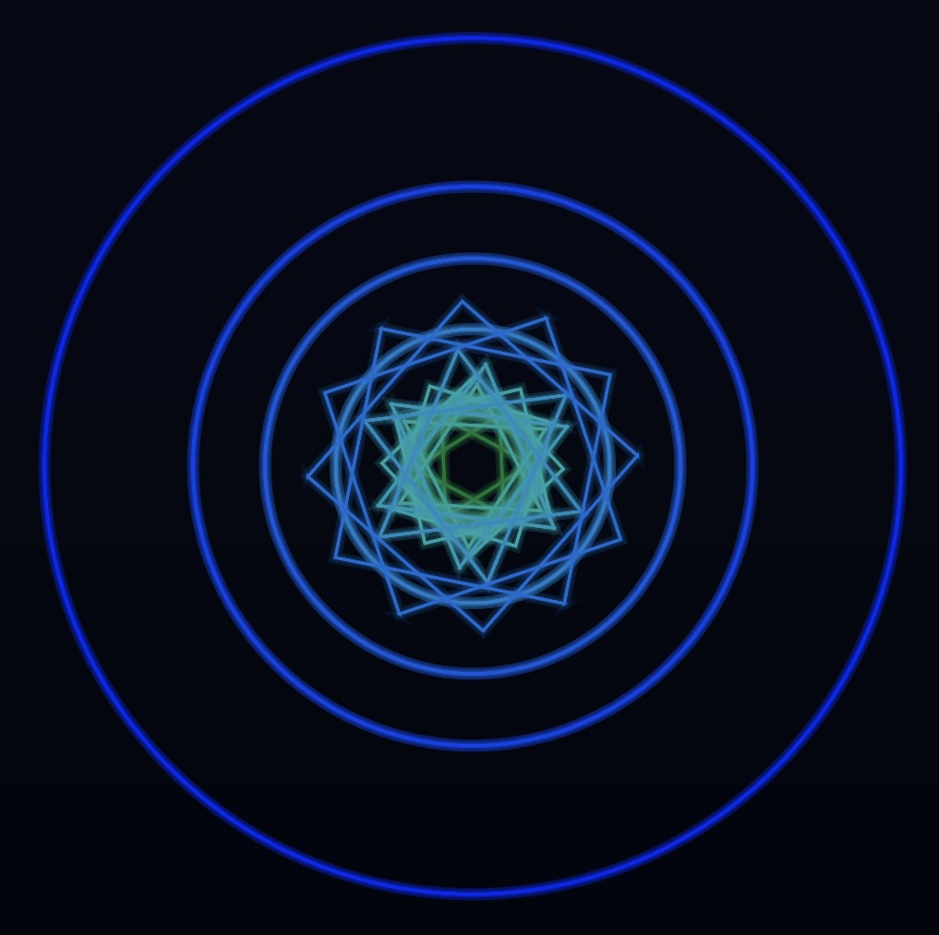
Circle and triangle weights create softer, orbital geometry while keeping the same tunnel logic.
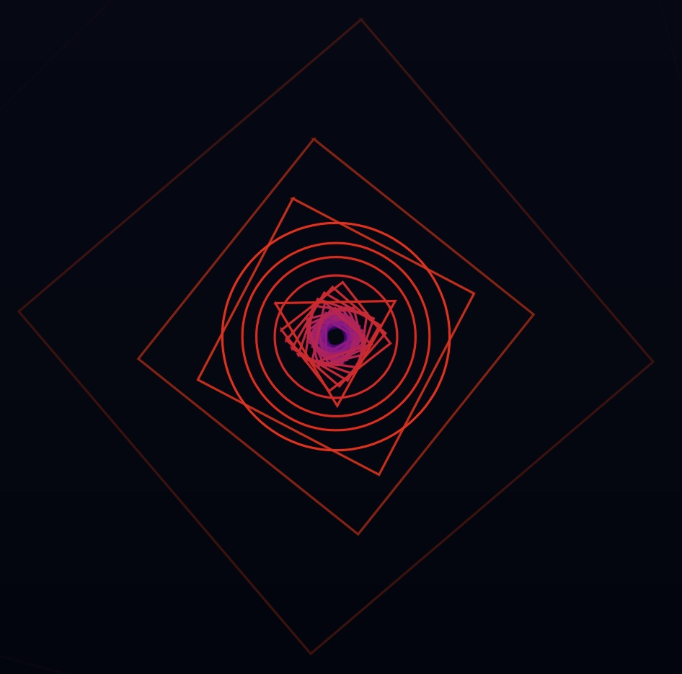
Manual colour mode: the whole tunnel follows the selected colour family instead of detected musical pitch.

What Geometry actually listens to
Important: Geometry reads level, pitch class and spectrum energy, but it is not trying to be a lab analyzer. It uses audio as fuel for motion and colour. That is the difference between analysis and visual performance.
Audio input | What it controls | Plain-English meaning
RMS / level | Visibility, activity, smoothing response | Silence makes the scene fade out. Signal wakes it up. No music, no tunnel party.
FFT band energy | Size pulse when React is active | Shapes breathe and push forward harder when the sound has energy.
Dominant pitch class | Tone Colour family | The strongest pitch-like tone chooses the colour family: C, C#, D... B.
React amount | Pulse + camera shake | 0 = steady tunnel. 1 = the screen starts trembling like the kick drum owes it money.

The tunnel engine: simple shapes, perspective, depth
Every shape has a depth phase: far away at birth, closer as it travels, then it passes the camera and gets recycled. The visual size follows perspective logic: far shapes are tiny, near shapes become huge. That is why the module feels like falling forward instead of just spinning flat icons on a wall.
Shapes are drawn back-to-front, so distant shapes stay behind nearer shapes. This matters visually: it prevents new shapes from flickering in front of old ones and keeps the tunnel readable instead of turning it into depth-confused spaghetti.
Depth does not mean “more reverb” or “more blur.” Here it means spawn distance. Low depth creates a shallow tunnel where shapes appear close and large. High depth creates a deeper tunnel where shapes start tiny and rush into view.

Shape weights: triangle, square and circle
Triangle, Square and Circle are not simple on/off buttons. They are probability weights. If Triangle is high and Circle is low, the system will mostly spawn triangles. If all three are equal, the tunnel becomes a mixed geometry engine. If one shape owns the probability pool, the visual gets a stronger identity.

FREE vs BPM: when shapes are born
Geometry has two spawn engines. FREE mode is the continuous ring: Complexity shapes exist at once, evenly spaced in depth, and Speed decides how fast they travel. BPM mode changes the meaning of the controls: shapes are spawned in bursts ON THE BEAT - Complexity becomes shapes-per-burst, Beat Div picks the musical division (with dotted and triplet variants), and BPM sets the tempo.
With the ALTER Creator plugin on a track, BPM mode locks to the DAW itself: the plugin streams the host tempo and song position (PPQ) over UDP, and Geometry phase-locks its beat clock to that grid. Press play from 1.1.1 and every burst lands exactly on the host beat - the host clock overrides the manual BPM while the DAW is playing, so the visual cannot drift from the music. Without a playing host, the manual BPM slider drives the clock.

Tunnel, Aperture and Module rotation
Three shaping controls complete the scene. Tunnel morphs the layout from shapes spread around the centre (0) into a fly-through tube (1). Aperture is the iris: 1 fills the centre with the incoming edges, 0 opens a clean ring. Module Rot spins the WHOLE module on top of the per-shape Rotation, and it is bipolar - negative values spin the other way.
Shape | Visual feeling | Good for | Watch out
Triangle | Sharp, aggressive, directional | Techno, bass music, hard drops, sci-fi rituals | Too much can feel spiky and hostile.
Square | Architectural, digital, structured | Grid visuals, cyberpunk layouts, precise motion | Too much can look stiff if Random and Rotation are low.
Circle | Orbital, smooth, hypnotic | Ambient, trance, fluid motion, softer stage looks | Too much can become gentle when you need attack.

Precise Tone Colour mapping
Tone Colour mode is where Geometry borrows the pitch-family idea from Synesthesia, but it behaves differently. Synesthesia uses shader iterations and octave-driven layer behaviour. Geometry is more direct: it detects the dominant pitch class, turns that into a base hue, then sweeps the colour across the tunnel depth.
Short version: Pitch class chooses the colour family. Tunnel depth sweeps through that family. Octave does not add extra iterations here. Complexity is a manual visual density control.
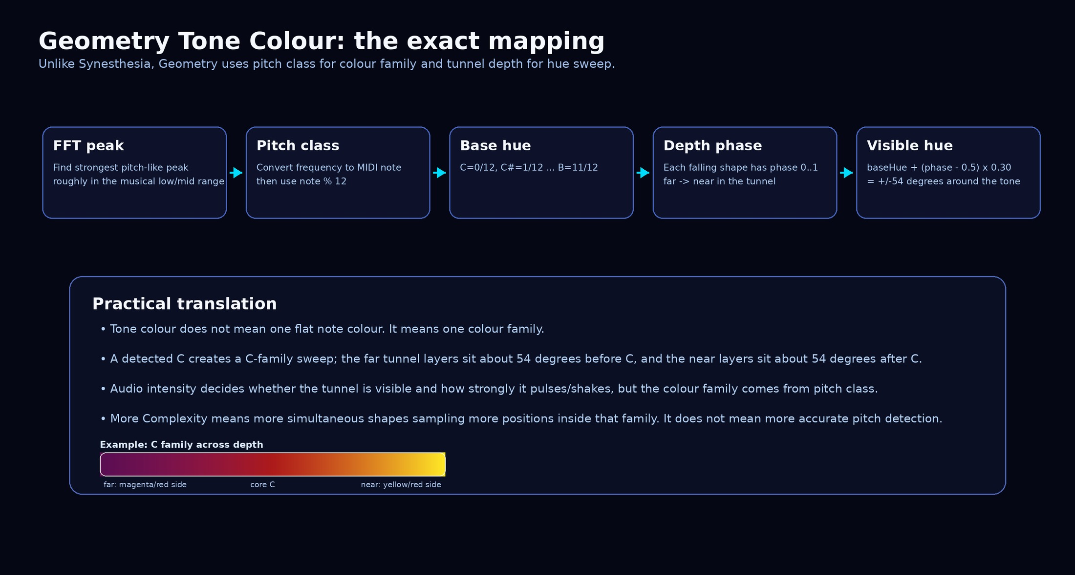
The exact tone-colour logic used by Geometry: pitch class sets the base hue, depth phase spreads the visible colour around it.

One note is a colour family, not one flat colour
When Geometry detects C, it does not paint every shape with one boring red line. C becomes a C-family sweep. Far layers sit on one side of the hue family, the middle sits around the C anchor, and near layers move to the other side. That is why the tunnel can feel alive even with one stable note.
The sweep is precise: Geometry moves the visible hue by about +/-54 degrees around the detected tone. So the core hue is the musical anchor, but the tunnel uses depth to unfold the family. This is not random colour drift; it is a controlled analogous palette.
Because tone detection uses pitch class, octaves repeat the same colour family. C2, C3, C4 and C5 all point to the same C family. Higher octaves do not automatically make the Geometry module more complex. If you want more shapes, raise Complexity. Do not blame the poor note for not doing the slider’s job.
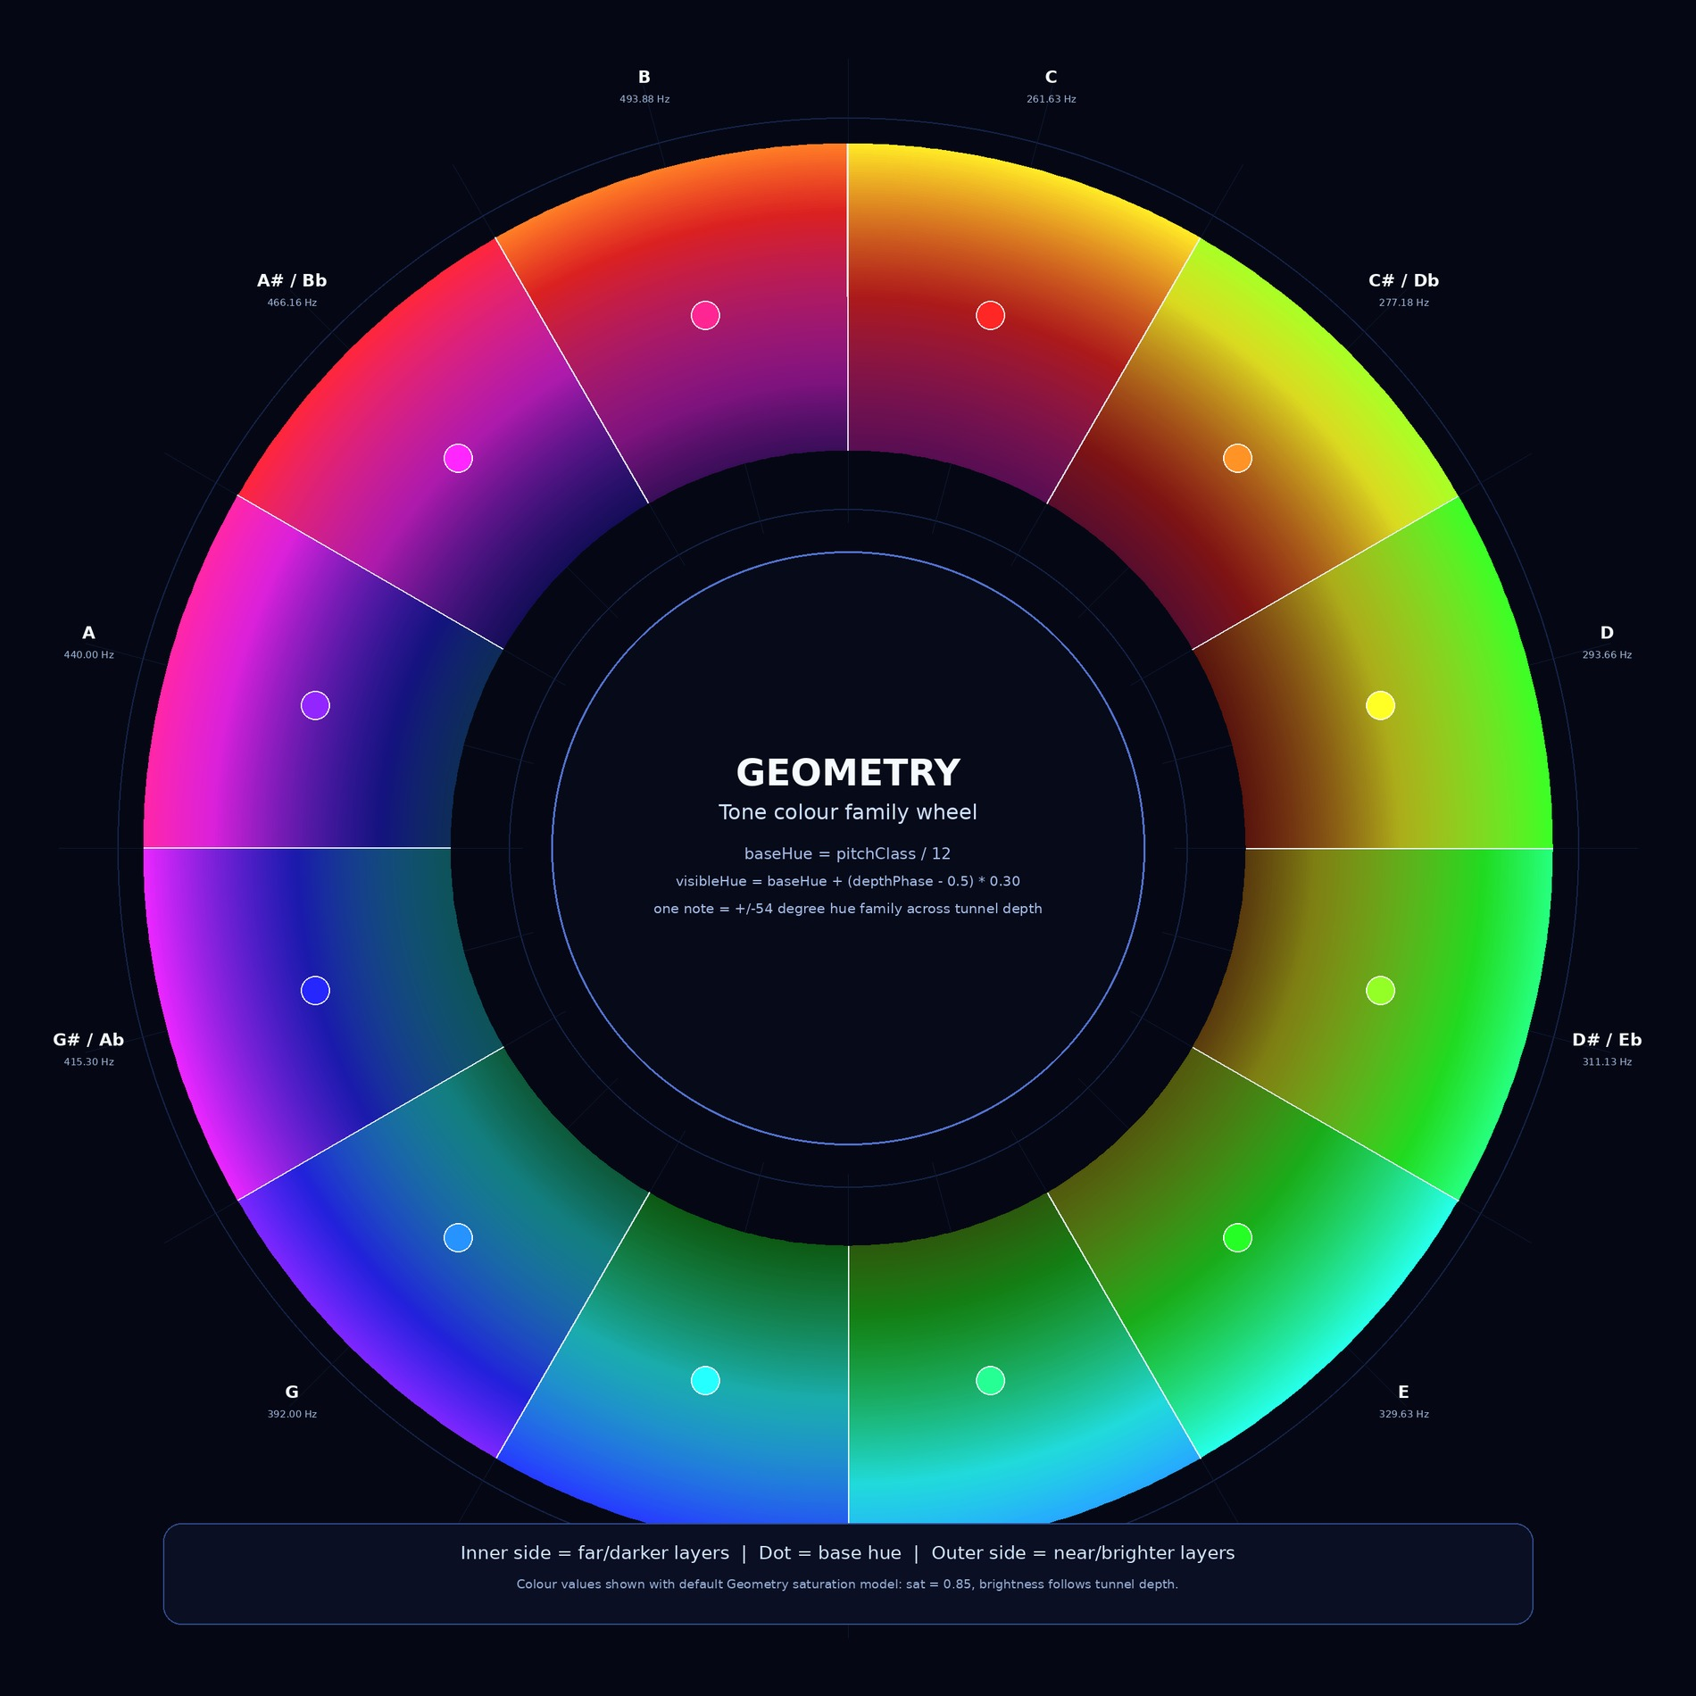
Tone Colour family wheel: each musical pitch class owns a family band, not one s ingle pixel-perfect colour.
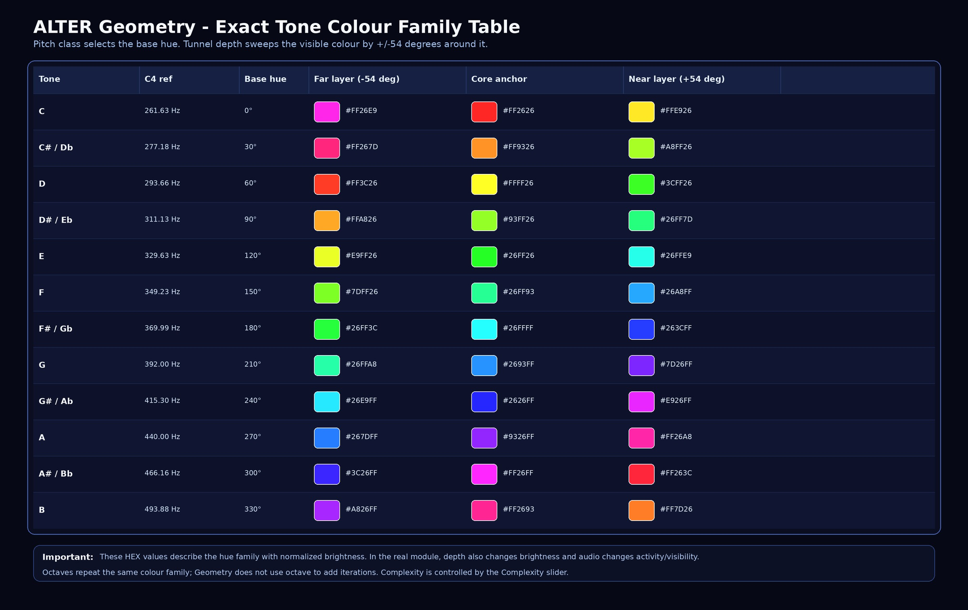
Exact normalized tone colour table. Real brightness still changes with tunnel depth and audio activity.

Tone Colour limits: what it can and cannot know
Geometry listens for the strongest pitch-like peak in a focused musical range. This is perfect for fundamentals, bass notes, leads, drones and tonal material. It is not a chord transcription engine and it is not trying to identify every note in a dense arrangement.
If the audio is noisy, percussive, extremely bright, or dominated by hats and air, the module may keep the previous smoothed hue instead of jumping around like a caffeinated clown. That is good behaviour. Otherwise every hi-hat tick would repaint the tunnel and everyone would need medical attention.
Multiple notes are simplified into a dominant colour decision. If a bass note and a lead fight for attention, whichever wins the detected peak can drive the colour family. For education: useful. For exact music theory analysis: wrong tool, friend.

Tone sensitivity window range
Geometry’s Tone Colour has a practical musical detection window, not infinite pitch vision. The module scans the FFT from bin 3 to bin 219, which at the current assumed 48 kHz / 2048-bin setup means roughly 35 Hz – 2.57 kHz; outside that range it does not directly choose a new pitch colour from the fundamental. The sweet range is roughly 200 Hz – 2 kHz, where the FFT spacing is fine enough that pitch-class colour feels stable and musically believable. The chunky / quantized range is roughly 35 Hz – 200 Hz: it still reacts, but low-end bins are wide as hell, so C, C#, D-type decisions can feel less surgical because one FFT bin covers a big musical step. The deaf range is below about 35 Hz, above about 2.6 kHz, or whenever the peak is too weak; in those cases Geometry keeps the previous smoothed hue instead of pretending random sub-rumble or hi-hat fizz is a meaningful note.

Zone | Approx range | Behaviour
Deaf / no direct pitch colour | < 35 Hz | Fundamental is not scanned; may still react if harmonics appear higher.
Chunky / quantized low range | 35–200 Hz | Works, but pitch colour can be rough because FFT bins are wide in musical terms.
Sweet musical range | 200 Hz–2 kHz | Best range for stable tone-colour tracking.
Upper edge / still possible | 2–2.57 kHz | Can still react, but this is already near the scan limit.
Deaf / texture-only high range | > 2.57 kHz | Not directly used for pitch colour; highs become motion/energy/texture, not note identity.

Controls
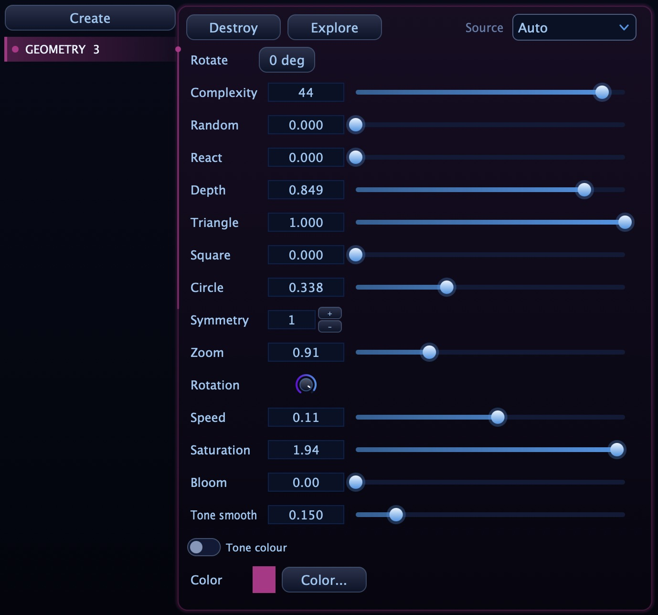
Geometry controller: shape weights, tunnel depth, reaction, tone colour and visual density live in one panel.
Control | What it does | How to use it
Source | Selects the audio source or automatic routing. | Use Auto for normal work; choose a specific source when routing several listener instances.
Rotate | Rotates the whole module in the layout. | Useful for custom stage composition. Do not confuse it with the internal Rotation knob.
Complexity | Number of simultaneous shape layers, from 1 to 48. | Higher = denser tunnel. Lower = cleaner symbol. More is not automatically better, calm down.
Random | Birth-angle randomness for new shapes. | 0 creates aligned/spiral behaviour. 1 creates chaotic spread.
React | Audio-driven pulse and camera shake strength. | 0 = steady. 1 = strong pulse/tremble. Use carefully in elegant visuals.
Depth | How far away shapes are born. | Low = shallow/large. High = deep/tiny-to-huge tunnel.
Triangle / Square / Circle | Probability weights for spawned shapes. | Blend them for mixed geometry or push one shape for a strong identity.
Symmetry | Number of rotated copies around the centre. | 1 is raw. Higher values create kaleidoscope geometry.
Zoom | Overall scale of the visual. | Use to fit the tunnel to the canvas or projection space.
Rotation | Internal self-spin strength of the shapes/tunnel. | Low = stable. High = spiral drive. This is where the tunnel starts doing space karate.
Speed | Forward falling motion speed. | Higher values rush the tunnel toward the viewer faster.
Saturation | Colour intensity. | 0 = grey-ish. 1 = standard neon. Higher values push colour harder.
Bloom | Glow around the shape strokes. | More bloom = more neon. Too much = beautiful soup.
Tone smooth | How quickly level/tone changes are followed. | Low = faster, twitchier. High = smoother and more musical.
Tone colour | Uses detected pitch class for hue family. | ON = sound chooses colour family. OFF = manual colour.
Color | Manual base colour. | Used when Tone colour is OFF or as the chosen visual identity.

How to actually use Geometry
Situation | Starting settings | What to look for | Do not do this
Clean VJ symbol | Complexity 8-16, Random low, Symmetry 4-8, Bloom medium | A readable mandala/tunnel shape that survives projection. | Do not crank every slider. A mess is not automatically futuristic.
High-energy drop | Complexity 32-48, React 0.4-0.8, Speed higher, Bloom medium/high | The tunnel should rush forward and pulse with the groove. | Do not over-shake the image unless the track actually deserves violence.
Sound design / tonal demo | Tone colour ON, Tone smooth medium, one strong tonal source | The colour family should follow the dominant note. | Do not test it with noisy hats and expect a music-theory miracle.
Minimal techno / hypnotic | Complexity 16-28, Random low, Rotation medium, Circle/Square emphasis | Steady repetition with slow spiral pressure. | Do not make it too random if the music is about discipline.
Ambient / cinematic | Circle high, React low, Speed low, Depth high, Bloom soft | Slow breathing geometry with spacious motion. | Do not let Complexity turn an atmosphere into a neon traffic accident.

Fast recipes

Neon Triangle Spiral
Triangle 1.0, Square 0, Circle 0, Complexity 24-44, Random 0-0.15, Rotation medium/high, Bloom 0.2-0.5. This creates the sharp tunnel look: clean, aggressive and dangerously photogenic.

Orbital Mandala
Circle high, Triangle low/medium, Square low, Symmetry 6-8, Speed low, Depth medium/high. Great for ambient, melodic techno and anything where the visual should hypnotize instead of punch.

Architectural Grid Fall
Square high, Random low, Complexity 20-36, Rotation low/medium. Feels like digital architecture falling through a wormhole.

Pitch-colour Demonstrator
Tone colour ON, Tone smooth around 0.2-0.5, clean synth/bass note input. Use one note at a time when you want the colour mapping to be obvious.

Common mistakes
Mistake | Why it sucks | Better move
Maxing Complexity by default | Everything becomes dense, and the eye loses the main shape. | Use high Complexity when density is the point; otherwise leave breathing room.
Thinking Tone colour is a tuner | It follows a dominant pitch class, not full harmony. | Use it as musical colour behaviour, not exact note analysis.
React too high on subtle music | Camera shake can overpower the geometry. | Use low React for elegance, high React for impact.
Random too high for clean spirals | The tunnel loses its repeatable shape language. | Lower Random when you want mandala/spiral structure.
Too much bloom | The beautiful neon strokes turn into glowing fog. | Increase bloom until it looks alive, then back off before it becomes soup.

Scientific accuracy review
Geometry is visually mathematical, but it is not a physics simulation and not a metering standard. It is a generative visual system driven by audio level, pitch class and controllable shape rules.

Final interpretation
Geometry turns simple primitives into a deep, musical, forward-moving visual structure. It does not need complex meshes or fake 3D models to feel big. It uses repetition, perspective, symmetry and audio movement - the old ingredients, done with enough neon to make them dangerous.
For VJs it is a stage weapon. For sound designers it is a tone-colour demonstrator. For DJs it is a visual tunnel that can follow musical energy. For beginners it is a brutally clear lesson: triangle, square and circle are not boring. They just needed to be thrown into a cybernetic wormhole.
In one line: Geometry is what happens when basic shapes stop being educational diagrams and start behaving like a club visual from the future.

Sources and technical basis
ALTER internal Geometry module: perspective tunnel behaviour, shape pool / Complexity, triangle-square-circle probability weights, Random birth angle, React pulse and shake, Depth spawn distance, Tunnel/Aperture layout, whole-module rotation, FREE and BPM spawn modes with host (DAW) transport lock, symmetry copies, manual colour, Tone Colour detection and HSV colour-family sweep.
ALTER audio data pipeline: RMS/level and FFT data received from the listener system are used as visual control signals for activity, pitch-family detection and audio reaction.
12-tone equal temperament / A4 = 440 Hz pitch conversion as implemented by the module: detected frequency is converted to a MIDI-style pitch, rounded to the nearest pitch class, and mapped into 12 colour families.
Standard geometry terminology: triangle, square, circle, rotational symmetry and perspective are used as descriptive visual concepts. They are product-behaviour explanations, not external delivery or measurement standards.

