ALTER
Spectrogram
The thermal camera for sound
Time runs sideways. Frequency runs vertically. Colour shows energy. If something is hiding in the mix, Spectrogram usually catches the bastard.
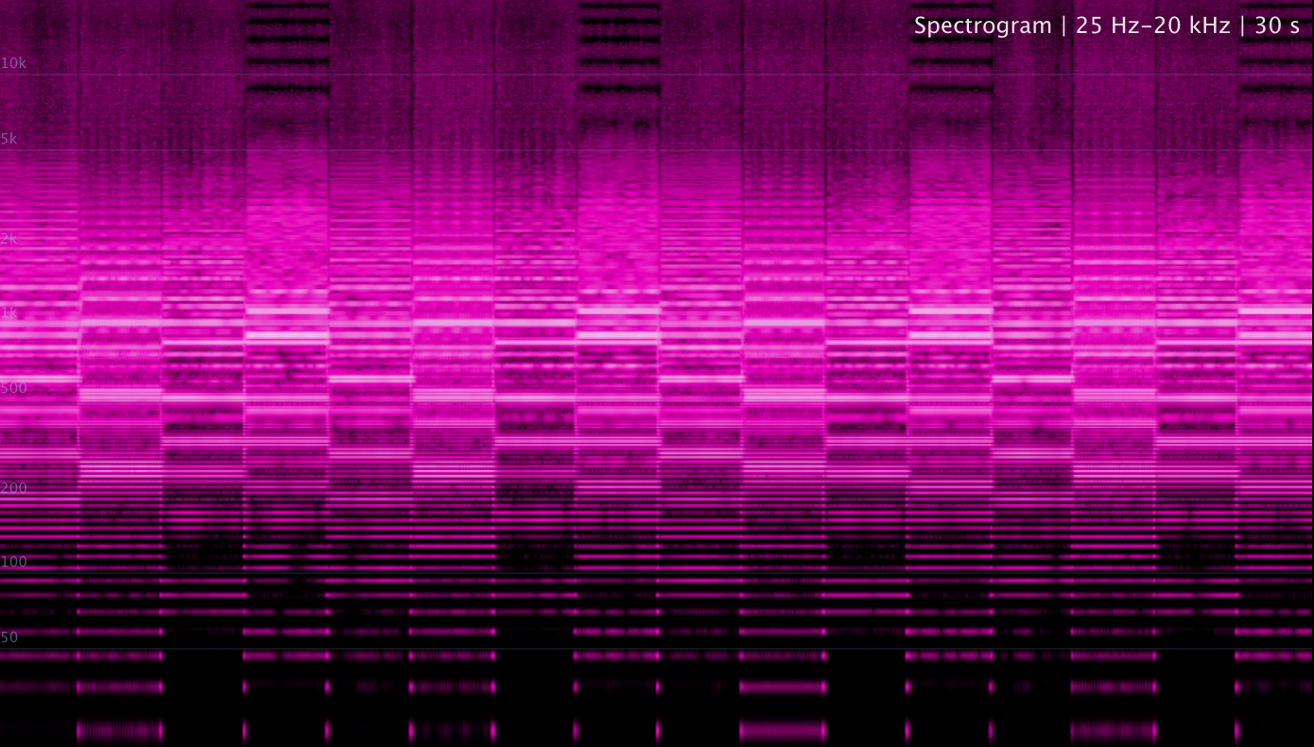
A 30-second time-frequency image: horizontal harmonic lines, vertical attacks and bright energy bands become visible at once.
TIME  left -> right  what happened and when | FREQUENCY  low -> high  where the energy lives | COLOUR  dark -> bright  how strong that energy is

What is a Spectrogram?
A spectrogram is a picture of sound over time. It does not only tell you that the signal is loud. It tells you where it is loud: sub, bass, mids, presence, air, noise, harmonics, clicks, edits, hiss, hum, codec scars - the whole messy crime scene.
Think of Spectrum Analyzer as a photo. Spectrogram is the security-camera footage. Spectrum shows the current frequency shape; Spectrogram shows how that shape changes, repeats, disappears, explodes, or slowly drifts across the track.
Technically, a spectrogram comes from slicing audio into short windows, running a frequency analysis on each slice, and stacking those slices over time. In normal-human language: it takes many tiny snapshots of the spectrum and glues them into a moving heat map.
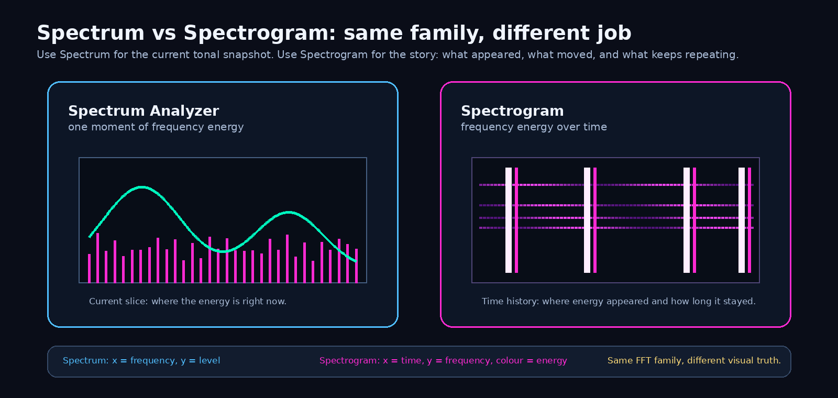
Spectrum is the current snapshot. Spectrogram is the memory of frequency behaviour.
Why Spectrum bins and Spectrogram rows do not match pixel-for-pixel
Same audio source, different visual job. Spectrum draws one current frequency slice. Spectrogram writes slice after slice into time. The raw FFT bins are still underneath, but the spectrogram stores them as log-frequency rows and colours them over time.
That means one sine wave is not supposed to become one mathematically perfect hairline. If the tone sits between FFT bin centres, the FFT already contains a small energy hill. Spectrogram maps that hill across neighbouring rows, so you see a ridge with thickness. That is not the module exposing some embarrassing secret. That is finite-window analysis doing its job.
The low end shows this more clearly because one FFT bin covers a larger musical distance down there. Spectrogram uses interpolation and thin-line behaviour so bass does not become a fat pixel brick, but it still cannot invent precision that was never measured. Cleaner display, same honest measurement.
Spectrum = one hill right now. Spectrogram = that hill written across time. They share the same 20 Hz-20 kHz world, but they do not need to share the same pixel grid.

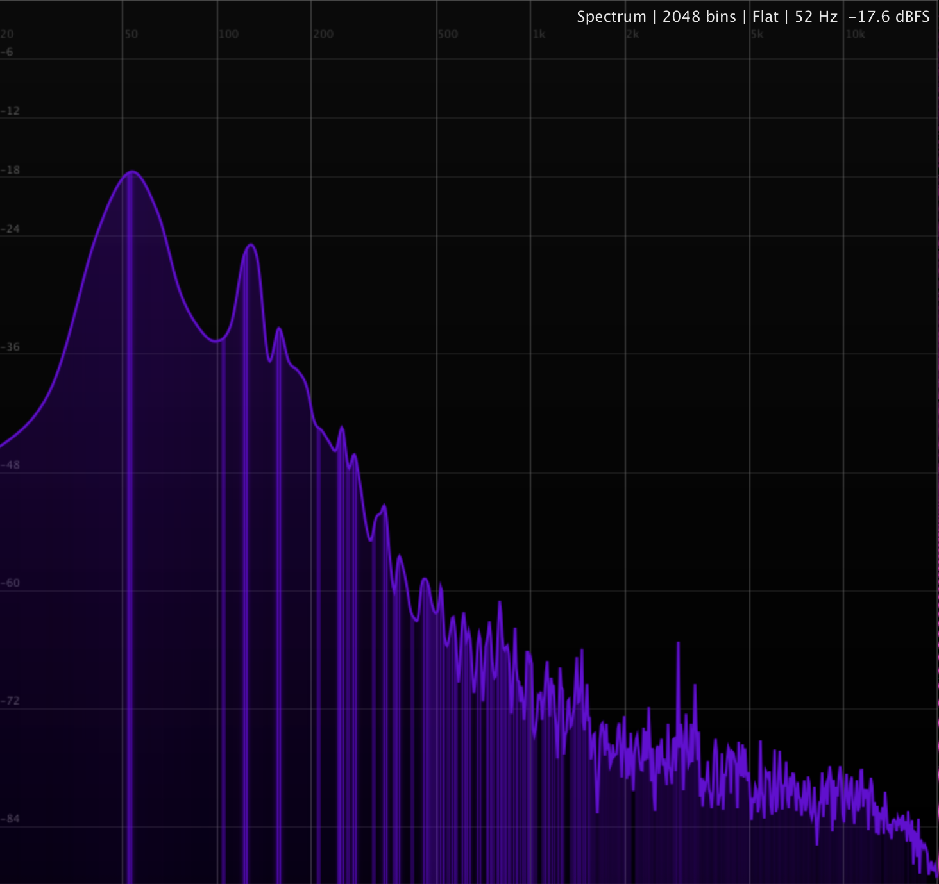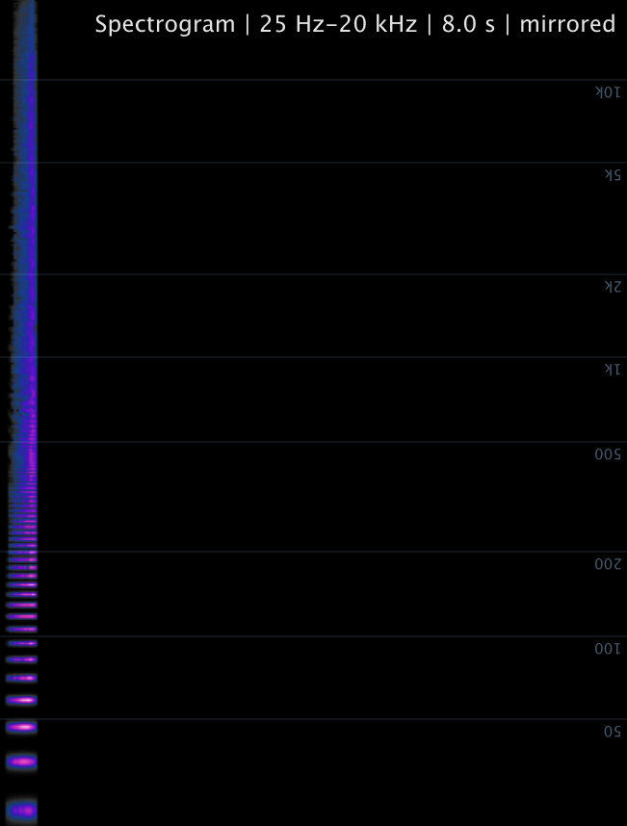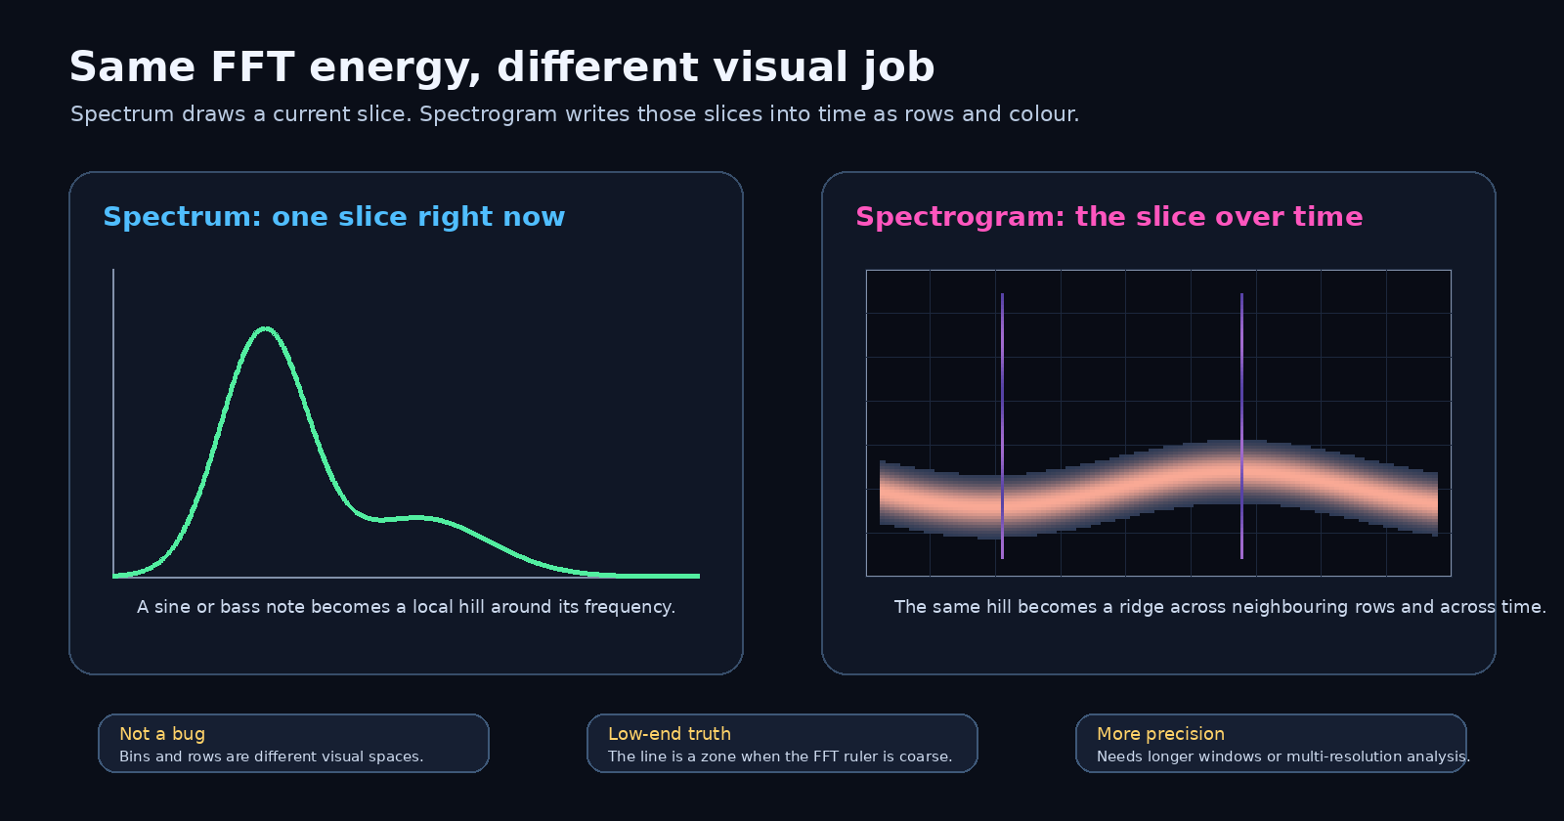
Spectrum and Spectrogram use the same FFT information differently: a live curve versus a time-frequency image. One tone can become a hill in Spectrum and a ridge in Spectrogram.

Naming review
Spectrogram is the correct name. This module is not just a spectrum analyzer, because it stores spectrum frames through time. The scientific term for this time-frequency image is spectrogram. So this name is solid. Keep it.

Visual Overview
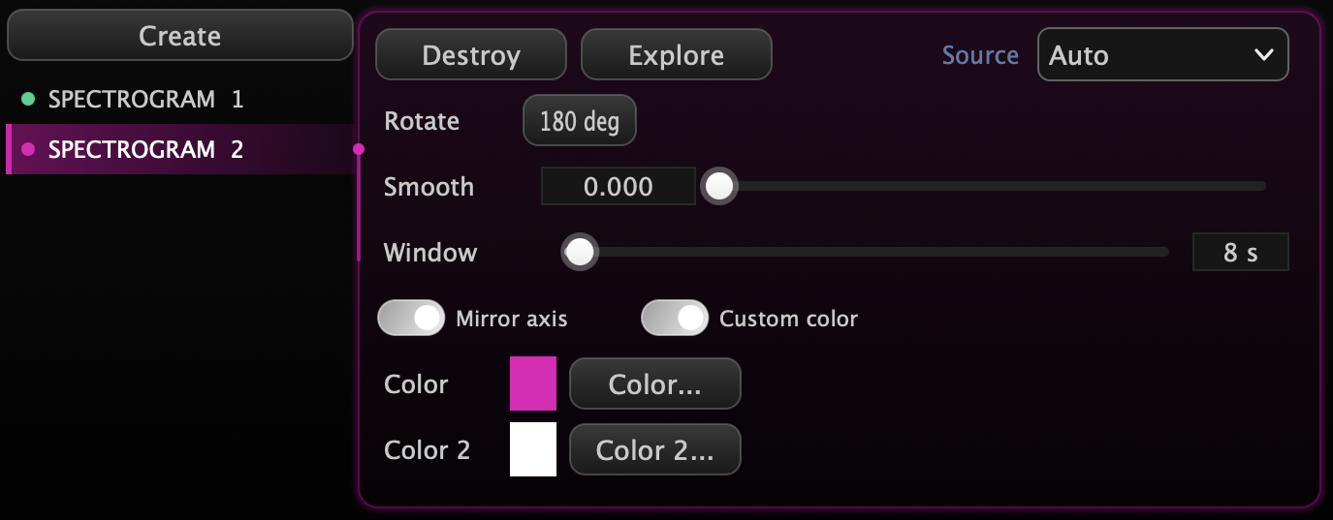
Controller view: Rotate, Smooth, Window, Row Fill, Mirror Axis, Constant-Q, Enhanced Freq, Custom Color, Color and Color 2.
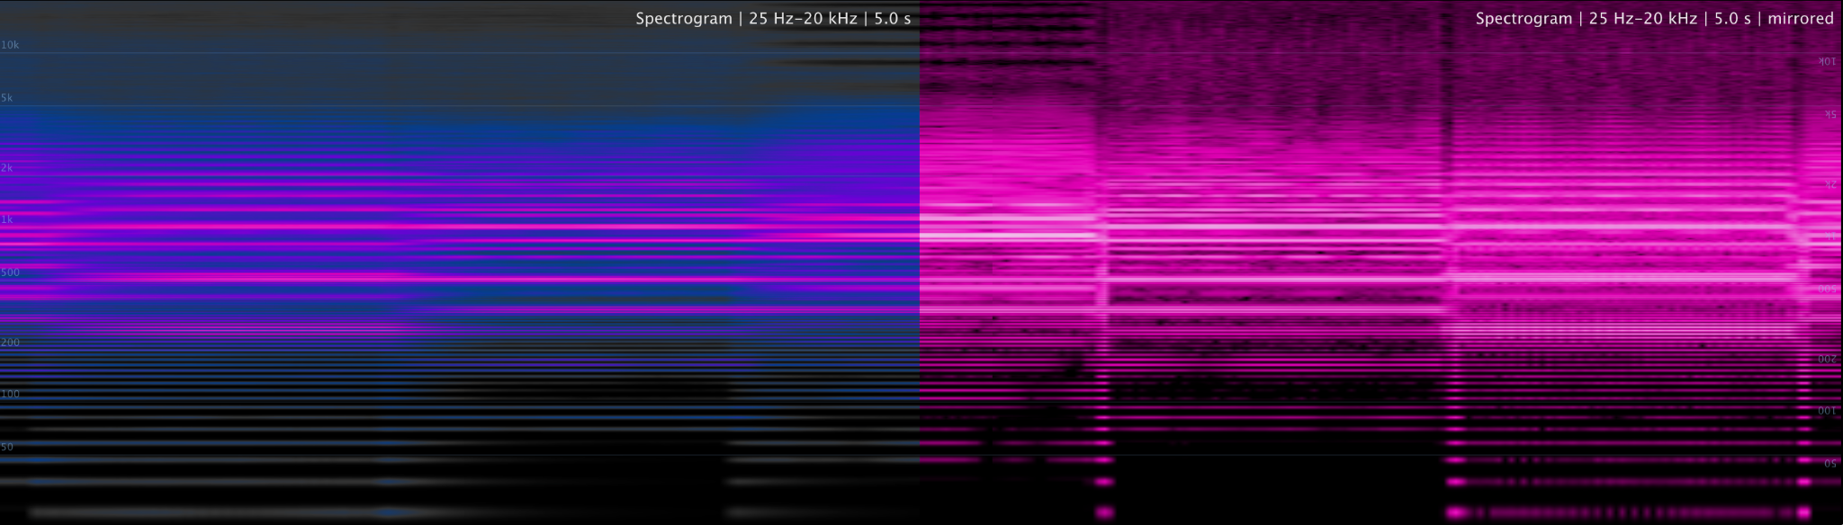
Mirrored axis view: useful when the visual direction needs to match stage layout, screen composition or personal reading preference.
Left side is smoothed – right side is not

How to read the picture

Horizontal lines = sustained tones
A stable bass note, vocal vowel, synth oscillator, guitar note or hum becomes a horizontal line. If you see evenly spaced lines above it, those are harmonics. Congratulations, you are now looking at tone structure instead of guessing like a caveman.

Vertical stripes = transients
Kicks, snares, claps, mouth clicks, edit pops and sharp attacks appear as vertical marks. If something clicks in the mix but you cannot find it by ear, the spectrogram often points at it like: here, this little bastard.

Bright low bands = bass pressure
A thick low-frequency band can mean powerful kick/bass energy. It can also mean uncontrolled mud eating headroom. The spectrogram will not flatter your low end. It shows the mess exactly where it lives.

High-frequency wash = air, noise or pain
A bright top area can be beautiful cymbal air, vocal breath or synth sparkle. If it never stops, it may be hiss, harshness or overexcited hi-hats trying to drill through the skull.

Dark gaps = empty space
Silence, rests and clean separations show up as dark zones. Do not be afraid of them. Space is not empty; space is what makes impact possible.

Frequency Zones: what to watch
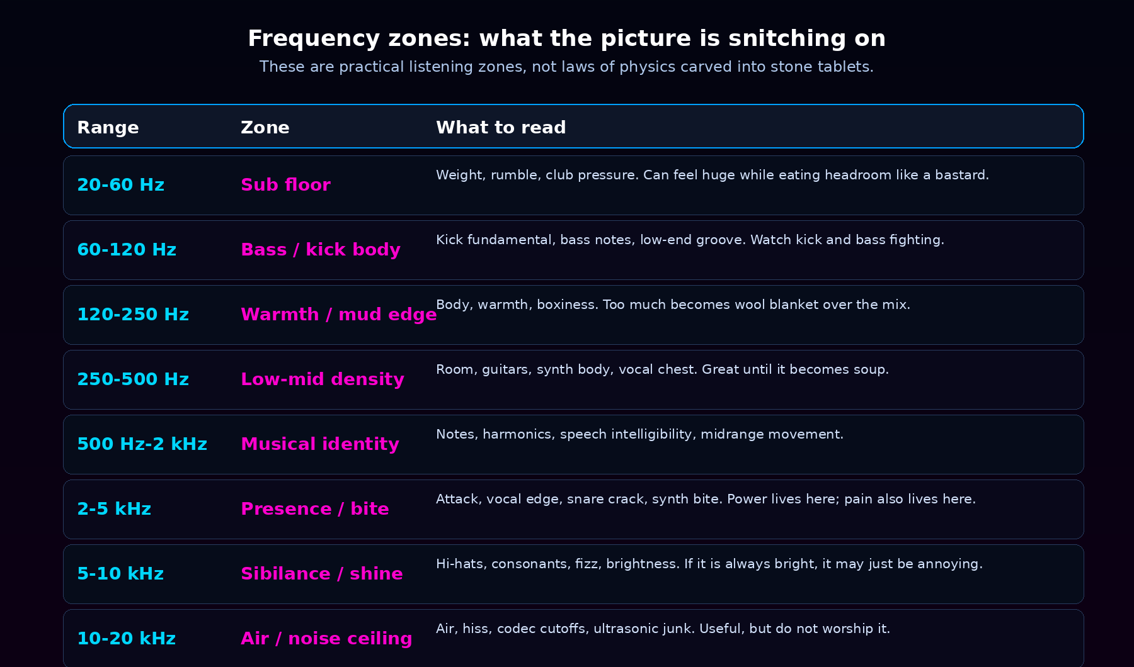
Practical reading zones. These are not rigid rules, but they are extremely useful when you are hunting problems.
A spectrogram is brutal for tonal-balance reality checks. If the sub area is glowing constantly, your master may feel huge but collapse on smaller systems. If the 2-5 kHz region is always screaming, the mix may feel exciting for ten seconds and exhausting for three minutes. If the 10-20 kHz area is a bright fog, it might be air - or just noisy bullshit wearing a fancy jacket.

How to actually use Spectrogram

While producing
Use it to see whether parts are fighting in the same frequency zone. If your pad, bass, kick and low vocal all paint the same 120-300 Hz mud cloud, do not blame the listener. The problem is right there, glowing at you.

While mixing
Use it for resonances, low-end control, click hunting, sibilance, hiss, hum and harshness. EQ decisions should still be made by ear, but the spectrogram shows where to start digging.

While mastering
Use it as a final scan for tonal balance and hidden garbage: constant high-frequency fizz, codec-looking cutoffs, low-end rumble between hits, or sections that become spectrally flat because the limiter smashed all movement out of the track.

While DJing or preparing live sets
Use long windows to compare tracks visually: does Track B have far less sub? More bright noise? A denser midrange? Spectrogram will show why the next track feels weak, harsh or weird before the crowd has to suffer through it.

While sound designing
Use it like a fingerprint scanner. Impacts, drones, risers, granular textures, FM tones and layered noise all leave different patterns. This is where sound design becomes visible architecture.
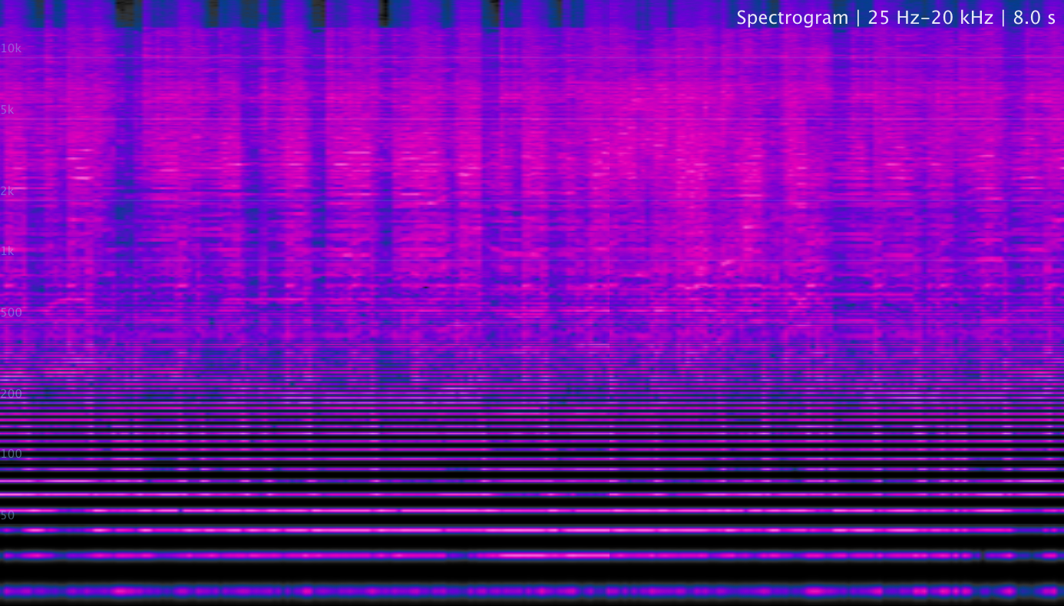
An 8-second view is great for phrase-level movement and fast spectral changes.

Window length: choose the correct scale
The Window control decides how much time is visible. Short windows are for detail. Long windows are for structure. The classic mistake is using a long window to hunt tiny clicks, then wondering why the click is not obvious. That is like using Google Maps to find a screw on the floor.
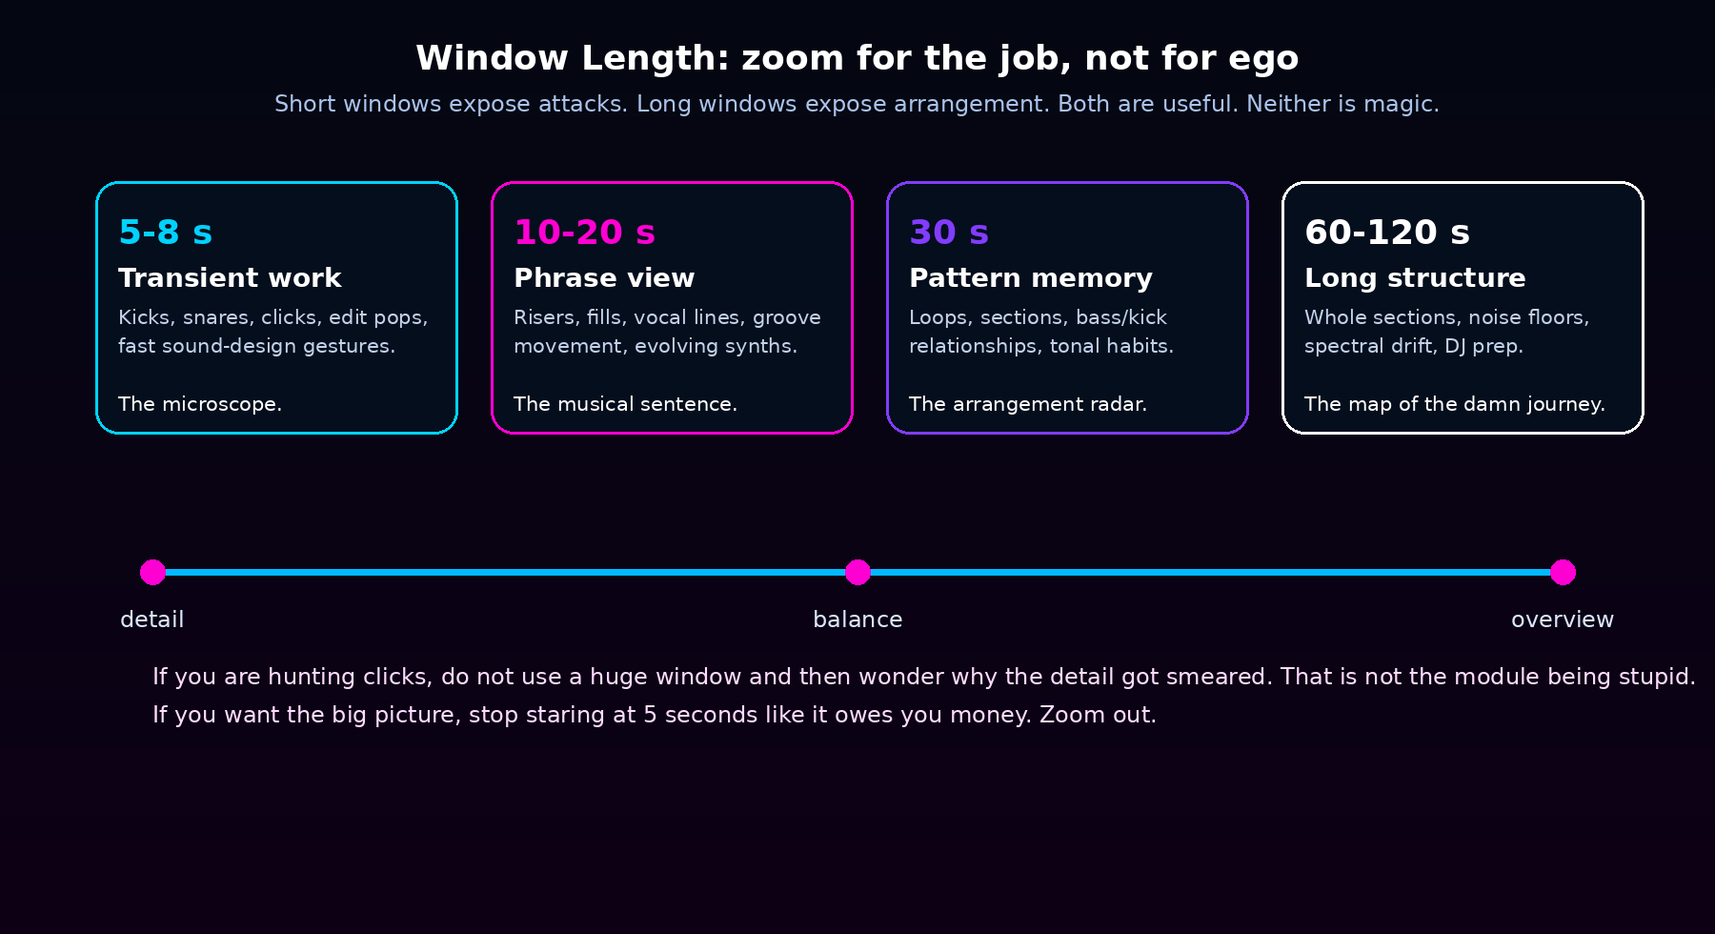
Window length changes what kind of truth you see: transient detail, phrase movement, arrangement structure or long-term spectral drift.

Display engines: Linear, Constant-Q and Enhanced Frequency
Spectrogram has three analysis engines, and switching them is not cosmetic. They answer different questions about the same audio.

Linear FFT - the default workhorse
Classic STFT rows: one FFT per time column, mapped onto the log-frequency axis. Balanced detail, lowest CPU, the right default for general mix reading. Its one physics problem: a single FFT bin covers a big musical distance in the sub range, so deep bass rows are naturally coarser.

Constant-Q - musical resolution everywhere
Constant-Q runs a multi-resolution analysis instead of one fixed window: a long window for bass, a medium one for mids and a short one for highs. Every log-frequency row shows true per-band energy, so each semitone from the sub range up to 20 kHz gets fair resolution. Use it when you read basslines, chords and harmony - the low end stops being a fat pixel brick. The trade-off is physics, not laziness: long bass windows react more slowly in time.

Enhanced Frequency - spectral reassignment
Enhanced Frequency is the forensic mode. The analyzer processes every incoming sample gap-free with heavy window overlap, and each FFT bin's energy is re-assigned to its TRUE instantaneous frequency and its true moment in time (time + frequency reassignment). Steady tones collapse into razor-thin lines, transients stay sharp verticals, and incoherent noise stops smearing - the look you know from high-end professional analyzers. Use it for tuning checks, pitch drift, vibrato depth, hum harmonics and click forensics. Constant-Q and Enhanced Frequency are mutually exclusive; pick the question first.
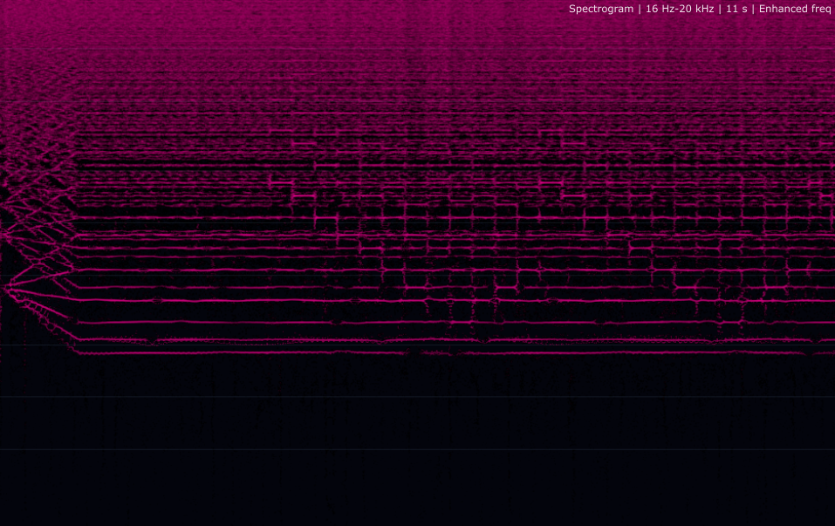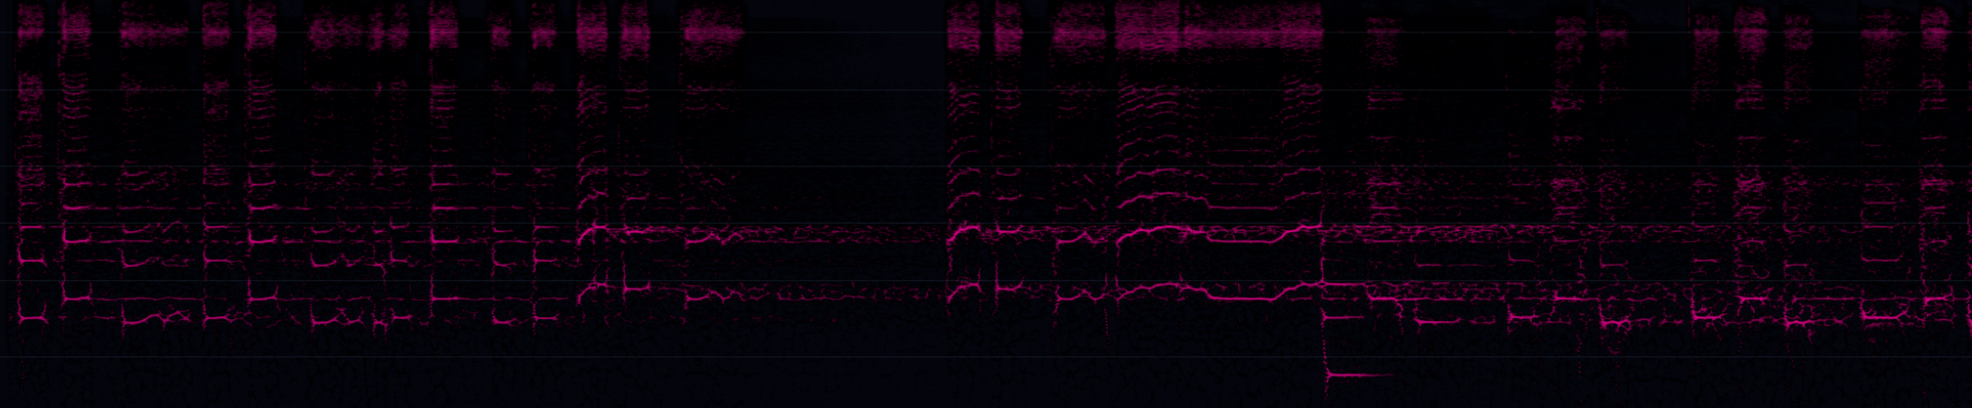

Row fill
Row Fill controls the vertical body of the drawn lines: 0 keeps thin, surgically placed lines; 1 fills the whole band row. Low values for analysis, higher values when the module doubles as a stage visual.

Controls
Control | What it does | How to use it without making a mess
Source | Chooses which audio source/instance feeds the module. | Use Auto for the active/default source; pin a specific source when you want this spectrogram to follow one track or bus.
Rotate | Rotates the module visually. | Great for installations and stage layouts. It changes the visual orientation, not the audio analysis.
Smooth | Temporal smoothing per frequency row. | 0 is raw and sharp for clicks/transients. Higher values look silkier but can smear fast events.
Window | Visible time span of the spectrogram history. | Short = detail. Long = arrangement. Do not use one setting for every job like a psychopath.
Mirror axis | Flips the frequency axis. | Use when you want lows at the top or when the screen composition works better inverted.
Custom color | Switches from theme heat map to a user gradient. | Use Color for mid-energy and Color 2 for loud peaks. Make it readable first, pretty second.
Color / Color 2 | Primary and peak colours for custom mode. | High contrast helps. If everything is neon-white, you have made a flashlight, not an analyzer.

Color is not decoration only
The colour map is part of the reading system. Dark means weak/quiet energy; bright means strong energy. A custom gradient can make the module fit your show, but do not murder readability just because the colour is sexy. If the viewer cannot tell quiet from loud, the visual is lying.
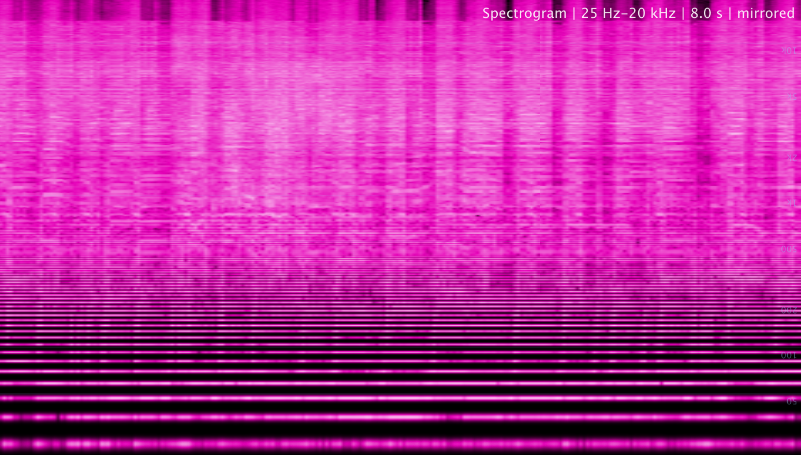
Custom gradient example: colour choices change the emotional tone of the visual while preserving the same analysis logic.
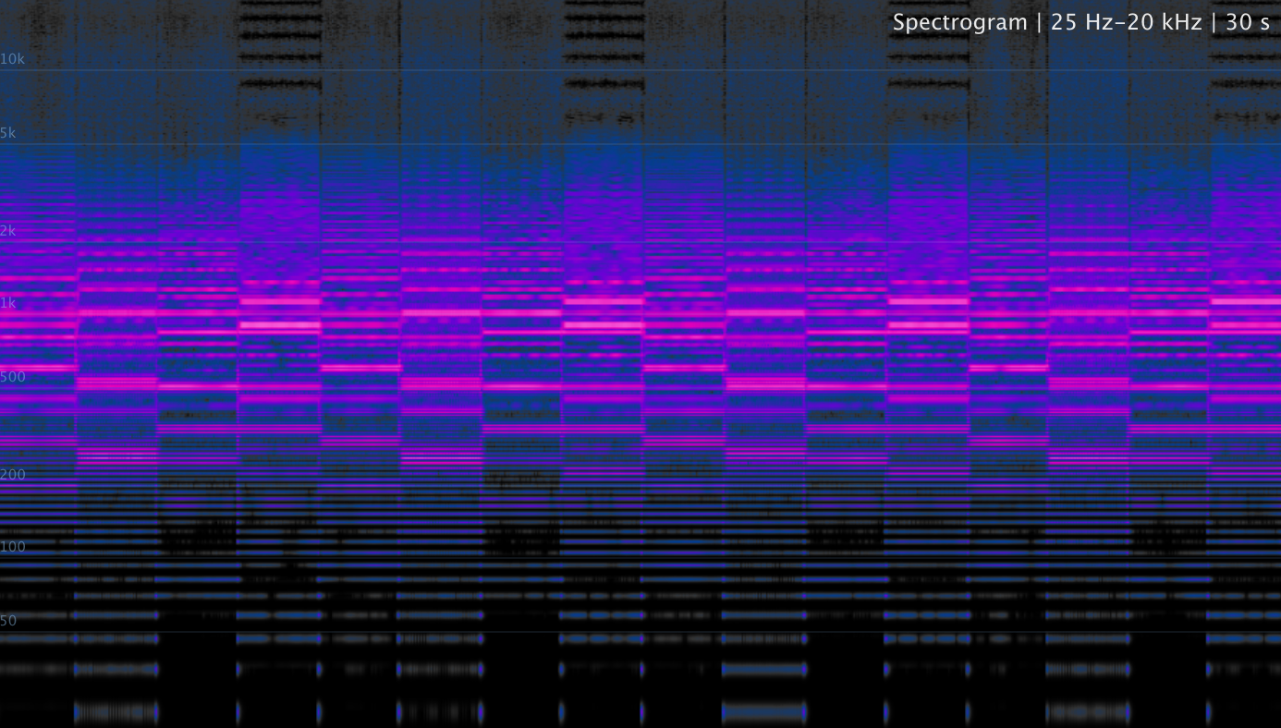
Mirrored/custom view: useful for creative display modes and installation-style visuals.

What Spectrogram reveals immediately
• hum and electrical noise, especially 50/60 Hz and harmonics
• mouth clicks, edit pops and ugly little transient gremlins
• constant low-end rumble between kick/bass events
• harsh high-frequency wash from hats, distortion, synths or bad processing
• missing fundamentals, weak harmonics or badly tuned layers
• over-compressed sections that stop breathing spectrally
• codec cutoffs and high-frequency damage
• arrangement patterns: risers, drops, fills, breakdowns and repeated motifs

Common mistakes

Thinking bright always means better
Bright can mean detail. It can also mean hiss, harshness, clipping dirt or overexcited high end. The spectrogram shows energy, not taste.

Ignoring the low end because you cannot hear it on laptop speakers
The spectrogram does not care about your speakers. If there is sub garbage, it shows up.

Using too much smoothing
Smoothing looks beautiful, but it can hide fast problems. Use low smoothing for repairs and higher smoothing for performance visuals.
Expecting one sine to draw one perfect row
A pure mathematical sine that plays forever would be infinitely narrow. A DAW test tone through a real FFT window is not that fairytale. It has a finite window, a window function, possible start/stop clicks, smoothing and display mapping. If it draws a little ridge, calm down - the analyzer is not drunk.

Treating it as a loudness meter
Spectrogram shows frequency energy over time. For RMS, LUFS and True Peak decisions, use Audio Meters. Different tool, different truth.

Naming and scientific accuracy review
Suggested UI labels: Window could be renamed to Time Window for clarity. Smooth could be renamed Temporal Smooth. Mirror Axis could be Mirror Frequency Axis. Custom Color could become Custom Gradient. None of these are required, but they are clearer for engineers and beginners.

Final interpretation
Spectrogram turns sound into a living map. It shows where energy appears, how it moves, how long it stays, and what parts of the mix are quietly causing trouble. For engineers, it is forensic analysis. For producers, it is arrangement x-ray. For sound designers, it is visual architecture. For VJs, it is a damn beautiful way to make audio behave like light.
If Spectrum shows what the sound is right now, Spectrogram shows what the sound has been doing behind your back.

Sources and basis
MathWorks Signal Processing Toolbox, spectrogram documentation: spectrogram as magnitude squared of the STFT and STFT as a way to analyze frequency content changing over time.
SciPy signal.stft documentation: STFT quantifies how the frequency and phase content of a nonstationary signal changes over time; uses windowed segments and overlap.
SciPy ShortTimeFFT.spectrogram documentation: spectrogram is the absolute square of the STFT and returns time-frequency slices.
ALTER Spectrogram module behaviour: scrolling real-time log-frequency display, newest data at the right edge, smoothing, time window, mirrored frequency axis and custom colour gradient.
ALTER shared FFT/Spectrogram mapping: FFT magnitudes are remapped into 1024 log-frequency rows and adaptive time columns (about one column per screen pixel, up to 240 columns per second). Enhanced Frequency mode runs a gap-free, hop-driven STFT (~93 % overlap) with full time+frequency reassignment; Constant-Q mode adds multi-resolution log-band analysis up to 20 kHz. Row interpolation and smoothing make tones readable, but finite-window analysis still controls the real precision floor.
ALTER Spectrogram Documentation

