ALTER
StereoScope
Stereo Field, Phase and Mono-Compatibility Visualizer
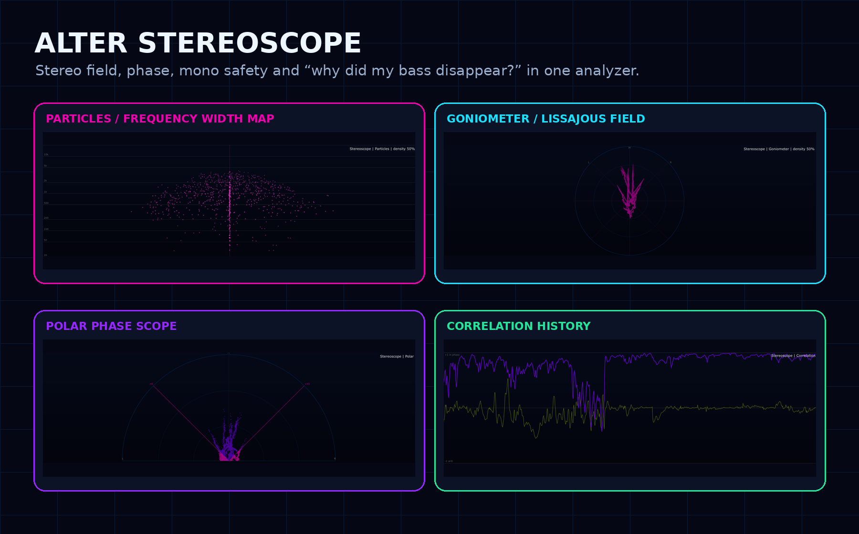
Four views, one question: is the stereo image powerful, controlled, or quietly sabotaging itself?
Wide is cool. Wide that disappears in mono is just expensive bullshit with reverb on it.

What is the StereoScope?
StereoScope is ALTER’s stereo field visualizer. It shows how your audio is distributed between the left and right channels, how much of the sound is shared in the centre, how much lives in the sides, and whether the stereo image will survive when collapsed to mono.
It is not a loudness meter. It is not a pitch detector. Its job is stereo truth: width, phase, balance, mid/side energy and mono compatibility.
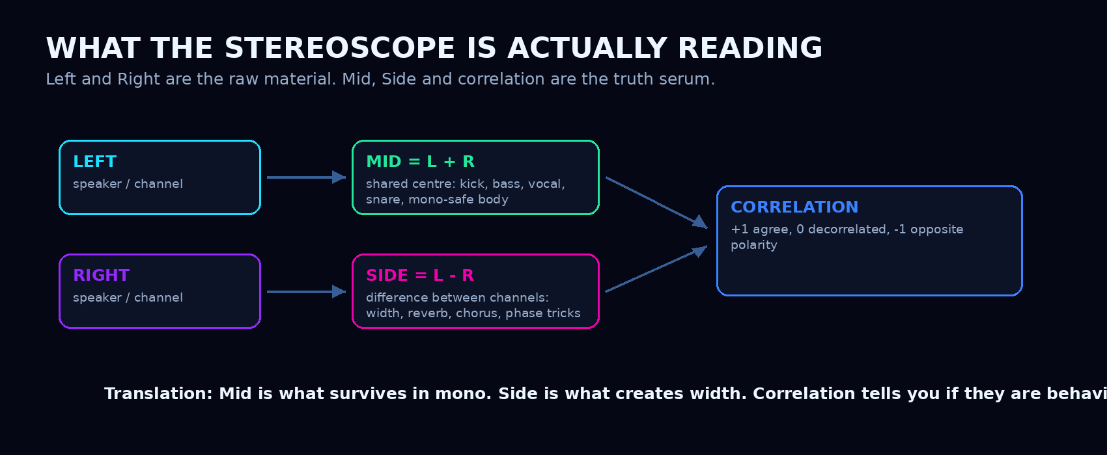
StereoScope compares Left and Right to reveal Mid, Side, correlation and balance behaviour.
Particles Mode / Frequency Width Map
Particles mode is the futuristic view: it shows where stereo width lives across the frequency range. Low frequencies at the bottom, highs at the top. The centre vertical line is Mid energy - the shared mono-compatible part. Horizontal spread is Side energy - what differs between left and right. The measurement is phase-aware: ALTER compares the complex Mid (L+R) and Side (L-R) spectra per frequency band, so truly decorrelated stereo fans outward even when both channel levels are equal, while the L/R balance decides which side the cloud leans toward. Mono content collapses to a tight centre dot.
Use it when you want to know whether your sub is stable, your midrange is getting weird, or your reverb and high-end width are actually doing something useful. It is especially good for spotting low-frequency stereo chaos, because sub bass should not be wandering around like it lost its damn keys.
Spectral Stereo Energy
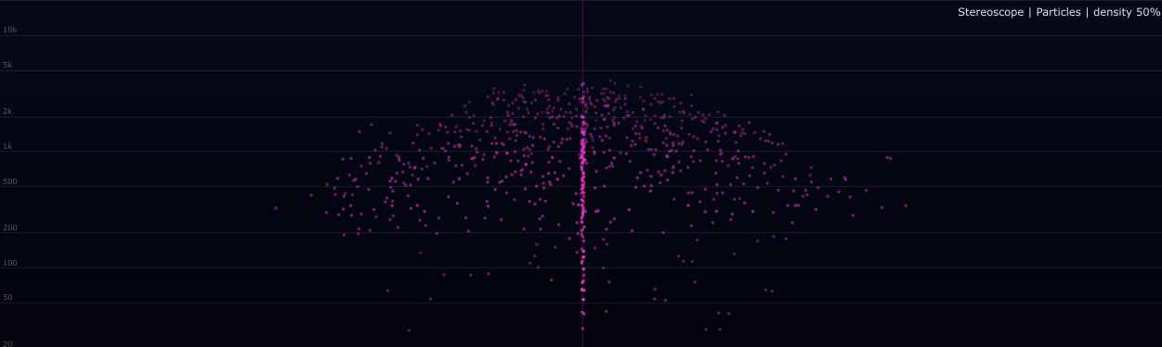
Particles mode maps frequency vertically and stereo side energy horizontally.

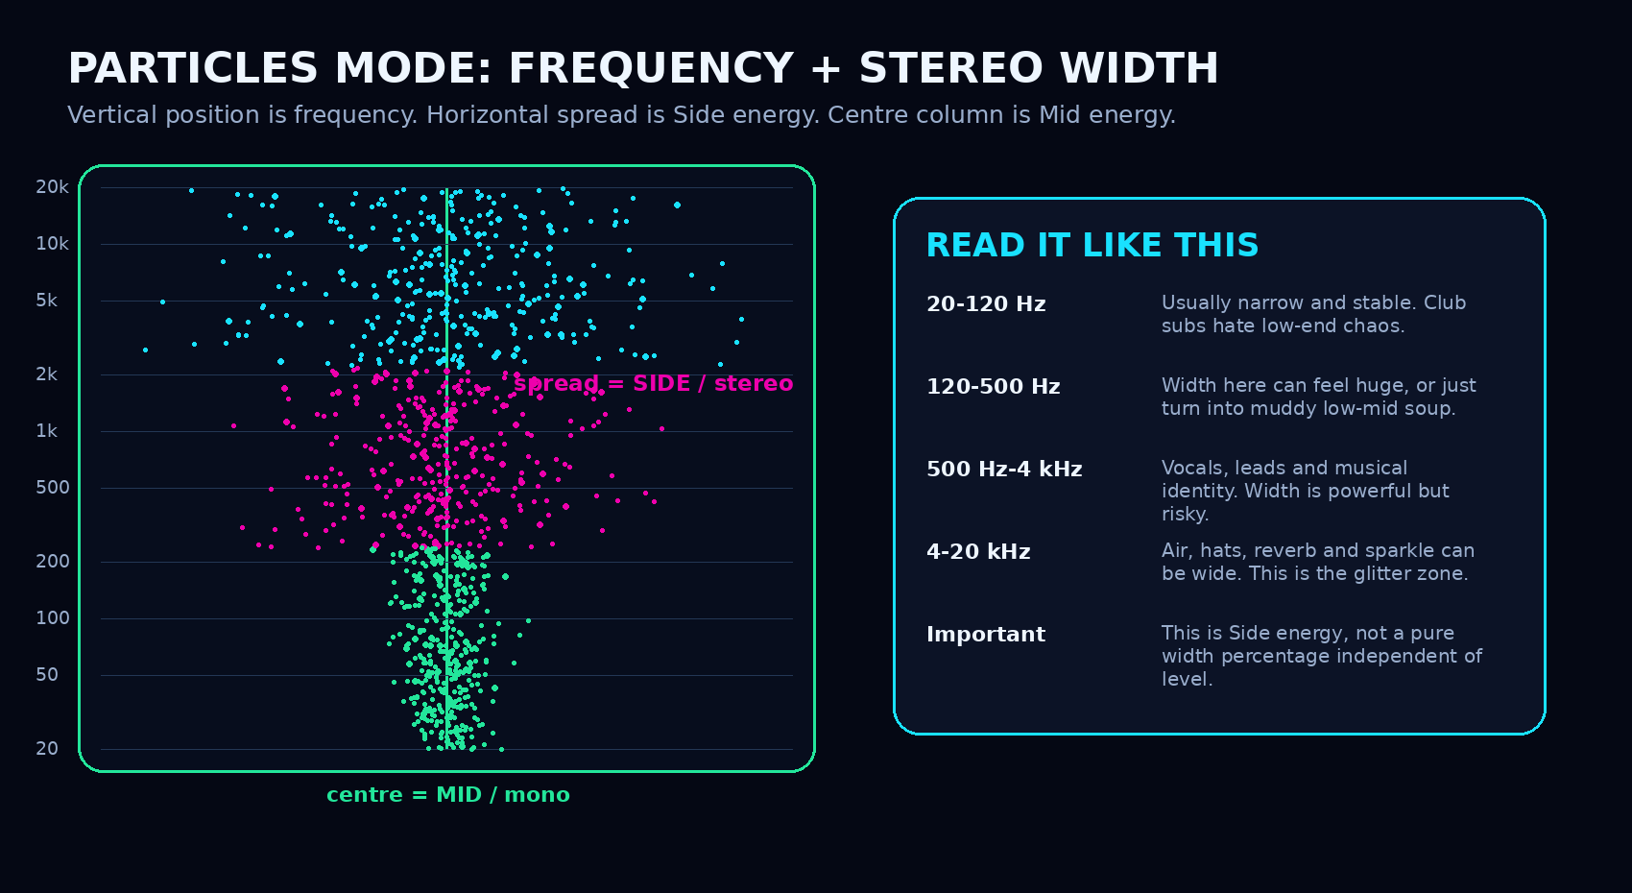
How to read Particles mode: frequency is vertical, Mid energy stays centred, Side energy fans outward.

Goniometer Mode / Classic Lissajous Stereo Scope

Goniometer mode shows the real-time stereo shape on a circular mid/side grid.
The goniometer is the classic audio vectorscope view. It plots the relationship between left and right samples as a Lissajous-style trace. A vertical shape usually means a strong mono centre. A diagonal tilt means channel dominance or panning. A wide horizontal smear means strong side energy or possible phase trouble.
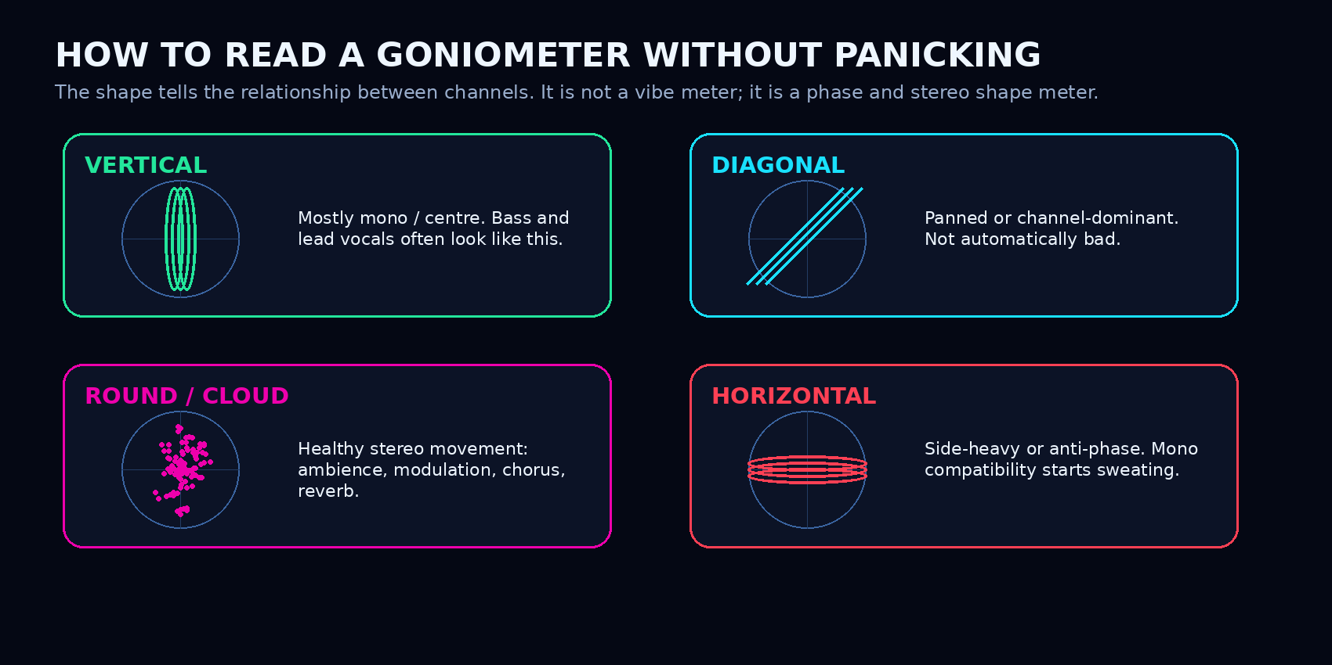
Basic goniometer patterns: vertical means centred, diagonal means panned, horizontal means side-heavy or anti-phase risk.

Polar Mode / Phase Direction Scope
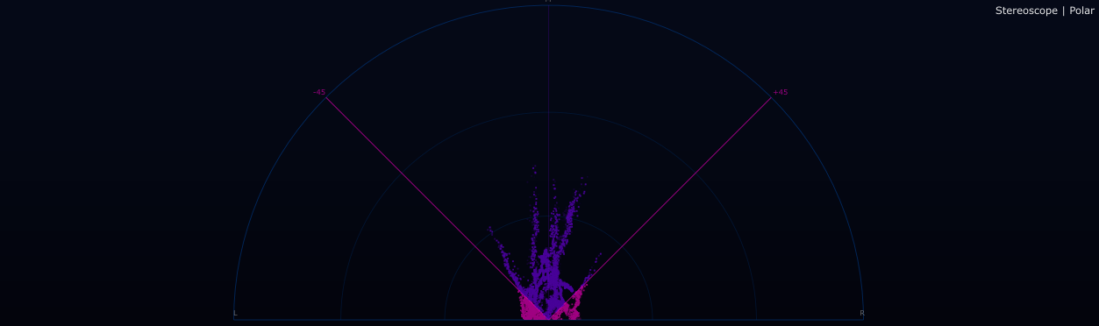
Polar mode shows phase direction and level from a bottom-centre origin.
Polar mode turns stereo phase into direction. Straight up means strong mono alignment. The farther points move toward the horizontal edges, the more side-dominant the sound becomes.
The +/-45 degree guides are useful warning lines, but do not treat them like religious law. A hard-panned mono signal can sit near a side guide and still be legitimate. The real trouble starts when important material lives beyond that guide for too long, because the side energy is overpowering the mid energy.
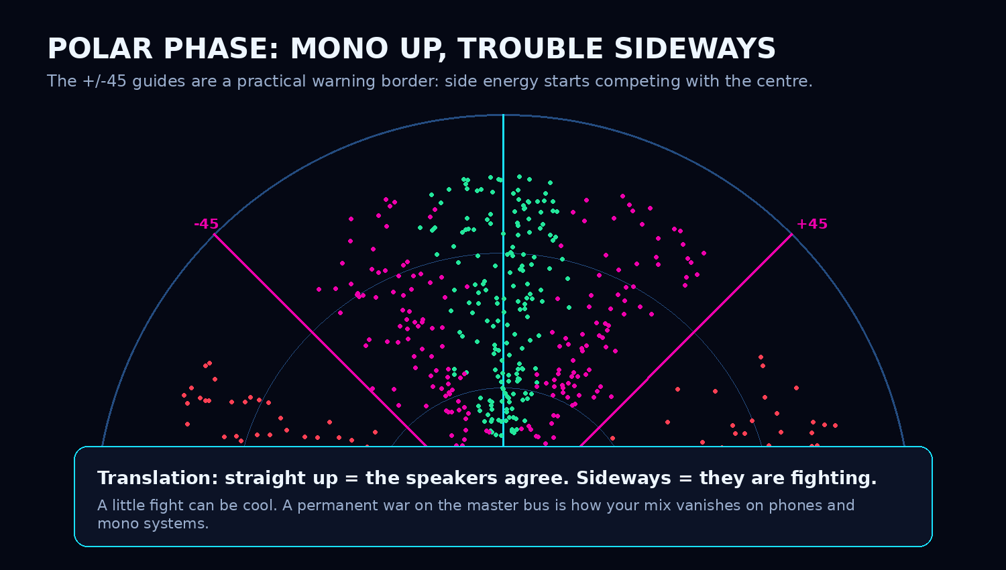
The +/-45 guides are practical warning guides, not a universal physical law.

Correlation Mode / Mono Survival History
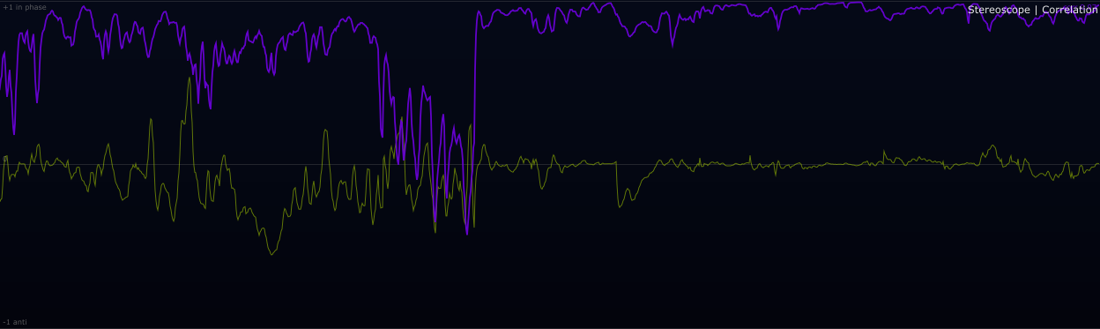
Correlation mode scrolls the L/R phase relationship over time; the secondary line tracks balance.
Correlation mode is the most direct mono-compatibility view. It shows how similar the left and right channels are over time. +1 means the channels are highly similar and mono-safe. 0 means decorrelated, wide, ambient or different. -1 means opposite polarity / anti-phase, which can cancel hard in mono.
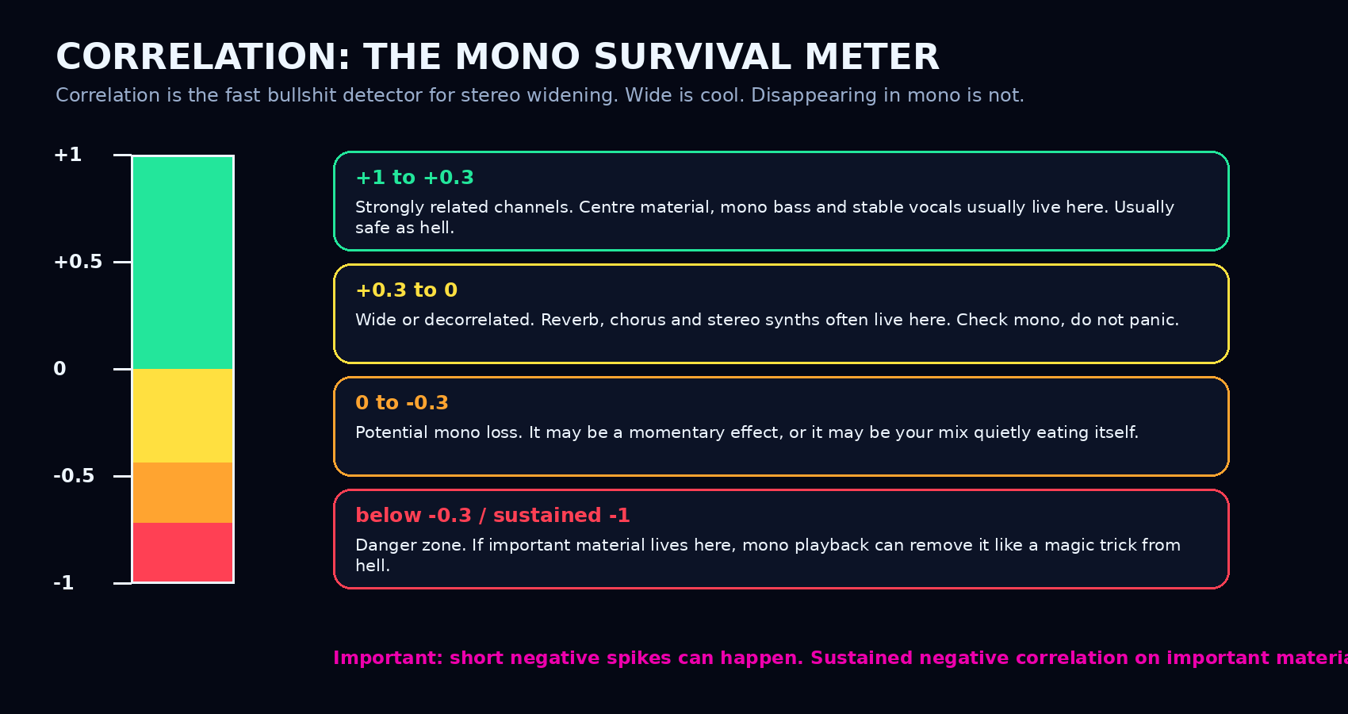
Correlation is a practical mono survival meter: positive is usually safe, sustained negative is a warning.

The core measurements, explained like a human
Mid and Side
Mid is the shared centre of the stereo signal. Side is the difference between left and right. This is the same basic idea used in mid/side processing, stereo imaging and many mastering workflows.
Mid is what survives in mono. Side is what makes the image wide. Too much Side with not enough Mid is where the mix starts doing dumb magic tricks.

Simple version: Mid = L + R. This is the shared material: kick, bass, vocal, snare, centre synths. Side = L - R. This is the difference material: stereo reverbs, chorus, hard-panned content, widening effects and phase movement.
Correlation
Correlation compares the left and right channels mathematically. If they move together, the value moves toward +1. If they are unrelated, it floats around 0. If one is basically the opposite of the other, it moves toward -1. That last one is the mono-cancellation monster.
How to actually use it
While producing
Use Particles mode while building the track. If the low end is spraying sideways, check stereo wideners, chorus, unison synths, stereo samples, Haas delays or phasey bass layers. Big bass is great. Bass that cancels on half the systems is not big; it is a prank.
While mixing
Keep important centre elements stable: kick, sub, bass body, lead vocal and main snare. Use Correlation mode on buses. If a guitar bus, synth bus or FX return sits around zero, that can be fine. If it lives below zero, solo it, mono-check it and ask what is disappearing.
While mastering
StereoScope is a safety check before final delivery. The master should keep width without sacrificing the centre. If a stereo enhancer makes correlation live below zero, congratulations: you made the mix wider and less reliable at the same time.
While DJing or preparing live sets
Use it to compare tracks before a set. A track with a wild stereo low end can sound impressive in headphones but lose weight in a club mono sub system. Correlation and Particles will show that problem quickly.
While sound designing
This is where you are allowed to break things on purpose. Anti-phase movement, huge side energy and weird polar shapes can be part of the art. Just know what you are doing. Creative destruction is cool; accidental cancellation is a sad technical accident.

Working ranges and practical targets
There are no official genre laws for stereo width. These are practical working zones: useful habits, not commandments.
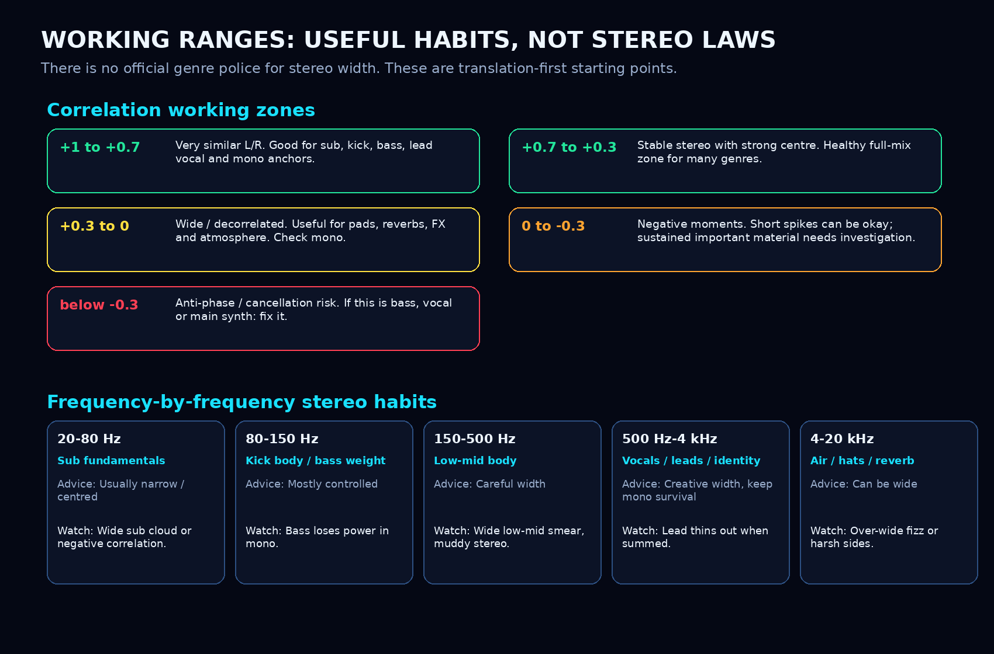
Correlation and frequency working zones. Use these as translation habits, not fake universal rules.

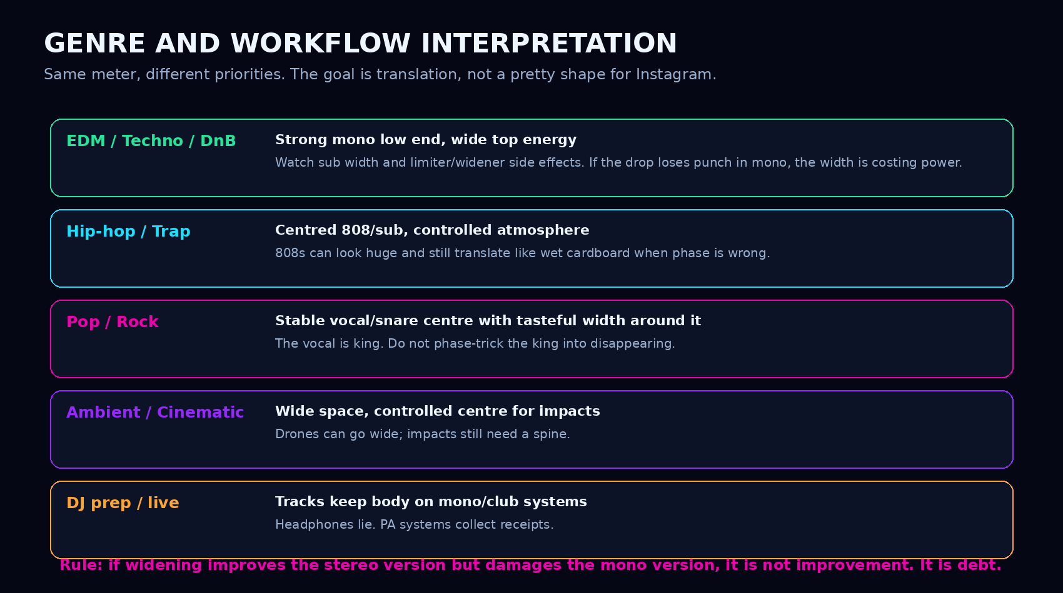
Genre and workflow interpretation: same tool, different priorities.

Controls
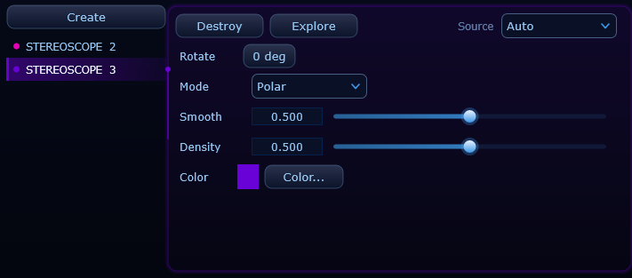
StereoScope controller: Source, Rotate, Mode, Smooth, Density and Color.
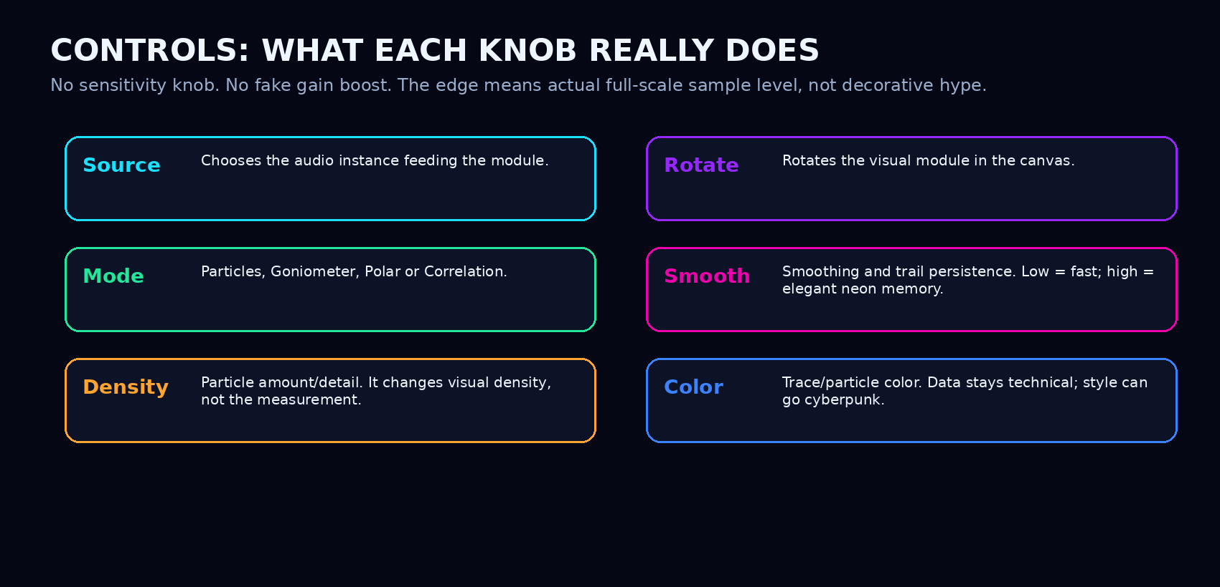
Control explanations without pretending a visual density knob changes the physics.
Common mistakes
Mistake 1: Thinking wider always means better
A wider mix can feel exciting for five seconds and then collapse in mono. Punch, focus and vocal centre matter more than “holy shit, look at that blob.”
Mistake 2: Panicking at every negative correlation spike
Short negative moments can happen with stereo effects, modulation or transitions. The real problem is sustained negative correlation on important material.
Mistake 3: Making the entire master narrow because you fear phase
Mono compatibility does not mean your mix should be a vertical stick forever. A good stereo image has a stable centre and controlled sides.
Mistake 4: Trusting headphones only
Headphones exaggerate separation because each ear receives its own channel directly. Speakers, clubs, phones and mono systems are less forgiving.
Mistake 5: Confusing sample full-scale with true peak
StereoScope uses waveform-level geometry. Delivery-level True Peak checking belongs in Audio Meters, because inter-sample peaks are a separate metering problem.

Final interpretation
StereoScope is the module that tells you whether your stereo image has a spine. It shows what is centred, what is wide, what is phasy, what is leaning, and what might disappear the second the real world turns your beautiful stereo into mono.
Make it wide on purpose. Keep the centre alive. And never trust a stereo effect that only sounds good when nobody checks mono.

Sources and basis
• ALTER internal Stereoscope guide and module behavior: Particles, Goniometer, Polar and Correlation mode descriptions.
• Solid State Logic Meter Plug-in User Guide: phase correlation +1 / -1 interpretation and persistent negative correlation warnings.
• Sound On Sound: phase-correlation meters and mono compatibility; low-frequency mono and side-information discussion.
• RTW Stereo Correlator materials: stereo correlation as a phase relationship and stereo compatibility tool for professional metering.
• Waves Audio: mono-compatibility guidance and cancellation risk when signals are out of phase.
• General math basis: Mid/Side as L+R and L-R, and normalized correlation as a -1 to +1 similarity measure.

