ALTER
Synesthesia
Sound-to-colour fractal engine for the part of your brain that wants music to become light.
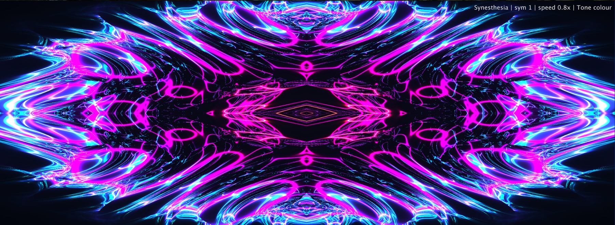
Synesthesia in neon symmetry: the module turns tone, energy and motion into a living visual field.
It is not a meter. It is the gorgeous part of ALTER that says: “what if the sound became light?”

What it does
Synesthesia is ALTER’s expressive audio-visual generator. It listens to the incoming signal and translates pitch movement, octave region and RMS energy into colour, symmetry, motion, glow and fractal-like curves.
This module is intentionally not a delivery meter, not a spectrum reference tool and not a scientific pitch lab. It is a performance-facing visual instrument. Spectrum tells you where the frequency energy is. Audio Meters tell you how loud or dangerous the signal is. Synesthesia tells you what the music wants to look like when you stop being boring for a second.
Use it for live visuals, VJ sets, streams, social media, installations, studio inspiration, music education and that very specific moment when a sound is good, but you want it to feel like it opened a portal.

Scientific accuracy
Scientifically the synesthesia is a neuropsychological phenomenon where one stimulus can elicit an automatic experience in another sensory or conceptual domain. ALTER is inspired by that idea; it does not claim to reproduce a real synesthete’s perception, and it definitely does not diagnose anything. We are making a visual instrument, not doing brain surgery in a club bathroom.

Visual overview
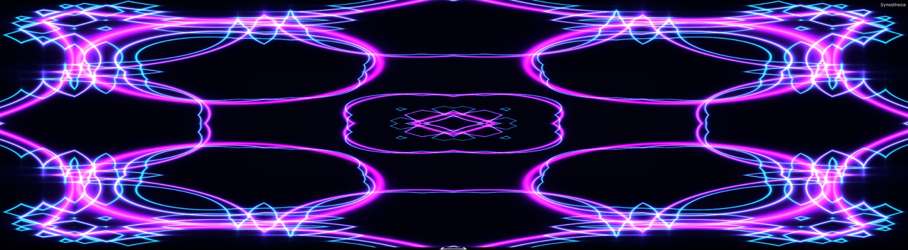
Tone colour, high symmetry and bright bloom create a clean cyber-kaleidoscope visual.

Different looks, same engine
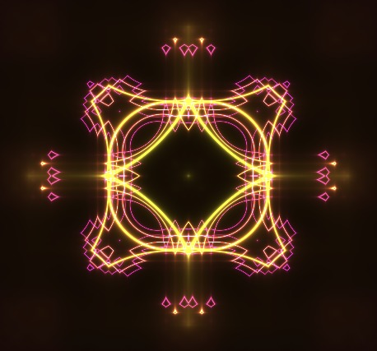 | 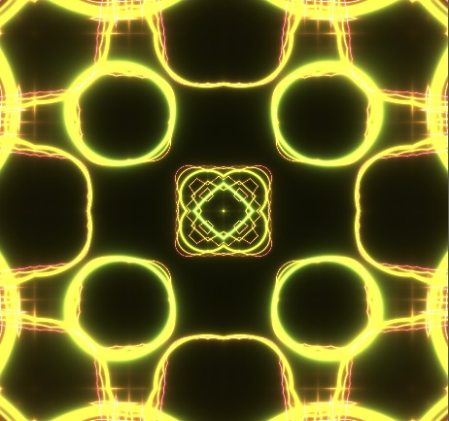
Compact neon form: symmetrical, readable and usable as a central stage motif. | High saturation / bright palette: more aggressive, more “holy shit, this thing is alive.”

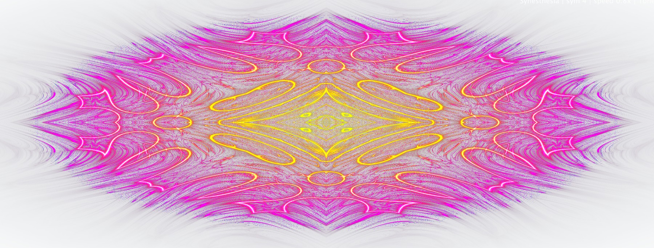 | 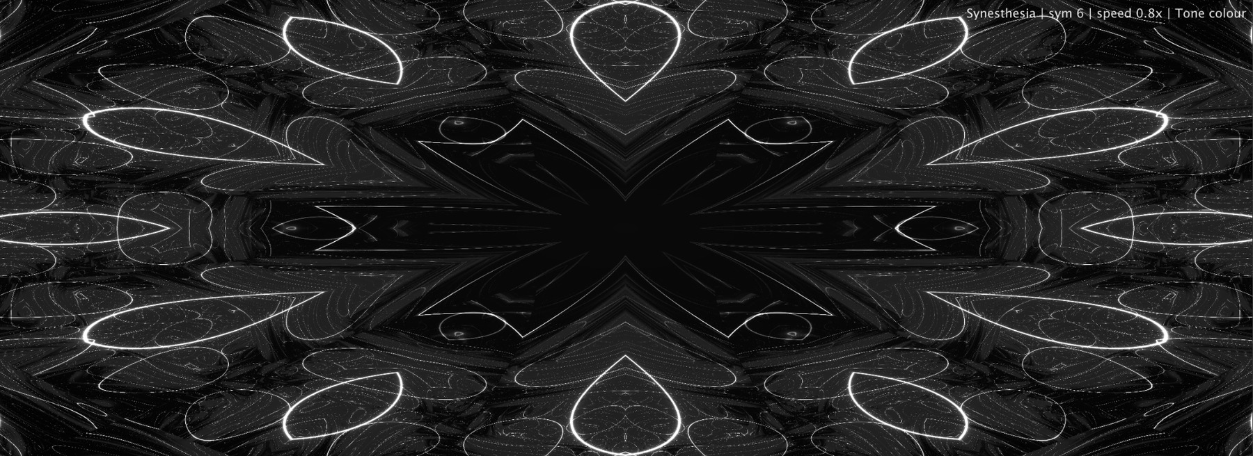
White-background palette: clean, gallery-like and better for bright themes or projection tests. | Monochrome mode: less colour information, more structure, line weight and optical motion.

What Synesthesia actually listens to
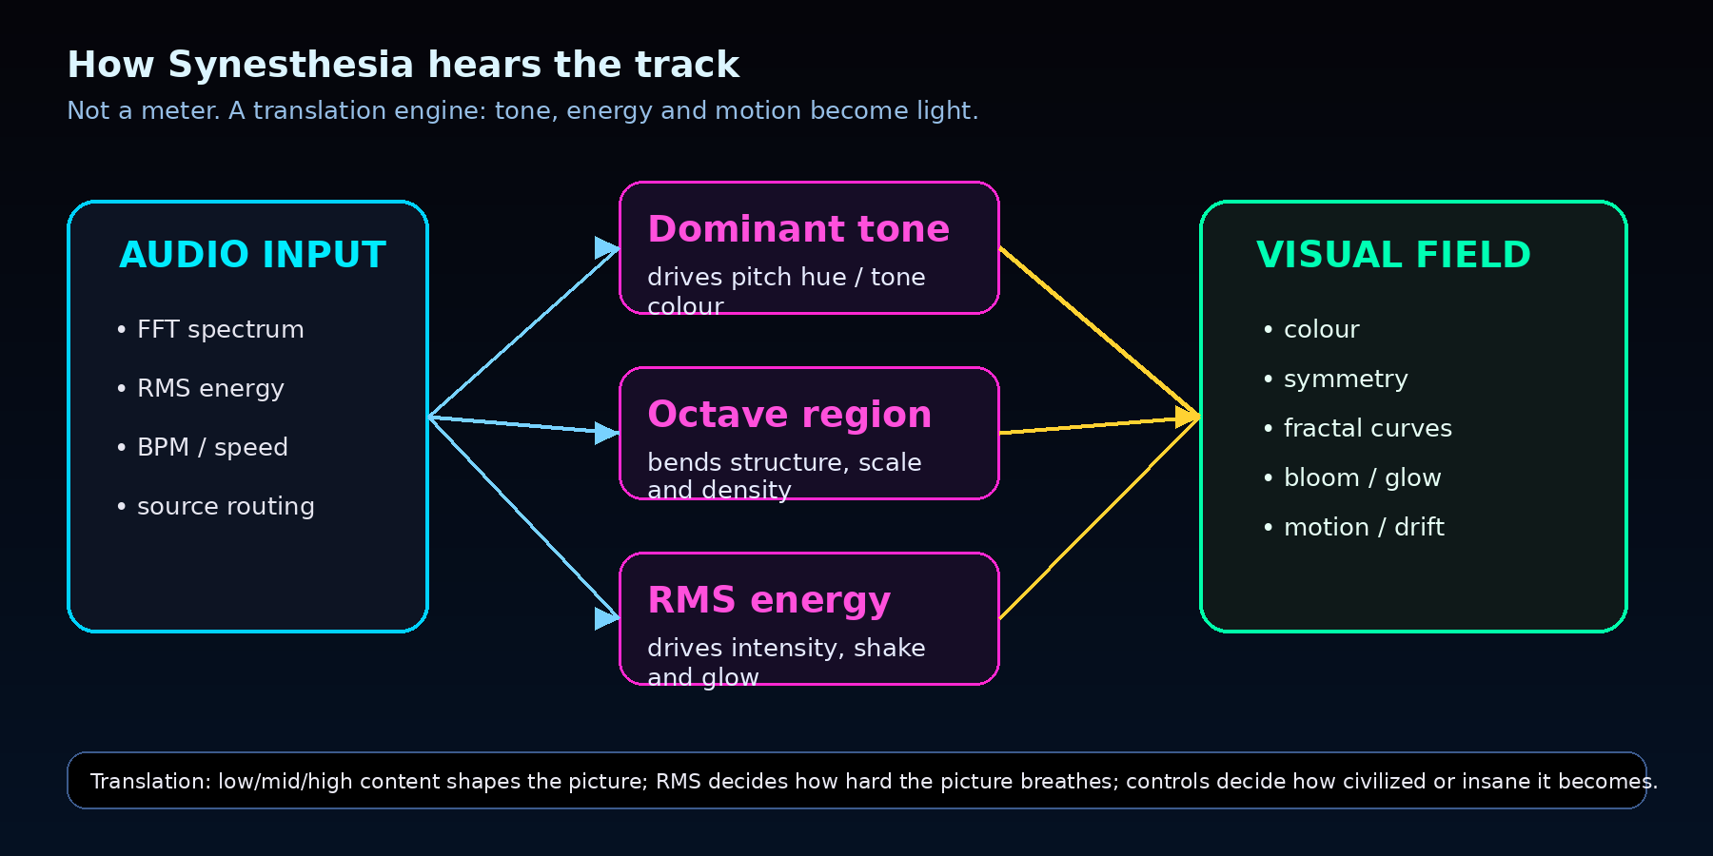
Audio-to-visual mapping: technical data becomes colour, structure and motion.
The module reads FFT spectrum data to estimate a dominant tone and octave region, and it reads RMS to estimate the current energy of the signal. In human terms: pitch decides colour and tonal identity, octave helps build structure, and RMS decides how hard the visual breathes, shakes and glows.
Important: this is not a forensic pitch tracker. Percussion, noise, distortion and huge FX layers do not always have one clean musical note. In those cases the module follows the strongest spectral region and turns it into visual mood. That is exactly what you want for a visual instrument: it should react to the character of the sound, not stop the show because a snare was not tuned to A minor.
If Spectrum is the microscope and Audio Meters are the warning lights, Synesthesia is the hallucination engine with good manners.

Exact Tone Colour Wheel — Mini Technical Guide
The pitch class chooses the colour family. The shader then paints secondary accents around that family, so one tone can become a living palette instead of one boring flat colour.
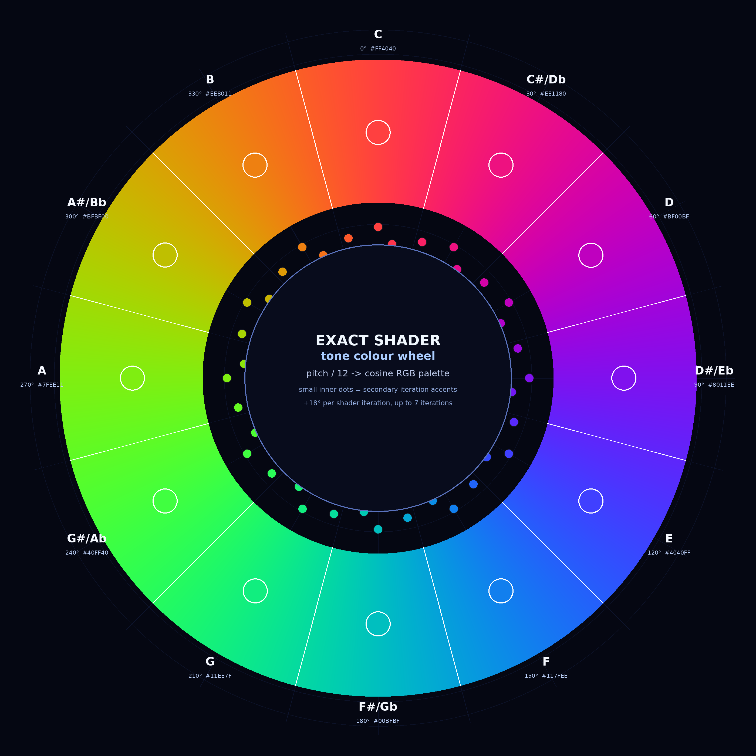
Exact shader colour wheel. Outer ring = continuous cosine palette. Inner dots = secondary iteration accents. C is at the top and pitch classes move clockwise.

Why we won’t see tone C as a red color in the visible module
The colour shift happens because Synesthesia does not draw one note with one flat colour. The detected note only chooses the starting hue family — basically the colour’s home address. After that, the shader adds several visual layers, and each layer nudges the hue a little further around the colour wheel.

So if C starts near a red/coral anchor, the next shader layers can move through hot pink, magenta, violet and blue-violet. That is why your C3 test does not look like a boring red block. It looks pink-purple, because the visible image is not just “C colour”; it is C colour expanded through shader layers.

The octave also matters. Higher octaves can activate more shader iterations, meaning more layers, more geometry, and more secondary hue shifts. In simple terms:
Note = chooses the colour family
Octave = decides how many layers of that family wake up
Shader iterations = push the colour into secondary tones

So the shift is not a bug and not random. It is a controlled shader behaviour: the pitch gives the base colour, then the visual engine lets that colour evolve. Or less politely: the note picks the paint, the octave opens more cans, and the shader starts making beautiful neon soup.

C does not visibly start as pure red because the shader does not display the base hue directly. The base hue is only the starting coordinate of the colour family. The actual visible colour is shifted by spatial position, layer offsets, cosine palette behaviour, brightness weighting and fractal geometry. For C, those shifts push the dominant visible stroke toward pink and violet even when Change is zero.

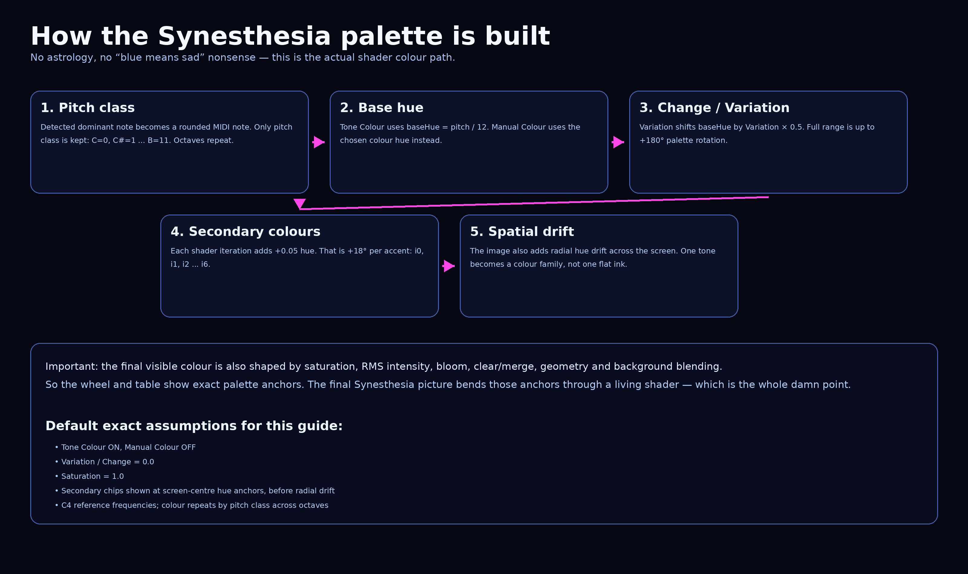
The actual colour path: pitch class -> base hue -> variation shift -> iteration accents -> radial drift -> final shader image.

How Synesthesia Maps Musical Notes to Colour
Synesthesia does not simply slap a random rainbow on the screen. It starts with the dominant tone in the audio, converts that frequency into a musical pitch, then reduces that pitch into a pitch class: C, C#, D, D# … up to B. That means the octave is not the main colour selector. A C in a deep bass octave and a C in a higher synth octave belong to the same colour family. The frequency doubles, the visual behaviour may get more energetic or more detailed, but the core tone colour stays in the same “C family.” That is why the colour wheel repeats every octave.
The important detail is that the shader does not use a simple classroom HSV wheel like “C = pure red, D = pure yellow.” It uses a smoother cosine palette. In practice, this means the colours feel more neon, blended and alive. The base tone gives the main hue, but the shader also creates secondary accent colours by shifting the hue slightly for each visual layer. So one note is not only one flat colour — it becomes a small colour family. That is why Synesthesia can paint a tone with a main colour and still produce glowing secondary trails, edges and accents around it.
Primary Colour vs Secondary Colour
The primary colour is the anchor. It is the main colour identity of the detected tone. Think of it as the “home colour” of the note.
The secondary colours are generated by small hue offsets inside the shader. Each additional visual layer shifts the hue forward, so the line does not look like one dead flat stroke. It gets a glowing edge, a coloured aftertaste, and that electric “alive” feeling. Basically: the note chooses the colour family, then the shader lets it breathe.
So if the detected tone is A, Synesthesia does not just draw “A = purple” and call it a day. It starts from the A hue, then creates nearby accent colours around that hue. That is why the visuals look like musical neon plasma instead of a boring PowerPoint pie chart from hell.
Why Octaves Share the Same Colour
Musically, C2, C3, C4 and C5 are all C. They are not the same frequency, but they have the same pitch identity. Every octave doubles the frequency:
C3 = 130.81 Hz
C4 = 261.63 Hz
C5 = 523.25 Hz
The frequency changes, but the note name stays C. Synesthesia follows that logic. The tone colour is based on the pitch class, not the absolute octave. That gives the visual system musical consistency: bass C and high C feel related instead of randomly changing colour just because the frequency doubled.
What Octave Can Still Affect
The octave can still matter visually. Higher tones can feel sharper, faster, more detailed or more nervous. Lower tones can feel heavier, wider or slower. But that is movement and structure — not the core colour family.
So the simple version is:
Pitch class = colour family
Octave = visual behaviour / energy context
Shader layers = secondary colours and glow
Or less politely:
The note picks the colour. The octave changes the attitude. The shader adds the sexy bullshit.
Example
If Synesthesia detects C, the base colour family is the C colour. If the same musical C appears one octave higher, it still belongs to the same colour family. But the higher octave may create a tighter, sharper, more active movement in the visual.
If the shader then draws multiple layers, each layer shifts the hue slightly, creating secondary colours around the base colour. That is why one tone can produce a rich neon gradient instead of a single flat line.

Does it cover whole frequency spectrum?
Synesthesia has a musical reaction window, so it does not keep changing tone colour and complexity forever across the whole frequency universe. The pitch colour is detected only from a focused low/mid FFT region: the module scans bins 3–85 for pitch class, which is roughly about 70 Hz to 2 kHz if we assume 48 kHz / 2048-bin mapping, and octave movement is scanned wider, bins 1–170, roughly 23 Hz to 4 kHz. If the detected peak is too weak, it keeps the previous smoothed value instead of freaking out on noise.
So the real behaviour is: bass, mids and musical fundamentals drive the tone identity best; very high frequencies mostly stop being “notes” and become texture, brightness, motion, or sparkle. That is good. Above a certain point, the audio is often hats, air, noise, distortion, consonants, reverb fizz — not stable pitch information. If Synesthesia tried to recolour the whole visual every time a hi-hat tick wins at 10 kHz, the module would turn into nervous rainbow diarrhea. Instead, the tone system follows the musically meaningful range, while RMS, speed, shader motion, bloom, saturation, symmetry and secondary layers keep the image alive. The note picks the colour family; the octave and energy influence attitude; but once the sound gets too high, too noisy, or too weak, Synesthesia stops pretending every sparkle is a meaningful note — which is exactly the right kind of restraint.

Why This Is Better Than Simple Random Colour
Random colour looks cool for about five seconds, then it becomes meaningless visual soup. Synesthesia’s tone colour system gives the visual identity a musical anchor. If the sound changes pitch, the colour changes in a predictable way. If the pitch returns, the colour identity returns too.
That means DJs, VJs, sound designers and curious beginners can actually learn from the visual:
same tone family → same colour family
new tone → new colour direction
higher/lower octave → related colour, different behaviour
So the module is not only pretty. It teaches your eyes to follow pitch relationships. Which is exactly the point: sound becomes visible without turning the screen into random neon spaghetti.
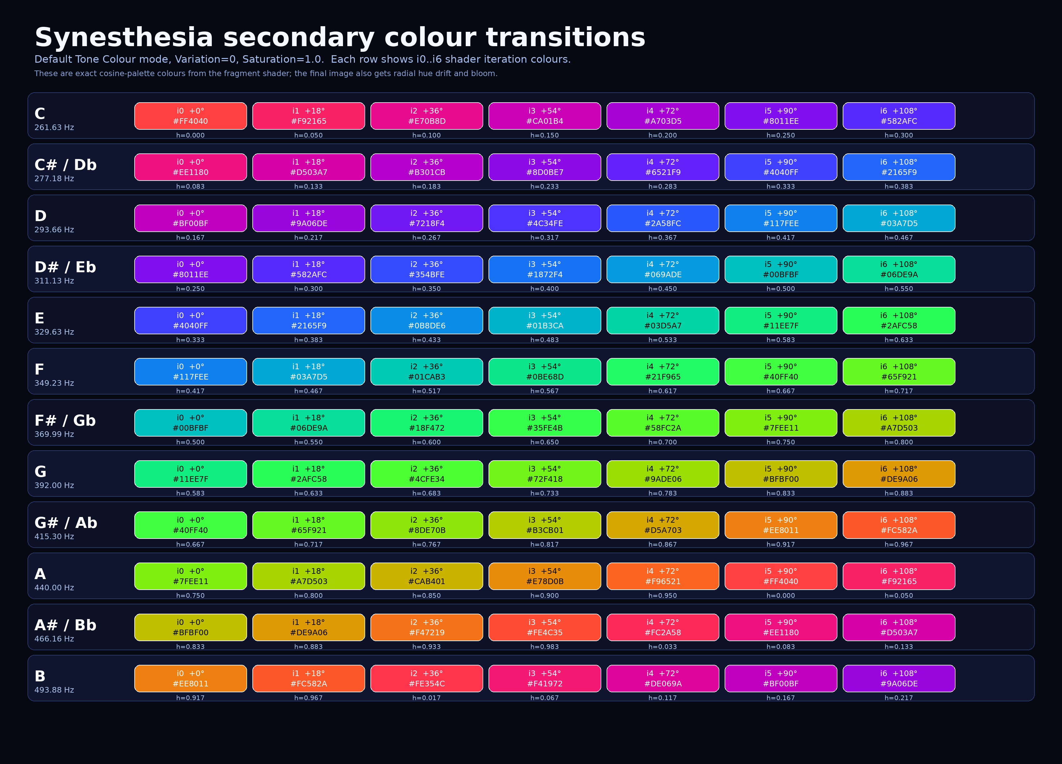
Exact transition strips. Each row shows primary + secondary shader iteration colours for one pitch class. Actual visible count depends on octave-iteration count.
Core i0 is the base tone colour; i1-i6 are secondary accent anchors in the default Tone Colour palette. Octave is responsible for how many secondary iterations will be visible an how complex hallucinations will look.

How to use this colour map
Core tone colour: main tone-colour relation. If the detected dominant tone is A, the visual family starts from the A colour anchor. Simple. Beautiful. Not mystical bullshit.
Secondary accents: module does not paint one flat colour. The shader walks forward on the hue wheel with each iteration, so the detected note becomes a family of related colours.
Variation / Change: This rotates the palette. At 0.0 the table is exact. As Variation rises, the whole colour identity shifts by up to half the wheel, while the structure also morphs. So the table is the default anchor map, not a frozen screenshot of every possible setting.
Manual Colour mode: When Manual Colour is active, the chosen colour replaces pitch-derived hue. In that mode, hsc is reduced, so the shader stays closer to the selected colour family and the secondary spread becomes tighter.
Saturation: Saturation does not change which tone was detected. It pulls the colour toward white or lets the neon family scream properly. At 1.0 the table colours are shown at full shader saturation.

Sculpting controls: Fragment, Transmute, Clear, Denoise
Four controls morph the fractal field itself. Fragment morphs the structure and rotates the palette identity. Transmute is a second, symmetric morph: radial rings and lens-waves that keep the composition centred. Clear reduces the layer count from the top - a cleanup that keeps reactivity while calming the image. Denoise fuses the thin dashed secondary curves into continuous lines and dims them slightly, so the back layers stay perceptually BEHIND the main stroke instead of competing with it. Bloom, not Denoise, is the thickness and glow control.

BPM sync - light that hits on the beat
BPM sync does not change the fractal's evolution speed; it adds a light wave that sweeps from the centre outward on every beat division. Beat Div picks the division, BPM sets the tempo. With an ALTER Creator plugin on a track, the pulse phase-locks to the DAW transport (tempo + song position streamed over UDP), so the flash lands exactly on the host's beats when you play from 1.1.1 - the manual BPM is only the fallback when nothing is playing.

Controls
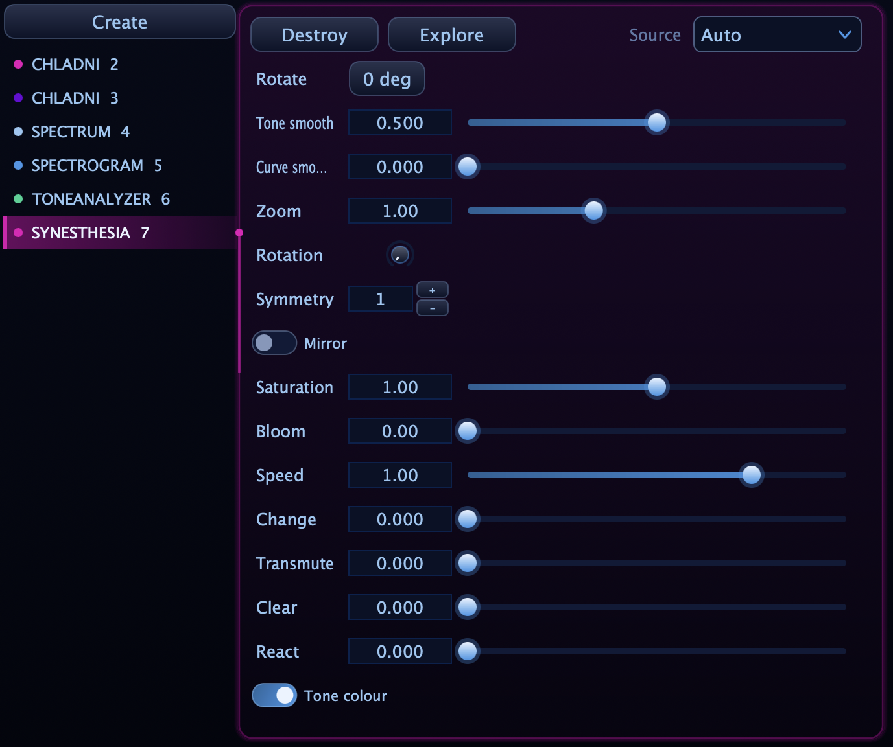
Controller settings: tone smoothing, curve smoothing, zoom, rotation, symmetry, mirror, saturation and the rest of the visual behaviour live here.

Control | What it does | How to use it
Source | Selects Auto routing or a specific audio source. | Use Auto for normal work; choose a source when multiple Listener instances feed different modules.
Rotate | Rotates the module container visually. | Useful for layouts and installations. This is not the same as internal visual Rotation.
Tone smooth | Smooths pitch/tone/octave response. | Low = twitchy colour changes. High = smoother tone identity and calmer colour transitions.
Curve smooth | Smooths the displayed geometry and motion lag. | Low = immediate shape changes. High = ghost-like drift and more elegant motion.
Zoom | Scales the pattern from close-up to wide field. | Zoom in for aggressive abstract texture; zoom out for full mandala structure.
Rotation | Rotates the internal visual field. | Slow rotation feels hypnotic. Too much can make the visual spin like a drunk satellite.
Symmetry | Sets 1-8 fold symmetry. | 1-2 = organic. 4-8 = mandala, crystal, cyber cathedral.
Mirror | Reflective fold of the visual field. | Turns chaotic motion into a more controlled kaleidoscope. Great for stage visuals.
Saturation | Colour intensity. | 0 = monochrome. 1 = normal. 2 = hyper-saturated nuclear candy.
Bloom | Glow around bright areas. | Small bloom adds depth; too much bloom can turn detail into soup.
Speed | Animation speed; can reverse when negative. | 0 = still. 0.8-1.2 = natural motion. Higher = intense performance energy.
Reactivity | Audio-driven shake/motion strength. | Use more for drums and heavy drops; use less for ambient or clean visuals.
Tone colour / Manual colour | Tone colour derives hue from audio; manual colour locks the palette. | Tone colour follows musical movement. Manual colour is better when branding or stage palette matters.
Change / Variation | Morphs the fractal into a different visual family. | Use for finding a new visual personality without changing the whole module.
Transmute | A second symmetric morph for rings, falloff and glow behaviour. | Use carefully. It can make the visual feel evolved instead of merely adjusted.
Clear | Cleans/merges small overlapping curves. | Higher values preserve main curves and reduce tiny noisy detail.

Tone Smooth vs Curve Smooth
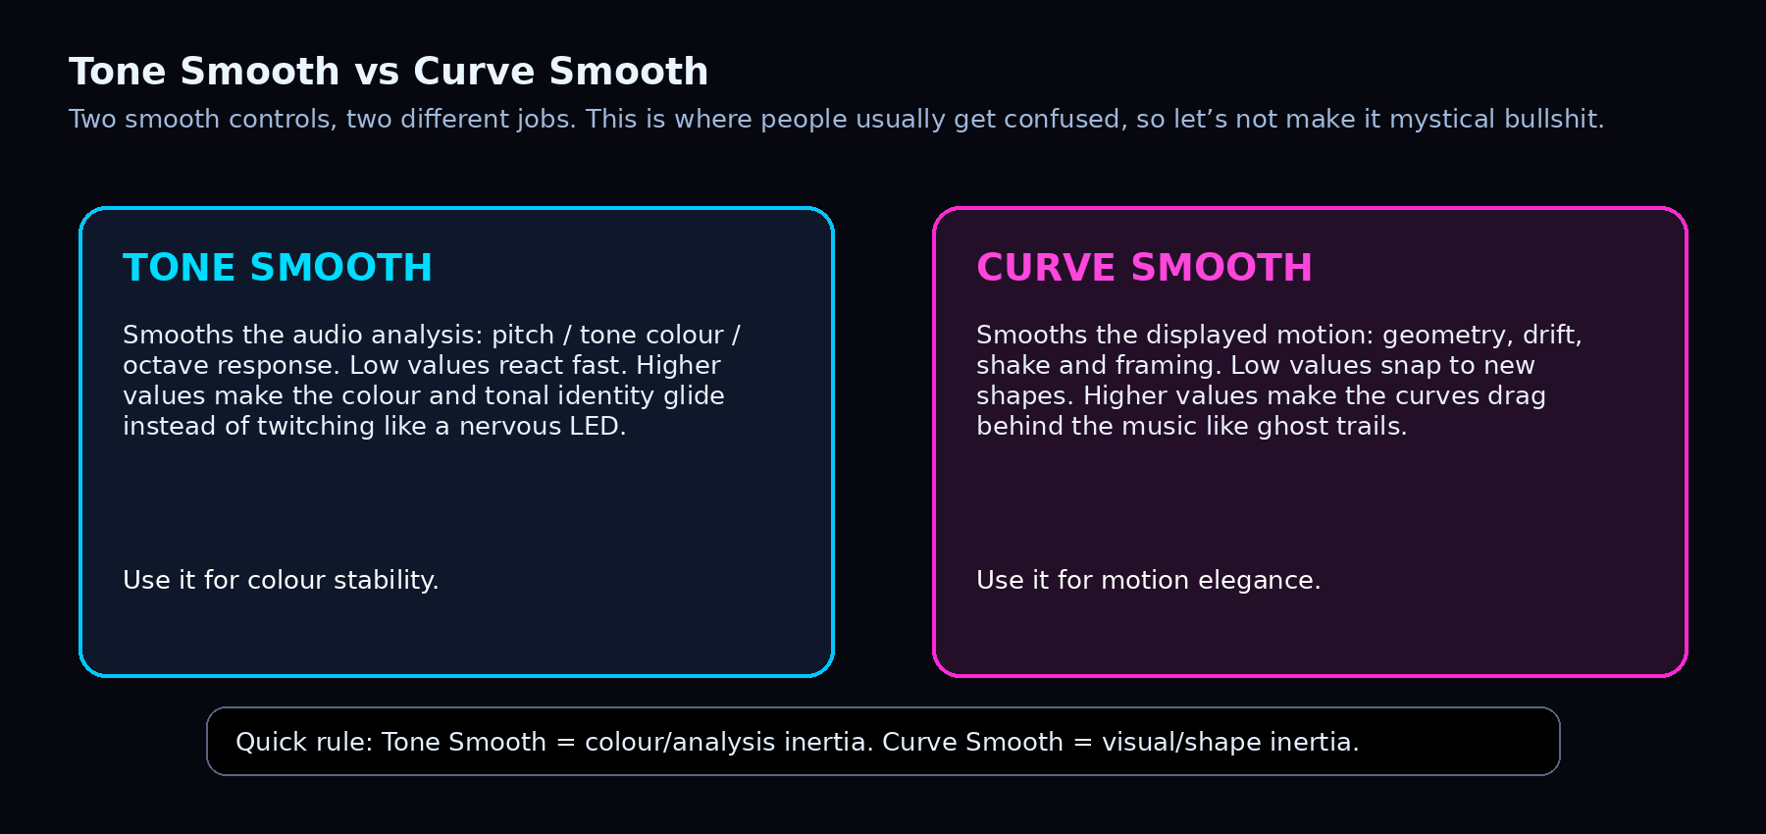
The two smoothing controls are separate on purpose: one calms the analysis, the other calms the motion.

Synesthesia vs measurement tools
Module | Reads | Best for | Main question
Spectrum Analyzer | Frequency distribution | EQ, references, mud, harshness, tonal balance | “Where is the energy?”
Spectrogram | Frequency history over time | movement, harmonics, notes, noise, evolving textures | “How did the energy move?”
Audio Meters | RMS, LUFS, True Peak, Level History | loudness, density, clipping risk, delivery safety | “Is this loud / safe / crushed?”
Synesthesia | Expressive sound-to-visual mapping | performance, mood, stage identity, inspiration | “What does this feel like as light?”
The mistake is to ask Synesthesia for engineering truth. It is not there to decide whether your master is -14 LUFS or whether your 120 Hz region is muddy. It is there to create a convincing visual translation of the music. Pair it with Spectrum or Audio Meters when the session needs numbers; let Synesthesia be the part that makes the room shut up and look at the screen.

How to actually use it
Situation | Practical setup
Live / VJ set | Detach it, fullscreen it and let it become the visual identity of the set. Symmetry and Mirror are your friends when the crowd needs something readable from distance.
DJ performance | Use slower Tone Smooth and moderate Curve Smooth so the visual follows transitions instead of freaking out on every hi-hat. Synesthesia should feel like the room is breathing with the mix.
Studio inspiration | Leave it in peripheral vision while designing sounds. Busy visuals often mean busy audio. Calm visuals often mean sparse audio. Is it scientific? No. Is it useful? Annoyingly often, yes.
Sound design | Use low smoothing and Tone colour to see how distorted basses, risers, impacts and drones change visual identity. It helps you feel the motion of a sound, not just measure it.
Installation / gallery | Use white or monochrome palettes, high curve smoothing and slower speed. Let the module become a living light object instead of a nightclub assault weapon.

Starting recipes
Recipe | Suggested settings | Best for
Neon mandala | Symmetry 4-8, Mirror ON, Tone colour ON, Saturation 1.2-1.8, Bloom 0.3-0.7, Speed 0.8-1.2 | Big-room, stream visuals, cyber identity.
Monochrome cyber | Saturation 0, Bloom 0.2-0.6, Symmetry 1-3, Curve Smooth 0.2-0.5, Manual colour white/grey | Industrial, techno, minimalist, high-contrast projection.
White gallery mode | Bright theme, Saturation 0.8-1.4, Bloom low, Curve Smooth high, Speed slow | Installations, clean web shots, less club and more “digital organism.”
Bass aggression | Reactivity higher, Curve Smooth low-mid, Bloom 0.5+, Speed 1.2-1.5, Symmetry 1-3 | Drops, impacts, dirty basses, chaotic energy.
Ambient drift | Tone Smooth high, Curve Smooth high, Speed 0.1-0.5, Bloom 0.2-0.5, Symmetry 2-6 | Slow evolving sets, drones, sleep/space textures.

Selected visual styles
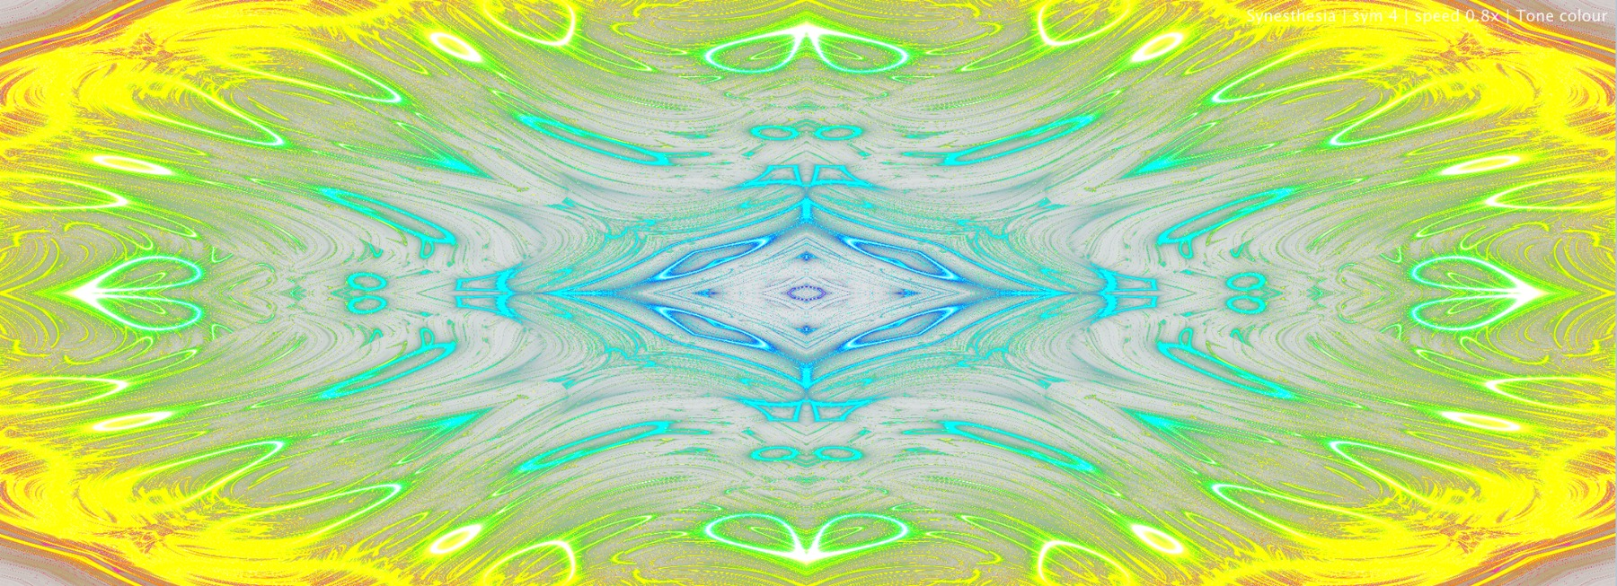
Bright background / high saturation: useful when the module needs to feel more like kinetic digital painting than nightclub hardware.
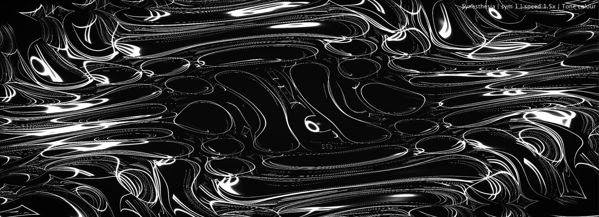
Monochrome flow: removes colour drama and exposes the structure of the visual field.
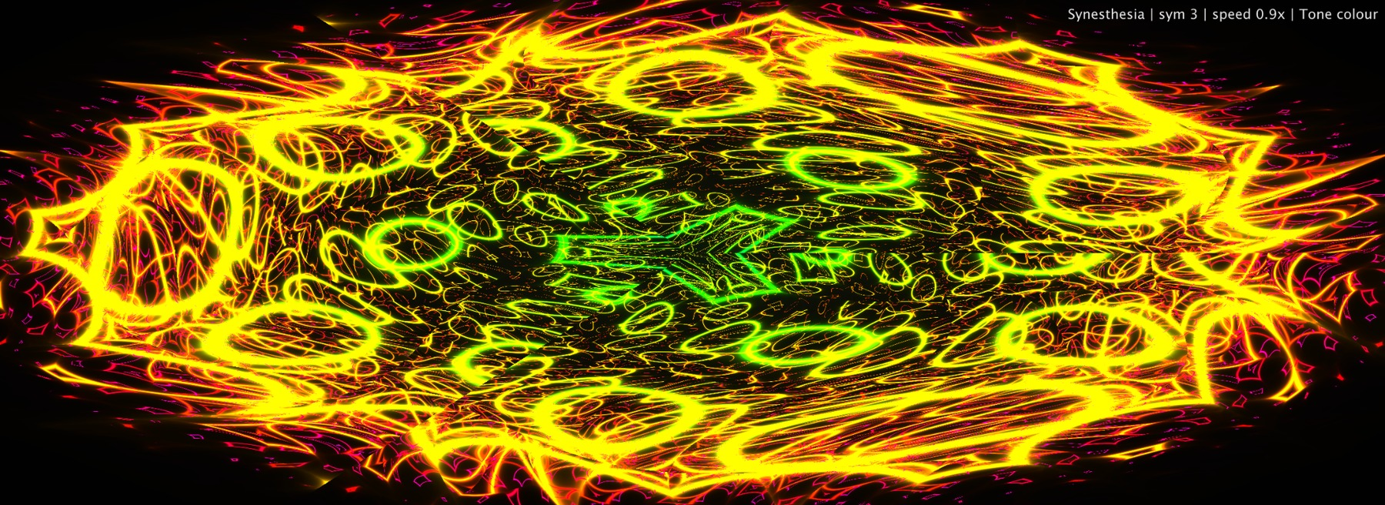
High-energy warm palette: useful for aggressive music, heavy drops and strong performance branding.
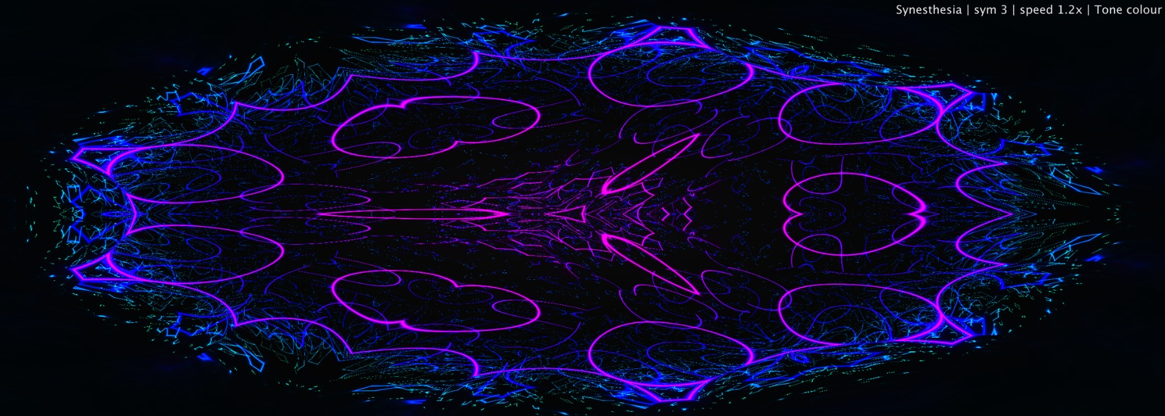
Darker tone-colour field with slower structural movement: good for deeper, moodier sets.

Common mistakes
Mistake | Why it sucks | Better move
Using it as a meter | It will look cool while lying to your engineering brain. | Use Spectrum and Audio Meters for decisions; use Synesthesia for perception and vibe.
Too much bloom | Everything becomes a glowing soup and detail dies. | Raise bloom until the curves feel alive, then stop before the picture turns into a fog machine.
Too much symmetry | The visual becomes pretty but emotionally frozen. | Use lower symmetry when the music needs aggression or organic motion.
Too little smoothing live | Fast material becomes twitchy and unreadable from the crowd. | Increase Tone Smooth and Curve Smooth for stage clarity.
Assuming colours are universal | Real synesthetic associations are personal; there is no official note-to-colour law. | Use Tone colour for reactive behaviour, manual colour for branding and design control.
Forgetting source routing | The module may react to the wrong track or master bus. | Use Source intentionally when multiple Listener plugins are active.

Final interpretation
Synesthesia is the emotional translator of ALTER. It does not ask whether your mix is compliant, whether your bass is too wide, or whether the master will survive Spotify. It asks a better question for performance: does the music have a visual identity?
The best use of this module is not to make every track look equally insane. The best use is to let different sounds create different worlds: clean geometric symmetry for precision, chaotic curves for distortion, monochrome ghosts for minimalism, bright bloom for euphoria, and heavy mirrored structures when the room needs to feel bigger than the speakers.
You do not use Synesthesia to prove the sound. You use it to make the sound visible enough that people feel it before they understand it.

Sources and technical basis
ALTER internal Synesthesia module: FFT-derived dominant tone and octave response, RMS-driven intensity and audio shake, smoothing behaviour, OpenGL shader state, symmetry, mirror, saturation, bloom, variation (Fragment), transmute, clear, denoise (back-layer fusing), beat-pulse BPM sync with host transport lock and source routing.
Jamie Ward, “Synesthesia,” Annual Review of Psychology 64:49–75 (2013), DOI 10.1146/annurev-psych-113011-143840. Used for the scientific framing of synesthesia as an elicited, automatic, perceptual/cognitive phenomenon with consistency and individual variation.
Matthew Joseph Adiletta and Oliver Thomas, “An Artistic Visualization of Music Modeling a Synesthetic Experience,” arXiv:2012.08034 (2020). Used as a digital-art reference for music-to-visual translation using audio input, DSP/FFT analysis and visual simulation.
ALTER product design position: Synesthesia is documented as a performance-facing generative visual module, not as a metering tool, pitch-correction tool or external delivery standard.
ALTER Synesthesia.h: dominant FFT peak is converted to frequency, then MIDI note, then rounded pitch class modulo 12. This defines the repeating tone-colour identity.
ALTER Synesthesia.h and SynShader.h: octave is tracked separately from pitch class and passed to the shader state, so octave can affect visual structure without changing the pitch-class colour loop.
ALTERGLHost.h fragment shader: baseHue = pitch / 12 in Tone Colour mode; Variation shifts baseHue by Variation × 0.5; iteration colour uses hue += i × 0.05; RGB is generated with the cosine palette formula.
12-tone equal temperament with A4 = 440 Hz is used for the reference frequency values and nearest-note ranges in the table image.

