Tone Analyzer
Documentation for people who want to find the notes, read the chord, and stop guessing.
Tone Analyzer shows the twelve pitch classes C through B, the exact notes currently detected, and the chord they form. It is a note-and-chord detective, not a rainbow keyboard. The colour is only a module-wide accent; note identity is shown by text and by the 12 pitch-class bars.
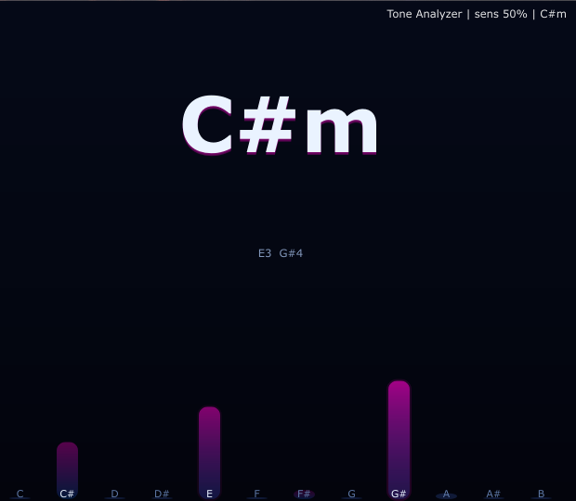
The main display: detected chord name, exact notes, and pitch-class energy bars.
How it works
- Peak picking scans the 55 Hz–5 kHz band and keeps strict local maxima only.
- Harmonic suppression ignores overtones so one real note does not spawn a fake army of extra notes.
- Level gating keeps only peaks within 18 dB of the strongest one.
- Temporal gating waits about 130 ms before a note appears, so random transients do not flicker in and out.
- Up to five simultaneous notes are kept, then the chord matcher tests common templates such as major, minor, 7th, sus, dim, aug, 6, m6 and add9.
How to use it
- Find the key of an unlabeled loop, sample or stem before you build around it.
- Tune 808s and kicks by checking the dominant note instead of eyeballing a waveform like a lost wizard.
- Verify stacked vocals: each pitch class should show up when the harmony is really there.
- Spot clashing resonances: a note that keeps returning is often a ringing room mode or a mistuned layer.
Bottom line: Tone Analyzer is a practical musical helper. It tells you what note is there, what chord it belongs to, and how stable that answer is. If the material is too noisy, too distorted, or too high in frequency, the analyser stops pretending and simply keeps the last stable result.
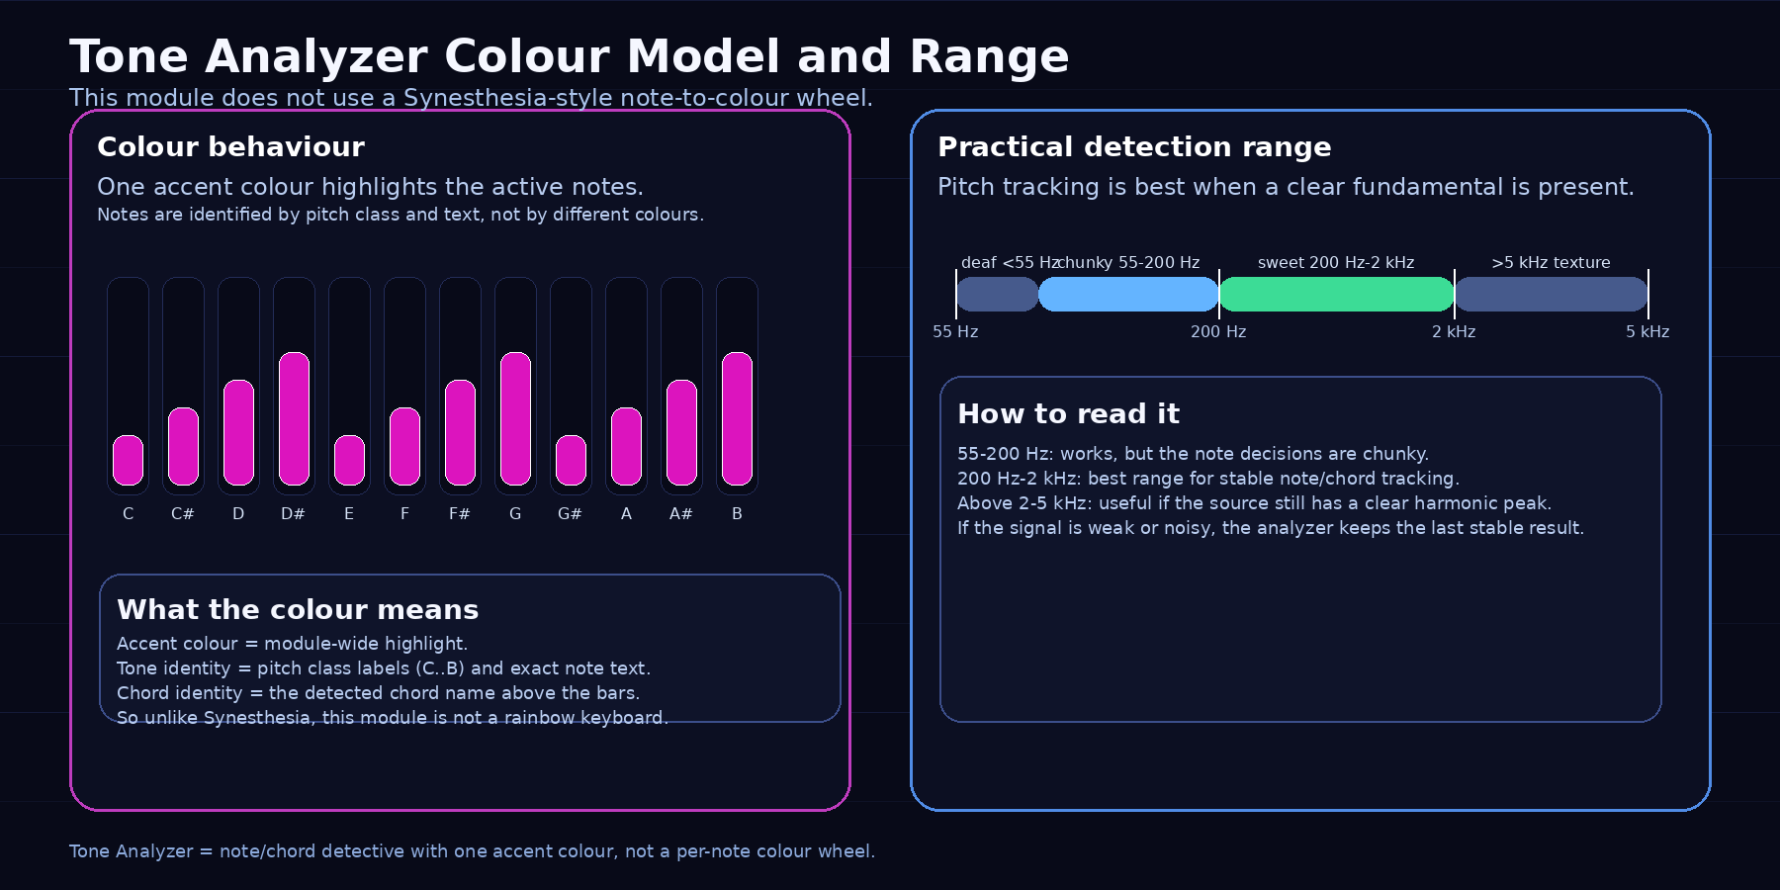
Colour is an accent, not a pitch map. The analyser stays readable because the note names do the heavy lifting.

Semitone ranges and chord templates
Tone Analyzer works with pitch classes, so note names repeat every octave, the practical semitone range is a soft zone around a center frequency rather than a hard wall, and chords are detected the same way: the module matches pitch-class templates, then names the result from the strongest stable root — because in real audio, notes are guide rails for the brain, not prison bars for the waveform.
Semitone reference map (12-TET, octave repeats every 2x)
Semitone | Note name | C4 reference
0 | C | 261.63 Hz
1 | C# / Db | 277.18 Hz
2 | D | 293.66 Hz
3 | D# / Eb | 311.13 Hz
4 | E | 329.63 Hz
5 | F | 349.23 Hz
6 | F# / Gb | 369.99 Hz
7 | G | 392.00 Hz
8 | G# / Ab | 415.30 Hz
9 | A | 440.00 Hz
10 | A# / Bb | 466.16 Hz
11 | B | 493.88 Hz

Practical note ranges
Each semitone is roughly the region halfway between neighbors. Example for C4:
- C4 practical zone: about 253.1–269.3 Hz
- C#4 practical zone: about 269.3–285.3 Hz
- D4 practical zone: about 285.3–302.3 Hz
And then the same pattern repeats in every octave, doubled or halved:
C3 = 130.81 Hz
C4 = 261.63 Hz
C5 = 523.25 Hz
So yes: the colour/note family repeats every octave, but the frequency changes by ×2 each octave.
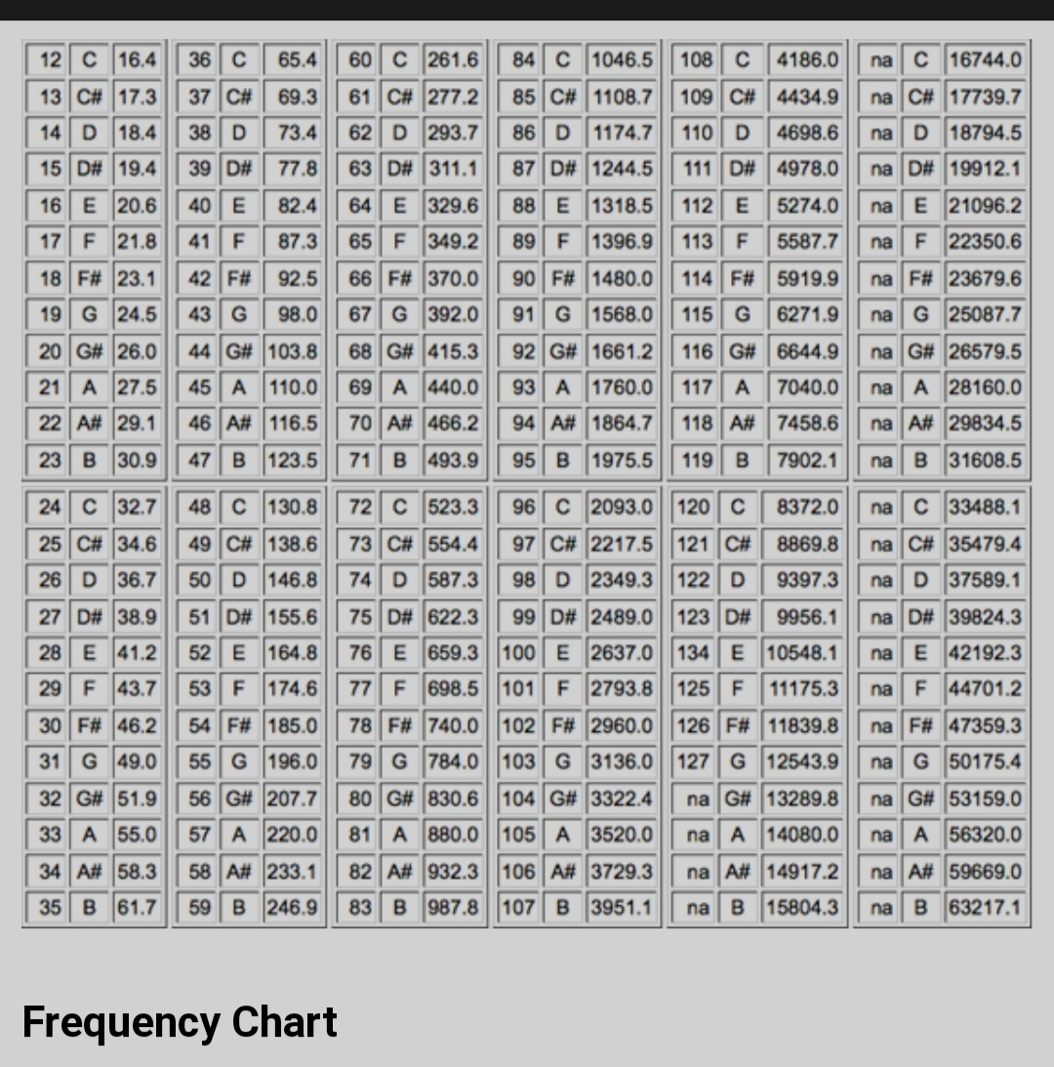
this is full frequency chart for semitones

Common chord formulas, semitones and full names
Chord | Semitone formula from root | Full name
Major | 0, 4, 7 | Major triad
Minor | 0, 3, 7 | Minor triad
Diminished | 0, 3, 6 | Diminished triad
Augmented | 0, 4, 8 | Augmented triad
Suspended 2 | 0, 2, 7 | Suspended second chord
Suspended 4 | 0, 5, 7 | Suspended fourth chord
Power chord | 0, 7 | Fifth dyad / power chord
Major 7 | 0, 4, 7, 11 | Major seventh chord
Dominant 7 | 0, 4, 7, 10 | Dominant seventh chord
Minor 7 | 0, 3, 7, 10 | Minor seventh chord
Half-diminished 7 | 0, 3, 6, 10 | Minor seventh flat five
Diminished 7 | 0, 3, 6, 9 | Diminished seventh chord
Minor major 7 | 0, 3, 7, 11 | Minor-major seventh chord
Add9 | 0, 4, 7, 14 | Major triad with added ninth
Minor add9 | 0, 3, 7, 14 | Minor triad with added ninth
Sus2 add4 hybrid | 0, 2, 5, 7 | Extended suspended chord

Simple explanation
- Major chord = happy / open / stable
- Minor chord = darker / sadder / more emotional
- Diminished = tense / unstable / spooky
- Augmented = floating / unresolved / weird in a cool way
- Sus2 / Sus4 = suspended, unresolved, waiting to drop
- Seventh chords = richer, jazzier, more complex
Each note is detected as a pitch class inside the 12-tone system, and each pitch class has a reference frequency in every octave. The analyzer does not treat notes like hard razor blades; it treats them like probability zones around a center frequency. That is why the visual still feels stable even if the exact peak sits a little sharp or flat. A chord is simply a stack of these semitone steps on top of each other: a major chord uses 0–4–7, a minor chord uses 0–3–7, a diminished chord uses 0–3–6, and so on. So the module is not just saying “this is one note”; it is reading which pitch classes are strongest together, then naming the harmonic shape they form.

Controls and practical ranges
Control / Zone | What it means | Practical advice
Sensitivity | Sets how far above the noise floor a peak must rise. | Low = stricter, good for dense mixes; high = more responsive, good for clean solo sources.
Accent Colour | Module-wide highlight colour only. | It does not encode notes. It just makes the module readable and stylish.
Sweet range | About 200 Hz–2 kHz. | This is the best zone for stable pitch and chord tracking.
Chunky low range | About 55 Hz–200 Hz. | Works, but note decisions are less surgical because FFT bins are wide down there.
Deaf / texture range | Below ~55 Hz or above ~5 kHz. | The module may still react, but it is less trustworthy as pure note identity.
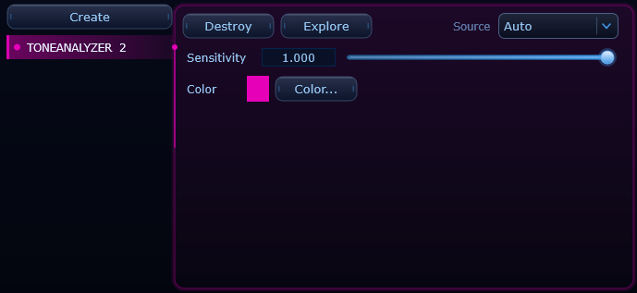
The control panel stays simple: sensitivity and a single accent colour. That is enough for this module.

