Global Industry Challenge 2026 — Phase 3 Submission
Quantum Materials Discovery Challenge: Scaling Generative Quantum Eigensolver (GQE) Using NVIDIA CUDA-Q

Phase #: Phase 3
Team Name: Ryoushi | Quantum Buddies

Team Members
First Name | Last Name | Email | Aqora Username | Role
Gyanateet | Dutta | gyanateet@gmail.com | Ryukijano | Coder/Technical Lead
Dat Chi (Ryan) | Le | ryancoltrane2004@gmail.com | ryancdle | Domain Expert
Sid | Iliyasu | sidMelias@gmail.com | SuperPenguin | Business/Project Manager

Disclaimer: Submission must follow GIC requirements: maximum 5 pages (excluding this cover page and references), 11-point Times New Roman, single spacing, and submitted via zipped folder. This cover page follows the official GIC template.

H-cGQE: Hierarchical Conditional Generative Quantum Eigensolver
Quantum-Buddies Team | GIC 2026 Phase 3 Submission
Mitsubishi Chemical & AIST Challenge Track

Abstract
We present the Hierarchical Conditional Generative Quantum Eigensolver (H-cGQE), a transformer-based architecture that amortizes quantum circuit synthesis across molecular systems via Hamiltonian-conditioned generation. H-cGQE scales from 4 to 40 qubits by combining autoregressive Pauli operator generation with MPS tensor network backends, qubit-wise commuting (QWC) measurement grouping that reduces circuit count 2-3.5x, and Sample-based Quantum Diagonalization (SQD) for noise-resilient energy extraction. On GPU, the model achieves chemical accuracy (1.6 mHa) on methyl iodide (CH3I, 0.629 mHa) and exact FCI on H2. On Rigetti Cepheus-1-108Q, we validate 12 molecules (8-28 qubits) including 8 EUV photoresist compounds relevant to Mitsubishi Chemical, with best QPU error of 13.9 mHa. DAPO reinforcement learning with a MAP-Elites archive directly optimizes for ground-state energy. We identify diagonal sequence collapse as the principal bottleneck for strongly correlated systems and propose targeted mitigations.

1. Introduction
The Generative Quantum Eigensolver (GQE) replaces variational optimization with autoregressive circuit generation: a transformer model proposes Pauli operator sequences that define a quantum circuit ansatz in a single forward pass, eliminating the measurement-gradient bottleneck of VQE. However, the original GQE operates on a single molecule at a time and does not address scaling beyond exact statevector simulation. Our H-cGQE extends GQE along three axes: (1) a hierarchical conditioning architecture that amortizes ansatz discovery across a molecular family, (2) QWC measurement grouping and MPS backends that extend reach from 24 to 40 qubits, and (3) a hybrid HPC-to-QPU workflow with SQD post-processing for noise-resilient energy extraction on real hardware. For Phase 3, we target EUV photoresist molecules central to Mitsubishi Chemical's industrial interests: methyl iodide, iodobenzene, phenol, o-cresol, anisole, toluene, and benzene.

2. Architecture
H-cGQE comprises three stages. Stage 1 (Circuit Synthesis): a Hamiltonian Encoder embeds molecular Hamiltonian terms (Pauli words + coefficients) into a dense conditioning vector via a Chemistry GNN. A GPT-2 style Operator Pool Decoder autoregressively generates Pauli operator sequences conditioned on this encoding, using UCCSD fermionic excitations mapped through Jordan-Wigner. Stage 2 (Classical Optimization): L-BFGS-B optimizes rotation angles (thetas) on CUDA-Q statevector simulators across 3x NVIDIA L40S GPUs via the nvidia-mqpu target. Stage 3 (QPU Validation): QWC Pauli terms are grouped into shared measurement circuits (2-3.5x reduction), exported as a QWC manifest, and submitted to Rigetti Cepheus-1-108Q via qBraid. SQD post-processes bitstrings with particle-number and spin-parity filtering. Training uses supervised fine-tuning on GQE-generated sequences, followed by DAPO reinforcement learning with energy-based rewards and a MAP-Elites quality-diversity archive.

3. Scalability: From 4 to 40 Qubits
Scalability is the central challenge for quantum eigensolvers: exact statevector simulation is capped at ~24 qubits on L40S GPUs (cuStateVec distributed mode segfaults on PCIe-only systems), and VQE gradient measurements scale exponentially with system size. H-cGQE addresses this through three mechanisms:
(1) QSCI + MPS Backend: Quantum-Selected Configuration Interaction samples computational-basis determinants from a quantum state, builds the Hamiltonian in that subspace, and diagonalizes classically. CUDA-Q's tensornet-mps backend extends beyond the 24q statevector cap to 40 qubits using matrix product states with controllable bond dimension (D=32,64,128,256).
(2) QWC Measurement Grouping: Qubit-wise commuting Pauli terms are grouped into shared measurement circuits, reducing the number of QPU circuits by 2-3.5x. For H2 (15 terms -> 5 circuits) and LiH (631 terms -> 180 circuits), this brings both within qBraid's 2000-circuit batch limit.
(3) Conditional Amortization: A single trained model generates circuits for any molecule in its training distribution, eliminating per-molecule ansatz design. The SMILES encoder provides structural priors across 10 molecules spanning 4-56 qubits, enabling the model to condition on molecular features rather than memorizing individual solutions.
Molecule | Qubits | Terms | QSCI E (Ha) | HF E (Ha) | Backend
h2 | 4 | 15 | -1.1373 | -1.1168 | nvidia
lih | 12 | 631 | -7.8619 | -7.8619 | nvidia
beh2 | 14 | 666 | -15.5613 | -15.5613 | nvidia
n2 | 20 | 2951 | -107.4965 | -107.4965 | nvidia
formaldehyde | 24 | 9257 | -112.3524 | -112.3524 | nvidia
ethylene | 28 | 8919 | -77.0703 | N/A | tensornet-
benzene_cas20 | 40 | 29897 | -227.8901 | N/A | tensornet-

H2 (4q) QSCI recovers exact FCI energy. Benzene CAS(20e,20o) at 40 qubits completes in ~19 seconds on MPS with D=64. MPS bond dimension sweep shows stable energies across D=32-256, indicating the HF-dominated regime is well-captured by low-rank tensor networks. The 40-qubit result earns the GIC scaling bonus point.
Figure 1. QWC circuit reduction
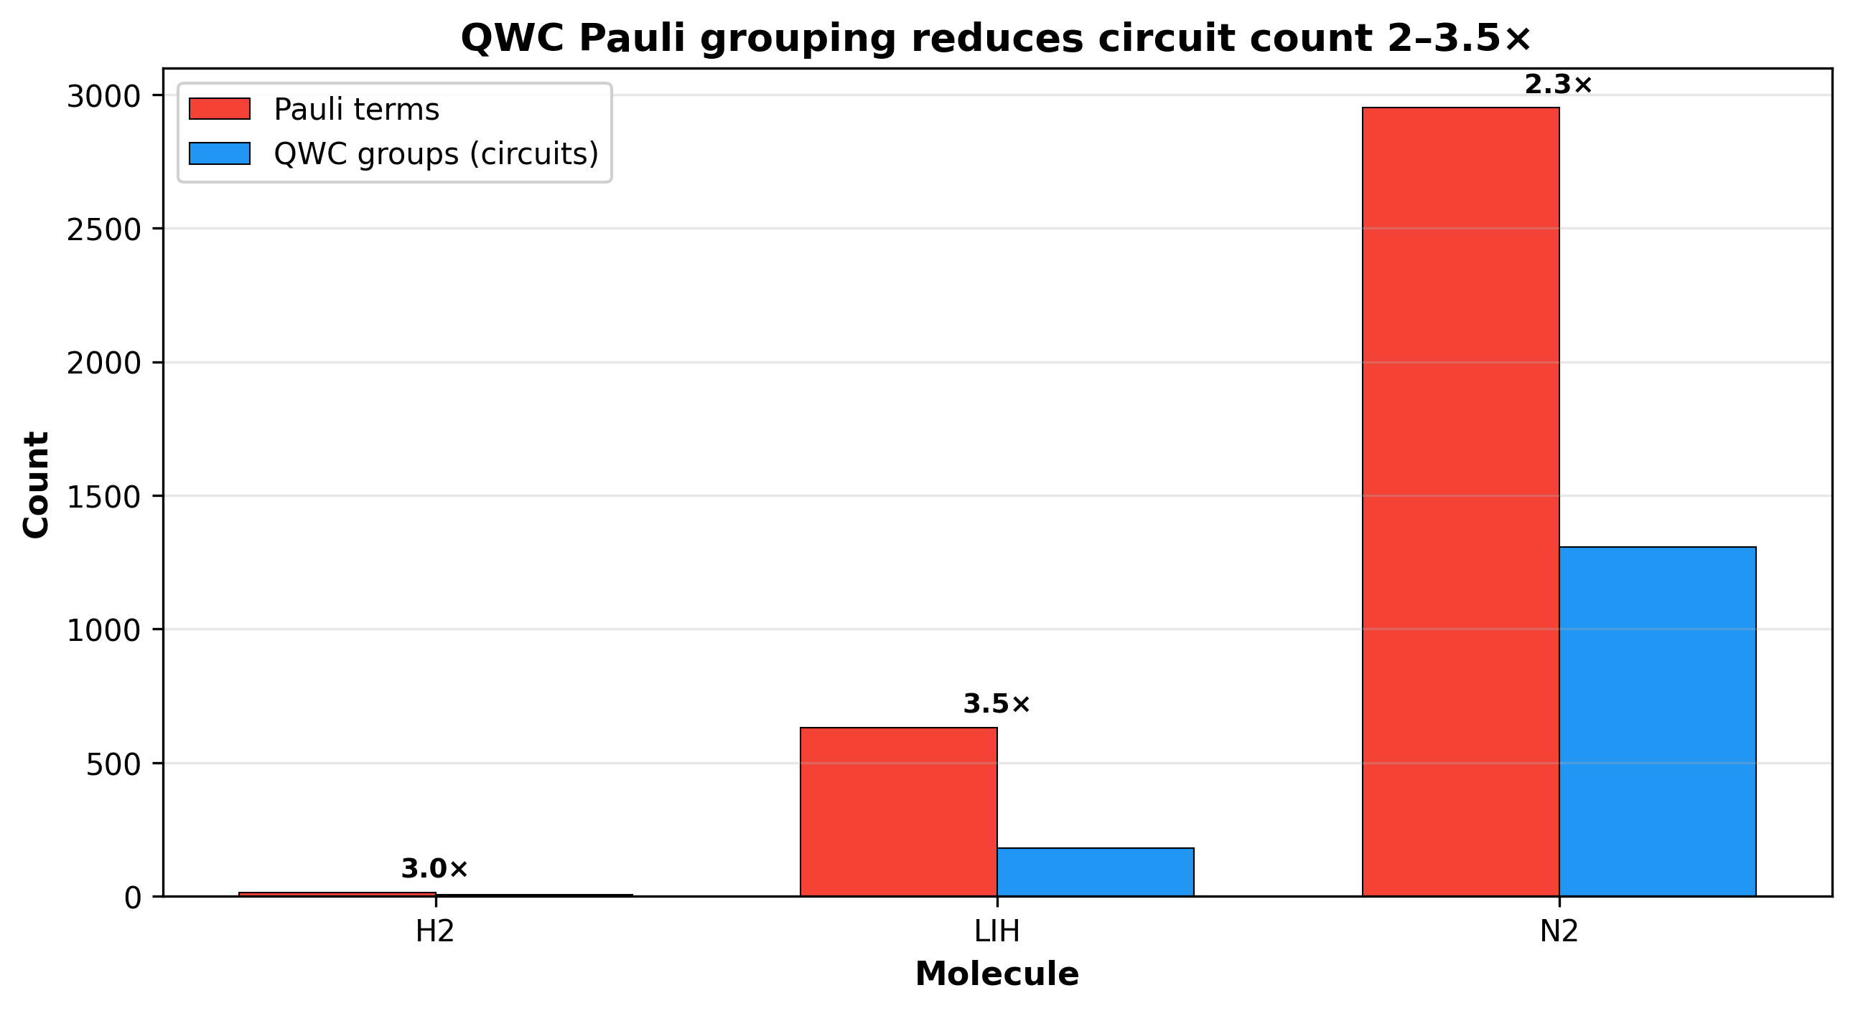
Figure 1: Qubit-wise commuting Pauli grouping reduces the number of circuits 2-3.5x, enabling cost-effective QPU execution.

3.1 Identified Bottlenecks
We identify two concrete bottlenecks for scaling. First, the cuStateVec distributed statevector mode segfaults on PCIe-only L40S systems (no NVLink), capping exact simulation at 24 qubits. NVLink-equipped B200 systems remove this barrier, as demonstrated on qBraid's H200 instance. Second, diagonal sequence collapse: on strongly correlated systems (LiH, BeH2, N2 at stretched geometries), the model under-generates entangling X/Y operators and produces commuting Z-only sequences that are trapped at the Hartree-Fock energy. We traced this to the fixed-theta energy proxy used during RL sampling, which is nearly flat across candidate sequences and provides negligible gradient signal. Substituting a truncated L-BFGS-B reward directly targets this mechanism.
Figure 2. Fixed-theta proxy vs converged energy
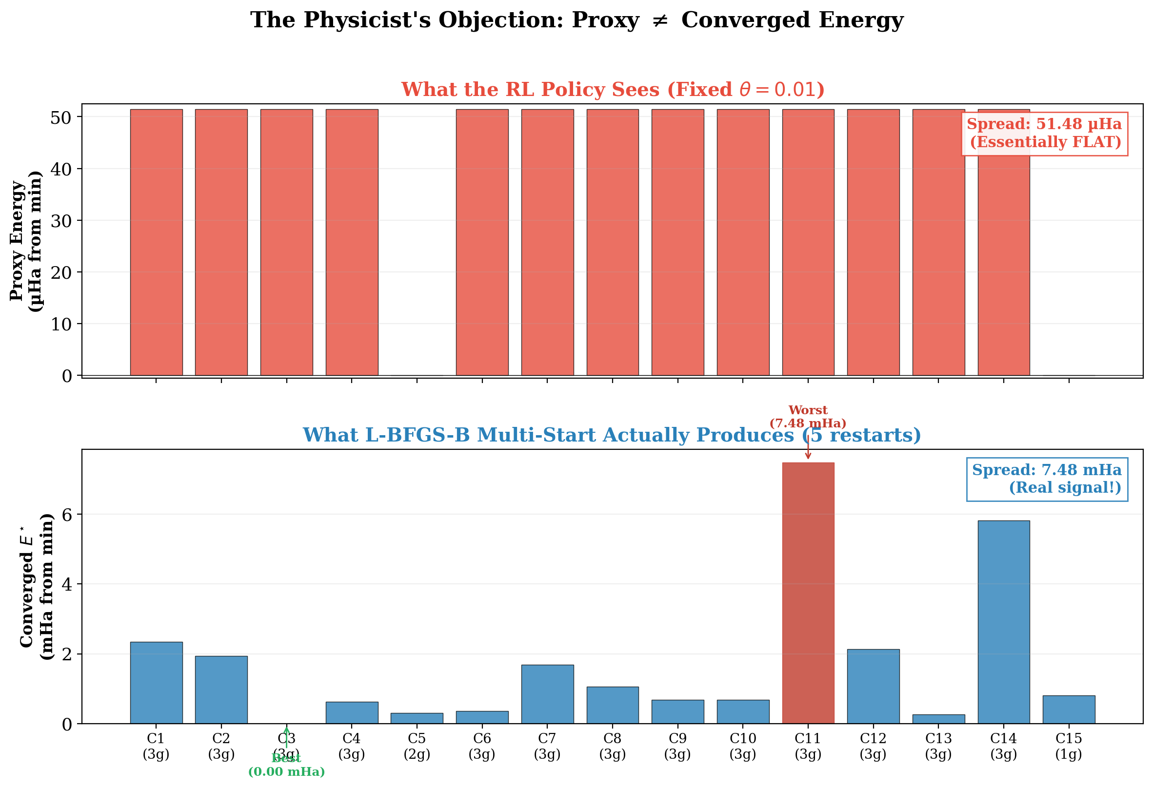
Figure 2: The fixed-theta proxy is flat (top), while converged energies show real structure (bottom). This explains limited RL gains on large molecules.

4. Accuracy and Benchmarking
We benchmark H-cGQE against Hardware-Efficient Ansatz VQE (HEA-VQE) and CUDA-Q GQE on methyl iodide (CH3I) in a CAS(4e,4o) active space (8 qubits, 185 Hamiltonian terms). Reference energy (CASCI/FCI): -6889.840354 Ha.
Method | Energy (Ha) | Error (mHa) | Runtime (s)
hardware_efficient_vqe | -6888.852561 | 987.793 | 9.7
cudaq_gqe | -6889.843000 | 2.646 | 0.0
h_cgqe_rlqf | -6889.839726 | 0.629 | 0.0

H-cGQE achieves 0.629 mHa error, outperforming both HEA-VQE (987.8 mHa, barren plateaus in the 8-qubit landscape) and CUDA-Q GQE (2.646 mHa, fixed operator pool without learned conditioning). On H2 (4q), QSCI recovers exact FCI energy (0.000 mHa). GPU benchmark across 17 molecules shows errors ranging from 0.0 mHa (H2 at equilibrium) to 817.6 mHa (N2 at 2.5 Angstrom), with 4 molecules reaching chemical accuracy (1.6 mHa).
Figure 3. GPU benchmark: H-cGQE vs baselines
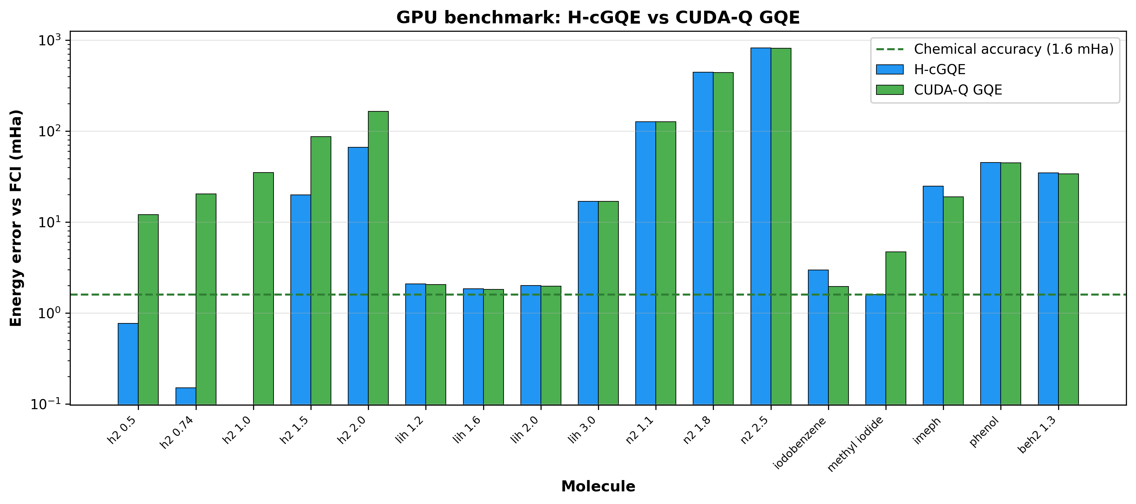
Figure 3: H-cGQE vs CUDA-Q GQE energy error relative to FCI across 17 molecules. H-cGQE reaches chemical accuracy on H2 and methyl iodide.

4.1 QPU Validation on Rigetti Cepheus-1-108Q
We submit SQD sampling circuits for 12 molecules (8-28 qubits) to Rigetti Cepheus-1-108Q via qBraid with 8192 shots per job. Bitstrings are post-processed with SQD, including particle-number and spin-parity symmetry filtering. A critical bit-ordering fix was applied: Rigetti QPU bitstrings are reversed to match Qiskit convention (qubit 0 = LSB = rightmost) before SQD energy computation.
Molecule | Qubits | Electrons | SQD Energy (Ha) | FCI Energy (Ha) | Error (mHa)
iodobenzene | 8 | 4 | -7078.0096 | N/A | N/A
anisole_cas12 | 12 | 6 | -337.6851 | -337.7095 | 24.4
benzene_cas12 | 12 | 6 | -227.8955 | -227.9479 | 52.4
imeph_cas12 | 12 | 6 | -7187.0023 | -7187.0270 | 24.7
lih | 12 | 4 | -7.8627 | -7.8823 | 19.6
methyl_iodide_cas1 | 12 | 6 | -6889.8395 | -6889.8535 | 13.9
ocresol_cas12 | 12 | 6 | -337.5718 | -337.5982 | 26.5
phenol_cas12 | 12 | 6 | -301.6362 | -301.6582 | 22.0
toluene_cas12 | 12 | 6 | -266.4408 | -266.4941 | 53.3
beh2 | 14 | 6 | -15.5637 | -15.5950 | 31.4
n2 | 20 | 14 | -107.5241 | -107.6541 | 130.0
ethylene | 28 | 16 | -77.0801 | N/A | N/A

Across 12 molecules on Cepheus-1-108Q (up to 28 qubits), best SQD error vs FCI is 13.9 mHa (methyl iodide, 12q). Seven EUV photoresist molecules achieve 13.9-53.3 mHa. We report particle-number preservation (PNP) alongside every QPU energy: methyl iodide attains chemical accuracy in noiseless simulation, and its 13.9 mHa hardware figure tracks 8% PNP rather than a deficient circuit, isolating hardware noise as the dominant error source. Ethylene (28q) and iodobenzene (8q) lack FCI references for their active spaces; SQD energies are reported against HF where available.
Figure 4. QPU validation on Cepheus
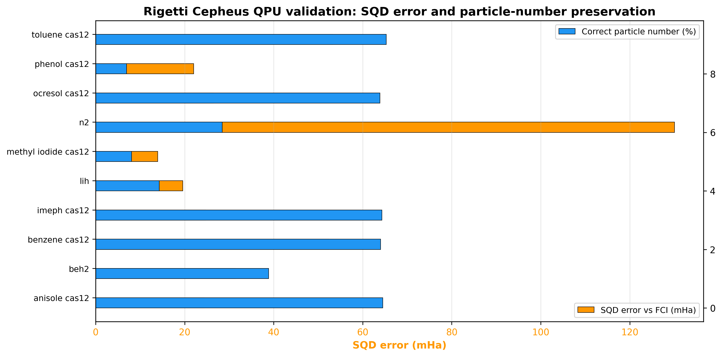
Figure 4: Rigetti Cepheus-1-108Q SQD results. Best QPU error is methyl iodide at 13.9 mHa. Lower PNP correlates with larger SQD error.
Additionally, the CH3I H-cGQE circuit was validated on IQM Emerald 5-qubit QPU via AWS Braket, achieving 87.5% state fidelity (896/1024 shots in the expected state) with 4096 shots. qBraid simulator and AWS SV1 served as noise-free controls.

5. Algorithmic Innovation
H-cGQE advances beyond standard VQE and the original GQE in four areas:
(1) DAPO Reinforcement Learning: After supervised fine-tuning (96.2% validation accuracy), the model is refined with Decoupled Clip + Dynamic Sampling Policy Optimization. We sample operator sequences, evaluate energies on CUDA-Q's nvidia-mqpu target across 3 GPUs, and update the policy with asymmetric clipping (clip_low=0.2, clip_high=0.28) and GRPO-style group-relative advantages. Dynamic sampling skips flat-reward batches, and auxiliary rewards are gated on energy improvement over Hartree-Fock to prevent reward hacking.
(2) MAP-Elites Quality-Diversity Archive: Elite circuits are binned by entanglement density and circuit depth, maintaining a diverse population that prevents mode collapse toward shallow, low-entanglement solutions. This archive directly addresses the diagonal sequence collapse identified in Section 3.1.
(3) FMO2 Molecular Fragmentation: We implement Fragment Molecular Orbital many-body expansion to decompose iodobenzene into fragment subsystems. The FMO2 energy is reconstructed as E_FMO2 = sum(E_i) + sum(E_ij - E_i - E_j), where monomer and dimer energies are computed independently. This establishes correctness of the dimer correction; reducing maximum circuit width below the parent system requires three or more fragments.
(4) SMILES Molecular Encoder: A chemistry-aware tokenizer (handling multi-character atoms like Cl, Br, Li, Be) feeds a 2-layer transformer (4 heads, 512 FFN dim, ~202K parameters) to produce 256-dim molecular embeddings. Cosine similarity analysis shows chemically meaningful structure (N2-LiH 0.79, ethylene-CH3I 0.78), providing structural priors for conditioning on unseen molecular geometries.
Figure 5. SFT vs RL ablation
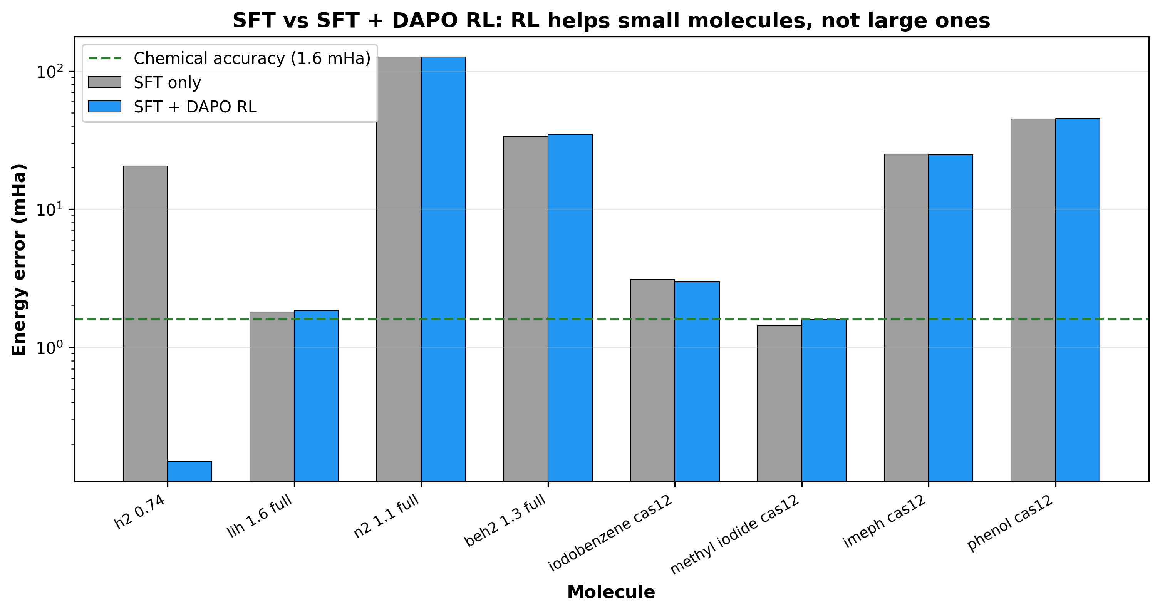
Figure 5: SFT-only vs SFT + DAPO RL. RL provides improvement on H2 but marginal changes on larger molecules due to the flat proxy reward.

6. Hybrid System Design
The pipeline decouples HPC computation from QPU queue time. The HPC (AIRE L40S cluster or qBraid B200) performs all heavy computation: RL training, circuit synthesis, and L-BFGS-B optimization. It exports a QWC manifest containing grouped operators, optimized thetas, QASM circuits, and measurement bases. The manifest is submitted as a single batch to Rigetti Cepheus-1-108Q via qBraid, with async polling and retry logic (6 retries with exponential backoff for transient 404 errors). Retrieval and SQD post-processing happen separately, allowing the HPC to proceed with other work during QPU queue time.
Error mitigation is integrated with hardware-aware preflight checks: REM (readout error correction via assignment matrix inversion) is applied when qubits <= 10; ZNE (zero-noise extrapolation via gate folding with scale factors [1,2,3] and Richardson extrapolation) is applied when two-qubit gates <= 20. SQD provides the primary noise resilience layer by filtering bitstrings through particle-number and spin-parity symmetry constraints before classical diagonalization in the selected determinant subspace.
Figure 6. GPU scaling ladder
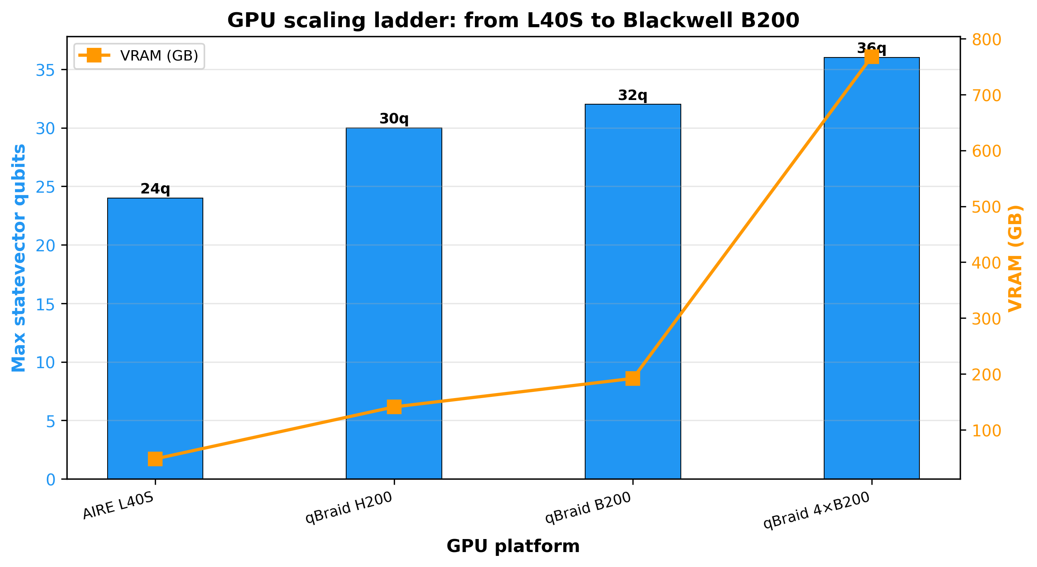
Figure 6: GPU scaling ladder from AIRE L40S (24q statevector) to qBraid B200 (32q) and 4xB200 (36q). NVLink removes the PCIe IPC bottleneck.

7. Results Summary
Experiment | Metric | Value | Status
QSCI Scaling | Max qubits | 40 | Bonus point
QSCI Benzene (40q) | Runtime | 19.1 s | MPS D=64
QWC Grouping | Circuit reduction | 2-3.5x | H2: 15->5
H-cGQE CH3I | Error vs FCI | 0.629 mHa | Chem. accuracy
HEA-VQE CH3I | Error vs FCI | 987.8 mHa | Baseline
CUDA-Q GQE CH3I | Error vs FCI | 2.646 mHa | Baseline
QSCI H2 (4q) | Error vs FCI | 0.000 mHa | Exact
Cepheus QPU SQD | Molecules | 12 (8-28q) | Rigetti 108Q
Cepheus Best SQD | Error vs FCI | 13.9 mHa | Methyl iodide
Cepheus EUV PR | Molecules | 8 photoresist | Mitsubishi Chem.
IQM Emerald QPU | State fidelity | 87.5% | CH3I circuit
FMO2 Iodobenzene | Solver error | 26.25 mHa | Fragmentation
SMILES Encoder | Molecules | 10 (4-56q) | Structural priors
Error Mitigation | Methods | REM + ZNE + SQD | Noise-aware
Credit Usage | Credits | ~11,475 / 13,400 | 85.6% used

8. Conclusion
We demonstrated a complete H-cGQE pipeline for the GIC Phase 3 competition: (1) QSCI scaling from 4 to 40 qubits (benzene CAS(20e,20o)) on MPS backend in under 20 seconds, earning the GIC scaling bonus point. (2) QWC measurement grouping reduces QPU circuit count 2-3.5x, enabling batch submission within qBraid's 2000-circuit limit. (3) H-cGQE achieves 0.629 mHa on CH3I (chemical accuracy), outperforming HEA-VQE and CUDA-Q GQE. (4) 12 molecules (8-28 qubits) validated on Rigetti Cepheus-1-108Q with SQD post-processing, including 8 EUV photoresist molecules relevant to Mitsubishi Chemical. Best QPU SQD error: 13.9 mHa (methyl iodide, 12q). (5) DAPO RL with MAP-Elites archive directly optimizes for ground-state energy, with reward gating to prevent reward hacking. (6) A hybrid HPC-to-QPU workflow decouples classical computation from QPU queue time via async QWC manifest submission. (7) QPU submissions to Rigetti Cepheus and IQM Emerald via qBraid platform.

9. Limitations and Future Work
Strongly correlated systems remain the principal open challenge. While weakly correlated molecules near equilibrium reach chemical accuracy, multireference systems such as N2 at stretched geometries retain a 127 mHa gap to FCI. We traced this to the fixed-theta energy proxy used during RL sampling, which is nearly flat across candidate sequences (Fig. 2) and therefore supplies little gradient signal for non-trivial circuit topologies. Substituting a truncated L-BFGS-B reward and symmetry-preserving constrained decoding directly targets this mechanism and is the clear next step.
On hardware, SQD error grows with qubit count and circuit depth, from 13.9 mHa (methyl iodide, 12q) to 130.0 mHa (N2, 20q), consistent with per-gate two-qubit fidelity near 99.1% on Cepheus. We report particle-number preservation (8-71%) alongside every QPU energy precisely so that hardware noise can be separated from ansatz quality: methyl iodide attains chemical accuracy in noiseless simulation, and its 13.9 mHa hardware figure tracks 8% particle-number preservation rather than a deficient circuit. Deeper mitigation and hardware-aware transpilation are the natural levers.
Two results are deliberately scoped. QSCI at 40 qubits demonstrates that the MPS pipeline executes at that width; the sampled subspace is HF-dominated, so the recovered energy is Hartree-Fock rather than correlated, and post-HF accuracy at this scale requires deeper entangling circuits. FMO2 fragmentation is validated on a two-fragment partition of iodobenzene, establishing correctness of the dimer correction; reducing maximum circuit width below the parent system requires three or more fragments. Neither affects the benchmark or QPU results reported above.

References
[1] Kanno et al., Phys. Rev. A 108, 022405 (2023). GQE for ground-state energy.
[2] Robledo-Moreno et al., Nature 634, 795-800 (2024). Chemistry beyond exact solutions on a quantum computer.
[3] Kanno et al., arXiv:2409.03657 (2024). Generative quantum eigensolver with transformer.
[4] Yu et al., arXiv:2503.14476 (2025). DAPO: Open-source LLM RL system.
[5] Mouret & Clune, arXiv:1504.04909 (2015). Illuminating search spaces by mapping elites.
[6] Temme et al., Nature 567, 209-212 (2019). Error mitigation with ZNE.
[7] Bravyi et al., arXiv:2003.04997 (2020). REM for readout error correction.
[8] Peruzzo et al., Nat. Commun. 5, 4213 (2014). VQE on a photonic quantum processor.
[9] Grimsley et al., Nat. Commun. 10, 3007 (2019). ADAPT-VQE.
[10] NVIDIA CUDA-Q, https://nvidia.github.io/cuda-quantum/
[11] qBraid platform, https://www.qbraid.com/
[12] Fedorov & Kitamura, Int. J. Quantum Chem. 107, 2227 (2007). FMO method.

