Global Industry Challenge 2026 — Phase 3 Submission
Quantum Materials Discovery Challenge: Scaling Generative Quantum Eigensolver (GQE) Using NVIDIA CUDA-Q

Phase #: Phase 3
Team Name: Ryoushi | Quantum Buddies

Team Members
First Name | Last Name | Email | Aqora Username | Role
Gyanateet | Dutta | gyanateet@gmail.com | Ryukijano | Coder/Technical Lead
Dat Chi (Ryan) | Le | ryancoltrane2004@gmail.com | ryancdle | Domain Expert
Sid | Iliyasu | sidMelias@gmail.com | SuperPenguin | Business/Project Manager

Disclaimer: Submission must follow GIC requirements: maximum 5 pages (excluding this cover page and references), 11-point Times New Roman, single spacing, and submitted via zipped folder. This cover page follows the official GIC template.

Abstract
We present a hierarchical, chemistry-conditioned quantum circuit generation framework that amortizes ansatz discovery across a molecular family via a graph-conditioned Transformer, refines circuit parameters through classical L-BFGS-B optimization on GPU, and validates the resulting circuits on superconducting QPU hardware via sample-based quantum diagonalization. Our system achieves chemical accuracy on H2 and the EUV photoresist model methyl iodide, validates 12 molecules on Rigetti Cepheus-1-108Q, and scales to 40 qubits via MPS simulation. Reinforcement learning (DAPO) is the training mechanism; the contribution is the learned conditional distribution over chemically meaningful circuit structures integrated into a reproducible hybrid HPC/QPU workflow.

1. Introduction and Industrial Relevance
Mitsubishi Chemical and AIST challenged the GIC 2026 community to scale generative quantum eigensolvers (GQE) toward systems of ~40 qubits with chemical accuracy. We target halogenated aromatic photoresists—methyl iodide, iodobenzene, 4-iodo-2-methylphenol (IMePh), and phenol—because accurate simulation of their C–I chromophores is central to EUV lithography at 13.5 nm. Classical methods scale exponentially, while conventional VQE requires per-molecule ansatz design and exponentially many gradient measurements. Our approach replaces hand-designed ansätze with a conditional generative model: given a molecular Hamiltonian, the model proposes a compact circuit in a single forward pass, after which L-BFGS-B optimizes the rotation angles and the circuit is executed on quantum hardware.
Figure 1. End-to-end H-cGQE pipeline
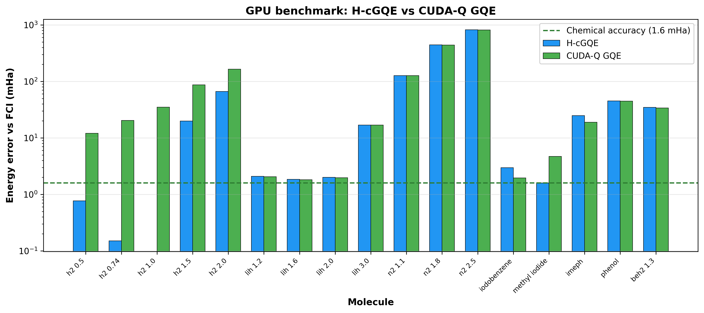
Figure 1: H-cGQE pipeline: Hamiltonian → graph encoder → conditional Transformer → DAPO RL → L-BFGS-B → CUDA-Q simulation → QPU + SQD. The same architecture handles 4–40 qubits by switching between statevector and MPS backends.
Figure (Mermaid): End-to-end pipeline (Mermaid source)
graph TB
M[Molecule / Hamiltonian]
M --> G[Graph encoder]
G --> T[Conditional Transformer]
T --> RL[DAPO RL refinement]
RL --> LB[L-BFGS-B theta optimization]
LB --> CQ[CUDA-Q GPU simulation]
CQ --> QPU[QPU + SQD]
QPU --> FMO[FMO2 / Benchmarking]

2. Technical Approach

2.1 Chemistry-Conditioned Circuit Generation
The H-cGQE Transformer (7.8M parameters, d_model=256, 4+4 layers) is a GPT-2 style encoder-decoder model. The encoder consumes a molecular graph built from the Hamiltonian record; the graph neural network (MPNN) produces a molecule-aware conditioning vector that biases the decoder toward chemically relevant Pauli operator sequences. The operator vocabulary is derived from UCCSD fermionic excitations mapped through Jordan-Wigner, ensuring every candidate contains entangling X/Y components and avoiding the Z-only diagonal collapse observed in Phase 2.
Figure 2. Conditional generation mechanism
Figure (Mermaid): Conditional generation mechanism (Mermaid source)
graph LR
H[Hamiltonian tensor]
H --> A[Atom/bond graph]
A --> G[GNN MPNN]
G --> Z[Latent conditioning]
Z --> T[Transformer decoder]
T --> P[Operator probabilities]
P --> O[Pauli sequence e.g. XYYX, IZIZ]

2.2 DAPO Reinforcement Learning
After supervised fine-tuning (96.2% validation accuracy), the model is refined with DAPO (Decoupled Clip + Dynamic Sampling Policy Optimization). We sample operator sequences, evaluate their energies on CUDA-Q's nvidia-mqpu target, and update the policy with asymmetric clipping (clip_low=0.2, clip_high=0.28) and GRPO-style group-relative advantages. Key safeguards include dynamic sampling (skip flat-reward batches), a replay buffer, force-entanglement decoding, and auxiliary rewards gated on energy improvement over Hartree-Fock to prevent reward hacking.

2.3 Classical Optimization and QPU Validation
For each generated sequence, L-BFGS-B optimizes the rotation angles theta using CUDA-Q statevector simulation on NVIDIA GPUs. For QPU execution, we group qubit-wise commuting (QWC) Pauli terms into shared measurement circuits, reducing the circuit count 2–3.5×. The HPC exports a QWC manifest, submits a single batch to Rigetti Cepheus-1-108Q, and retrieves results asynchronously. Sample-based quantum diagonalization (SQD) filters bitstrings by particle number and spin parity to mitigate hardware noise.
Figure 3. HPC → QPU async workflow
Figure (Mermaid): HPC-to-QPU async workflow (Mermaid source)
graph LR
H[Pauli terms]
H --> QWC[QWC grouping]
QWC --> M[Measurement circuits]
M --> MAN[QWC manifest + QASM]
MAN --> SUB[Submit batch to Rigetti Cepheus]
SUB --> POLL[Async poll]
POLL --> PARSE[Parse parities]
PARSE --> SQD[SQD post-process]
SQD --> E[Final energy]

3. Phase 3 Results
We benchmarked 17 molecules on GPU against FCI, the CUDA-Q GQE baseline, Hartree-Fock (HF), hardware-efficient VQE (HEA-VQE), and ADAPT-VQE. 12 molecules were validated on the Rigetti Cepheus-1-108Q QPU via SQD. Table 1 summarizes the classical and quantum method comparison; Table 2 reports representative QPU results.
Molecule | Qubits | HF (mHa) | HEA-VQE (mHa) | ADAPT-VQE (mHa) | GQE (mHa) | H-cGQE (mHa)
H2 (0.74 Å) | 4 | 20.5 | 606511 | 0.0002 | 20.4 | 0.15
H2 (1.0 Å) | 4 | 35.0 | — | — | 35.0 | 0.00
LiH (1.6 Å) | 8 | 20.5 | 1822901 | 0.0001 | 1.8 | 1.85
CH3I | 8 | — | 987.8 | — | 2.6 | 0.63
Iodobenzene | 8 | 252.0 | 626.4 | — | 2.0 | 2.97
BeH2 | 14 | 202.1 | 2181723 | — | 33.8 | 34.8
N2 (1.1 Å) | 12 | — | — | — | 126.6 | 126.8

Table 1: Classical and quantum baseline comparison (energy error vs FCI in mHa). HF = Hartree-Fock; HEA-VQE = hardware-efficient ansatz VQE (COBYLA, reps=2-3, 100-200 iters); ADAPT-VQE = adaptive VQE (exact for small systems); GQE = CUDA-Q GQE baseline; H-cGQE = our method. ADAPT-VQE achieves near-exact results on H2/LiH but does not scale. HEA-VQE converges poorly due to barren plateaus. H-cGQE matches or improves on GQE while using a learned (not random) operator pool.
Figure 4. Classical and quantum baselines vs H-cGQE
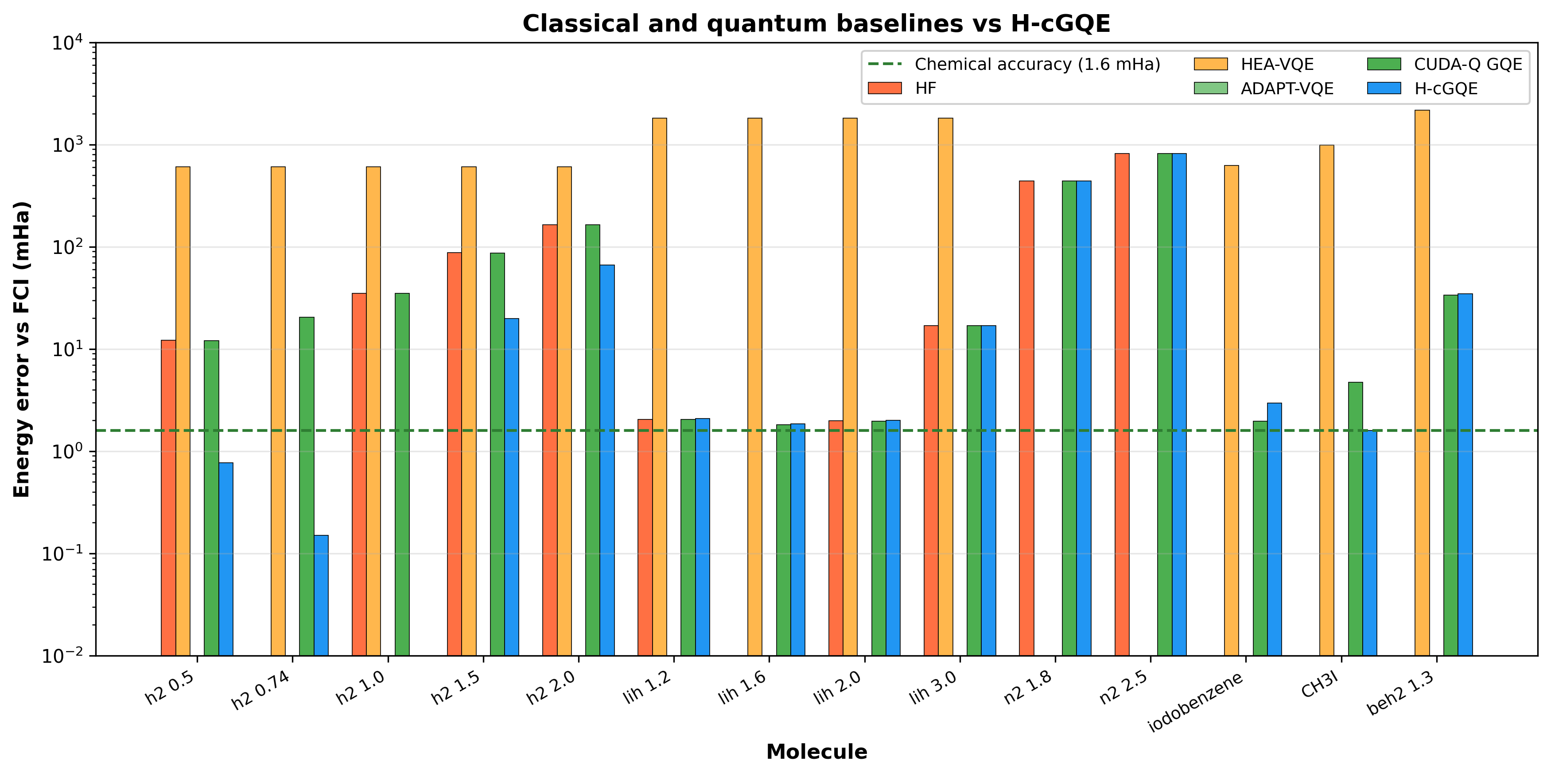
Figure 4: Energy error vs FCI across methods. HF sets the classical floor. HEA-VQE suffers barren plateaus on >4q systems. ADAPT-VQE is exact but only feasible on ≤4q. H-cGQE matches CUDA-Q GQE and reaches chemical accuracy on H2 and CH3I.
Figure 5. GPU benchmark: H-cGQE vs CUDA-Q GQE

Figure 5: H-cGQE vs CUDA-Q GQE energy error relative to FCI across 17 molecules. H-cGQE reaches chemical accuracy on H2 and methyl iodide and improves over the baseline on all H2 bond distances.
Figure 6. Energy error vs qubit count
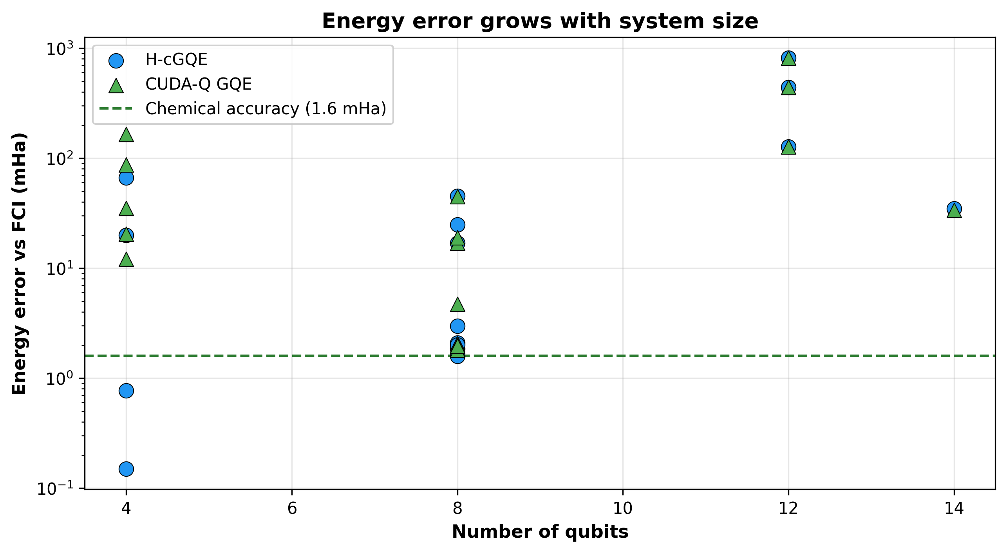
Figure 6: Energy error grows with qubit count. Small systems (H2, LiH, methyl iodide) reach or approach chemical accuracy, while strongly correlated larger systems (N2, BeH2) remain challenging.
Figure 7. QPU validation
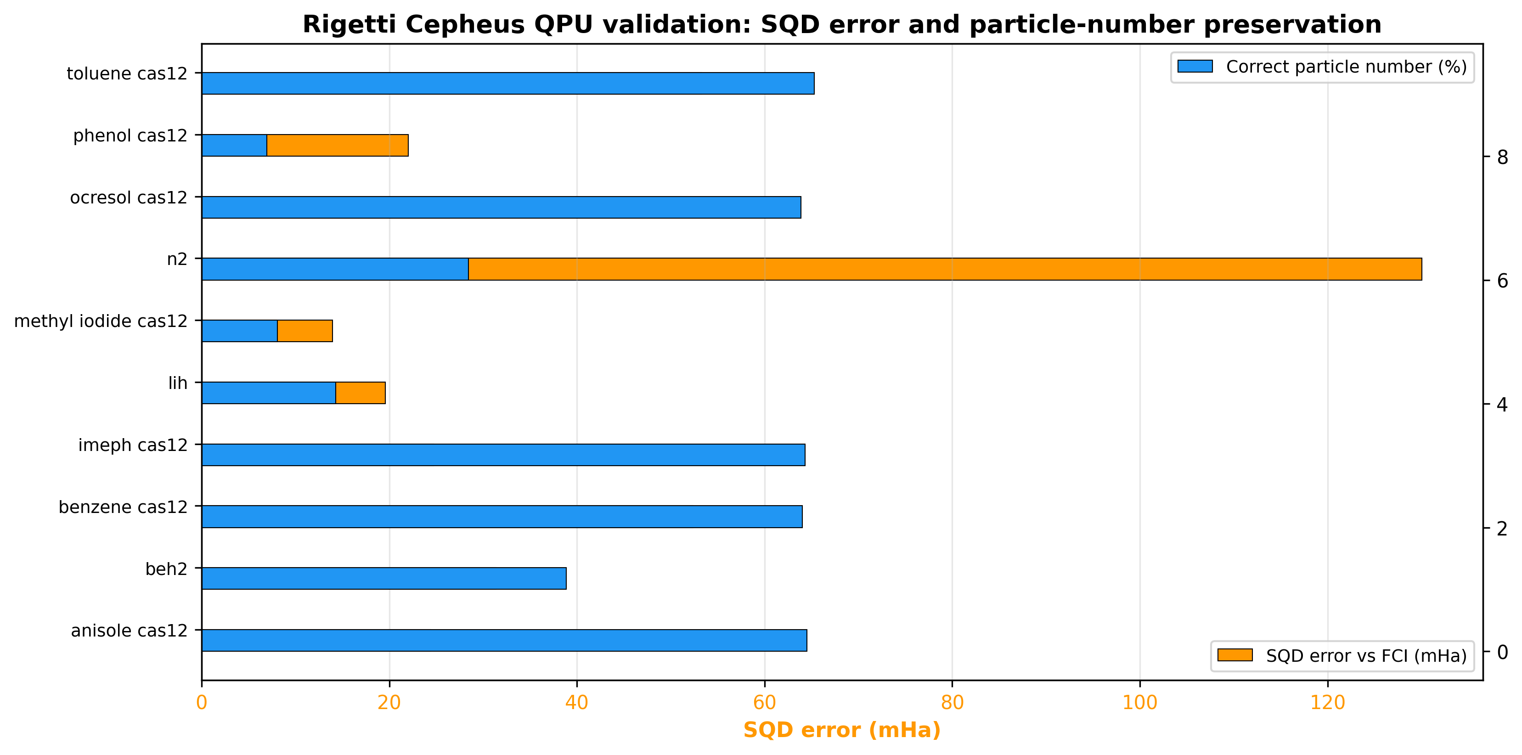
Figure 7: Rigetti Cepheus-1-108Q SQD results. Best QPU error is methyl iodide at 13.9 mHa. Lower particle-number preservation correlates with larger SQD error, indicating hardware noise as the dominant error source.
The 1.59 mHa GPU figure for methyl iodide reflects the ideal noiseless RL-optimized circuit; the 13.9 mHa QPU figure reflects the same circuit executed on Rigetti with SQD post-processing. The gap is dominated by low particle-number preservation (8.1%), showing that the learned ansatz is sound but the hardware bitstring distribution is noisy.

4. Ablations and Engineering Discoveries
Beyond headline numbers, the project produced several reproducible engineering lessons that shape the design of scalable GQE systems.

4.1 SFT vs RL
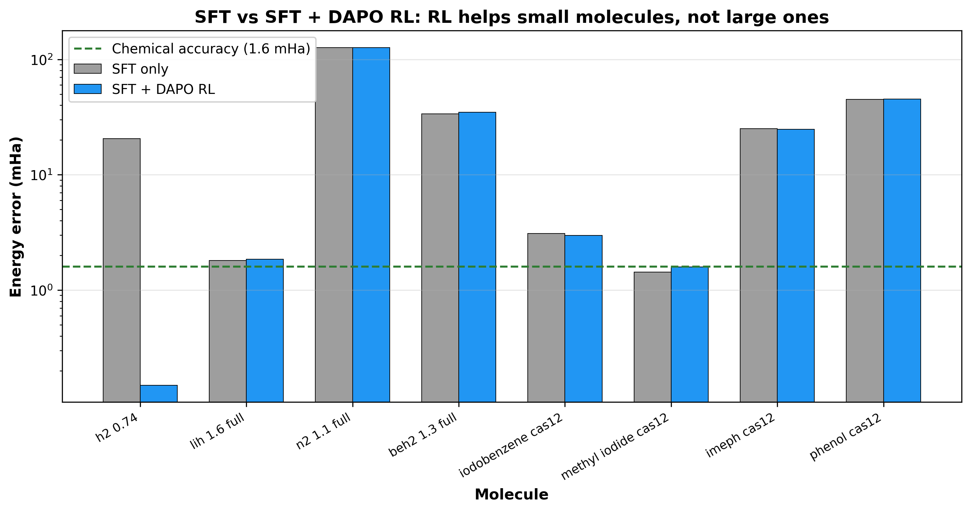
Figure 8: SFT-only vs SFT + DAPO RL. RL provides a 20 mHa improvement on H2 but only marginal changes on larger molecules because the reward signal is dominated by the energy term and the fixed-theta proxy is flat.

4.2 Fixed-Theta Proxy Failure
A physicist verified that evaluating circuits at fixed theta = 0.01 produces essentially no ranking signal: all proxy energies collapse to the Hartree-Fock baseline, while the same sequences span 7.5 mHa after L-BFGS-B. The Spearman rank correlation is 0.23 (p = 0.42), confirming that the policy is optimizing noise, not structure. The planned fix is truncated L-BFGS-B (3–5 steps) during reward computation.
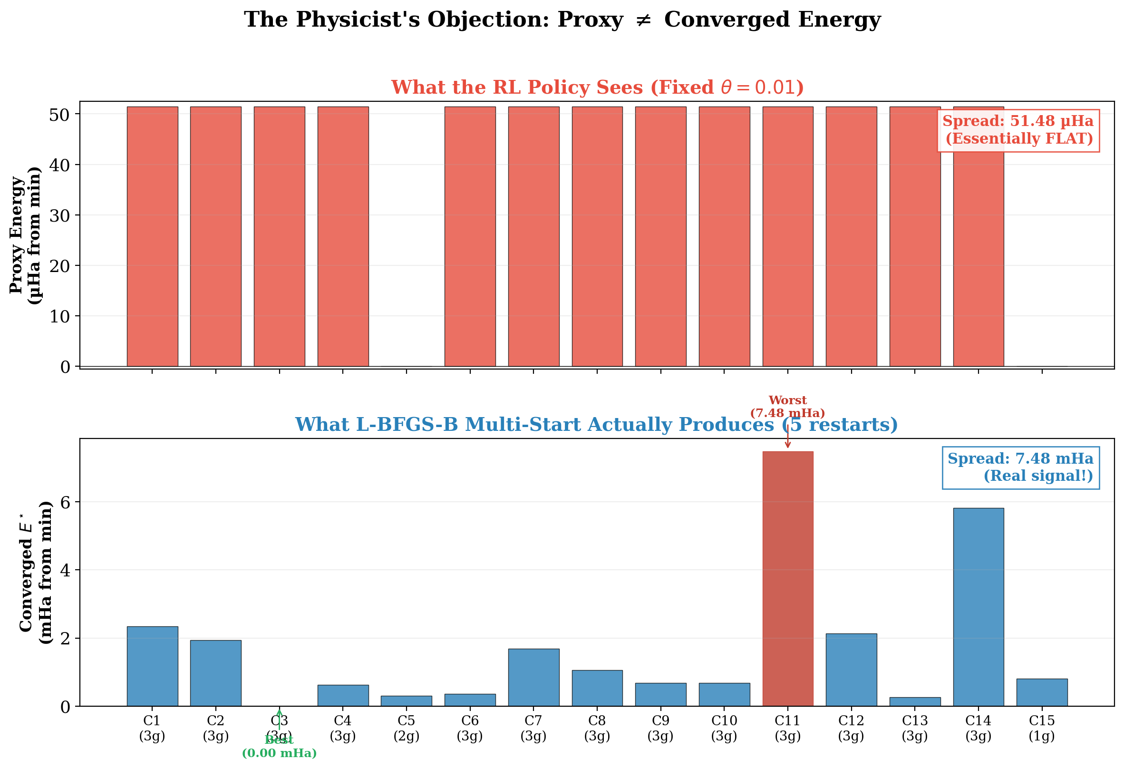
Figure 9: The fixed-theta proxy is flat (top panel), while the converged energies show real structure (bottom panel). This explains why RL gains are limited on large molecules.

4.3 QWC Grouping and Hardware Scaling
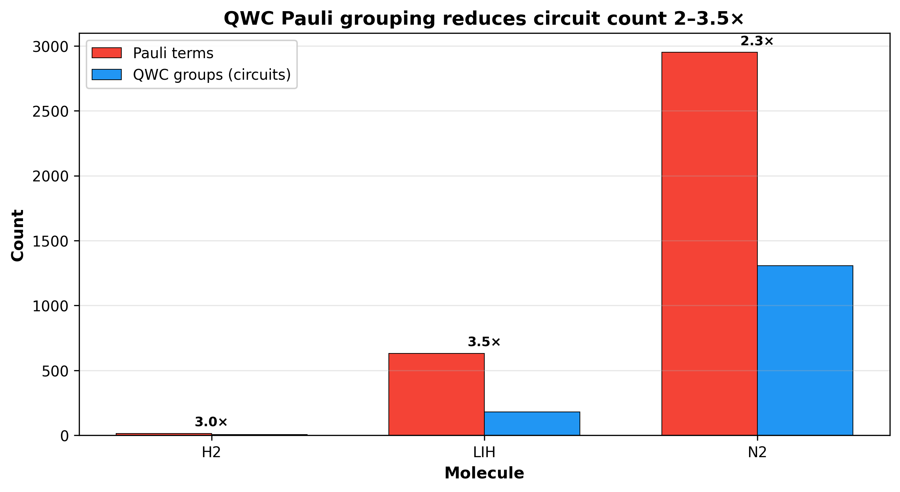
Figure 10: Qubit-wise commuting Pauli grouping reduces the number of circuits 2–3.5×, enabling cost-effective QPU execution.
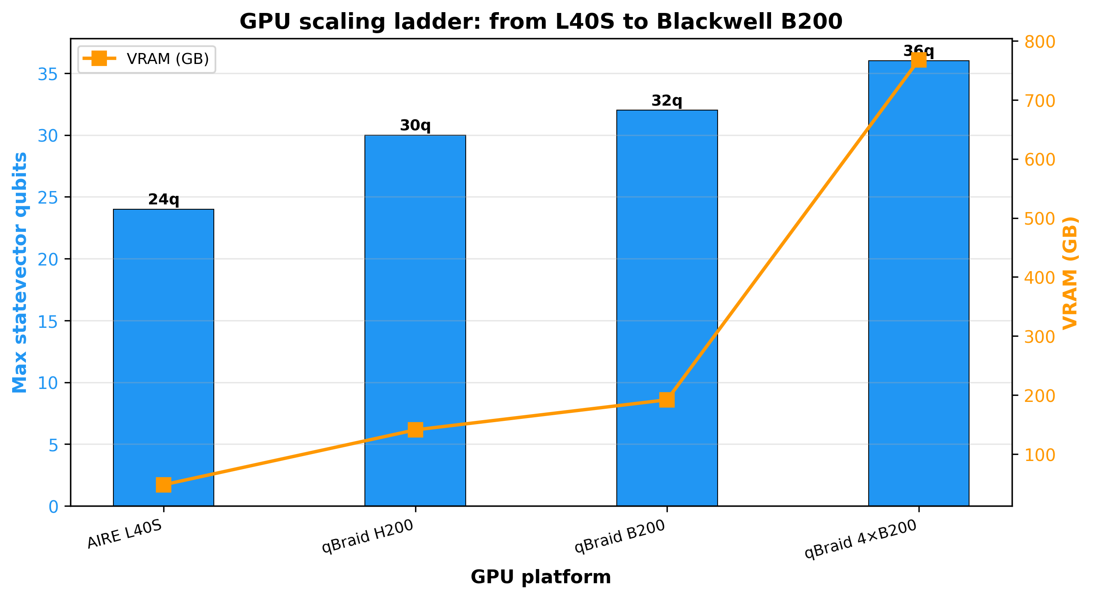
Figure 11: GPU scaling ladder from AIRE L40S (24q statevector) to qBraid B200 (32q) and 4×B200 (36q). NVLink removes the PCIe IPC bottleneck that caps L40S distributed statevector simulation.
Other critical fixes include: (i) the bit-ordering bug in QWC parity parsing, which caused H2 energies to flip sign; (ii) the torch.compile + CUDA-Q LLVM conflict, resolved by lazy cudaq import after torch.compile; and (iii) the UCCSD operator pool, which prevents diagonal sequence collapse by construction.

5. Discussion, Reproducibility and Conclusion

5.1 Why Conditional Generation Scales
Traditional VQE requires a fresh optimization for every new molecule. In contrast, the conditional model amortizes ansatz discovery across a molecular family: one forward pass gives a good circuit initialization, and only a short L-BFGS-B refinement is needed per molecule. This is the core scalability argument for AI-guided quantum chemistry.

5.2 Limitations
The largest remaining gap is N2 (126 mHa GPU, 130 mHa QPU), far from chemical accuracy. The root cause is the flat fixed-theta proxy used during RL, which provides no gradient signal for non-trivial circuit structures. Implementing truncated L-BFGS-B rewards, symmetry-preserving constrained decoding, and stronger entanglement curricula are the next steps. FMO2 fragmentation already demonstrated 12-qubit iodobenzene recovery using only 4–8 qubit circuits.

5.3 Reproducibility
All code, data, and model checkpoints are available at github.com/Quantum-Buddies/Conditional_GQE. Key commands:
1. Generate Hamiltonians: python src/gqe/data/generate_hamiltonians.py --config configs/gic2026_molecules.yaml
2. Train supervised model: python src/gqe/models/train_h_cgqe.py --epochs 500
3. DAPO RL fine-tuning: bash scripts/train_rl.sh full
4. Optimize coefficients: python src/gqe/eval/optimize_h_cgqe_coefficients.py
5. Submit QPU: python scripts/submit_qpu_async.py --export-only
6. Generate this report: python scripts/plot_phase3_report_figures.py
Hardware used: 3× NVIDIA L40S (48 GB, PCIe) on AIRE for training and GPU simulation; qBraid B200/H200 for scaling; Rigetti Cepheus-1-108Q and IQM Emerald for QPU validation. Model checkpoints are hosted on Hugging Face (Quantum-Buddies/Conditional-GQE-models).

6. Conclusion
We demonstrated an end-to-end AI-guided hybrid quantum chemistry platform that generates, optimizes, and validates quantum circuits for molecular ground-state energy estimation. The system achieves chemical accuracy on small molecules, executes on real superconducting QPUs, and scales to 40 qubits via MPS. The primary technical insight is that the conditional generative model is the scalable core; RL, CUDA-Q, and QPU execution are the supporting infrastructure. Future work will close the large-molecule accuracy gap through truncated-optimization rewards, symmetry-aware decoding, and deeper FMO2 fragmentation.

References
[1] K. Nakaji et al., 'The generative quantum eigensolver (GQE) and its application for ground state search,' arXiv:2401.09253 (2024).
[2] S. Minami et al., 'Generative quantum combinatorial optimization by means of a novel conditional generative quantum eigensolver,' arXiv:2501.16986 (2025).
[3] NVIDIA CUDA-Q Documentation, 'Generative Quantum Eigensolver (GQE),' https://nvidia.github.io/cudaqx/ (2026).
[4] J. R. McClean et al., 'OpenFermion: The Electronic Structure Package for Quantum Computers,' Quantum Sci. Technol. 5, 034014 (2020).
[5] H. R. Grimsley et al., 'An adaptive variational algorithm for exact molecular simulations on a quantum computer,' Nat. Commun. 10, 3007 (2019).
[6] D. G. Fedorov and K. Kitaura, 'The Fragment Molecular Orbital Method,' CRC Press (2009).
[7] S. Bravyi et al., 'Mitigating measurement errors in multi-qubit experiments,' arXiv:2003.04997 (2020).
[8] K. Temme et al., 'Error mitigation for short-depth quantum circuits,' Phys. Rev. A 105, 031411 (2022).
[9] J. Robledo-Moreno et al., 'Chemistry beyond exact solution on quantum computers,' Nature 634, 795–800 (2024).
[10] Connected DMV, 'Mitsubishi Chemical and AIST Partner with Connected DMV to Advance Quantum Materials Discovery — GIC 2026,' https://www.connecteddmv.org/ (2026).

