ONBOARDING ACCREDITATION — SUBMISSION ITEM 1
Objectives-Based Onboarding Project Plan
CalcFocus | Marketing Hub Professional + Sales Hub Professional | April – July 2026

Engagement Overview
Customer | CalcFocus (calcfocus.com)
HubSpot Portal ID | [TO BE INSERTED — customer portal ID]
Industry | Computer Software
Company size | 58 employees
Location | Philadelphia, Pennsylvania, USA
Engagement start | 22 April 2026 (portal opened) / 27 April 2026 (plan of record)
Onboarding completion | 17 July 2026 — client confirmed
Hubs onboarded | Marketing Hub, Sales Hub
Subscription levels | Marketing Hub Professional, Sales Hub Professional
Users onboarded | [TO BE INSERTED] — 10 attended the 17 July training
Delivery partner | Quantum Business Solutions

Value realised inside 90 days
Kickoff 27 April 2026. Full team training delivered on live, migrated data on 16–17 July 2026 — day 80–81 of the engagement.
All 75 onboarding tasks were complete and client-confirmed within the 90-day window.

1. Objectives and Scope
CalcFocus, a 58-person software business, had purchased HubSpot but had not implemented it. There was no trustworthy CRM baseline. Contact data sat in spreadsheets and disconnected lists. Pipeline data sat with individual sellers. Sales stage nomenclature did not match how the business actually forecast. There was no lifecycle model, no segmentation, no marketing infrastructure and no reporting layer.

In scope
- Two-hub implementation across Marketing Hub and Sales Hub
- Migration of contact, deal, account and product data into HubSpot
- Lifecycle stage and segmentation architecture
- Lead routing, attribution and reporting
- End-user enablement and administrator handover

Out of scope
Scope discipline was built into the plan rather than managed informally. The project plan carries a dedicated “Wish List — Items Identified Out of Scope During Onboarding” phase. Requests surfacing mid-engagement were captured there and deferred to the post-onboarding roadmap, so neither silently absorbed nor lost.

2. Key Roles and Responsibilities
Organisation | Stakeholders | Responsibility
Quantum Business Solutions | Shawn Peterson, Marko Ajder, Patrick Dodge, Barb Peterson, Jelena Andric | Onboarding delivery, configuration, migration, enablement
CalcFocus — executive | Lucy, Steve Meade | Sponsorship, forecast model definition, sign-off
CalcFocus — sales | Nate, Alex Terruso | Pipeline data, deal stage validation, sales process input
CalcFocus — marketing / ops | Christine Peart, Kristin Wheeler, Pam Doggett, Lori Baca, MacKenzie Braun | Product library, list data, campaign requirements, end users

Responsibilities were assigned at task level rather than by role description. A distinct set of plan tasks is flagged as client actions and was gated before kickoff rather than chased afterwards: brand assets, Microsoft 365 admin consent, DNS provider access, WordPress admin access, internal IP addresses for tracking exclusion, the existing contacts spreadsheet, ad and social account connections, and three configuration questionnaires.

3. Onboarding Journey and Timeline
The engagement ran as an eight-phase gated plan. All 75 onboarding tasks were completed.
Phase | Tasks | Complete | Outcome
Pre-Kickoff | 7 | 7 (100%) | Client prerequisites gated before kickoff
HubSpot Kick-Off | 9 | 9 (100%) | Goals, KPIs, stakeholders, SoW and Mutual Commitment reviewed
Foundational Configuration | 21 | 21 (100%) | Lifecycle, personas, routing, segmentation, integrations
Marketing Hub Configuration | 25 | 25 (100%) | Sending domain, forms, nurture framework, dashboard
Sales Hub Set-Up | 12 | 12 (100%) | Pipeline, dashboard, task queues, custom outcomes
Onboarding Wrap-Up | 1 | 1 (100%) | Client confirmation of completion
TOTAL ONBOARDING | 75 | 75 (100%)

Two further phases sit outside the onboarding scope: an ongoing client-success phase (45 of 76 tasks closed to date) and the out-of-scope wish list.
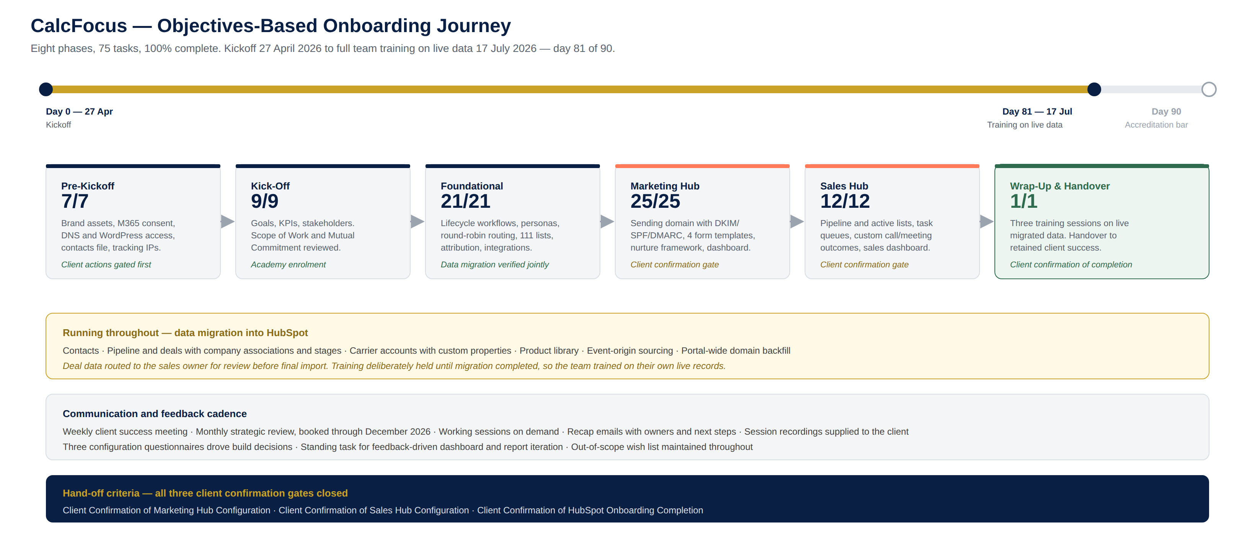
Figure 1 — The CalcFocus onboarding journey, its parallel migration workstream, the communication and feedback cadence, and the three hand-off gates.

4. Communication Plan
Channel | Cadence | Purpose
Client success meeting | Weekly | Progress, blockers, decisions
Strategic review | Monthly — booked through December 2026 | Roadmap and value review
Working sessions | On demand | Hands-on configuration with the client team
Recap emails | After each key session | Action items, owners, next steps
Session recordings | Every recorded session | Supplied to the client for their own archives

All correspondence is logged against the CRM record: 19 calls, approximately 230 emails, 36 meetings and 30 transcripts.

5. Success Metrics and Hand-off Criteria

Hand-off criteria
Three formal client confirmation gates were built into the plan and all three are closed:
- Client Confirmation of Marketing Hub Configuration
- Client Confirmation of Sales Hub Configuration
- Client Confirmation of HubSpot Onboarding Completion
Hand-off from onboarding to ongoing account management is evidenced by the transition to the retained client-success cadence, with weekly meetings and monthly strategic reviews scheduled through December 2026.

Success metrics
TO COMPLETE BEFORE SUBMISSION
This section must state the KPIs agreed at kickoff that defined success for CalcFocus.
Submission item 3 then requires actual numbers reported against these same KPIs, so the two documents must use an identical metric set.
Source: the kickoff record, or confirm directly with Lucy and Christine Peart at the next monthly strategic review.
Suggested metrics: pipeline visibility, forecast accuracy, records migrated by object, lead response time, marketing-sourced pipeline, weekly active users.

6. Risk Management
Risk identified | Mitigation delivered
Client-side dependencies stalling the build | Gated as explicit pre-kickoff tasks with named owners, completed before kickoff
Migrating unreliable or duplicated data | Joint client/QBS verification of imported baseline data; deal data routed to the sales owner for review before final import
Training landing on sample rather than real data | Training deliberately scheduled after migration completed, so the team trained on their own live records
Scope creep during onboarding | Standing out-of-scope wish list maintained throughout the engagement
Configured pipeline not matching the business forecast model | Sales stage nomenclature and probability percentages rebuilt to the client's own model as specified by the sales leadership
Capability gaps at the licensed tier | Enterprise-only churn reporting identified early; workarounds built using calculated properties rather than pushing a licence upgrade

7. Training Strategy
Training was sequenced deliberately after data migration so that every session ran against the client's own live records.
Session | Date | Audience
HubSpot Working Session | 16 July 2026 | Core project team
HubSpot Training Session | 17 July 2026 | Full team — 10 attendees, recorded with transcript
HubSpot Sales Training Session | 17 July 2026 | Sales and marketing teams
Email and marketing setup session | Scheduled on demand | Marketing owners

Enablement was also embedded throughout the plan rather than confined to set-piece sessions. Over twenty discrete education tasks cover workflow creation, lead statuses, record creation forms, uploading records, brand guidelines, campaigns, nurture content, lead scoring, blog settings, CTAs, forms, chatbot, custom ad audiences, source data, Google Analytics integration, sales sequences, meeting links, meeting and call outcomes, and sales collateral. Named client staff were enrolled in Quantum Academy.
TO COMPLETE BEFORE SUBMISSION
HubSpot asks this section to name the documentation delivered — administrator guides, integration documentation, troubleshooting FAQs.
Recorded sessions and Quantum Academy enrolment are evidenced. Confirm which written artefacts exist and attach them.
Known candidate: the CalcFocus Outlook integration overview document.

8. Feedback Mechanisms
- Weekly client success meeting as the standing feedback loop throughout the engagement
- Three client questionnaires — Email Type, Email Settings, Forms Settings — feeding configuration decisions directly
- Client review gate on migrated deal data before final import
- A standing plan task to provide ongoing support for dashboard and report adjustments as feedback is received, making feedback-driven iteration a planned activity rather than an incidental one
- Three formal client confirmation gates at hub and engagement level

