ONBOARDING ACCREDITATION — SUBMISSION ITEM 2
Integration Documentation
PacTec | Salesforce and ZoomInfo | May – September 2026

This document profiles two integration use cases delivered for a single customer: a Salesforce integration, and an additional use case using the ZoomInfo marketplace integration.
Subscription gate — action required before submission
Submission item 2 requires the profiled customer to hold both Marketing Hub and Sales Hub at Professional or above.
PacTec's Marketing Hub Professional subscription is confirmed. The Sales Hub tier is NOT confirmed, and cannot be assumed: PacTec runs Salesforce as their system of record.
Confirm the Sales Hub tier with the Partner Development Manager before submitting. If PacTec does not hold Sales Hub Professional or above, this item requires a different customer.

Engagement Overview
Customer | PacTec (pactecinc.com)
HubSpot Portal ID | [TO BE INSERTED — customer portal ID]
Industry | Business Supplies and Equipment — nuclear and industrial waste packaging
Company size | 200 employees
Location | Clinton, Louisiana, USA
Engagement | HubSpot, ZoomInfo and Salesforce Integration — 50 hours
Period | May – September 2026
Delivery status | 70 of 71 scoped tasks complete (98.6%)
Subscription | Marketing Hub Professional (confirmed); Sales Hub tier to be confirmed
Delivery partner | Quantum Business Solutions

Use Case 1 — Salesforce Integration

Business use case
PacTec operates a three-system revenue stack: Salesforce as the CRM of record, ZoomInfo for prospect data and buyer intent, and HubSpot for marketing and demand generation. The systems were not exchanging usable data.
Three specific failures defined the problem:
- The Salesforce to HubSpot activity sync had stopped on 5 February 2026 and the cause had never been established. Five months of activity history was not reaching HubSpot.
- Deal sync had never been configured at all, so marketing had no visibility of revenue outcomes and no basis for attribution.
- Fourteen standard Salesforce integration properties were missing from HubSpot, silently breaking field mapping and reporting.
The business consequence was that marketing could not see what closed, sales could not see marketing context, and neither system could be trusted for reporting.

Solution description
The HubSpot–Salesforce integration was designed and configured under a strict constraint: Salesforce remains the system of record. The governing question was therefore not how much data could be synchronised, but what must deliberately not be, so that Salesforce is protected from HubSpot-side noise while marketing gains the revenue visibility it lacked.
Alternatives considered. A middleware or iPaaS layer was assessed and rejected for this use case. The native integration met the object coverage and directional requirements, and inserting middleware between two systems that already had a reliability problem would have added a failure point rather than removed one. Separately, an upgrade to Salesforce integration version 2 was researched and its duplicate-record exposure assessed before any decision was taken, rather than upgrading blind.
A deliberate design decision sits at the centre of the build. Rather than replicating over four hundred ZoomInfo intent fields into Salesforce, a single condensed custom field — HubSpot Summary — was created and mapped, carrying the intent narrative into the Salesforce record where the seller actually works. This traded field sprawl for usable context, and was validated with live test contacts before release.

Data flow diagram
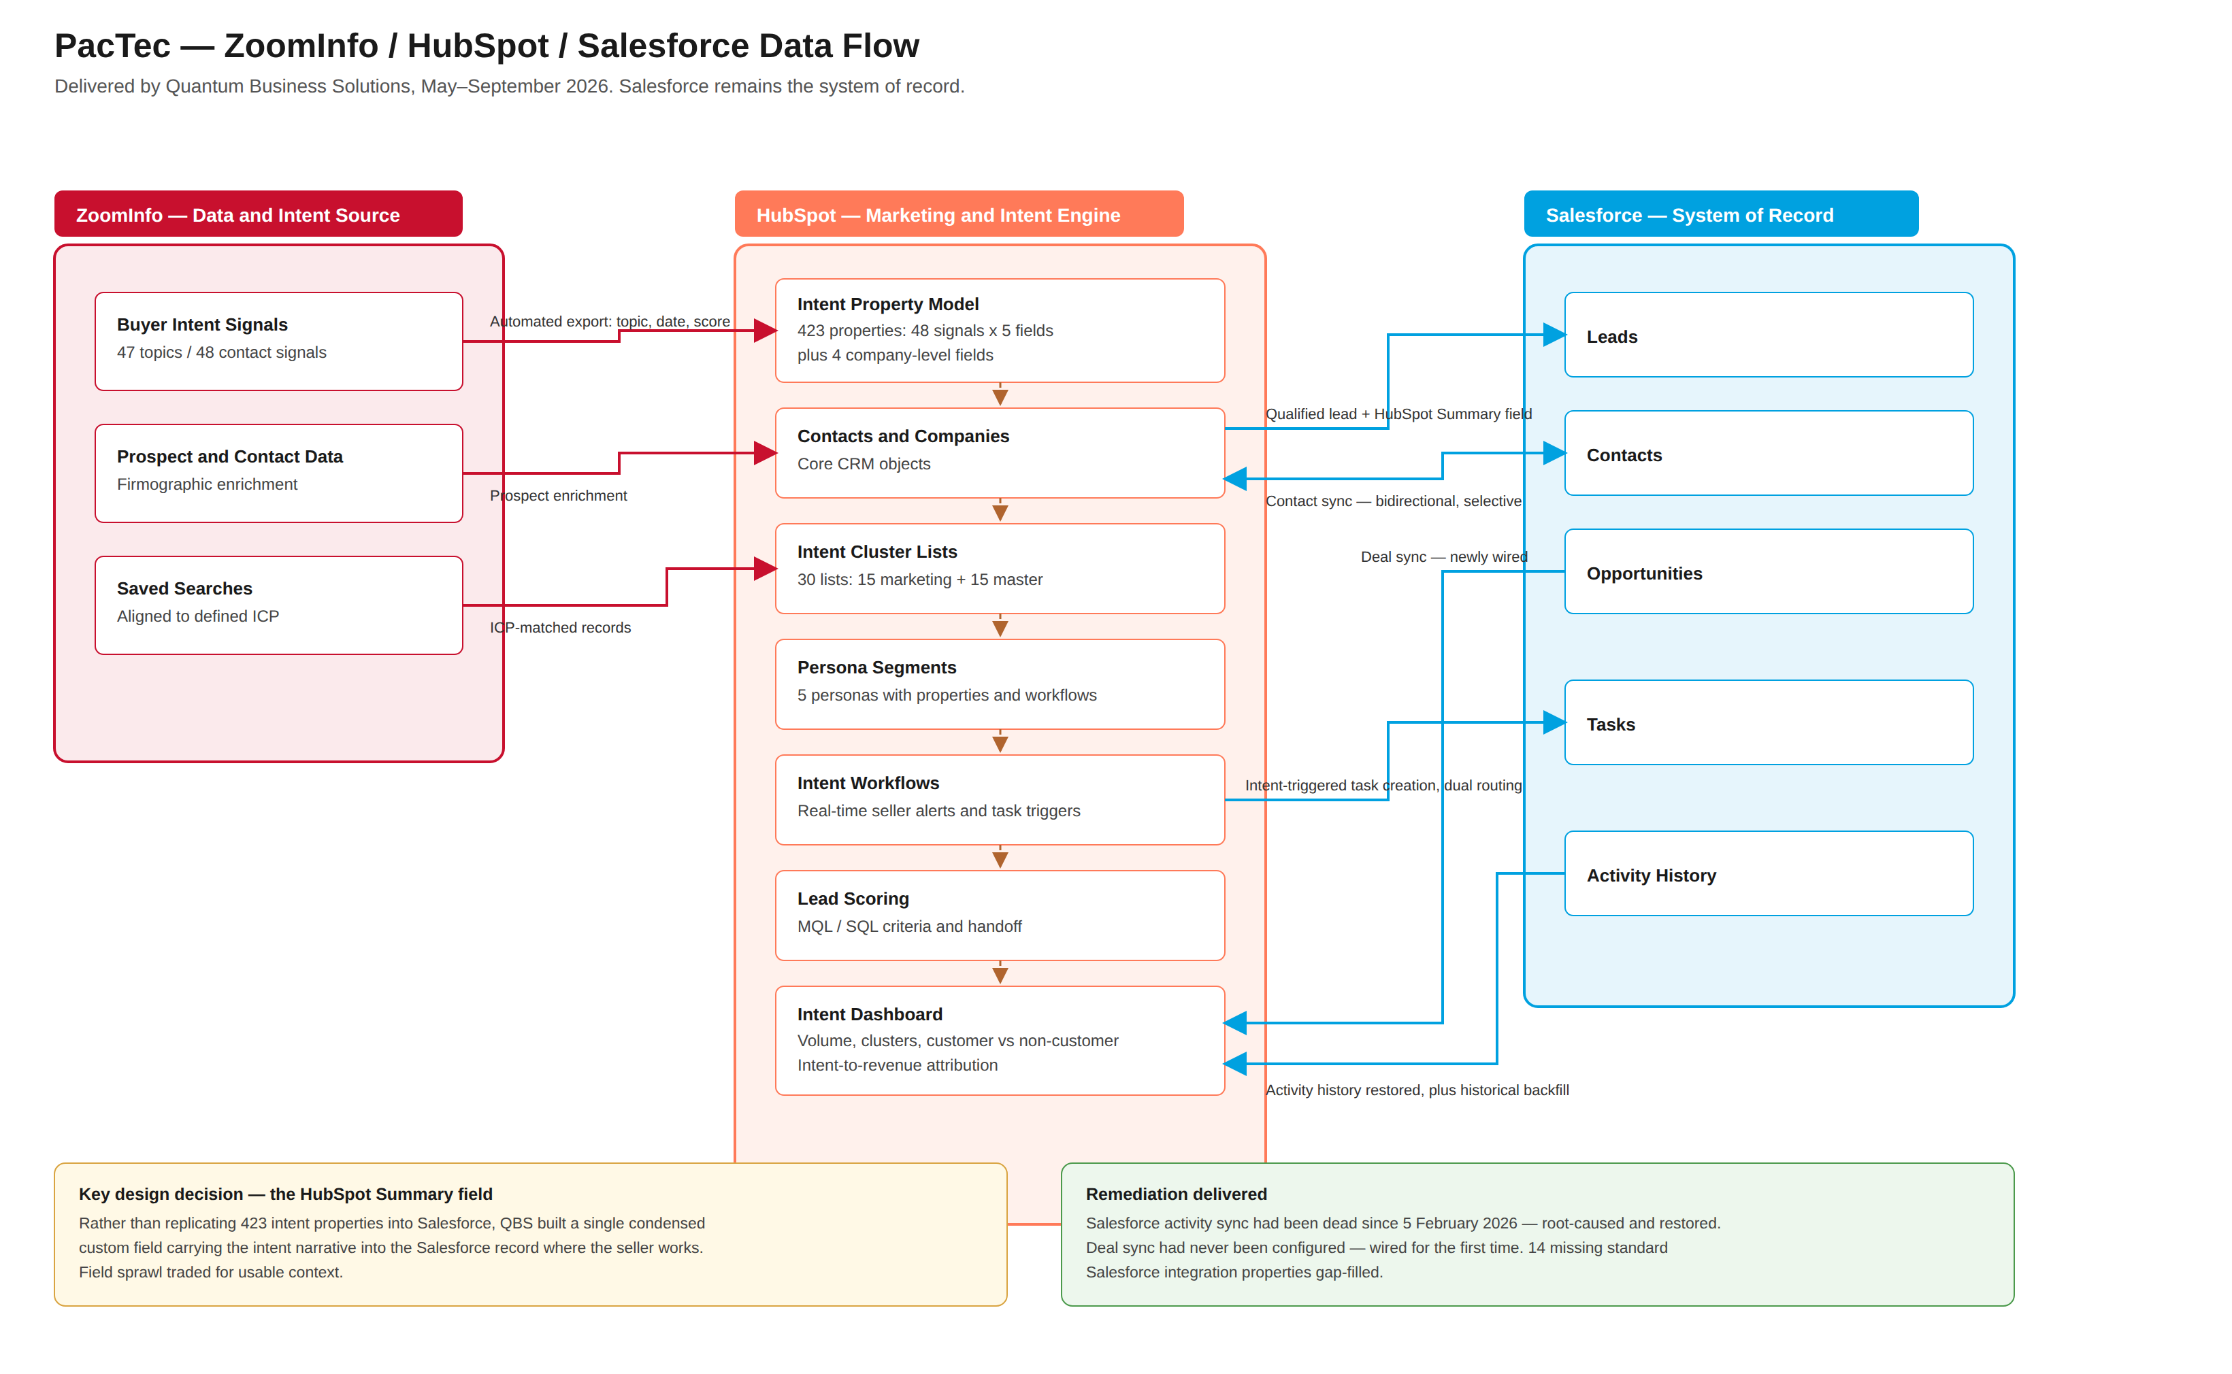
Figure 1 — PacTec integration architecture. ZoomInfo supplies intent and prospect data into HubSpot's property model; HubSpot clusters, scores and routes it; and HubSpot exchanges records bidirectionally with Salesforce, which remains the system of record.

Object coverage and sync direction
Object | HubSpot to Salesforce | Salesforce to HubSpot | Notes
Contacts | Yes | Yes | Bidirectional with selective sync rules
Leads | Yes | — | Qualified leads carrying the HubSpot Summary field
Deals / Opportunities | — | Yes | Newly wired; previously not configured
Tasks | Yes | — | Intent-triggered creation with dual routing
Activities | — | Yes | Restored after outage, plus historical backfill

How the integration was used
- Connector installed and object alignment defined across contacts, leads, deals, tasks and activities
- Field mapping, sync rules and inclusion criteria configured
- Selective sync configured with explicit decisions on what must not synchronise
- Pipeline stages aligned between the two systems
- Salesforce-sourced HubSpot properties created, and fourteen missing standard integration properties gap-filled
- The 5 February 2026 sync failure root-caused and the Salesforce to HubSpot activity sync restored
- Salesforce to HubSpot deal sync wired for the first time
- Historical Salesforce activity data imported into HubSpot to backfill the outage gap
- HubSpot to Salesforce task creation investigated, remediated and extended to dual routing for intent triggers
- Custom HubSpot Summary field mapped and validated end to end with live test contacts

Results and achieved benefits
TO COMPLETE BEFORE SUBMISSION
HubSpot requires quantified improvements here: efficiency, data accuracy, conversion rates or cost savings.
Suggested measures: activity records backfilled; sync error rate before and after; opportunities now visible in HubSpot that previously were not; seller response time to intent-triggered tasks.
Capture at the next monthly strategic review with Katie Lanoix and Christina Reckard.

Use Case 2 — ZoomInfo Marketplace Integration

Business use case
PacTec was paying for ZoomInfo buyer intent data that could not reach a seller. There was no property model in HubSpot to receive the signals, no segmentation to act on them, no alerting, and no path from an intent spike to a Salesforce opportunity. The spend could not be justified because no line connected a signal to revenue.

Solution description
The ZoomInfo marketplace integration was deployed together with a purpose-built HubSpot property and workflow architecture designed to make intent operationally usable. A clustering model was layered on top so that sellers receive coherent themes rather than forty-seven separate signal types.

How the integration was used
Component | Built
Intent property model | 47 intent topics deployed as 423 HubSpot properties — five properties for each of 48 contact-level signals, plus four company-level properties
Data export | Automated ZoomInfo to HubSpot export configured; the same property model then replicated into Salesforce alongside the client's administrator
Targeting | ZoomInfo saved searches aligned to the defined ideal customer profile
Alerting | Intent signal to HubSpot workflow to real-time sales alert chain
Cross-system path | ZoomInfo prospect to HubSpot lead to Salesforce opportunity workflow, tested end to end with dummy contacts before go-live
Personas | Five personas with properties, segments and workflows: Head of Organization, Head of Operations, Head of Procurement, Industrial Waste Management, Nuclear Waste Management
Clustering | 30 intent cluster lists — 15 marketing email and 15 master; Facilities Management activated as the pilot cluster
Commercial governance | ZoomInfo subscription audited for seats against bulk credits; account-level intent delivery escalated to ZoomInfo support
Reporting | Intent dashboard covering volume, clusters and customer versus non-customer, plus an intent-to-revenue attribution process

Results and achieved benefits
TO COMPLETE BEFORE SUBMISSION
Suggested measures: intent-sourced pipeline value; alerts generated per period; opportunities attributed to intent triggers; seller response time; ZoomInfo credit efficiency after the subscription audit.

Supporting Delivery Record
Phase | Tasks | Complete
Phase 0 — Kick-Off and Discovery | 19 | 19 (100%)
Phase 1 — HubSpot Foundational Configuration | 8 | 8 (100%)
Phase 2 — Contact and List Import, Lifecycle, MQL/SQL | 7 | 7 (100%)
Phase 3 — Marketing Hub Configuration | 12 | 12 (100%)
Phase 4 — ZoomInfo and HubSpot Integration | 7 | 7 (100%)
Phase 5 — Salesforce and HubSpot Integration | 9 | 9 (100%)
Phase 6 — Revenue Efficiency Model Build | 4 | 4 (100%)
Phase 7 — Training and Wrap-Up | 5 | 4 (80%)
TOTAL | 71 | 70 (98.6%)

Discovery included a full technical audit across website, email, HubSpot, ZoomInfo and Salesforce, with PacTec's Salesforce administrator exporting a complete field inventory before any mapping work began. Engagement record: 28 calls, approximately 115 logged emails, 22 tickets, 37 meetings and 21 transcripts.
Open delivery item
One task remains open: QA and Go-Live Readiness Review (Phase 7). Closing it before submission presents a 100% complete plan rather than 98.6%.

