Accurate calculations for the electronic excited states of benzene

Alan Guilherme Falkowski ª, Marco A. P. Lima ^{b}

Instituto de Física “Gleb Wataghin”, Universidade Estadual de Campinas, Campinas, Brazil

^{(a)} PhD student
^{(b)} PhD advisor

I. Project proposed

A. Summary of the PhD project: Convergence of the multichannel coupling in the electron-molecule collisions

The collision of low-energy electrons (< 20 eV) with molecules can provide relevant information about their electronic excited states, in particular triplet states, which are inaccessible via photoabsorption spectroscopy. Such collisions take place in several environments, being of direct relevance to the development of new radiosensitizing drugs, the modelling and optimization of non-thermal plasmas and of combustion chambers, and the understanding of the chemical evolution of interstellar media, for example. In particular, there is a great need for accurate electronic excitation cross sections, which are experimentally difficult to be obtained.

Our group has large experience on simulating the scattering of low-energy electrons with molecules, while looking at both fundamental and application aspects. To do so, we employ the Schwinger multichannel method [1], and our most recent computational implementation has allowed us to describe the scattering dynamics with up to 430 excited states considered as open channels. Despite recent methodological and computational advances, there are still many challenges for the theoretical side. A key one concerns the so-called convergence of the multichannel coupling effects, which in short determine the quality of the computed excitation cross sections as more and more electronic excited states are accounted for in the calculations.

In my PhD project, we propose to carry out an in-depth study in order to assess the limit of the multichannel convergence in the description of electron scattering by molecules. This will be pursued by (i) improving the description of the excited states, (ii) better accounting for the long-range interaction potential, and (iii) including a type of pseudopotential to mimic the ionization channels. The first applications will concern ethylene and benzene, and in a latter stage biologically relevant molecules, such as adenine and 8-bromoadenine.

Another key challenge for scattering calculations concerns the characterization of the lower-lying excited states, which are usually the ones with more well-defined bands in electron energy loss spectra measurements. In this regard, a fair comparison between theoretical and experimental excitation cross sections requires precise assignments of the states that compose each of the experimentally observed bands. In a recent publication [2], we have shown, employing equation-of-motion coupled-cluster with singles and doubles (EOM-CCSD) calculations, that the second band in the electron energy loss spectra of ethanol would actually comprise four singlet states and four triplet states, rather than the two states of each multiplicity, as had been previously suggested [3]. This finding lead us to a reinterpretation of the experimentally reported cross sections, as a better agreement with our results was only attained when the correct number (and the right) excited states was taken into account [2].

The situation clearly becomes more complicated for larger molecules and at higher impact energies (though still below the ionization threshold), where the density of excited states increases and an accurate description becomes even more challenging. Here lies the key motivation for attending the Workshop.

B. Potential impact of the Cybertraining Workshop on the PhD project

The skills that are going to be conveyed during the Workshop would have a direct and important impact on the development of my PhD project. My experience with excited state calculations is currently limited to configuration interaction with singles (CIS), and in some extent to time-dependent density functional theory (TDDFT) and EOM-CCSD. Therefore, learning multireference methodologies and the skills to operate modern quantum chemistry packages would be a significant step forward. Such calculations would be required to accurately describe singlet and triplet excited states of the targeted molecules of my project. As stated before, this information is pivotal for correctly comparing computed excitation cross sections with experiment. In addition, accurate transition dipole moments are equally important, as they provide a major correction for the long-range interaction potential, which is only poorly described with our current scattering code.

Finally, I also found the several other topics that are going to be covered in the Workshop to be very exciting and engaging. In a broader sense, the Workshop would further promote a first contact with correlated subjects that call my attention, such as nonadiabatic dynamics, quantum-classical methods and trajectory surface hopping.

C. Project to be performed during the Cybertraining Workshop

The benzene molecule is a great system to work with due to the scarcity of studies on electronic excitation by impact of electrons. It can also be seen as the simplest aromatic molecule, and as such it can provide key insights about electron induced excitation of larger aromatic molecules. While the lower-lying excited states of benzene are quite well characterized [4], the assignments above ~7 eV become more dubious. In view of the motivations stated before, precise excitation energies (and transition dipole moments) are needed in the context of electron collisions.

During the Workshop, we propose to study the lower-lying singlet and triplet excited states of benzene, making use of methodologies and softwares to be covered in the Workshop. The calculations will be performed with multiconfigurational self-consistent field (MCSCF) and multireference configuration interaction (MRCI) methods, which are implemented in the COLUMBUS quantum chemistry package. If time allows, we also plan to perform exploratory trajectory surface hopping calculations for some of the excited states of benzene, using the Newton-X package.

II. Computational Aspects

The benzene molecule have 42 electrons and 21 doubly occupied orbitals in the Hartree-Fock (HF) approximation. In the D_{6h} point group representation, the ground state is in ¹A_{1g} irreducible representation and the electronic configuration is (2a_{1g})² (2e_{1u})² (2e_{2g})⁴ (3a_{1g})² (2b_{1u})²(1b_{2u})² (3e_{1u})⁴ (1a_{2u})² (3e_{2g})⁴ (1e_{1g})⁴.

In general, all the calculations were performed using D_{2h} point group and the aug-cc-pVDZ basis set. The D_{2h} is a subgroup of D_{6h} and most of packages not use D_{6h} because is not a Abelian group.

Table 2: Summary of the configurations used in the SCF calculation and in the multi reference calculations.
 |  | Irreducible representation
 |  | a_{g} | b_{3u} | b_{2u} | b_{1g} | b_{1u} | b_{2g} | b_{3g} | a_{u}
SCF | DOCC | 6 | 5 | 4 | 3 | 1 | 1 | 1 | 0
 | OPSH | 0 | 0 | 0 | 0 | 0 | 0 | 0 | 0
MCSCF | DOCC | 6 | 5 | 4 | 3 | 0 | 0 | 0 | 0
 | RAS | 0 | 0 | 0 | 0 | 0 | 0 | 0 | 0
 | CAS | 0 | 0 | 0 | 0 | 3 | 1 | 1 | 1
 | AUX | 0 | 0 | 0 | 0 | 0 | 0 | 0 | 0
MRCI | FC | 2 | 2 | 1 | 1 | 0 | 0 | 0 | 0
 | FV | 0 | 0 | 0 | 0 | 0 | 0 | 0 | 0
 | DOCC | 4 | 3 | 3 | 2 | 0 | 0 | 0 | 0
 | ACT | 0 | 0 | 0 | 0 | 3 | 1 | 1 | 1
 | AUX | 0 | 0 | 0 | 0 | 0 | 0 | 0 | 0
 | INT | 4 | 3 | 3 | 2 | 3 | 1 | 1 | 1

First of all, we need to start with the geometry. The geometry were optimized in GAMESS-US package using second order Møller–Plesset perturbation theory (MP2). In the same package, we performed a HF Self-Consistent Field (SCF) calculation. This HF calculation helped us to know the occupation of each irreducible representation (IR) of benzene. A summary is given in the Table 2.

From the HF calculation, we obtained important information's to do the multireference calculations. We performed single point calculations with MCSCF using the COLUMBUS package. The complete active space (CAS) chosen has 6 electrons in 6 orbitals, so we have a CASSCF(6,6). In the CAS, we used the three π occupied orbitals and the three lowermost π* unoccupied orbitals. The Table 2 shows important aspects for the CAS construction.

In the Figure 1 we have a plot of the orbitals used in the active space. With this calculation, we obtained the ground state correction and the lower-lying two B_{2u} singlets and B_{3u} triplets for benzene molecule. The distinct row tables used are in details the Table 3.

Table 3: The distinct row tables used in the CASSCF and in the MRCISD.
States | Multiplicity | N. electrons | Symmetry
1 | 1 | 42 | A_{g}
2 | 1 | 42 | B_{2u}
3 | 3 | 42 | B_{3u}
Number of distinct rows (DRTs): |  |  | 3

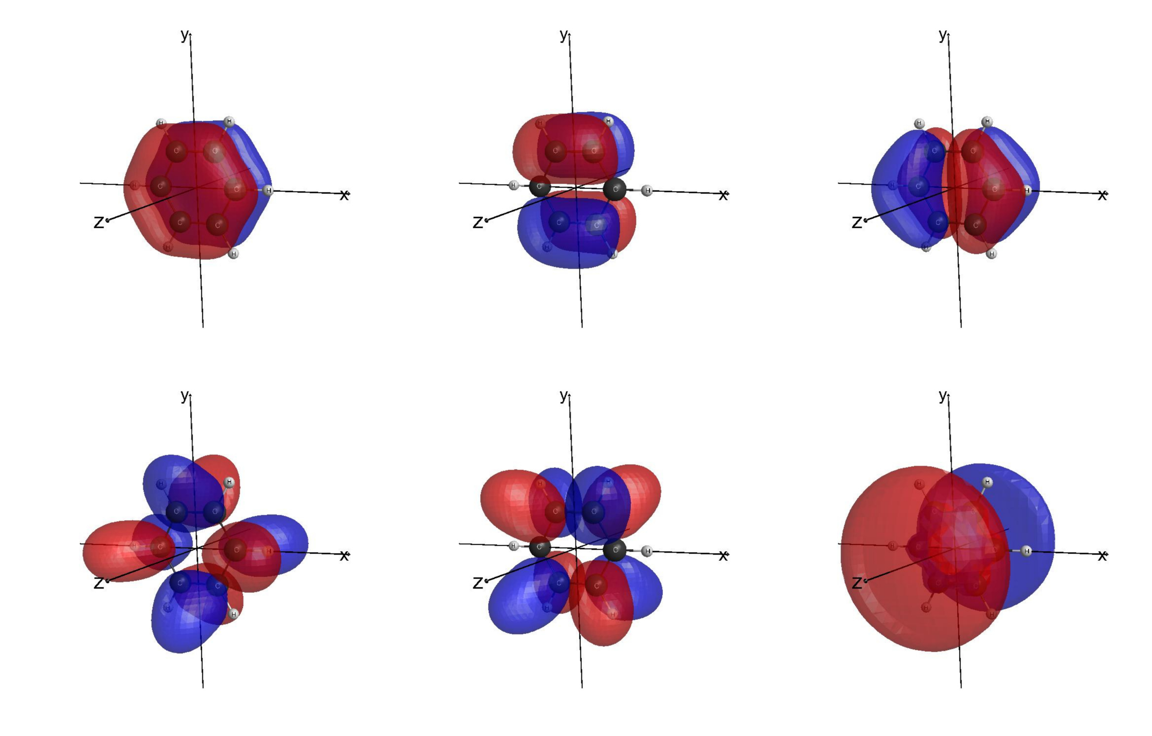
Figure 1: The three π occupied orbitals and the three lowermost π* unoccupied orbitals. Top-left π₁, top-center π₂, top-right π₃. Bottom-left π₄*, bottom-center π₅*, bottom-right π₆*. The figures are made in the wxmacmolplt.

Also, we performed a MRCI with Singles and Doubles excitations (MRCISD). The six core orbitals (1s of each carbon atom) has been frozen, because they not play an important role in the correlation. The active space used is the same of the CASSCF calculation, i.e., we have a MRCI(6,6). With this approach, we calculated the ground state corrections and the lowest-lying two B_{2u} singlets and two B_{3u} triplets. The table 2 shows some details about the orbitals used.

For sake of comparison, we used the EOM-CCSD to obtain the lowest-lying B_{2u} singlets and B_{3u} triplets. This calculation were realized in the PSI4 quantum chemistry package.

III. Results and Discussion

The Table 3 and 4 shows the results obtained with the CASSCF(6,6) and MRCI(6,6). In all tables in this section, we shown the results for the ground state X¹A_{g}, for the first and second singlet B_{2u} , and for the first and second triplet B_{3u}. In addition, in these tables we have the most important configuration state functions for each state and the percentage of importance.

Table 3: Results for the CASSCF(6,6) calculation.

List of active orbitals
(1 b_{1u} )(2 b_{1u})(3 b_{1u})(1 b_{2g})(1 b_{3g})(1 a_{u})
State | ∆E (eV) | Configuration | %
CASSCF(6,6)
X¹A_{g} | 0.00 | (1 b_{1u})²(2 b_{1u})⁰(3 b_{1u})⁰(1 b_{2g})²(1 b_{3g})²(1 a_{u})⁰ | 94
1¹B_{2u} | 5.75 | (1 b_{1u})²(2 b_{1u})⁰(3 b_{1u})⁰(1 b_{2g})¹(1 b_{3g})²(1 a_{u})¹ | 44
 |  | (1 b_{1u})²(2 b_{1u})¹(3 b_{1u})⁰(1 b_{2g})²(1 b_{3g})¹(1 a_{u})⁰ | 42
2¹B_{2u} | 7.67 | (1 b_{1u})²(2 b_{1u})⁰(3 b_{1u})¹(1 b_{2g})²(1 b_{3g})¹(1 a_{u})⁰ | 62
 |  | (1 b_{1u})²(2 b_{1u})¹(3 b_{1u})⁰(1 b_{2g})²(1 b_{3g})¹(1 a_{u})⁰ | 25
1³B_{3u} | 4.39 | (1 b_{1u})²(2 b_{1u})⁰(3 b_{1u})⁰(1 b_{2g})²(1 b_{3g})¹(1 a_{u})¹ | 50
 |  | (1 b_{1u})²(2 b_{1u})¹(3 b_{1u})⁰(1 b_{2g})¹(1 b_{3g})²(1 a_{u})⁰ | 41
2³B_{3u} | 5.14 | (1 b_{1u})²(2 b_{1u})¹(3 b_{1u})⁰(1 b_{2g})¹(1 b_{3g})²(1 a_{u})⁰ | 47
 |  | (1 b_{1u})²(2 b_{1u})⁰(3 b_{1u})⁰(1 b_{2g})²(1 b_{3g})¹(1 a_{u})¹ | 44

Table 4: As in the Table 4 but for the MRCI(6,6) calculation. The vertical excitation energies ∆E+P are obtained with the Pople’s correction.

List of active orbitals
(1 b_{1u} )(2 b_{1u})(3 b_{1u})(1 b_{2g})(1 b_{3g})(1 a_{u})
State | ∆E/∆E+P (eV) | Configuration | %
MRCI(6,6)
X¹A_{g} | 0.00 / 0.00 | (1 b_{1u})²(2 b_{1u})⁰(3 b_{1u})⁰(1 b_{2g})²(1 b_{3g})²(1 a_{u})⁰ | 78
1¹B_{2u} | 5.39 / 4.98 | (1 b_{1u})²(2 b_{1u})⁰(3 b_{1u})⁰(1 b_{2g})¹(1 b_{3g})²(1 a_{u})¹ | 36
 |  | (1 b_{1u})²(2 b_{1u})¹(3 b_{1u})⁰(1 b_{2g})²(1 b_{3g})¹(1 a_{u})⁰ | 34
2¹B_{2u} | 7.73 / 7.44 | (1 b_{1u})²(2 b_{1u})¹(3 b_{1u})⁰(1 b_{2g})²(1 b_{3g})¹(1 a_{u})⁰ | 35
 |  | (1 b_{1u})²(2 b_{1u})⁰(3 b_{1u})¹(1 b_{2g})²(1 b_{3g})¹(1 a_{u})⁰ | 27
 |  | (1 b_{1u})²(2 b_{1u})⁰(3 b_{1u})⁰(1 b_{2g})¹(1 b_{3g})²(1 a_{u})¹ | 16
1³B_{3u} | 4.32 / 4.15 | (1 b_{1u})²(2 b_{1u})⁰(3 b_{1u})⁰(1 b_{2g})²(1 b_{3g})¹(1 a_{u})¹ | 40
 |  | (1 b_{1u})²(2 b_{1u})¹(3 b_{1u})⁰(1 b_{2g})¹(1 b_{3g})²(1 a_{u})⁰ | 35
2³B_{3u} | 5.01 / 4.83 | (1 b_{1u})²(2 b_{1u})⁰(3 b_{1u})⁰(1 b_{2g})²(1 b_{3g})¹(1 a_{u})¹ | 38
 |  | (1 b_{1u})²(2 b_{1u})¹(3 b_{1u})⁰(1 b_{2g})¹(1 b_{3g})²(1 a_{u})⁰ | 37

In the table 5, we summarize the results and compared with the experimental results. The results obtained with CASSCF are in reasonable agreement with the experimental vertical excitation energies. The MRCI and EOM-CCSD calculations are in good agreement with the experiment. For the 2¹B_{2u}, 1³B_{3u} and 2³B_{3u} the EOM-CCSD provide better results than the MRCI, and the opposite occurs for the 1¹B_{2u} state. This results indicates that if we employed a more sophisticated CAS in our MRCI calculation, maybe we can describe better the experiment.

Table 5: Summary of the calculations performed compared with the experimental results. All energies are in eV. The MRCI vertical excitation energies are with the Pople’s correction.
State | CASSCF | MRCI | EOM-CCSD | Exp.^{(a)}
X¹A_{g} | 0.00 | 0.00 | 0.00 | 0.00
1¹B_{2u} | 5.75 | 4.98 | 5.07 | 4.90
2¹B_{2u} | 7.67 | 7.44 | 7.25 | 6.94
1³B_{3u} | 4.39 | 4.15 | 3.87 | 3.95
2³B_{3u} | 5.14 | 4.83 | 4.82 | 4.76

(a) Lassettre et al. J Chem. Phys. 48, 5066 (1968), Doering et al. J. Chem. Phys. 51, 2866 (1969), Nakashima et al. J. Chem. Phys. 72, 2226 (1980), Nakashima et al. J. Chem. Phys. 73, 5976 (1980).

IV. Conclusion

We performed a single point calculation with the multi reference methods CASSCF and MRCI, and for a single reference with EOM-CCSD. Our results are in good agreement with the experimental results and indicates that the inclusion of more electrons and more orbitals can improve these aspect. In the CAS space, we have just π orbitals. Take into account sigma orbitals should improve our results, and this will be made in a future work. Unfortunately we were not able to do non-adiabatic dynamics calculations due to lack of time. With the tools and theory learned in this cybertraining, we are able to do accurate vertical excitation energies calculations with multiference methods. More applications will be made, as for the ethylene molecule, adenine, etc.

V. References

[1] R. F. da Costa, M. T. do N. Varella, M. H. F. Bettega, M. A. P. Lima, Eur. Phys. J. D 69, 159 (2015).
[2] A. G. Falkowski, M. A. P. Lima, and F. Kossoski, J. Chem. Phys. 152, 244302 (2020).
[3] L. R. Hargreaves, M. A. Khakoo, C. Winstead, and V. McKoy, J. Phys. B: At., Mol. Opt. Phys. 49, 185201 (2016).
[4] P.-F. Loos, F. Lipparini, M. Boggio-Pasqua, A. Scemama, and D. Jacquemin, J. Chem. Theory Comput. 16, 1711 (2020).

