VISTA Seminar

Seminar 96

October 29, 2025
10:00 am – 11:30 am EDT Buffalo / 2:00 – 3:30 pm GMT London / 3:00 pm – 4:30 pm CET Paris / 10 pm – 11:30 pm CST Beijing

TOC:

1. Presenter 1: Prof. Basile F. E. Curchod, University of Bristol, UK……......page 2
2. Presenter 2: Dr. Victor Manuel Freixas, University of California, Irvine, USA…………………………………………………………………………...page 3
3. How to connect………………………………………………………..….. page 4

Describing photoexcitation in nonadiabatic molecular dynamics.
Basile F. E. Curchod
School of Chemistry, University of Bristol, UK
Email: basile.curchod@bristol.ac.uk
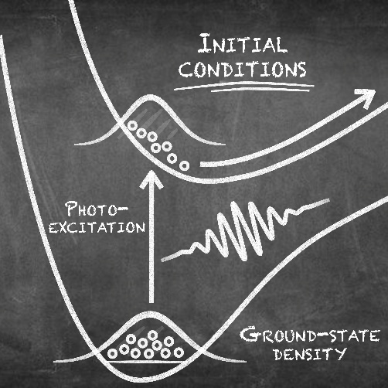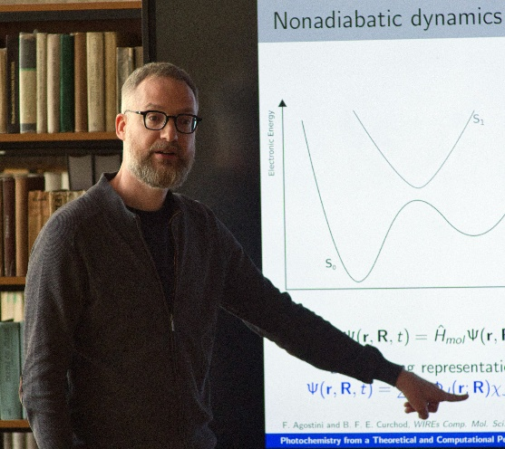

A significant number of computational strategies have been developed over the past decades to simulate the excited-state dynamics of molecules beyond the Born-Oppenheimer approximation. When combined with advanced electronic-structure methods, these techniques – often based on coupled or uncoupled trajectories – have the potential to unravel the mechanistic details of photochemical reactions of direct interest to physical, atmospheric, and material chemists.
Despite all these extensive developments, the very first step of any photochemical reaction – photoexcitation – is dramatically approximated in most applications of nonadiabatic dynamics.[1] In an ideal world, the initial ground-state nuclear wavefunction, representing the molecule of interest, should be coupled, for example, to the time-dependent electromagnetic field of a laser pulse, leading to a transfer of nuclear amplitude to an excited electronic state based on the precise characteristics of the field. In practice, two strong approximations are made to simplify the photoexcitation process.[2] (1) A harmonic Wigner distribution is often used to represent the ground-state distribution of the molecule, from which initial nuclear positions and momenta can be sampled. (2) These pairs of nuclear positions-momenta are then promoted to a given excited electronic state and used to initiate the nonadiabatic molecular dynamics – a so-called sudden excitation approximation.
In this talk, I will discuss the limitations of these two approximations, supported by numerical simulations of realistic molecular systems. I will then present more rigorous strategies to describe the photoexcitation process: ab initio molecular dynamics with a quantum thermostat to sample pairs of nuclear positions-momenta in the ground electronic state[3] and the promoted nuclear density approach to incorporate the effect of a laser pulse at the level of the initial conditions at no cost.[4]

References:
[1] J. Suchan, D. Hollas, B. F. E. Curchod, P. Slavíček, On the Importance of Initial Conditions for Excited-State Dynamics, Faraday Discuss., 212, 307 (2018). https://doi.org/10.1039/C8FD00088C
[2] J. Janoš, P. Slavíček, B. F. E. Curchod, Selecting Initial Conditions for Trajectory-Based Nonadiabatic Simulations, Acc. Chem. Res., 58, 261 (2025). https://doi.org/10.1021/acs.accounts.4c00687
[3] A. Prlj, D. Hollas, B. F. E. Curchod, Deciphering the Influence of Ground-State Distributions on the Calculation of Photolysis Observables, J. Phys. Chem. A, 127, 7400 (2023). https://doi.org/10.1021/acs.jpca.3c02333
[4] J. Janoš, P. Slavíček, B. F. E. Curchod, Including Photoexcitation Explicitly in Trajectory-Based Nonadiabatic Dynamics at No Cost, J. Phys. Chem. Lett., 15, 10614 (2024). https://doi.org/10.1021/acs.jpclett.4c02549
X-ray Circular Dichroism: A window to local chirality in molecules

Victor Manuel Freixas

University of California, Irvine
Email: vfreixas@uci.edu

Chirality is a fundamental molecular property with far-reaching implications in biophysics, catalysis, and drug design. Optical circular dichroism (OCD) has long served as the primary spectroscopic probe of molecular chirality in the UV–visible regime. While chirality is often associated with localized stereogenic centers, certain molecular architectures—such as helicenes—exhibit global chirality arising from extended π-conjugation and screw-like topology. In these systems, the electric and magnetic transition densities are delocalized, and OCD effectively probes the collective chiral response of the entire molecule. Recent advances in synchrotron and free-electron laser technologies, particularly the generation of X-rays with tunable circular polarization, have enabled X-ray circular dichroism (XCD). In contrast to OCD, XCD is element- and site-specific, granting access to local manifestations of chirality encoded in core-level electronic transitions. To quantify the extent to which chirality emerges as a local or global feature, we introduce chiral population analysis, a framework that decomposes the dichroic response into contributions from individual atomic orbitals—analogous to how Mulliken population analysis distributes electronic charge. This approach provides both quantitative and visual insight: by mapping orbital contributions onto real-space isosurfaces, one can directly trace the spatial origin of the dichroic signal. Within this representation, electric transition dipole contributions appear as lobe-like features, magnetic dipole contributions as loop structures, and regions where both coexist form spiral patterns.

How to connect

Alexey Akimov is inviting you to a scheduled Zoom meeting.

Topic: VISTA, Seminar 96
Time: Oct 29, 2025 10:00 AM Eastern Time (US and Canada)
Join Zoom Meeting
https://buffalo.zoom.us/j/93697013464?pwd=IFUrgjFysHy7qiuM7Uk5G75PbwXDZq.1

Meeting ID: 936 9701 3464
Passcode: 612025

How to stay updated

A. VISTA Mailing list:

- Follow the link:
https://listserv.buffalo.edu/scripts/wa.exe?A0=CHE-VISTA-LIST&X=OA41BBB2DC6071987DF&Y=alexeyak%40buffalo.edu
- Click the menu icon in the upper right part of the list (yellow highlight in the picture below)
- Click the “Subscribe or Unsubscribe” option (purple highlight below) – it will bring you to the next window where you’ll be asked for your email/name (I think it the name is optional to provide). This way, you can subscribe to the mailing list to stay tuned or unsubscribe if you find the seminars irrelevant to you or just get too much emails to deal with.
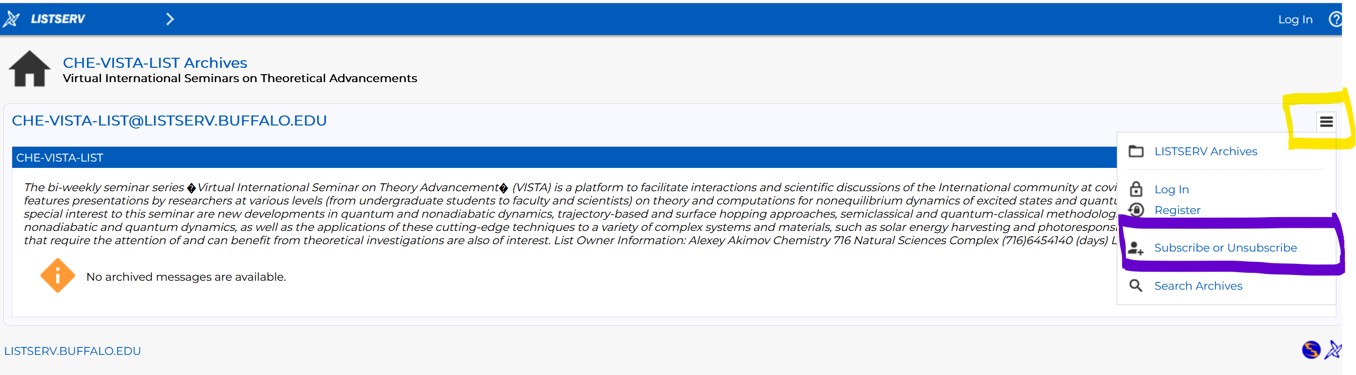

B. Slack Workspaces:

- VISTA workspace: https://join.slack.com/t/vista-atk8254/shared_invite/zt-mdlteo5v-P1Hc7XVupkwMbnGhNG4KIw
- Quantum Dynamics Hub workspace: https://join.slack.com/t/quantumdynamicshub/shared_invite/zt-mjbhjssx-GGhsbYHxeBMvhmumK_j7LA

