VISTA Seminar

Seminar 91

June 4, 2025
10:00 am – 11:30 am EDT Buffalo / 3:00 – 4:30 pm BST London / 4:00 pm – 5:30 pm CEST Paris / 10 pm – 11:30 pm CST Beijing

TOC:

1. Presenter 1: Prof. Mohammad R. Momeni, University of Missouri – Kansas City, USA………………………………………………………………….….page 2
2. Presenter 2: Dr. Nathan London, University of Missouri – Kansas City, USA………………………………………………………………....……......page 3
3. How to connect………………………………………………………..….. page 4

Real-Time Dynamics in Bead-Fourier Path Integral Representation
Mohammad R. Momeni
Division of Energy, Matter and Systems, School of Science and Engineering, University of Missouri-Kansas City,
Kansas City 64110, MO, United States
Email: mmomenitaheri@umkc.edu
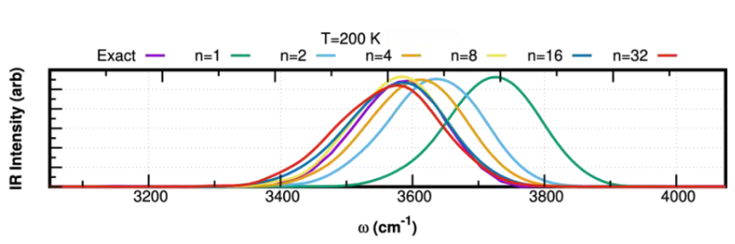

Historically, Feynman’s representation of quantum mechanics (QM) in terms of the sum over all paths or path integrals (PIs) was initially applied within the Monte-Carlo (MC) scheme for calculating QM equilibrium properties. Parrinello and Rahman showed that by simply adding a fictitious kinetic energy term, one can extend them to path integral molecular dynamics (PIMD).[1] Early on, it was found that large beads are needed to converge equilibrium properties for low temperatures and light nuclei. A large number of beads creates ring polymers with stiffer harmonic springs. In the best-case scenario, where lack of ergodicity does not produce incorrect sampling, large beads will require smaller time steps for stable integrations in PIMD, leading to higher computational cost.[2] Therefore, overall, it is highly beneficial from both accuracy and efficiency standpoints, especially for on-the-fly ab initio PIMD (AI-PIMD) simulations, to lower the number of beads. One alternative to bead PIs is the bead-Fourier (BF) approach, which combines the bead and Fourier methods to imaginary time PIs into one scheme. When compared to pure Fourier PIs, the addition of a few beads drastically reduces the number of Fourier components needed to converge to exact results. This places BF-PIs as a natural middle ground between the extremes of bead PIs and Fourier PIs. In this presentation, I will present a brand-new family of our recently developed real-time methods based on BF-PIs, including BF ring polymer MD (BF-RPMD) and BF centroid MD (BF-CMD).[3] I will show detailed benchmarks that showcase the accuracy of these new schemes compared to the legacy RPMD and CMD methods. Finally, I will discuss our calculated infrared (IR) spectra for the 2D O-H model system using BF-CMD, compared to the CMD and QM spectra, showing great promise for treating the so-called “curvature problem” and red-shifting of the stretch peaks of CMD.[4] I will also mention our ongoing efforts in extending these methods to adiabatic/partially adiabatic BF-CMD methods for atomistic simulations using our in-house developed general-purpose software DL_POLY Quantum.[5,6]

References:
[1] M. Parrinello, A. Rahman, J. Chem. Phys. 80, 860 (1984).
[2] R. W. Hall, B. J. Berne, J. Chem. Phys. 81, 3641 (1984).
[3] N. London, M. R. Momeni, https://arxiv.org/abs/2505.13707.
[4] D. K. Limbu, N. London, M. O. Faruque, M. R. Momeni, J. Chem. Phys. 162, 014111 (2025).
[5] N. London, D. K. Limbu, M. O. Faruque, F. A. Shakib, M. R. Momeni, J. Phys. Chem. A 129, 4015 (2025).
[6] N. London, D. K. Limbu, M. R. Momeni, F. A. Shakib, J. Chem. Phys. 160, 132501 (2024).
BF-CMD: Centroid Molecular Dynamics Using Bead-Fourier Path-Integrals

Nathan London¹ and Mohammad R. Momeni¹

¹Division of Energy, Matter and Systems, School of Science and Engineering, University of Missouri—Kansas City
Email: nlondon@umkc.edu

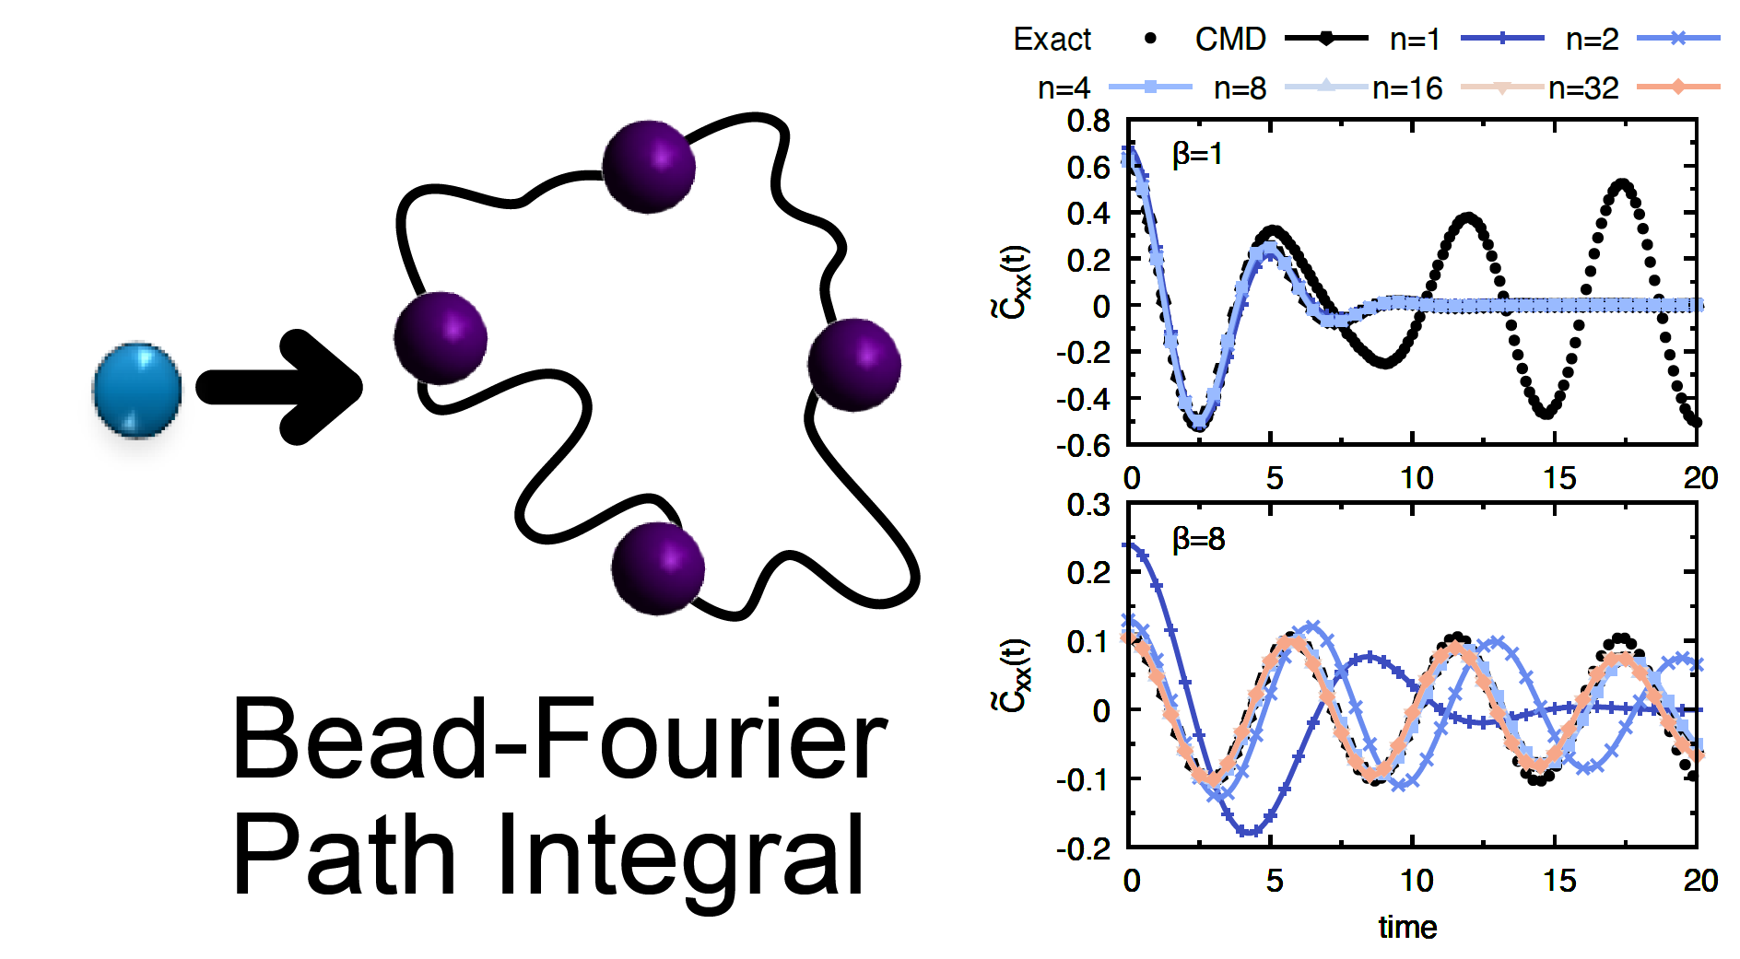

Nuclear quantum effects (NQEs) play a critical role in a number of chemical phenomena, including reaction rates and vibrational spectra, and therefore, their accurate incorporation in dynamical simulations is essential for creating a truly predictive theory. Propagating complex condensed phase and interfacial systems with thousands of degrees of freedom (DOFs) fully quantum mechanically with quantum nuclei is beyond current computational capabilities. Methods to efficiently and accurately incorporate NQEs into classical MD simulations are thus a key area of developmental focus. One particular branch of research is utilizing Feynman's path-integral (PI) formulation of quantum statistical mechanics. Methods based upon PI formulation, such as PIMD, centroid MD (CMD), and ring polymer MD (RPMD), extend classical MD simulations to include some NQEs like zero-point energy and quantum tunneling through introducing multiple “replicas” of the system connected with harmonic springs. The additional copies of the system retain a similar computational cost scaling to classical simulations, making PI methods attractive for large-scale simulations. An alternate PI formulation, bead-Fourier (BF) PIs, introduces fluctuations along the imaginary time path between replicas (known as “beads”) through a Fourier series. The addition of the Fourier components reduces the number of beads to converge equilibrium properties, which can reduce problems associated with extended ring polymers, including the lack of ergodicity during sampling, as well as the flattening of effective potentials in CMD methods. Here we introduce the BF-CMD method, where we utilize BF-PIs to generate the CMD effective potential. We showcase the method by calculating position autocorrelation functions of model systems. Our results show that with the inclusion of just a single Fourier component, we can achieve the same accuracy as conventional discretized CMD with a significant reduction in the number of beads needed.

How to connect

Alexey Akimov is inviting you to a scheduled Zoom meeting.

Topic: VISTA, Seminar 91
Time: Jun 4, 2025 10:00 AM Eastern Time (US and Canada)
Join Zoom Meeting
https://buffalo.zoom.us/j/93049384432?pwd=rb5InyAouUGI7ZNkkNxkaZ1paVdTAX.1

Meeting ID: 930 4938 4432
Passcode: 285312

How to stay updated

A. VISTA Mailing list:

- Follow the link:
https://listserv.buffalo.edu/scripts/wa.exe?A0=CHE-VISTA-LIST&X=OA41BBB2DC6071987DF&Y=alexeyak%40buffalo.edu
- Click the menu icon in the upper right part of the list (yellow highlight in the picture below)
- Click the “Subscribe or Unsubscribe” option (purple highlight below) – it will bring you to the next window where you’ll be asked for your email/name (I think it the name is optional to provide). This way, you can subscribe to the mailing list to stay tuned or unsubscribe if you find the seminars irrelevant to you or just get too much emails to deal with.
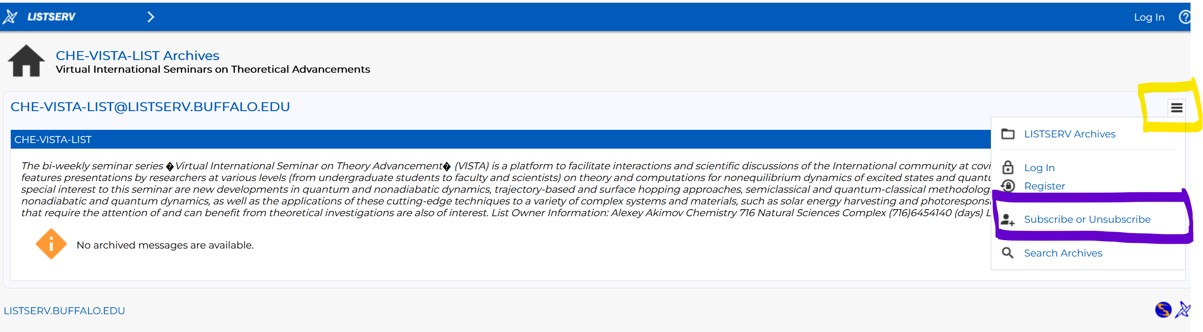

B. Slack Workspaces:

- VISTA workspace: https://join.slack.com/t/vista-atk8254/shared_invite/zt-mdlteo5v-P1Hc7XVupkwMbnGhNG4KIw
- Quantum Dynamics Hub workspace: https://join.slack.com/t/quantumdynamicshub/shared_invite/zt-mjbhjssx-GGhsbYHxeBMvhmumK_j7LA

