VISTA Seminar

Seminar 106

April 8, 2026
10:00 am – 11:30 am EDT Buffalo / 3:00 – 4:30 pm BST London / 4:00 pm – 5:30 pm CEST Paris / 10 pm – 11:30 pm CST Beijing

TOC:

1. Presenter 1: Prof. Lukas Muehler, Penn State University, USA..………….page 2
2. Presenter 2: Dr. Brieuc Le De, University of California, Merced, USA.….page 3
3. How to connect………………………………………………………..….. page 4

Strong Correlations and Topological Transitions in Chemical Reactions

Lukas Muehler
Department of Chemistry, Penn State University, USA
108 Benkovic Building, University Park, PA 16802
Email: lfm5572@psu.edu

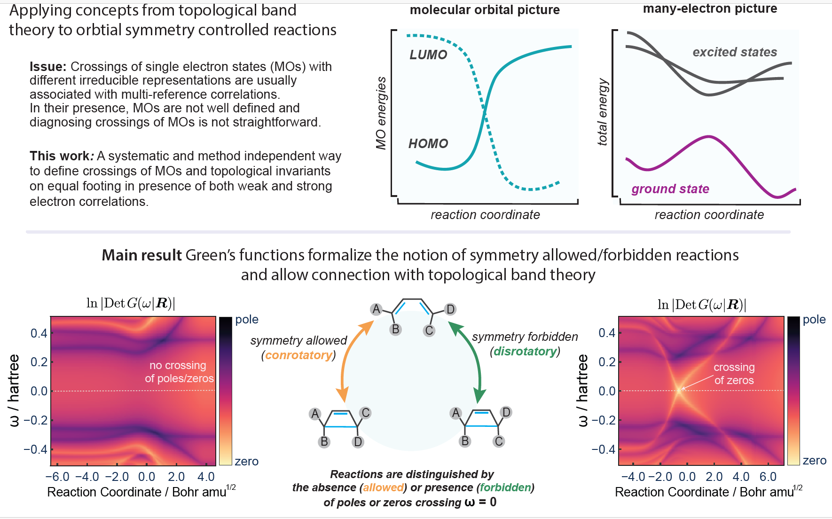

Classifying energy level connectivity via topological invariants has become a standard tool in condensed-matter physics. Despite many fundamental questions, extending these concepts to molecular systems has recently attracted significant interest. Reactions governed by orbital symmetry conservation are ideal candidates to test this extension, as they classify pathways as symmetry-allowed or symmetry-forbidden depending on whether molecular orbitals cross along the reaction coordinate. However, the presence of strong electronic correlations in these reactions invalidate the framework underlying topological band theory, preventing direct generalization. Here, we introduce a formalism in terms of Green's functions to classify orbital symmetry controlled reactions even in the presence of strong electronic correlations. Focusing on prototypical 4pi electrocyclizations, we show that symmetry-forbidden pathways are characterized by crossings of Green's function zeros, in stark contrast to the crossings of poles as predicted by molecular-orbital theory. We introduce symmetry-resolved invariants that provide endpoint diagnostics for symmetry-preserving paths and motivate direct zero-tracking when symmetry is weakly broken. The result is a many-body generalization of orbital-crossing selection rules and a bridge to established concepts from topological and strong interaction physics in a molecular setting.

Theory of Photoinduced Excited State Proton Transfer
Brieuc Le Dé,^{1,2} Simon Huppert,² Riccardo Spezia³ and Alex W. Chin²

¹Department of Chemistry and Biochemistry, University of California, Merced, CA 95343, USA
²Institut des NanoSciences de Paris (INSP), Sorbonne Université, CNRS, Paris, 75005, France
³Laboratoire de Chimie Théorique (LCT), Sorbonne Université, CNRS, Paris, 75005, France
Email: blede@ucmerced.edu

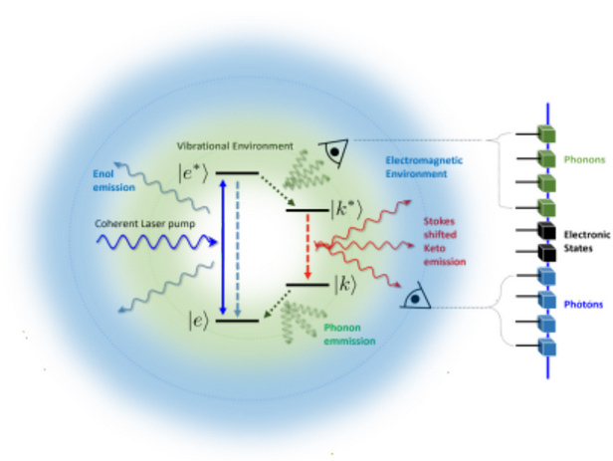

Photoinduced Excited State Proton Transfer (ESPT) is characterized by a transfer of a proton between two moieties of a molecule when the system is photoexcited, often seen via an exceptionally large Stokes shift (≥ 100 nm) in fluorescence spectra. This ultrafast process, occurring at the limit of many experimental probe timescales, plays fundamental roles in diverse biological mechanisms and provides an excellent platform for developing tailored drug delivery systems and optical devices [1]. Despite its apparent simplicity, ESPT presents significant computational challenges due to the quantum nature of nuclear motion, which cannot be neglected because of out-of-equilibrium effects occurring in the ultrafast regime. By developing simple prototype systems, we focused especially on short time behaviors parametrized by the photoexcitation shape and vibrations of the system. This surrounding environment is included with great accuracy through fully quantized theoretical simulation and powerful numerical Tensor-Network techniques [2,3], permitting us to include hundreds of vibrations modes. Studying the wavepacket propagation of test bed molecule models for ultrafast ESPT with explicit description of vibrations, we revealed the importance of the pump duration on initial conditions and on the subsequent dynamics [4]. The presented study helps gain insight into the non-equilibrium dynamics of proton transfer and provides new design principles mimicking this natural and essential process.

References
[1] P. Goyal and S. Hammes-Schiffer ACS Energy Lett. 2, 512–519 (2017).
[2] A. J. Dunnett, D. Gowland, C. M. Isborn, et al. J. Chem. Phys 155, 144112 (2021).
[3] B. Le Dé, S. Huppert, R. Spezia and A.W. Chin: J. Chem. Theory Comput. 20, 8749−8766 (2024)
[4] B. Le Dé, S. Huppert, R. Spezia and A.W. Chin: J. Phys. Chem. Lett. 16, 2514−2521 (2025)
How to connect

Alexey Akimov is inviting you to a scheduled Zoom meeting.

Topic: VISTA, Seminar 106
Time: Apr 8, 2026 10:00 AM Eastern Time (US and Canada)
Join Zoom Meeting
https://buffalo.zoom.us/j/95658657597?pwd=UOmGrwhThEh2DirBweOLED7bBab4lb.1

Meeting ID: 956 5865 7597
Passcode: 986060

How to stay updated

A. VISTA Mailing list:

- Follow the link:
https://listserv.buffalo.edu/scripts/wa.exe?A0=CHE-VISTA-LIST&X=OA41BBB2DC6071987DF&Y=alexeyak%40buffalo.edu
- Click the menu icon in the upper right part of the list (yellow highlight in the picture below)
- Click the “Subscribe or Unsubscribe” option (purple highlight below) – it will bring you to the next window where you’ll be asked for your email/name (I think it the name is optional to provide). This way, you can subscribe to the mailing list to stay tuned or unsubscribe if you find the seminars irrelevant to you or just get too much emails to deal with.
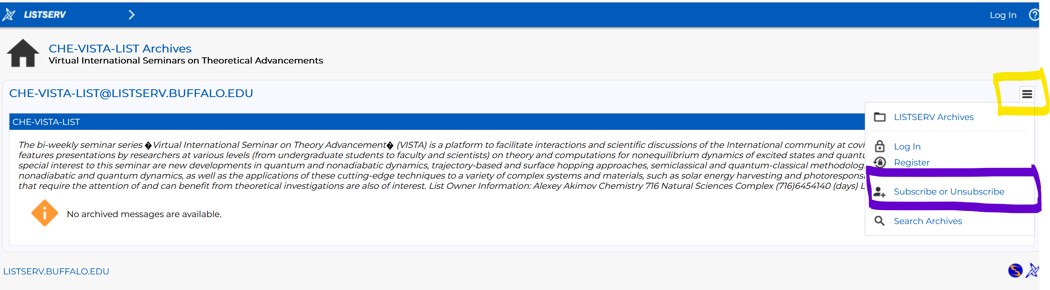

B. Slack Workspaces:

- VISTA workspace: https://join.slack.com/t/vista-atk8254/shared_invite/zt-mdlteo5v-P1Hc7XVupkwMbnGhNG4KIw
- Quantum Dynamics Hub workspace: https://join.slack.com/t/quantumdynamicshub/shared_invite/zt-mjbhjssx-GGhsbYHxeBMvhmumK_j7LA

