VISTA Seminar

Seminar 107

April 22, 2026
10:00 am – 11:30 am EDT Buffalo / 3:00 – 4:30 pm BST London / 4:00 pm – 5:30 pm CEST Paris / 10 pm – 11:30 pm CST Beijing

TOC:

1. Presenter 1: Prof. Wei Fang, Fudan University, Shanghai, USA..……...….page 2
2. Presenter 2: Mr. Mohammad Shakiba, University at Buffalo, NY, USA..…page 3
3. How to connect………………………………………………………..….. page 4

Instanton theory simulation of nuclear quantum effects

Wei Fang

Department of Chemistry, Fudan University, Shanghai China
Email: wei_fang@fudan.edu.cn



Ring-polymer instanton theory is a quantum transition state theory that calculates tunneling rates by optimizing the minimum-action tunneling path (instanton) and elucidates the underlying mechanism. When combined with ab initio methods, it enables exploration of tunneling in chemical reactions of larger molecules. In recent years, by advancing instanton theory methods and integrating with cutting-edge machine learning tools and high-precision electronic structure calculations, we have made notable progress in tunneling simulations. Furthermore, the instanton theory framework can be extended to the simulation of complex nuclear quantum effects, such as non-adiabatic tunneling and tunneling splitting, while maintaining a favorable balance of reliability and efficiency. Recently, we developed a new method based on instantons for constructing quantum effective potentials and, integrated with machine learning, rigorously incorporates nuclear quantum effects into classical molecular dynamics simulations. Tests demonstrate that the new method is robust and efficient, capable of rigorously and accurately computing quantum thermodynamic properties (e.g., free energy, enthalpy). This method has the potential to become a new paradigm for quantum effect simulations in the era of artificial intelligence, replacing the currently complex and computationally expensive path integral molecular dynamics simulations.

Assessment of Trajectory Surface Hopping Methods in Long-Time Nonadiabatic Dynamics
Mohammad Shakiba,¹ Daeho Han,¹ Saikat Mukherjee,² Alexey V. Akimov¹

‍‍¹Department of Chemistry, State University of New York at Buffalo, Buffalo
²Faculty of Chemistry, Nicolaus Copernicus University in Torun, Torun 87100, Poland
Email: mshakiba@buffalo.edu

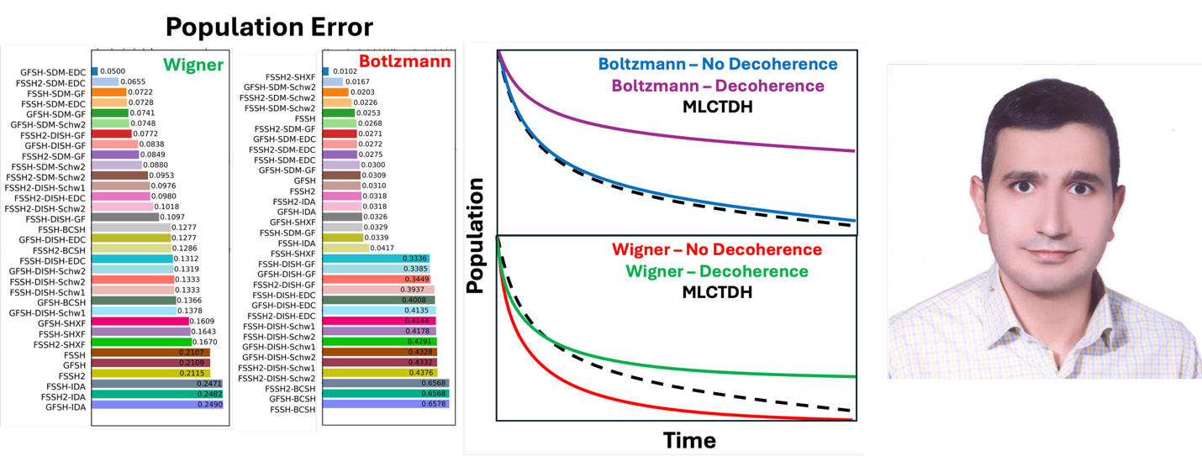
One of the key challenges in mixed quantum-classical approaches is the proper choice of method for simulating excited-state dynamics. In this presentation, I will discuss a systematic assessment of a large set of trajectory surface hopping (TSH) methodologies for modeling long-time population dynamics in a two-level spin-boson model. 132 different combinations of TSH schemes (FSSH, FSSH-2, and GFSH), decoherence corrections (SDM, BCSH, ID-A, SHXF, and DISH), several decoherence times, Shenvi-Subbotnik-Young phase correction (SSY), and two initial condition sampling methods (Boltzmann and Wigner) are benchmarked against exact results. Based on this analysis, a ranking of the 132 methodological recipes is established and discussed. Our results show that inclusion of the SSY correction systematically accelerates the dynamics. We also find that the choice of initial-condition sampling plays a critical role. For the TSH methods with decoherence correction, Wigner sampling leads to faster population transfer and generally requires decoherence corrections for improved agreement with the reference results. In contrast, Boltzmann sampling yields an almost perfect match to the exact results even without decoherence corrections, likely due to error cancellation.
References:
Mohammad Shakiba, Daeho Han, Saikat Mukherjee, and Alexey V Akimov. “Assessment of trajectory surface hopping methods in long-time nonadiabatic dynamics”. Journal of Chemical Physics 164, 104110 (2026).

How to connect

Alexey Akimov is inviting you to a scheduled Zoom meeting.

Topic: VISTA, Seminar 107
Time: Apr 22, 2026 10:00 AM Eastern Time (US and Canada)
Join Zoom Meeting
https://buffalo.zoom.us/j/95411222391?pwd=2oKbVsboGR7fRr1wChhOpBTkNSEOTj.1

Meeting ID: 954 1122 2391
Passcode: 234914

How to stay updated

A. VISTA Mailing list:

- Follow the link:
https://listserv.buffalo.edu/scripts/wa.exe?A0=CHE-VISTA-LIST&X=OA41BBB2DC6071987DF&Y=alexeyak%40buffalo.edu
- Click the menu icon in the upper right part of the list (yellow highlight in the picture below)
- Click the “Subscribe or Unsubscribe” option (purple highlight below) – it will bring you to the next window where you’ll be asked for your email/name (I think it the name is optional to provide). This way, you can subscribe to the mailing list to stay tuned or unsubscribe if you find the seminars irrelevant to you or just get too much emails to deal with.
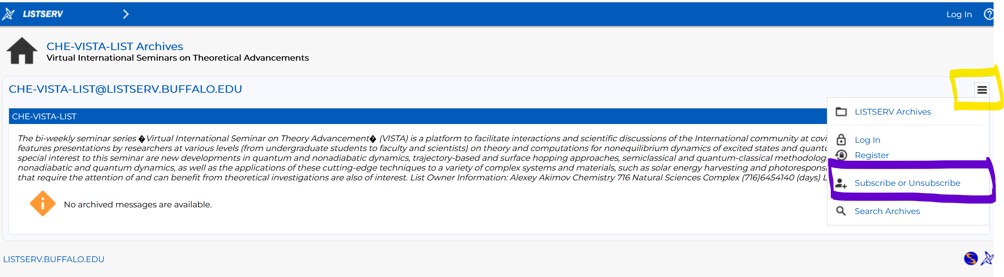

B. Slack Workspaces:

- VISTA workspace: https://join.slack.com/t/vista-atk8254/shared_invite/zt-mdlteo5v-P1Hc7XVupkwMbnGhNG4KIw
- Quantum Dynamics Hub workspace: https://join.slack.com/t/quantumdynamicshub/shared_invite/zt-mjbhjssx-GGhsbYHxeBMvhmumK_j7LA

