VISTA Seminar

Seminar 105

March 25, 2026
10:00 am – 11:30 am EDT Buffalo / 2:00 – 3:30 pm GMT London / 3:00 pm – 4:30 pm CET Paris / 10 pm – 11:30 pm CST Beijing

TOC:

1. Presenter 1: Prof. Cesare Tronci, University of Surrey, UK……………….page 2
2. Presenter 2: Ms. Pritha Ghosh, Texas A&M University, USA…………….page 3
3. How to connect………………………………………………………..….. page 4

Koopmon trajectories in nonadiabatic quantum-classical dynamics

Cesare Tronci
School of Mathematics and Physics, University of Surrey, Guildford, UK
Email: c.tronci@surrey.ac.uk

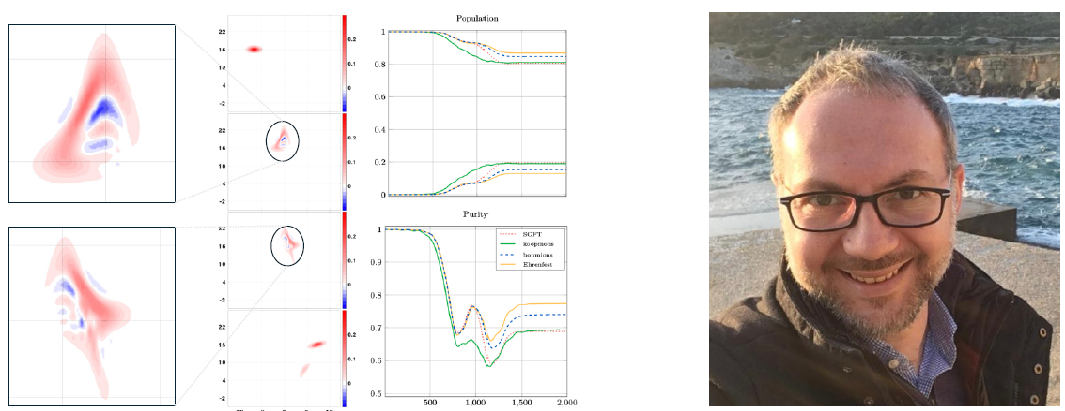
Established mixed quantum-classical (MQC) models of nonadiabatic dynamics beyond the multi-trajectory Ehrenfest scheme often suffer from consistency issues such as the violation of Heisenberg's principle. For example, this is the case for surface hopping and the quantum-classical Liouville equation, while the Ehrenfest model struggles to capture sufficient levels of accuracy. These consistency violations are usually ignored since common simulation results often appear unaffected. Here, we propose to tackle the problem by a new methodological strategy that not only leads to retaining physical consistency but also allows to accurately reproduce electronic decoherence. For this purpose, we blend the theory of Koopman wavefunctions in classical mechanics with the exact factorization method and variational techniques in Hamiltonian dynamics. The resulting model deviates from the Ehrenfest scheme due to the appearance of nonlinear backreaction terms, whose nonlinear character calls for suitable closures. Benefiting from the underlying Dirac-Frenkel variational principle, here we apply a regularization technique that allows to introduce the coupled trajectories of computational particles — the koopmons — sampling the classical phase-space paths. In the case of Tully's nonadiabatic problems (Tully II in figure), the method reproduces the results of fully quantum simulations with levels of accuracy that are not achieved by standard MQC Ehrenfest or surface-hopping simulations. In addition, the koopmon method is computationally advantageous over fully quantum hydrodynamic approaches. As a further step, we probe the limits of the method by considering Rabi’s spin-boson problem in both the ultrastrong and the deep strong coupling regimes, where MQC treatments appear hardly applicable. Finally, higher-dimensional extensions are also discussed.

Mean-field Mixed Quantum-Classical Approach for Many-
Body Quantum Dynamics of Exciton-Polaritons

Pritha Ghosh, Arshath Manjalingal, Sachith Wickramasinghe, Saeed Rahmanian Koshkaki,
Arkajit Mandal*

Department of Chemistry, Texas A&M University, College Station, Texas
77843, USA
Email: pritha2000@tamu.edu
*Corresponding Author: mandal@tamu.edu

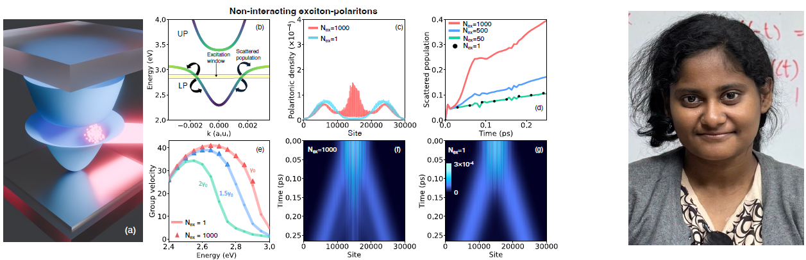
In this work, we use a mixed quantum-classical (mean-field) many-body approach for simulating the quantum dynamics of excitons and exciton-polaritons beyond the single‑excitation subspace. We combine the multitrajectory Ehrenfest approach, which propagates slow degrees of freedom classically, with the Gross-Pitaevskii method, which propagates fast degrees of freedom in a meanfield fashion. We use this mean-field many-body Ehrenfest approach to analyze how the phononinduced dynamic disorder and the many-body interaction affect the incoherent and coherent dynamics of excitons and exciton-polaritons. We examine how the number of excitations and the strength of repulsive exciton-exciton interaction nonlinearly influence the transport, Frohlich scattering and decoherence.

Keywords: mean-field Ehrenfest, exciton-polaritons, Gross-Pitaevskii, non-linear, decoherence.

How to connect

Alexey Akimov is inviting you to a scheduled Zoom meeting.

Topic: VISTA, Seminar 105
Time: Mar 25, 2026 10:00 AM Eastern Time (US and Canada)
Join Zoom Meeting
https://buffalo.zoom.us/j/96023174430?pwd=udpx2uHa2hxeBuGMMdrdd6apCfK8y3.1

Meeting ID: 960 2317 4430
Passcode: 667322

How to stay updated

A. VISTA Mailing list:

- Follow the link:
https://listserv.buffalo.edu/scripts/wa.exe?A0=CHE-VISTA-LIST&X=OA41BBB2DC6071987DF&Y=alexeyak%40buffalo.edu
- Click the menu icon in the upper right part of the list (yellow highlight in the picture below)
- Click the “Subscribe or Unsubscribe” option (purple highlight below) – it will bring you to the next window where you’ll be asked for your email/name (I think it the name is optional to provide). This way, you can subscribe to the mailing list to stay tuned or unsubscribe if you find the seminars irrelevant to you or just get too much emails to deal with.
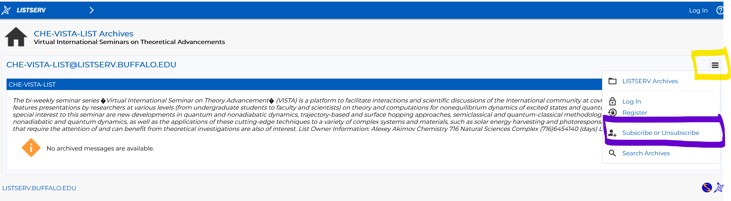

B. Slack Workspaces:

- VISTA workspace: https://join.slack.com/t/vista-atk8254/shared_invite/zt-mdlteo5v-P1Hc7XVupkwMbnGhNG4KIw
- Quantum Dynamics Hub workspace: https://join.slack.com/t/quantumdynamicshub/shared_invite/zt-mjbhjssx-GGhsbYHxeBMvhmumK_j7LA

