VISTA Seminar

Seminar 89

May 7, 2025
10:00 am – 11:30 am EDT Buffalo / 3:00 – 4:30 pm BST London / 4:00 pm – 5:30 pm CEST Paris / 10 pm – 11:30 pm CST Beijing

TOC:

1. Presenter 1: Prof. Marcio T. do N. Varella, Universidade de Sao Paulo, Brazil………………………………………………………………………….page 2
2. Presenter 2: Dr. Aric Hackebill, University of Vermont, USA…………….page 3
3. How to connect………………………………………………………..….. page 4

Towards efficient modeling of positrons in heterogeneous environments

Mateus Bergami¹, Leonardo Bin Martins¹, Jorge Charry², Andres Reyes², Kaline Coutinho¹, Marcio T. do N. Varella¹
¹Instituto de Física, Universidade de São Paulo, Rua do Matão 1731, 05508-090, São Paulo, Brazil
²Department of Chemistry, Universidad Nacional de Colombia, 111321 Bogotá, Colombia
Email: mvarella@if.usp.br

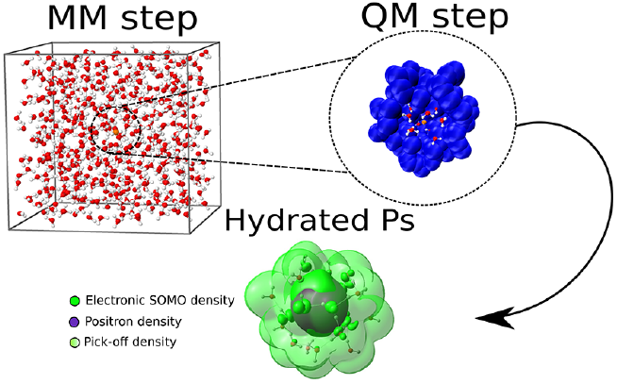
Positrons and positronium (Ps) atoms are utilized as probes in the field of materials sciences. Specifically, positron annihilation lifetime spectroscopy (PALS) is a widely applied technique, for instance, in the investigation of conformational, structural, and microenvironmental properties of biomimetic systems [1], as well as phase transitions of lipid bilayers [2] and pharmaceutically relevant compounds [3]. The contribution from Ps particles to the annihilation events in positron emission tomography (PET) could also allow for improved accuracy [4] and diagnosis [5].
In view those applications, we have developed force fields for Ps-liquid interactions. More specifically, we integrate the Sequential Quantum Mechanics/Molecular Mechanics (S-QM/MM) method [6] with the Any-Particle Molecular Orbital (APMO) method [7]. Since the initial MM step consists of classical Monte Carlo simulations for the liquid system, an essential aspect is to develop Ps-atom force fields, i.e., model interactions to be used in the Monte Carlo calculations. Once statistically uncorrelated Ps-solvent configurations are obtained, quantum properties can be obtained from Hartree-Fock (HF) and post-HF APMO calculations, properly averaged over the statistical ensemble.
We discuss recently obtained results for Ps in water [8,9] and other polar solvents, namely methanol, ethanol and acetonitrile. Our ultimate goal is obtaining reliable force fields to describe Ps interactions with several elements, such that complex chemical environments can be studied. We believe our present results are encouraging.

References:
[1]. C. Fong et al., Phys. Chem. Chem. Phys. 17, 17527 (2015)
[2]. A. B. García-Arribas et al., Langmuir 53, 5434 (2016).
[3]. N. Chieng et al., Eur. J. Pharm. Biopharm. 85, 197 (2013).
[4]. P. Moskal et al., Physics in Medicine & Biology 64, 055017 (2019).
[5]. K. Shibuya et al., Communications Physics 3, 1 (2020).
[6]. K. Coutinho, S. Canuto, Adv. Quantum Chem. 28, 89 (1997).
[7]. A. Reyes, F. Moncada, J. Charry, Int. J. Quantum Chem. 119, e25705 (2019).
[8]. M. Bergami et al., J. Phys. Chem. B 126, 2699 (2022).
[8]. M. Bergami et al., J. Phys. Chem. B 128, 10178 (2024).

Quantum Trajectories: Discrete or Continuous?

Aric Hackebill¹ and Bill Poirier²

Department of Chemistry, University of Vermont (Burlington, VT)
Email : aric.hackebill@uvm.edu ¹, bill.poirier@uvm.edu²

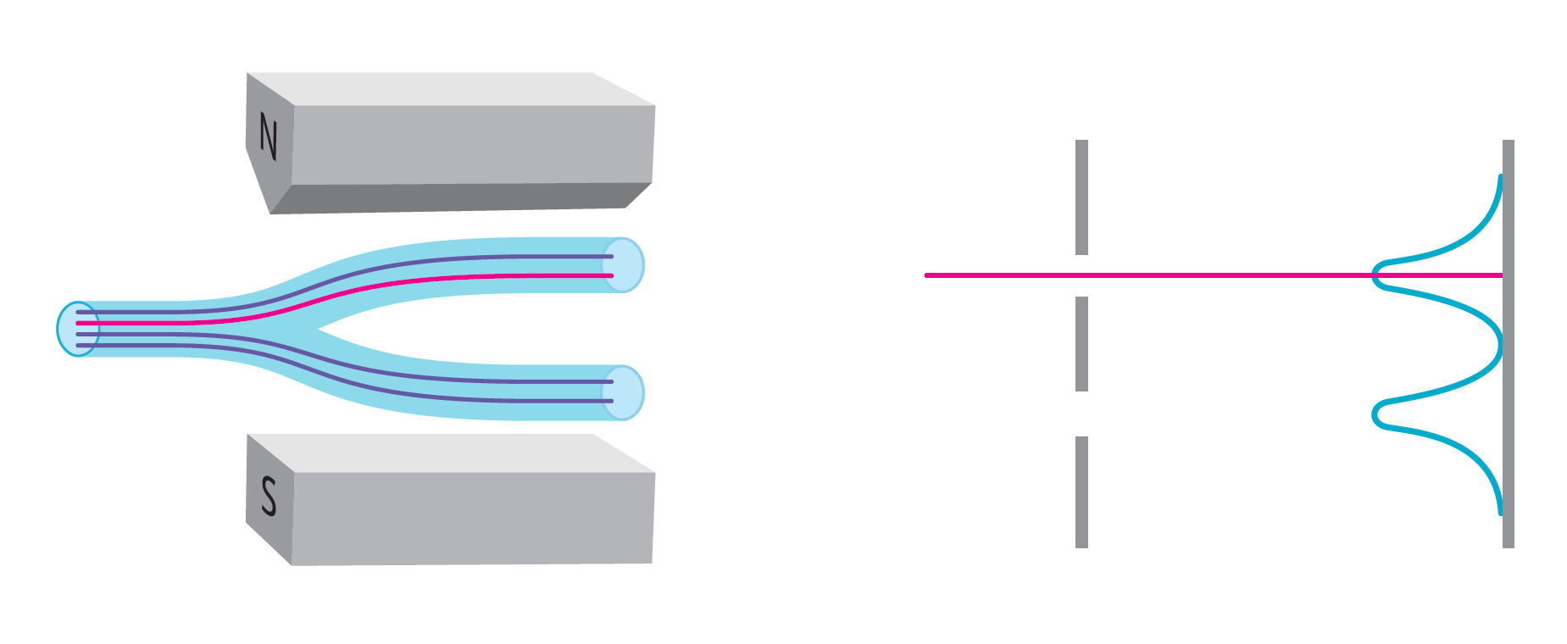

Trajectory approaches to quantum mechanics attempt to resolve foundational issues with standard quantum mechanics by providing a picture of the world in which particles travel on well-defined trajectories at all times. Among the trajectory approaches, there is the “many interacting worlds” (MIW) approach, which eliminates the wavefunction and replaces it with many interacting trajectories. The MIW approach itself has two formulations — one in which there are a finite number of trajectories[1] and one in which there is a continuum of trajectories[2] — that agree empirically so long as the density of trajectories in the finite formulation is very large. We detail a way to test the finite formulation by using a sequence of Stern-Gerlach setups to reduce the density of trajectories to the degree that the finite formulation would be expected to yield experimental results that deviate from those of standard quantum mechanics.

References:

[1] M. J. Hall, D.-A. Deckert, and H. J. Wiseman, Phys. Rev. X 4, 041013 (2014).
[2] B. Poirier, Chemical Physics 370, 4-14 (2010).

How to connect

Alexey Akimov is inviting you to a scheduled Zoom meeting.

Topic: VISTA, Seminar 89
Time: May 7, 2025 10:00 AM Eastern Time (US and Canada)
Join Zoom Meeting
https://buffalo.zoom.us/j/91961605086?pwd=iKOuLJmxO8PbPXW1o1o0uZl2jhEmEa.1

Meeting ID: 919 6160 5086
Passcode: 738807

