VISTA Seminar

Seminar 80

December 11, 2024
10:00 am – 11:30 am EST Buffalo / 3:00 – 4:30 pm GMT London / 4:00 pm – 5:30 pm CET Paris / 11 pm – 12:30 am CST Beijing

TOC:

1. Presenter 1: Prof. Christine Aikens, Kansas State University, USA…….....page 2
2. Presenter 2: Mr. Victor Suarez, Georgia Institute of Technology, USA.…..page 3
3. How to connect………………………………………………………..….. page 4

Time-Dependent Density Functional Theory Studies of
Electron Dynamics in Plasmonic Systems

Christine M. Aikens

Department of Chemistry, Kansas State University, USA
Email: cmaikens@ksu.edu

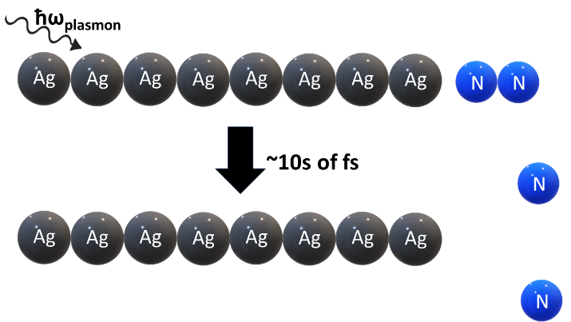

Plasmonic systems such as silver nanoparticles are of interest for applications such as nanoantennas and plasmon-enhanced photocatalysis. In order to fulfill this potential, we must understand how energy flows throughout the system and how energy transfers between two nanoparticles or between a nanoparticle and adsorbate. In this work, we present our studies that employ real-time time-dependent density functional theory (RT-TDDFT) to examine plasmon decay and electronic energy transfer processes. Using Ehrenfest dynamics, we examine electron-nuclear dynamics in systems such as silver nanowires and acenes, which display collective effects akin to those in nanoparticle systems. We investigate the propensity for non-linear excitations in tetrahedral silver nanoparticle systems. We discuss the ability of plasmonic excitation in nanoparticle systems to activate bonds in small molecule adsorbates, which can lead to photocatalysis.

Intermolecular Coulombic Decay in Water Dimers: A Computational Study

Victor Suarez, Joshua S. Kretchmer

School of Chemistry and Biochemistry, Georgia Institute of Technology,
901 Atlantic Drive, Atlanta, GA 30332, USA; Email: vsuarez6@gatech.edu

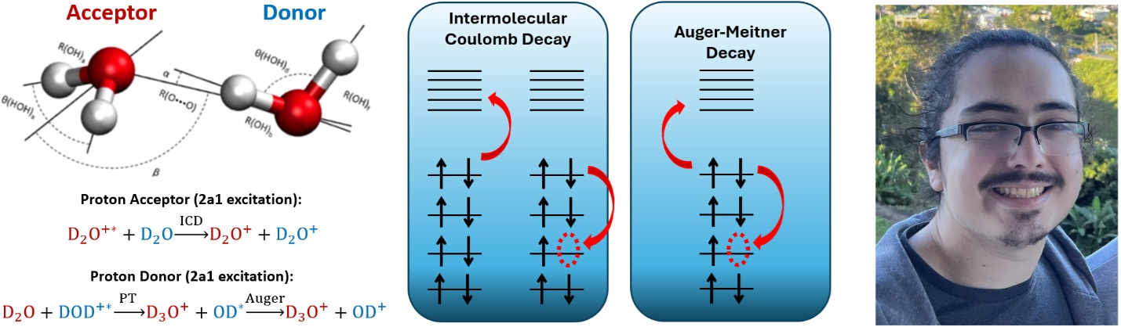

Following inner valence excitations within molecular systems, electrons can undergo competing ultrafast relaxation pathways, such as intermolecular coulombic decay (ICD), electron-transfer mediated decay (ETMD), and Auger-Meitner decay. These relaxation pathways generate secondary ionized low-energy electrons (LEEs), which can perform highly reactive downstream chemistry. For example, LEEs emitted from water following ICD has attracted attention in recent years as a significant factor governing DNA damage from exposure to ionizing radiation. The Kretchmer group aims to shed light on the ultrafast relaxation mechanisms within water through the use of our recently developed extension of real-time time-dependent density functional theory (RT-TDDFT) with Ehrenfest nuclear dynamics. Previous work exploring the electron dynamics within water dimers suggested that proton transfer following inner-valence excitation of the donor 2a1 orbital shut down the possibility of ICD. However, our recent study has revealed a new plausible pathway involving a proton transfer followed by direct Auger decay of the donor water. In this talk, I will discuss our newly developed real-time methodology, this new finding in the context of previous work, and future directions to corroborate this finding.

References:
[1] Wang, Y.-S.; Zhong, J. X.; Rohan, M. C.; Orlando, T. M.; Kretchmer, J. S. Modeling Intermolecular Coulombic Decay with Non-Hermitian Real-Time Time-Dependent Density Functional Theory. The Journal of Physical Chemistry Letters 2024, 15 (30), 7806–7813.

How to connect

Alexey Akimov is inviting you to a scheduled Zoom meeting.

Topic: VISTA, Seminar 80
Time: Dec 11, 2024 10:00 AM Eastern Time (US and Canada)

Join Zoom Meeting
https://buffalo.zoom.us/j/99583063814?pwd=bhxyKaCycz9PNFNvggVin4WBxaSOBh.1

Meeting ID: 995 8306 3814
Passcode: 689948

