VISTA Seminar

Seminar 115

October 28, 2026
10:00 am – 11:30 am EDT Buffalo / 3:00 – 4:30 pm BST London / 4:00 pm – 5:30 pm CEST Paris / 10 pm – 11:30 pm CST Beijing

TOC:

1. Presenter 1: Prof. Loic Joubert-Doriol, Universite Gustave Eiffel, France..page 2
2. Presenter 2: Dr. Juliana de Abrantes, University of Surrey,UK..…....……..page 3
3. How to connect………………………………………………………..….. page 4

Reaction Timescales for Non-Adiabatic Processes in Non-Equilibrium Steady States

Loïc Joubert-Doriol¹, Kenneth A. Jung², Artur F. Izmaylov², Paul Brumer²
¹Laboratoire Modélisation et Simulation Multi Echelle, Université Gustave Eiffel
²Department of Chemistry, University of Toronto
Email: loic.joubert-doriol@univ-eiffel.fr



The extraction of characteristic timescales of non-adiabatic processes is essential for understanding complex molecular dynamics. At equilibrium, rate constants can be rigorously related to time-correlation functions through linear-response theory and the fluctuation–dissipation theorem [1]. However, extending this connection to driven open quantum systems evolving toward a non-equilibrium steady state (NESS) remains a largely unresolved challenge.
In this work, we investigate reaction timescales in quantum systems subject to continuous incoherent-light driving and coupled to dissipative environments (see figure below). These systems evolve toward a NESS characterized by a persistent energy flow between distinct reservoirs, leading to dynamical behavior that differs substantially from both equilibrium dynamics and transient dynamics induced by ultrafast excitation [2]. We introduce a projector-based framework [3] that partitions the system Hilbert space into physically relevant configurations, enabling the direct extraction of effective reaction rates under NESS conditions. Applying this framework to a model light-harvesting system, we demonstrate a pronounced dependence of the resulting timescales on the properties of the driving field, highlighting the role of non-equilibrium conditions in shaping quantum reaction dynamics. This approach provides a general framework for characterizing reaction timescales in driven-dissipative quantum systems beyond the equilibrium regime.

References:
¹ Miller, W. H., Schwartz, S. D. and Tromp, J. W., J. Chem. Phys. 1983, 79, 4889.
² Brumer, P. J. Phys. Chem. Lett. 2018, 9, 2946.
³ Joubert-Doriol, L., Jung, K. A., Izmaylov, A. F., and Brumer, P. J. Chem. Theory Comput. 2023, 19, 1130.

The Hidden Routes of DNA Photostability
Juliana G. de Abrantes,¹* Josene M. Toldo,^{2,3} Mario Barbatti,^{3,4} and Marco Sacchi¹

¹School of Chemistry and Chemical Engineering, University of Surrey, Guildford, GU2 7XH, UK
²Lyon 1 Université, ENS de Lyon, CNRS, Laboratoire de Chimie, UMR 5182, 69342 Lyon Cedex 07, France
³Aix Marseille University, CNRS, ICR, Marseille, France
⁴Institut Universitaire de France, 75231 Paris, France
Email : juliana.g.abrantes@gmail.com
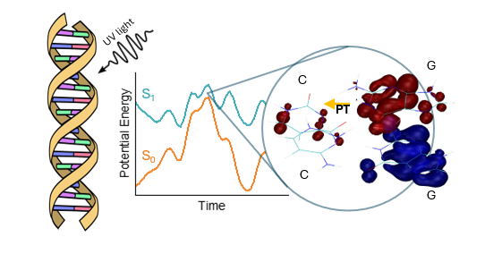
DNA’s extraordinary resistance to UV-induced damage—essential to the survival of genetic material since prebiotic times—stems from its ability to rapidly and efficiently dissipate energy through damage-free relaxation channels. Multiple decay pathways have been previously identified, but the detailed interplay [1] of these competing mechanisms was not fully understood.
In this talk, I will present nonadiabatic excited-state dynamics simulations of alternating and non-alternating stacked cytosine–guanine tetramers. Using fewest-switches surface hopping combined with linear-response TDDFT, we follow the relaxation of initially photoexcited states and analyse the evolving electronic character with various electronic structure descriptors [2].
The simulations reveal an initial population of a G C charge-transfer state, followed by a diversity of charge redistribution events during the trajectories, culminating with interstrand proton transfer as the dominant relaxation mechanism.
These findings provide a dynamical picture of DNA photostability, in which charge separation, proton motion, and structural fluctuations play a co-dependent role in funneling excitation energy back to the ground state [3].

References:
[1] Martínez-Fernández, L.; Green, J. A.; Esposito, L.; Jouybari, M. Y.; Zhang, Y.; Santoro, F.; Kohler, B.; Improta, R. The photoactivated dynamics of dGpdC and dCpdG sequences in DNA: a comprehensive quantum mechanical study. Chemical Science 2024, 15, 9676−9693.
[2] Plasser, F. and Lischka, H. Analysis of Excitonic and Charge Transfer Interactions from Quantum Chemical Calculations. Journal of Chemical Theory and Computation 2012, 8.8, 2777–2789.
[3] De Abrantes, J. G., Toldo, J. M., Barbatti, M., & Sacchi, M. The Hidden Routes of DNA Photostability: Charge and Proton Transfer in Excited Cytosine–Guanine Tetramers. The Journal of Physical Chemistry Letters 2026, 17(20), 5709.
How to connect

Alexey Akimov is inviting you to a scheduled Zoom meeting.

Topic: Seminar #115: Loic Joubert-Doriol and Juliana Abrantes
Time: Oct 28, 2026 10:00 AM Eastern Time (US and Canada)
Join Zoom Meeting
https://buffalo.zoom.us/j/95803595307?pwd=lthL3QrSsEd0wjPijtPKZ9klWdddE5.1

Meeting ID: 958 0359 5307
Passcode: 516686

How to stay updated

A. VISTA Mailing list:
- Follow the link: https://listserv.buffalo.edu/scripts/wa.exe?A0=CHE-VISTA-LIST&X=OA41BBB2DC6071987DF&Y=alexeyak%40buffalo.edu
- Click the menu icon in the upper right part of the list (yellow highlight in the picture below)
- Click the “Subscribe or Unsubscribe” option (purple highlight below) – it will bring you to the next window where you’ll be asked for your email/name (I think it the name is optional to provide). This way, you can subscribe to the mailing list to stay tuned or unsubscribe if you find the seminars irrelevant to you or just get too much emails to deal with.
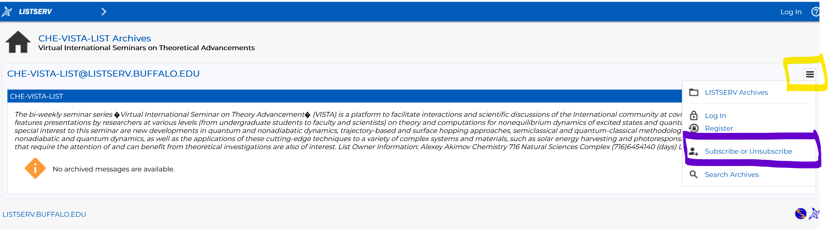

B. Slack Workspaces:
- VISTA workspace: https://join.slack.com/t/vista-atk8254/shared_invite/zt-mdlteo5v-P1Hc7XVupkwMbnGhNG4KIw
- Quantum Dynamics Hub workspace: https://join.slack.com/t/quantumdynamicshub/shared_invite/zt-mjbhjssx-GGhsbYHxeBMvhmumK_j7LA

C. Gmail calendar: https://calendar.google.com/calendar/u/4?cid=Y19jMjhjZjc3YmQxZWY1MWFkMzAwNjQ2MDVkZmQ1YjY3OGMyZmMxMGJmYjZhZmUyOGViZjg0MzA0NzVhMmY5NDAyQGdyb3VwLmNhbGVuZGFyLmdvb2dsZS5jb20

