VISTA Seminar

Seminar 113

September 30, 2026
10:00 am – 11:30 am EDT Buffalo / 3:00 – 4:30 pm BST London / 4:00 pm – 5:30 pm CEST Paris / 10 pm – 11:30 pm CST Beijing

TOC:

1. Presenter 1: Prof. Giovanni Granucci, University of Pisa, Italy...……...….page 2
2. Presenter 2: Dr. Miguel Recio-Poo, Universitat de Barcelona, Spain……..page 3
3. How to connect………………………………………………………..….. page 4

Simulating the transient photoelectronic spectrum of
azobenzene with surface hopping
Giovanni Granucci
Department of Chemistry and Industrial Chemistry, University of Pisa
Email: giovanni.granucci@unipi.it

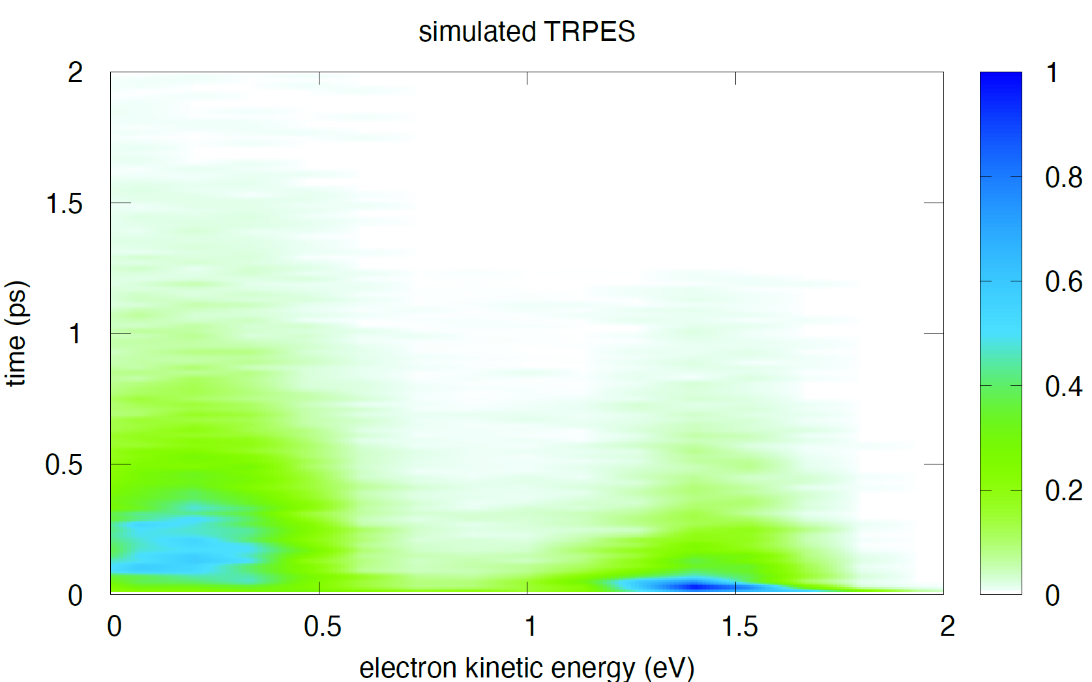

Azobenzene is a photochromic compound, subject to photoreversible trans-cis isomerization. It is well known that trans-azobenzene violates Kasha’s rule: the photoisomerization quantum yield depend on the excitation wavelength. More than 20 years ago, Schultz et al.¹ published the time-resolved photoelectron spectrum (TRPES) of ππ∗ excited trans-azobenzene, one of the very few gas phase experimental studies on azobenzene photodynamics. The TRPES spectrum was interpreted in terms of a very peculiar nonadiabatic behavior of the first three ππ∗ states, S₂, S₃, and S₄. In particular, the decrease of the photoisomerization quantum yield with increasing excitation energy was explained in terms of the direct decay of S₃ and S₄ to S₀. To challenge this interpretation, we performed a simulation of the TRPES of trans-azobenzene². Our simulated spectrum is in good agreement with the experimental data, both in terms of the energetic position of the bands and their lifetimes. Our results show that the wavelength dependence of the photoisomerization quantum yield is due to a different dynamics in S₁, whether this state is populated directly by photon absorption or by the radiationless conversion of the upper states.

References

¹T. Schultz, J. Quenneville, B. Levine, A. Toniolo, T. J. Martinez, S. Lochbrunner, M. Schmitt, J. P. Shaffer, M. Z. Zgierski, and A. Stolow, J. Am. Chem. Soc. 125, 8098–8099 (2003).
²D. Macis, G. Granucci, and M. Persico, J. Chem. Phys. 162, 204101 (2025).

Nonadiabatic excited-state dynamics in nanoscale TiO₂: from size and environment to fluxional nuclear motion
Miguel Recio-Poo
Departament de Ciència de Materials i Química, Universitat de Barcelona, Spain
Email: miguelrecio@ub.edu
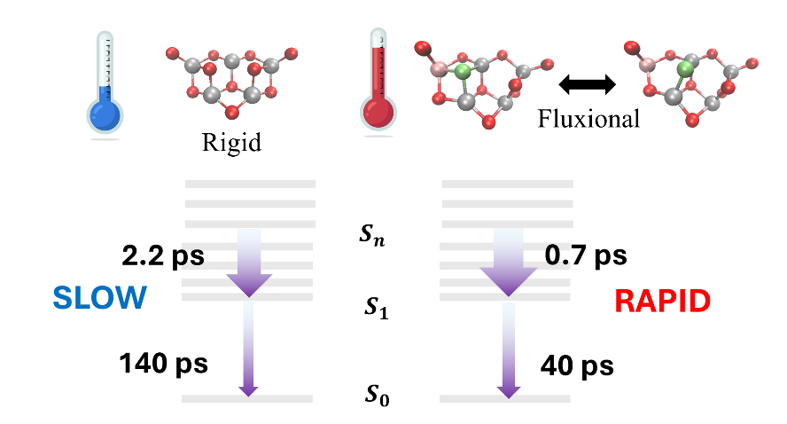

Excited-state relaxation in TiO₂ is governed by a delicate interplay between electronic structure and nuclear motion, making it highly sensitive to changes in size, local environment, and structural flexibility. Using nonadiabatic molecular dynamics, we investigate these effects across a series of finite TiO₂ systems. Size-dependent trends in small (TiO₂)_{n} clusters reveal how energy gaps, state densities, and nonadiabatic couplings collectively determine relaxation and recombination times, while hydrated titania models illustrate how the surrounding chemical environment can further reshape the electronic structure and modify nonadiabatic decay pathways. Together, these systems provide a controlled framework for understanding how increasingly complex structural degrees of freedom influence photoinduced dynamics in nanoscale titania.
Particular attention is given to structural fluxionality, using (TiO₂)₅ as a model system. Finite-temperature dynamics reveal a thermally activated local Ti–O coordination rearrangement that continuously modulates the low-energy excited-state manifold, producing a broader and heterogeneous distribution of excitation energies rather than simple thermal broadening around a single structure. This fluxional motion affects relaxation and recombination through distinct mechanisms: relaxation toward the lowest excited states is accelerated by reshaping the energetic landscape and reducing the energy that must be dissipated, whereas ground-state recombination is enhanced by increasing the probability of sampling configurations with strong S₀–S₁ nonadiabatic coupling. These results show that excited-state dynamics in structurally fluxional oxide clusters emerge from a thermally sampled structural ensemble, rather than from the properties of a single optimized geometry, highlighting local coordination fluxionality as an active structural mechanism for controlling nonradiative decay.

How to connect

Alexey Akimov is inviting you to a scheduled Zoom meeting.

Topic: Seminar #113: Giovanni Granucci and Miguel Recio-Poo
Time: Sep 30, 2026 10:00 AM Eastern Time (US and Canada)
Join Zoom Meeting
https://buffalo.zoom.us/j/91777294858?pwd=Z0Sj0wHYXpKJtbir4hG1lCGhVqpNgI.1

Meeting ID: 917 7729 4858
Passcode: 268299

How to stay updated

A. VISTA Mailing list:
- Follow the link: https://listserv.buffalo.edu/scripts/wa.exe?A0=CHE-VISTA-LIST&X=OA41BBB2DC6071987DF&Y=alexeyak%40buffalo.edu
- Click the menu icon in the upper right part of the list (yellow highlight in the picture below)
- Click the “Subscribe or Unsubscribe” option (purple highlight below) – it will bring you to the next window where you’ll be asked for your email/name (I think it the name is optional to provide). This way, you can subscribe to the mailing list to stay tuned or unsubscribe if you find the seminars irrelevant to you or just get too much emails to deal with.
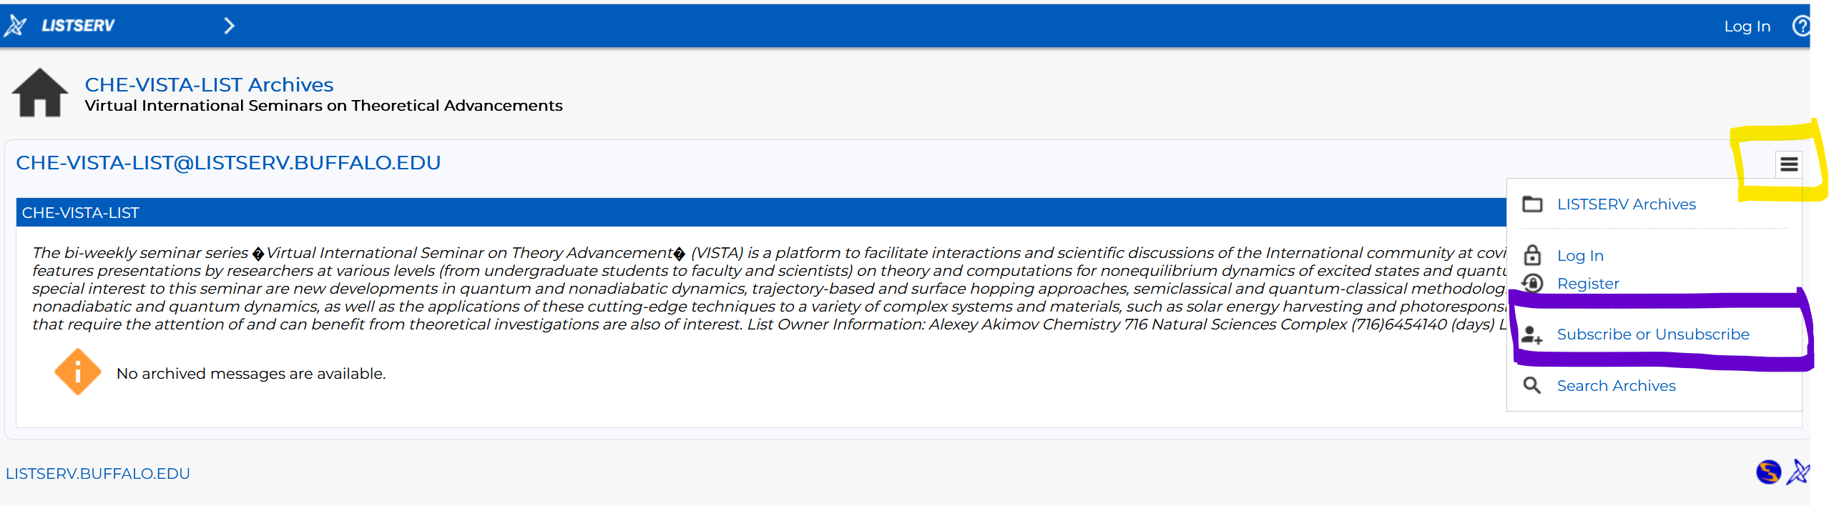

B. Slack Workspaces:
- VISTA workspace: https://join.slack.com/t/vista-atk8254/shared_invite/zt-mdlteo5v-P1Hc7XVupkwMbnGhNG4KIw
- Quantum Dynamics Hub workspace: https://join.slack.com/t/quantumdynamicshub/shared_invite/zt-mjbhjssx-GGhsbYHxeBMvhmumK_j7LA

C. Gmail calendar: https://calendar.google.com/calendar/u/4?cid=Y19jMjhjZjc3YmQxZWY1MWFkMzAwNjQ2MDVkZmQ1YjY3OGMyZmMxMGJmYjZhZmUyOGViZjg0MzA0NzVhMmY5NDAyQGdyb3VwLmNhbGVuZGFyLmdvb2dsZS5jb20

M. Recio-Poo; C. H. Rotteger; F. Illas; S. T. Bromley; Á. Morales-García; S. G. Sayres & A. V. Akimov, J. Am. Chem. Soc., 2025, 147, 40900–40909
M. Recio-Poo; M. Shakiba ; F. Illas; S. T. Bromley; A. V. Akimov & Á. Morales-García, J. Phys. Chem. C, 2025, 129, 1806–1823.
M. Recio-Poo; S. T. Bromley; S. G. Sayres; F. Illas; A. V. Akimov & Á. Morales-García; J. Phys. Chem. Lett., 2026, 17, 7907-7915.

