VISTA Seminar

Seminar 92

September 3, 2025
10:00 am – 11:30 am EDT Buffalo / 3:00 – 4:30 pm BST London / 4:00 pm – 5:30 pm CEST Paris / 10 pm – 11:30 pm CST Beijing

TOC:

1. Presenter 1: Prof. Mohammad R. Momeni, University of Missouri – Kansas City, USA………………………………………………………………….….page 2
2. Presenter 2: Dr. Nathan London, University of Missouri – Kansas City, USA………………………………………………………………....……......page 3
3. How to connect………………………………………………………..….. page 4

Memory kernel coupling theory for spin-phonon interactions in
molecular qubits

Wenjie Dou
Department of Chemistry, Westlake University, Hangzhou 310030, China
Department of Physics, Westlake University, Hangzhou 310030, China
Institute of Natural Sciences, Westlake Institute for Advanced Study, Hangzhou 310024 Zhejiang,
China
Email: douwenjie@westlake.edu.cn

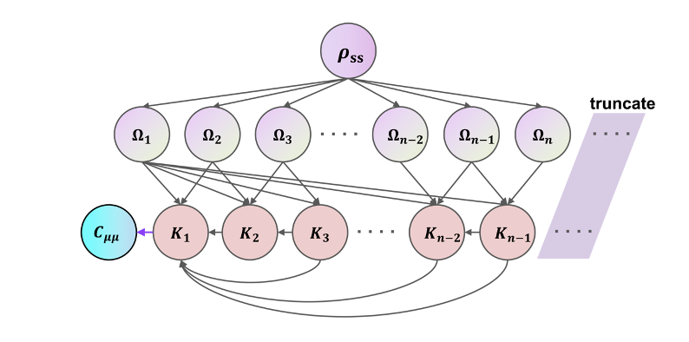

Dynamical observables are often described by time correlation functions (TCFs). However, efficiently computing TCFs for complex quantum systems remains a significant challenge, as it typically requires solving the full dynamical evolution of the system. In this work, we propose the memory kernel coupling theory (MKCT)—a general theoretical framework for calculating TCFs. This approach builds upon the memory kernel formalism established by Mori and avoid the calculation of projected dynamics by further decomposing the memory kernel into auxiliary kernel functions. This general framework is numerically validated on typical open quantum systems, namely the spin-boson model and the Anderson impurity model. Furthermore, we apply it to systems with nonlinear environment coupling, obtaining accurate dynamical and spectral properties. Finally, we employ MKCT to study the spin-phonon relaxation process in a molecular qubit. The numerical results successfully explain novel spin relaxation phenomena observed in experiments.

References:

[1] W Liu, Y Su, Y Wang, W Dou. Memory kernel coupling theory: Obtain time correlation function from higher-order moments. arXiv:2407.01923
[2] RH Bi, Y Su, Y Wang, L Sun, W Dou. Spin-lattice relaxation with non-linear couplings: Comparison between Fermi's golden rule and extended dissipaton equation of motion. J. Chem. Phys. 2025, 161, 024105
[3] RH Bi, W Liu, W Dou. Universal structure of computing moments for exact quantum dynamics: Application to arbitrary system–bath couplings. J. Chem. Phys. 2025, 162, 224106

Trajectory-based nonadiabatic dynamics with a surface-hopping motif: Recent progress in Libra
Daeho Han
Department of Chemistry, Ulsan National Institute of Science and Technology (UNIST), Ulsan 44919, S. Korea
InnoCORE AI-CRED Institute, Korea Advanced Institute of Science and Technology (KAIST), Daejeon 34141, S. Korea
Email: daehohan@unist.ac.kr

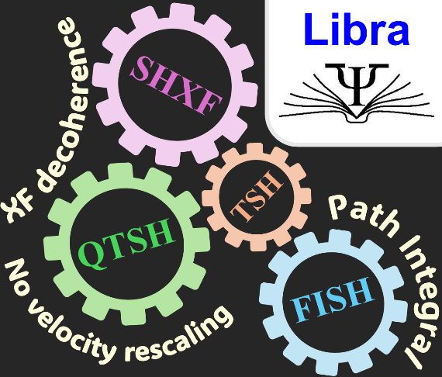

The trajectory surface hopping (TSH) method has served as a workhorse for simulating nonadiabatic processes in electron–nuclear correlated systems, and its ideas and algorithms have underpinned many modern trajectory-based approaches. In this talk, I will report recent advances and new implementations in trajectory-based methods with the TSH motif, using the Libra package. First, I briefly review surface hopping with exact factorization (SHXF) within the broader XF family, [1] which addresses the long-standing overcoherence problem. Second, I present quantum-trajectory surface hopping (QTSH), [2] which “relaxes” the overly strict energy-conservation requirement in conventional FSSH. Third, I introduce the novel fully-integrated surface hopping (FISH) method [3] based on the neglect of back-reaction approximation (NBRA). FISH can be viewed as a reduction of the conventional NBRA-TSH framework that removes the need for multiple stochastic realizations and naturally applies decoherence by summing over histories of piecewise-coherent evolution and discarding in-between coherence.

References:

[1] Han, D.; Akimov, A. V. Nonadiabatic Dynamics with Exact Factorization: Implementation and Assessment. J. Chem. Theory Comput. 2024, 20 (12), 5022–5042.
[2] Han, D.; Martens, C. C.; Akimov, A. V. Generalization of Quantum-Trajectory Surface Hopping to Multiple Quantum States. J. Chem. Theory Comput. 2025, 21 (6), 2839–2853.
[3] Han, D.; Shakiba, M.; Akimov, A. V. Fully-Integrated Surface Hopping as Quantum Decoherence Correction in Nonadiabatic Dynamics. J. Phys. Chem. Lett. 2025, 16 (28), 7168–7176.

How to connect

Alexey Akimov is inviting you to a scheduled Zoom meeting.

Topic: VISTA, Seminar 92
Time: Sep 3, 2025 10:00 AM Eastern Time (US and Canada)
Join Zoom Meeting
https://buffalo.zoom.us/j/98277786370?pwd=8IPpbyiY1Sw6VYw7taeuQJtYsiPMIm.1

Meeting ID: 982 7778 6370
Passcode: 512850

How to stay updated

A. VISTA Mailing list:

- Follow the link:
https://listserv.buffalo.edu/scripts/wa.exe?A0=CHE-VISTA-LIST&X=OA41BBB2DC6071987DF&Y=alexeyak%40buffalo.edu
- Click the menu icon in the upper right part of the list (yellow highlight in the picture below)
- Click the “Subscribe or Unsubscribe” option (purple highlight below) – it will bring you to the next window where you’ll be asked for your email/name (I think it the name is optional to provide). This way, you can subscribe to the mailing list to stay tuned or unsubscribe if you find the seminars irrelevant to you or just get too much emails to deal with.
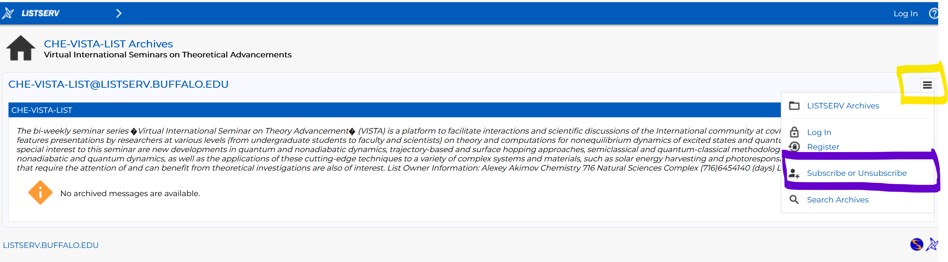

B. Slack Workspaces:

- VISTA workspace: https://join.slack.com/t/vista-atk8254/shared_invite/zt-mdlteo5v-P1Hc7XVupkwMbnGhNG4KIw
- Quantum Dynamics Hub workspace: https://join.slack.com/t/quantumdynamicshub/shared_invite/zt-mjbhjssx-GGhsbYHxeBMvhmumK_j7LA

