VISTA Seminar

Seminar 101

January 28, 2026
10:00 am – 11:30 am EST Buffalo / 3:00 – 4:30 pm GMT London / 4:00 pm – 5:30 pm CET Paris / 11 pm – 12:30 pm CST Beijing

TOC:

1. Presenter 1: Prof. Nadia Rega, University of Napoli Federico II, Italy…...page 2
2. Presenter 2: Mr. Arshath Manjalingal, Texas A&M University, USA……..page 3
3. How to connect………………………………………………………..….. page 4

Tracking ultrafast vibrational pathways, from electronic structure to solvent driven dynamics

Nadia Rega
University of Napoli Federico II
Email: nadrega@unina.it

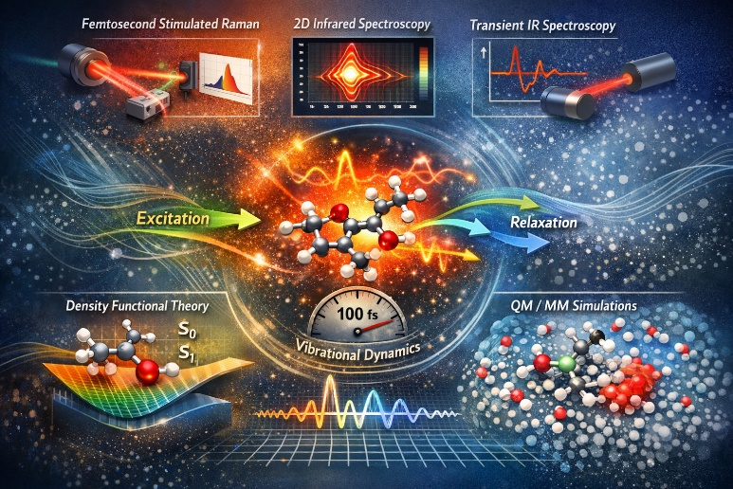

Time resolved and multidimensional vibrational spectroscopies, such as femtosecond stimulated Raman, transient IR, and two dimensional infrared, offer a powerful window into the non equilibrium structural dynamics of photoexcited molecular systems. Interpreting these signals at a quantitative level, however, requires theoretical frameworks capable of capturing electronic excitation, nuclear motion, and environmental effects on equal footing.
In this talk, I will present a multiscale strategy that combines Density Functional Theory, excited state ab initio dynamics, hybrid QM/MM potentials, and accurate non periodic boundary conditions for solvation. This approach enables an atomistic description of ultrafast relaxation pathways, revealing the transient activation of specific vibrational modes and their role in steering photochemical and photophysical processes.
Time resolution is preserved through wavelet based analyses, which allow vibrational couplings to be disentangled and anharmonic contributions to be quantified along the dynamics. A key aspect of this work is the accuracy of the QM/MM interaction, which proves essential for maintaining the delicate interplay between solute and solvent degrees of freedom in transient vibrational analyses.
Applications will be discussed for molecular rotors, π stacked charge transfer complexes, photoacids, and protein DNA crosslinking models. I will conclude by outlining ongoing methodological developments and perspectives for extending these approaches to increasingly complex photoactive systems.

Tilted Material in an Optical Cavity: Light-Matter Moiré Effect and Coherent Frequency Conversion

Arshath Manjalingal†, Saeed Rahmanian Koshkaki†, Logan Blackham, Arkajit Mandal*

Department of Chemistry, Texas A&M University, College Station, Texas 77843, USA
† Equal Contribution
Email: avmanjalingal@tamu.edu
*Corresponding Author: mandal@tamu.edu

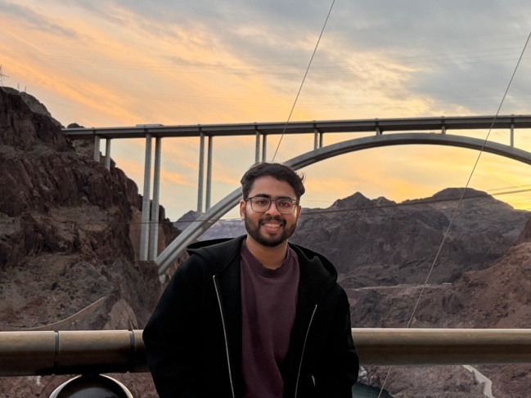

Exciton-polaritons formed inside optical cavities offer a highly tunable platform for exploring novel quantum phenomena. Here, we introduce and theoretically characterize a light–matter moiré effect (LMME) that arises when a 2D material is tilted inside a planar optical cavity, in contrast to stacking multiple layers at a twist angle as is done in forming 2D moiré hetero-structures. We show that this geometric tilt produces emergent periodicity in the light–matter coupling, yielding displaced replicas of the polariton dispersion and flat bands near the Brillouin-zone center. Through time-dependent quantum dynamical simulations, we demonstrate that LMME enables coherent frequency conversion and remains robust against phonon-induced decoherence. Our findings establish LMME as a new platform for engineering polariton band structures, the generation of flat bands and performing coherent frequency conversion relevant for developing polariton-based quantum devices.

How to connect

Alexey Akimov is inviting you to a scheduled Zoom meeting.

Topic: VISTA, Seminar 101
Time: Jan 28, 2026 10:00 AM Eastern Time (US and Canada)
Join Zoom Meeting
https://buffalo.zoom.us/j/92200248094?pwd=qfYK2e0fEnAGX3NglUmQIBSBUKPy1i.1

Meeting ID: 922 0024 8094
Passcode: 218116

How to stay updated

A. VISTA Mailing list:

- Follow the link:
https://listserv.buffalo.edu/scripts/wa.exe?A0=CHE-VISTA-LIST&X=OA41BBB2DC6071987DF&Y=alexeyak%40buffalo.edu
- Click the menu icon in the upper right part of the list (yellow highlight in the picture below)
- Click the “Subscribe or Unsubscribe” option (purple highlight below) – it will bring you to the next window where you’ll be asked for your email/name (I think it the name is optional to provide). This way, you can subscribe to the mailing list to stay tuned or unsubscribe if you find the seminars irrelevant to you or just get too much emails to deal with.
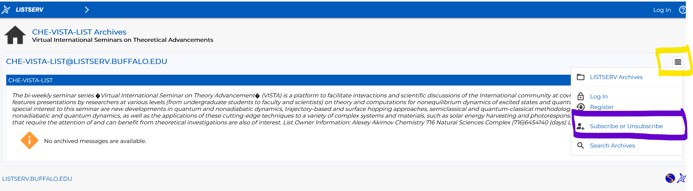

B. Slack Workspaces:

- VISTA workspace: https://join.slack.com/t/vista-atk8254/shared_invite/zt-mdlteo5v-P1Hc7XVupkwMbnGhNG4KIw
- Quantum Dynamics Hub workspace: https://join.slack.com/t/quantumdynamicshub/shared_invite/zt-mjbhjssx-GGhsbYHxeBMvhmumK_j7LA

