VISTA Seminar

Seminar 86

March 26, 2025
10:00 am – 11:30 am EDT Buffalo / 2:00 – 3:30 pm GMT London / 3:00 pm – 4:30 pm CET Paris / 10 pm – 11:30 pm CST Beijing

TOC:

1. Presenter 1: Prof. Bing Gu, Westlake University, China…………………..page 2
2. Presenter 2: Dr. Yujuan Xie, Westlake University, China…………...……..page 3
3. How to connect………………………………………………………..….. page 4

Topological Quantum Molecular Dynamics
Bing Gu
Department of Chemistry & Department of Physics, Westlake University, Ha
Email: gubing@westlake.edu.cn

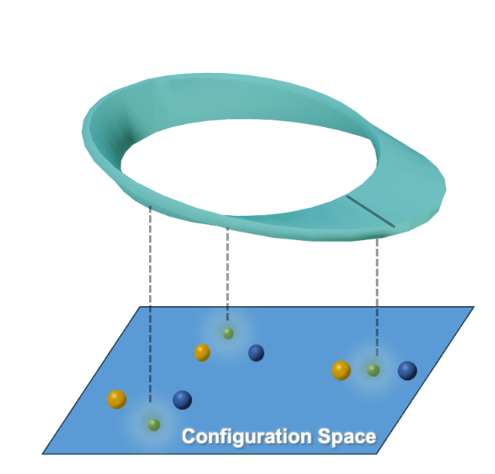

Ultrafast spectroscopy provides a direct means to monitor real-time photochemical events in the femtosecond timescale. The key to understanding such experiments is to model the coupled electron-nuclear motion when the nuclear wavepacket passes through conical intersections—the region where two or more electronic states become degenerate. I will discuss our recent efforts in developing a divergence-free topological quantum molecular dynamics framework for the correlated electron–nuclear wave packet dynamics. It captures all effects beyond Born-Oppenheimer, including nonadiabatic transitions, coherence, geometric phase, and diagonal Born-Oppenheimer corrections.

Incorporating Geometric Phase Effects by Local Diabatic Representation
Yujuan Xie, Ruoxi Liu, and Bing Gu
Westlake University, Hangzhou, Zhejiang 310030, China
Email: xieyujuan@westlake.edu.cn

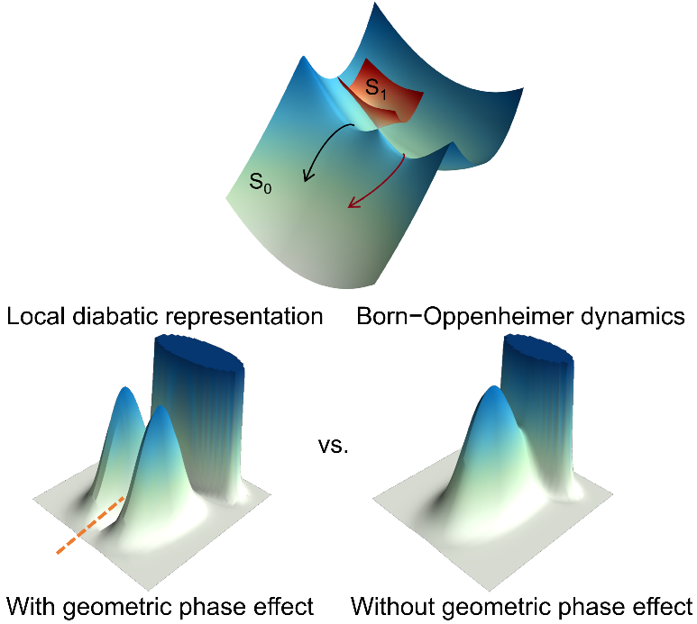

We present a unified framework for molecular quantum dynamics that incorporates geometric phase effects in both adiabatic and nonadiabatic processes. By employing a discrete local trivialization of the molecular fiber bundle, we construct a global electronic overlap matrix that intrinsically encodes nonadiabatic transitions and geometric phase effects, circumventing the need for singular derivative couplings. This approach integrates naturally with electronic structure methods and enables numerically exact ab initio simulations of conical intersection dynamics.
To demonstrate its efficacy, we apply our method to the photodissociation of phenol and to the adiabatic and nonadiabatic dynamics of $H_{3}^{+}$. In the adiabatic regime, our approach captures geometric phase effects associated with energetically inaccessible conical intersections using only a single adiabatic potential energy surface, eliminating the need for vector potentials. Additionally, our simulation of the internal conversion dynamics of $H_{3}^{+}$ confirms that the framework accurately describes both geometric phase effects and nonadiabatic transitions. By extending beyond the Born-Oppenheimer approximation, our method provides a robust and efficient tool for investigating quantum effects in molecular systems with intricate quantum topology.

How to connect

Alexey Akimov is inviting you to a scheduled Zoom meeting.

Topic: VISTA, Seminar 86
Time: Mar 26, 2025 10:00 AM Eastern Time (US and Canada)
Join Zoom Meeting
https://buffalo.zoom.us/j/91416948475?pwd=FnAUehK8zPqg5JXDu2AFn1Ubvk2TRA.1

Meeting ID: 914 1694 8475
Passcode: 401751

