VISTA Seminar

Seminar 99

December 17, 2025
10:00 am – 11:30 am EST Buffalo / 3:00 – 4:30 pm GMT London / 4:00 pm – 5:30 pm CET Paris / 11 pm – 12:30 pm CST Beijing

TOC:

1. Presenter 1: Prof. Thomas Niehaus, University Claude Bernard Lyon, France………………………………………………………………………...page 2
2. Presenter 2: Mr. Logan Blackham, Texas A&M University, USA.………..page 3
3. How to connect………………………………………………………..….. page 4

Nonadiabatic Dynamics Beyond Standard TDDFT: A Finite-Temperature Perspective

Thomas Niehaus
Université Claude Bernard Lyon
Email: thomas.niehaus@univ-lyon1.fr

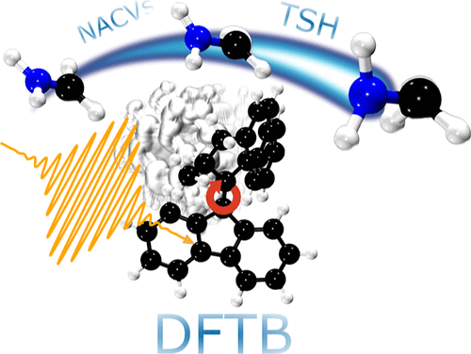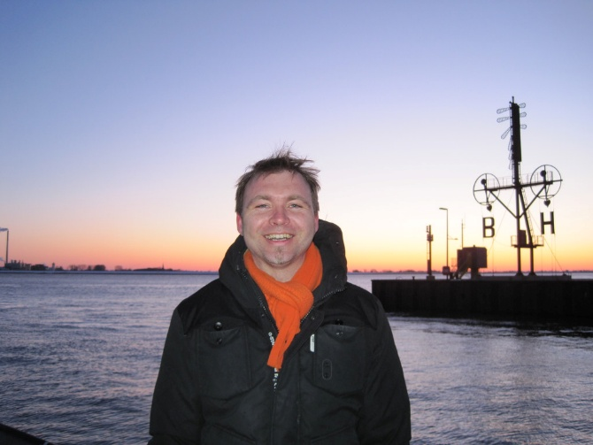

Nonadiabatic molecular dynamics (NAMD) simulations based on time-dependent density functional theory (TDDFT) have become a widely used tool for studying excited-state processes in molecules and materials. However, these simulations face persistent challenges in describing the relaxation toward the electronic ground state. On the technical level, the self-consistent field (SCF) procedure often fails to converge near regions where ground and excited states become nearly degenerate. On a more fundamental level, standard TDDFT provides an incorrect description of the topology of conical intersections (CIs), which govern many nonadiabatic transitions [1]. Several approaches have been proposed to address these deficiencies [2-4].
In this talk, I will discuss the finite-temperature extension of TDDFT (FT-TDDFT) developed in Nakai’s group [5], which shows promise in mitigating at least the convergence issues. We introduce a new definition of the excited-state entropy within FT-TDDFT and analyze its implications for the topology of conical intersections. If time permits, I will also present preliminary results from NAMD simulations of stilbene carried out with this approach at the TD-DFTB [6] level using the PyUnixMD package [7].

References:
[1] B.G. Levine et al. – Mol. Phys. 104 1039 (2006)
[2] Y. Shao et al. – JCP 118 4807 (2003)
[3] M. Filatov et al. – CPL 304 429 (1999)
[4] L. Xu et al. – JCTC 21 3600 (2025)
[5] T. Yoshikawa, T. Doi, and H. Nakai – JCP 152 244111 (2020)
[6] T. Niehaus - THEOCHEM 914 38 (2009)
[7] https://github.com/skmin-lab/unixmd

Microscopic theory of polaron-polariton dispersion and propagation

Logan Blackham

Department of Chemistry, Texas A&M University
Email: warchildsveinn@tamu.edu
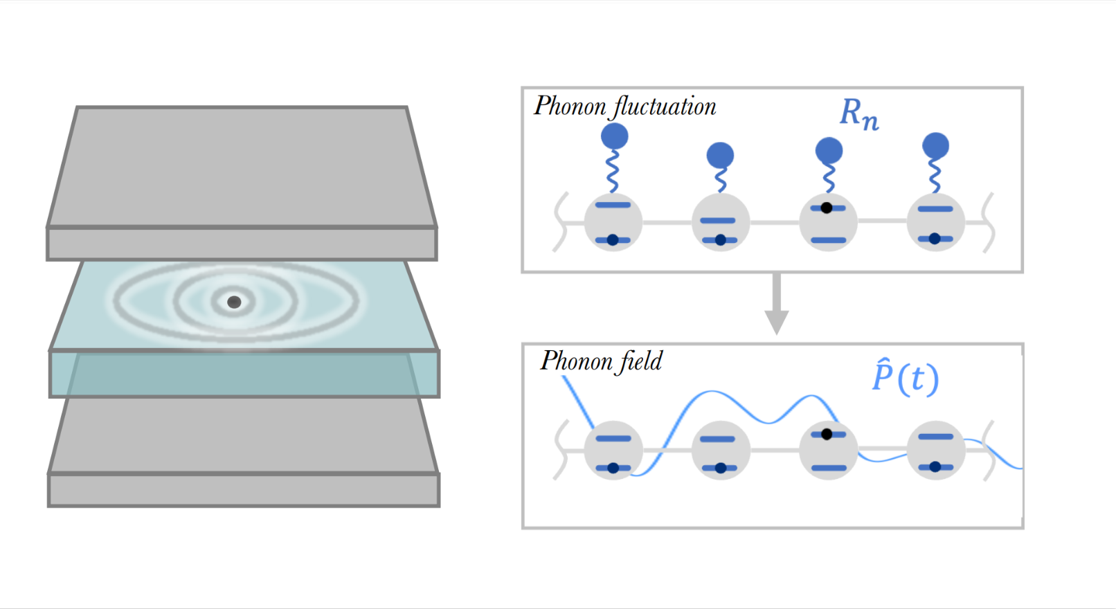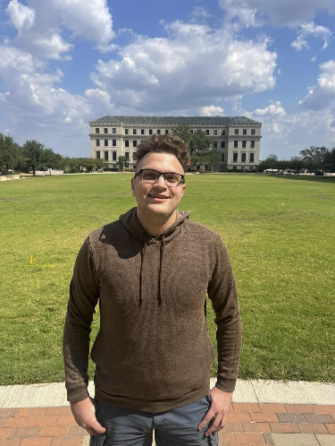
We develop an analytical, microscopic theory to describe polaron-polariton dispersion, formed by hybridizing excitons, photons, and phonons, as well as their coherent dynamics inside optical cavities. Starting from a microscopic light-matter Hamiltonian, we derive a simple analytical model by employing a nonperturbative treatment of the phonon and photon couplings to excitons. Within our theoretical framework, phonons are treated as classical fields, which are then quantized via the Floquet formalism. We show that, to a good approximation, the entire polaron-polariton system can be described with a band picture despite the phonons breaking translational symmetry. Our theory also sheds light on the long-lived coherent ballistic motion of exciton-polaritons with high excitonic character that propagate with group velocities lower than expected from pure exciton-polariton bands, offering a microscopic explanation for these puzzling experimental observations.

How to connect

Alexey Akimov is inviting you to a scheduled Zoom meeting.

Topic: VISTA, Seminar 99
Time: Dec 17, 2025 10:00 AM Eastern Time (US and Canada)
Join Zoom Meeting
https://buffalo.zoom.us/j/91254340419?pwd=bdbyaITDO5YF0bddRON8Q1BMWGd09J.1

Meeting ID: 912 5434 0419
Passcode: 620961

How to stay updated

A. VISTA Mailing list:

- Follow the link:
https://listserv.buffalo.edu/scripts/wa.exe?A0=CHE-VISTA-LIST&X=OA41BBB2DC6071987DF&Y=alexeyak%40buffalo.edu
- Click the menu icon in the upper right part of the list (yellow highlight in the picture below)
- Click the “Subscribe or Unsubscribe” option (purple highlight below) – it will bring you to the next window where you’ll be asked for your email/name (I think it the name is optional to provide). This way, you can subscribe to the mailing list to stay tuned or unsubscribe if you find the seminars irrelevant to you or just get too much emails to deal with.
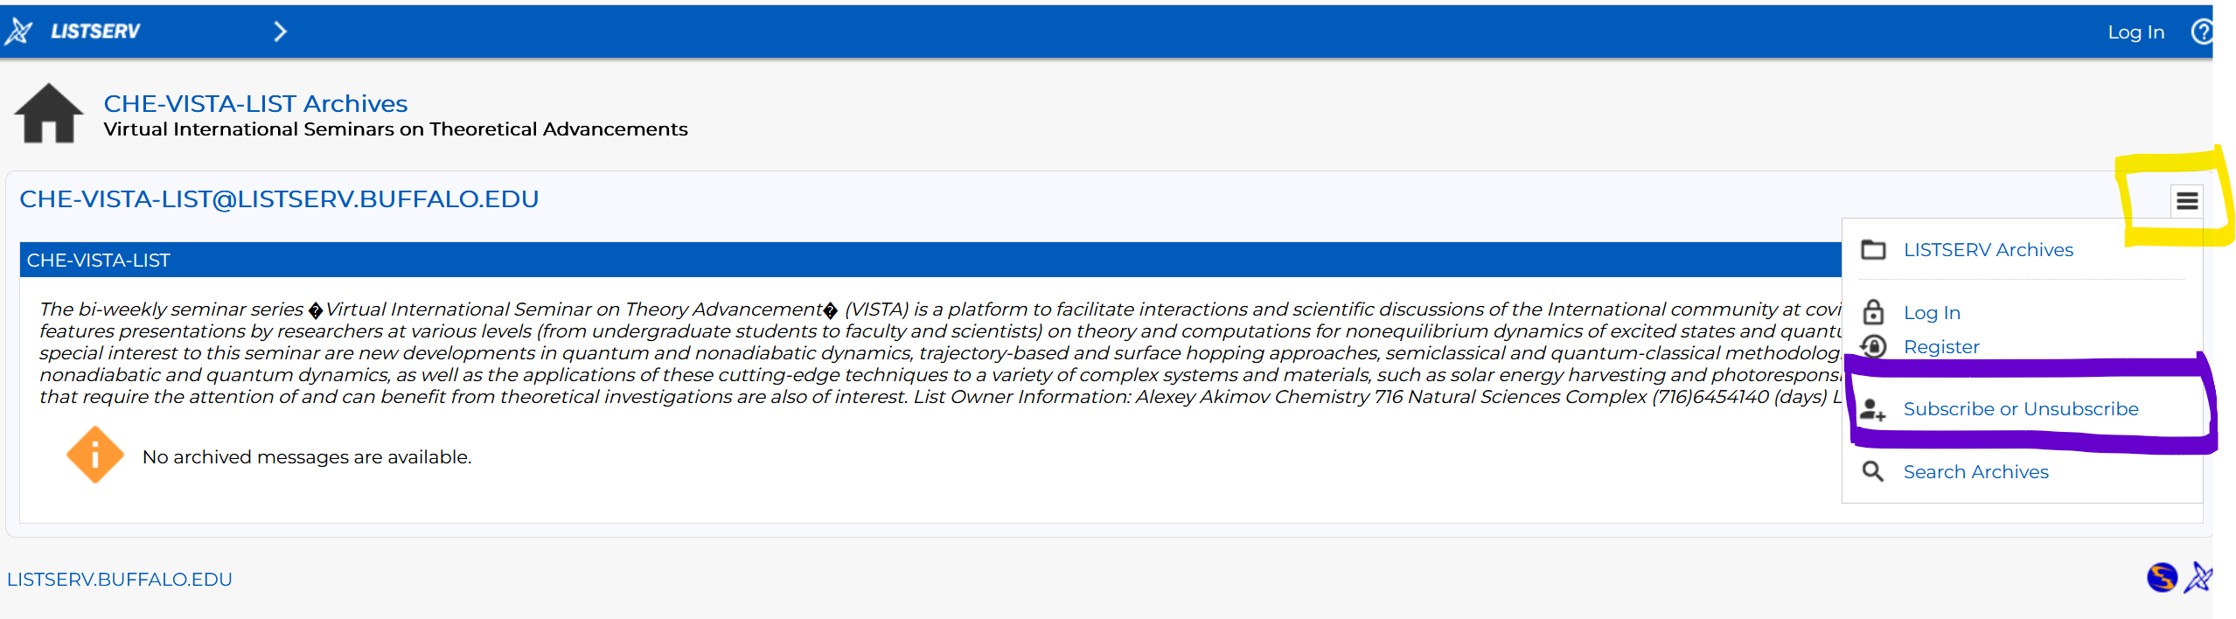

B. Slack Workspaces:

- VISTA workspace: https://join.slack.com/t/vista-atk8254/shared_invite/zt-mdlteo5v-P1Hc7XVupkwMbnGhNG4KIw
- Quantum Dynamics Hub workspace: https://join.slack.com/t/quantumdynamicshub/shared_invite/zt-mjbhjssx-GGhsbYHxeBMvhmumK_j7LA

