VISTA Seminar

Seminar 79

November 13, 2024
10:00 am – 11:30 am EST / 3:00 – 4:30 pm GMT London / 4:00 pm – 4:30 pm CET Paris / 11 pm – 12:30 pm CST Beijing

TOC:

1. Presenter 1: Prof. Chaoyuan Zhu, National Yang Ming Chiao Tung University, China……………………………………………………………………….....page 2
2. Presenter 2: Mr. Mohammad Shakiba, University at Buffalo…….………. page 3
3. How to connect………………………………………………………..….. page 4

Global switching trajectory surface hopping molecular dynamics simulation on on-the-fly TDDFT potential energy surfaces

Chaoyuan Zhu

Institute of Molecular Science, National Yang Ming Chiao Tung University, Taiwan, China
cyzhu@nycu.edu.tw

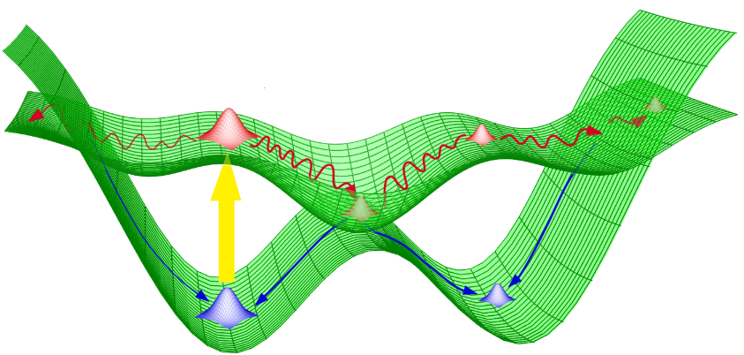

The time-dependent density function theory (TDDFT) provides accurate ab initio potential energy surfaces for performing nonadiabatic molecular dynamic simulation for large photochemical systems, and global switching algorithm in which calculation for nonadiabatic coupling vectors are not necessary makes trajectory surface hopping molecular dynamics simulation even easy and fast. However, it is well-known that ordinary TDDFT has difficulty in describing the S₀/S₁ conical intersections. It was demonstrated that potential energy surfaces calculated by TDDFT with and without spin-flip can simulate quite similar answer for average quantities like quantum yields and lifetimes.
Furthermore, global switching trajectory surface hopping molecular dynamics simulation on ordinary TDDFT potential energy surfaces can correctly describe complicated conical intersection networks between the S₀ and S₁ for ultrafast photoisomerization of dMe-OMe-NAIP as well as for retinal protonated Schiff-base photoisomerization. Simulated quantum yields and lifetimes agree well with experimental measurements. It was confirmed that the ordinary TDDFT on-the-fly potential energy surfaces could be very reliable simulation method for large photochemical and photophysical systems.

References:

[1] L. Yue and C. Zhu, Chapter 12 (page 431) in Time-Dependent Density Functional Theory: Nonadiabatic Molecular Dynamics edited by Chaoyuan Zhu, Jenny Stanford Publishing, Routledge Taylor & Francis Group, Jan 2023.
[2] L. Yue, Y.-J. Liu and C. Zhu, Phys. Chem. Chem. Phys. 20, 24123 (2018).
[3] Y. Hu, C. Xu, L. Ye, F. L. Gu and C. Zhu, Chem. Chem. Phys., 23, 5236 (2021).
[4] Y. Liu and C. Zhu, Phys. Chem. Chem. Phys., 23, 23861 (2021).

Nonadiabatic molecular dynamics with machine-learned Kohn-Sham Hamiltonian mapping

Mohammad Shakiba and Alexey V. Akimov

Department of Chemistry, University at Buffalo, The State University of New York, Buffalo, NY 14260-3000; Email: mshakiba@buffalo.edu

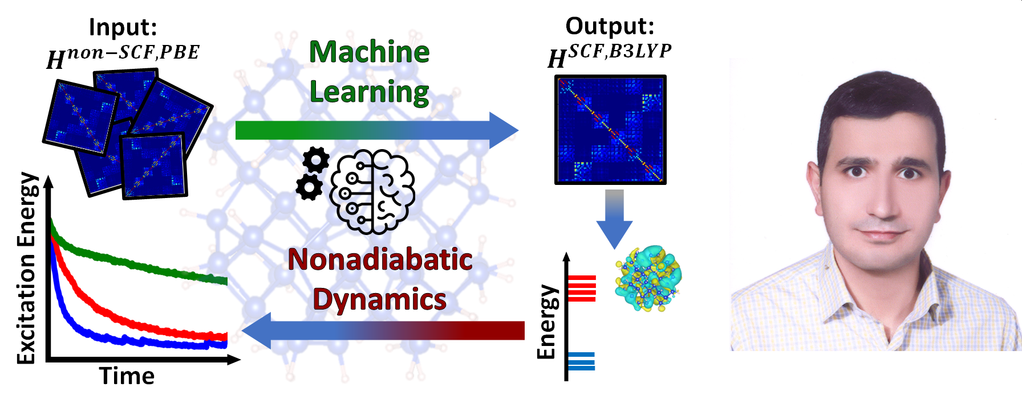
Nonadiabatic molecular dynamics (NA-MD) simulations can effectively model excited-state dynamics in solar energy materials but face challenges in nanoscale systems due to complex electronic structure calculations. Even methods like density functional theory (DFT) or time-dependent DFT (TD-DFT) can be impractical for long simulations, specially with hybrid functionals. Machine learning (ML) has been increasingly used to reduce computational costs, but most models focus on specific properties, requiring large datasets, and costly training, particularly for nanoscale systems.
In this presentation, I will introduce a conceptually simpler yet novel and general ML strategy from our group for constructing the Kohn-Sham (KS) Hamiltonian matrix at a desired level of theory. We observed that the KS Hamiltonian from a converged charge density maps smoothly from a simple non-self-consistent atomic density guess. Using this, we map an initial guess KS Hamiltonian from one theory level, such as PBE, to a converged KS Hamiltonian at another level, like B3LYP or HSE06. This approach requires fewer training data points, accelerates calculations with high accuracy, and is scalable and applicable to various nanoscale materials. I will also demonstrate how atomic orbital matrices, even when obtained at a low level of theory, can be used as feature vectors, bypassing the need for neural network for feature extraction. Additionally, I will show our implementation of a user-friendly interface in Libra, making this method accessible and practical for a wide range of users. Finally, I will demonstrate how this model, when applied to NA-MD simulations of hot-carrier relaxation dynamics, produces timescales within the error margins of conventional methods.

References:
[1] Shakiba, M. and Akimov A. V., Machine-learned Kohn-Sham Hamiltonian mapping for nonadiabatic molecular dynamics, J. Chem. Theory Comput. 2024, 20, 2992-3007.

How to connect

Alexey Akimov is inviting you to a scheduled Zoom meeting.

Topic: VISTA, Seminar 79
Time: Nov 13, 2024 10:00 AM Eastern Time (US and Canada)

Join Zoom Meeting
https://buffalo.zoom.us/j/95923348685?pwd=FOseOJJbaGZjracD0exQXv554deBxy.1

Meeting ID: 959 2334 8685
Passcode: 955293

